**4.1. Types of education and its structure**

**LEAD- IN**

**Task 1**. Look at the word cloud below and find different kind of schools and give their definitions.

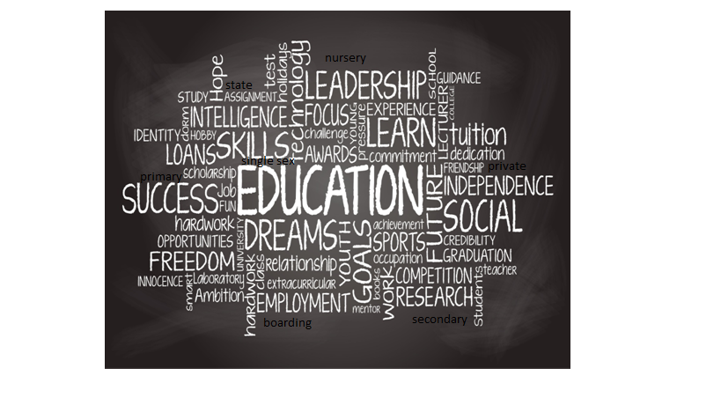

**Task 2**. Compare the given table according to the education system of our country and discuss

|  |  |  |  |
| --- | --- | --- | --- |
| **Age range** | **British Education** | **American Education** | **Kazakh Education** |
| nursery school/ kindergarten | 2-5 ages | 5-6 ages |  |
| primary school /elementary school | 5-11 ages | 5-11 ages |  |
| secondary school | 11-18 ages | junior high school (11-14 ages)  high school (14-18 ages) |  |
| College /University | 18+ | 18+ |  |

**Task 3.** What types of subjects / sports do you know?

|  |  |
| --- | --- |
| SUBJECTS | TYPES OF SPORT |
|  |  |
|  |  |
|  |  |
|  |  |