**Overview:**

This code operates a small Watering Station designed to monitor soil moisture and air temperature, and automatically water plants based on predefined conditions. The system utilizes a LiquidCrystal display for user feedback and an analog sensor for soil moisture measurement.

**Hardware Requirements:**

* Arduino board (Uno, Nano, etc.)
* LiquidCrystal library
* Soil moisture sensor
* Temperature sensor (analog or digital)
* 16x2 LCD display
* Resistors and wires for connections

**Libraries Used:**

* LiquidCrystal.h: Used to control the LCD display.

**Pin Configuration:**

* LCD:
  + RS (Register Select): 12
  + EN (Enable): 11
  + Data Pins: d4 (5), d5 (4), d6 (3), d7 (2)
* Soil Moisture Sensor: A0
* Temperature Sensor: A2
* Watering Pump (Assumed): 8 (configured as OUTPUT)

**Functionality:**

1. **setup() Function**:
   * Initializes the LCD display.
   * Prints "STARTING" on the display for 1 second.
   * Clears the LCD display.
   * Configures pin A0 as input for soil moisture sensor.
   * Initializes Serial communication at a baud rate of 9600.
   * Configures pin 8 as output for controlling the watering pump.
2. **loop() Function**:
   * Reads analog values from the soil moisture and temperature sensors.
   * Converts the analog reading of the soil moisture sensor to a percentage value.
   * Calculates the air temperature based on the analog reading from the temperature sensor.
   * Prints the soil moisture and air temperature values to the Serial Monitor.
   * Checks predefined conditions:
     + If the air temperature is below 0°C, displays "Plant frozen" on the LCD.
     + If the air temperature is above 100°C, displays "Plant burned" on the LCD.
     + If soil moisture is below 60% and air temperature is below 24°C, activates the watering pump and displays "Watering" on the LCD.
     + Otherwise, displays "Monitoring" on the LCD and deactivates the watering pump.
   * Displays the current air temperature and soil moisture percentage on the LCD.

Block Diagram:

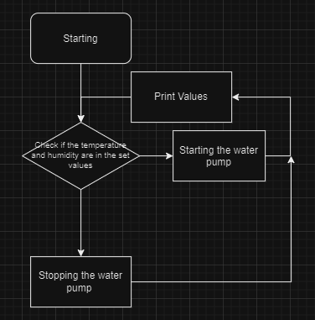

Components:

| **Name** | **Quantity** | **Component** |
| --- | --- | --- |
| 2 | UMainBoard | 1 | Arduino Uno R3 |
| 3 | U1 | 1 | LCD 16 x 2 |
| 4 | R1 | 1 | 1 kΩ Resistor |
| 5 | Rpot1 | 1 | 250 Ω Potentiometer |
| 6 | U2 | 1 | Temperature Sensor [TMP36] |
| 7 | SEN1 | 1 | Soil Moisture Sensor |
| 8 | M2 | 1 | DC Motor |

El Diagram:

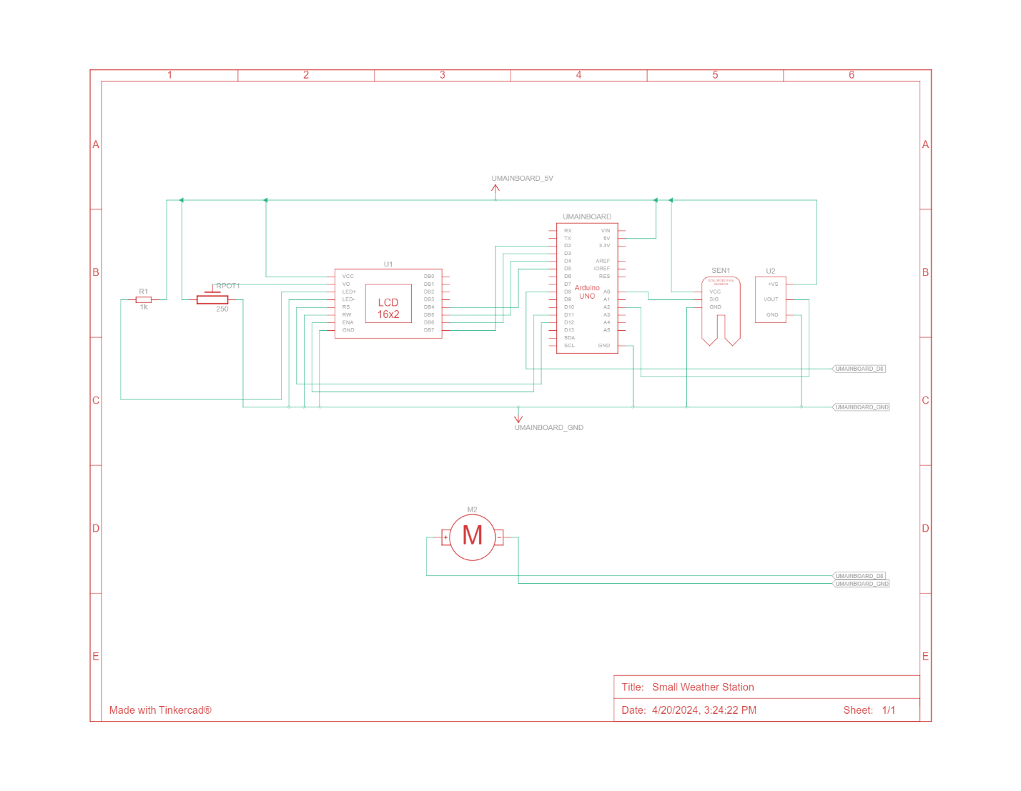

Source code:

#include <LiquidCrystal.h>

const int rs = 12, en = 11, d4 = 5, d5 = 4, d6 = 3, d7 = 2;

LiquidCrystal lcd(rs, en, d4, d5, d6, d7);

int soil_moisture = 0;

int air_temperature = 0;

void setup()

{

lcd.begin(16, 2);

lcd.print("STARTING");

delay(1000);

lcd.clear();

pinMode(A0,INPUT);

Serial.begin(9600);

pinMode(8,OUTPUT);

}

void loop()

{

soil_moisture = map(analogRead(A0),876,0,100,0);

int reading = analogRead(A2);

float voltage = reading * 4.68;

voltage /= 1024.0;

air_temperature = (voltage - 0.5) * 100;

Serial.println(soil_moisture);

Serial.println(air_temperature);

if(air_temperature < 0)

{

lcd.setCursor(0,0);

lcd.write("Plant forzen ");

}

else if (air_temperature > 100)

{

lcd.setCursor(0,0);

lcd.write("Plant burned ");

}

else if(soil_moisture < 60 && air_temperature < 24)

{

digitalWrite(8,HIGH);

lcd.setCursor(0,0);

lcd.write("Watering ");

}

else

{

lcd.setCursor(0,0);

lcd.write("Monitoring ");

digitalWrite(8,LOW);

}

lcd.setCursor(0,1);

lcd.print(air_temperature);

lcd.print("C");

lcd.setCursor(6,1);

lcd.print(soil_moisture);

lcd.print("%");

delay(10);

}