ANALYTICS REPORT & INSIGHTS DOCUMENTATION
E-commerce Sales Performance Analysis | Portfolio Project
Prepared by: Piyush Kumar | Tools: Python, pandas, matplotlib

1. Executive Summary
This project demonstrates a structured analysis of 300 e-commerce orders across four product categories, four regions, three sales channels, and the 2025 calendar year. The dataset is synthetic and intended for learning and portfolio demonstration only. Total sample revenue is INR 704,005.99, total sample profit is INR 203,877.88, and the calculated profit margin is 28.96%. Average revenue per order is INR 2,346.69. The highest-revenue category in this sample is Electronics (INR 268,558.41); the highest-revenue region is West (INR 205,949.54); and the strongest sales channel by revenue is Website (INR 271,976.68). These findings illustrate how basic analytics can summarize performance and guide questions for further investigation.

2. Business Objective and Questions
The objective is to turn transaction-level sales data into clear performance measures and practical business insights. The analysis answers six questions: (1) What are total revenue and profit? (2) How does revenue change month by month? (3) Which product categories contribute the most revenue and profit? (4) Which region generates the most revenue? (5) Which sales channel contributes the most revenue? (6) What actions could improve sales performance while protecting profitability?

3. Dataset and Methodology
The project uses a synthetic CSV dataset containing 300 sample orders dated in 2025. Fields include order ID, order date, region, sales channel, product category, product, quantity, unit price, discount rate, revenue, cost, and profit. The dataset is designed to be safe for practice and does not represent a real retailer. The workflow includes loading the CSV, checking missing values and duplicate order IDs, validating revenue values, deriving a month field, calculating key performance indicators, grouping results by category/region/channel/month, and preparing charts with pandas and matplotlib.

4. Key Performance Indicators
Metric | Sample result
Total revenue | ₹704,005.99
Total profit | ₹203,877.88
Unique orders | 300
Units sold | 604
Average revenue per order | ₹2,346.69
Profit margin (profit ÷ revenue) | 28.96%

5. Findings and Visualizations
Category analysis: Electronics is the largest revenue category in the sample at ₹268,558.41. Region analysis: West leads sample revenue at ₹205,949.54. Channel analysis: Website has the highest sample revenue at ₹271,976.68. The highest-revenue month is 2025-10 at ₹93,048.71. These are descriptive results from generated sample records; they should not be generalized to a real company. For a real deployment, findings should be checked against verified source data and business context.

Monthly revenue trend
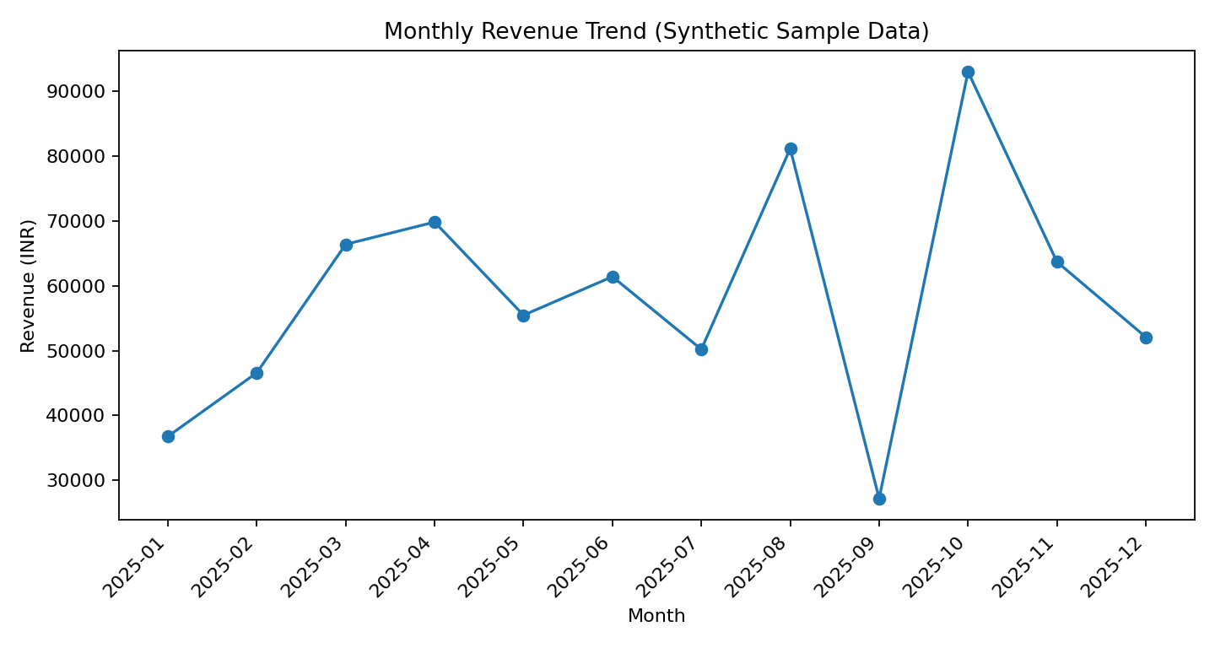

Revenue by category
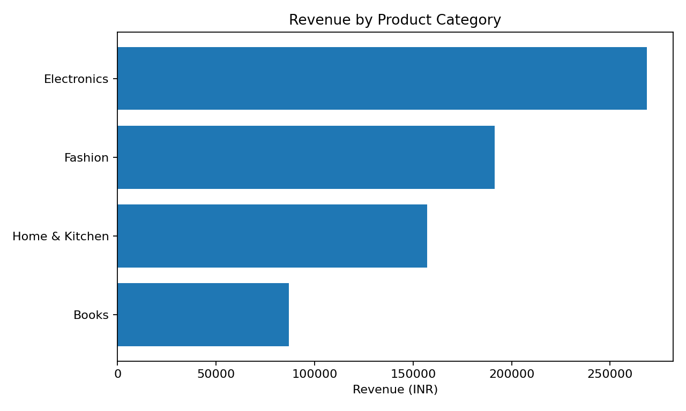

Revenue by region
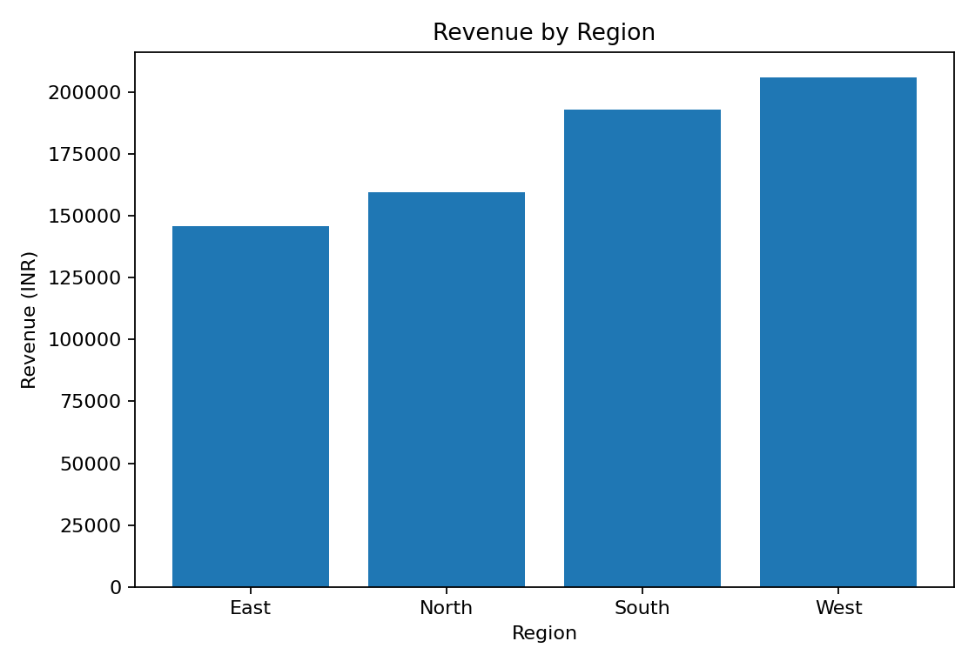

Revenue by sales channel
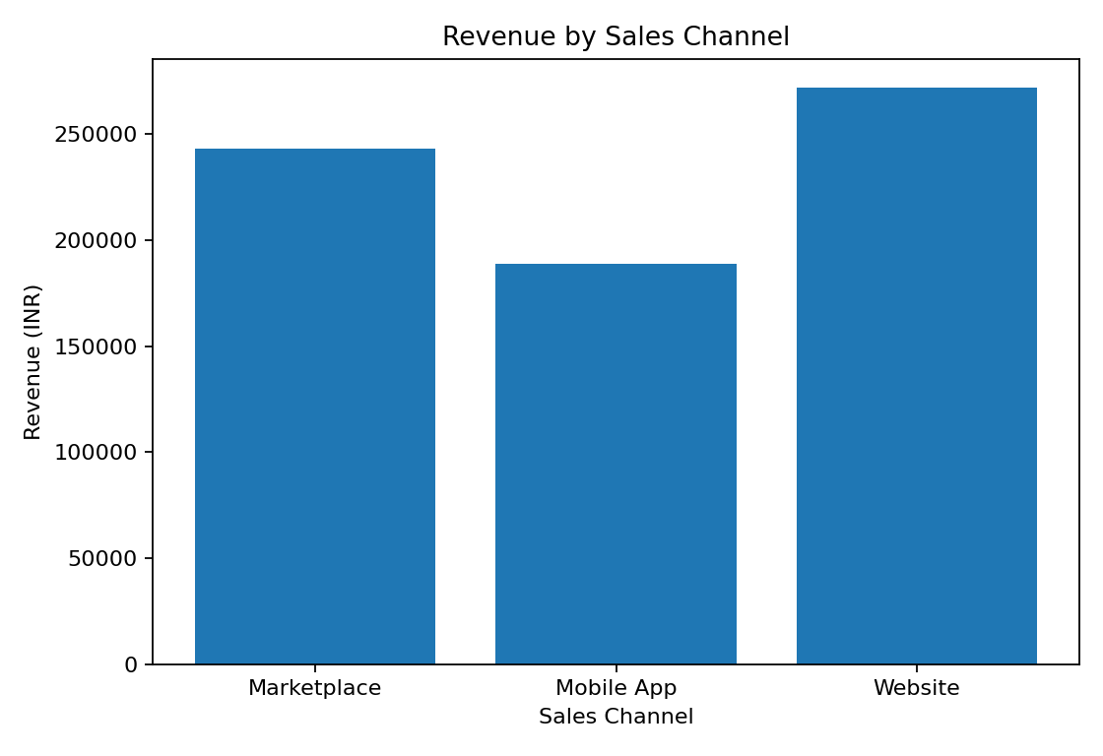

6. Business Insights
- The Electronics category is the current sample leader for revenue. Review its product-level performance and stock availability before expanding investment.
- The West region has the highest sample revenue. Compare order count, average order value, delivery costs, and customer acquisition costs to understand whether it is also the most profitable region.
- The Website channel leads sample revenue. Assess conversion rate, return rate, and channel fees before shifting more marketing budget to it.
- Monthly revenue varies, so a real business should investigate seasonal effects, campaigns, stock-outs, and pricing changes before interpreting peaks or dips.
- Revenue alone is not enough: monitor profit and profit margin together to avoid prioritizing sales that may be costly to fulfill.

7. Actionable Recommendations
- Build a monthly dashboard with revenue, profit, margin, order count, average order value, and year-over-year or month-over-month change.
- Investigate the top category and its best-selling products; maintain appropriate inventory while tracking gross margin and returns.
- Compare regions using both revenue and contribution profit, including shipping and promotional costs.
- Evaluate each sales channel using conversion rate, fees, customer retention, and return rate rather than revenue alone.
- Review discounts by category and channel to test whether promotions generate incremental profit instead of simply reducing margin.
- For future analysis, use validated real business data, document data definitions, check outliers, and record the date range and exclusions.

8. Limitations and Next Steps
The records are synthetic, and no customer demographics, returns, marketing spend, shipping costs, or inventory levels are included. Therefore, this project demonstrates the analytical process rather than proving actual business performance. Next steps include adding realistic return and cost-to-serve fields, creating an interactive Power BI dashboard, writing SQL queries for the same KPIs, and validating the results with a stakeholder before making operational decisions.

9. Conclusion
This project shows a repeatable beginner-level analytics workflow: define a business objective, inspect data quality, calculate KPIs, analyze trends and segments, visualize results, and translate findings into recommendations. The report and Python script can be reused as a portfolio foundation. All numerical results should be labeled as synthetic sample findings unless the dataset is replaced with verified data.

Appendix: Reproducibility
Install dependencies with: pip install pandas matplotlib. Run the project with: python analysis.py. The script prints data-quality checks and KPIs, then regenerates the main charts.

