Al-Based Phishing Website Detection using Hybrid Feature Learning
Piyush Kumar Pradhan¹, Raja Kishor Nayak², Tanmaya Mangaraj³, Aditya Pal⁴, S Ramananda Sagar⁵, Mr. Subhasish Mohanty6
Department of Computer Science and Engineering, Siksha ‘O’ Anusandhan (Deemed to be) University, Bhubaneswar, Odisha, India

piyushpradhan911@gmail.com¹
nayakrajakishor1@gmail.com²
tmangaraj13@gmail.com³
adityapal5181@gmail.com⁴
ramananda0007@gmail.com⁵
subhasishmohanty@soa.ac.in6
Abstract. In phishing attacks, cybercriminals trick users, often through email, into giving away their credentials on a fake website that is similar to the real one. The article presents a comprehensive machine learning framework that automatically detects phishing websites using only the URLs. The URLs are inferred from the page.

Moreover, the framework does not rely on any external service provider. Using data from various datasets sourced from Kaggle, we were able to create a balanced dataset of 10,000 samples (5,000 phishing, 5,000 legitimate) The twenty-one features, which come from a URL, were created and selected using the Recursive Feature Elimination (RFE). Eight different classifiers have been trained and evaluated. The highest achieved performance is produced by the Stacking Ensemble with 90.95% (ROC-AUC: 0.9608) while Gradient Boosting gives 90.65% and Voting Ensemble gives 90.55%. The SHAP analysis shows that URLs length, path length, and file name length are the most discriminative features The proposed framework displays that phishing can be detected with an accuracy of almost about 91% using only the URL-based features. Therefore, it is a lightweight and real-time deployable defense mechanism.
Keywords: Phishing Website Detection , Machine Learning, Ensemble Learning,Stacking Ensemble , Explainable AI(SHAP) , Hybrid Feature Learning.

- Introduction
Phishing is a type of cyberattack that is used to deceive users by creating fake websites and emails that impersonate organizations to steal login credentials and user information. Most of the current methods to fight phishing are based on traditional anti-phishing techniques and use blacklists that are not able to face in real time newly created phishing websites. Moreover, the use of URL features is one of the most efficient ways to detect phishing websites, since URLs can be easily extracted from web pages without loading them and without using external APIs.
  - Motivations
Many phishing detection systems give good accuracy, but most of them depend on webpage content or external services, which makes detection slower and less suitable for real-time use. Also, very few studies focus only on URL-based features along with explainable AI methods. In this project, we use only URL lexical and structural features to build a fast and lightweight phishing detection system. We also use SHAP analysis to understand and explain how the model makes decisions
  - Objectives
The main purpose of this study is to build a fast and lightweight phishing website detection system using only URL-based features, without depending on webpage content or external services. This study also aims to compare different machine learning models to find the best one for phishing detection. In addition, SHAP analysis is used to understand which URL features are most important in identifying phishing websites and to make the model decisions easier to explain.
  - Original Contributions
This work provides the following main contribution to phishing website detection:
- URL Feature Extraction: A simple system was developed to extract 21 important features from URLs for detecting phishing websites without opening the webpage.
- Comparison of ML Models: Eight different machine learning models were tested and compared to find the best model for phishing detection.
- Explainable Detection System: SHAP analysis was used to understand how the model makes decisions and which URL features are most useful in detecting phishing websites.
- Fast and Lightweight Solution: A stacking ensemble model achieved around 91% accuracy using only URL features, making the system suitable for real-time phishing detection.
  - Paper Layout
This paper is going to be about phishing website detection. The phishing website detection is what we will be talking about in the rest of this paper.The next part is Section 2. It is about what other people have done before us on phishing website detection.Then we have Section 3 which's about the system we made for phishing website detection the dataset we used for phishing website detection how we got the features for phishing website detection and the machine learning models we used for phishing website detection.After that we have Section 4 which's about what we found out when we did the experiments on phishing website detection and how well the models worked for phishing website detection.The last part is Section 5. It is about what we learned from the whole project on phishing website detection and what we think could be done to make the system, for phishing website detection better in the future for phishing website detection.

- Literature Survey
Nusrath Tabassum and others in 2021 showed that combining URL and hyperlink-based features works well for phishing website detection.Their system used features from the client-side for phishing website detection.They tested five classifiers for phishing website detection. It gives 98.28 percent for phishing website detection.However it still needed a lot of work to create features for phishing website detection.It also struggled with obfuscated phishing domains for phishing website detection.

Sumitra Das Gupta and others in 2022 built on this idea for phishing website detection.They used of 6,000 URLs and combined URL attributes. They used 4 classification of phishing website detection.Their best result was 99.17 percent accuracy for phishing website detection.However extracting hyperlinks increased processing time for phishing website detection.This made the framework less suitable for real-time use of phishing website detection.

Mukta Mithra Raj and others in 2022 also studied phishing website detection.They tested eight baseline classifiers on a dataset of over 11,000 URLs for phishing website detection.Their hybrid voting classifier achieved 97.07 percent accuracy for phishing website detection.They found that reducing features did not always improve performance for phishing website detection.Sometimes having features is better than having features for phishing website detection.

Rekha Pal and others in 2023 used Extra Tree Classifiers, Pearson Correlation, Forward Selection, PCA and a Logit-LR model for phishing website detection.Random Forest with Logit-based feature selection produced the accuracy of 97.48 percent for phishing website detection.However their architecture still relied on handcrafted features for phishing website detection.It also did not handle imbalance well for phishing website detection.

Kavya. Sumathi D. In 2024 proposed a stacking framework for phishing website detection.It used LSTM for temporal sequence modelling CNN for visual webpage analysis and Random Forest for feature classification of phishing website detection.The system achieved 97.1 percent accuracy for phishing website detection.However it was computationally complex for phishing website detection.Needed large-scale training infrastructure for phishing website detection.

Rangaswamy K.. Others in 2025 compared ML and DL models used on a large-scale dataset for phishing website detection.CNN achieved 98 percent accuracy for phishing website detection.It was good at capturing URL patterns for phishing website detection.However it needed a lot of GPU resources for phishing website detection.Was hard to interpret for phishing website detection.

Raheleh Ghadami and Javad Rahebi in 2025 proposed a GAN-augmented hybrid framework for phishing website detection.It combined CNN-GRU-FMRCNN feature extraction with Transformer-based learning for phishing website detection.The system achieved 99.12 percent accuracy for phishing website detection.However it was computationally prohibitive and susceptible to crafted phishing URLs for phishing website detection.

Wakchaure Sanchit Sanjay and others in 2025 introduced the pipeline for phishing website detection.It combined Rough Set Theory-Based Hybrid Feature Selection with a MLP classifier for phishing website detection.The approach reduced the feature space and training time for phishing website detection.It maintained 98.29 percent accuracy for phishing website detection.This lightweight design is suitable for edge- phishing website detection.

Ashvini Jadhav and Pankaj Chandre in 2025 took a -domain approach for phishing website detection.They integrated URL, HTML content, email header and SPF/DKIM/DMARC authentication features for phishing website detection.Their hybrid voting classifier achieved 99.87 percent accuracy for phishing website detection.It showed that heuristic-guided feature integration improves scalability and policy compliance for phishing website detection.

K. Pavan Sankar and P. Bhaskar Naidu in 2025 proposed the Hybrid LSD ensemble for phishing website detection.It combined Logistic Regression, SVC and Decision Tree with a CNN architecture for phishing website detection.The 1D CNN configuration achieved 99.70 percent accuracy for phishing website detection.It confirmed that convolutional architectures applied to tokenised URL sequences outperform classifiers for phishing website detection.

Pratik Ahirwar and Anurag Shrivastava in 2026 reviewed URL-based and deep learning phishing detection approaches for phishing website detection.They concluded that deep learning architectures improve detection for phishing website detection.However they also documented limitations like large-scale training requirements and high computational complexity for phishing website detection.

Sravanthi A.. Others in 2026 proposed an AI decision engine for phishing website detection.It combined Random Forest for URL classification with LSTM for character-level URL analysis for phishing website detection.The system improved detection of phishing attacks for phishing website detection. They struggle to detect obfuscation techniques for phishing website detection.Transformer-based semantic URL understanding is underexplored for phishing website detection.Explainable AI integration is rare for phishing website detection.Most frameworks lack attack resistance for phishing website detection.Multimodal detection is limited for phishing website detection.Lightweight architectures suitable for real-time deployment are needed for phishing website detection.The proposed framework addresses these gaps in phishing website detection.
- Proposed System/Model
  - Dataset Description
After the data was cleaned and organized, it generated a data of 10,000 URLs. It is important to maintain balance when developing a dataset in order for machine learning models to understand both classes and provide better accuracy metrics and results.

The original dataset also including URL text and some metadata columns, which were also removed prior to training the models. All other data was converted to numeric forms and a small number of missing values was imputed using the median of each column.

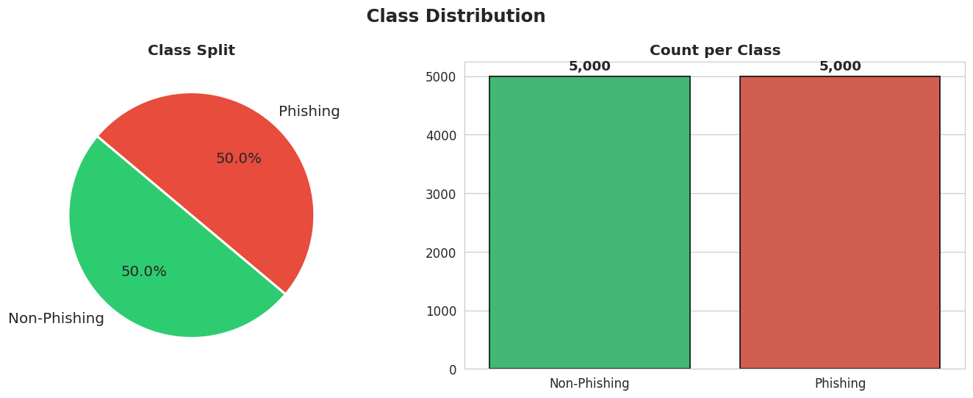
Fig. 1 : Class Distribution – 5,000 Phishing vs 5,000 Non-Phishing samples
  - Schematic Layout of the proposed system/model
The process implemented by the phishing detection system is straightforward and easy to understand. The first step includes the collection of both phishing and normal website URLs, which comes from the various publicly posted datasets on Kaggle. Once the data is collected, extraneous columns are deleted, labels are formatted as they should be, and empty fields are edited to remove their absence. The significant data is extracted from the URLs, and the features are evaluated to decide which ones are optimal. The data is then prepared by normalizing it, as it is already balanced, and then moving on to training the machine learning models, which is the next step of the process. The final step includes utilizing different machine learning models and training each of them on their own distinct training and testing datasets. Lastly, the models are evaluated by various performance metrics to understand the models' interpretations, including 6 Parameter and SHAP analysis.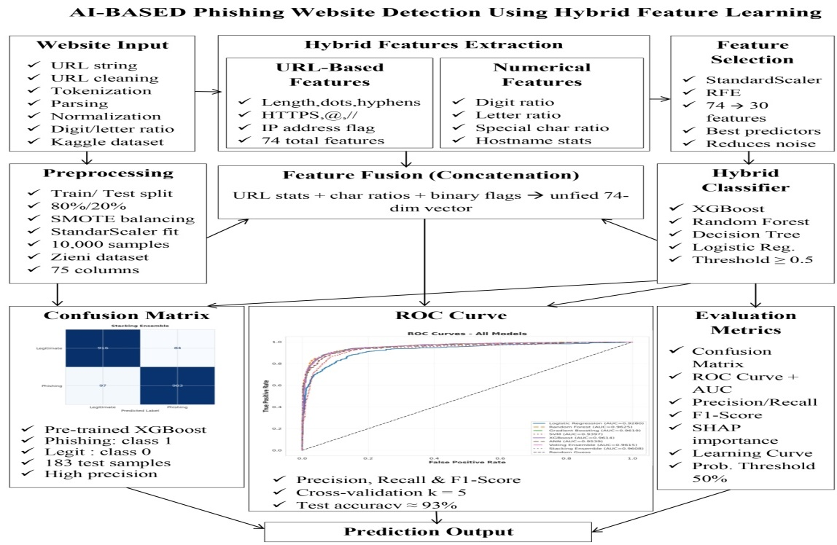
Fig 2. End-to-end system pipeline for phishing website detection.

  - Methodologies Used
The phishing detection system's objective is to detect phishing attempts rapidly by employing different techniques that utilize the URL characteristics.

- Step 1: Feature Engineering of URLs
21 different lexical and structural characteristics have been created to assist in identifying whether a URL is a phishing URL, through identifying various patterns.

- Step 2: RFE to Select Features
To select features for the predictive machine learning algorithms, the Random Forest algorithm and recursive feature elimination were used. Recursive feature elimination reduced the number of features with a high likelihood of causing overfitting to a prediction model and allowed for an improvement of model performance.

- Step 3: Training Machine Learning Models
In this study, two baseline models based on logistic regression and SVM (support vector machine), three advanced models based on random forests, gradient boosting, and XGBoost, and two ensemble models using voting or stacking methods were developed. This provided an opportunity to determine how well various machine learning algorithms can detect phishing URLs.

- Step 4: The Use of SHAP Analysis
It determine how predictions from different models are generated for each URL. In addition, SHAP, when used with phishing detection algorithms, was used to determine the global and local explanations for the different algorithms’ model outputs.
- Experimentation and Model Evaluation
  - Experimental Setup
Google Colaboratory was the environment where all experiments for this project were conducted and Python 3.10 was used to program the experiments. The systems were tested on an NVIDIA T4 (16 GB vram, 12.7 GB ram). Various Python libraries were employed to train, evaluate, and analyse the explainability partitioned in to 80% training and 20% testing.

All classes were equally representatively and same amount when the data was sampled (i.e., stratified). A fixed value of 42 was used for the random state assigned to the sampling, which enabled replicable results to be obtained. All of the feature values were standard scaled so that the model could perform better, and maintain consistency through evaluation, prior to any trains, by using only the feature's in the train data when fitting StandardScaler.

  - Results and Outputs
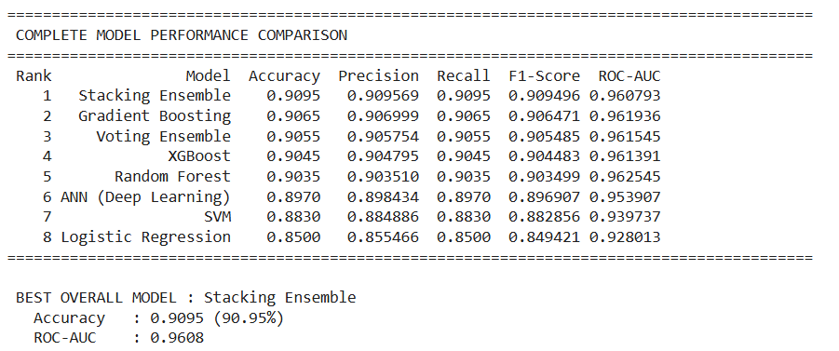

Fig. 3: Complete Model Performance Comparison
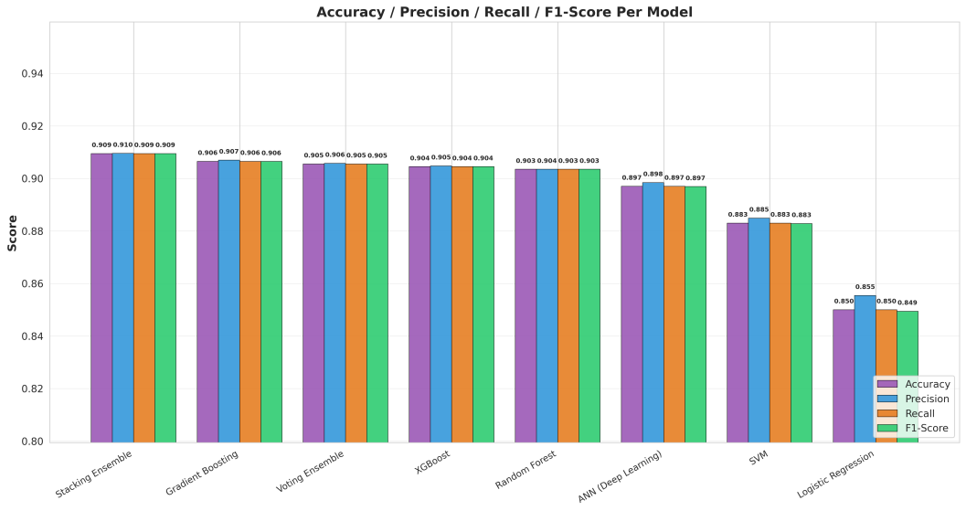

Fig. 4. Grouped bar chart of all model.
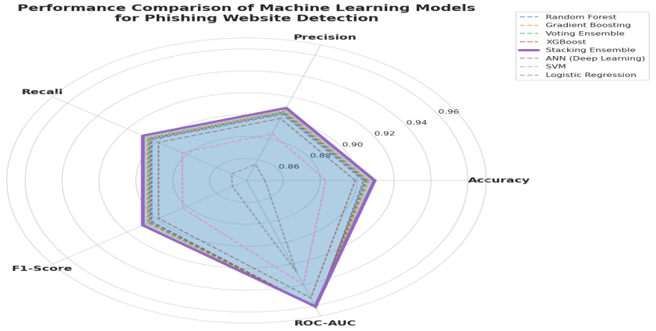
Fig. 5. Radar chart comparing all five performance metrics across models.
  - Validation/System Performance Evaluation
- Confusion Matrix Analysis - The Stacking Ensemble model produced 916 legitimate (not phishing!) URL classifications, and 903 phishing URL classifications. There were 84 legitimate sites identified as phishing, and 97 phishing sites that were incorrectly not classified as such, yielding a fairly balanced error distribution for both classes, and thus demonstrating reliable performance in real-world cyber-security applications 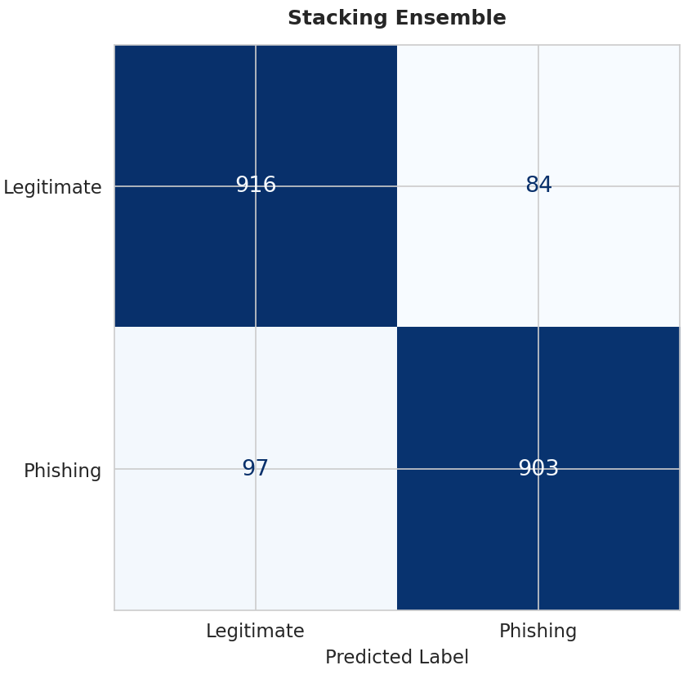
Fig. 6. Confusion Matrix for the best-performing Stacking Ensemble model.

- Cross Validation Analysis - A five-fold cross-validation test (Random Forest) was used to establish system stability; The average weighted F1-score across the five tests was 0.9021, with very little variation among the different folds, demonstrating that the model generalises to a dataset and displays a consistent level of performance between different splits of the data.

- SHAP Feature Importance Analysis - SHAP was used to rank the most relevant URL features that contributed to the detection of phishing. The findings indicated that URL length, path length and file name length have the greatest impact upon detecting phishing; Longer and more complicated URLs generally increase the chance that the site will be classified as phishing. Attackers are known to use long URLs and complicated structures to mislead and confuse users.
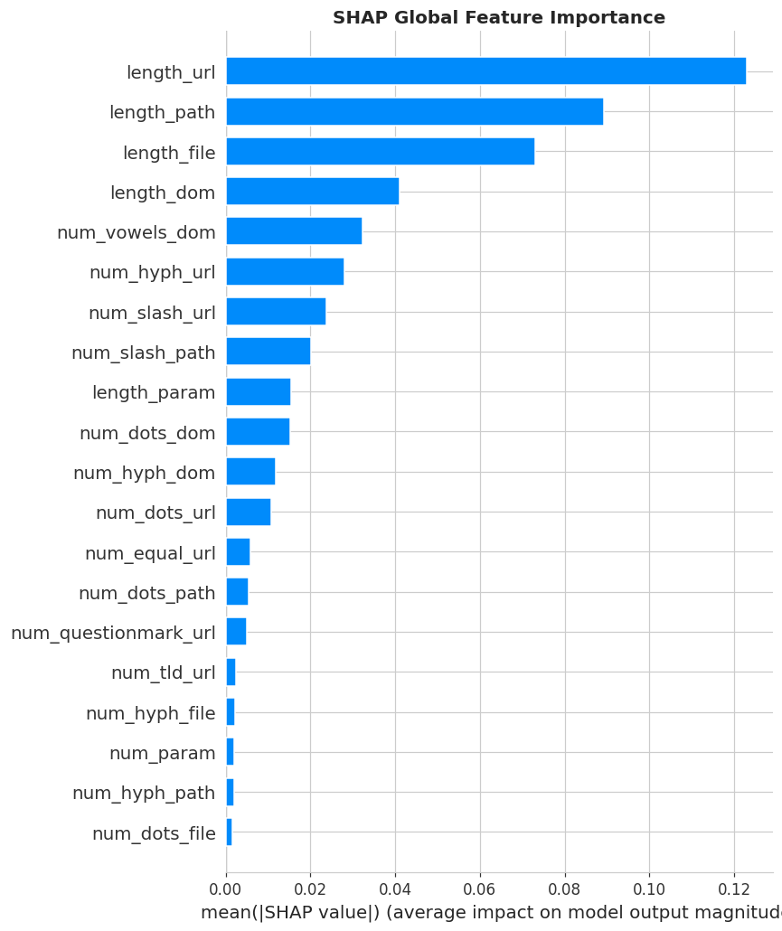
Fig. 7. SHAP Global Feature Importance – top 20 features ranked by mean |SHAP|.
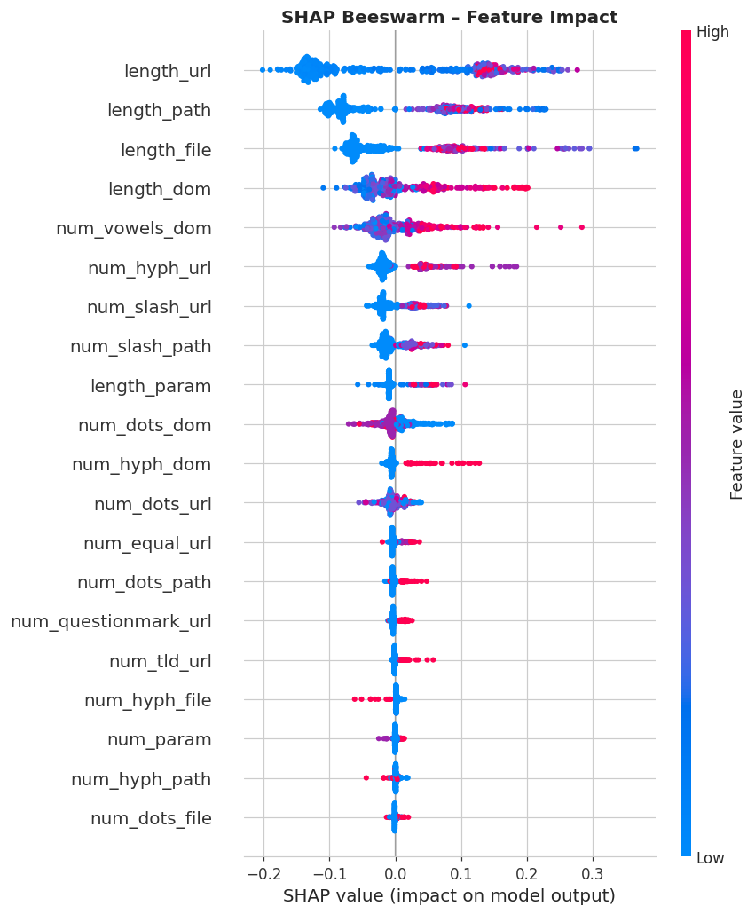
Fig. 10. SHAP Beeswarm Plot showing per-instance feature impact and
directionality
  - Discussions on Contributions
The results of this study show that the proposed phishing detection system has shown effective results. The ensemble and boosting models have outperformed the basic machine learning models (Logistic Regression and SVM) because using multiple models in combination helps to generate accurate predictions and decrease error rates. The Stacking Ensemble Model produced the highest accuracy out of all models, while Gradient Boosting produced the highest ROC-AUC score for identifying phishing risks.

The ANN model performed slightly inferior to tree-based models as expected, because this is typical for a tabular dataset. Additionally, through SHAP analysis, it was confirmed that such features as URL length, Path length, and filename length are extremely useful for phishing detection purposes. One consistent theme with phishing websites is they tend to use longer and more complex URLs as a way to mislead users.

These results demonstrate that the use of URL-based features alone can allow phishing websites to be detected with high accuracy and for phishing websites to be detected without needing to utilize webpage content or outside services. Therefore, the system is lightweight and can operate efficiently in real-time conditions when used within browser extensions and cybersecurity applications.

- Conclusion and Future Scope
It presented phishing website detection system using machine learning and 21 URL-based features without using webpage content or external services. Eight different machine learning models were tested on a dataset of 10,000 URLs, and the Stacking Ensemble model achieved the best accuracy of 90.95%. SHAP analysis showed that URL length, path length, and file name length are the most important features for identifying phishing websites. The results show that URL-based features alone can detect phishing websites with nearly 91% accuracy while keeping the system fast and lightweight for real-time use. In the future, this system can be added to Chrome or Firefox browser extensions to give instant phishing warnings to users.

In the future the phishing detection system can be made better by adding things like WHOIS details and DNS information and SSL certificate data. This will help it find phishing websites more accurately. The system can also look at the content of websites including how the HTML's structured and how similar webpages are to each other.This will make the system better at finding phishing websites.The phishing detection system can be turned into a Chrome or Firefox browser extension. This will help keep people safe while they are browsing the internet.It can also be used by organizations and companies as a cloud-based security service.To make the system even better it can be updated all the time to deal with phishing techniques. The phishing detection system can also be used to find cyber threats, like spam links and malicious redirects and fake login pages and IDN-based attacks.The phishing detection system will be able to find phishing websites and other cyber threats accurately.

References
- N. Tabassum, F. F. Neha, M. S. Hossain, and H. S. Narman,“A hybrid machine learning-based phishing website detection technique through dimensionality reduction,”in Proc. IEEE Int. Black Sea Conf. Commun. Netw. (BlackSeaCom), 2021.
- S. D. Gupta, K. T. Shahriar, H. Alqahtani, D. Alsalman, and I. H. Sarker,“Modeling hybrid feature-based phishing websites detection using machine learning techniques,”Annals of Data Science, 2022.
- M. M. Raj and J. A. A. Jothi,“Hybrid approach for phishing website detection using classification algorithms,”PARADIGM Plus, vol. 3, no. 3, pp. 16–29, 2022.
- R. Pal, M. K. Pandey, S. Pal, and D. C. Yadav,“Phishing detection: A hybrid model with feature selection and machine learning techniques,”Int. J. Exp. Res. Rev., vol. 36, pp. 99–108, 2023.
- S. Kavya and D. Sumathi,“Design of a hybrid AI-based phishing website detection using LSTM, CNN, and random forest-based ensemble learning analysis,”in Proc. 8th Int. Conf. Electron., Commun. Aerosp. Technol. (ICECA), 2024.
- K. Rangaswamy, S. Khaleel, N. Pradeep, K. S. S. R. Krishna, and J. V. Charan,“Phishing website detection using machine learning and deep learning techniques,”Power System Technology, 2025.
- K. P. Sankar and P. B. Naidu,“URL-based phishing detection using a hybrid machine learning model,”Industrial Engineering Journal, vol. 54, no. 5, May 2025.
- A. Jadhav and P. Chandre,“A hybrid heuristic-machine learning framework for phishing detection using multi-domain feature analysis,”Engineering, Technology & Applied Science Research, vol. 15, no. 5, pp. 27219–27226, Oct. 2025.
- S. S. Wakchaure, J. S. Kale, S. R. Dange, and G. S. Wakchaure,“Phishing website detection using hybrid machine learning and feature optimization techniques,”Industrial Engineering Journal, vol. 54, no. 11, Nov. 2025.
- R. Ghadami and J. Rahebi,“An explainable hybrid deep learning-optimization framework for robust phishing attack detection using GAN and transformer-based feature learning,”Ain Shams Engineering Journal, vol. 16, Art. no. 103745, Dec. 2025.
- P. Ahirwar and A. Shrivastava, "Phishing website detection: A systematic review of URL-based and deep learning approaches," International Journal of Innovations in Science Engineering and Management, vol. 5, no. 2, pp. 29–37, Apr. 2026.
- A. Sravanthi, A. A. Kousar, A. R. Dabole, G. J. G, and S. Elango, "Hybrid AI for phishing site detection," International Research Journal of Modernization in Engineering Technology and Science, vol. 8, no. 4, pp. 10446–10453, Apr. 2026.

