**Technical Specification Document**

**SAP Batch Management Data**

Prepared By: Debidutta Swain (AIRDIT Software Solutions)

**Technical specification content**

1. Business Requirement
2. Development Tools
3. Development Objects

* Table.
* CDS (Core Data Service).
* Data Definition
* Access Control
* SEGW – OData Project.

1. Business API / OData API and Output Screen
2. **Business Requirement:**

Develop an OData GET API for Material Batch management data and through this API User can access only those plant data for which he/she will be assigned.

API LOGIC :

CASE 1 pass the ERSDA with LAEDA=blank

CASE 2 pass the LAEDA with ERSDA= blank

CASE 3 pass the ERSDA and LAEDA from MCH1 table and fetch the value

**Based on the logic fetch following data.**

Here this FS is a incomplete FS , for that I discussed with Funtional consultant and we came to a conclusion that first we will consider MCHA as base table as we are filtering bsed on plant and plant related details we are getting from MCHA table .  
 then we will fetch the MCH1 table details while joining the MCHA table details with MCH1 and at last we fill filter the data based on User Authorized plant through Authorization Object.

From MCHA Cosider ***MATNR,WERKS & CHARG***.  
From MCH1 following fields will considered and in the table section of this attachment, only consider MCH1 (due Writing Mistake).

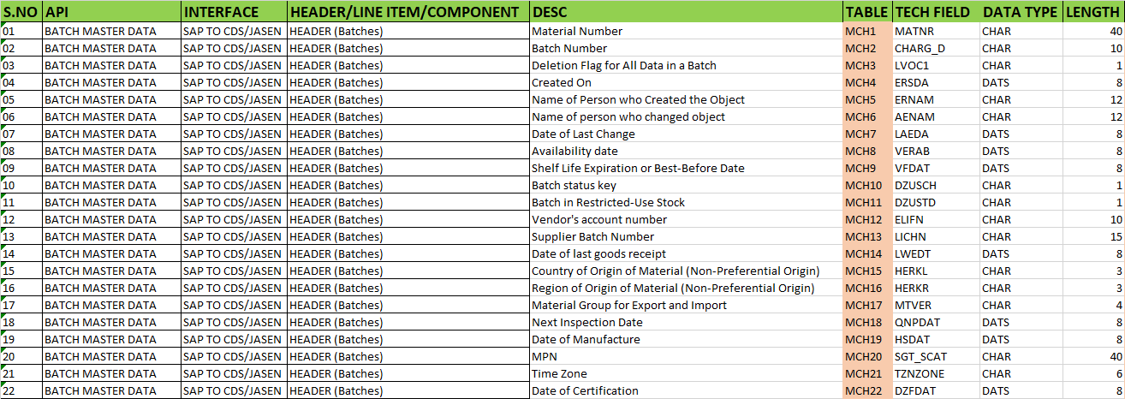

FS Prepared by:

|  |  |  |  |
| --- | --- | --- | --- |
| User Story ID # |  | Module | MM |
| Date | 13.08.2025 | SL User |  |
| Consultant | Sunil Kumar | Developer |  |
| Priority | ☐Urgent ☒High ☐Medium ☐Low | | |
| Application Type | ☐Report ☐Transaction ☐Interface ☒ Enhancement/Change ☐Others | | |
| Execute Model | ☐Batch ☐ Foreground ☒Manual ☐Quarterly ☐Monthly  ☐Weekly ☐Daily ☐Real time | | |
| Output Type | ☐Message ☐Dialog Screen ☐ABAP List ☐ALV List ☐ALV Grid | | |
| Remarks | SAP BATCH MANAGEMENT DATA | | |

**2.Development Status & Tools**

For development these are the following tool used :

* **Eclipse for ABAP /ADT(ABAP Development Tool)**

**Core Data Service**

* Interface/Basic CDS view:

Created on top of Required Database. Naming convention: ZI_*****

* Composite CDS view:

Created on top of Interface basic view for join/association. Naming convention: ZCO_*****

* Consumption view:

Expose only those field required for Business Requirement. Naming convention: ZC_*****

* Access Control

Provide Access on data based on User. Naming convention: ZDCL_*****

* **SEGW OData Project**
* Created OData project with “Data Source Reference” Using the consumption CDS view. Here in this CDS association has been done due to which in ODATA project all the association and navigation property generate automatically.
* For Service Registration used Tcode : /N/IWFND/MAINT_SERVICE.
* To Check the final data at Gateway Client used Tcode :/N/IWFND/GW_CLIENT.

NOTE : For CDS development process, I followed the VDM approach.

**3.Development Objects**

* Table:
* **MCHA:** Batches
* **MCH1:** Batches (if Batch Management Cross-Plant)
* **CDS view:**
* **Basic CDS View:**

As I am following the VDM modelling in this development, I had created Basic CDS view on top of Database table and the source of Basic View Should be a Database View or Standard CDS view.

* Table: **MCHA (**Batches)
* CDS View: ZI_MM_MCHA_BATCHESDETAIL
* //----------------------------------------------------------------------//
* //Created By : AIRDIT--Debidutta Swain(9000RUPESH)
* //---------------------------------------------------------------------//
* @AbapCatalog.sqlViewName: 'ZIMCHA'
* @AbapCatalog.compiler.compareFilter: true
* @AbapCatalog.preserveKey: true
* @AccessControl.authorizationCheck: #NOT_REQUIRED
* @EndUserText.label: 'Basic CDS:MCH1:Batches'
* @Metadata.ignorePropagatedAnnotations: true
* @VDM.viewType: #BASIC
* **define** **view** ZI_MM_MCHA_BatchesDetail
* **as** **select** **from** mcha
* **{**
* **key** matnr **as** MaterialCode**,**
* **key** werks **as** Plant**,**
* **key** charg **as** BatchNumber**,**
* lvorm **as** DeletionFlag
* **}**
* Table: **MCH1(**Batches (if Batch Management Cross-Plant))
* CDS View: ZI_MM_MCH1_BATCHESCROSSPLANT
* //--------------------------------------------------------------//
* //Created By : AIRDIT--Debidutta Swain(9000RUPESH)
* //--------------------------------------------------------------//
* @AbapCatalog.sqlViewName: 'ZIMCH1'
* @AbapCatalog.compiler.compareFilter: true
* @AbapCatalog.preserveKey: true
* @AccessControl.authorizationCheck: #NOT_REQUIRED
* @EndUserText.label: 'Basic CDS:MCH1:Batches (if Batch Management Cross-Plant)'
* @Metadata.ignorePropagatedAnnotations: true
* **define** **view** ZI_MM_MCH1_BatchesCrossPlant
* **as** **select** **from** mch1
* **{**
* **key** matnr **as** MaterialCode**,**
* **key** charg **as** BatchNumber**,**
* lvorm **as** DeletionFlag**,**
* ersda **as** CreatedOn**,**
* ernam **as** CreatedBy**,**
* laeda **as** LastChangedOn**,**
* aenam **as** ChangedBy**,**
* verab **as** AvailabilityDate**,**
* vfdat **as** SelfLifeExpiration**,** //--> Self Life Expiration Or Best Before Date
* zusch **as** BatchStatusKey**,**
* zustd **as** BatchRestrictedUseStock**,**
* lifnr **as** VandorCode**,**
* licha **as** SupplierBatchNumber**,**
* lwedt **as** DateOfLastGoodsRecipt**,**
* herkl **as** CountryOriginMaterial**,** //-->Country of Origin of Material (Non-Preferential Origin)
* herkr **as** RegionOriginMaterial**,** //-->Region of Origin of Material (Non-Preferential Origin)
* mtver **as** MaterialGroupImpExp**,** //-->Material Group for Export and Import
* qndat **as** NextInspectionDate**,**
* hsdat **as** DateOfManufacture**,**
* sgt_scat **as** MPN**,**
* ersda_tz_sys **as** TimeZoneSYS**,**
* ersda_tz_usr **as** TimeZoneUSR**,**
* zfdat **as** DateOfCertification
* **}**
* **Composite CDS view**

As I am following the VDM modelling in this development, I had created Composite CDS view on top of Basic View where I will do all the necessary Joins/association needed for the Current Business Requirement.

* View name: ZCO_MM_MCH1_BATCHESCROSSPLANT
* //--------------------------------------------------------------//
* //Created By : AIRDIT--Debidutta Swain(9000RUPESH)
* //--------------------------------------------------------------//
* @AbapCatalog.sqlViewName: 'ZCOMCH1'
* @AbapCatalog.compiler.compareFilter: true
* @AbapCatalog.preserveKey: true
* @AccessControl.authorizationCheck: #NOT_REQUIRED
* @EndUserText.label: 'Composite CDS:MCH1:Batches(Cross-Plant)'
* @Metadata.ignorePropagatedAnnotations: true
* @VDM.viewType: #COMPOSITE
* **define** **view** ZCO_MM_MCH1_BatchesCrossPlant
* **as** **select** **from** ZI_MM_MCH1_BatchesCrossPlant **as** mch1
* //--> Join for Vandor Name
* **left** **outer** **join** lfa1 **on** lfa1**.**lifnr **=** mch1**.**VandorCode
* //--> Material Origin Country Name
* **left** **outer** **join** t005t **on** t005t**.**land1 **=** mch1**.**CountryOriginMaterial
* **and** t005t**.**spras **=** **$session.system_language**
* //--> Material Origin Region Name
* **left** **outer** **join** t005u **on** t005u**.**land1 **=** mch1**.**CountryOriginMaterial
* **and** t005u**.**bland **=** mch1**.**RegionOriginMaterial
* **and** t005t**.**spras **=** **$session.system_language**
* **{**
* **key** mch1**.**MaterialCode**,**
* **key** mch1**.**BatchNumber**,**
* mch1**.**DeletionFlag**,**
* mch1**.**CreatedOn**,**
* mch1**.**CreatedBy**,**
* mch1**.**LastChangedOn**,**
* mch1**.**ChangedBy**,**
* mch1**.**AvailabilityDate**,**
* mch1**.**SelfLifeExpiration**,**
* mch1**.**BatchStatusKey**,**
* mch1**.**BatchRestrictedUseStock**,**
* **case** mch1**.**BatchRestrictedUseStock
* **when** 'X' **then** 'Yes'
* **else** 'NO'
* **end** **as** BatchRestrictedUseStockText**,**
* mch1**.**VandorCode**,**
* lfa1**.**name1 **as** VandorName**,**
* mch1**.**SupplierBatchNumber**,**
* mch1**.**DateOfLastGoodsRecipt**,**
* mch1**.**CountryOriginMaterial**,**
* t005t**.**landx50 **as** CountryOriginMaterialText**,**
* mch1**.**RegionOriginMaterial**,**
* t005u**.**bezei **as** RegionOriginMaterialText**,**
* mch1**.**MaterialGroupImpExp**,**
* mch1**.**NextInspectionDate**,**
* mch1**.**DateOfManufacture**,**
* mch1**.**MPN**,**
* mch1**.**TimeZoneSYS**,**
* mch1**.**TimeZoneUSR**,**
* mch1**.**DateOfCertification
* **}**
* **where**
* mch1**.**DeletionFlag **<>** 'X'
* View name: ZCO_MM_MCHA_BATCHESDETAIL
* //--------------------------------------------------------------//
* //Created By : AIRDIT--Debidutta Swain(9000RUPESH)
* //--------------------------------------------------------------//
* @AbapCatalog.sqlViewName: 'ZCOMCHA'
* @AbapCatalog.compiler.compareFilter: true
* @AbapCatalog.preserveKey: true
* @AccessControl.authorizationCheck: #NOT_REQUIRED
* @EndUserText.label: 'Composite CDS:MCHA:Batches'
* @Metadata.ignorePropagatedAnnotations: true
* @VDM.viewType: #COMPOSITE
* **define** **view** ZCO_MM_MCHA_batchesDetail
* **as** **select** **from** ZI_MM_MCHA_BatchesDetail **as** MCHA
* //--> Join for Material Description
* **left** **outer** **join** makt **on** makt**.**matnr **=** MCHA**.**MaterialCode
* **and** makt**.**spras **=** **$session.system_language**
* //--> Plant Description
* **left** **outer** **join** t001w **on** t001w**.**werks **=** MCHA**.**Plant
* //-->Joining the MCH1 Table details with MCHA table
* **left** **outer** **join** ZCO_MM_MCH1_BatchesCrossPlant **as** mch1 **on** MCHA**.**MaterialCode **=** mch1**.**MaterialCode
* **and** MCHA**.**BatchNumber **=** mch1**.**BatchNumber
* **{**
* **key** MCHA**.**MaterialCode**,**
* **key** MCHA**.**BatchNumber**,**
* **key** MCHA**.**Plant**,**
* makt**.**maktx **as** MaterialCodeName**,**
* t001w**.**name1 **as** PlantName**,**
* mch1**.**CreatedOn**,**
* mch1**.**CreatedBy**,**
* mch1**.**LastChangedOn**,**
* mch1**.**ChangedBy**,**
* mch1**.**AvailabilityDate**,**
* mch1**.**SelfLifeExpiration**,**
* mch1**.**BatchStatusKey**,**
* mch1**.**BatchRestrictedUseStock**,**
* mch1**.**BatchRestrictedUseStockText**,**
* mch1**.**VandorCode**,**
* mch1**.**VandorName**,**
* mch1**.**SupplierBatchNumber**,**
* mch1**.**DateOfLastGoodsRecipt**,**
* mch1**.**CountryOriginMaterial**,**
* mch1**.**CountryOriginMaterialText**,**
* mch1**.**RegionOriginMaterial**,**
* mch1**.**RegionOriginMaterialText**,**
* mch1**.**MaterialGroupImpExp**,**
* mch1**.**NextInspectionDate**,**
* mch1**.**DateOfManufacture**,**
* mch1**.**MPN**,**
* mch1**.**TimeZoneSYS**,**
* mch1**.**TimeZoneUSR**,**
* mch1**.**DateOfCertification
* **}**
* **where**
* MCHA**.**DeletionFlag **<>** 'X'
* **Consumption CDS view**

As I am following the VDM modelling in this development, I had created Consumption CDS view on top of Composite CDS View where I had added all the field which are need to Expose as per the Business Requirement.

* CDS View name: ZC_MM_BATCHMANAGEMENTDATA
* //--------------------------------------------------------------//
* //Created By : AIRDIT--Debidutta Swain(9000RUPESH)
* //--------------------------------------------------------------//
* @AbapCatalog.sqlViewName: 'ZCBATCH'
* @AbapCatalog.compiler.compareFilter: true
* @AbapCatalog.preserveKey: true
* @AccessControl.authorizationCheck: #CHECK
* @EndUserText.label: 'Consuption View:Batch management Data'
* @Metadata.ignorePropagatedAnnotations: true
* @VDM.viewType: #CONSUMPTION
* **define** **view** ZC_MM_BatchManagementData
* **as** **select** **from** ZCO_MM_MCHA_batchesDetail
* **{**
* **key** MaterialCode**,**
* **key** BatchNumber**,**
* **key** Plant**,**
* MaterialCodeName**,**
* PlantName**,**
* CreatedOn**,**
* CreatedBy**,**
* LastChangedOn**,**
* ChangedBy**,**
* AvailabilityDate**,**
* SelfLifeExpiration**,**
* BatchStatusKey**,**
* BatchRestrictedUseStock**,**
* BatchRestrictedUseStockText**,**
* VandorCode**,**
* VandorName**,**
* SupplierBatchNumber**,**
* DateOfLastGoodsRecipt**,**
* CountryOriginMaterial**,**
* CountryOriginMaterialText**,**
* RegionOriginMaterial**,**
* RegionOriginMaterialText**,**
* MaterialGroupImpExp**,**
* NextInspectionDate**,**
* DateOfManufacture**,**
* MPN**,**
* TimeZoneSYS**,**
* TimeZoneUSR**,**
* DateOfCertification
* **}**
* **CDS Access Control.**

In SAP, CDS (Core Data Services) access control is a feature that enhances security by restricting data access to CDS views based on user roles and defined conditions. It allows you to control which users can see specific data within a CDS view, ensuring that only authorized users can access sensitive information.

* **DCL Name: ZDCL_MM_BATCHMANAGEMENT**
* //--------------------------------------------------------------//
* //Created By : AIRDIT--Debidutta Swain(9000RUPESH)
* //--------------------------------------------------------------//
* @EndUserText.label: 'DCL for Batch management based on Plant'
* @MappingRole: true
* **define** **role** ZDCL_MM_BATCHMANAGEMENT **{**
* **grant**
* **select**
* **on**
* ZC_MM_BatchManagementData
* **where**
* **(** Plant **)** **=** **aspect** **pfcg_auth(** ZPLANTS**,**WERKS **);**
* **}**
* **SEGW – OData Project**

**Project Name: ZGW_MM_BATCH_MANAGEMENT**

**Service Name:** **ZGW_MM_BATCH_MANAGEMENT_SRV**

**Entity type: ZC_MM_BATCHMANAGEMENTDATATYPE**

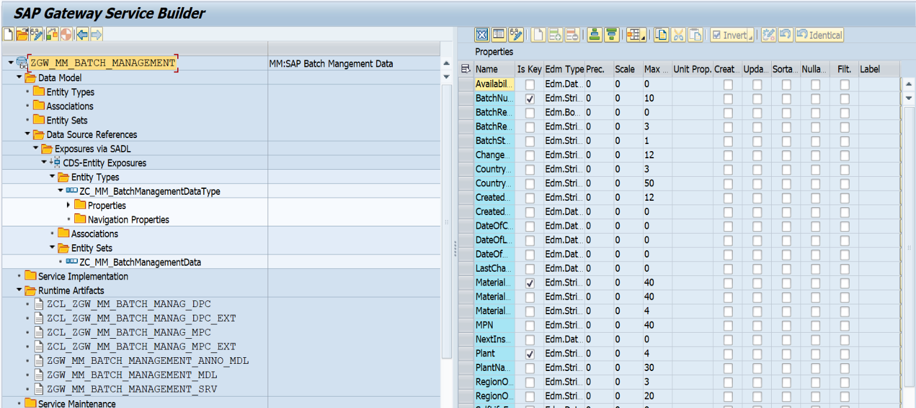**Entity set:** **ZC_MM_BATCHMANAGEMENTDATA**

**4.Business API / OData API and Output Screen**

Here these are the following 3 cases by using which we can do filtration on batch data.

* **CASE 1:** pass the MCH1-ERSDA(CreatedOn)
* **CASE 2:** pass the MCH1-LAEDA(LastChangedOn)
* **CASE 3:** pass the MCH1-ERSDA(CreatedOn) and MCH1-LAEDA(LastChangedOn)

**Testing API and Output Screen.**

* ***CASE 1:*** *pass the MCH1-ERSDA(CreatedOn)*
* **When ERSDA(CretedOn) = 14-08-2025**

***GUI Level***

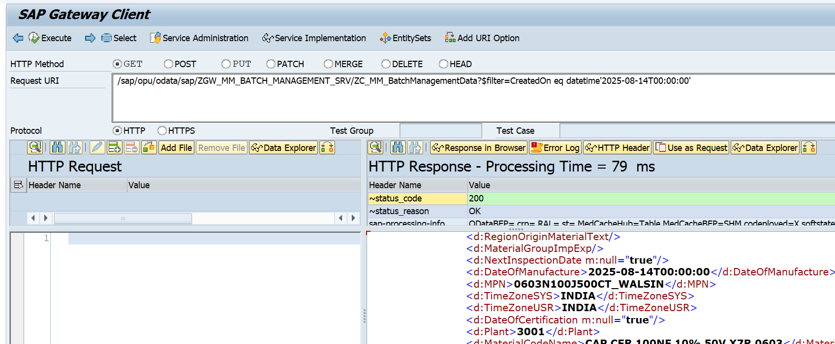API: /sap/opu/odata/sap/ZGW_MM_BATCH_MANAGEMENT_SRV/ZC_MM_BatchManagementData?$filter=CreatedOn eq datetime'2025-08-14T00:00:00

API for count Record

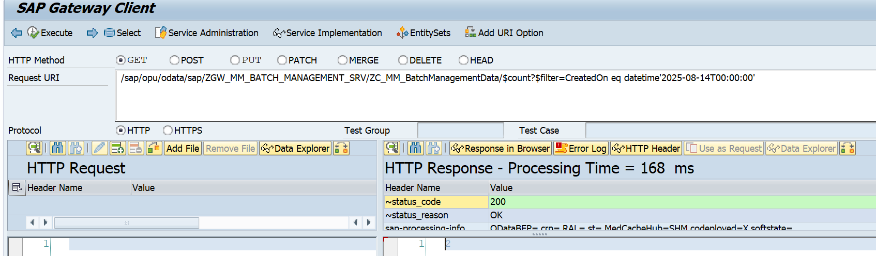/sap/opu/odata/sap/ZGW_MM_BATCH_MANAGEMENT_SRV/ZC_MM_BatchManagementData?$filter=CreatedOn eq datetime'2025-08-14T00:00:00

Postman Level:

API: http://mehdevpas.minda.com:8001/sap/opu/odata/sap/ZGW_MM_BATCH_MANAGEMENT_SRV/ZC_MM_BatchManagementData?$filter=CreatedOn eq datetime'2025-08-14T00:00:00'

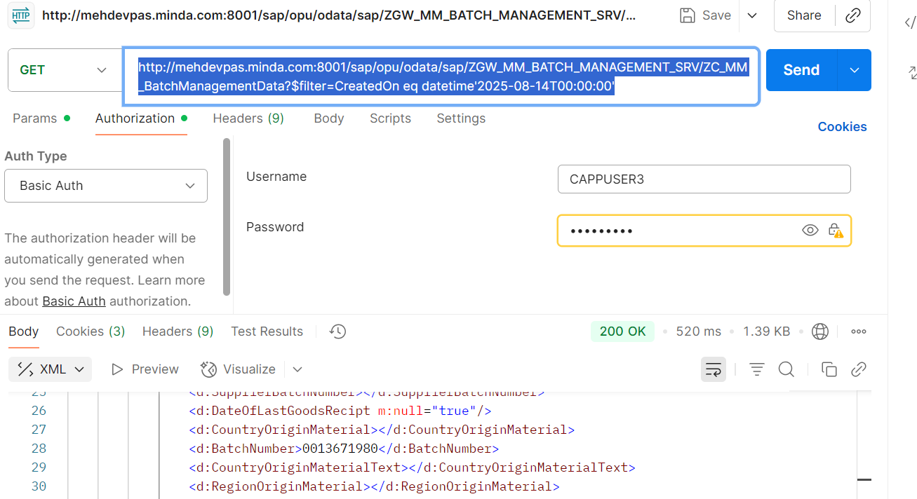

* **When ERSDA(CretedOn) in range**

from 27.07.2025 to 18.08.2025

*GUI Level*

API

/sap/opu/odata/sap/ZGW_MM_BATCH_MANAGEMENT_SRV/ZC_MM_BatchManagementData?$filter=CreatedOn ge datetime'2025-07-27T00:00:00' and CreatedOn le datetime'2025-08-18T00:00:00'

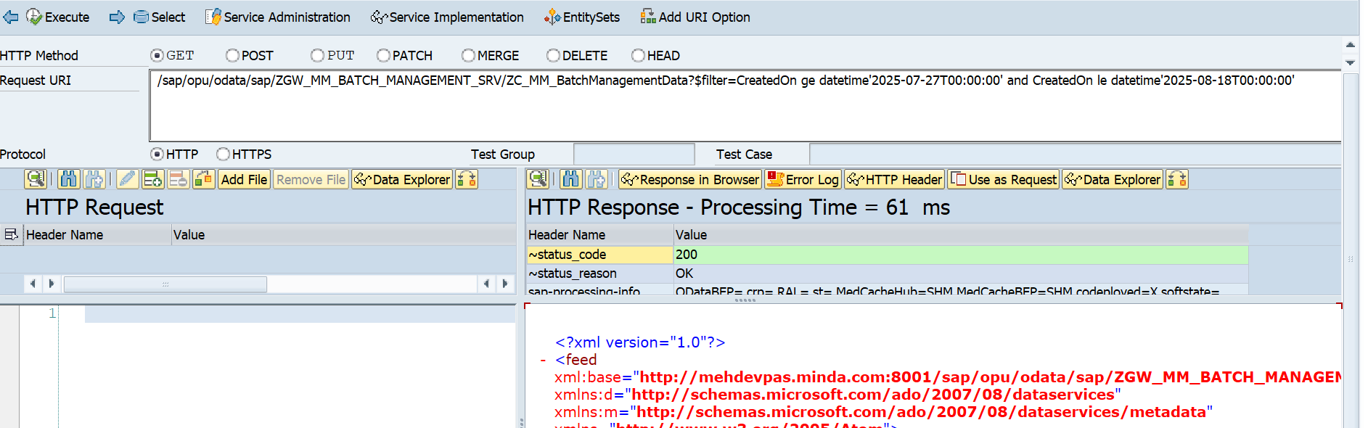

*Postman Level*

API

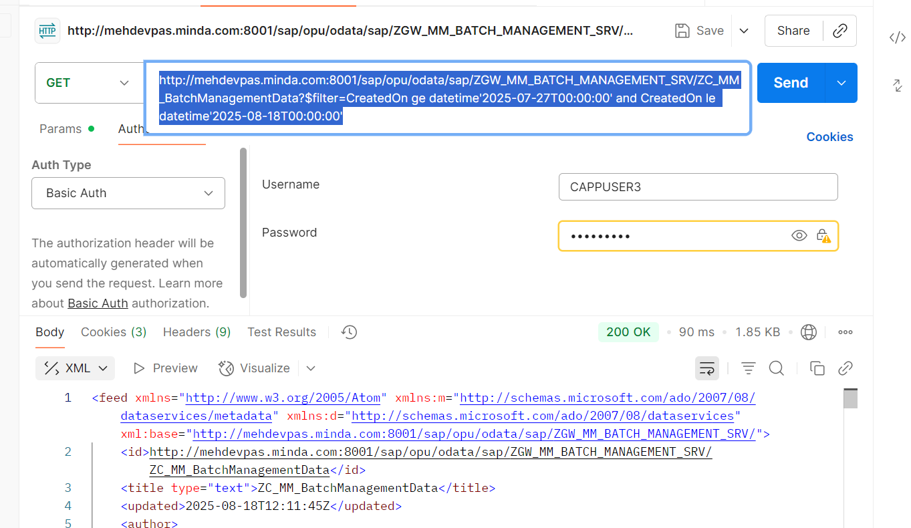http://mehdevpas.minda.com:8001/sap/opu/odata/sap/ZGW_MM_BATCH_MANAGEMENT_SRV/ZC_MM_BatchManagementData?$filter=CreatedOn ge datetime'2025-07-27T00:00:00' and CreatedOn le datetime'2025-08-18T00:00:00'

* ***CASE 2:*** *pass the MCH1-LAEDA(LastChangedOn)*
* **When LAEDA(LastChangedOn***)* **= 14-08-2025**

***GUI Level***

API

/sap/opu/odata/sap/ZGW_MM_BATCH_MANAGEMENT_SRV/ZC_MM_BatchManagementData?$filter=LastChangedOn eq datetime'2025-08-14T00:00:00'

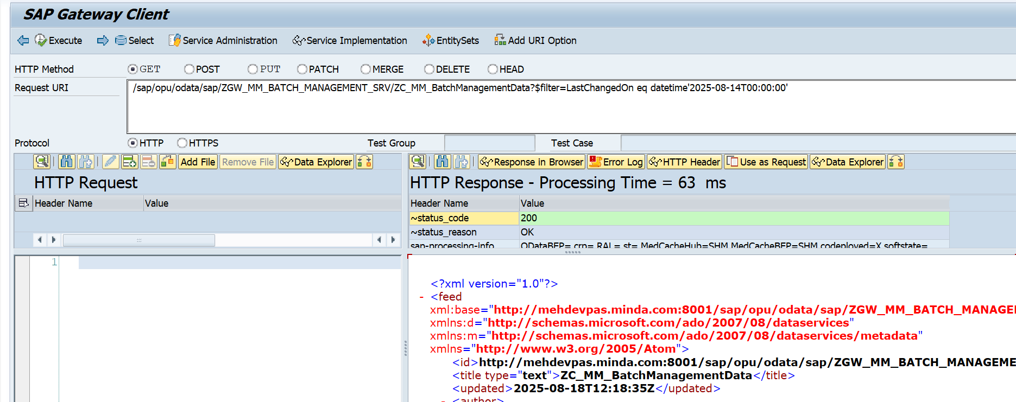

Postman level

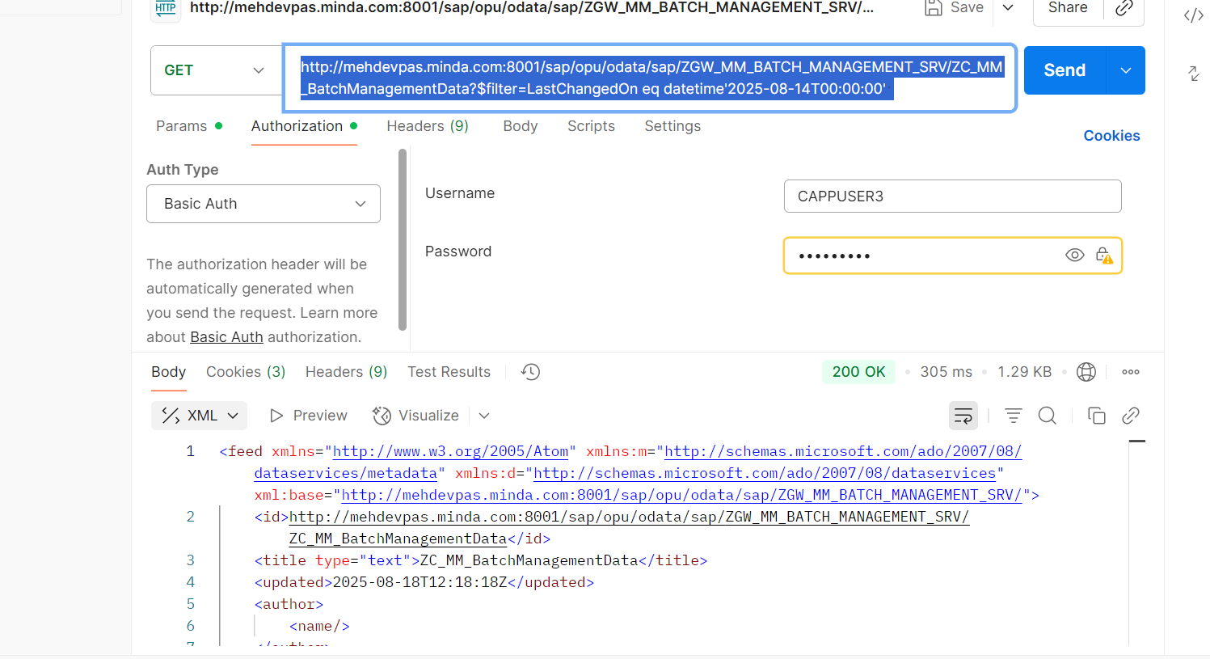http://mehdevpas.minda.com:8001/sap/opu/odata/sap/ZGW_MM_BATCH_MANAGEMENT_SRV/ZC_MM_BatchManagementData?$filter=LastChangedOn eq datetime'2025-08-14T00:00:00'

* **When LAEDA(LastChangedOn***)* **in Range**

**From** *04.12.2024 to 19.08.2025*

Records in between the date range.

/sap/opu/odata/sap/ZGW_MM_BATCH_MANAGEMENT_SRV/ZC_MM_BatchManagementData?$filter=LastChangedOn ge datetime'2024-12-04T00:00:00' and LastChangedOn le datetime'2025-08-19T00:00:00'

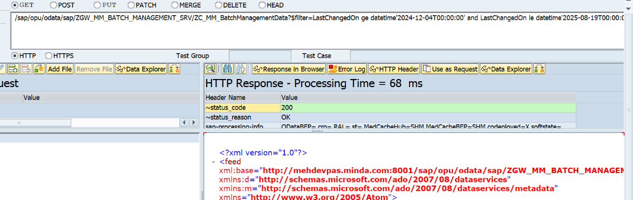

Count the number of records for this date range.

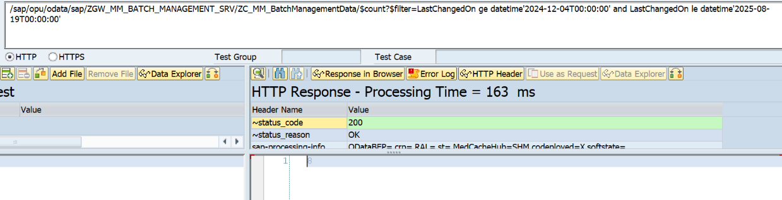/sap/opu/odata/sap/ZGW_MM_BATCH_MANAGEMENT_SRV/ZC_MM_BatchManagementData/$count?$filter=LastChangedOn ge datetime'2024-12-04T00:00:00' and LastChangedOn le datetime'2025-08-19T00:00:00'

Postman Level

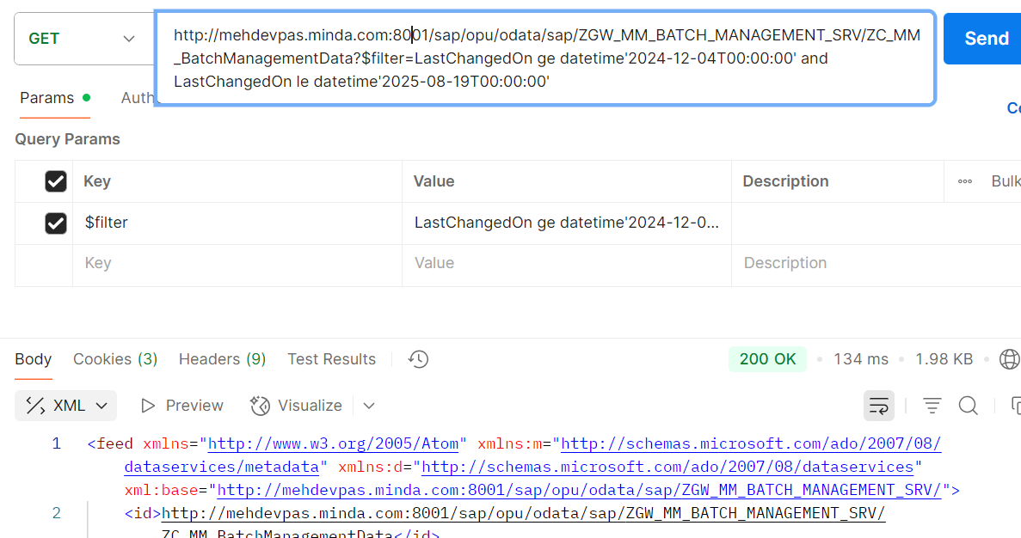http://mehdevpas.minda.com:8001/sap/opu/odata/sap/ZGW_MM_BATCH_MANAGEMENT_SRV/ZC_MM_BatchManagementData?$filter=LastChangedOn ge datetime'2024-12-04T00:00:00' and LastChangedOn le datetime'2025-08-19T00:00:00'

* **CASE 3:** pass the MCH1-ERSDA(CreatedOn) and MCH1-LAEDA(LastChangedOn)

GUI Level API Testing:

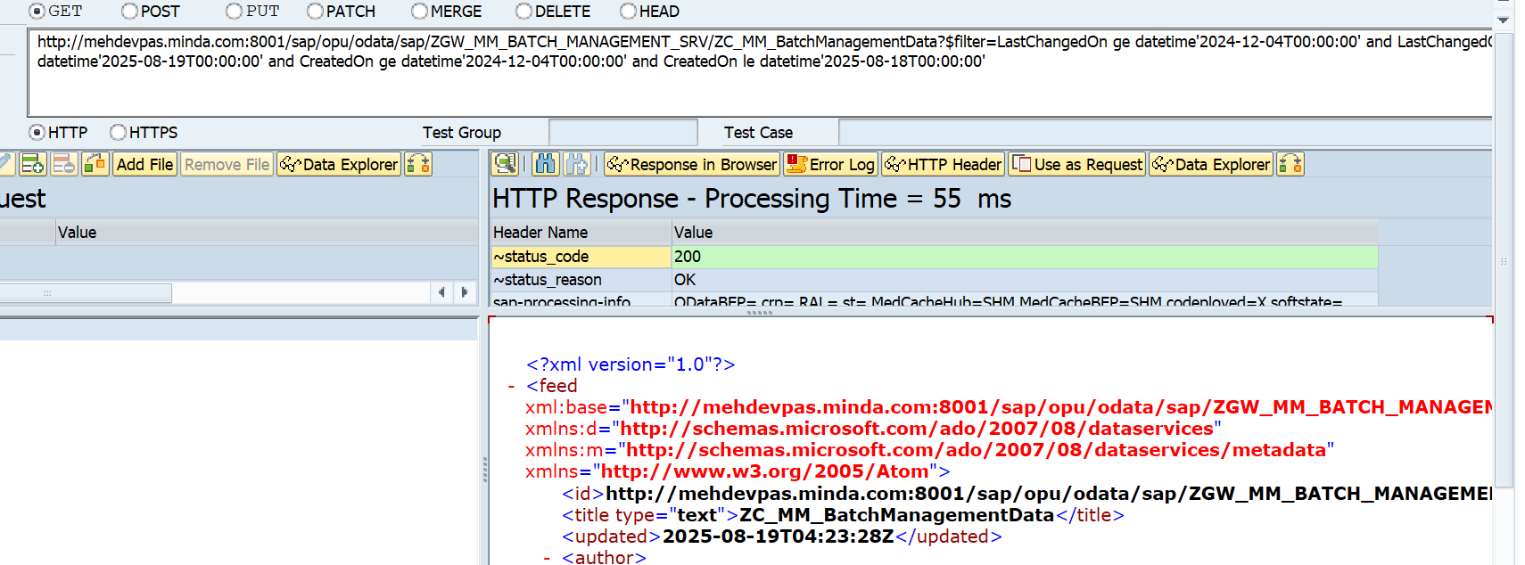sap/opu/odata/sap/ZGW_MM_BATCH_MANAGEMENT_SRV/ZC_MM_BatchManagementData/$count?$filter=LastChangedOn ge datetime'2024-12-04T00:00:00' and LastChangedOn le datetime'2025-08-19T00:00:00' and CreatedOn ge datetime'2024-12-04T00:00:00' and CreatedOn le datetime'2025-08-18T00:00:00'

Postman Level Testing:

http://mehdevpas.minda.com:8001/sap/opu/odata/sap/ZGW_MM_BATCH_MANAGEMENT_SRV/ZC_MM_BatchManagementData?$filter=LastChangedOn ge datetime'2024-12-04T00:00:00' and LastChangedOn le datetime'2025-08-19T00:00:00' and CreatedOn ge datetime'2024-12-04T00:00:00' and CreatedOn le datetime'2025-08-18T00:00:00'

