Technical Specification Form

PROJECT: SAP BOM DATA

SAP Technical Cum Functional Specification Form

|  |  |  |  |
| --- | --- | --- | --- |
| User Story ID # |  | Module | PP |
| Date | 04.06.2025 | SL User |  |
| Consultant | Sunil Kumar | Developer | **DEBIDUTTA SWAIN** |
| Priority | ☐Urgent ☒High ☐Medium ☐Low | | |
| Application Type | ☐Report ☐Transaction ☐Interface ☒ API Development ☐Others | | |
| Execute Model | ☐Batch ☐ Foreground ☒OData ☐Quarterly ☐Monthly  ☐Weekly ☐Daily ☐Real time | | |
| Output Type | ☐Message ☐Dialog Screen ☐ABAP List ☐ALV List ☐ALV Grid | | |
| Remarks | SAP BOM DATA | | |

**Technical specification content**

1. Business Requirement
2. Development Tools
3. Development Objects

* Table.
* CDS Data Definition.
* CDS Access Control.
* SEGW – OData Project.

1. Business API / OData API and Output Screen
2. **Business Requirement:**

Develop an OData GET API for BOM Master data, through which Business user can check BOM Master Header and Item data in External SAP application. In the External SAP application, user can able to see following details in a List view manner.

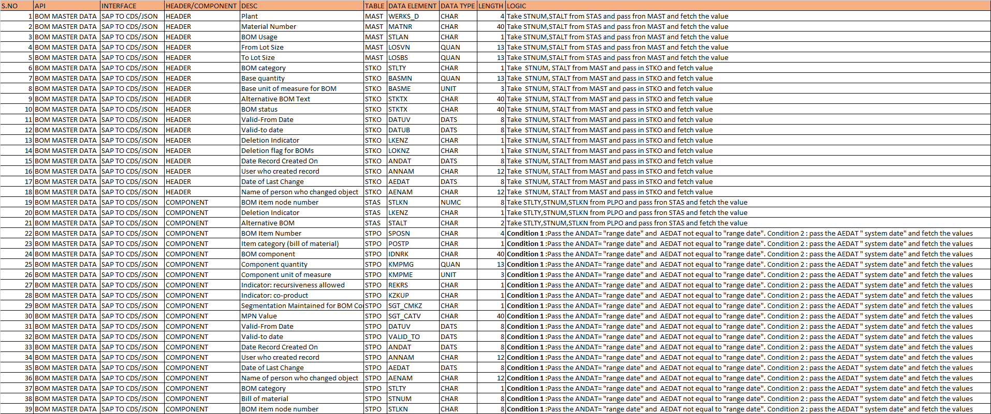

**2.Development Status & Tools**

For development these are the following tool used :

* **Eclipse for ABAP /ADT(ABAP Development Tool)**
* Interface/Basic CDS view:

Created on top of Required Database. Naming convention: ZI_*****

* Composite CDS view:

Created on top of Interface basic view for join/association. Naming convention: ZCO_*****

* Consumption view:

Expose only those field required for Business Requirement. Naming convention: ZC_*****

* **SEGW OData Project**
* Created OData project with “Data Source Reference” Using the consumption CDS view. Here in this CDS association has been done due to which in ODATA project all the association and navigation property generate automatically.
* For Service Registration used Tcode : /N/IWFND/MAINT_SERVICE.
* To Check the final data at Gateway Client used Tcode :/N/IWFND/GW_CLIENT.

NOTE : For CDS development process, I followed the VDM approach.

**3.Development Objects**

* Table:
* **MAST:** Material to BOM Link
* **STKO:** BOM Header
* **STAS:** BOMs - Item Selection
* **STPO:** BOM item
* **CDS Data Definition:**
* **Basic CDS View:**

As I am following the VDM modeling in this development, I had created Basic CDS view on top of Database table and the source of Basic View Should be a Database View or Standard CDS view.

* **MAST:** Material to BOM Link

CDS Name: ZI_PP_MAST_MaterialBOMLink

* //-----------------------------------------------------------------------------------------------------------------------//
* //Created By : AIRDIT--Debidutta Swain(9000RUPESH)
* //Cretaed on : 21-07-2025
* //FS Shared By : KPMG--Sunil kumar
* //Description : This Basic View contain Material to BOM Link Details.
* //----------------------------------------------------------------------------------------------------------------------//
* @AbapCatalog.sqlViewName: 'ZIMAST'
* @AbapCatalog.compiler.compareFilter: true
* @AbapCatalog.preserveKey: true
* @AccessControl.authorizationCheck: #NOT_REQUIRED
* @EndUserText.label: 'Basic CDS:MAST:Material to BOM Link'
* @Metadata.ignorePropagatedAnnotations: true
* @VDM.viewType: #BASIC
* **define** **view** ZI_PP_MAST_MaterialBOMLink
* **as** **select** **from** mast
* **{**
* **key** matnr **as** MateriaLCode**,**
* **key** werks **as** Plant**,**
* **key** stlan **as** BOMUsage**,**
* **key** stlnr **as** BillOfMaterial**,**
* **key** stlal **as** AlternativeBOM**,**
* losvn **as** FromLotSize**,**
* losbs **as** ToLotSize**,**
* andat **as** BOMCretedOn**,**
* annam **as** BOMCretedBy
* **}**
* **STKO:** BOM Header

**CDS Name:** ZI_PP_STKO_BOMHeader

* //-----------------------------------------------------------------------------------------------------------------------//
* //Created By : AIRDIT--Debidutta Swain(9000RUPESH)
* //Cretaed on : 21-07-2025
* //FS Shared By : KPMG--Sunil kumar
* //Description : This Basic View contain BOM Header.
* //----------------------------------------------------------------------------------------------------------------------//
* @AbapCatalog.sqlViewName: 'ZISTKO'
* @AbapCatalog.compiler.compareFilter: true
* @AbapCatalog.preserveKey: true
* @AccessControl.authorizationCheck: #NOT_REQUIRED
* @EndUserText.label: 'Basic CDS:STKO:BOM Header'
* @Metadata.ignorePropagatedAnnotations: true
* **define** **view** ZI_PP_STKO_BOMHeader
* **as** **select** **from** stko
* **{**
* **key** stlnr **as** BillOfMaterial**,**
* **key** stlal **as** AlternativeBOM**,**
* **key** stlty **as** BOMCategory**,**
* **key** stkoz **as** HeaderInternalCounter**,**
* bmein **as** BaseUnitOfMesure**,**
* @Semantics.quantity.unitOfMeasure: 'BaseUnitOfMesure'
* bmeng **as** BOMQuantity**,**
* stktx **as** AlternativeBOMText**,**
* stlst **as** BOMStatus**,**
* datuv **as** HedaerValidFromDate**,**
* valid_to **as** HeaderValidToDate**,**
* loekz **as** HedaerDelationFlag**,**
* lkenz **as** HeaderDelationIndicator**,**
* andat **as** HeaderCreatedOn**,**
* annam **as** HeaderCreatedBy**,**
* aedat **as** HeaderChangedOn**,**
* aenam **as** HeaderChangedBy
* **}**
* **STAS:** BOMs - Item Selection

**CDS Name:** ZI_PP_STKO_BOMHeader

* //-----------------------------------------------------------------------------------------------------------------------//
* //Created By : AIRDIT--Debidutta Swain(9000RUPESH)
* //Cretaed on : 21-07-2025
* //FS Shared By : KPMG--Sunil kumar
* //Description : This Basic View Contain BOMs - Item Selection means Relation in between STKO and STPO.
* //----------------------------------------------------------------------------------------------------------------------//
* @AbapCatalog.sqlViewName: 'ZISTAS'
* @AbapCatalog.compiler.compareFilter: true
* @AbapCatalog.preserveKey: true
* @AccessControl.authorizationCheck: #NOT_REQUIRED
* @EndUserText.label: 'Basic CDS:STAS: BOMs - Item Selection'
* @VDM.viewType :#BASIC
* **define** **view** ZI_PP_STAS_BOMItemSelection
* **as** **select** **from** stas
* **{**
* **key** stlnr **as** BillOfMaterial**,**
* **key** stlal **as** AlternativeBOM**,**
* **key** stlty **as** BOMCategory**,**
* **key** stlkn **as** BOMItemNodeNumber**,**
* lkenz **as** DelationIndicator
* **}**
* **STPO:** BOM item

CDS View Name: ZI_PP_STPO_BOMItem

* //-----------------------------------------------------------------------------------------------------------------------//
* //Created By : AIRDIT--Debidutta Swain(9000RUPESH)
* //Cretaed on : 21-07-2025
* //FS Shared By : KPMG--Sunil kumar
* //Description : This Basic View contail BOM Item/component Details.
* //----------------------------------------------------------------------------------------------------------------------//
* @AbapCatalog.sqlViewName: 'ZISTPO'
* @AbapCatalog.compiler.compareFilter: true
* @AbapCatalog.preserveKey: true
* @AccessControl.authorizationCheck: #NOT_REQUIRED
* @EndUserText.label: 'Basic CDS:STPO:BOM item'
* @VDM.viewType: #BASIC
* **define** **view** ZI_PP_STPO_BOMItem
* **as** **select** **from** stpo
* **{**
* **key** stlnr **as** BillOfMaterial**,**
* **key** stlty **as** BOMCategory**,**
* **key** stlkn **as** BOMItemNodeNumber**,**
* posnr **as** BOMItemNumber**,**
* postp **as** ItemCategory**,**
* idnrk **as** BOMComponent**,**
* meins **as** ComponentUnit**,**
* @Semantics.quantity.unitOfMeasure: 'ComponentUnit'
* menge **as** ComponentQuantity**,**
* rekrs **as** IndRecursivenessAllowed**,**
* kzkup **as** IndCoProduct**,**
* sgt_cmkz **as** SegmentationMaintained**,**
* sgt_catv **as** MPNValue**,**
* datuv **as** ComponentValidFrom**,**
* valid_to **as** ComponentValidTo**,**
* andat **as** ComponentCreatedOn**,**
* annam **as** ComponentCreatedBy**,**
* aedat **as** ComponentCahngedOn**,**
* aenam **as** ComponentChangedBy
* **}**
* **Composite CDS view**

As I am following the VDM modeling in this development, I had created Composite CDS view on top of Basic View where I will do all the necessary Joins/association needed for the Current Business Requirement.

**1.CDS View name : ZCO_PP_BOMHeaderDetails**

* //-----------------------------------------------------------------------------------------------------------------------//
* //Created By : AIRDIT--Debidutta Swain(9000RUPESH)
* //Cretaed on : 21-07-2025
* //FS Shared By : KPMG--Sunil kumar
* //Description : This Composite View contain the Final details of BOM Including both header and Item.
* // and also here we are ignoring the deleted header alternatives with Fiteration along with
* // necessary Joins.
* //----------------------------------------------------------------------------------------------------------------------//
* @AbapCatalog.sqlViewName: 'ZCOHEADER'
* @AbapCatalog.compiler.compareFilter: true
* @AbapCatalog.preserveKey: true
* @AccessControl.authorizationCheck: #NOT_REQUIRED
* @EndUserText.label: 'Composite CDS:BOM Header Details'
* @VDM.viewType: #COMPOSITE
* **define** **view** ZCO_PP_BOMHeaderDetails
* **as** **select** **from** ZI_PP_MAST_MaterialBOMLink **as** mast
* **left** **outer** **join** makt **on** mast**.**MateriaLCode **=** makt**.**matnr
* **and** makt**.**spras **=** **$session.system_language**
* **left** **outer** **join** t001w **on** mast**.**Plant **=** t001w**.**werks
* **left** **outer** **join** t416t **on** mast**.**BOMUsage **=** t416t**.**stlan
* **and** t416t**.**spras **=** **$session.system_language**
* //--> Joining STKO table deatils with MAST table details.
* **left** **outer** **join** ZCO_PP_STKO_BOMHEADER **as** STKO **on** mast**.**BillOfMaterial **=** STKO**.**BillOfMaterial
* **and** mast**.**AlternativeBOM **=** STKO**.**AlternativeBOM
* //--> Joining Item/Cpmponent Details with Existing Header Details to Show Header With Possible Item Details.
* **left** **outer** **join** ZCO_PP_BOMItemDetails **as** Component **on** mast**.**BillOfMaterial **=** Component**.**BillOfMaterial
* **and** mast**.**AlternativeBOM **=** Component**.**AlternativeBOM
* **and** STKO**.**BOMCategory **=** Component**.**BOMCategory
* //-----------------------------------------------------------------------------------------------------------------------//
* //NOTE :
* //--> "ZI_PP_MAST_MaterialBOMLink(MAST) & ZCO_PP_STKO_BOMHEADER(STKO)": Contain The Data Related to Header as per FS.
* //--> "ZCO_PP_BOMItemDetails(Component) ": Contains The Item/Component Details as per Alternative accoding To the FS.
* //----------------------------------------------------------------------------------------------------------------------//
* **{**
* **key** mast**.**MateriaLCode**,**
* **key** mast**.**Plant**,**
* **key** mast**.**BOMUsage**,**
* **key** mast**.**BillOfMaterial**,**
* **key** mast**.**AlternativeBOM**,**
* **key** STKO**.**BOMCategory**,**
* makt**.**maktx **as** MaterialDescription**,**
* t001w**.**name1 **as** PlantDescription**,**
* t416t**.**antxt **as** BOMUsageDescription**,**
* STKO**.**BOMCategoryDescription**,**
* mast**.**FromLotSize**,**
* mast**.**ToLotSize**,**
* mast**.**BOMCretedOn**,**
* mast**.**BOMCretedBy**,**
* STKO**.**BaseUnitOfMesure**,**
* STKO**.**BOMQuantity**,**
* STKO**.**AlternativeBOMText**,**
* STKO**.**BOMStatus**,**
* STKO**.**BOMStatusDescription**,**
* STKO**.**HedaerValidFromDate**,**
* **case**
* **when** STKO**.**HeaderValidToDate **=** '00000000'
* **then** **cast(** '99991231' **as** *datub***)**
* **else** **cast(** STKO**.**HeaderValidToDate **as** *datub* **preserving** **type** **)**
* **end** **as** HedaerValidToDate**,**
* STKO**.**HedaerDelationFlag**,**
* STKO**.**HeaderDelationIndicator**,**
* STKO**.**HeaderCreatedOn**,**
* STKO**.**HeaderCreatedBy**,**
* STKO**.**HeaderChangedOn**,**
* STKO**.**HeaderChangedBy**,**
* Component**.**BOMItemNodeNumber**,**
* Component**.**BOMItemNumber**,**
* Component**.**ItemCategory**,**
* Component**.**ItemCategoryText**,**
* Component**.**BOMComponent**,**
* Component**.**BOMComponentText**,**
* Component**.**ComponentUnit**,**
* Component**.**ComponentQuantity**,**
* Component**.**IndRecursivenessAllowed**,**
* Component**.**IndCoProduct**,**
* Component**.**SegmentationMaintained**,**
* Component**.**MPNValue**,**
* Component**.**ComponentValidFrom**,**
* Component**.**ComponentValidTo**,**
* Component**.**ComponentCreatedOn**,**
* Component**.**ComponentCreatedBy**,**
* Component**.**ComponentCahngedOn**,**
* Component**.**ComponentChangedBy
* **}**
* **where**
* HedaerDelationFlag **=** ' '
* **and** STKO**.**HeaderDelationIndicator **=** ' '
* **and** mast**.**Plant **<>** ' '
* **and** mast**.**BOMUsage **=** '1'

**2.CDS View Name : ZCO_PP_STKO_BOMHEADER**

* //-----------------------------------------------------------------------------------------------------------------------//
* //Created By : AIRDIT--Debidutta Swain(9000RUPESH)
* //Cretaed on : 21-07-2025
* //FS Shared By : KPMG--Sunil kumar
* //Description : This Composite View contain Headef details with Some additional info.
* // like material desc.,status desc. etc.
* //----------------------------------------------------------------------------------------------------------------------//
* @AbapCatalog.sqlViewName: 'ZCOSTKO'
* @AbapCatalog.compiler.compareFilter: true
* @AbapCatalog.preserveKey: true
* @AccessControl.authorizationCheck: #NOT_REQUIRED
* @EndUserText.label: 'Composite CDS:STKO:BOM Header Details'
* @VDM.viewType: #COMPOSITE
* **define** **view** ZCO_PP_STKO_BOMHEADER
* **as** **select** **from** ZI_PP_STKO_BOMHeader **as** STKO
* **left** **outer** **join** dd07t **as** BOMCategoryDesc **on** BOMCategoryDesc**.**domname **=** 'STLTY'
* **and** BOMCategoryDesc**.**domvalue_l **=** STKO**.**BOMCategory
* **and** BOMCategoryDesc**.**ddlanguage **=** **$session.system_language**
* **left** **outer** **join** t415t **on** STKO**.**BOMStatus **=** t415t**.**stlst
* **and** t415t**.**spras **=** **$session.system_language**
* **{**
* **key** STKO**.**BillOfMaterial**,**
* **key** STKO**.**AlternativeBOM**,**
* **key** STKO**.**BOMCategory**,**
* BOMCategoryDesc**.**ddtext **as** BOMCategoryDescription**,**
* STKO**.**BaseUnitOfMesure**,**
* STKO**.**BOMQuantity**,**
* STKO**.**AlternativeBOMText**,**
* STKO**.**BOMStatus**,**
* t415t**.**sttxt **as** BOMStatusDescription**,**
* STKO**.**HedaerValidFromDate**,**
* STKO**.**HeaderValidToDate**,**
* STKO**.**HedaerDelationFlag**,**
* STKO**.**HeaderDelationIndicator**,**
* STKO**.**HeaderCreatedOn**,**
* STKO**.**HeaderCreatedBy**,**
* STKO**.**HeaderChangedOn**,**
* STKO**.**HeaderChangedBy
* **}**

**3.CDS View Name : ZCO_PP_STKO_BOMHEADER**

* //-----------------------------------------------------------------------------------------------------------------------//
* //Created By : AIRDIT--Debidutta Swain(9000RUPESH)
* //Cretaed on : 23-07-2025
* //FS Shared By : KPMG--Sunil kumar
* //Description : This Composite View contain the Final Item/Component Details of BOM along
* // with here we are ignoring Deleted Componet by Filterartion as STAS table level.
* //----------------------------------------------------------------------------------------------------------------------//
* @AbapCatalog.sqlViewName: 'ZCOITEM'
* @AbapCatalog.compiler.compareFilter: true
* @AbapCatalog.preserveKey: true
* @AccessControl.authorizationCheck: #NOT_REQUIRED
* @EndUserText.label: 'Composite CDS:BOM Item Details'
* @VDM.viewType: #COMPOSITE
* **define** **view** ZCO_PP_BOMItemDetails
* **as** **select** **from** ZI_PP_STAS_BOMItemSelection **as** STAS
* //--> Joining BOM Component details with Item selection details based on Common Related field
* **left** **outer** **join** ZCO_PP_STPO_BOMITEM **as** STPO **on** STAS**.**BillOfMaterial **=** STPO**.**BillOfMaterial
* **and** STAS**.**BOMCategory **=** STPO**.**BOMCategory
* **and** STAS**.**BOMItemNodeNumber **=** STPO**.**BOMItemNodeNumber
* **{**
* **key** STAS**.**BillOfMaterial**,**
* **key** STAS**.**AlternativeBOM**,**
* **key** STAS**.**BOMCategory**,**
* **key** STAS**.**BOMItemNodeNumber**,**
* STPO**.**BOMItemNumber**,**
* STPO**.**ItemCategory**,**
* STPO**.**ItemCategoryText**,**
* STPO**.**BOMComponent**,**
* STPO**.**BOMComponentText**,**
* STPO**.**ComponentUnit**,**
* STPO**.**ComponentQuantity**,**
* STPO**.**IndRecursivenessAllowed**,**
* STPO**.**IndCoProduct**,**
* STPO**.**SegmentationMaintained**,**
* STPO**.**MPNValue**,**
* STPO**.**ComponentValidFrom**,**
* **case**
* **when** STPO**.**ComponentValidTo **=** '00000000'
* **then** **cast(**'99991231' **as** *datub***)**
* **else** **cast(** STPO**.**ComponentValidTo **as** *datub* **preserving** **type** **)**
* **end** **as** ComponentValidTo**,**
* STPO**.**ComponentCreatedOn**,**
* STPO**.**ComponentCreatedBy**,**
* STPO**.**ComponentCahngedOn**,**
* STPO**.**ComponentChangedBy
* **}**
* **where**
* STAS**.**DelationIndicator **=** ' '

**4.CDS View Name : ZCO_PP_STPO_BOMITEM**

* //-----------------------------------------------------------------------------------------------------------------------//
* //Created By : AIRDIT--Debidutta Swain(9000RUPESH)
* //Cretaed on : 23-07-2025
* //FS Shared By : KPMG--Sunil kumar
* //Description : This Composite View contain Item Details along with compnent Desc and Item Catagory Desc.
* //----------------------------------------------------------------------------------------------------------------------//
* @AbapCatalog.sqlViewName: 'ZCOSTPO'
* @AbapCatalog.compiler.compareFilter: true
* @AbapCatalog.preserveKey: true
* @AccessControl.authorizationCheck: #NOT_REQUIRED
* @EndUserText.label: 'Composite CDS:STPO:BOM item'
* @VDM.viewType: #COMPOSITE
* **define** **view** ZCO_PP_STPO_BOMITEM
* **as** **select** **from** ZI_PP_STPO_BOMItem **as** STPO
* **left** **outer** **join** t418t **on** STPO**.**ItemCategory **=** t418t**.**postp
* **and** t418t**.**spras **=** **$session.system_language**
* **left** **outer** **join** makt **on** STPO**.**BOMComponent **=** makt**.**matnr
* **and** makt**.**spras **=** **$session.system_language**
* **{**
* **key** STPO**.**BillOfMaterial**,**
* **key** STPO**.**BOMCategory**,**
* **key** STPO**.**BOMItemNodeNumber**,**
* STPO**.**BOMItemNumber**,**
* STPO**.**ItemCategory**,**
* t418t**.**ptext **as** ItemCategoryText**,**
* STPO**.**BOMComponent**,**
* makt**.**maktx **as** BOMComponentText**,**
* STPO**.**ComponentUnit**,**
* STPO**.**ComponentQuantity**,**
* STPO**.**IndRecursivenessAllowed**,**
* STPO**.**IndCoProduct**,**
* STPO**.**SegmentationMaintained**,**
* STPO**.**MPNValue**,**
* STPO**.**ComponentValidFrom**,**
* STPO**.**ComponentValidTo**,**
* STPO**.**ComponentCreatedOn**,**
* STPO**.**ComponentCreatedBy**,**
* STPO**.**ComponentCahngedOn**,**
* STPO**.**ComponentChangedBy
* **}**
* **Consumption CDS view**

As I am following the VDM modeling in this development, I had created Consumption CDS view on top of Composite CDS View where I had added all the field which are need to Expose as per the Business Requirement.

**CDS View Name : ZC_PP_BillOfMaterial_Details**

* //-----------------------------------------------------------------------------------------------------------------------//
* //Created By : AIRDIT--Debidutta Swain(9000RUPESH)
* //Cretaed on : 23-07-2025
* //FS Shared By : KPMG--Sunil kumar
* //Description : This Consuption View contain the Final details of BOM Including both header and Item.
* //----------------------------------------------------------------------------------------------------------------------//
* @AbapCatalog.sqlViewName: 'ZCBOM'
* @AbapCatalog.compiler.compareFilter: true
* @AbapCatalog.preserveKey: true
* @AccessControl.authorizationCheck: #CHECK
* @EndUserText.label: 'Consuption View:Bill Of Material Details'
* @VDM.viewType: #CONSUMPTION
* **define** **view** ZC_PP_BillOfMaterial_Details
* **as** **select** **from** ZCO_PP_BOMHeaderDetails
* **{**
* **key** MateriaLCode**,**
* **key** Plant**,**
* **key** BOMUsage**,**
* **key** BillOfMaterial**,**
* **key** AlternativeBOM**,**
* BOMCategory**,**
* MaterialDescription**,**
* PlantDescription**,**
* BOMUsageDescription**,**
* BOMCategoryDescription**,**
* FromLotSize**,**
* ToLotSize**,**
* BOMCretedOn**,**
* BOMCretedBy**,**
* BaseUnitOfMesure**,**
* BOMQuantity**,**
* AlternativeBOMText**,**
* BOMStatus**,**
* BOMStatusDescription**,**
* HedaerValidFromDate**,**
* HedaerValidToDate**,**
* HeaderCreatedOn**,**
* HeaderCreatedBy**,**
* HeaderChangedOn**,**
* HeaderChangedBy**,**
* BOMItemNodeNumber**,**
* BOMItemNumber**,**
* ItemCategory**,**
* ItemCategoryText**,**
* BOMComponent**,**
* BOMComponentText**,**
* ComponentUnit**,**
* ComponentQuantity**,**
* IndRecursivenessAllowed**,**
* IndCoProduct**,**
* SegmentationMaintained**,**
* MPNValue**,**
* ComponentValidFrom**,**
* ComponentValidTo**,**
* ComponentCreatedOn**,**
* ComponentCreatedBy**,**
* ComponentCahngedOn**,**
* ComponentChangedBy
* **}**
* **CDS Access Control:**

CDS View in which DCL used: ZC_PP_BillOfMaterial_Details

CDS Access Control Name: ZDCL_PP_BILLOFMATERIAL

* @EndUserText.label: 'DCL for Bill Of Material based on Plant'
* @MappingRole: true
* **define** **role** ZDCL_PP_BILLOFMATERIAL **{**
* **grant**
* **select**
* **on**
* ZC_PP_BillOfMaterial_Details
* **where**
* **(**Plant**)** **=** **aspect** **pfcg_auth(**ZPLANTS**,**WERKS**);**
* **}**
* **SEGW /ODATA Project:**

As it a GET related API, So I have followed the approach “Reference to data Source” I orderbto achieve the final Output.

**Project Name :** ZGW_PP_BOM_DETAIL

**Entity Type:** ZC_PP_BillOfMaterial_DetailsType

**Entity Set:** ZC_PP_BillOfMaterial_Details

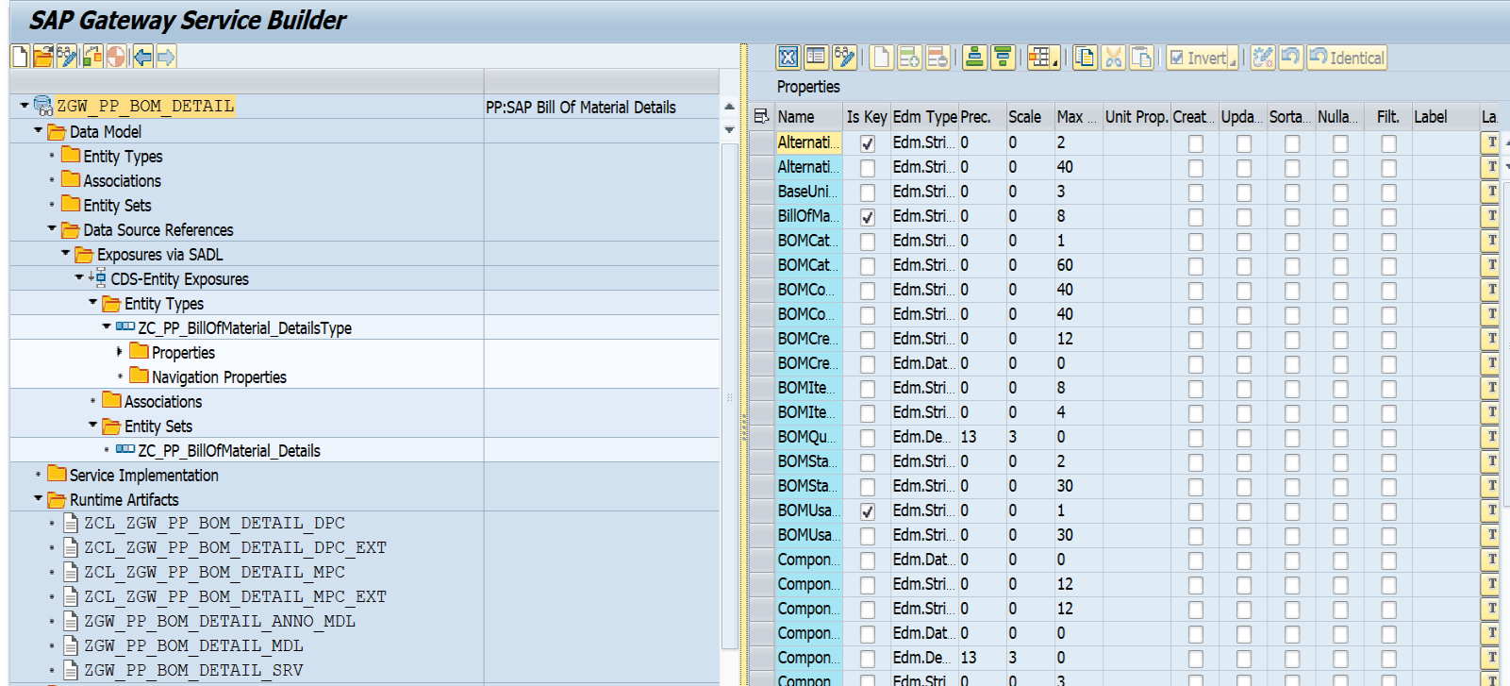**Service Name:** ZGW_PP_BOM_DETAIL_SRV

**4.Business API / OData API and Output Screen Screenshot:**

Here as per FS, filtration is done based on STOP(Component) table’s ANDAT(Date Record Created On) and AEDAT(Date of Last Change) Fields.in Entity type the field name is ANDAT-ComponentCreatedOn and AEDAT-ComponentCahngedOn.  
  
**Testing Client : DEV-190 & Postman**

**Case 1: For get all the existing Bom details (Header with Item).**

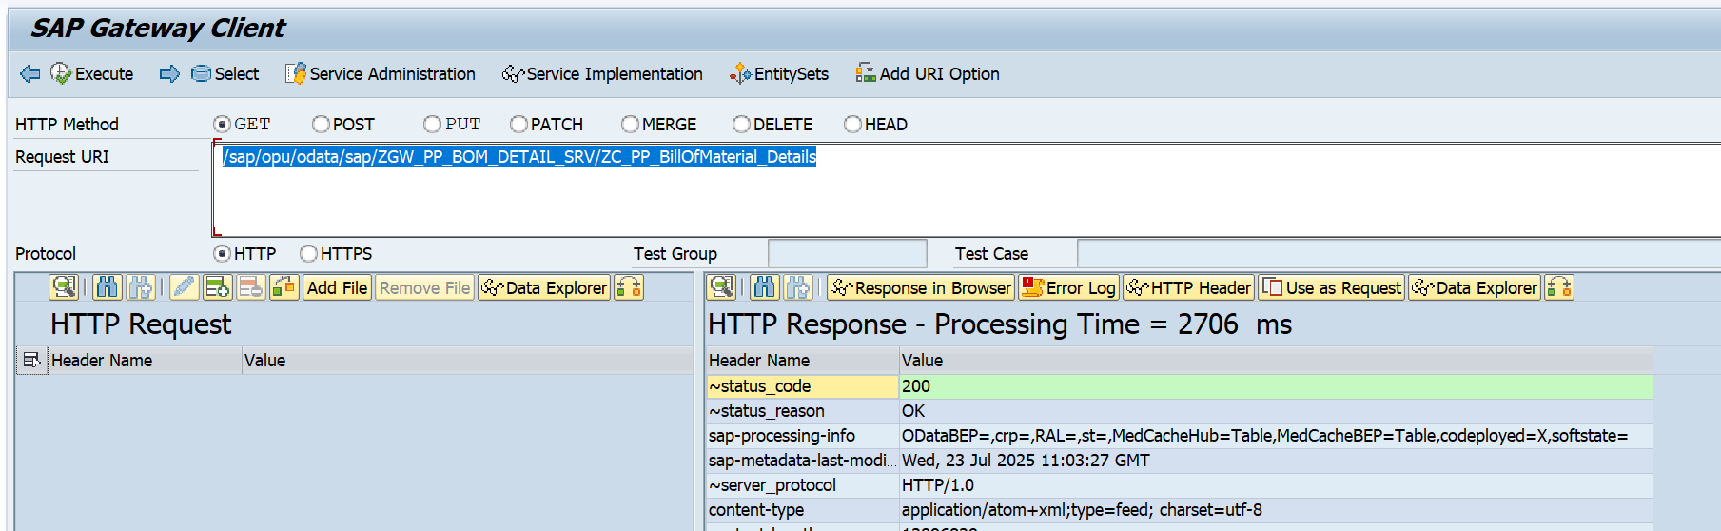**Gateway API:** /sap/opu/odata/sap/ZGW_PP_BOM_DETAIL_SRV/ZC_PP_BillOfMaterial_Details

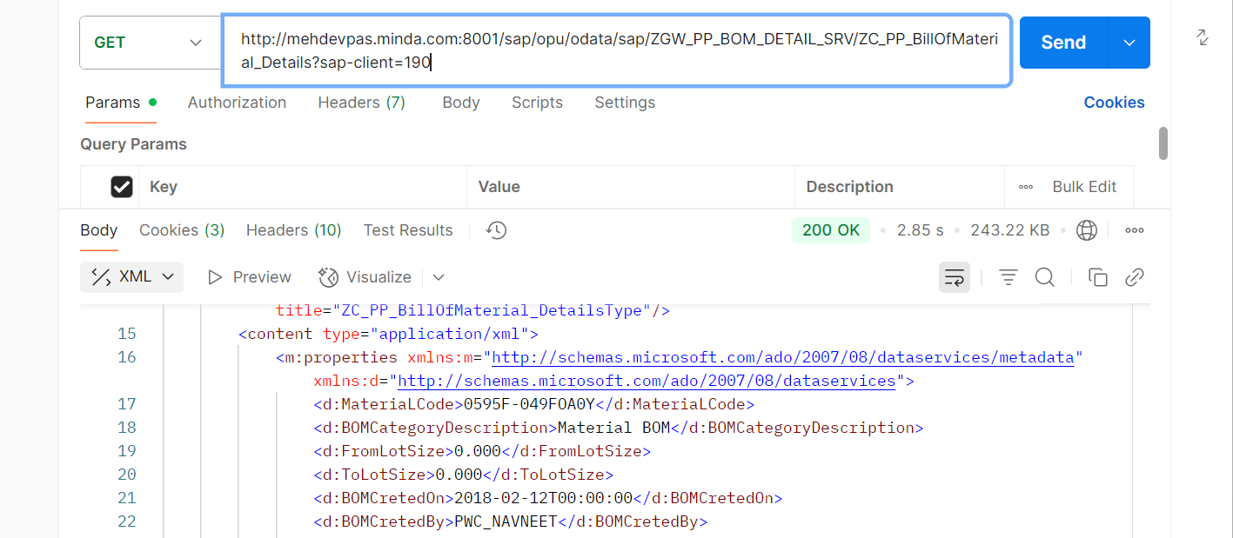**Postman API:** [**http://mehdevpas.minda.com:8001/sap/opu/odata/sap/ZGW_PP_BOM_DETAIL_SRV/ZC_PP_BillOfMaterial_Details?sap-client=190**](http://mehdevpas.minda.com:8001/sap/opu/odata/sap/ZGW_PP_BOM_DETAIL_SRV/ZC_PP_BillOfMaterial_Details?sap-client=190)

**Case 2: For get the Bom details based on STOP-ANDAT(Created on Date).**

Filtration is done based on “ComponentCreatedOn” Field:

Date range: “06.07.2025 to 24.07.2025”

**Gateway API:**

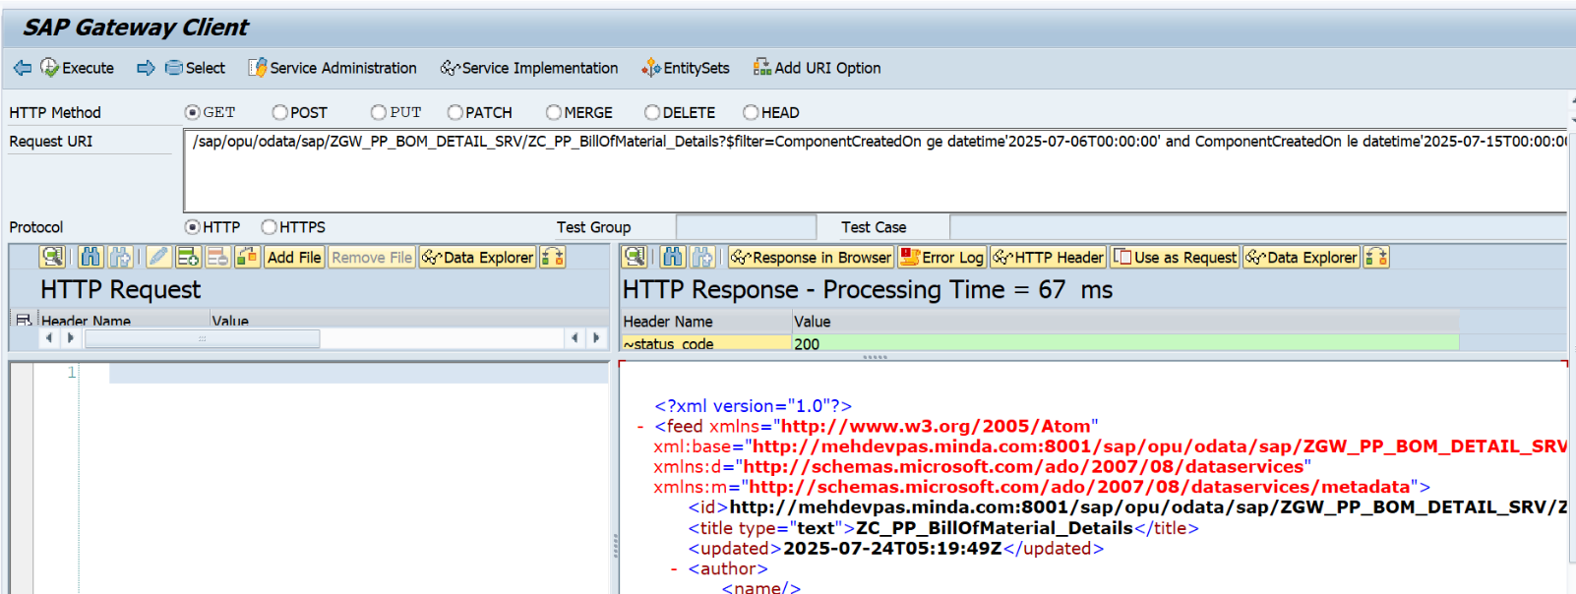/sap/opu/odata/sap/ZGW_PP_BOM_DETAIL_SRV/ZC_PP_BillOfMaterial_Details?$filter=ComponentCreatedOn ge datetime'2025-07-06T00:00:00' and ComponentCreatedOn le datetime'2025-07-24T00:00:00'

Number of record

/sap/opu/odata/sap/ZGW_PP_BOM_DETAIL_SRV/ZC_PP_BillOfMaterial_Details/$count?$filter=ComponentCreatedOn ge datetime'2025-07-06T00:00:00' and ComponentCreatedOn le datetime'2025-07-15T00:00:00'

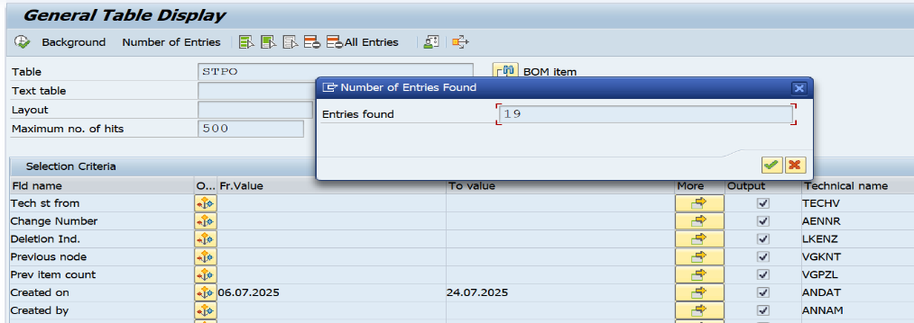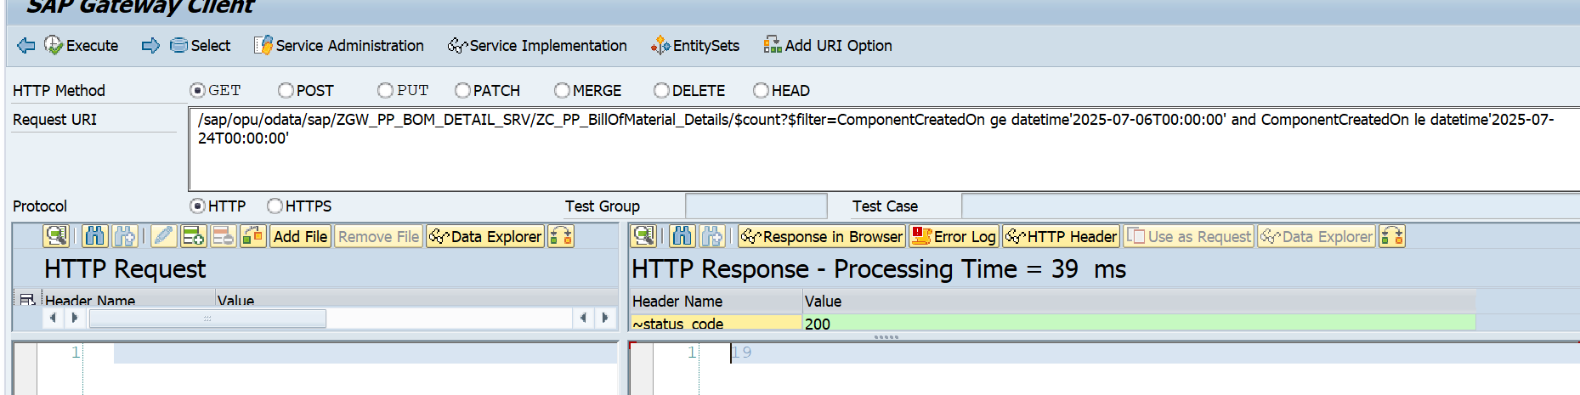Output value : 19

Database level Check

**Postman level**

http://mehdevpas.minda.com:8001/sap/opu/odata/sap/ZGW_PP_BOM_DETAIL_SRV/ZC_PP_BillOfMaterial_Details?$filter=ComponentCreatedOn ge datetime'2025-07-06T00:00:00' and ComponentCreatedOn le datetime'2025-07-15T00:00:00' & sap-client=190

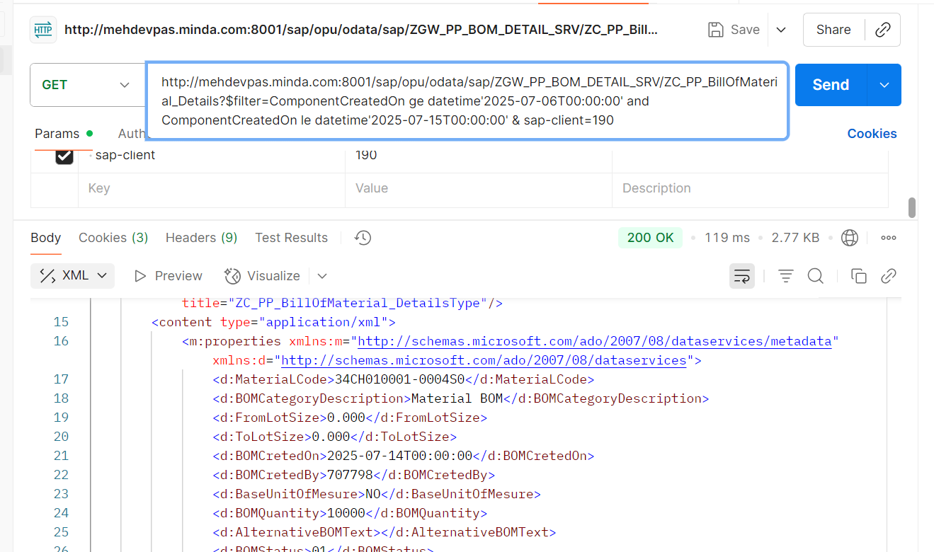

**Case 3: For get the Bom details based on STOP-AEDAT(Changed on Date).**

Filtration is done based on “ComponentCahngedOn” Field:

Date range: “18.06.2025 to 24.07.2025”

**Gateway API:**

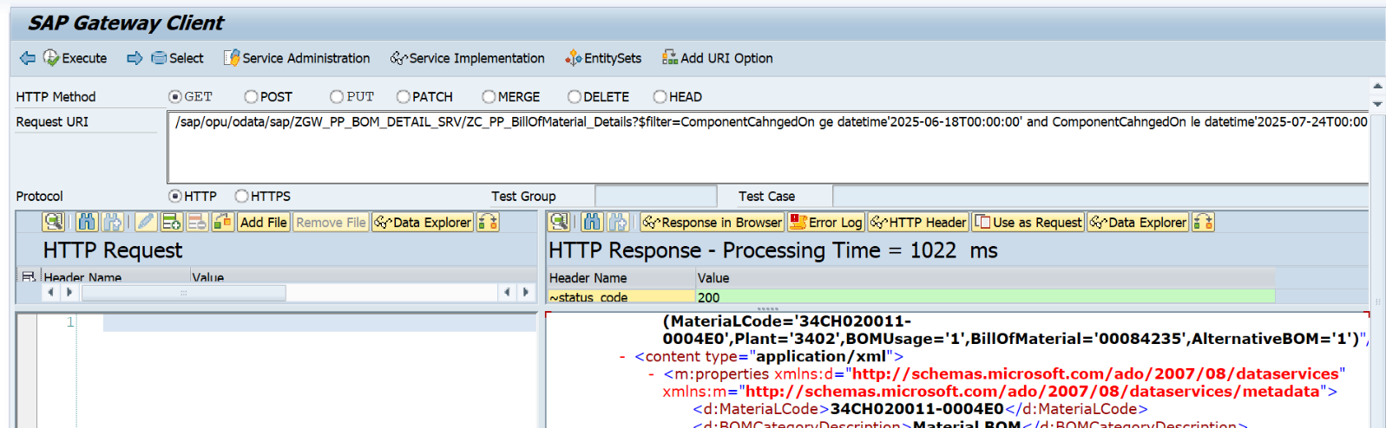/sap/opu/odata/sap/ZGW_PP_BOM_DETAIL_SRV/ZC_PP_BillOfMaterial_Details?$filter=ComponentCahngedOn ge datetime'2025-06-18T00:00:00' and ComponentCahngedOn le datetime'2025-07-24T00:00:00'

Check Number Record:

/sap/opu/odata/sap/ZGW_PP_BOM_DETAIL_SRV/ZC_PP_BillOfMaterial_Details/$count?$filter=ComponentCahngedOn ge datetime'2025-06-18T00:00:00' and ComponentCahngedOn le datetime'2025-07-24T00:00:00'

Output Value as Response : 21

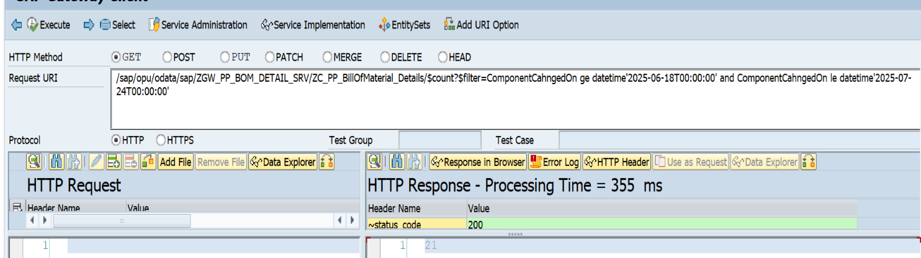

Database Level check :

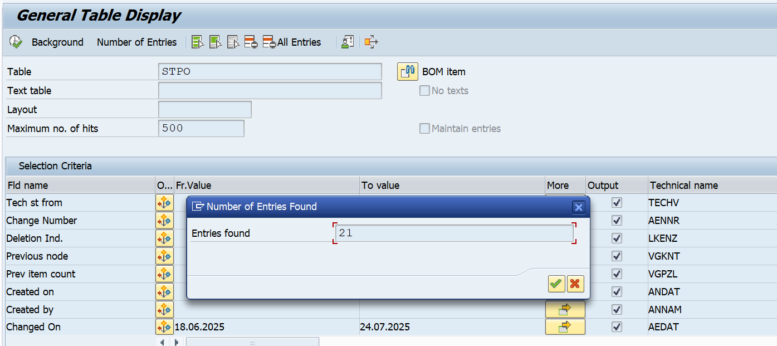

**Postman Level Checking:**

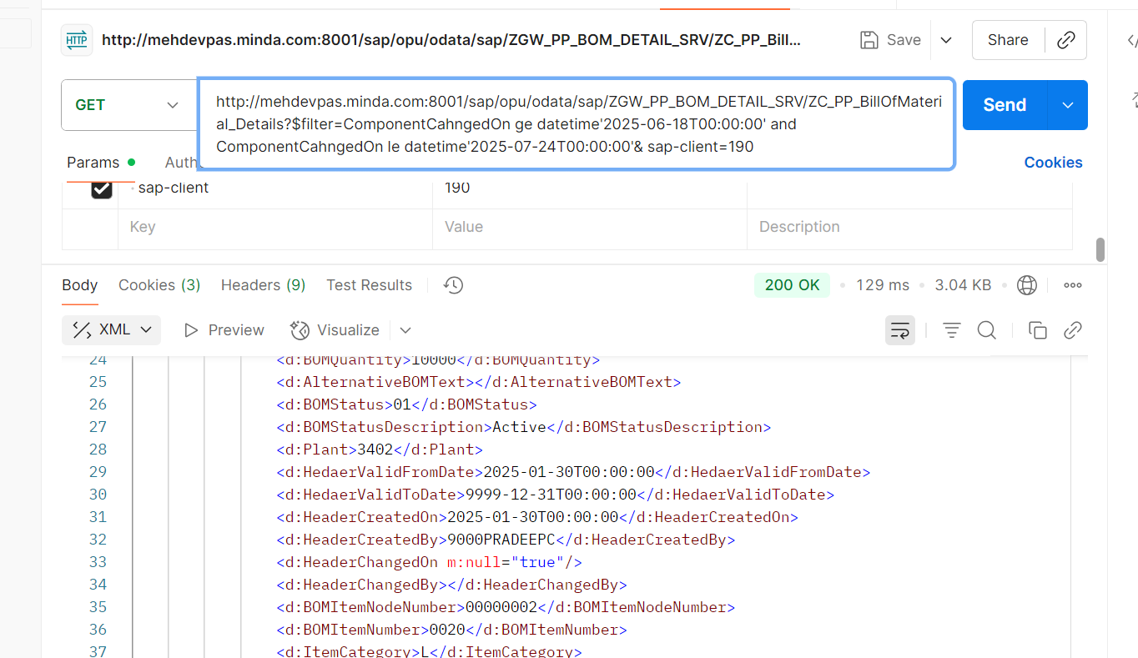http://mehdevpas.minda.com:8001/sap/opu/odata/sap/ZGW_PP_BOM_DETAIL_SRV/ZC_PP_BillOfMaterial_Details?$filter=ComponentCahngedOn ge datetime'2025-06-18T00:00:00' and ComponentCahngedOn le datetime'2025-07-24T00:00:00'& sap-client=190

**Case 4: If you want to filter based on the Two date field.**

Filtration is done based on “ComponentCreatedOn” & “ComponentCahngedOn” Field:

Date range: “18.06.2025 to 24.07.2025”

**Gateway API test**

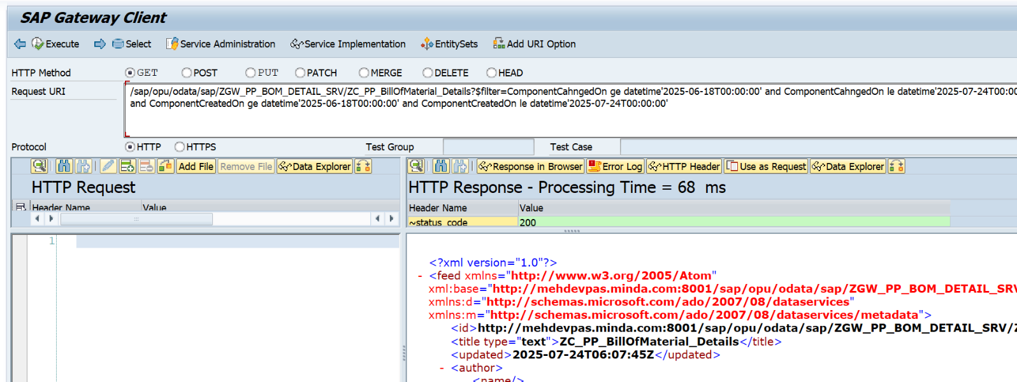/sap/opu/odata/sap/ZGW_PP_BOM_DETAIL_SRV/ZC_PP_BillOfMaterial_Details?$filter=ComponentCahngedOn ge datetime'2025-06-18T00:00:00' and ComponentCahngedOn le datetime'2025-07-24T00:00:00' and ComponentCreatedOn ge datetime'2025-06-18T00:00:00' and ComponentCreatedOn le datetime'2025-07-24T00:00:00'

Number of Records for check

/sap/opu/odata/sap/ZGW_PP_BOM_DETAIL_SRV/ZC_PP_BillOfMaterial_Details/$count?$filter=ComponentCahngedOn ge datetime'2025-06-18T00:00:00' and ComponentCahngedOn le datetime'2025-07-24T00:00:00' and ComponentCreatedOn ge datetime'2025-06-18T00:00:00' and ComponentCreatedOn le datetime'2025-07-24T00:00:00'

Output Value : 16

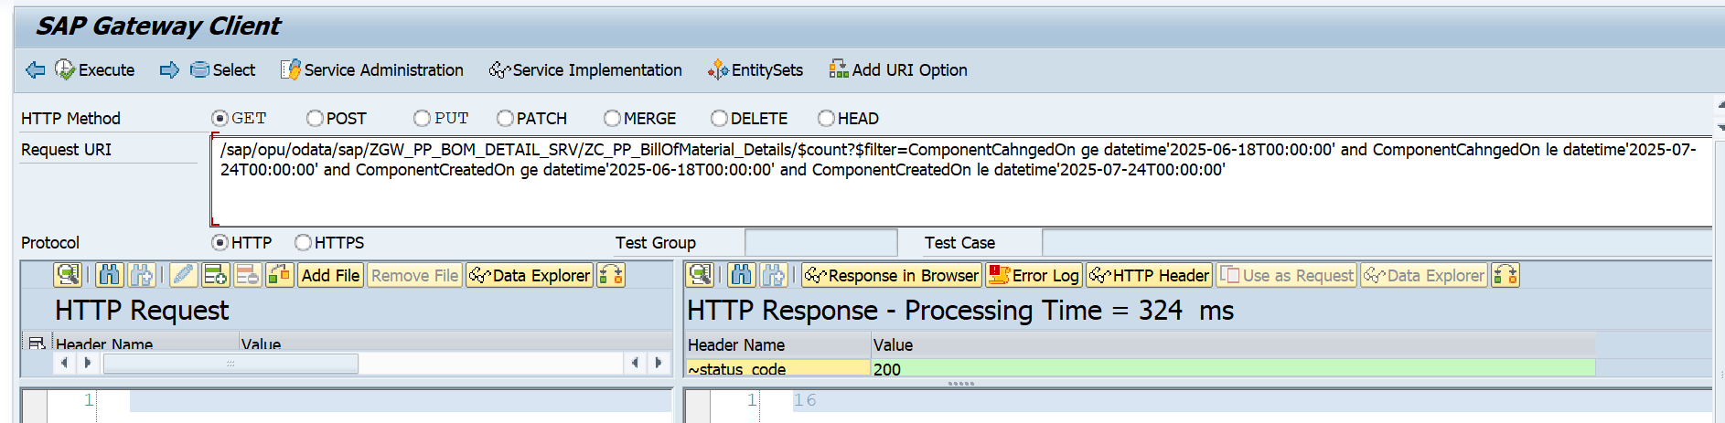

Database Level Testing

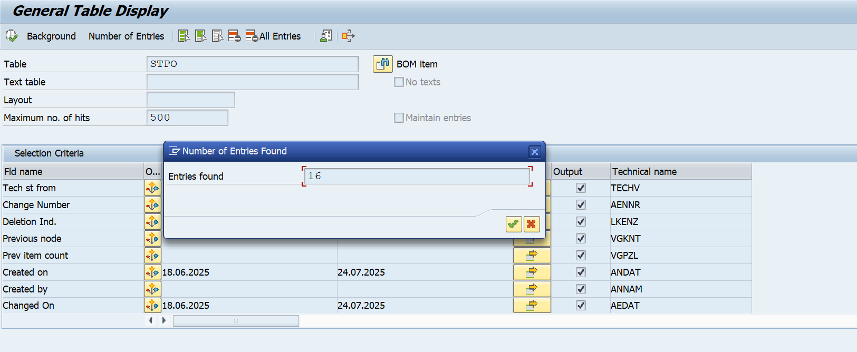

**Postman Level Testing**

http://mehdevpas.minda.com:8001/sap/opu/odata/sap/ZGW_PP_BOM_DETAIL_SRV/ZC_PP_BillOfMaterial_Details?$filter=ComponentCahngedOn ge datetime'2025-06-18T00:00:00' and ComponentCahngedOn le datetime'2025-07-24T00:00:00' and ComponentCreatedOn ge datetime'2025-06-18T00:00:00' and ComponentCreatedOn le datetime'2025-07-24T00:00:00'& sap-client=190

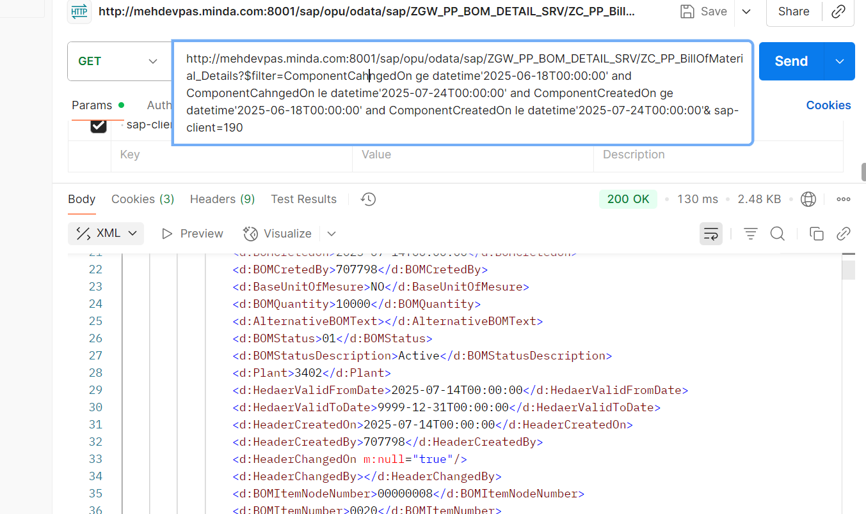

**case 5: If you want to Fitter based on Material Number.**

Material Code : “7421B-028C-B91”

**Gateway**

/sap/opu/odata/sap/ZGW_PP_BOM_DETAIL_SRV/ZC_PP_BillOfMaterial_Details?$filter=MateriaLCode eq '7421B-028C-B91'

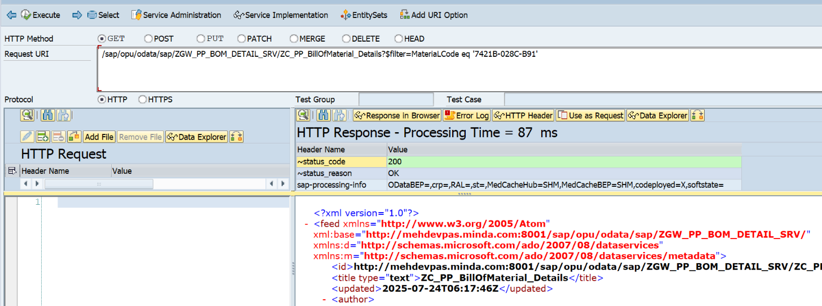

**Postman Testing:**

http://mehdevpas.minda.com:8001/sap/opu/odata/sap/ZGW_PP_BOM_DETAIL_SRV/ZC_PP_BillOfMaterial_Details?$filter=MateriaLCode eq '7421B-028C-B91' & sap-client=190

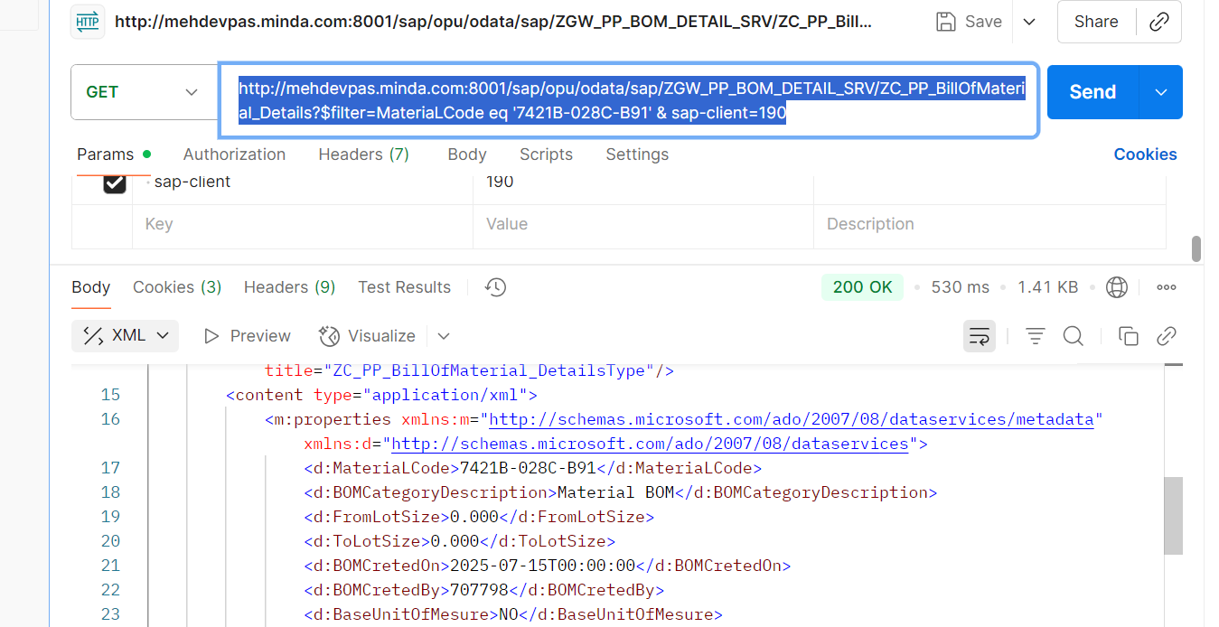

**Case 6: If you want to filter based on Plant.**

Plant: 1211

**Gateway**

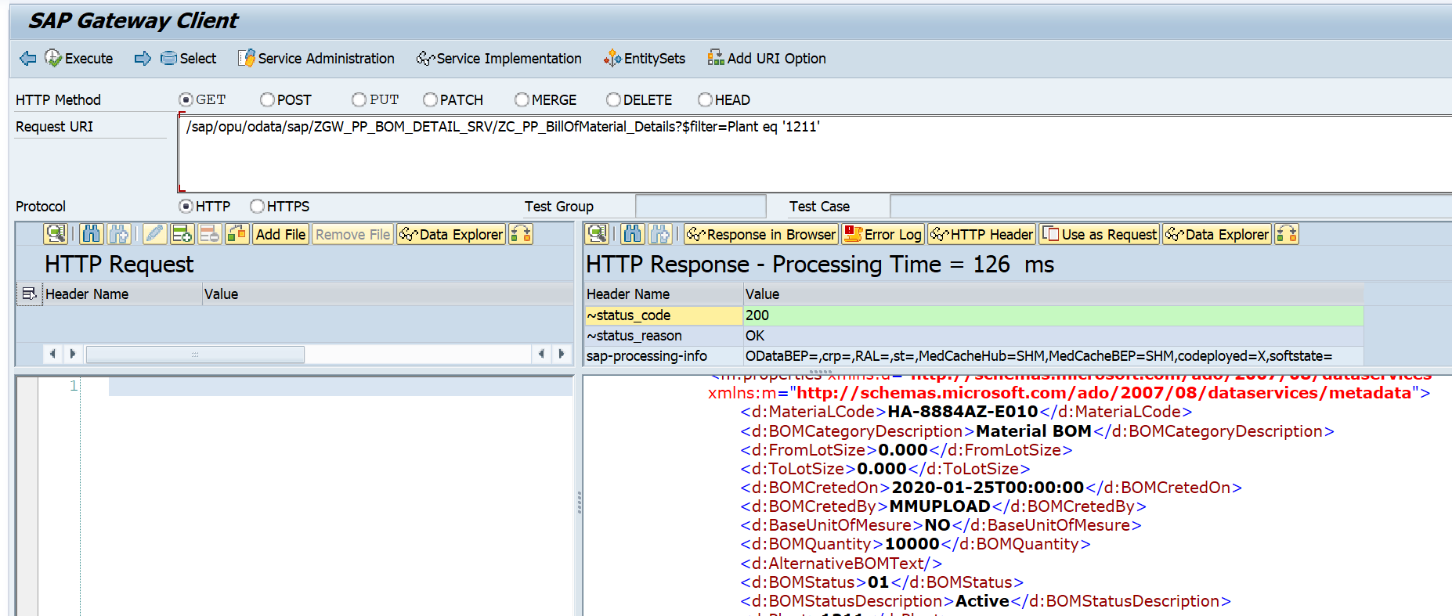/sap/opu/odata/sap/ZGW_PP_BOM_DETAIL_SRV/ZC_PP_BillOfMaterial_Details?$filter=Plant eq '1211'

Count Number of record :

/sap/opu/odata/sap/ZGW_PP_BOM_DETAIL_SRV/ZC_PP_BillOfMaterial_Details/$count?$filter=Plant eq '1211'

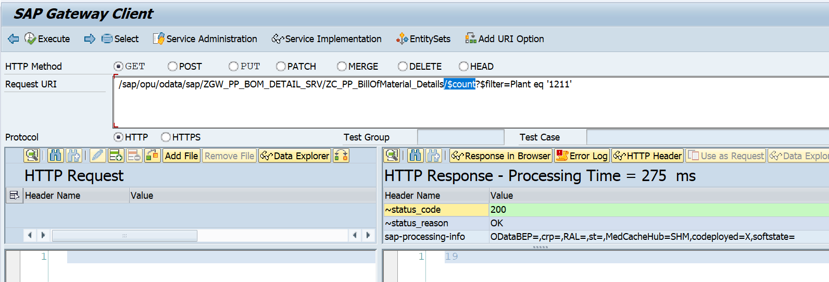

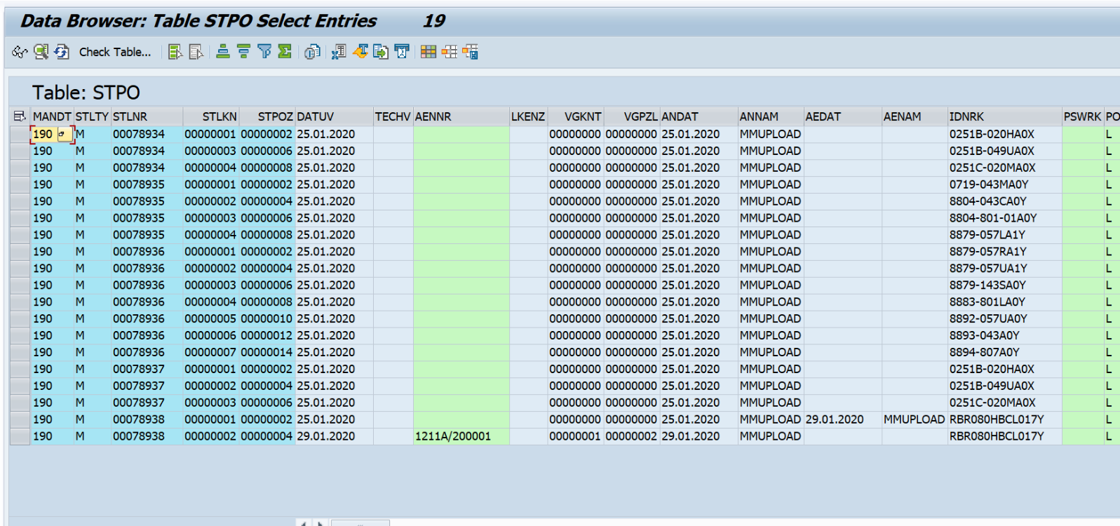Database table level

Postman check

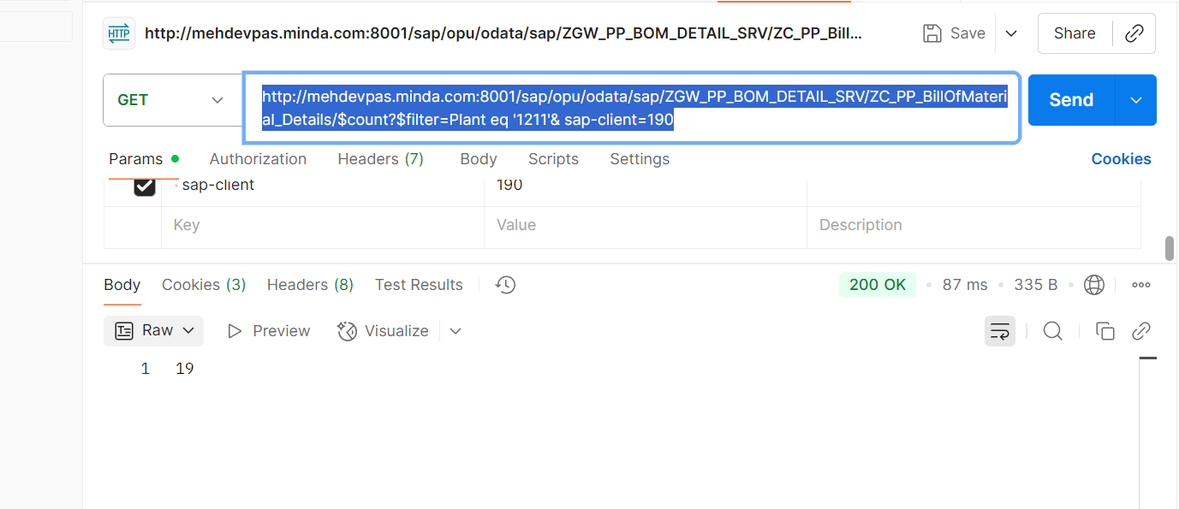http://mehdevpas.minda.com:8001/sap/opu/odata/sap/ZGW_PP_BOM_DETAIL_SRV/ZC_PP_BillOfMaterial_Details/$count?$filter=Plant eq '1211'& sap-client=190