Technical Specification Form

SAP MIGO Data API

Prepared By: Debidutta Swain (AIRDIT Software Solutions)

**Technical specification content**

1. Business Requirement
2. Development Tools
3. Development Objects

* Table.
* CDS Data Definition.
* CDS Access Control
* SEGW – OData Project.

1. Business API / OData API and Output Screen
2. **Business Requirement:**

Develop an OData GET API for MIGO details, where end user can pass the Posting date(in range) and Movement Type(In parameter) as input and Get the Corresponding details .

Here end user only those Plant data for which end-user is authorized.

The following Details provided by Functional consultant in order to develop API:

Input screeen: BUDAT_MKPF(Posting date)

MJAHR(Document Year)

BWART(Movement Type)

API LOGIC : Pass the above details in to MSEG table & fetch the line item and join the details of item level with header table to fatch header details based on Document number(MBLNR) and Document Year (MJAHR).

|  |  |  |  |  |  |  |  |  |
| --- | --- | --- | --- | --- | --- | --- | --- | --- |
| **S.NO** | **API** | **INTERFACE** | **HEADER/LINE ITEM/COMPONENT** | **DESC** | **TABLE** | **TECH FIELD** | **DATA TYPE** | **LENGTH** |
| 01 | MIGO MASTER DATA | SAP TO CDS/JASEN | LINE ITEM (MIGO) | Posting Date | MSEG | BUDAT_MKPF | DATS | 8 |
| 02 | MIGO MASTER DATA | SAP TO CDS/JASEN | LINE ITEM (MIGO) | Material Doc. Year | MSEG | MJAHR | NUMC | 4 |
| 03 | MIGO MASTER DATA | SAP TO CDS/JASEN | LINE ITEM (MIGO) | Movement type | MSEG | BWART | CHAR | 3 |
| 04 | MIGO MASTER DATA | SAP TO CDS/JASEN | LINE ITEM (MIGO) | Material Document | MSEG | MBLNR | CHAR | 10 |
| 05 | MIGO MASTER DATA | SAP TO CDS/JASEN | LINE ITEM (MIGO) | Material Doc.Item | MSEG | ZEILE | NUMC | 4 |
| 06 | MIGO MASTER DATA | SAP TO CDS/JASEN | LINE ITEM (MIGO) | Identification | MSEG | LINE_ID | NUMC | 6 |
| 07 | MIGO MASTER DATA | SAP TO CDS/JASEN | LINE ITEM (MIGO) | Material | MSEG | MATNR | CHAR | 40 |
| 08 | MIGO MASTER DATA | SAP TO CDS/JASEN | LINE ITEM (MIGO) | Plant | MSEG | WERKS | CHAR | 4 |
| 09 | MIGO MASTER DATA | SAP TO CDS/JASEN | LINE ITEM (MIGO) | Storage location | MSEG | LGORT | CHAR | 4 |
| 10 | MIGO MASTER DATA | SAP TO CDS/JASEN | LINE ITEM (MIGO) | Batch | MSEG | CHARG | CHAR | 10 |
| 11 | MIGO MASTER DATA | SAP TO CDS/JASEN | LINE ITEM (MIGO) | Vendor | MSEG | LIFNR | CHAR | 10 |
| 12 | MIGO MASTER DATA | SAP TO CDS/JASEN | LINE ITEM (MIGO) | Debit/Credit ind | MSEG | SHKZG | CHAR | 1 |
| 13 | MIGO MASTER DATA | SAP TO CDS/JASEN | LINE ITEM (MIGO) | Currency | MSEG | WAERS | CUKY | 5 |
| 14 | MIGO MASTER DATA | SAP TO CDS/JASEN | LINE ITEM (MIGO) | Amt.in loc.cur. | MSEG | DMBTR | CURR | 13 |
| 15 | MIGO MASTER DATA | SAP TO CDS/JASEN | LINE ITEM (MIGO) | Delivery costs | MSEG | BNBTR | CURR | 13 |
| 16 | MIGO MASTER DATA | SAP TO CDS/JASEN | LINE ITEM (MIGO) | Quantity | MSEG | MENGE | QUAN | 13 |
| 17 | MIGO MASTER DATA | SAP TO CDS/JASEN | LINE ITEM (MIGO) | Base Unit of Measure | MSEG | MEINS | UNIT | 3 |
| 18 | MIGO MASTER DATA | SAP TO CDS/JASEN | LINE ITEM (MIGO) | Qty in unit of entry | MSEG | ERFMG | QUAN | 13 |
| 19 | MIGO MASTER DATA | SAP TO CDS/JASEN | LINE ITEM (MIGO) | Unit of Entry | MSEG | ERFME | UNIT | 3 |
| 20 | MIGO MASTER DATA | SAP TO CDS/JASEN | LINE ITEM (MIGO) | Qty in OPUn | MSEG | BPMNG | QUAN | 13 |
| 21 | MIGO MASTER DATA | SAP TO CDS/JASEN | LINE ITEM (MIGO) | Order Price Unit | MSEG | BPRME | UNIT | 3 |
| 22 | MIGO MASTER DATA | SAP TO CDS/JASEN | LINE ITEM (MIGO) | Purchase order | MSEG | EBELN | CHAR | 10 |
| 23 | MIGO MASTER DATA | SAP TO CDS/JASEN | LINE ITEM (MIGO) | Item | MSEG | EBELP | NUMC | 5 |
| 24 | MIGO MASTER DATA | SAP TO CDS/JASEN | LINE ITEM (MIGO) | Fisc. Year Ref. Doc. | MSEG | LFBJA | NUMC | 4 |
| 25 | MIGO MASTER DATA | SAP TO CDS/JASEN | LINE ITEM (MIGO) | Reference Document | MSEG | LFBNR | CHAR | 10 |
| 26 | MIGO MASTER DATA | SAP TO CDS/JASEN | LINE ITEM (MIGO) | Reference Doc. Item | MSEG | LFPOS | NUMC | 4 |
| 27 | MIGO MASTER DATA | SAP TO CDS/JASEN | LINE ITEM (MIGO) | Controlling Area | MSEG | KOKRS | CHAR | 4 |
| 28 | MIGO MASTER DATA | SAP TO CDS/JASEN | LINE ITEM (MIGO) | Fiscal Year | MSEG | GJAHR | NUMC | 4 |
| 29 | MIGO MASTER DATA | SAP TO CDS/JASEN | LINE ITEM (MIGO) | Company Code | MSEG | BUKRS | CHAR | 4 |
| 30 | MIGO MASTER DATA | SAP TO CDS/JASEN | LINE ITEM (MIGO) | Statistically relev. | MSEG | KZSTR | CHAR | 1 |
| 31 | MIGO MASTER DATA | SAP TO CDS/JASEN | LINE ITEM (MIGO) | Movement indicator | MSEG | KZBEW | CHAR | 1 |
| 32 | MIGO MASTER DATA | SAP TO CDS/JASEN | LINE ITEM (MIGO) | Profit Center | MSEG | PRCTR | CHAR | 10 |
| 33 | MIGO MASTER DATA | SAP TO CDS/JASEN | LINE ITEM (MIGO) | Commitment item | MSEG | FIPOS | CHAR | 14 |
| 34 | MIGO MASTER DATA | SAP TO CDS/JASEN | LINE ITEM (MIGO) | Qty in order unit | MSEG | BSTMG | QUAN | 13 |
| 35 | MIGO MASTER DATA | SAP TO CDS/JASEN | LINE ITEM (MIGO) | Order Unit | MSEG | BSTME | UNIT | 3 |
| 36 | MIGO MASTER DATA | SAP TO CDS/JASEN | LINE ITEM (MIGO) | Supplier | MSEG | EMLIF | CHAR | 10 |
| 37 | MIGO MASTER DATA | SAP TO CDS/JASEN | LINE ITEM (MIGO) | Partner Profit Ctr | MSEG | PPRCTR | CHAR | 10 |
| 38 | MIGO MASTER DATA | SAP TO CDS/JASEN | LINE ITEM (MIGO) | Fund | MSEG | GEBER | CHAR | 10 |
| 39 | MIGO MASTER DATA | SAP TO CDS/JASEN | LINE ITEM (MIGO) | Funds center | MSEG | FISTL | CHAR | 16 |
| 40 | MIGO MASTER DATA | SAP TO CDS/JASEN | LINE ITEM (MIGO) | Stock Material | MSEG | MATBF | CHAR | 40 |
| 41 | MIGO MASTER DATA | SAP TO CDS/JASEN | LINE ITEM (MIGO) | Quantity string | MSEG | BUSTM | CHAR | 4 |
|  | MIGO MASTER DATA | SAP TO CDS/JASEN | LINE ITEM (MIGO) | Value String | MSEG | BUSTW | CHAR | 4 |
| 43 | MIGO MASTER DATA | SAP TO CDS/JASEN | LINE ITEM (MIGO) | Quantity updating | MSEG | MENGU | CHAR | 1 |
| 44 | MIGO MASTER DATA | SAP TO CDS/JASEN | LINE ITEM (MIGO) | Value updating | MSEG | WERTU | CHAR | 1 |
| 45 | MIGO MASTER DATA | SAP TO CDS/JASEN | LINE ITEM (MIGO) | Valuated stock | MSEG | LBKUM | QUAN | 13 |
| 46 | MIGO MASTER DATA | SAP TO CDS/JASEN | LINE ITEM (MIGO) | Totl val. bf.posting | MSEG | SALK3 | CURR | 13 |
| 47 | MIGO MASTER DATA | SAP TO CDS/JASEN | LINE ITEM (MIGO) | Price control | MSEG | VPRSV | CHAR | 1 |
| 48 | MIGO MASTER DATA | SAP TO CDS/JASEN | LINE ITEM (MIGO) | Del. Note Quantity | MSEG | LSMNG | QUAN | 13 |
| 49 | MIGO MASTER DATA | SAP TO CDS/JASEN | LINE ITEM (MIGO) | Delivery Note Unit | MSEG | LSMEH | QUAN | 13 |
| 50 | MIGO MASTER DATA | SAP TO CDS/JASEN | LINE ITEM (MIGO) | Date of Manufacture | MSEG | HSDAT | DATS | 8 |
| 51 | MIGO MASTER DATA | SAP TO CDS/JASEN | LINE ITEM (MIGO) | SLED/BBD | MSEG | VFDAT | DATS | 8 |
| 52 | MIGO MASTER DATA | SAP TO CDS/JASEN | LINE ITEM (MIGO) | Stock Type Modif. | MSEG | ZUSTD_T156M | CHAR | 1 |
| 53 | MIGO MASTER DATA | SAP TO CDS/JASEN | LINE ITEM (MIGO) | Trans./Event Type | MSEG | VGART_MKPF | CHAR | 2 |
| 54 | MIGO MASTER DATA | SAP TO CDS/JASEN | LINE ITEM (MIGO) | Entry Date | MSEG | CPUDT_MKPF | DATS | 8 |
| 55 | MIGO MASTER DATA | SAP TO CDS/JASEN | LINE ITEM (MIGO) | Time of Entry | MSEG | CPUTM_MKPF | TIMS | 6 |
| 56 | MIGO MASTER DATA | SAP TO CDS/JASEN | LINE ITEM (MIGO) | User Name | MSEG | USNAM_MKPF | CHAR | 12 |
| 57 | MIGO MASTER DATA | SAP TO CDS/JASEN | LINE ITEM (MIGO) | Reference | MSEG | XBLNR_MKPF | CHAR | 16 |
| 58 | MIGO MASTER DATA | SAP TO CDS/JASEN | LINE ITEM (MIGO) | Transaction Code | MSEG | TCODE2_MKPF | CHAR | 20 |
| 59 | MIGO MASTER DATA | SAP TO CDS/JASEN | LINE ITEM (MIGO) | Delivery | MSEG | VBELN_IM | CHAR | 10 |
| 60 | MIGO MASTER DATA | SAP TO CDS/JASEN | LINE ITEM (MIGO) | Item | MSEG | VBELP_IM | NUMC | 6 |
| 61 | MIGO MASTER DATA | SAP TO CDS/JASEN | LINE ITEM (MIGO) | MPN | MSEG | SGT_SCAT | CHAR | 40 |
| 62 | MIGO MASTER DATA | SAP TO CDS/JASEN | LINE ITEM (MIGO) | Requirement MPN | MSEG | SGT_RCAT | CHAR | 40 |
| 63 | MIGO MASTER DATA | SAP TO CDS/JASEN | LINE ITEM (MIGO) | Rec. Stock Segment | MSEG | SGT_UMSCAT | CHAR | 40 |
| 64 | MIGO MASTER DATA | SAP TO CDS/JASEN | LINE ITEM (MIGO) | Delivery Completed | MSEG | ELIKZ | CHAR | 1 |
| 65 | MIGO MASTER DATA | SAP TO CDS/JASEN | LINE ITEM (MIGO) | Reason for Movement | MSEG | GRUND | NUMC | 4 |
| 66 | MIGO MASTER DATA | SAP TO CDS/JASEN | LINE ITEM (MIGO) | Reservation | MSEG | RSNUM | NUMC | 10 |
| 67 | MIGO MASTER DATA | SAP TO CDS/JASEN | LINE ITEM (MIGO) | Item number of reservation | MSEG | RSPOS | NUMC | 4 |
| 68 | MIGO MASTER DATA | SAP TO CDS/JASEN | LINE ITEM (MIGO) | G/L Account | MSEG | SAKTO | CHAR | 10 |
| 69 | MIGO MASTER DATA | SAP TO CDS/JASEN | LINE ITEM (MIGO) | Receiving Material | MSEG | UMMAT | CHAR | 40 |
| 70 | MIGO MASTER DATA | SAP TO CDS/JASEN | LINE ITEM (MIGO) | Receiving plant | MSEG | UMWRK | CHAR | 4 |
| 71 | MIGO MASTER DATA | SAP TO CDS/JASEN | LINE ITEM (MIGO) | Receiving stor. loc. | MSEG | UMLGO | CHAR | 4 |
| 72 | MIGO MASTER DATA | SAP TO CDS/JASEN | LINE ITEM (MIGO) | Receiving Batch | MSEG | UMCHA | CHAR | 10 |
| 73 | MIGO MASTER DATA | SAP TO CDS/JASEN | LINE ITEM (MIGO) | Sp. ind. stock tfr. | MSEG | UMSOK | CHAR | 1 |
| 74 | MIGO MASTER DATA | SAP TO CDS/JASEN | LINE ITEM (MIGO) | Special Stock | MSEG | SOBKZ | CHAR | 1 |
| 75 | MIGO MASTER DATA | SAP TO CDS/JASEN | LINE ITEM (MIGO) | Receiving Material | MSEG | UMMAB | CHAR | 40 |

|  |  |  |  |  |  |  |  |  |
| --- | --- | --- | --- | --- | --- | --- | --- | --- |
| **S.NO** | **API** | **INTERFACE** | **HEADER/LINE ITEM/COMPONENT** | **DESC** | **TABLE** | **TECH FIELD** | **DATA TYPE** | **LENGTH** |
| 01 | MIGO MASTER DATA | SAP TO CDS/JASEN | HEADER (MIGO) | Trans./Event Type | MSEG | VGART | CHAR | 2 |
| 02 | MIGO MASTER DATA | SAP TO CDS/JASEN | HEADER (MIGO) | Document type | MSEG | BLART | CHAR | 2 |
| 03 | MIGO MASTER DATA | SAP TO CDS/JASEN | HEADER (MIGO) | Doc. type reval. | MSEG | BLAUM | CHAR | 2 |
| 04 | MIGO MASTER DATA | SAP TO CDS/JASEN | HEADER (MIGO) | Document Date | MSEG | BLDAT | DATS | 8 |
| 05 | MIGO MASTER DATA | SAP TO CDS/JASEN | HEADER (MIGO) | Posting Date | MSEG | BUDAT | DATS | 8 |
| 06 | MIGO MASTER DATA | SAP TO CDS/JASEN | HEADER (MIGO) | Entry Date | MSEG | CPUDT | DATS | 8 |
| 07 | MIGO MASTER DATA | SAP TO CDS/JASEN | HEADER (MIGO) | Time of Entry | MSEG | CPUTM | TIMS | 6 |
| 08 | MIGO MASTER DATA | SAP TO CDS/JASEN | HEADER (MIGO) | Reference | MSEG | XBLNR | CHAR | 16 |
| 09 | MIGO MASTER DATA | SAP TO CDS/JASEN | HEADER (MIGO) | Bill of Lading | MSEG | FRBNR | CHAR | 16 |
| 10 | MIGO MASTER DATA | SAP TO CDS/JASEN | HEADER (MIGO) | User Name | MSEG | USNAM | CHAR | 12 |
| 11 | MIGO MASTER DATA | SAP TO CDS/JASEN | HEADER (MIGO) | Document Header Text | MSEG | BKTXT | CHAR | 25 |
| 12 | MIGO MASTER DATA | SAP TO CDS/JASEN | HEADER (MIGO) | Gate Entry No | ZTMM01003_MIGO | GNO | CHAR | 10 |
| 13 | MIGO MASTER DATA | SAP TO CDS/JASEN | HEADER (MIGO) | Gate entry year | ZTMM01003_MIGO | GYEAR | NUMC | 4 |
| 14 | MIGO MASTER DATA | SAP TO CDS/JASEN | HEADER (MIGO) | Plant | ZTMM01003_MIGO | WERKS | CHAR | 4 |
| 15 | MIGO MASTER DATA | SAP TO CDS/JASEN | HEADER (MIGO) | Amount | ZTMM01003_MIGO | ZINVAMT | CURR | 13 |

Person Responsible for Functional Specification:

SAP Technical Cum Functional Specification Form

|  |  |  |  |
| --- | --- | --- | --- |
| User Story ID # |  | Module | MM |
| Date | 22/08/2025 | SL User |  |
| Consultant | Wajid Choudhary | Developer |  |
| Priority | ☐Urgent ☒High ☐Medium ☐Low | | |
| Application Type | ☐Report ☐Transaction ☐Interface ☒ Enhancement/Change ☐Others | | |
| Execute Model | ☐Batch ☐ Foreground ☒Manual ☐Quarterly ☐Monthly  ☐Weekly ☐Daily ☐Real time | | |
| Output Type | ☐Message ☐Dialog Screen ☐ABAP List ☐ALV List ☐ALV Grid | | |
| Remarks | SAP MIGO DATA | | |

**2.Development Status & Tools**

For development these are the following tool used :

* **Eclipse for ABAP /ADT(ABAP Development Tool)**
* Interface/Basic CDS view:

Created on top of Required Database. Naming convention: ZI_*****

* Composite CDS view:

Created on top of Interface basic view for join/association. Naming convention: ZCO_*****

* Consumption view:

Expose only those field required for Business Requirement. Naming convention: ZC_*****

* CDS Access Control:

Access control created to handle Visibility on SAP Data.

Naming convention: ZDCL_*****

* **SEGW OData Project**
* Created OData project with “Data Source Reference” Using the consumption CDS view. Here in this CDS association has been done due to which in ODATA project all the association and navigation property generate automatically.
* For Service Registration used Tcode : /N/IWFND/MAINT_SERVICE.
* To Check the final data at Gateway Client used Tcode :/N/IWFND/GW_CLIENT.

NOTE: For CDS development process, I followed the VDM approach.

**3.Development Objects**

* ***Table:***
* **MKPF:** Material Document Header
* **MSEG(NSDM_V_MSEG):** Document Segment: Material
* **ZTMM01003_MIGO**: ZTMM01003_MIGO\
* ***CDS Data Definition:***
* **Basic CDS View:**

As I am following the VDM modeling in this development, I had created Basic CDS view on top of Database table and the source of Basic View Should be a Database View or Standard CDS view.

* Table: MKPF (Material Document Header)
* Table Replacement View: **NSDM_V_MKPF**
* CDS view name: **ZI_MM_MKPF_HEADERMATERIALDOC**
* //---------------------------------------------------------------//
* //Creted By : Debidutta Swain(9000Rupesh)-@AIRDIT
* //Creted On : 25-08-2025
* //--------------------------------------------------------------//
* @AbapCatalog.sqlViewName: 'zimkpf'
* @AbapCatalog.compiler.compareFilter: true
* @AbapCatalog.preserveKey: true
* @AccessControl.authorizationCheck: #NOT_REQUIRED
* @EndUserText.label: 'Basic View:MKPF:Header Material Document'
* @Metadata.ignorePropagatedAnnotations: true
* @VDM.viewType: #BASIC
* **define** **view** ZI_MM_MKPF_HeaderMaterialDoc
* **as** **select** **from** nsdm_v_mkpf
* **{**
* **key** mblnr **as** MaterialDocument**,**
* **key** mjahr **as** MaterialDocumentYear**,**
* vgart **as** TransEventTypeMkpf**,**
* blart **as** DocumentType**,**
* blaum **as** DocumentTypeReval**,**
* budat **as** PostingDateMKPF**,**
* cpudt **as** EntryDateMKPF**,**
* cputm **as** TimeOfEntryMKPF**,**
* xblnr **as** ReferenceMKPF**,**
* frbnr **as** BillOfLanding**,**
* usnam **as** UserNameMKPF**,**
* bktxt **as** DocuemntHeaderText
* **}**

* Table: MSEG (Document Segment: Material)
* Table Replacement View: **NSDM_V_MSEG**
* CDS view name: **ZI_MM_MSEG_MIGODATA**
* //---------------------------------------------------------------//
* //Creted By : Debidutta Swain(9000Rupesh)-@AIRDIT
* //Creted On : 25-08-2025
* //--------------------------------------------------------------//
* @AbapCatalog.sqlViewName: 'ZIMSEG'
* @AbapCatalog.compiler.compareFilter: true
* @AbapCatalog.preserveKey: true
* @AccessControl.authorizationCheck: #NOT_REQUIRED
* @EndUserText.label: 'Basic CDS:MSEG:Document Segment: Material'
* @Metadata.ignorePropagatedAnnotations: true
* @VDM.viewType: #BASIC
* **define** **view** ZI_MM_MSEG_MIGOData
* **as** **select** **from** nsdm_v_mseg
* **{**
* **key** mblnr **as** MaterialDocument**,**
* **key** mjahr **as** MaterialDocumentYear**,**
* **key** zeile **as** MaterialDocumentItem**,**
* line_id **as** Identification**,**
* budat_mkpf **as** PostingDate**,**
* bwart **as** MovementType**,**
* matnr **as** Material**,**
* werks **as** Plant**,**
* lgort **as** StorageLocation**,**
* charg **as** BtachNumber**,**
* lifnr **as** VendorCode**,**
* shkzg **as** DebitCreditIndicator**,**
* waers **as** CurrencyKey**,**
* @Semantics.amount.currencyCode: 'CurrencyKey'
* dmbtr **as** AmountLocalCurrency**,** //Amount in Local Currency
* @Semantics.amount.currencyCode: 'CurrencyKey'
* bnbtr **as** DelivryCosts**,**
* meins **as** UnitOfMesure**,**
* @Semantics.quantity.unitOfMeasure: 'UnitOfMesure'
* menge **as** Quantity**,**
* @Semantics.quantity.unitOfMeasure: 'UnitOfMesure'
* erfmg **as** QuantityInUnitEntry**,** //Quantity in Unit of Entry
* erfme **as** UnitOfEntry**,**
* @Semantics.quantity.unitOfMeasure: 'UnitOfMesure'
* bpmng **as** QuantityInPOPriceUnit**,** //Quantity in Purchase Order Price Unit
* bprme **as** OrderPriceUnit**,**
* ebeln **as** PurchaseOrder**,**
* ebelp **as** PurchaseOrderItem**,**
* lfbja **as** FiscalYearRefDocument**,** //Fiscal Year of a Reference Document
* lfbnr **as** DocumentNoRefDocument**,** //Document No. of a Reference Document
* lfpos **as** ItemOfRefDocument**,** //Item of a Reference Document
* kokrs **as** ControllingArea**,**
* gjahr **as** FiscalYear**,**
* bukrs **as** CompanyCode**,**
* kzstr **as** StatisticallyRelevent**,**
* kzbew **as** MovementIndicator**,**
* prctr **as** ProfitCenter**,**
* fipos **as** CommitmentItem**,**
* @Semantics.quantity.unitOfMeasure: 'OrderUnit'
* bstmg **as** QuantityInOrderUnit**,**
* bstme **as** OrderUnit**,**
* emlif **as** Supplier**,**
* pprctr **as** PartnerProfitCenter**,**
* geber **as** Fund**,**
* fistl **as** FundsCenter**,**
* matbf **as** StockMaterial**,**
* bustm **as** QauntityString**,**
* bustw **as** ValueString**,**
* mengu **as** QuantityUpdating**,**
* wertu **as** ValueUpdating**,**
* lbkum **as** ValuatedStock**,**
* salk3 **as** TotlValBFPosting**,** //Value of total valuated stock before the posting
* vprsv **as** PriceControl**,**
* @Semantics.quantity.unitOfMeasure: 'DeliveryNoteUnit'
* lsmng **as** DelNoteQuantity**,**
* lsmeh **as** DeliveryNoteUnit**,**
* hsdat **as** DateOfManufacture**,**
* vfdat **as** SLEDorBBD**,**
* zustd_t156m **as** StockTypeModif**,**
* vgart_mkpf **as** TransEventType**,**
* cpudt_mkpf **as** EntryDate**,**
* cputm_mkpf **as** TimeOfEntry**,**
* usnam_mkpf **as** UserName**,**
* xblnr_mkpf **as** Reference**,**
* tcode2_mkpf **as** TransactionCode**,**
* vbeln_im **as** Delivery**,**
* vbelp_im **as** DeliveryItem**,**
* sgt_scat **as** MPN**,**
* sgt_rcat **as** RequirementMPN**,**
* sgt_umscat **as** RecStockSegment**,**
* elikz **as** DeliveryCompleted**,**
* grund **as** ReasonOfMovement**,**
* rsnum **as** Reservation**,**
* rspos **as** ReservationItem**,**
* sakto **as** GLAccount**,**
* ummat **as** receivingMaterialMAT**,**
* umwrk **as** ReceivingPlant**,**
* umlgo **as** ReceivingStrgLocation**,**
* umcha **as** ReceivingBatch**,**
* umsok **as** SpIndStockTransfer**,**
* sobkz **as** SpecialStock**,**
* ummab **as** ReceivingMaterialMAB
* **}**
* Table: ZTMM01003_MIGO
* CDS view name: **ZI_MM_ZTMM01003_MIGO**
* //---------------------------------------------------------------//
* //Creted By : Debidutta Swain(9000Rupesh)-@AIRDIT
* //Creted On : 25-08-2025
* //--------------------------------------------------------------//
* @AbapCatalog.sqlViewName: 'ZIGATEENT'
* @AbapCatalog.compiler.compareFilter: true
* @AbapCatalog.preserveKey: true
* @AccessControl.authorizationCheck: #NOT_REQUIRED
* @EndUserText.label: 'Basic View:ZTMM01003_MIGO:Gate Entry Detail'
* @Metadata.ignorePropagatedAnnotations: true
* @VDM.viewType: #BASIC
* **define** **view** ZI_MM_ZTMM01003_MIGO
* **as** **select** **from** ztmm01003_migo
* **{**
* **key** mblnr **as** MaterialDocument**,**
* **key** mjahr **as** MaterialDocumentYear**,**
* **key** gno **as** GateEntryNo**,**
* **key** gyear **as** GateEntryYear**,**
* **key** werks **as** GateEntryPlant**,**
* zinvamt **as** AmountInDocumentCurrency
* **}**

* **Composite CDS view**

As I am following the VDM modeling in this development, I had created Composite CDS view on top of Basic View where I will do all the necessary Joins/association needed for the Current Business Requirement.

* CDS Name: ZCO_MM_MATERIALDOCUMENTHEADER
* Description: Composite CDS: Material Document Header
* //---------------------------------------------------------------//
* //Creted By : Debidutta Swain(9000Rupesh)-@AIRDIT
* //Creted On : 25-08-2025
* //--------------------------------------------------------------//
* @AbapCatalog.sqlViewName: 'ZCOMKPF'
* @AbapCatalog.compiler.compareFilter: true
* @AbapCatalog.preserveKey: true
* @AccessControl.authorizationCheck: #NOT_REQUIRED
* @EndUserText.label: 'Composite CDS:Material Docuemnt Header'
* @VDM.viewType: #COMPOSITE
* @Metadata.ignorePropagatedAnnotations: true
* **define** **view** ZCO_MM_MaterialDocumentHeader
* **as** **select** **from** ZI_MM_MKPF_HeaderMaterialDoc **as** MKPF
* **left** **outer** **join** ZI_MM_ZTMM01003_MIGO **as** ZTMM01003_MIGO **on** MKPF**.**MaterialDocument **=** ZTMM01003_MIGO**.**MaterialDocument
* **and** MKPF**.**MaterialDocumentYear **=** ZTMM01003_MIGO**.**MaterialDocumentYear
* **{**
* **key** MKPF**.**MaterialDocument**,**
* **key** MKPF**.**MaterialDocumentYear**,**
* MKPF**.**TransEventTypeMkpf**,**
* MKPF**.**DocumentType**,**
* MKPF**.**DocumentTypeReval**,**
* MKPF**.**PostingDateMKPF**,**
* MKPF**.**EntryDateMKPF**,**
* MKPF**.**TimeOfEntryMKPF**,**
* MKPF**.**ReferenceMKPF**,**
* MKPF**.**BillOfLanding**,**
* MKPF**.**UserNameMKPF**,**
* MKPF**.**DocuemntHeaderText**,**
* ZTMM01003_MIGO**.**GateEntryNo**,**
* ZTMM01003_MIGO**.**GateEntryYear**,**
* ZTMM01003_MIGO**.**GateEntryPlant**,**
* ZTMM01003_MIGO**.**AmountInDocumentCurrency
* **}**
* CDS Name: ZCO_MM_MSEG_MIGODATA
* Description: Composite CDS: MSEG: MIGO Details
* //---------------------------------------------------------------//
* //Creted By : Debidutta Swain(9000Rupesh)-@AIRDIT
* //Creted On : 25-08-2025
* //--------------------------------------------------------------//
* @AbapCatalog.sqlViewName: 'ZCOMSEG'
* @AbapCatalog.compiler.compareFilter: true
* @AbapCatalog.preserveKey: true
* @AccessControl.authorizationCheck: #NOT_REQUIRED
* @EndUserText.label: 'Composite CDS:MSEG:MIGO Details'
* @Metadata.ignorePropagatedAnnotations: true
* @VDM.viewType: #COMPOSITE
* **define** **view** ZCO_MM_MSEG_MIGOData
* **as** **select** **from** ZI_MM_MSEG_MIGOData **as** MSEG
* //--> Material Description
* **left** **outer** **join** makt **on** MSEG**.**Material **=** makt**.**matnr
* **and** makt**.**spras **=** **$session.system_language**
* //--> Plant Description
* **left** **outer** **join** t001w **on** MSEG**.**Plant **=** t001w**.**werks
* //--> Storage Location Description
* **left** **outer** **join** t001l **on** MSEG**.**Plant **=** t001l**.**werks
* **and** MSEG**.**StorageLocation **=** t001l**.**lgort
* //--> Vendor Description
* **left** **outer** **join** lfa1 **as** Vendor **on** MSEG**.**VendorCode **=** Vendor**.**lifnr
* //--> CompanyCode Description
* **left** **outer** **join** t001 **on** MSEG**.**CompanyCode **=** t001**.**bukrs
* //--> Controlling Area Description
* **left** **outer** **join** tka01 **on** MSEG**.**ControllingArea **=** tka01**.**kokrs
* //--> Supplier Description
* **left** **outer** **join** lfa1 **as** Supplier **on** MSEG**.**Supplier **=** Supplier**.**lifnr
* //--> Statistically Relevent Description
* **left** **outer** **join** dd07t **as** StatisRelv **on** StatisRelv**.**domname **=** 'KZSTR'
* **and** StatisRelv**.**domvalue_l **=** MSEG**.**StatisticallyRelevent
* **and** StatisRelv**.**ddlanguage **=** **$session.system_language**
* //--> Movement Indicator Description
* **left** **outer** **join** dd07t **as** MvmtInd **on** MvmtInd**.**domname **=** 'KZBEW'
* **and** MvmtInd**.**domvalue_l **=** MSEG**.**MovementIndicator
* **and** MvmtInd**.**ddlanguage **=** **$session.system_language**
* **{**
* **key** MSEG**.**MaterialDocument**,**
* **key** MSEG**.**MaterialDocumentYear**,**
* **key** MSEG**.**MaterialDocumentItem**,**
* MSEG**.**Identification**,**
* MSEG**.**PostingDate**,**
* MSEG**.**MovementType**,**
* MSEG**.**Material**,**
* makt**.**maktx **as** MaterialText**,**
* MSEG**.**Plant**,**
* t001w**.**name1 **as** PlantText**,**
* MSEG**.**StorageLocation**,**
* t001l**.**lgobe **as** StorageLocationText**,**
* MSEG**.**BtachNumber**,**
* MSEG**.**VendorCode**,**
* Vendor**.**name1 **as** VandorCodeText**,**
* MSEG**.**DebitCreditIndicator**,**
* **case** MSEG**.**DebitCreditIndicator
* **when** 'H' **then** 'Credit'
* **when** 'S' **then** 'Debit'
* **else** ' ' **end** **as** DebitCreditIndicatorText**,**
* MSEG**.**CurrencyKey**,**
* MSEG**.**AmountLocalCurrency**,**
* MSEG**.**DelivryCosts**,**
* MSEG**.**UnitOfMesure**,**
* MSEG**.**Quantity**,**
* MSEG**.**QuantityInUnitEntry**,**
* MSEG**.**UnitOfEntry**,**
* MSEG**.**QuantityInPOPriceUnit**,**
* MSEG**.**OrderPriceUnit**,**
* MSEG**.**PurchaseOrder**,**
* MSEG**.**PurchaseOrderItem**,**
* MSEG**.**FiscalYearRefDocument**,**
* MSEG**.**DocumentNoRefDocument**,**
* MSEG**.**ItemOfRefDocument**,**
* MSEG**.**ControllingArea**,**
* tka01**.**bezei **as** ControllingAreaText**,**
* MSEG**.**FiscalYear**,**
* MSEG**.**CompanyCode**,**
* t001**.**butxt **as** CompanyCodeText**,**
* MSEG**.**StatisticallyRelevent**,**
* StatisRelv**.**ddtext **as** StatisticallyReleventText**,**
* MSEG**.**MovementIndicator**,**
* MvmtInd**.**ddtext **as** MovementIndicatorText**,**
* MSEG**.**ProfitCenter**,**
* MSEG**.**CommitmentItem**,**
* MSEG**.**QuantityInOrderUnit**,**
* MSEG**.**OrderUnit**,**
* MSEG**.**Supplier**,**
* Supplier**.**name1 **as** SupplierText**,**
* MSEG**.**PartnerProfitCenter**,**
* MSEG**.**Fund**,**
* MSEG**.**FundsCenter**,**
* MSEG**.**StockMaterial**,**
* MSEG**.**QauntityString**,**
* MSEG**.**ValueString**,**
* MSEG**.**QuantityUpdating**,**
* MSEG**.**ValueUpdating**,**
* MSEG**.**ValuatedStock**,**
* MSEG**.**TotlValBFPosting**,**
* MSEG**.**PriceControl**,**
* MSEG**.**DelNoteQuantity**,**
* MSEG**.**DeliveryNoteUnit**,**
* MSEG**.**DateOfManufacture**,**
* MSEG**.**SLEDorBBD**,**
* MSEG**.**StockTypeModif**,**
* MSEG**.**TransEventType**,**
* MSEG**.**EntryDate**,**
* MSEG**.**TimeOfEntry**,**
* MSEG**.**UserName**,**
* MSEG**.**Reference**,**
* MSEG**.**TransactionCode**,**
* MSEG**.**Delivery**,**
* MSEG**.**DeliveryItem**,**
* MSEG**.**MPN**,**
* MSEG**.**RequirementMPN**,**
* MSEG**.**RecStockSegment**,**
* MSEG**.**DeliveryCompleted**,**
* MSEG**.**ReasonOfMovement**,**
* MSEG**.**Reservation**,**
* MSEG**.**ReservationItem**,**
* MSEG**.**GLAccount**,**
* MSEG**.**receivingMaterialMAT**,**
* MSEG**.**ReceivingPlant**,**
* MSEG**.**ReceivingStrgLocation**,**
* MSEG**.**ReceivingBatch**,**
* MSEG**.**SpIndStockTransfer**,**
* MSEG**.**SpecialStock**,**
* MSEG**.**ReceivingMaterialMAB
* **}**
* // //--> Material Type Description
* // left outer join t156t on MSEG.MovementType = t156t.bwart
* // and MSEG.SpecialStock = t156t.sobkz
* // and MSEG.MovementIndicator = t156t.kzbew
* // and t156t.spras = $session.system_language
* CDS Name: ZCO_MM_MATERIALDOCUMENTITEM
* Description: Composite View:MIGO Item Details
* //---------------------------------------------------------------//
* //Creted By : Debidutta Swain(9000Rupesh)-@AIRDIT
* //Creted On : 26-08-2025
* //--------------------------------------------------------------//
* @AbapCatalog.sqlViewName: 'ZCOMIGOITEM'
* @AbapCatalog.compiler.compareFilter: true
* @AbapCatalog.preserveKey: true
* @AccessControl.authorizationCheck: #NOT_REQUIRED
* @EndUserText.label: 'Composite View:MIGO Item Details'
* @Metadata.ignorePropagatedAnnotations: true
* @VDM.viewType: #COMPOSITE
* **define** **view** ZCO_MM_MaterialDocumentItem
* **as** **select** **from** ZCO_MM_MSEG_MIGOData **as** MIGOItem
* **left** **outer** **join** ZCO_MM_MaterialDocumentHeader **as** MIGOHeader **on** MIGOHeader**.**MaterialDocument **=** MIGOItem**.**MaterialDocument
* **and** MIGOHeader**.**MaterialDocumentYear **=** MIGOItem**.**MaterialDocumentYear
* **{**
* **key** MIGOItem**.**MaterialDocument**,**
* **key** MIGOItem**.**MaterialDocumentYear**,**
* **key** MIGOItem**.**MaterialDocumentItem**,**
* MIGOItem**.**Identification**,**
* MIGOItem**.**PostingDate**,**
* MIGOItem**.**MovementType**,**
* MIGOItem**.**Material**,**
* MIGOItem**.**MaterialText**,**
* MIGOItem**.**Plant**,**
* MIGOItem**.**PlantText**,**
* MIGOItem**.**StorageLocation**,**
* MIGOItem**.**StorageLocationText**,**
* MIGOItem**.**BtachNumber**,**
* MIGOItem**.**VendorCode**,**
* MIGOItem**.**VandorCodeText**,**
* MIGOItem**.**DebitCreditIndicator**,**
* MIGOItem**.**DebitCreditIndicatorText**,**
* MIGOItem**.**CurrencyKey**,**
* MIGOItem**.**AmountLocalCurrency**,**
* MIGOItem**.**DelivryCosts**,**
* MIGOItem**.**UnitOfMesure**,**
* MIGOItem**.**Quantity**,**
* MIGOItem**.**QuantityInUnitEntry**,**
* MIGOItem**.**UnitOfEntry**,**
* MIGOItem**.**QuantityInPOPriceUnit**,**
* MIGOItem**.**OrderPriceUnit**,**
* MIGOItem**.**PurchaseOrder**,**
* MIGOItem**.**PurchaseOrderItem**,**
* MIGOItem**.**FiscalYearRefDocument**,**
* MIGOItem**.**DocumentNoRefDocument**,**
* MIGOItem**.**ItemOfRefDocument**,**
* MIGOItem**.**ControllingArea**,**
* MIGOItem**.**ControllingAreaText**,**
* MIGOItem**.**FiscalYear**,**
* MIGOItem**.**CompanyCode**,**
* MIGOItem**.**CompanyCodeText**,**
* MIGOItem**.**StatisticallyRelevent**,**
* MIGOItem**.**StatisticallyReleventText**,**
* MIGOItem**.**MovementIndicator**,**
* MIGOItem**.**MovementIndicatorText**,**
* MIGOItem**.**ProfitCenter**,**
* MIGOItem**.**CommitmentItem**,**
* MIGOItem**.**QuantityInOrderUnit**,**
* MIGOItem**.**OrderUnit**,**
* MIGOItem**.**Supplier**,**
* MIGOItem**.**SupplierText**,**
* MIGOItem**.**PartnerProfitCenter**,**
* MIGOItem**.**Fund**,**
* MIGOItem**.**FundsCenter**,**
* MIGOItem**.**StockMaterial**,**
* MIGOItem**.**QauntityString**,**
* MIGOItem**.**ValueString**,**
* MIGOItem**.**QuantityUpdating**,**
* MIGOItem**.**ValueUpdating**,**
* MIGOItem**.**ValuatedStock**,**
* MIGOItem**.**TotlValBFPosting**,**
* MIGOItem**.**PriceControl**,**
* MIGOItem**.**DelNoteQuantity**,**
* MIGOItem**.**DeliveryNoteUnit**,**
* MIGOItem**.**DateOfManufacture**,**
* MIGOItem**.**SLEDorBBD**,**
* MIGOItem**.**StockTypeModif**,**
* MIGOItem**.**TransEventType**,**
* MIGOItem**.**EntryDate**,**
* MIGOItem**.**TimeOfEntry**,**
* MIGOItem**.**UserName**,**
* MIGOItem**.**Reference**,**
* MIGOItem**.**TransactionCode**,**
* MIGOItem**.**Delivery**,**
* MIGOItem**.**DeliveryItem**,**
* MIGOItem**.**MPN**,**
* MIGOItem**.**RequirementMPN**,**
* MIGOItem**.**RecStockSegment**,**
* MIGOItem**.**DeliveryCompleted**,**
* MIGOItem**.**ReasonOfMovement**,**
* MIGOItem**.**Reservation**,**
* MIGOItem**.**ReservationItem**,**
* MIGOItem**.**GLAccount**,**
* MIGOItem**.**receivingMaterialMAT**,**
* MIGOItem**.**ReceivingPlant**,**
* MIGOItem**.**ReceivingStrgLocation**,**
* MIGOItem**.**ReceivingBatch**,**
* MIGOItem**.**SpIndStockTransfer**,**
* MIGOItem**.**SpecialStock**,**
* MIGOItem**.**ReceivingMaterialMAB**,**
* MIGOHeader**.**TransEventTypeMkpf**,**
* MIGOHeader**.**DocumentType**,**
* MIGOHeader**.**DocumentTypeReval**,**
* MIGOHeader**.**PostingDateMKPF**,**
* MIGOHeader**.**EntryDateMKPF**,**
* MIGOHeader**.**TimeOfEntryMKPF**,**
* MIGOHeader**.**ReferenceMKPF**,**
* MIGOHeader**.**BillOfLanding**,**
* MIGOHeader**.**UserNameMKPF**,**
* MIGOHeader**.**DocuemntHeaderText**,**
* MIGOHeader**.**GateEntryNo**,**
* MIGOHeader**.**GateEntryYear**,**
* MIGOHeader**.**GateEntryPlant**,**
* MIGOHeader**.**AmountInDocumentCurrency
* **}**
* **Consumption CDS view**

As I am following the VDM modeling in this development, I had created Consumption CDS view on top of Composite CDS View where I had added all the field which are need to Expose as per the Business Requirement.

* CDS View name: ZC_MM_MIGODETAILS
* Description : 'Consumption View: SAP MIGO Details'
* //---------------------------------------------------------------//
* //Creted By : Debidutta Swain(9000Rupesh)-@AIRDIT
* //Creted On : 26-08-2025
* //--------------------------------------------------------------//
* @AbapCatalog.sqlViewName: 'ZCMIGO'
* @AbapCatalog.compiler.compareFilter: true
* @AbapCatalog.preserveKey: true
* @AccessControl.authorizationCheck: #CHECK
* @EndUserText.label: 'Consumption View:SAP MIGO Details'
* @Metadata.ignorePropagatedAnnotations: true
* @VDM.viewType: #CONSUMPTION
* **define** **view** ZC_MM_MIGODetails
* **as** **select** **from** ZCO_MM_MaterialDocumentItem
* **{**
* **key** MaterialDocument**,**
* **key** MaterialDocumentYear**,**
* **key** MaterialDocumentItem**,**
* Identification**,**
* PostingDate**,**
* MovementType**,**
* Material**,**
* MaterialText**,**
* Plant**,**
* PlantText**,**
* StorageLocation**,**
* StorageLocationText**,**
* BtachNumber**,**
* VendorCode**,**
* VandorCodeText**,**
* DebitCreditIndicator**,**
* DebitCreditIndicatorText**,**
* CurrencyKey**,**
* AmountLocalCurrency**,**
* DelivryCosts**,**
* UnitOfMesure**,**
* Quantity**,**
* QuantityInUnitEntry**,**
* UnitOfEntry**,**
* QuantityInPOPriceUnit**,**
* OrderPriceUnit**,**
* PurchaseOrder**,**
* PurchaseOrderItem**,**
* FiscalYearRefDocument**,**
* DocumentNoRefDocument**,**
* ItemOfRefDocument**,**
* ControllingArea**,**
* ControllingAreaText**,**
* FiscalYear**,**
* CompanyCode**,**
* CompanyCodeText**,**
* StatisticallyRelevent**,**
* StatisticallyReleventText**,**
* MovementIndicator**,**
* MovementIndicatorText**,**
* ProfitCenter**,**
* CommitmentItem**,**
* QuantityInOrderUnit**,**
* OrderUnit**,**
* Supplier**,**
* SupplierText**,**
* PartnerProfitCenter**,**
* Fund**,**
* FundsCenter**,**
* StockMaterial**,**
* QauntityString**,**
* ValueString**,**
* QuantityUpdating**,**
* ValueUpdating**,**
* ValuatedStock**,**
* TotlValBFPosting**,**
* PriceControl**,**
* DelNoteQuantity**,**
* DeliveryNoteUnit**,**
* DateOfManufacture**,**
* SLEDorBBD**,**
* StockTypeModif**,**
* TransEventType**,**
* EntryDate**,**
* TimeOfEntry**,**
* UserName**,**
* Reference**,**
* TransactionCode**,**
* Delivery**,**
* DeliveryItem**,**
* MPN**,**
* RequirementMPN**,**
* RecStockSegment**,**
* DeliveryCompleted**,**
* ReasonOfMovement**,**
* Reservation**,**
* ReservationItem**,**
* GLAccount**,**
* receivingMaterialMAT**,**
* ReceivingPlant**,**
* ReceivingStrgLocation**,**
* ReceivingBatch**,**
* SpIndStockTransfer**,**
* SpecialStock**,**
* ReceivingMaterialMAB**,**
* TransEventTypeMkpf**,**
* DocumentType**,**
* DocumentTypeReval**,**
* PostingDateMKPF**,**
* EntryDateMKPF**,**
* TimeOfEntryMKPF**,**
* ReferenceMKPF**,**
* BillOfLanding**,**
* UserNameMKPF**,**
* DocuemntHeaderText**,**
* GateEntryNo**,**
* GateEntryYear**,**
* GateEntryPlant**,**
* AmountInDocumentCurrency
* **}**
* **CDS Access Control:**
* CDS View name where used: ZC_MM_MIGODETAILS
* CDS Access Control Name: ZDCL_MM_MIGODETAILS
* @EndUserText.label: 'DCL FOR Filter MIGO Details Based on Authorized Plant'
* @MappingRole: true
* **define** **role** ZDCL_MM_MIGODETAILS **{**
* **grant**
* **select**
* **on**
* ZC_MM_MIGODetails
* **where**
* **(**Plant**)** **=** **aspect** **pfcg_auth(**ZPLANTS**,**WERKS**);**
* **}**
* **SEGW OData Project**

**Project Name:** ZGW_MM_MIGO_DETAILS

**Project Service Name:** ZGW_MM_MIGO_DETAILS_SRV

**Entity Types:** ZC_MM_MIGODetailsType

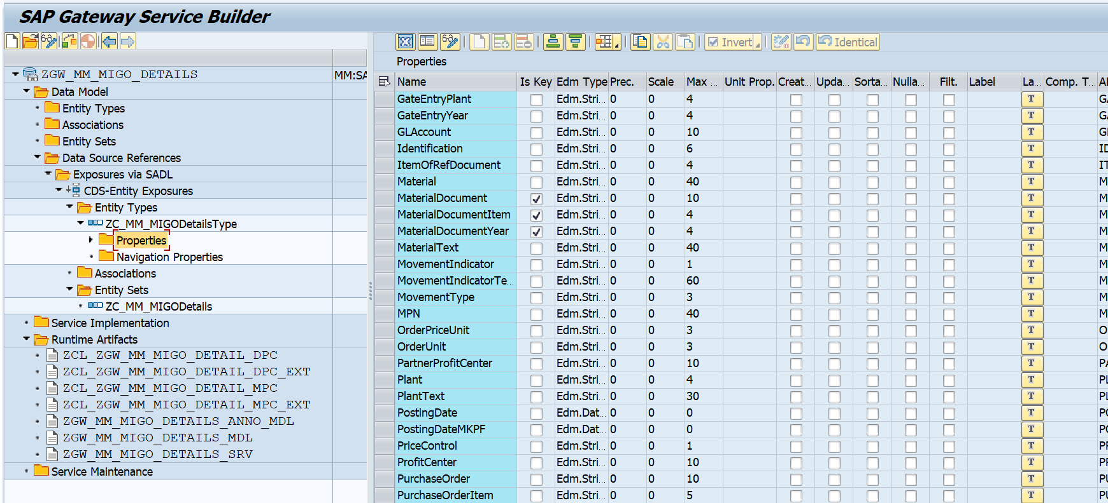**Entity Sets:** ZC_MM_MIGODetails

**4.Business API / OData API and Output Screen**

**Case 1: Based on Posting Date**

**Field Name in Entity Type:** PostingDate

* ***Single Posting Date: 25.08.2025***

Gateway Client

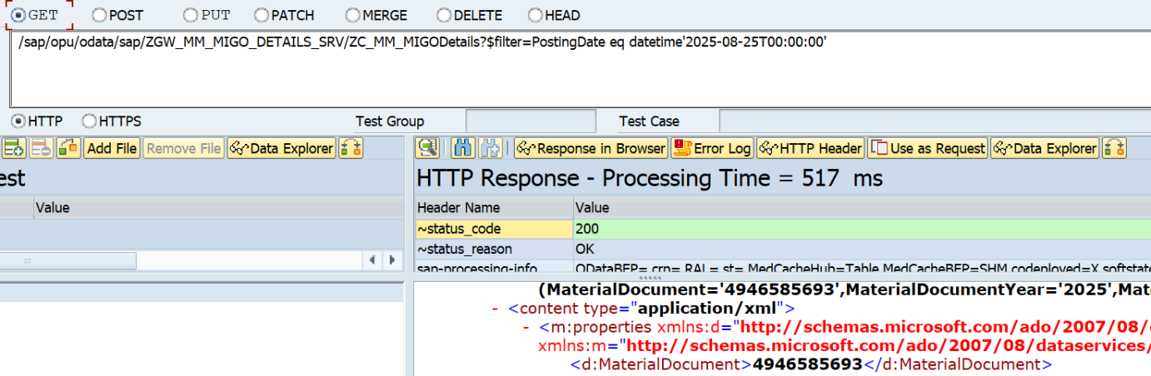 /sap/opu/odata/sap/ZGW_MM_MIGO_DETAILS_SRV/ZC_MM_MIGODetails?$filter=PostingDate eq datetime'2025-08-25T00:00:00'

Count the Number Of Record

/sap/opu/odata/sap/ZGW_MM_MIGO_DETAILS_SRV/ZC_MM_MIGODetails/$count?$filter=PostingDate eq datetime'2025-08-25T00:00:00'

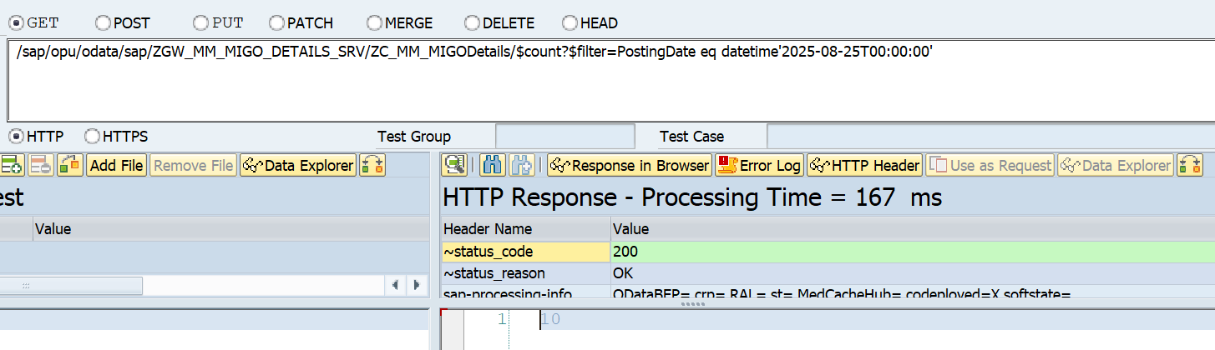

API for Postman:

http://mehdevpas.minda.com:8001/sap/opu/odata/sap/ZGW_MM_MIGO_DETAILS_SRV/ZC_MM_MIGODetails?$filter=PostingDate eq datetime'2025-08-25T00:00:00'

* ***Posting Date in Range: from 24.08.2024 to 27.08.2025***

Gateway Client

/sap/opu/odata/sap/ZGW_MM_MIGO_DETAILS_SRV/ZC_MM_MIGODetails?$filter=PostingDate ge datetime'2024-08-25T00:00:00' and PostingDate le datetime'2025-08-27T00:00:00'

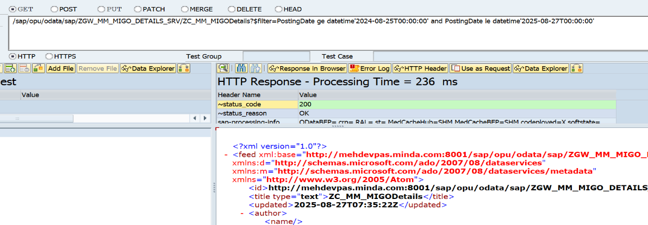

Count the Number Of records

/sap/opu/odata/sap/ZGW_MM_MIGO_DETAILS_SRV/ZC_MM_MIGODetails/$count?$filter=PostingDate ge datetime'2024-08-25T00:00:00' and PostingDate le datetime'2025-08-27T00:00:00'

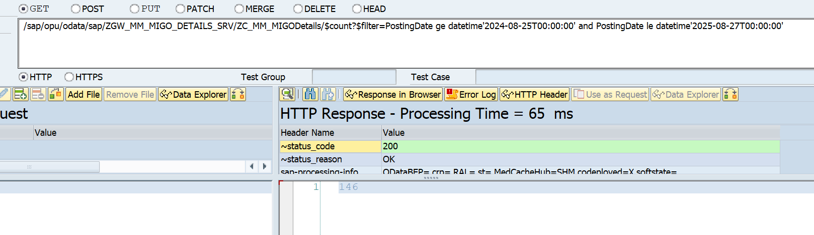

Postman API

http://mehdevpas.minda.com:8001/sap/opu/odata/sap/ZGW_MM_MIGO_DETAILS_SRV/ZC_MM_MIGODetails/?$filter=PostingDate ge datetime'2024-08-25T00:00:00' and PostingDate le datetime'2025-08-27T00:00:00'

**Case 2: Based on Movement Type**

**Field Name in Entity Type:** MovementType

* ***Single Movement Type: 101***

Gateway Client

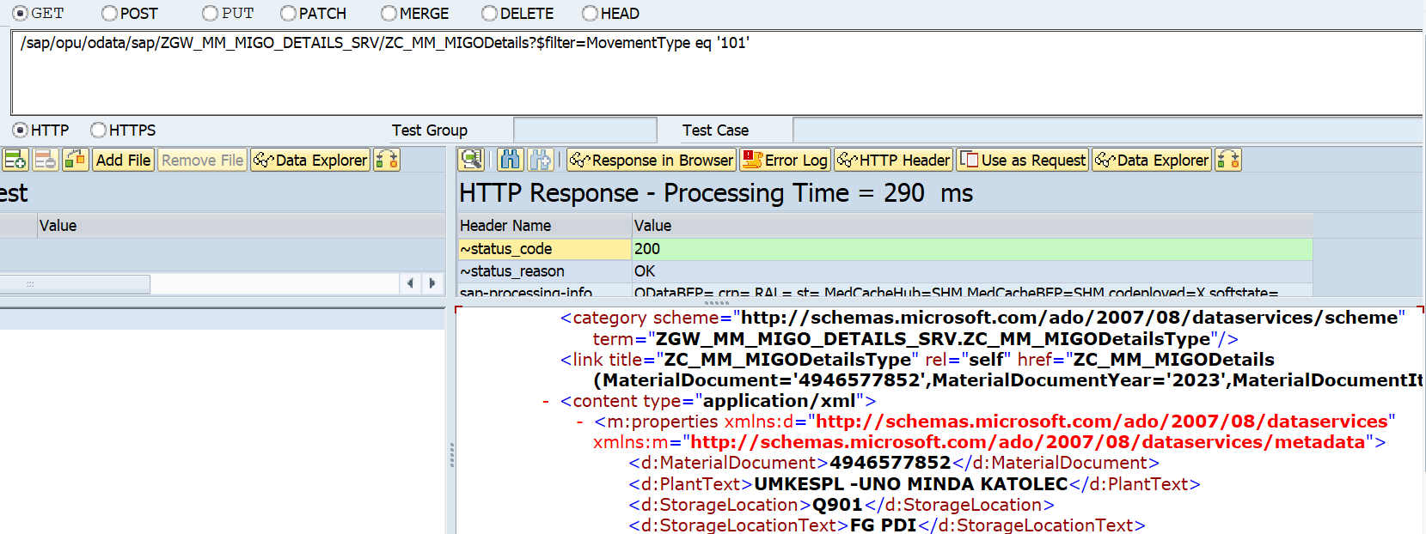/sap/opu/odata/sap/ZGW_MM_MIGO_DETAILS_SRV/ZC_MM_MIGODetails?$filter=MovementType eq '101'

Count the Number of Record

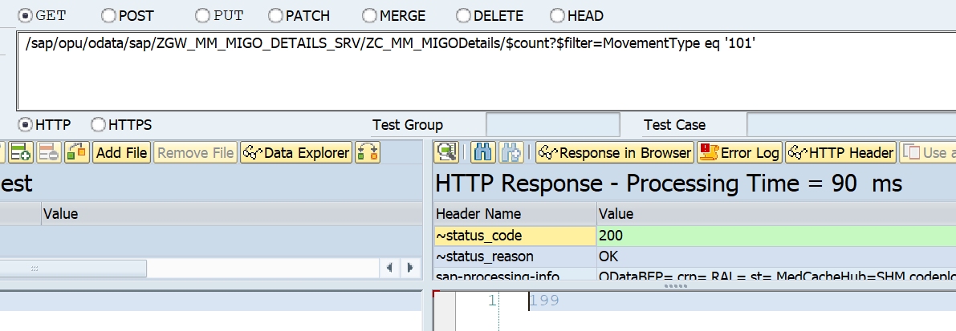/sap/opu/odata/sap/ZGW_MM_MIGO_DETAILS_SRV/ZC_MM_MIGODetails/$count?$filter=MovementType eq '101'

Postman API

http://mehdevpas.minda.com:8001/sap/opu/odata/sap/ZGW_MM_MIGO_DETAILS_SRV/ZC_MM_MIGODetails/?$filter=MovementType eq '101'

**Case 3: Based on Document Year**

Field Name in Entity Type: MaterialDocumentYear

Material Document Year: 2025

Gateway Client

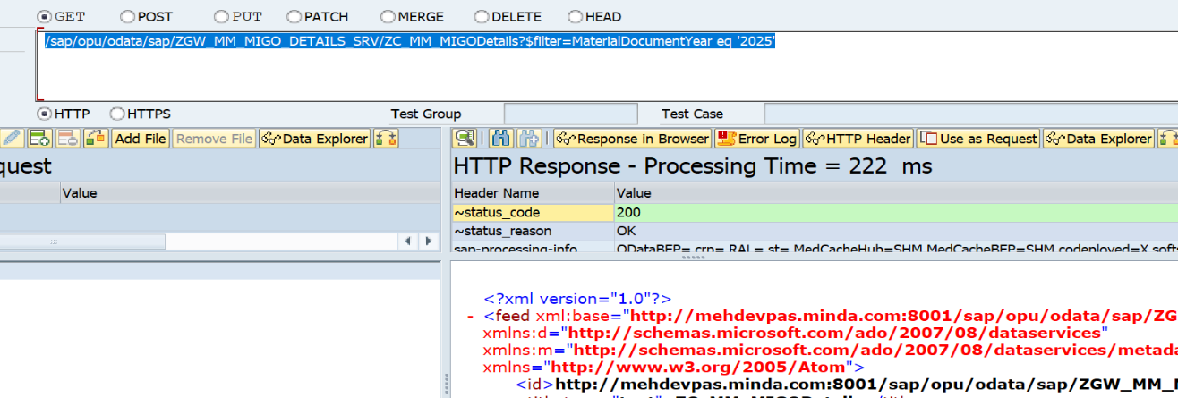/sap/opu/odata/sap/ZGW_MM_MIGO_DETAILS_SRV/ZC_MM_MIGODetails?$filter=MaterialDocumentYear eq '2025'

Count the Number Of records

/sap/opu/odata/sap/ZGW_MM_MIGO_DETAILS_SRV/ZC_MM_MIGODetails/$count?$filter=MaterialDocumentYear eq '2025'

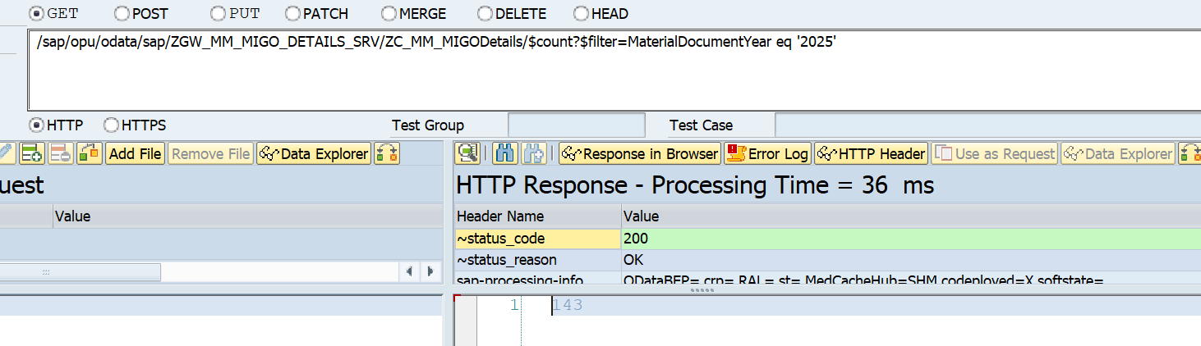

Postman API

http://mehdevpas.minda.com:8001/sap/opu/odata/sap/ZGW_MM_MIGO_DETAILS_SRV/ZC_MM_MIGODetails?$filter=MaterialDocumentYear eq '2025'

**Case 4: based on Posting Date, Movement Type and Document Year Combination**

* *Posting Date: 07.02.2024*
* *Movement Type: from 201 to 561*
* *Document Year: 2024*

Gateway Client

/sap/opu/odata/sap/ZGW_MM_MIGO_DETAILS_SRV/ZC_MM_MIGODetails/?$filter=PostingDate eq datetime'2024-02-07T00:00:00' and MovementType ge '201' and MovementType le '561' and MaterialDocumentYear eq '2024'

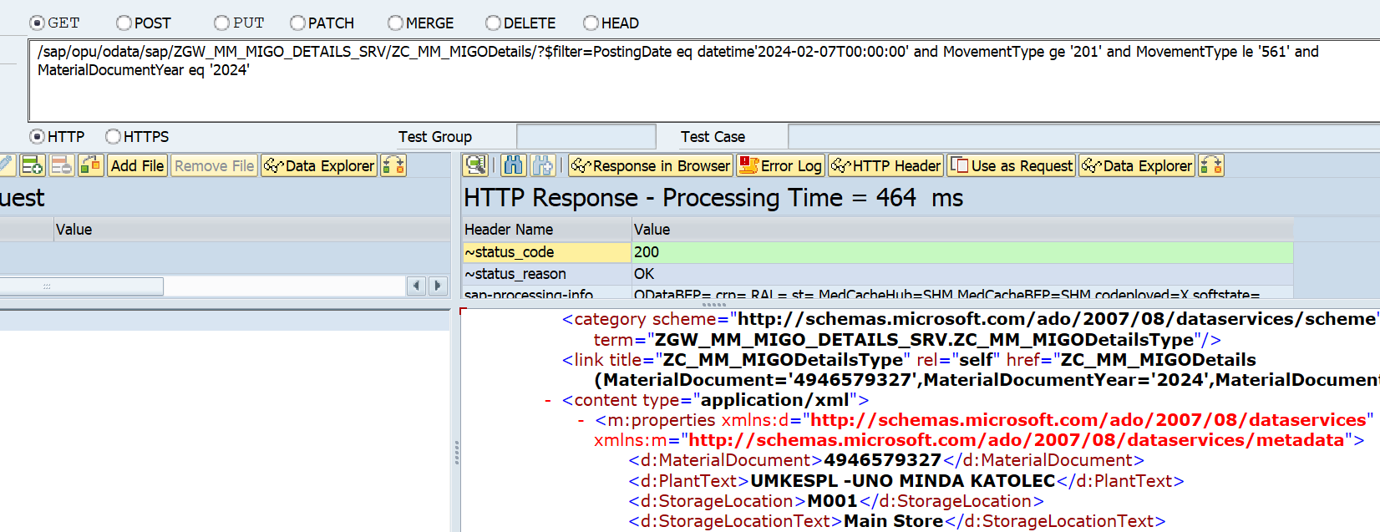

Count the Number of Records

/sap/opu/odata/sap/ZGW_MM_MIGO_DETAILS_SRV/ZC_MM_MIGODetails/$count?$filter=PostingDate eq datetime'2024-02-07T00:00:00' and MovementType ge '201' and MovementType le '561' and MaterialDocumentYear eq '2024'

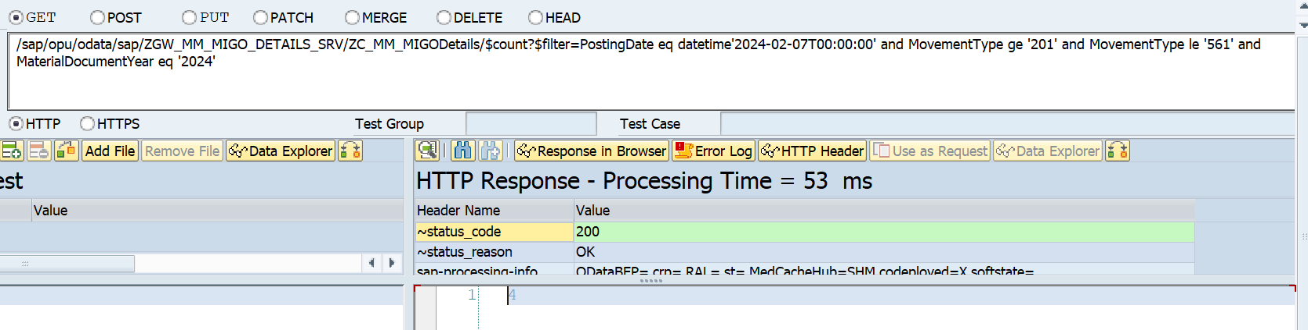

Postman Testing

http://mehdevpas.minda.com:8001/sap/opu/odata/sap/ZGW_MM_MIGO_DETAILS_SRV/ZC_MM_MIGODetails/?$filter=PostingDate eq datetime'2024-02-07T00:00:00' and MovementType ge '201' and MovementType le '561' and MaterialDocumentYear eq '2024'

* *Posting Date: from 01.08.2025 to 27.08.2025*
* *Movement Type: from 201 to 561*
* *Document Year: from 2024 to 2025*

Gateway Client

/sap/opu/odata/sap/ZGW_MM_MIGO_DETAILS_SRV/ZC_MM_MIGODetails?$filter=PostingDate ge datetime'2024-08-01T00:00:00' and PostingDate le datetime'2025-08-27T00:00:00' and MovementType ge '201' and MovementType le '561' and MaterialDocumentYear ge '2024' and MaterialDocumentYear le '2025'

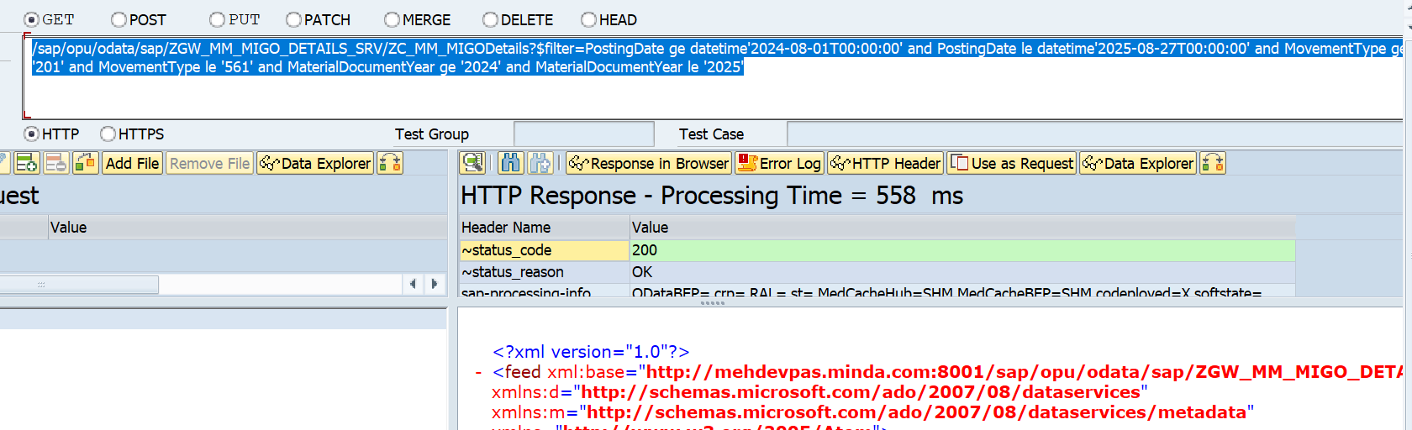

Count Number Of Record

/sap/opu/odata/sap/ZGW_MM_MIGO_DETAILS_SRV/ZC_MM_MIGODetails/$count?$filter=PostingDate ge datetime'2024-08-01T00:00:00' and PostingDate le datetime'2025-08-27T00:00:00' and MovementType ge '201' and MovementType le '561' and MaterialDocumentYear ge '2024' and MaterialDocumentYear le '2025'

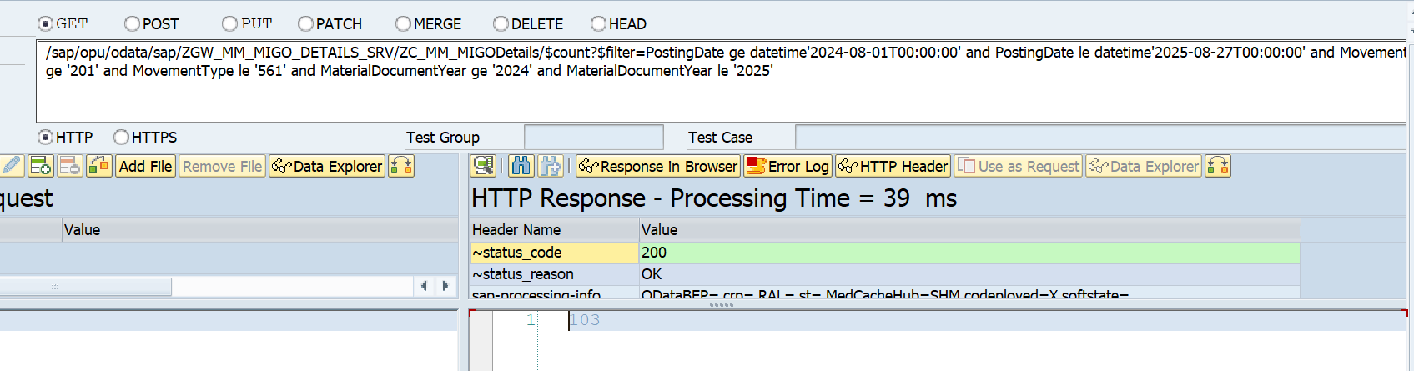

Postman Testing

http://mehdevpas.minda.com:8001/sap/opu/odata/sap/ZGW_MM_MIGO_DETAILS_SRV/ZC_MM_MIGODetails/$count?$filter=PostingDate ge datetime'2024-08-01T00:00:00' and PostingDate le datetime'2025-08-27T00:00:00' and MovementType ge '201' and MovementType le '561' and MaterialDocumentYear ge '2024' and MaterialDocumentYear le '2025'