Technical Specification Form

PROJECT: SAP TRANSFER POSTING

SAP Technical Specification Form

|  |  |  |  |
| --- | --- | --- | --- |
| User Story ID # | 9000RUPESH | Module | PP |
| Date | 17-07-2025 | SL User |  |
| Consultant |  | Developer | Debidutta swain |
| Priority | ☐Urgent ☐High ☒Medium ☐Low | | |
| Application Type | ☐Report ☐Form ☐Interface ☒ODATA ☐Others | | |
| Execute Model | ☐Batch ☐ Foreground ☐Manual ☐Quarterly ☐Monthly  ☐Weekly ☐ Daily ☒Real time | | |
| Output Type | ☐Message ☐Dialog Screen ☐ABAP List ☒List View ☐ALV Grid | | |
| Remarks | SAP TRANSFER POSTING | | |

**Technical specification content**

1. Business Requirement
2. Development Tools
3. Development Objects

* Function Module
* DDIC Structure
* SEGW – OData Project.

1. Business API / OData API with Payload
2. Positive and Negative Testing Screenshot
3. **Business Requirement:**

Develop an OData POST API to perform Transfer posting from one storage location to another storage location from Outside SAP Environment .

**FS Details**

**Run the BAPI: BAPI_GOODSMVT_CREATE**

**GOODSMVT_HEADER = PSTNG_DATE = “System date”**

**DOC_DATE= “System Date”**

**GOODSMVT_CODE = “04”**

**Tables:**

**GOODSMVT_ITEM:**

**MATERIAL = "MATNR "**

**PLANT = "WERKS"**

**STGE_LOC = " Fetch Issue storage location"**

**BATCH = " CHARG "**

**MOVE_TYPE = "Constant= 311"**

**ENTRY_QNT = " Fetch Transfer stock QTY "**

**ENTRY_UOM = " Fetch Transfer stock UOM "**

**MOVE_MAT = " MATNR "**

**MOVE_PLANT = "WERKS"**

**MOVE_STLOC = " Fetch Receiving location"**

**IN CASE OF REVERSAL**

**STGE_LOC = " Fetch Receiving location"**

**MOVE_STLOC = " Fetch Issue storage location "**

**2.Development Tools :**

For development these are the following tool used :

* **OData Project**
* Created OData project with SEGW Tcode. Here I have used IMPORT from **DDIC structure** for Data modeling and Redefine the Create Entities Method to Achieve our Business Requirement .
* For Service Registration used Tcode : /O/IWFND/MAINT_SERVICE.
* To Check the final data at Gateway Client used Tcode :/O/IWFND/GW_CLIENT.

**3.Development Objects :**

* **Function Module:**

BAPI Name: BAPI_GOODSMVT_CREATE

Description : Post Goods Movements with MB_CREATE_GOODS_MOVEMENT

* **DDIC Structure:**

**Header**

Structure Name: ZPP_GOODSMVT_HEADER_ST  
Description: Structure: Material Document Header Data

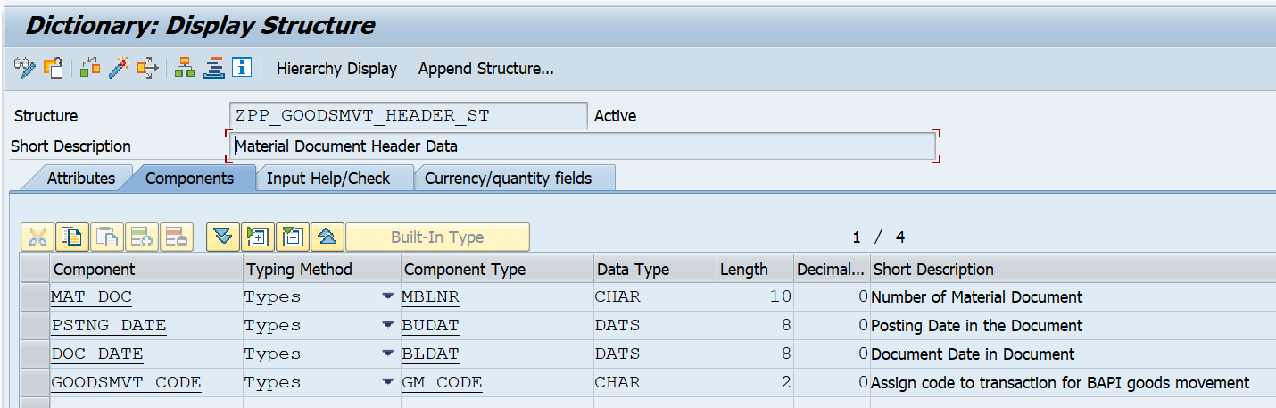

**Item**

Structure Name: ZPP_GOODSMVT_ITEM_ST  
Description: Structure: Material Document Item Data

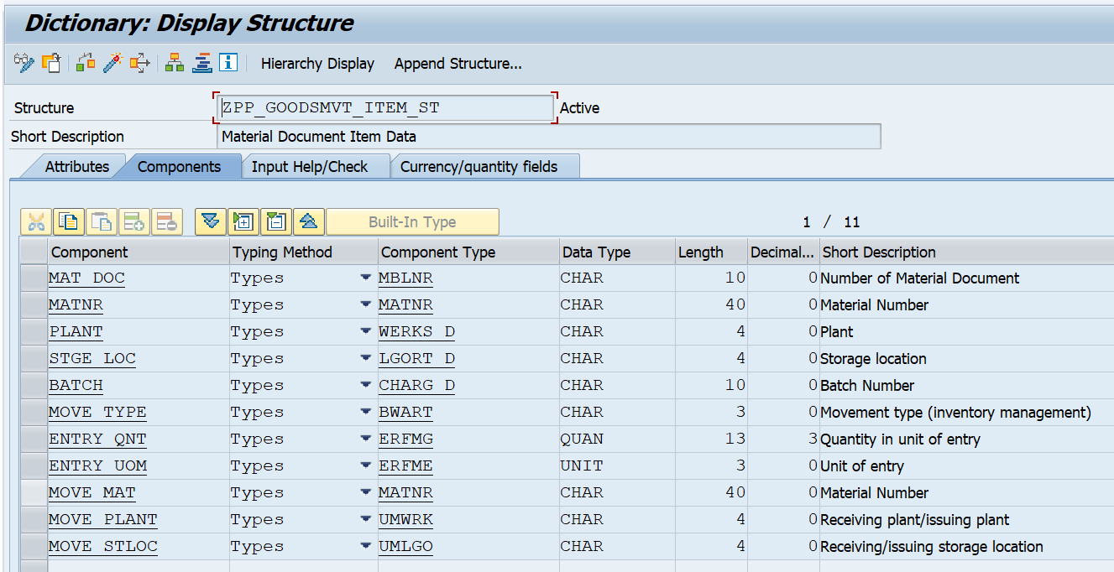

* **SEGW – OData Project:**

**Project Name:** ZGW_PP_PRDC_ORD_TRANS_POSTING

**Service Name:** ZGW_PP_PRDC_ORD_TRANS_POSTING_SRV

**Entities Type:**

* Goodsmvt_header
* Goodsmvt_item

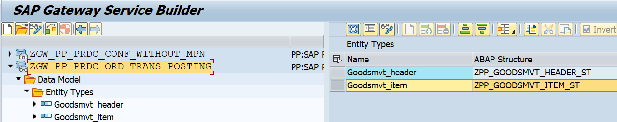

**Entity sets:**

* Goodsmvt_headerSet
* Goodsmvt_itemSet

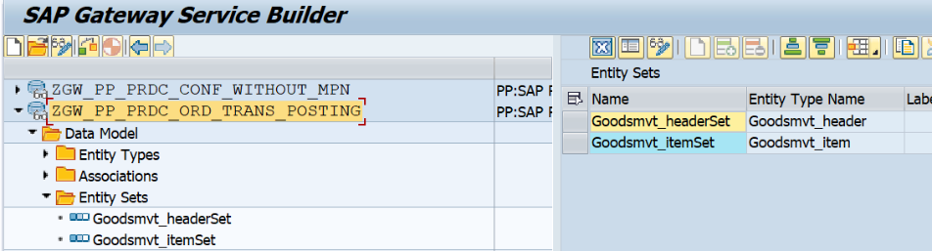

**Association:**

Basically Association is done in ODATA to create the relationship in between header and item Entity .

For more idea about how to create association please [click here](https://saplearners.com/association-and-navigation-in-sap-netweaver-gateway/) and check the step from 1 to 5.

Association Name: HeaderToItem

Referential Constraints : MatDoc

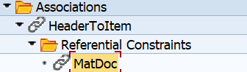Referential Constraints means based on Which Relation is Established in between Header and Item Entity Set.

**Association set:**

Name: HeaderToItemSet

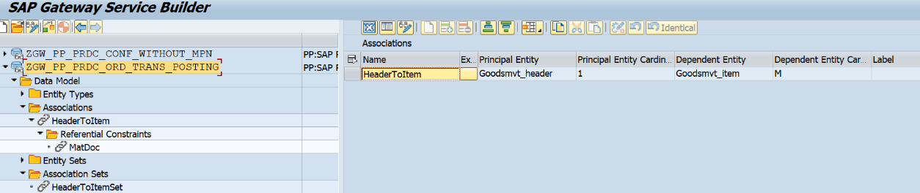

**Navigation Properties:**

When we do Parent child relation in SEGW Odata project, one Navigation property also got created at the time of Create Association and this navigation property will help us to:

* navigate from Header details to Item details at the time of GET operation
* Carries item details with header details at the time of POST operation.

Also, it is needed at the time of deep entity modeling at MPC_EXT Class, otherwise it will not Carrey the item detail from outside sap system. Always navigation Property comes under Header Entity after successfully creation of Association.

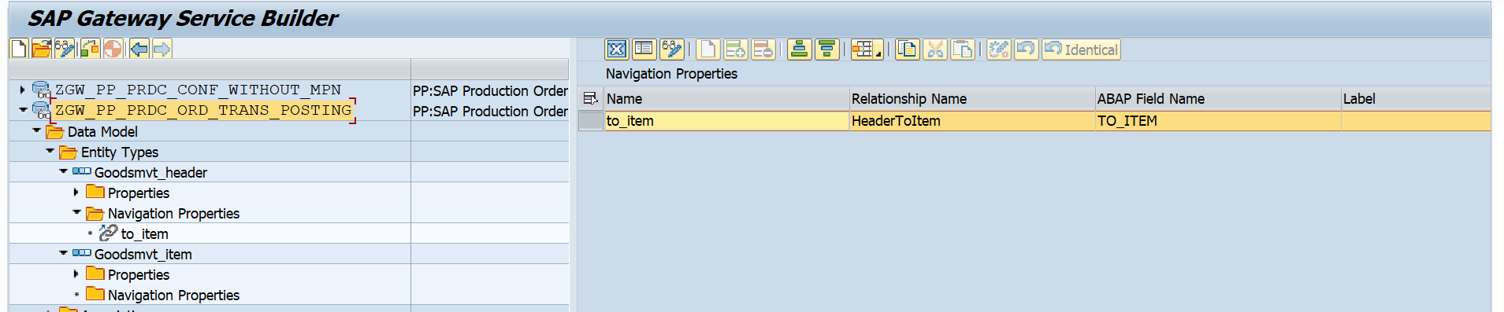

**Runtime Artifacts**

Here 6 Runtime Artifices to created after Generating the Project.

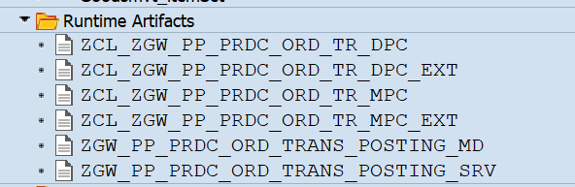

Here the operation can be handled through “CREATE_DEEP_ENTITY”. so, for that I had followed the following steps:

**step: 1**

* Go to Runtime Artifacts node, open the ZCL_ZGW_PP_PRDC_ORD_TR_MPC_EXT class in **ABAP Workbench** & click on the **Types** tab.
* Click on Change button for edit.
* Click on the **Direct Type Entity** Button. Then create deep entity & activate.

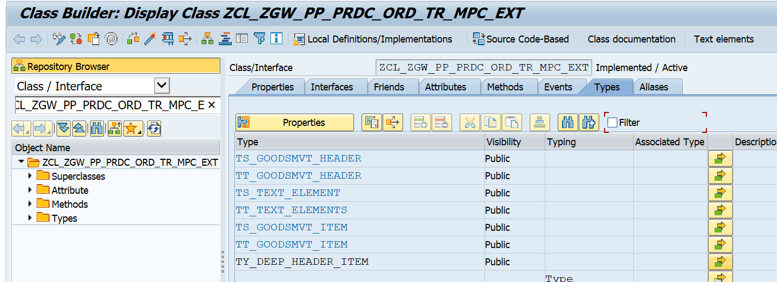

**Business Logic for Type declaration in MPC_EXT.**

class ZCL_ZGW_PP_PRDC_ORD_TR_MPC_EXT definition  
  public  
  inheriting from ZCL_ZGW_PP_PRDC_ORD_TR_MPC  
  create public .  
  
public section.  
  
  types:  
   BEGIN OF TY_DEEP_HEADER_ITEM ,  
    MAT_DOC       Type  MBLNR,  
    PSTNG_DATE    Type  BUDAT,  
    DOC_DATE      Type  BLDAT,  
    GOODSMVT_CODE Type  GM_CODE,  
*\*   Navigation property name should be used otherwise empty records will be shown In all API operations*  
    to_item       TYPE  TABLE OF TS_GOODSMVT_ITEM WITH DEFAULT KEY,  
   END OF TY_DEEP_HEADER_ITEM .  
  
  methods DEFINE  
    redefinition .

**Step: 2**

**Redefine** the **DEFINE** method of the ZCL_ZGW_PP_PRDC_ORD_TR_MPC_EXT and Enter the below code.

**Business Logic Under Define Method.**

method DEFINE.  
    SUPER->DEFINE( ).  
    DATA:lo_entity_type  TYPE REF TO /iwbep/if_mgw_odata_entity_typ.  
  
    LO_ENTITY_TYPE = MODEL->GET_ENTITY_TYPE( IV_ENTITY_NAME = 'Goodsmvt_header' ).  
    LO_ENTITY_TYPE->BIND_STRUCTURE(  
      exporting  
        IV_STRUCTURE_NAME   = 'ZCL_ZGW_PP_PRDC_ORD_TR_MPC_EXT=>TY_DEEP_HEADER_ITEM' ).  
  endmethod.

**Step : 3**

Go to the **ZCL_ZGW_PP_PRDC_ORD_TR_DPC_EXT** class & redefine the method:  **CREATE_DEEP_ENTIT**y.

**Business Logic CREATE_DEEP_ENTITY method.**

method /IWBEP/IF_MGW_APPL_SRV_RUNTIME~CREATE_DEEP_ENTITY.  
  
IF IV_ENTITY_SET_NAME = 'Goodsmvt_headerSet'.  
*"--> Constant Declaration.*  
CONSTANTS: LC_GM_CODE   TYPE GM_CODE VALUE '04',  
           LC_MOVE_TYPE TYPE BWART   VALUE '311'.  
  
*"--> Data Object Declaration.*  
DATA: LS_DEEP_ENTITY TYPE ZCL_ZGW_PP_PRDC_ORD_TR_MPC_EXT=>TY_DEEP_HEADER_ITEM,  
      ls_header      TYPE ZPP_GOODSMVT_HEADER_ST,  
      lt_item        TYPE TABLE OF ZCL_ZGW_PP_PRDC_ORD_TR_MPC_EXT=>TS_GOODSMVT_ITEM.  
  
DATA:LS_GOODSMVT_HEADER  TYPE BAPI2017_GM_HEAD_01,  
     LS_GOODSMVT_CODE    TYPE BAPI2017_GM_CODE,  
     LS_GOODSMVT_ITEM    TYPE BAPI2017_GM_ITEM_CREATE,  
     LT_GOODSMVT_ITEM    TYPE TABLE OF BAPI2017_GM_ITEM_CREATE,  
     LS_RETURN           TYPE BAPIRET2,  
     LT_RETURN           TYPE TABLE OF BAPIRET2,  
     LS_GOODSMVT_HEADRET TYPE BAPI2017_GM_HEAD_RET,  
     LV_MATERIALDOCUMENT TYPE BAPI2017_GM_HEAD_RET-MAT_DOC,  
     LV_MATDOCUMENTYEAR  TYPE BAPI2017_GM_HEAD_RET-DOC_YEAR.  
  
DATA: lo_message         TYPE REF TO /iwbep/if_message_container,  
      LV_MESSAGE TYPE BAPI_MSG.  
  
*"--> Get the Requested Payload Details.*  
 CLEAR:LS_GOODSMVT_HEADER,LS_GOODSMVT_CODE,LS_GOODSMVT_ITEM,LS_DEEP_ENTITY,LS_HEADER,LS_RETURN,  
       LS_GOODSMVT_HEADRET,LV_MATERIALDOCUMENT,LV_MATDOCUMENTYEAR,LV_MESSAGE,lo_message.  
 REFRESH:LT_GOODSMVT_ITEM,LT_ITEM,LT_RETURN.  
  
 *"--> Prepare the Response message object.*  
  LO_MESSAGE = MO_CONTEXT->GET_MESSAGE_CONTAINER( ).  
  
  TRY.  
   IO_DATA_PROVIDER->READ_ENTRY_DATA(  
    importing  
     ES_DATA = LS_DEEP_ENTITY  
     ).  
    catch /IWBEP/CX_MGW_TECH_EXCEPTION. *" Technical Exception*  
 ENDTRY.  
  
 IF LS_DEEP_ENTITY is NOT INITIAL.  
  LS_HEADER = CORRESPONDING #( LS_DEEP_ENTITY ).  
  lt_item   = LS_DEEP_ENTITY-TO_ITEM.  
 ENDIF.  
  
 *"--> Preparing data for BAPI .*  
 IF LS_HEADER IS NOT INITIAL.  
   LS_GOODSMVT_HEADER-PSTNG_DATE = LS_HEADER-PSTNG_DATE.  
   LS_GOODSMVT_HEADER-DOC_DATE   = LS_HEADER-DOC_DATE.  
   LS_GOODSMVT_CODE-GM_CODE      = LC_GM_CODE.  
  
   IF LT_ITEM IS NOT INITIAL.  
     LOOP AT LT_ITEM INTO DATA(LS_ITEM).  
  
       LS_GOODSMVT_ITEM = CORRESPONDING #( LS_ITEM ).  
       LS_GOODSMVT_ITEM-MOVE_TYPE = LC_MOVE_TYPE.  
       LS_GOODSMVT_ITEM-MATERIAL  = LS_ITEM-MATNR.  
  
       APPEND LS_GOODSMVT_ITEM TO LT_GOODSMVT_ITEM.  
       CLEAR: LS_GOODSMVT_ITEM,LS_ITEM.  
     ENDLOOP.  
   ENDIF.  
 ENDIF.  
  
 *"-->Passing Data to BAPI for create record in sap System.*  
  CALL FUNCTION 'BAPI_GOODSMVT_CREATE'  
    EXPORTING  
      GOODSMVT_HEADER              = LS_GOODSMVT_HEADER  
      GOODSMVT_CODE                = LS_GOODSMVT_CODE  
    IMPORTING  
     GOODSMVT_HEADRET              = LS_GOODSMVT_HEADRET  
     MATERIALDOCUMENT              = LV_MATERIALDOCUMENT  
     MATDOCUMENTYEAR               = LV_MATDOCUMENTYEAR  
    TABLES  
      GOODSMVT_ITEM                = LT_GOODSMVT_ITEM  
      RETURN                       = LT_RETURN  
       .  
  
  IF LS_GOODSMVT_HEADRET IS NOT INITIAL.  
     CALL FUNCTION 'BAPI_TRANSACTION_COMMIT'  
      EXPORTING  
        WAIT          = ABAP_TRUE  
      IMPORTING  
        RETURN        = LS_RETURN  
        .  
    IF LS_RETURN IS INITIAL.  
      *"--> Creted Material document number obly added in the Header Entity.*  
      LS_DEEP_ENTITY-MAT_DOC = LV_MATERIALDOCUMENT.  
      LOOP AT  LS_DEEP_ENTITY-TO_ITEM ASSIGNING FIELD-SYMBOL(<FS_DATA>).  
        <FS_DATA>-MAT_DOC = LV_MATERIALDOCUMENT.  
      ENDLOOP.  
  
      COPY_DATA_TO_REF(  
        exporting  
          IS_DATA = LS_DEEP_ENTITY  
        changing  
          CR_DATA = ER_DEEP_ENTITY  
      ).  
  
     LV_MESSAGE = |Material Document '{ LV_MATERIALDOCUMENT }' Cretaed Successfully.|.  
     LO_MESSAGE->ADD_MESSAGE_TEXT_ONLY(  
           exporting  
             IV_MSG_TYPE               =   /iwbep/cl_cos_logger=>SUCCESS         *" Message Type*  
             IV_MSG_TEXT               =   LV_MESSAGE                            *" MESSAGE TEXT*  
             IV_ADD_TO_RESPONSE_HEADER =   ABAP_TRUE                             *" Add the message to the header*  
         ).  
    ENDIF.  
  else.  
    IF LT_RETURN IS NOT INITIAL.  
      lo_message->add_messages_from_bapi(  
          EXPORTING  
           it_bapi_messages          = LT_RETURN  
           ).  
         RAISE EXCEPTION TYPE /iwbep/cx_mgw_busi_exception  
         EXPORTING  
          textid            = /iwbep/cx_mgw_busi_exception=>BUSINESS_ERROR  
          message_container = lo_message.  
    ENDIF.  
  ENDIF.  
ENDIF.  
endmethod.

4.Business API / OData API with Payload

API: /sap/opu/odata/sap/ZGW_PP_PRDC_ORD_TRANS_POSTING_SRV/Goodsmvt_headerSet

**Payload:**

{

"MatDoc": "",

"PstngDate": "\/Date(1752537600000)\/",

"DocDate": "\/Date(1752537600000)\/",

"GoodsmvtCode": "04",

"to_item":{

"results" : [

{

"MatDoc": "",

"Matnr": "0001-0002SW-A01Y",

"Plant": "1001",

"StgeLoc": "A001",

"Batch": "0013671547",

"MoveType": "311",

"EntryQnt": "1",

"EntryUom": "NO",

"MoveMat": "0001-0002SW-A01Y",

"MovePlant": "1001",

"MoveStloc": "M011"

},

{

"MatDoc": "",

"Matnr": "0001-0002SW-A022Y",

"Plant": "1001",

"StgeLoc": "A001",

"Batch": "0013671546",

"MoveType": "311",

"EntryQnt": "1",

"EntryUom": "PAC",

"MoveMat": "0001-0002SW-A022Y",

"MovePlant": "1001",

"MoveStloc": "M011"

}

]

}

}

**5.Positive and Negative Testing Screenshot :**

**Positive Testing Screen:**

Before Transfer Posting the material (Mentioned in Payload) quantity at **MB52 Tcode.**



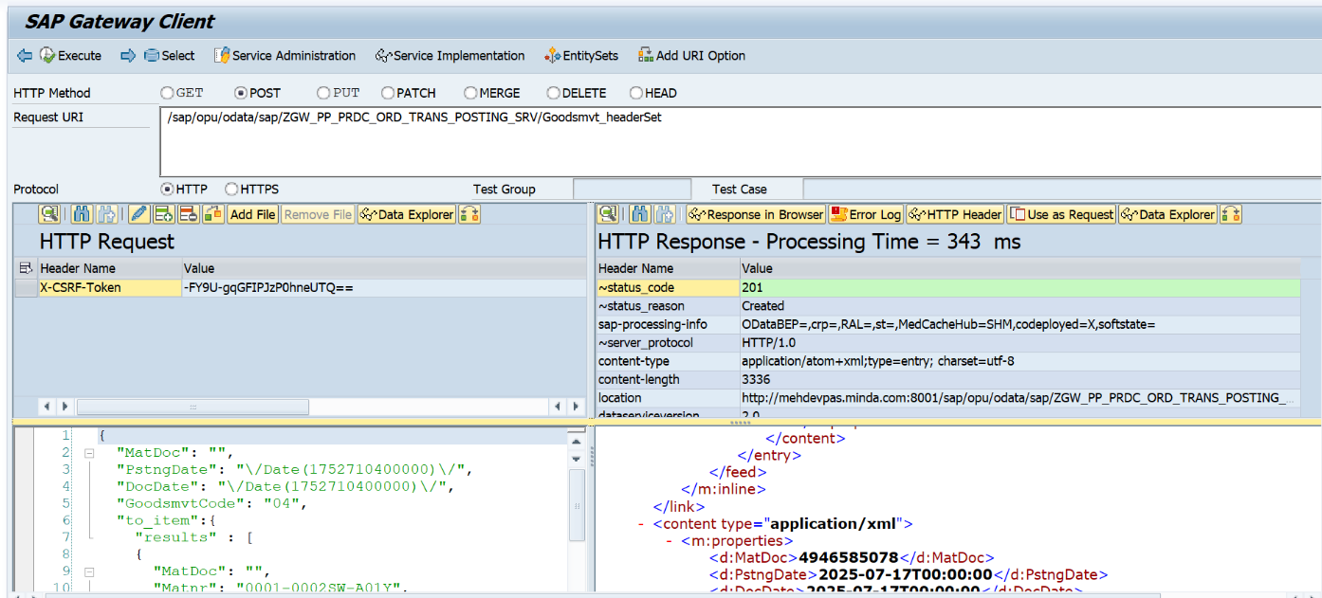Transfer posting Request :

After Transfer Posting , the material (Mentioned in Payload) quantity at **MB52 Tcode.**

Here Only 1 quantity transferred from each Material.



Success message from backend in Header Response With Created Material Document Number.

Message: Material Document '4946585080' Cretaed Successfully.

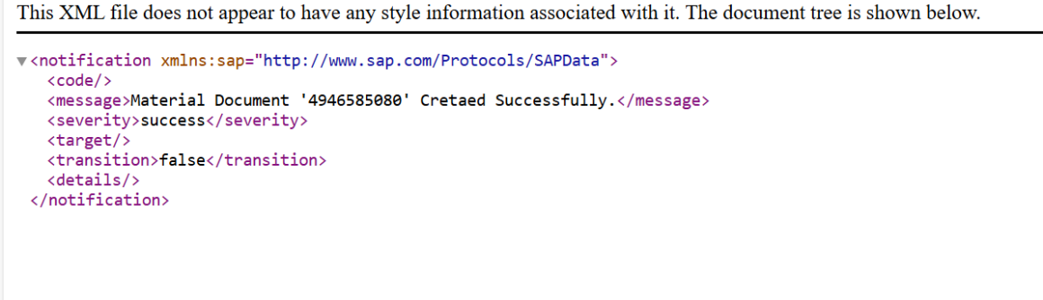

Checking Also at Database level:

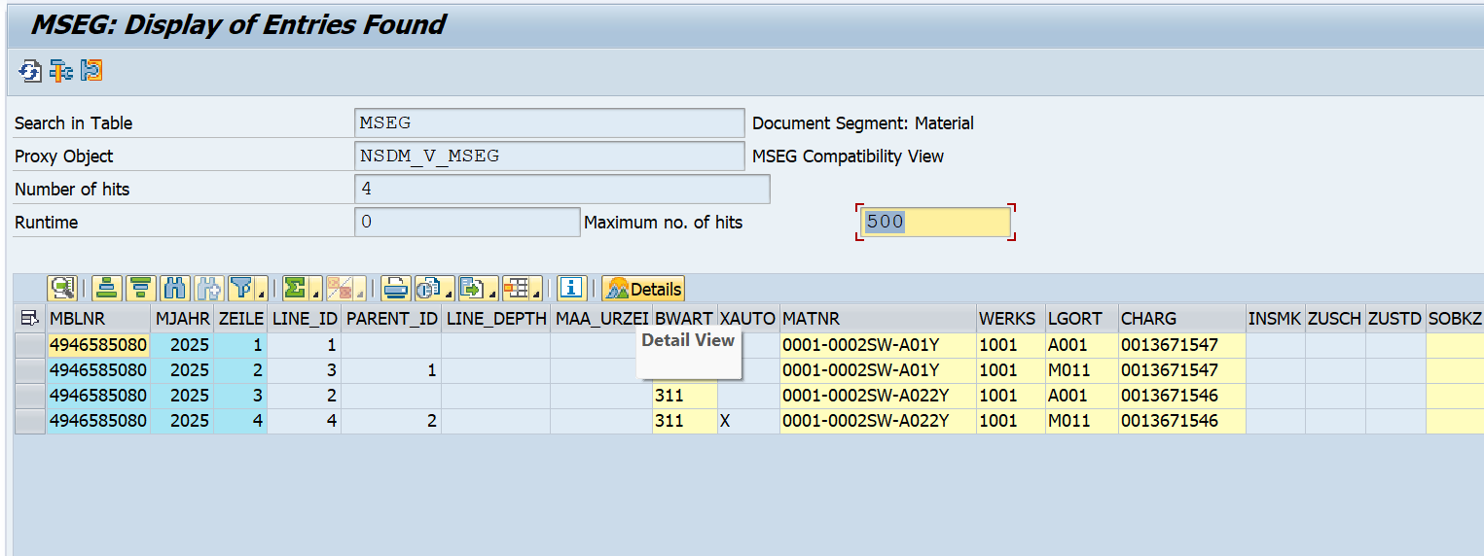

**Negative Testing Screen.**

**CASE 1:**

If you trying to transfer material’s quantity which is grater the available quantity.

EX: material: 0003-038LH-S01

Plant : 1001

Storage Loc.: A001

Batch: 0013646112

Available Unrestricted Stuck : 5

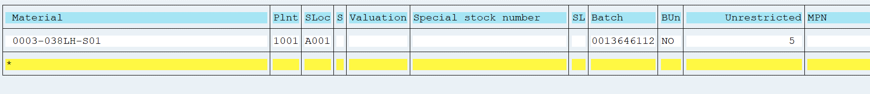

But here user if try to post a request of Grater then 5 (here I entered 7) ,then following error will through:

**Error** : M7/021 :Deficit of BA Unrestricted-use 2 NO : 0003-038LH-S01 1001 A001 0013646112.  
note : if such kind of error came that means, entered struck transfer quantity is grater then available quantity.

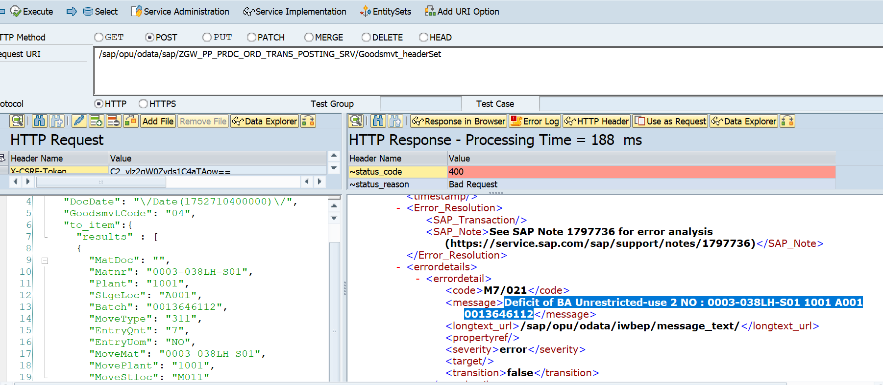

**Case 2**

If some one entered wrong material Number.

Error : M3/351 : Material <Material Code> not maintained in plant 1001

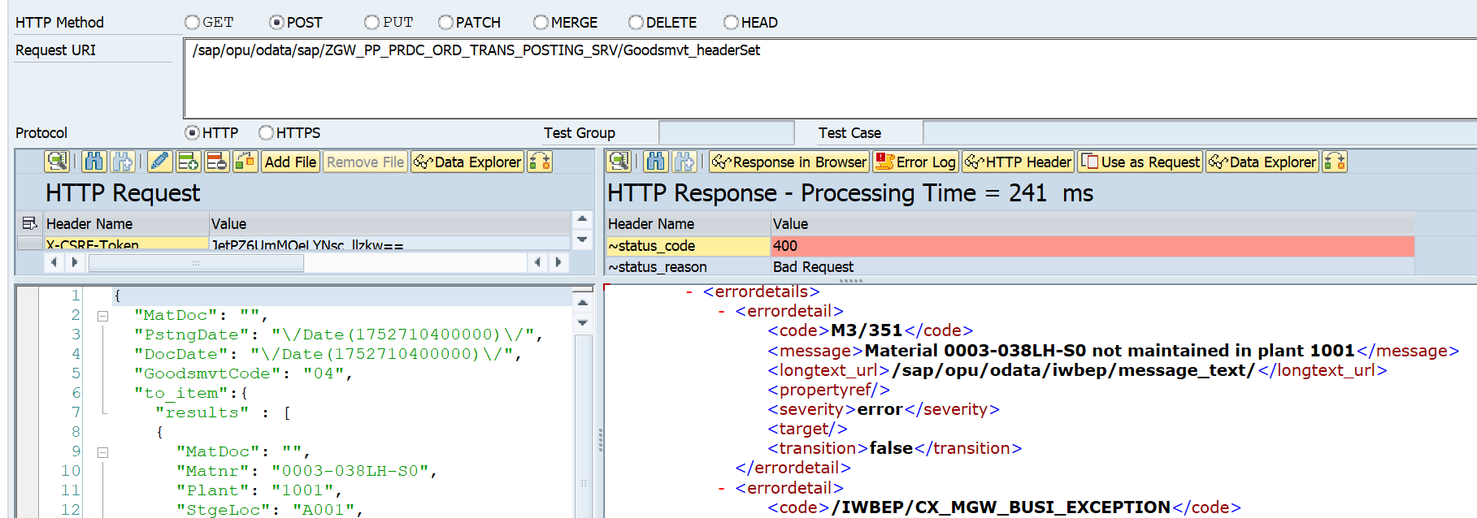

**Case 3**

If Wrong Batch Number entered .

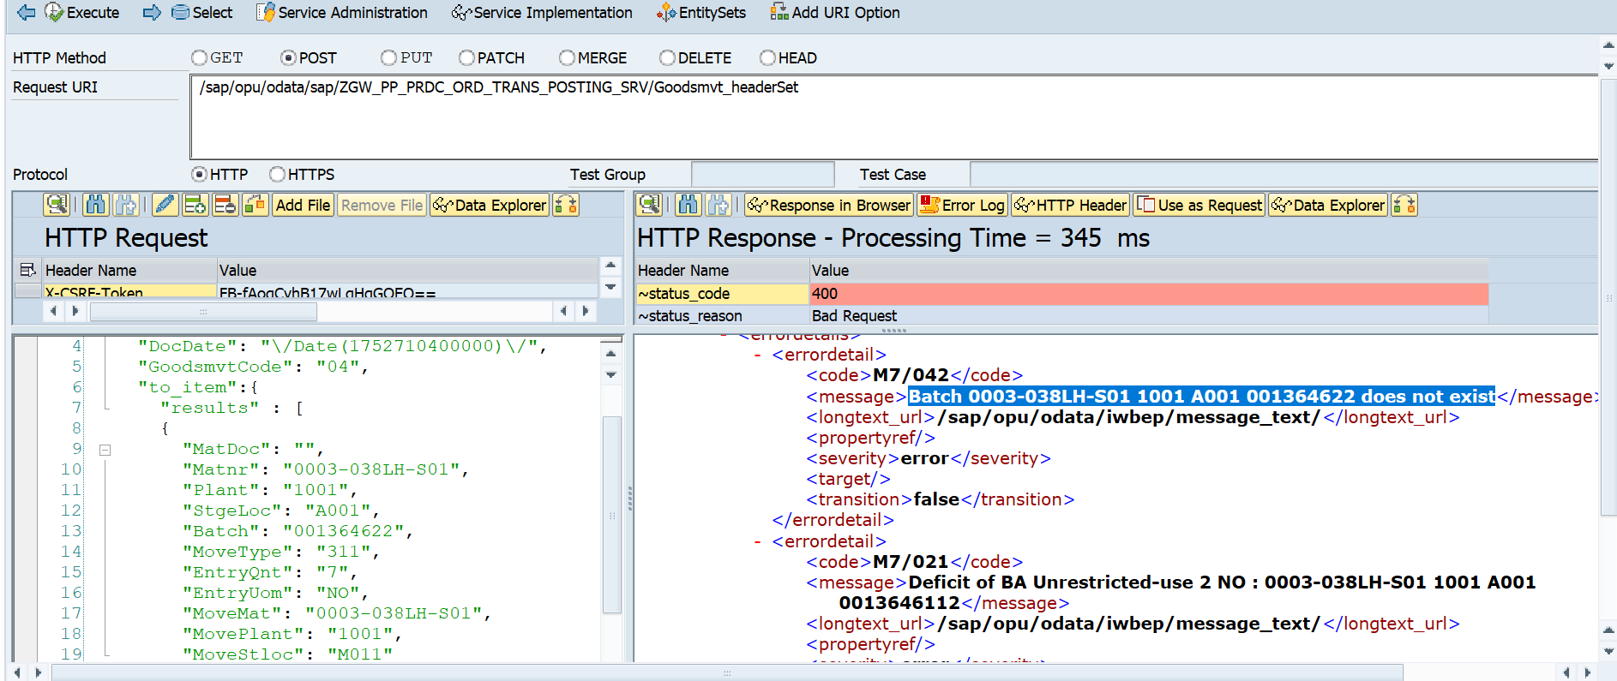Error: M7/042 : Batch 0003-038LH-S01 1001 A001 001364622 does not exist

**Note :** like above, if any wrong data trying to pass, BAPI will handle those errors and BAPI error will raise as Business Exceptions in the Response body , even if you maintained 10 line item and error found in one line item then BAPI will not perform transfer posting other remaining correct data.

**Case 4**

If you are trying to do transfer posting to an unauthorized Plant.

Here I have used a SAP user That is “CAPPUSER3”, who only have the authorization of 3001 Plant, but here I am trying to do Transfer posting to Plant 1001, so in this case bellow error will arise with the first unauthorized plant if system encounter.  
  
if you see such kind of issue then pass the authorized plant in the item level.  
  
Error:M7/120: You have no authorization for this transaction in plant<Plant code>.

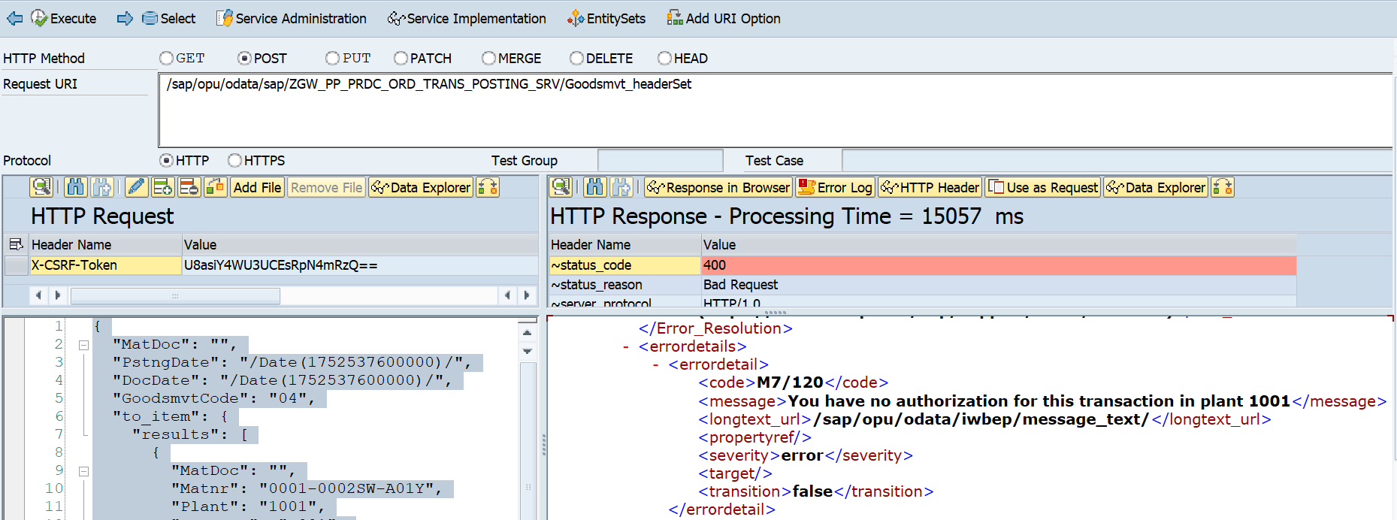

Postman

