Technical Specification Form

SAP PRODUCTION GOODS ISSUE

Prepared By: Debidutta Swain (AIRDIT Software Solutions)

**Technical specification content**

1. Business Requirement
2. Development Tools
3. Development Objects

* DDIC Structure
* SEGW – OData Project.

1. Business API / OData API and Output Screen
2. **Business Requirement:**

Develop an OData POST API for Production Goods Issue, through which Business user can Perform the Goods issue against Production Order from External SAP application.

Business Logic mentioned in FS.  
**ORDERID : this field used in case of production order transfer posting**

**Run the BAPI: BAPI_GOODSMVT_CREATE**

**GOODSMVT_HEADER = PSTNG_DATE = “System date”**

**DOC_DATE= “System Date”**

**GOODSMVT_CODE = “03”**

**Tables:**

**GOODSMVT_ITEM:**

**MATERIAL = "MATNR "**

**PLANT = "WERKS"**

**STGE_LOC = " Fetch Issue storage location"**

**BATCH = " CHARG "**

**MOVE_TYPE = "Constant= 261"**

**ENTRY_QNT = " Fetch Transfer stock QTY "**

**ENTRY_UOM = " Fetch Transfer stock UOM "**

**ORDERID = " PRODUCTION ORDER "**

**RESERV_NO = "RESERVATION NO"**

**RES_ITEM = " RESERVATION ITEM NO"**

**2.Development Tools :**

For development these are the following tool used :

* **OData Project**
* Created OData project with SEGW Tcode. Here I have used IMPORT from **DDIC structure** for Data modeling and Redefine the Creat Entity Method To Achieve our Business Requirement .
* For Service Registration used Tcode : /N/IWFND/MAINT_SERVICE.
* To Check the final data at Gateway Client used Tcode :/N/IWFND/GW_CLIENT.

**3.Development Objects :**

* **Function Module:**

BAPI Name: BAPI_GOODSMVT_CREATE

Description : Post Goods Movements with MB_CREATE_GOODS_MOVEMENT

* **DDIC Structure**

**Header**

Name: ZPP_GOODSISSUE_HEADER_ST

Description: Material Document Header Data for Goods Issue

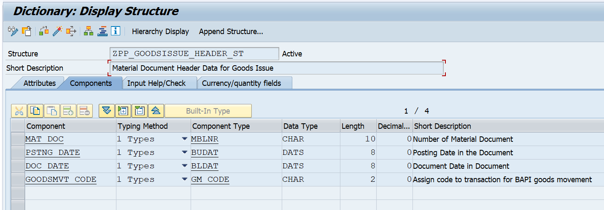

**Item**

Name: ZPP_GOODSISSUE_ITEM_ST

Description: Material Document Item Data for Goods Issue

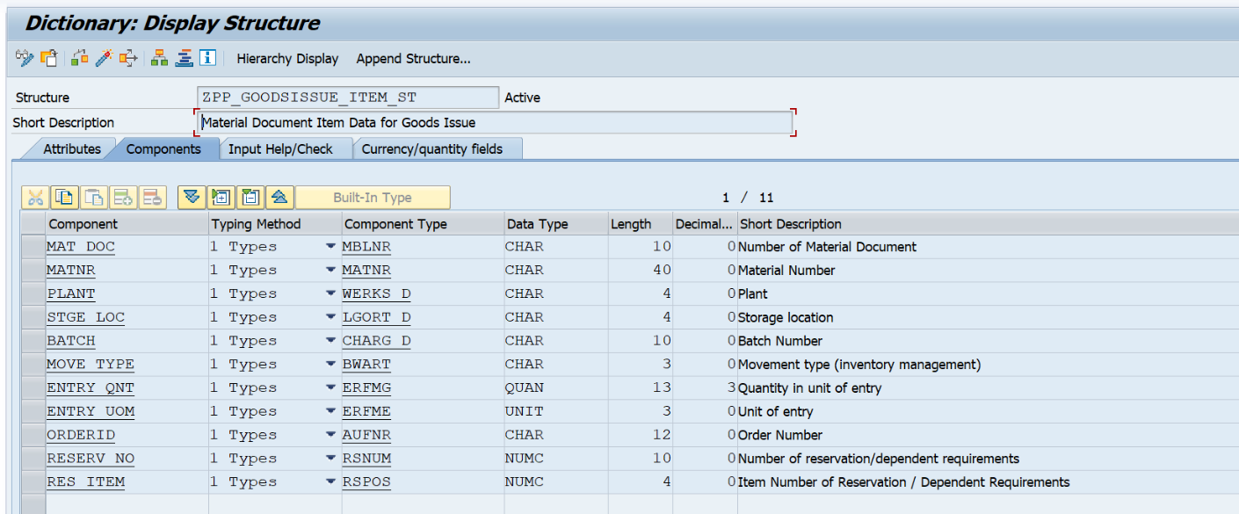

* **SEGW – OData Project:**

**Project Name:** ZGW_PP_PRODUCTION_GOODS_ISSUE

**Project Description:** PP: SAP Production Goods Issue

***Entity Type:***

Header: Goodsissue_header

Item: Goodsissue_item

***Entity Sets:***

Header: Goodsissue_headerSet

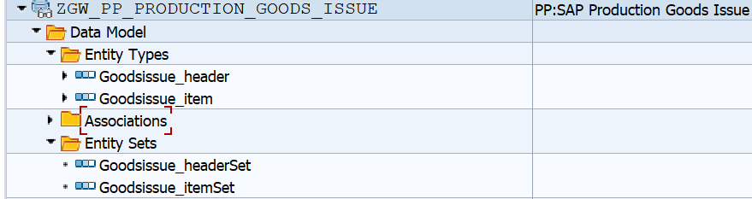Item: Goodsissue_itemSet

***Association:***

Basically Association is done in ODATA to create the relationship in between header and item Entity.

For more idea about how to create association please [click here](https://saplearners.com/association-and-navigation-in-sap-netweaver-gateway/) and check the step from 1 to 5.

Association Name: ***HeaderToItem***

Principal Entity: ***Goodsissue_header***

Dependent Entity: ***Goodsissue_item***

Navigation Property name: ***to_item***

Dependent Property: ***matdoc***

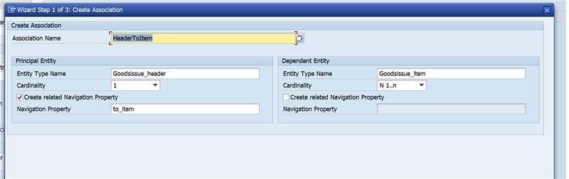

**Navigation Properties:**

When we do Parent child relation in SEGW Odata project, one Navigation property also got created at the time of Create Association and this navigation property will help us to:

* navigate from Header details to Item details at the time of GET operation
* Carries item details with header details at the time of POST operation.

Also, it is needed at the time of deep entity modeling at MPC_EXT Class, otherwise it will not Carrey the item detail from outside sap system. Always navigation Property comes under Header Entity after successfully creation of Association.

* **Runtime Artifacts**

Here 6 Runtime Artifices to created after Generating the Project.

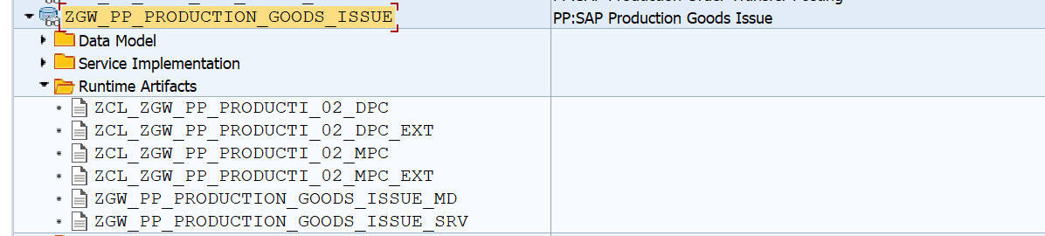

Here the operation can be handled through “CREATE_DEEP_ENTITY”. so, for that I had followed the following steps:

**step: 1**

* Go to Runtime Artifacts node, open the ZCL_ZGW_PP_PRODUCTI_02_MPC_EXT class in **ABAP Workbench** & click on the **Types** tab.
* Click on Change button for edit.
* Click on the **Direct Type Entity** Button. Then create deep entity & activate.

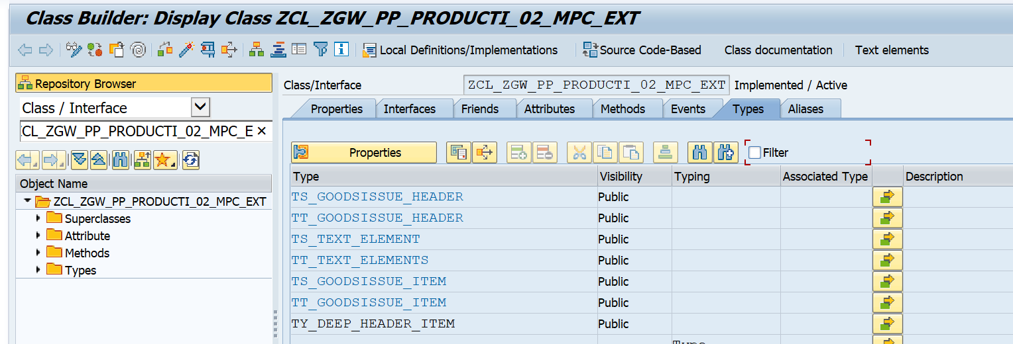

**Business Logic for Type declaration in MPC_EXT.**

class ZCL_ZGW_PP_PRODUCTI_02_MPC_EXT definition  
  public  
  inheriting from ZCL_ZGW_PP_PRODUCTI_02_MPC  
  create public .  
  
public section.  
  
   types:  
   BEGIN OF TY_DEEP_HEADER_ITEM ,  
    MAT_DOC       Type  MBLNR,  
    PSTNG_DATE    Type  BUDAT,  
    DOC_DATE      Type  BLDAT,  
    GOODSMVT_CODE Type  GM_CODE,  
*\*   Navigation property name should be used otherwise empty records will be shown In all API operations*  
    to_item       TYPE  TABLE OF TS_GOODSISSUE_ITEM WITH DEFAULT KEY,  
   END OF TY_DEEP_HEADER_ITEM .  
  
  
  methods DEFINE  
    redefinition .

**Step: 2**

**Redefine** the **DEFINE** method of the ZCL_ZGW_PP_PRODUCTI_02_MPC_EXT and Enter the below code

**Business Logic Under Define Method.**

  method DEFINE.  
   SUPER->DEFINE( ).  
   DATA:LO_ENTITY_TYPE TYPE REF TO /IWBEP/IF_MGW_ODATA_ENTITY_TYP.  
  
   LO_ENTITY_TYPE = MODEL->GET_ENTITY_TYPE( IV_ENTITY_NAME = 'Goodsissue_header' ).  
   LO_ENTITY_TYPE->BIND_STRUCTURE(  
     exporting  
       IV_STRUCTURE_NAME   = 'ZCL_ZGW_PP_PRODUCTI_02_MPC_EXT=>TY_DEEP_HEADER_ITEM'  
   ).  
  endmethod.

**Step : 3**

Go to the **ZCL_ZGW_PP_PRDC_ORD_TR_DPC_EXT class** & redefine the method:  **CREATE_DEEP_ENTIT**y.

**Business Logic CREATE_DEEP_ENTITY method.**

method /IWBEP/IF_MGW_APPL_SRV_RUNTIME~CREATE_DEEP_ENTITY.

IF IV_ENTITY_NAME = 'Goodsissue_header'.

"--> Constant Declaration.

CONSTANTS: LC_GM_CODE TYPE GM_CODE VALUE '03',

LC_MOVE_TYPE TYPE BWART VALUE '261'.

"--> Data Object Declaration.

DATA:LS_DEEP_ENTITY TYPE ZCL_ZGW_PP_PRODUCTI_02_MPC_EXT=>TY_DEEP_HEADER_ITEM,

LS_HEADER TYPE ZCL_ZGW_PP_PRODUCTI_02_MPC_EXT=>TS_GOODSISSUE_HEADER,

LT_ITEM TYPE TABLE OF ZCL_ZGW_PP_PRODUCTI_02_MPC_EXT=>TS_GOODSISSUE_ITEM.

DATA:LS_GOODSMVT_HEADER TYPE BAPI2017_GM_HEAD_01,

LS_GOODSMVT_CODE TYPE BAPI2017_GM_CODE,

LS_GOODSMVT_ITEM TYPE BAPI2017_GM_ITEM_CREATE,

LT_GOODSMVT_ITEM TYPE TABLE OF BAPI2017_GM_ITEM_CREATE,

LS_RETURN TYPE BAPIRET2,

LT_RETURN TYPE TABLE OF BAPIRET2,

LS_GOODSMVT_HEADRET TYPE BAPI2017_GM_HEAD_RET,

LV_MATERIALDOCUMENT TYPE BAPI2017_GM_HEAD_RET-MAT_DOC,

LV_MATDOCUMENTYEAR TYPE BAPI2017_GM_HEAD_RET-DOC_YEAR.

DATA: lo_message TYPE REF TO /iwbep/if_message_container,

LV_SUCCESS_MESSAGE TYPE BAPI_MSG.

"--> Get the Requested Payload Details.

CLEAR:LS_GOODSMVT_HEADER,LS_GOODSMVT_CODE,LS_GOODSMVT_ITEM,LS_DEEP_ENTITY,LS_HEADER,LS_RETURN,

LS_GOODSMVT_HEADRET,LV_MATERIALDOCUMENT,LV_MATDOCUMENTYEAR,LV_SUCCESS_MESSAGE,lo_message.

REFRESH:LT_GOODSMVT_ITEM,LT_ITEM,LT_RETURN.

TRY.

IO_DATA_PROVIDER->READ_ENTRY_DATA(

importing

ES_DATA = LS_DEEP_ENTITY

).

catch /IWBEP/CX_MGW_TECH_EXCEPTION. " Technical Exception

ENDTRY.

IF LS_DEEP_ENTITY IS NOT INITIAL.

LS_HEADER = CORRESPONDING #( LS_DEEP_ENTITY ).

LT_ITEM = CORRESPONDING #( LS_DEEP_ENTITY-TO_ITEM ).

IF LS_HEADER IS NOT INITIAL.

LS_GOODSMVT_HEADER-PSTNG_DATE = LS_HEADER-PSTNG_DATE.

LS_GOODSMVT_HEADER-DOC_DATE = LS_HEADER-DOC_DATE.

LS_GOODSMVT_CODE-GM_CODE = LC_GM_CODE.

IF LT_ITEM IS NOT INITIAL.

LOOP AT LT_ITEM INTO DATA(LS_ITEM).

LS_GOODSMVT_ITEM = CORRESPONDING #( LS_ITEM ).

LS_GOODSMVT_ITEM-MOVE_TYPE = LC_MOVE_TYPE.

LS_GOODSMVT_ITEM-MATERIAL = LS_ITEM-MATNR.

APPEND LS_GOODSMVT_ITEM TO LT_GOODSMVT_ITEM.

CLEAR: LS_GOODSMVT_ITEM,LS_ITEM.

ENDLOOP.

ENDIF.

ENDIF.

"-->Passing Data to BAPI for create record in sap System.

CALL FUNCTION 'BAPI_GOODSMVT_CREATE'

EXPORTING

GOODSMVT_HEADER = LS_GOODSMVT_HEADER

GOODSMVT_CODE = LS_GOODSMVT_CODE

IMPORTING

GOODSMVT_HEADRET = LS_GOODSMVT_HEADRET

MATERIALDOCUMENT = LV_MATERIALDOCUMENT

MATDOCUMENTYEAR = LV_MATDOCUMENTYEAR

TABLES

GOODSMVT_ITEM = LT_GOODSMVT_ITEM

RETURN = LT_RETURN

.

"--> Prepare the Response message.

LO_MESSAGE = MO_CONTEXT->GET_MESSAGE_CONTAINER( ).

IF LS_GOODSMVT_HEADRET IS NOT INITIAL.

CALL FUNCTION 'BAPI_TRANSACTION_COMMIT'

EXPORTING

WAIT = ABAP_TRUE

IMPORTING

RETURN = LS_RETURN

.

IF LS_RETURN IS INITIAL.

"--> Creted Material document number obly added in the Header Entity.

LS_DEEP_ENTITY-MAT_DOC = LV_MATERIALDOCUMENT.

LOOP AT LS_DEEP_ENTITY-TO_ITEM ASSIGNING FIELD-SYMBOL(<FS_DATA>).

<FS_DATA>-MAT_DOC = LV_MATERIALDOCUMENT.

ENDLOOP.

COPY_DATA_TO_REF(

exporting

IS_DATA = LS_DEEP_ENTITY

changing

CR_DATA = ER_DEEP_ENTITY

).

LV_SUCCESS_MESSAGE = |Material Document '{ LV_MATERIALDOCUMENT }' Cretaed Successfully.|.

LO_MESSAGE->ADD_MESSAGE_TEXT_ONLY(

exporting

IV_MSG_TYPE = /iwbep/cl_cos_logger=>SUCCESS " Message Type

IV_MSG_TEXT = LV_SUCCESS_MESSAGE " MESSAGE TEXT

IV_ADD_TO_RESPONSE_HEADER = ABAP_TRUE " Add the message to the header

).

ENDIF.

else.

IF LT_RETURN IS NOT INITIAL.

lo_message->add_messages_from_bapi(

EXPORTING

it_bapi_messages = LT_RETURN

).

RAISE EXCEPTION TYPE /iwbep/cx_mgw_busi_exception

EXPORTING

textid = /iwbep/cx_mgw_busi_exception=>BUSINESS_ERROR

message_container = lo_message.

ENDIF.

ENDIF.

ENDIF.

ENDIF.

endmethod.

4.Business API / OData API with Payload

API: /sap/opu/odata/sap/ZGW_PP_PRDC_ORD_TRANS_POSTING_SRV/Goodsmvt_headerSet

**Payload:**

{

  "MatDoc": "",

  "PstngDate": "/Date(1754438400000)/", 🡪 Today’s date in JSON Format

  "DocDate": "/Date(1754438400000)/", 🡪 Today’s date in JSON Format

  "GoodsmvtCode": "03",

  "to_item": {

    "results": [

      {

        "MatDoc": "",

        "Matnr": "ECAP00052BE",

        "Plant": "3402",

        "StgeLoc": "M011",

        "Batch": "0013670558",

        "MoveType": "261",

        "EntryQnt": "1",

        "EntryUom": "NO",

        "Orderid": "404983450",

        "ReservNo": "0090746947",

        "ResItem": "0001"

      }

    ]

  }

}

**5.Positive and Negative Testing Screenshot :**

*Tcode****: /n/iwfnd/gw_client***

***API:***

/sap/opu/odata/sap/ZGW_PP_PRODUCTION_GOODS_ISSUE_SRV/Goodsissue_headerSet

**Steps to follow for Check.**

**Step1:**put the above API in URL Request section and choose the radio button “POST” in the HTTP Method section.

**Step2:**

Payload: (Keep the payload In Header Request Section.)

{

  "MatDoc": "",

  "PstngDate": "/Today’s date in Microsoft JSON Format/ISO 8601 format like: Date(0000000000000 /",

  "DocDate": "/ Today’s date in Microsoft JSON Format/ISO 8601 format like: Date(0000000000000)/",

  "GoodsmvtCode": "03",

  "to_item": {

    "results": [

      {

        "MatDoc": "",

        "Matnr": "Material Code",

        "Plant": "Plant Code",

        "StgeLoc": "Storage Location Code",

        "Batch": "Material batch no from MCHB ",

        "MoveType": "261",

        "EntryQnt": " quantity grater then 0",

        "EntryUom": "UNIT OF MEASURE of material",

        "Orderid": "Order No",

        "ReservNo": "Reservation Number",

        "ResItem": "Reservation Item Number"

      }

    ]

  }

}

**Step3:**

Click the Execute Button and Wait for the response in HTTP Response section.

Here according to Business logic, if Record successfully created in SAP system then Crated Material document number came with a success message in the HTTP Response Header’s SAP-message section with a status code 201 - Created, else whatever the error raise in Backend those will be displayed in the HTTP Response Body section.

**Positive Testing Screen:**

**Single line item test scenario**

**GUI Testing Screen:**

Payload:

{

  "MatDoc": "",

  "PstngDate": "/Date(1754438400000)/",

  "DocDate": "/Date(1754438400000)/",

  "GoodsmvtCode": "03",

  "to_item": {

    "results": [

      {

        "MatDoc": "",

        "Matnr": "ECAP00052BE",

        "Plant": "3402",

        "StgeLoc": "M011",

        "Batch": "0013670558",

        "MoveType": "261",

        "EntryQnt": "1",

        "EntryUom": "NO",

        "Orderid": "404983450",

        "ReservNo": "0090746947",

        "ResItem": "0001"

      }

    ]

  }

}

Screenshot

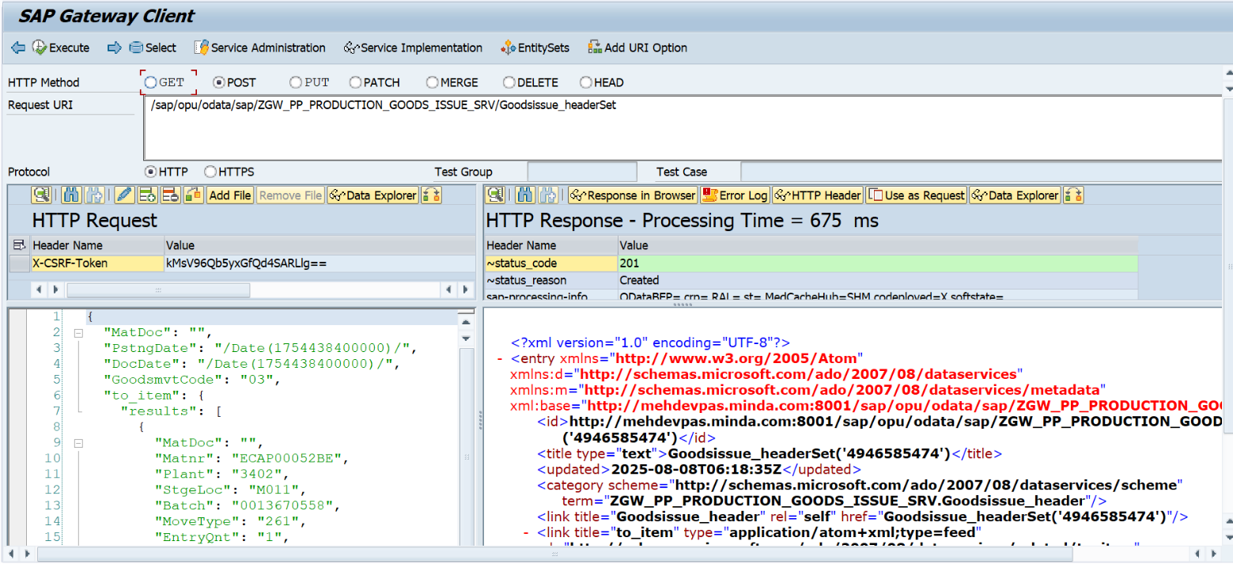--------------

Success Meesage as response :

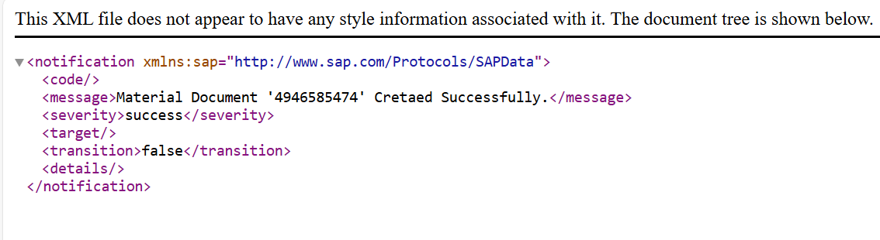

**Postman Testing:**

API:

<http://11.1.3.57:8001/sap/opu/odata/sap/ZGW_PP_PRODUCTION_GOODS_ISSUE_SRV/Goodsissue_headerSet>

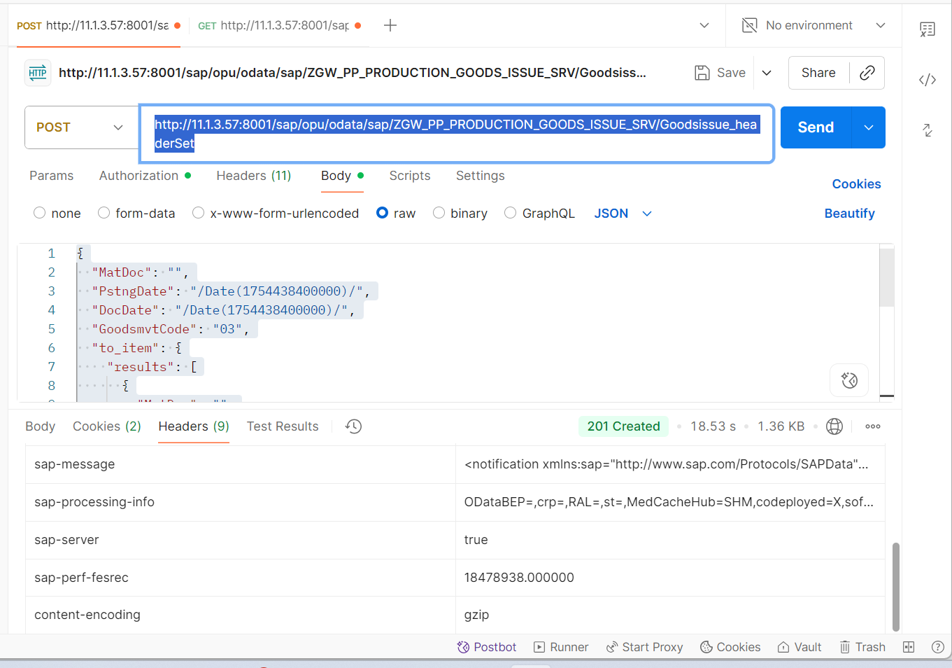

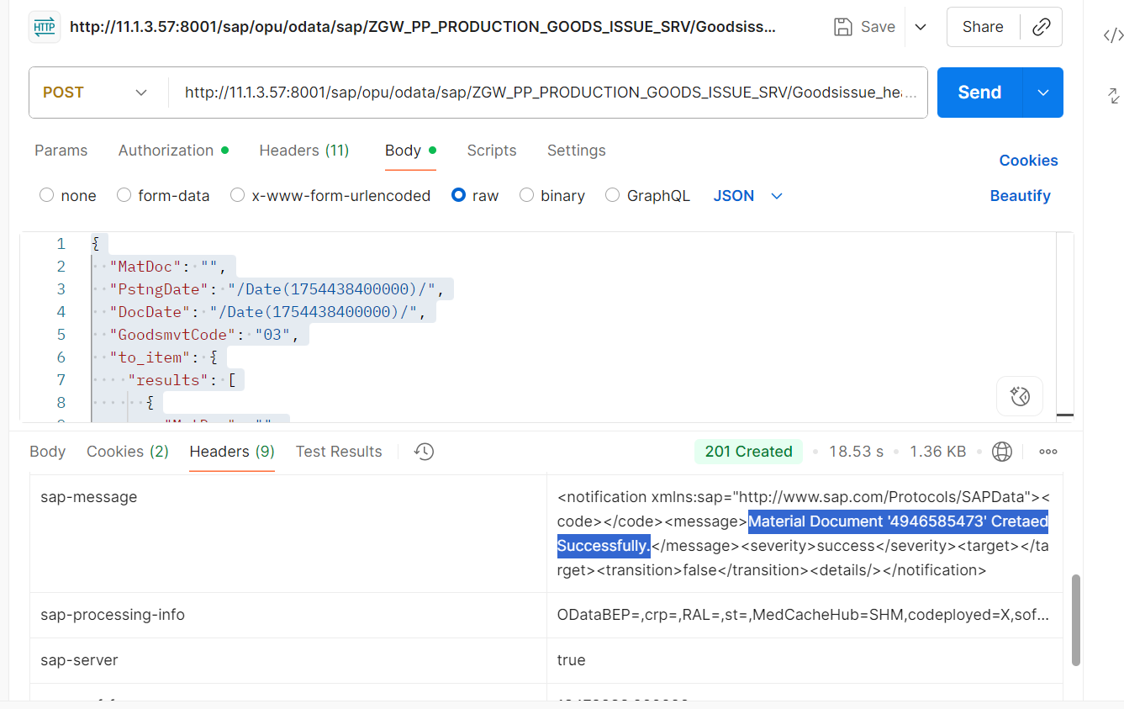

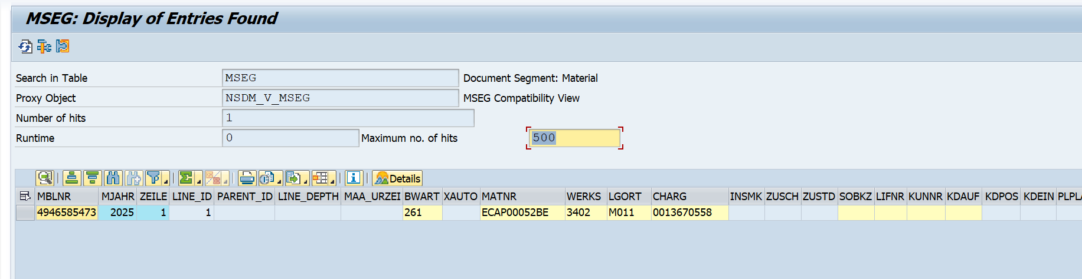Database Screenshot of Document created Successfully:

**Multiple item test scenario.**

API:

<http://11.1.3.57:8001/sap/opu/odata/sap/ZGW_PP_PRODUCTION_GOODS_ISSUE_SRV/Goodsissue_headerSet>

**Postman Level**

Payload

{

"MatDoc": "",

"PstngDate": "/Date(1754870400000)/",

"DocDate": "/Date(1754870400000)/",

"GoodsmvtCode": "03",

"to_item": {

"results": [

{

"MatDoc": "",

"Matnr": "ECAP00052BE",

"Plant": "3402",

"StgeLoc": "M011",

"Batch": "0013670558",

"MoveType": "261",

"EntryQnt": "1",

"EntryUom": "NO",

"Orderid": "404983450",

"ReservNo": "0090746947",

"ResItem": "0001"

},

{

"MatDoc": "",

"Matnr": "ECAP00053BE",

"Plant": "3402",

"StgeLoc": "M011",

"Batch": "0013669260",

"MoveType": "261",

"EntryQnt": "1",

"EntryUom": "NO",

"Orderid": "404983450",

"ReservNo": "0090746947",

"ResItem": "0002"

},

{

"MatDoc": "",

"Matnr": "ECAP00060BE",

"Plant": "3402",

"StgeLoc": "M011",

"Batch": "0013669263",

"MoveType": "261",

"EntryQnt": "1",

"EntryUom": "NO",

"Orderid": "404983450",

"ReservNo": "0090746947",

"ResItem": "0003"

},

{

"MatDoc": "",

"Matnr": "34CH020001-00022Y0",

"Plant": "3402",

"StgeLoc": "M011",

"Batch": "0013669347",

"MoveType": "261",

"EntryQnt": "1",

"EntryUom": "NO",

"Orderid": "404983450",

"ReservNo": "0090746947",

"ResItem": "0004"

},

{

"MatDoc": "",

"Matnr": "34CH020001-00023Y0",

"Plant": "3402",

"StgeLoc": "M011",

"Batch": "0013670407",

"MoveType": "261",

"EntryQnt": "1",

"EntryUom": "NO",

"Orderid": "404983450",

"ReservNo": "0090746947",

"ResItem": "0005"

}

]

}

}

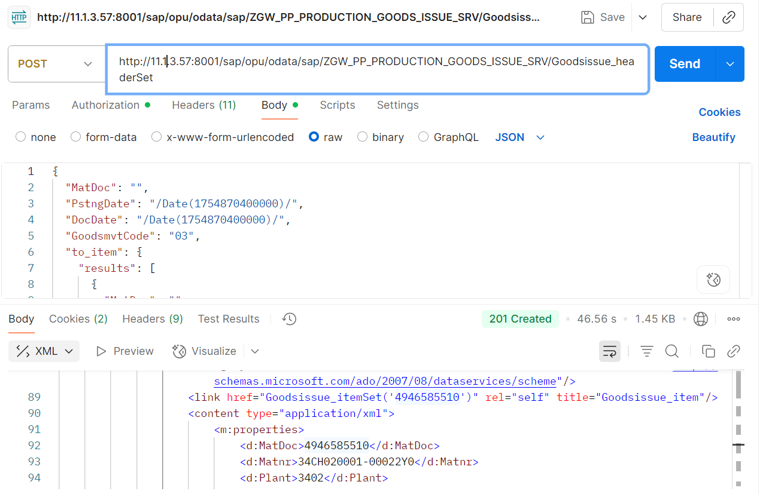

Database level Check:

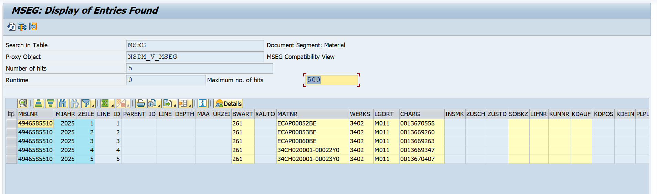

**Note: Please consider the important point at the time of Prepare payload.**

* Header Posting date and Document Date are by default Today’s date.
* Goods movement code (Goodsmvtcode) and Movement Type (MoveType) are constant Value that is ‘03’ and ‘261’ respectively.
* Remaining all the fields in the payload are mandatory field except material documents number (MatDoc) because that field I had taken to establish relation ship in between header and item entity set and that should be blank at header and respected item also.
* Until you haven’t filled the details from frontend, it should through mandatory field error and won’t be hit/trigger the Post API. if it happens then inconsistent data will create in SAP Backend.

**Negative Testing:**

Consider the above Payload.

**Case 1:**

If user didn’t pass any Quantity or 0.  
  
