Technical Specification Form

SAP QM Transfer posting (321, 322, 349 & 350 Movement type) API

Prepared By: Debidutta Swain (AIRDIT Software Solutions)

**Technical specification content**

1. Business Requirement
2. Development Tools
3. Development Objects

* Table.
* CDS Data Definition.
* CDS Access Control
* SEGW – OData Project.

Business API / OData API and Output Screen

1. **Business Requirement:**

Develop an OData GET API for Transfer Posting details, where end user can pass the Posting date (in range) and Movement Type (In parameter) as input and Get the Corresponding details.

Here end user only those Plant data for which end-user is authorized.

The following Details provided by Functional consultant in order to develop API:

* Movement Type: 321, 322, 349 & 350
* Created Date (**CPUDT_MKPF**)
* Automatic Item Creation Indicator(XAUTO) = Blank

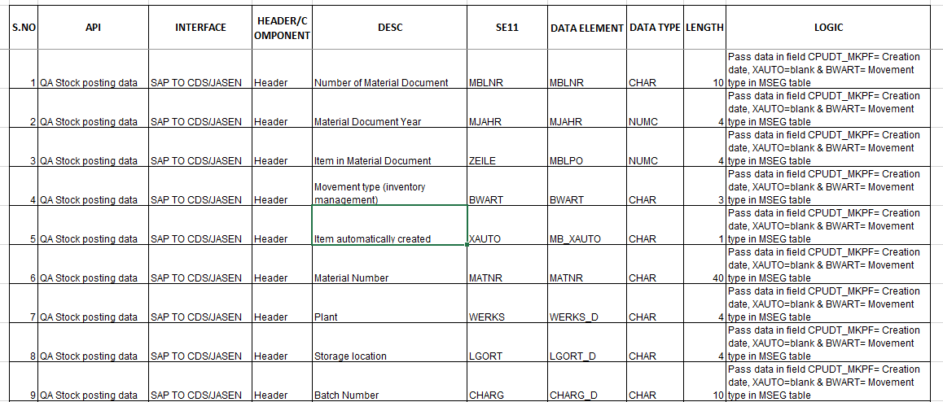

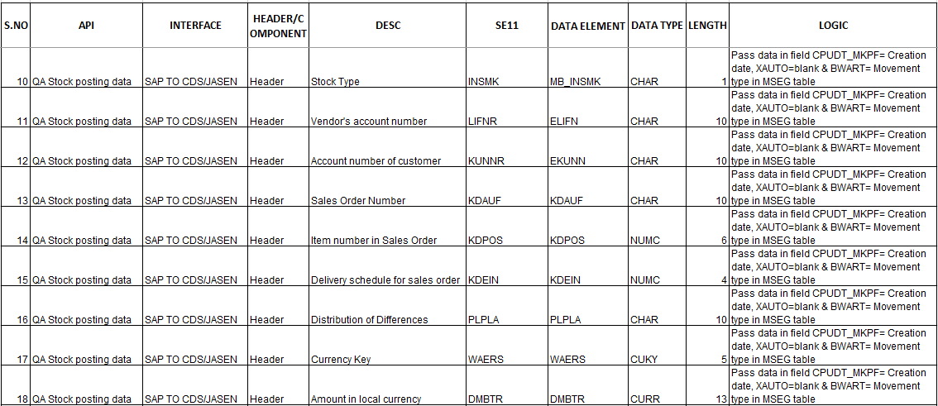

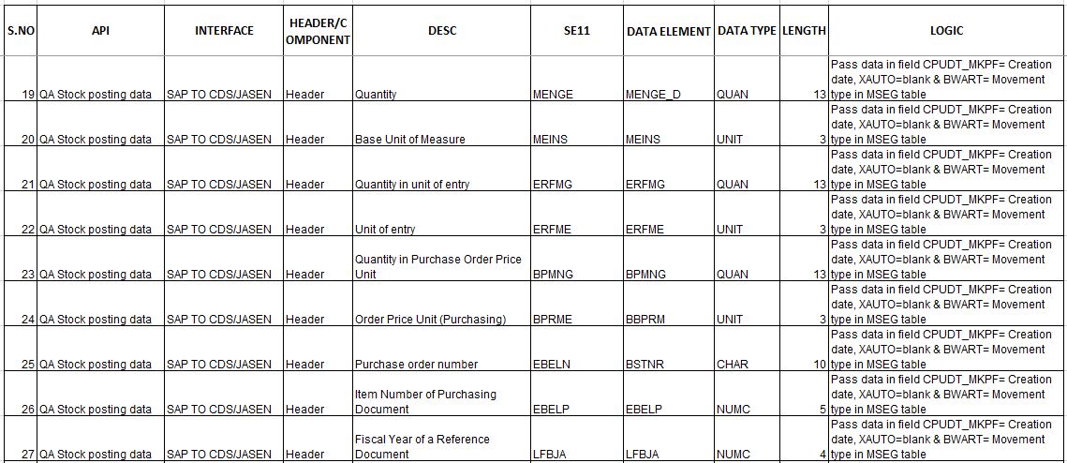

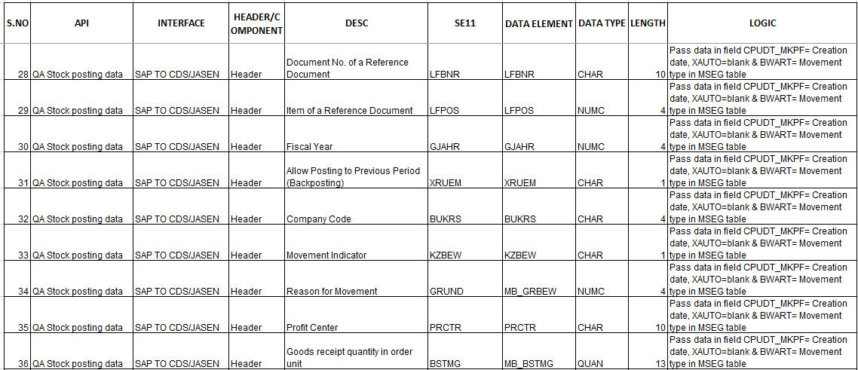

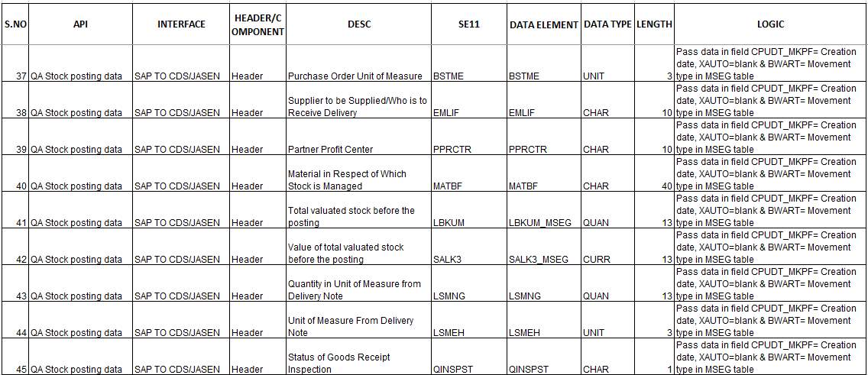

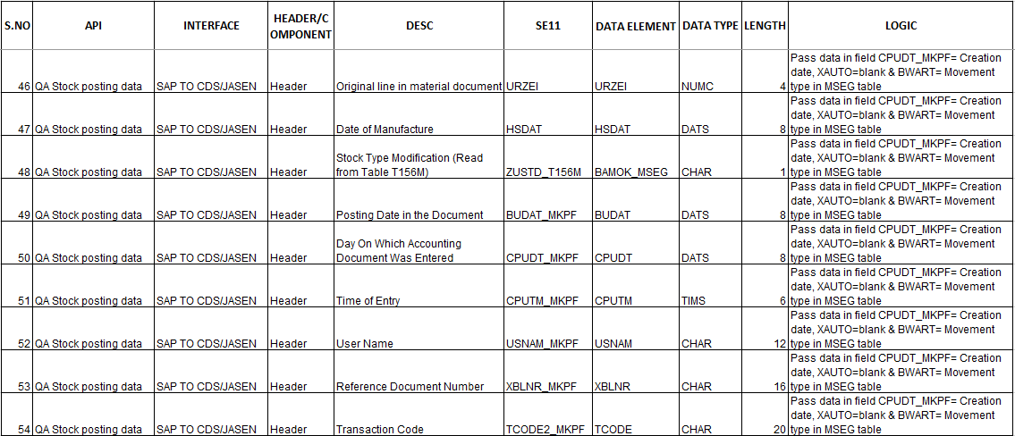

SAP Technical Cum Functional Specification Form

|  |  |  |  |
| --- | --- | --- | --- |
| User Story ID # |  | Module | QM |
| Date | 18.09.2025 | SL User |  |
| Consultant | Bhaskar Joshi | Developer |  |
| Priority | ☐Urgent ☒High ☐Medium ☐Low | | |
| Application Type | ☐Report ☐Transaction ☐Interface ☒ Enhancement/Change ☐Others | | |
| Execute Model | ☐Batch ☐ Foreground ☒OData API ☐Quarterly ☐Monthly  ☐Weekly ☐Daily ☐Real time | | |
| Output Type | ☐Message ☐Dialog Screen ☐ABAP List ☐ List view ☐ALV Grid | | |
| Remarks | Transfer Posting DATA | | |

**2.Development Status & Tools**

For development these are the following tool used :

* **Eclipse for ABAP /ADT(ABAP Development Tool)**
* Interface/Basic CDS view:

Created on top of Required Database. Naming convention: ZI_*****

* Composite CDS view:

Created on top of Interface basic view for join/association. Naming convention: ZCO_*****

* Consumption view:

Expose only those field required for Business Requirement. Naming convention: ZC_*****

* CDS Access Control:

Access control created to handle Visibility on SAP Data.

Naming convention: ZDCL_*****

* **SEGW OData Project**
* Created OData project with “Data Source Reference” Using the consumption CDS view. Here in this CDS association has been done due to which in ODATA project all the association and navigation property generate automatically.
* For Service Registration used Tcode : /N/IWFND/MAINT_SERVICE.
* To Check the final data at Gateway Client used Tcode :/N/IWFND/GW_CLIENT.

**3.Development Objects**

* ***Table:***
* **MSEG(NSDM_V_MSEG):** Document Segment: Material
* ***CDS Data Definition:***
* **Basic CDS View:**

As I am following the VDM modeling in this development, I had created Basic CDS view on top of Database table and the source of Basic View Should be a Database View or Standard CDS view.

* Table: MSEG(NSDM_V_MSEG): Document Segment: Material
* CDS View Name: ZI_QM_MSEG_TRANSFERPOSTINGDATA
* //---------------------------------------------------------------//
* //Created By :Debidutta Swain(9000Rupesh):AIRDIT Software
* //Created on :02-09-2025
* //--------------------------------------------------------------//
* @AbapCatalog.sqlViewName: 'ZIQMMSEG'
* @AbapCatalog.compiler.compareFilter: true
* @AbapCatalog.preserveKey: true
* @AccessControl.authorizationCheck: #NOT_REQUIRED
* @EndUserText.label: 'Basic view:MSEG: Transfer Posting Data'
* @Metadata.ignorePropagatedAnnotations: true
* @VDM.viewType: #BASIC
* **define** **view** ZI_QM_MSEG_TransferPostingData
* **as** **select** **from** nsdm_v_mseg
* **{**
* **key** mblnr **as** MaterialDocumentNumber**,**
* **key** mjahr **as** MaterialDocumentYear**,**
* **key** zeile **as** MaterialDocuemntItem**,**
* bwart **as** MovementType**,**
* budat_mkpf **as** PostingDate**,**
* cpudt_mkpf **as** CreatedDate**,**
* cputm_mkpf **as** CreatedTime**,**
* usnam_mkpf **as** UserName**,**
* xauto **as** AutoCreatedItem**,**
* matnr **as** MaterialCode**,**
* werks **as** Plant**,**
* lgort **as** StorageLocation**,**
* charg **as** BatchNumber**,**
* insmk **as** StockType**,**
* lifnr **as** VendorAccountNumber**,**
* kunnr **as** CustomerAccountNumber**,**
* kdauf **as** SalesOrderNumber**,**
* kdpos **as** SalesOrderItemNumber**,**
* kdein **as** SOrderDeliverySchedule**,**
* plpla **as** DistributionDifference**,**
* waers **as** CurrencyKey**,**
* @Semantics.amount.currencyCode: 'CurrencyKey'
* dmbtr **as** AmountLocalCurrency**,**
* meins **as** BaseUnitOfMesure**,**
* @Semantics.quantity.unitOfMeasure: 'BaseUnitOfMesure'
* menge **as** Quantity**,**
* erfme **as** UnitOfEntry**,**
* @Semantics.quantity.unitOfMeasure: 'UnitOfEntry'
* erfmg **as** QuantityInUnitOfEntry**,**
* bprme **as** OrderPriceUnitPO**,**
* @Semantics.quantity.unitOfMeasure: 'OrderPriceUnitPO'
* bpmng **as** QuantityPOPriceUnit**,**
* ebeln **as** PurchaseOrder**,**
* ebelp **as** PurchaseOrderItem**,**
* lfbja **as** FiscalYearReferenceDoc**,**
* lfbnr **as** DocumentNoReferenceDoc**,**
* lfpos **as** ItemNumberReferenceDoc**,**
* gjahr **as** FiscalYear**,**
* xruem **as** AllowPostingPreviousPeriod**,**
* bukrs **as** CompanyCode**,**
* kzbew **as** MovementIndicator**,**
* grund **as** ReasonForMovement**,**
* prctr **as** ProfitCenter**,**
* bstme **as** PurchaseOrderUOM**,**
* @Semantics.quantity.unitOfMeasure: 'PurchaseOrderUOM'
* bstmg **as** GoodsReciptQuantityOrderUnit**,**
* emlif **as** SuppliedSupplier**,**
* pprctr **as** ParentProfitCenter**,**
* matbf **as** MaterialStockManaged**,**
* lbkum **as** ValuatedStockBeforePost**,**
* salk3 **as** ValueOfValuatedStockBeforePost**,**
* lsmeh **as** UOMDeliveryNote**,**
* @Semantics.quantity.unitOfMeasure: 'UOMDeliveryNote'
* lsmng **as** QuantityUOMDeliveryNote**,**
* qinspst **as** StatuOfGRInspection**,**
* urzei **as** OriginalLineMaterialDoc**,**
* hsdat **as** DateOfManufacture**,**
* zustd_t156m **as** StockTypeModification**,**
* xblnr_mkpf **as** ReferenceDocumentNo**,**
* tcode2_mkpf **as** TransactionCode
* **}**
* **Composite CDS view**

As I am following the VDM modeling in this development, I had created Composite CDS view on top of Basic View where I will do all the necessary Joins/association needed for the Current Business Requirement.

* CDS Name: ZCO_QM_MSEG_TRANSFERPOSTING
* Description: Composite View: 'Composite view:MSEG: Transfer Posting Data'
* //--------------------------------------------------------------------------//
* //Created By :Debidutta Swain(9000Rupesh):AIRDIT Software
* //Created on :20-09-2025
* //--------------------------------------------------------------------------//
* @AbapCatalog.sqlViewName: 'ZCOQMMSEG'
* @AbapCatalog.compiler.compareFilter: true
* @AbapCatalog.preserveKey: true
* @AccessControl.authorizationCheck: #NOT_REQUIRED
* @EndUserText.label: 'Composite view:MSEG: Transfer Posting Data'
* @Metadata.ignorePropagatedAnnotations: true
* @VDM.viewType: #COMPOSITE
* define view ZCO_QM_MSEG_TransferPosting
* as select from ZI_QM_MSEG_TransferPostingData as Mseg
* //--> Material Code Description.
* left outer join makt on makt.matnr = Mseg.MaterialCode
* and makt.spras = $session.system_language
* //--> Plant Description
* left outer join t001w on t001w.werks = Mseg.Plant
* //--> Storage Location Description
* left outer join t001l on t001l.werks = Mseg.Plant
* and t001l.lgort = Mseg.StorageLocation
* //--> Stock Type Description
* left outer join dd07t as StockType on StockType.domname = 'MB_INSMK'
* and StockType.ddlanguage = $session.system_language
* and StockType.domvalue_l = Mseg.StockType
* //--> Vendor Description
* left outer join lfa1 on lfa1.lifnr = Mseg.VendorAccountNumber
* //-->Customer Description
* left outer join kna1 on kna1.kunnr = Mseg.CustomerAccountNumber
* //--> Movement Indicator Description
* left outer join dd07t as MovementInd on MovementInd.domname = 'KZBEW'
* and MovementInd.ddlanguage = $session.system_language
* and MovementInd.domvalue_l = Mseg.MovementIndicator
* //--> Company Code Description
* left outer join t001 on t001.bukrs = Mseg.CompanyCode
* //--> Stock Type Modification Description
* left outer join dd07t as StockTypeModif on StockTypeModif.domname = 'BAMOK_MSEG'
* and StockTypeModif.ddlanguage = $session.system_language
* and StockTypeModif.domvalue_l = Mseg.StockTypeModification
* {
* key Mseg.MaterialDocumentNumber,
* key Mseg.MaterialDocumentYear,
* key Mseg.MaterialDocuemntItem,
* Mseg.MovementType,
* Mseg.PostingDate,
* Mseg.CreatedDate,
* Mseg.CreatedTime,
* Mseg.UserName,
* Mseg.AutoCreatedItem,
* Mseg.MaterialCode,
* makt.maktx as MaterialCodeText,
* Mseg.Plant,
* t001w.name1 as PlantText,
* Mseg.StorageLocation,
* t001l.lgobe as StorageLocationText,
* Mseg.BatchNumber,
* Mseg.StockType,
* StockType.ddtext as StockTypeText,
* Mseg.VendorAccountNumber,
* lfa1.name1 as VendorText,
* Mseg.CustomerAccountNumber,
* kna1.name1 as CustomerText,
* Mseg.SalesOrderNumber,
* Mseg.SalesOrderItemNumber,
* Mseg.SOrderDeliverySchedule,
* Mseg.DistributionDifference,
* Mseg.CurrencyKey,
* Mseg.AmountLocalCurrency,
* Mseg.BaseUnitOfMesure,
* Mseg.Quantity,
* Mseg.UnitOfEntry,
* Mseg.QuantityInUnitOfEntry,
* Mseg.OrderPriceUnitPO,
* Mseg.QuantityPOPriceUnit,
* Mseg.PurchaseOrder,
* Mseg.PurchaseOrderItem,
* Mseg.FiscalYearReferenceDoc,
* Mseg.DocumentNoReferenceDoc,
* Mseg.ItemNumberReferenceDoc,
* Mseg.FiscalYear,
* Mseg.AllowPostingPreviousPeriod,
* Mseg.CompanyCode,
* t001.butxt as CompanyCodeText,
* Mseg.MovementIndicator,
* MovementInd.ddtext as MovementIndicatorText,
* Mseg.ReasonForMovement,
* Mseg.ProfitCenter,
* Mseg.PurchaseOrderUOM,
* Mseg.GoodsReciptQuantityOrderUnit,
* Mseg.SuppliedSupplier,
* Mseg.ParentProfitCenter,
* Mseg.MaterialStockManaged,
* Mseg.ValuatedStockBeforePost,
* Mseg.ValueOfValuatedStockBeforePost,
* Mseg.UOMDeliveryNote,
* Mseg.QuantityUOMDeliveryNote,
* Mseg.StatuOfGRInspection,
* Mseg.OriginalLineMaterialDoc,
* Mseg.DateOfManufacture,
* Mseg.StockTypeModification,
* StockTypeModif.ddtext as StockTypeModificationText,
* Mseg.ReferenceDocumentNo,
* Mseg.TransactionCode
* }
* where
* Mseg.AutoCreatedItem <> 'X'
* **Consumption CDS view**

As I am following the VDM modeling in this development, I had created Consumption CDS view on top of Composite CDS View where I had added all the field which are need to Expose as per the Business Requirement.

* CDS View name: ZC_QM_TRANSFERPOSTING_DETAILS
* Description : Consumption View:QM:TranferPosting Data
* //--------------------------------------------------------------------------//
* //Created By :Debidutta Swain(9000Rupesh):AIRDIT Software
* //Created on :22-09-2025
* //--------------------------------------------------------------------------//
* @AbapCatalog.sqlViewName: 'ZCQMTPOSTING'
* @AbapCatalog.compiler.compareFilter: true
* @AbapCatalog.preserveKey: true
* @AccessControl.authorizationCheck: #CHECK
* @EndUserText.label: 'Consumption View:QM:TranferPosting Data'
* @Metadata.ignorePropagatedAnnotations: true
* @VDM.viewType: #CONSUMPTION
* **define** **view** ZC_QM_TransferPosting_Details
* **as** **select** **from** ZCO_QM_MSEG_TransferPosting
* **{**
* **key** MaterialDocumentNumber**,**
* **key** MaterialDocumentYear**,**
* **key** MaterialDocuemntItem**,**
* MovementType**,**
* PostingDate**,**
* CreatedDate**,**
* CreatedTime**,**
* UserName**,**
* AutoCreatedItem**,**
* MaterialCode**,**
* MaterialCodeText**,**
* Plant**,**
* PlantText**,**
* StorageLocation**,**
* StorageLocationText**,**
* BatchNumber**,**
* StockType**,**
* StockTypeText**,**
* VendorAccountNumber**,**
* VendorText**,**
* CustomerAccountNumber**,**
* CustomerText**,**
* SalesOrderNumber**,**
* SalesOrderItemNumber**,**
* SOrderDeliverySchedule**,**
* DistributionDifference**,**
* CurrencyKey**,**
* AmountLocalCurrency**,**
* BaseUnitOfMesure**,**
* Quantity**,**
* UnitOfEntry**,**
* QuantityInUnitOfEntry**,**
* OrderPriceUnitPO**,**
* QuantityPOPriceUnit**,**
* PurchaseOrder**,**
* PurchaseOrderItem**,**
* FiscalYearReferenceDoc**,**
* DocumentNoReferenceDoc**,**
* ItemNumberReferenceDoc**,**
* FiscalYear**,**
* AllowPostingPreviousPeriod**,**
* CompanyCode**,**
* CompanyCodeText**,**
* MovementIndicator**,**
* MovementIndicatorText**,**
* ReasonForMovement**,**
* ProfitCenter**,**
* PurchaseOrderUOM**,**
* GoodsReciptQuantityOrderUnit**,**
* SuppliedSupplier**,**
* ParentProfitCenter**,**
* MaterialStockManaged**,**
* ValuatedStockBeforePost**,**
* ValueOfValuatedStockBeforePost**,**
* UOMDeliveryNote**,**
* QuantityUOMDeliveryNote**,**
* StatuOfGRInspection**,**
* OriginalLineMaterialDoc**,**
* DateOfManufacture**,**
* StockTypeModification**,**
* StockTypeModificationText**,**
* ReferenceDocumentNo**,**
* TransactionCode
* **}**
* **CDS Access Control:**
* CDS View name where used: ZC_QM_TRANSFERPOSTING_DETAILS
* CDS Access Control Name: ZDCL_QM_TRANSFERPOSTINGDATA
* @EndUserText.label: 'DCL For Filtering Transfer Posting Details'
* @MappingRole: true
* **define** **role** ZDCL_QM_TRANSFERPOSTINGDATA **{**
* **grant**
* **select**
* **on**
* ZC_QM_TransferPosting_Details
* **where**
* **(**Plant**)** **=** **aspect** **pfcg_auth(**ZPLANTS**,**WERKS**);**
* **}**
* **SEGW OData Project**

**Project Name:** ZGW_QM_TRANSFER_POSTING_DETAIL

**Project Service Name:** ZGW_QM_TRANSFER_POSTING_DETAIL_SRV

Entity Type: ZC_QM_TransferPosting_DetailsType

Entity Sets: ZC_QM_TransferPosting_Details

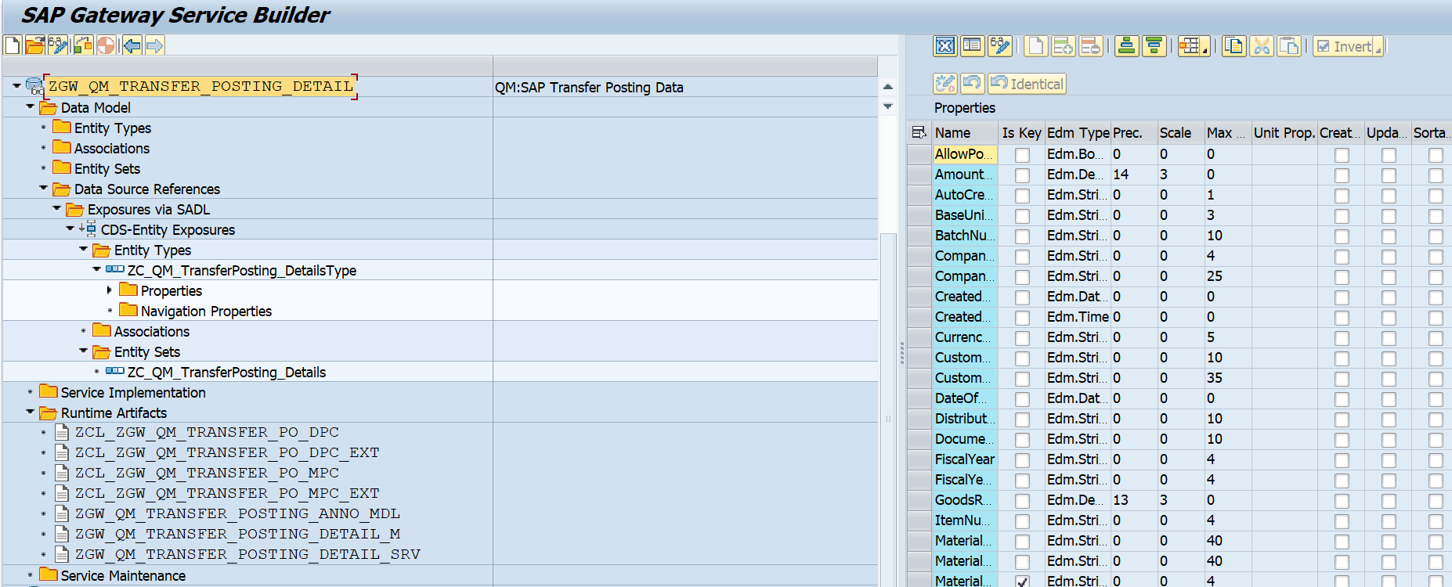

**4.Business API / OData API and Output Screen**

Based on FS I have added filter condition based on Created Date and Movement Type and below are the technical name at Entity Type

* CreatedDate
* MovementType

**Test Case**

Here all the test case tested with a Date range from 01.01.2024 to 19.09.2025.

Case 1: Movement Type 321

API: /sap/opu/odata/sap/ZGW_QM_TRANSFER_POSTING_DETAIL_SRV/ZC_QM_TransferPosting_Details?$filter=MovementType eq '321' and CreatedDate ge datetime'2024-01-01T00:00:00' and CreatedDate le datetime'2025-09-19T00:00:00'

Postman API :

http://mehdevpas.minda.com:8001/sap/opu/odata/sap/ZGW_QM_TRANSFER_POSTING_DETAIL_SRV/ZC_QM_TransferPosting_Details?$filter=MovementType eq '321' and CreatedDate ge datetime'2024-01-01T00:00:00' and CreatedDate le datetime'2025-09-19T00:00:00'

GUI Screen

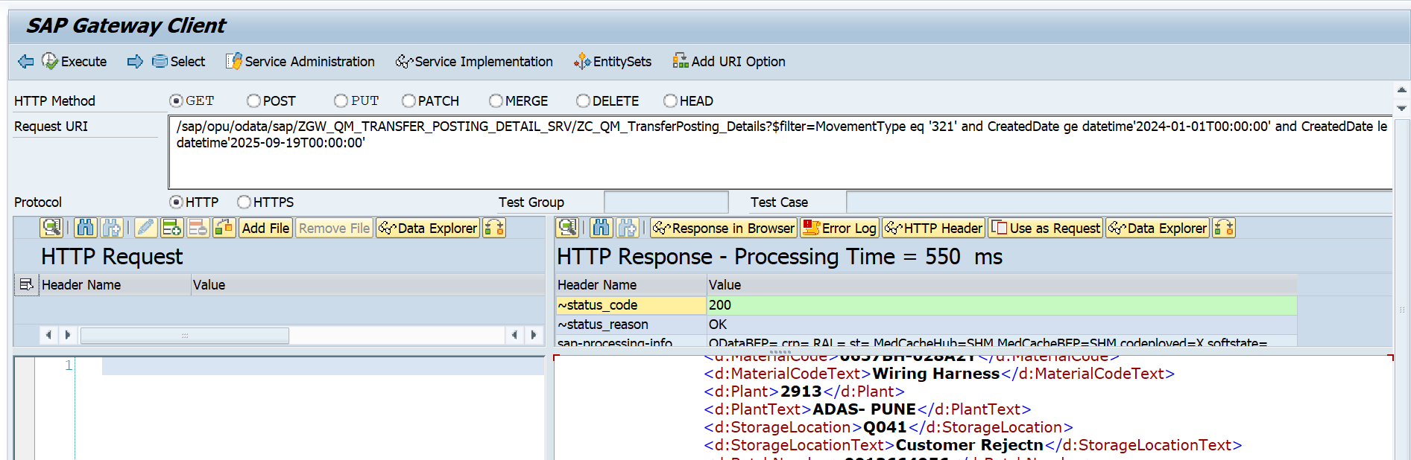

Number of Records For the API

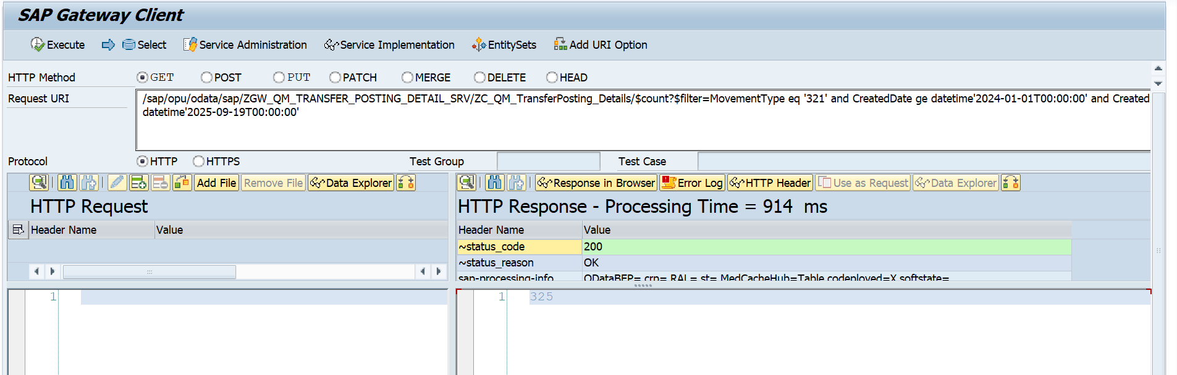

**Case 2: Movement Type 322**

API: /sap/opu/odata/sap/ZGW_QM_TRANSFER_POSTING_DETAIL_SRV/ZC_QM_TransferPosting_Details?$filter=MovementType eq '322' and CreatedDate ge datetime'2024-01-01T00:00:00' and CreatedDate le datetime'2025-09-19T00:00:00'

Postman API :

http://mehdevpas.minda.com:8001/sap/opu/odata/sap/ZGW_QM_TRANSFER_POSTING_DETAIL_SRV/ZC_QM_TransferPosting_Details?$filter=MovementType eq '322' and CreatedDate ge datetime'2024-01-01T00:00:00' and CreatedDate le datetime'2025-09-19T00:00:00'

Gateway testing Screen

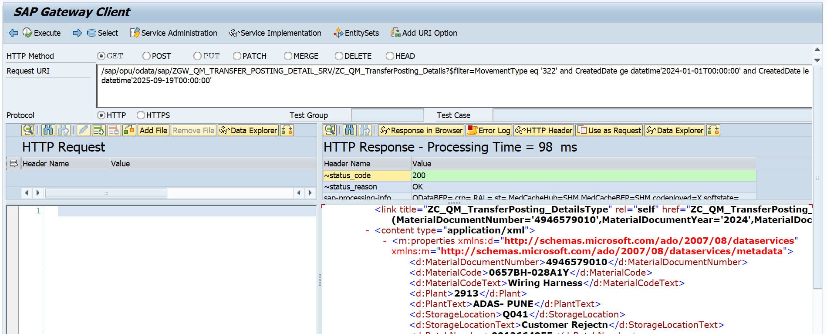

Number of Entries for the API

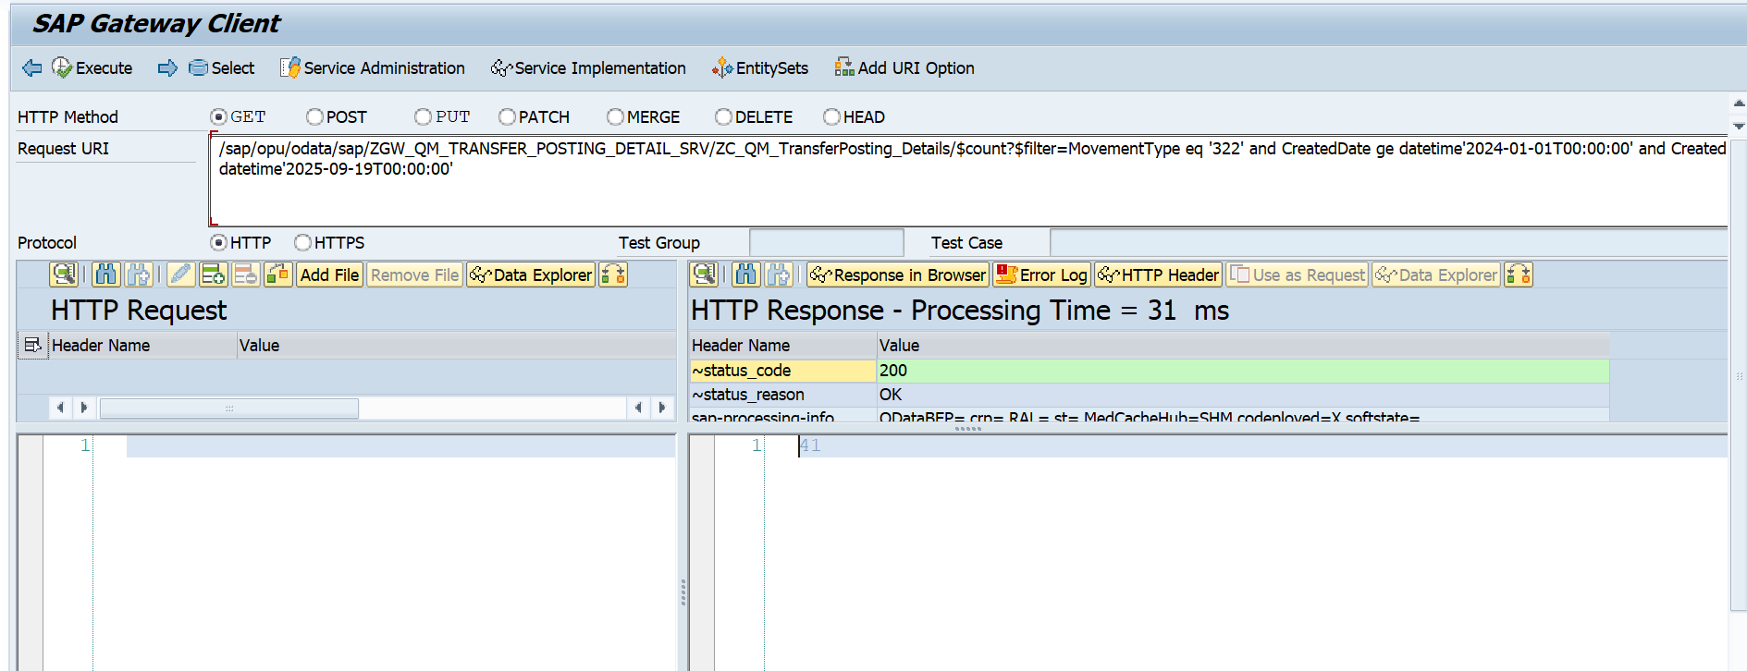

Case 3: Movement Type 349

API: /sap/opu/odata/sap/ZGW_QM_TRANSFER_POSTING_DETAIL_SRV/ZC_QM_TransferPosting_Details?$filter=MovementType eq '349' and CreatedDate ge datetime'2024-01-01T00:00:00' and CreatedDate le datetime'2025-09-19T00:00:00'

Postman API :

http://mehdevpas.minda.com:8001/sap/opu/odata/sap/ZGW_QM_TRANSFER_POSTING_DETAIL_SRV/ZC_QM_TransferPosting_Details?$filter=MovementType eq '349' and CreatedDate ge datetime'2024-01-01T00:00:00' and CreatedDate le datetime'2025-09-19T00:00:00'

Gateway test Screen

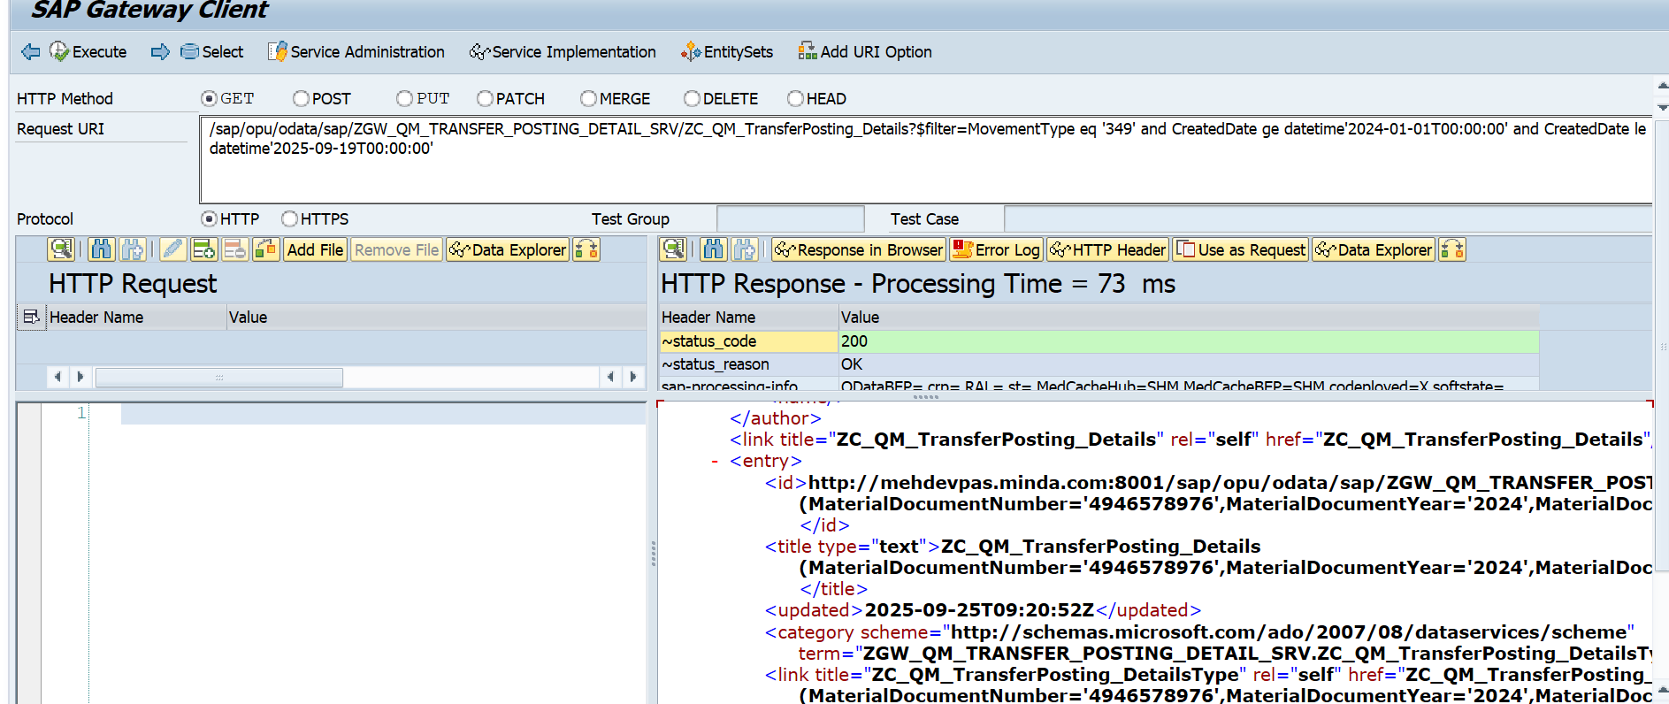

Number of Entries for the API

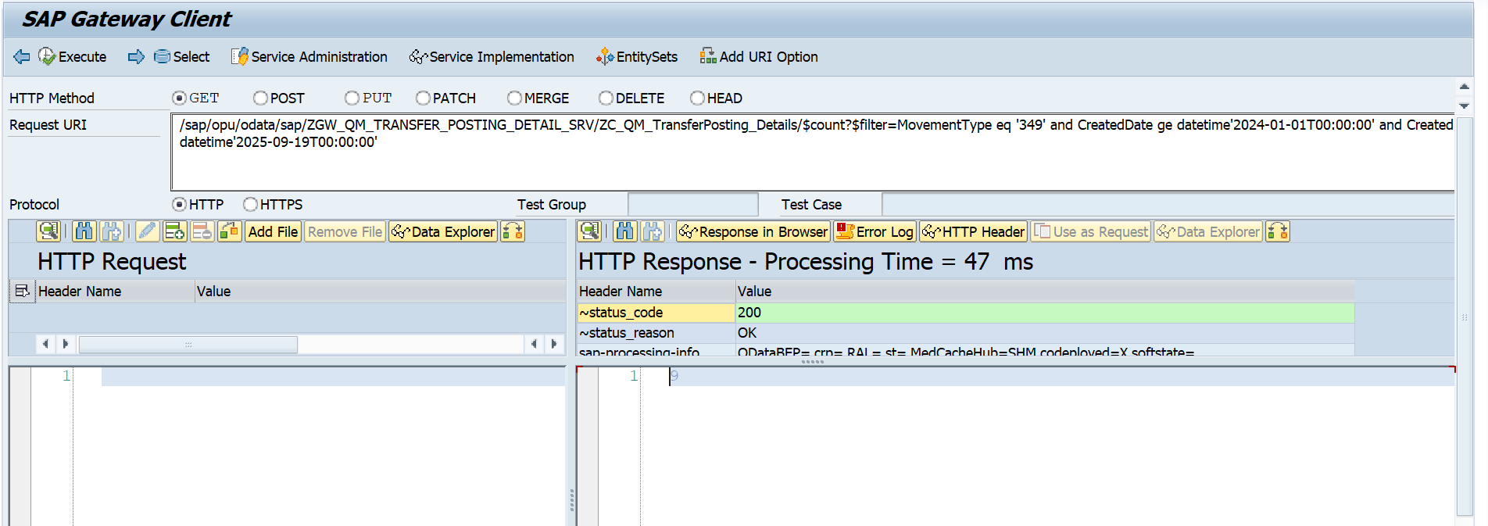

**Case 4: Movement Type 350**

API: /sap/opu/odata/sap/ZGW_QM_TRANSFER_POSTING_DETAIL_SRV/ZC_QM_TransferPosting_Details?$filter=MovementType eq '350' and CreatedDate ge datetime'2024-01-01T00:00:00' and CreatedDate le datetime'2025-09-19T00:00:00'

Postman API :

http://mehdevpas.minda.com:8001/sap/opu/odata/sap/ZGW_QM_TRANSFER_POSTING_DETAIL_SRV/ZC_QM_TransferPosting_Details?$filter=MovementType eq '350' and CreatedDate ge datetime'2024-01-01T00:00:00' and CreatedDate le datetime'2025-09-19T00:00:00'

Gateway Test Screen

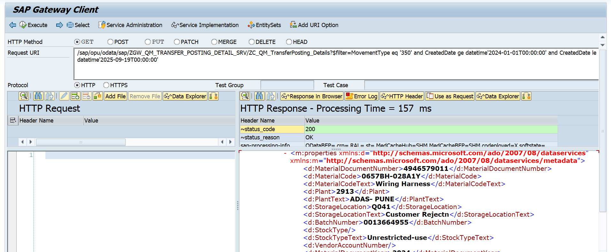

Number of Entries for the API

