Technical Specification Form

SAP Delivery Master Data API

Prepared By: Debidutta Swain (AIRDIT Software Solutions)

**Technical specification content**

1. Business Requirement
2. Development Tools
3. Development Objects

* Table.
* CDS Data Definition.
* CDS Access Control
* SEGW – OData Project.

1. Business API / OData API and Output Screen
2. **Business Requirement:**

Develop an OData GET API for Delivery Master details, where end user can pass the Posting date (in range) and Movement Type (In parameter) as input and Get the Corresponding details.

Here end user only those Plant data for which end-user is authorized.

The following Details provided by Functional consultant in order to develop API:

Input screeen: Created On :ERDAT🡪 likp

Changed On : AEDAT🡪likp

Movement Type : BWART🡪lips

Revised FS : (After discussing with Functional Consultant Ashish Kumar and development done based on this Revised FS.)

|  |  |
| --- | --- |
| **Filed** | **Logic** |
| Delivery number | Take VBELN from LIKP |
| Delivery Type | Pass Vbeln and Fetch LFART---likp |
| Material Code | Pass Vbeln and Fetch MATNR from LIPS |
| Quantity | Pass Vbeln and Fetch kmpmg from Lips |
| Picked Quantity | Pass Vbeln and Fetch LFIMG-->lips |
| Batch number | Pass VBELEN and Fetch CHARG--> lips |
| Sloc | Pass Vbeln and fetch LGORT--> lips |
| Movement type | Pass Vbeln and Fetch BWART-->lips |
| Created On | Pass Vbeln and Fetch ERDAT-->likp |
| changed on | likp---->aedat |
| plant | lips--> werks |

Additional logic:

* Ignore the Deleted Delivery from LIKP(spe_loekz not equal to X)
* Plant must be at line item level (LIPS🡪WERKS not equal to Null)
* Picked Quantity greater then 0 (LIPS🡪LFIMG Grater then 0)

Initial Provided FS:

|  |  |
| --- | --- |
| **Filed** | **Logic** |
| Delivery number | Take VBELN from LIKP |
| Delivery Type | Pass Vbeln and Fetch LFART |
| Material Code | Pass Vbeln and Fetch MATNR from LIPS |
| Quantity | Pass Vbeln and Fetch MENGE from LIKP |
| Picked Quantity | Pass Vbeln and Fetch /CWM/PIKMG |
| Batch number | Pass VBELEN and Fetch CHARG |
| Sloc | Pass Vbeln and fetch LGORT |
| Movement type | Pass Vbeln and Fetch BWART |
| Created On | Pass Vbeln and Fetch ERDAT |

**Person Responsible for Functional Specification:**

SAP Technical Cum Functional Specification Form

|  |  |  |  |
| --- | --- | --- | --- |
| User Story ID # |  | Module | MM |
| Date | 10/09/2025 | SL User |  |
| Consultant | Ashish Kumar | Developer |  |
| Priority | ☐Urgent ☒High ☐Medium ☐Low | | |
| Application Type | ☐Report ☐Transaction ☐Interface ☒ Enhancement/Change ☐Others | | |
| Execute Model | ☐Batch ☐ Foreground ☒OData ☐Quarterly ☐Monthly  ☐Weekly ☐Daily ☐Real time | | |
| Output Type | ☐Message ☐Dialog Screen ☐ABAP List ☐ALV List | | |
| Remarks | SAP Delivery Master Data | | |

**2.Development Status & Tools**

For development these are the following tool used :

* **Eclipse for ABAP /ADT(ABAP Development Tool)**
* Interface/Basic CDS view:

Created on top of Required Database. Naming convention: ZI_*****

* Composite CDS view:

Created on top of Interface basic view for join/association. Naming convention: ZCO_*****

* Consumption view:

Expose only those field required for Business Requirement. Naming convention: ZC_*****

* CDS Access Control:

Access control created to handle Visibility on SAP Data.

Naming convention: ZDCL_*****

* **SEGW OData Project**
* Created OData project with “Data Source Reference” Using the consumption CDS view. Here in this CDS association has been done due to which in ODATA project all the association and navigation property generate automatically.
* For Service Registration used Tcode : /N/IWFND/MAINT_SERVICE.
* To Check the final data at Gateway Client used Tcode :/N/IWFND/GW_CLIENT.

**3.Development Objects**

* ***Table:***
* **LIKP:** SD Document: Delivery Header Data
* **LIPS:** SD document: Delivery: Item data
* ***CDS Data Definition:***
* **Basic CDS View:**

As I am following the VDM modeling in this development, I had created Basic CDS view on top of Database table and the source of Basic View Should be a Database View or Standard CDS view.

* Table: LIKP (SD Document: Delivery Header Data)
* CDS view name: ZI_SD_LIKP_DELIVERYHEADER
* //-------------------------------------------------------//
* //Created By : AIRDIT--Debidutta Swain(9000RUPESH)
* //Cretaed on : 12-09-2025
* //-------------------------------------------------------//
* @AbapCatalog.sqlViewName: 'ZILIKP'
* @AbapCatalog.compiler.compareFilter: true
* @AbapCatalog.preserveKey: true
* @AccessControl.authorizationCheck: #NOT_REQUIRED
* @EndUserText.label: 'Basic view:LIPS:SD: Delivery:Header data'
* @Metadata.ignorePropagatedAnnotations: true
* @VDM.viewType: #BASIC
* **define** **view** ZI_SD_LIKP_DeliveryHeader
* **as** **select** **from** likp
* **{**
* vbeln **as** DeliveryNo**,**
* lfart **as** DeliveryType**,**
* erdat **as** CreatedOn**,**
* ernam **as** CreatedBy**,**
* aedat **as** ChangedOn**,**
* aenam **as** ChangedBy**,**
* spe_loekz **as** DelationInd
* **}**
* Table: LIPS (SD document: Delivery: Item data)
* CDS view name: ZI_SD_LIPS_DELIVERYITEM
* //--------------------------------------------------//
* //Created By : AIRDIT--Debidutta Swain(9000RUPESH)
* //Cretaed on : 12-09-2025
* //-------------------------------------------------//
* @AbapCatalog.sqlViewName: 'ZILIPS'
* @AbapCatalog.compiler.compareFilter: true
* @AbapCatalog.preserveKey: true
* @AccessControl.authorizationCheck: #NOT_REQUIRED
* @EndUserText.label: 'Basic view:LIPS:SD: Delivery: Item data'
* @VDM.viewType: #BASIC
* @Metadata.ignorePropagatedAnnotations: true
* **define** **view** ZI_SD_LIPS_DeliveryItem
* **as** **select** **from** lips
* **{**
* **key** vbeln **as** DeliveryNo**,**
* **key** posnr **as** DeliveryItemNo**,**
* pstyv **as** DeliveryItemCatagory**,**
* werks **as** Plant**,**
* lgort **as** StorageLocation**,**
* bwart **as** MovementType**,**
* matnr **as** MaterialCode**,**
* kmpmg **as** ComponentQuantity**,**
* lfimg **as** PickedQuantity**,**
* charg **as** BatchNumnber
* **}**
* **Composite CDS view**

As I am following the VDM modeling in this development, I had created Composite CDS view on top of Basic View where I will do all the necessary Joins/association needed for the Current Business Requirement.

* CDS Name: ZCO_SD_LIKP_DELIVERYHEADER
* Description: Composite View:LIPS:Delivery:Header Data
* //--------------------------------------------------//
* //Created By : AIRDIT--Debidutta Swain(9000RUPESH)
* //Cretaed on : 15-09-2025
* //-------------------------------------------------//
* @AbapCatalog.sqlViewName: 'ZCOLIKP'
* @AbapCatalog.compiler.compareFilter: true
* @AbapCatalog.preserveKey: true
* @AccessControl.authorizationCheck: #NOT_REQUIRED
* @EndUserText.label: 'Composite View:LIPS:Delivery:Header Data'
* @VDM.viewType: #COMPOSITE
* @Metadata.ignorePropagatedAnnotations: true
* **define** **view** ZCO_SD_LIKP_DELIVERYHEADER
* **as** **select** **from** ZI_SD_LIKP_DeliveryHeader **as** LIKP
* **left** **outer** **join** tvlkt **on** tvlkt**.**lfart **=** LIKP**.**DeliveryType
* **and** tvlkt**.**spras **=** **$session.system_language**
* **{**
* **key** LIKP**.**DeliveryNo**,**
* LIKP**.**DeliveryType**,**
* tvlkt**.**vtext **as** DeliveryTypeDesc**,**
* LIKP**.**CreatedOn**,**
* LIKP**.**CreatedBy**,**
* LIKP**.**ChangedOn**,**
* LIKP**.**ChangedBy**,**
* LIKP**.**DelationInd
* **}**
* **where**
* LIKP**.**DelationInd **<>** 'X'
* CDS view name: ZCO_SD_LIPS_DELIVERYITEM
* Description: Composite View:LIPS:Delivery:Item Data
* //--------------------------------------------------//
* //Created By : AIRDIT--Debidutta Swain(9000RUPESH)
* //Cretaed on : 15-09-2025
* //-------------------------------------------------//
* @AbapCatalog.sqlViewName: 'ZCOLIPS'
* @AbapCatalog.compiler.compareFilter: true
* @AbapCatalog.preserveKey: true
* @AccessControl.authorizationCheck: #NOT_REQUIRED
* @EndUserText.label: 'Composite View:LIPS:Delivery:Item Data'
* @VDM.viewType: #COMPOSITE
* @Metadata.ignorePropagatedAnnotations: true
* **define** **view** ZCO_SD_LIPS_DeliveryItem
* **as** **select** **from** ZI_SD_LIPS_DeliveryItem **as** lips
* **left** **outer** **join** makt **on** makt**.**matnr **=** lips**.**MaterialCode
* **and** makt**.**spras **=** **$session.system_language**
* **left** **outer** **join** t001w **on** t001w**.**werks **=** lips**.**Plant
* **left** **outer** **join** t001l **on** t001l**.**werks **=** lips**.**Plant
* **and** t001l**.**lgort **=** lips**.**StorageLocation
* **left** **outer** **join** tvapt **on** tvapt**.**spras **=** **$session.system_language**
* **and** tvapt**.**pstyv **=** lips**.**DeliveryItemCatagory
* //--> Joining Header details with item
* **inner** **join** ZCO_SD_LIKP_DELIVERYHEADER **as** likp **on** likp**.**DeliveryNo **=** lips**.**DeliveryNo
* **{**
* **key** lips**.**DeliveryNo**,**
* **key** lips**.**DeliveryItemNo**,**
* likp**.**DeliveryType**,**
* likp**.**DeliveryTypeDesc**,**
* lips**.**DeliveryItemCatagory**,**
* tvapt**.**vtext **as** DeliveryItemCatagoryDesc**,**
* lips**.**Plant**,**
* t001w**.**name1 **as** PlantDesc**,**
* lips**.**StorageLocation**,**
* t001l**.**lgobe **as** StorageLocationDesc**,**
* lips**.**MovementType**,**
* lips**.**MaterialCode**,**
* makt**.**maktx **as** MaterialCodeDesc**,**
* lips**.**ComponentQuantity**,**
* lips**.**PickedQuantity**,**
* lips**.**BatchNumnber**,**
* likp**.**CreatedOn**,**
* likp**.**CreatedBy**,**
* likp**.**ChangedOn**,**
* likp**.**ChangedBy**,**
* likp**.**DelationInd
* **}**
* **where**
* likp**.**DelationInd **<>** 'X'
* **and** lips**.**PickedQuantity **<>** 0
* **and** lips**.**Plant **<>** ' '
* **Consumption CDS view**

As I am following the VDM modeling in this development, I had created Consumption CDS view on top of Composite CDS View where I had added all the field which are need to Expose as per the Business Requirement.

* CDS View name: ZC_SD_DELIVERYMASTERDATA
* Description : Consumption View:SD:Delivery Master Data
* //--------------------------------------------------//
* //Created By : AIRDIT--Debidutta Swain(9000RUPESH)
* //Cretaed on : 15-09-2025
* //--------------------------------------------------//
* @AbapCatalog.sqlViewName: 'ZCDELIVERY'
* @AbapCatalog.compiler.compareFilter: true
* @AbapCatalog.preserveKey: true
* @AccessControl.authorizationCheck: #CHECK
* @EndUserText.label: 'Consumption View:SD:Delivery Master Data'
* @Metadata.ignorePropagatedAnnotations: true
* @VDM.viewType: #CONSUMPTION
* **define** **view** ZC_SD_DeliveryMasterData
* **as** **select** **from** ZCO_SD_LIPS_DeliveryItem
* **{**
* **key** DeliveryNo**,**
* **key** DeliveryItemNo**,**
* DeliveryType**,**
* DeliveryTypeDesc**,**
* DeliveryItemCatagory**,**
* DeliveryItemCatagoryDesc**,**
* Plant**,**
* PlantDesc**,**
* StorageLocation**,**
* StorageLocationDesc**,**
* MovementType**,**
* MaterialCode**,**
* MaterialCodeDesc**,**
* ComponentQuantity**,**
* PickedQuantity**,**
* BatchNumnber**,**
* CreatedOn**,**
* CreatedBy**,**
* ChangedOn**,**
* ChangedBy
* **}**

* **CDS Access Control:**
* CDS View name where used: ZC_MM_MIGODETAILS
* CDS Access Control Name: ZDCL_MM_MIGODETAILS
* @EndUserText.label: 'DCL for fliter Delivery Master data against Plant'
* @MappingRole: true
* **define** **role** ZDCL_SD_DELIVERYMASTER **{**
* **grant**
* **select**
* **on**
* ZC_SD_DeliveryMasterData
* **where**
* **(**Plant**)** **=** **aspect** **pfcg_auth(**ZPLANTS**,**WERKS**);**
* **}**
* **SEGW OData Project**

**Project Name:** ZGW_SD_DELIVERY_DETAILS

**Project Service Name:** ZGW_SD_DELIVERY_DETAILS_SRV

Entity Type: ZC_SD_DeliveryMasterDataType

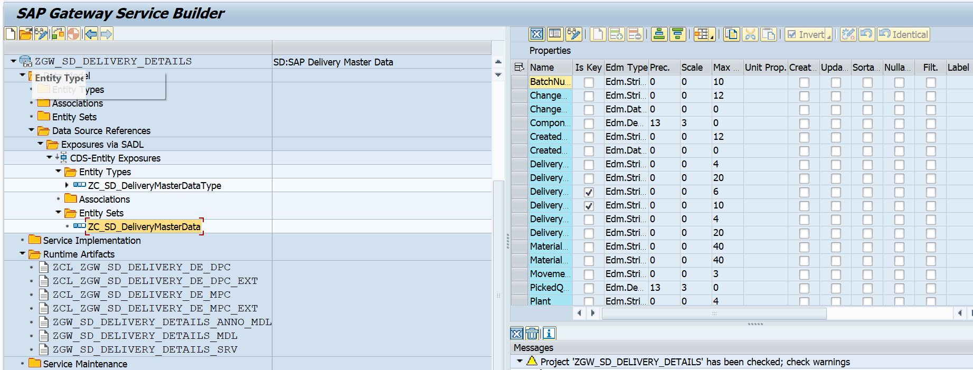Entity Sets: ZC_SD_DeliveryMasterData

**4.Business API / OData API and Output Screen**

**Case 1: Based on Created On**

Field name in Entity: CreatedOn

* 1. **: Single Created on Date**

Date: 16.09.2025

Gateway Level API:

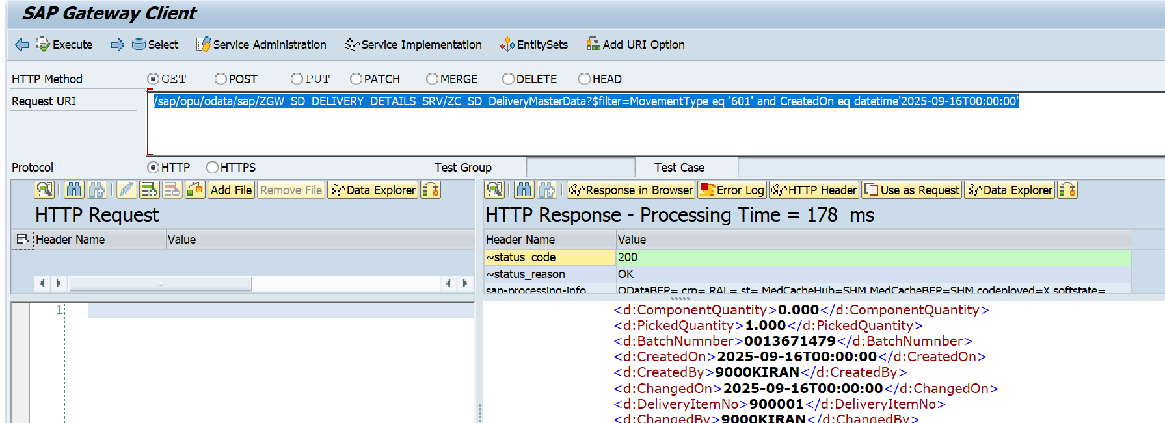/sap/opu/odata/sap/ZGW_SD_DELIVERY_DETAILS_SRV/ZC_SD_DeliveryMasterData?$filter=MovementType eq '601' and CreatedOn eq datetime'2025-09-16T00:00:00'

Postman Level API Test:

http://mehdevpas.minda.com:8001/sap/opu/odata/sap/ZGW_SD_DELIVERY_DETAILS_SRV/ZC_SD_DeliveryMasterData?$filter=MovementType eq '601' and CreatedOn eq datetime'2025-09-16T00:00:00'

**1.2: Range Created on Date**

Date: from 08.09.2025 TO 16.09.2025

Gateway API

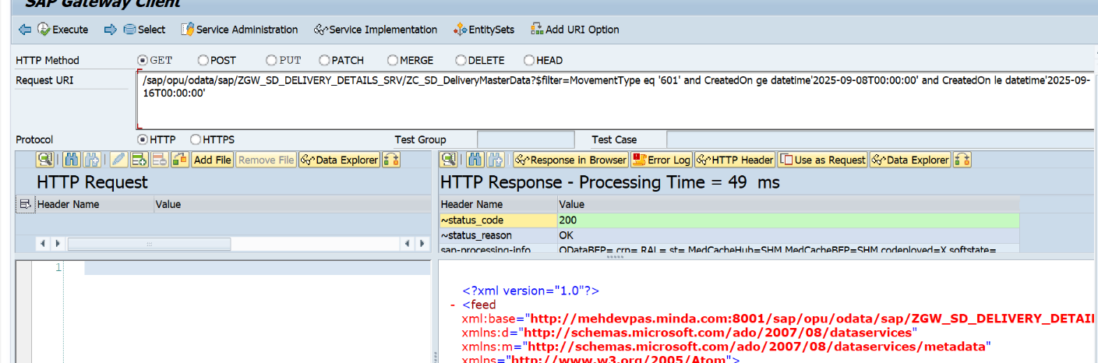/sap/opu/odata/sap/ZGW_SD_DELIVERY_DETAILS_SRV/ZC_SD_DeliveryMasterData?$filter=MovementType eq '601' and CreatedOn ge datetime'2025-09-08T00:00:00' and CreatedOn le datetime'2025-09-16T00:00:00'

API for check number of record

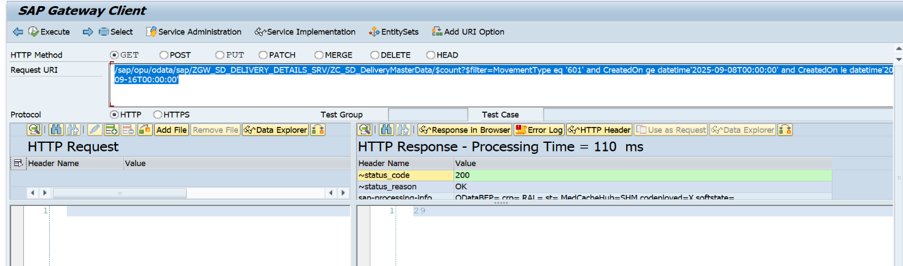/sap/opu/odata/sap/ZGW_SD_DELIVERY_DETAILS_SRV/ZC_SD_DeliveryMasterData/$count?$filter=MovementType eq '601' and CreatedOn ge datetime'2025-09-08T00:00:00' and CreatedOn le datetime'2025-09-16T00:00:00'

Postman Check API

http://mehdevpas.minda.com:8001/sap/opu/odata/sap/ZGW_SD_DELIVERY_DETAILS_SRV/ZC_SD_DeliveryMasterData?$filter=MovementType eq '601' and CreatedOn ge datetime'2025-09-08T00:00:00' and CreatedOn le datetime'2025-09-16T00:00:00'

**Case 2: Based On Changed On**

Field name in Entity: ChangedOn

2.1: Single Changed on Date

Date: 08.09.2025

Gateway Level Testing

/sap/opu/odata/sap/ZGW_SD_DELIVERY_DETAILS_SRV/ZC_SD_DeliveryMasterData?$filter=MovementType eq '601' and ChangedOn eq datetime'2025-09-08T00:00:00'

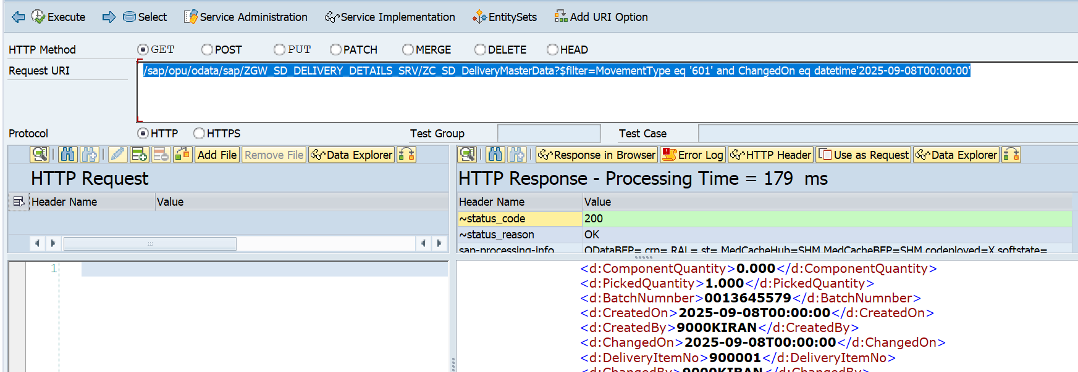

Postman Level testing API

http://mehdevpas.minda.com:8001/sap/opu/odata/sap/ZGW_SD_DELIVERY_DETAILS_SRV/ZC_SD_DeliveryMasterData?$filter=MovementType eq '601' and ChangedOn eq datetime'2025-09-08T00:00:00'

2.2: Range Changed On date

Gateway API Test

Date: from 08.09.2025 on 16.09.2025

/sap/opu/odata/sap/ZGW_SD_DELIVERY_DETAILS_SRV/ZC_SD_DeliveryMasterData?$filter=MovementType eq '601' and ChangedOn ge datetime'2025-09-08T00:00:00' and ChangedOn le datetime'2025-09-16T00:00:00'

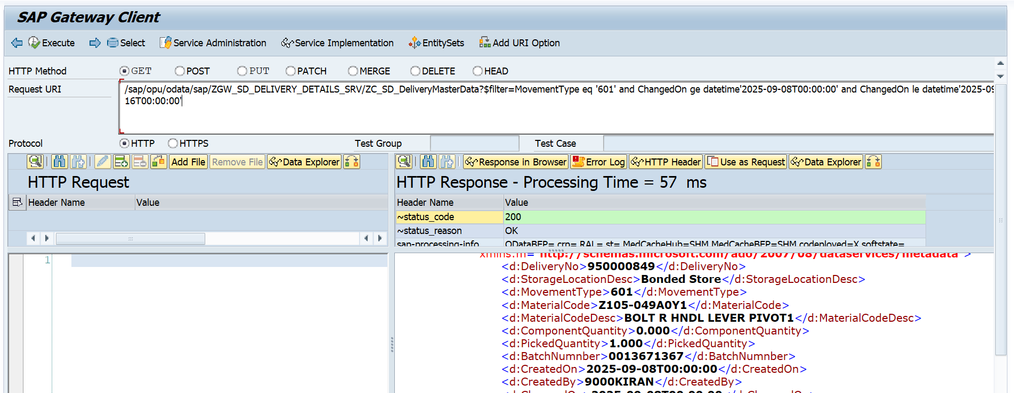

Postman API testing

http://mehdevpas.minda.com:8001/sap/opu/odata/sap/ZGW_SD_DELIVERY_DETAILS_SRV/ZC_SD_DeliveryMasterData?$filter=MovementType eq '601' and ChangedOn ge datetime'2025-09-08T00:00:00' and ChangedOn le datetime'2025-09-16T00:00:00'