Technical Specification Form
BOM FG Header Material Details
Created by: 9000RUPESH (AIRDIT Software)

Technical Specification Document Content:
- Business Requirement.
- Development Object used.
- Development Approach step by step.
- Testing API with Payload and Testing screen’s Screenshot.

1.Business Requirement.
Title: Development of GET API for BOM FG Header Material Retrieval.
🔹 Objective
Develop a GET API that enables business users to retrieve Finished Goods (FG) header materials along with their associated Bill of Materials (BOM) components from the custom SAP table ZTPP_BOMFGHEADER. The API should support filtering based on specific component material and plant location to facilitate efficient BOM analysis and decision-making.
Input
PLANT= WERKS
BOM COMPONENT= IDNRK

Output
FG Material: MATNR

2.Development Object used.
For development I used the following sap Tools/tcode:
- CDS View
Here CDS View used for Crete an Entity for OData Project.
Business Tool: Eclips
- Interface/Basic CDS view:
Created on top of Required Database. Naming convention: ZI_*****
- Composite CDS view:
Created on top of Interface basic view for join/association. Naming convention: ZCO_*****
- Consumption view:
Expose only those field required for Business Requirement. Naming convention: ZC_*****

- OData Project
Creating an OData (Open Data Protocol) project is essential for building and consuming standardized, RESTful APIs that allow applications to exchange data seamlessly over the web. The project defines the data model and the interface for performing create, read, update, and delete (CRUD) operations on server-side data.
Tcode: SEGW

- OData service Registration
Tcode:/N/IWFND/MAINT_SERVICE

- OData API Testing
Here for testing the OData API’s , we have to use the tcode /N/IWFND/MAINT_SERVICE or /N/IWFND/GW_CLIENTG in order to test whether it’s working as per our expectation or not.

3.Development Approach step by step.
- Table:
- ZTPP_BOMFGHEADER : Component wise Header FG Material

- CDS Data Definition:
- Basic CDS View:
As I am following the VDM modelling in this development, I had created Basic CDS view on top of Database table and the source of Basic View Should be a Database View or Standard CDS view.
- CDS view name: ZI_PP_BOM_FGMATERIAL
- @AbapCatalog.sqlViewName: 'ZFGMATERIAL'
- @AbapCatalog.compiler.compareFilter: true
- @AbapCatalog.preserveKey: true
- @AccessControl.authorizationCheck: #NOT_REQUIRED
- @EndUserText.label: 'Basic view:BOM FG Material Details'
- @Metadata.ignorePropagatedAnnotations: true
- @VDM.viewType:#BASIC
- define view ZI_PP_BOM_FGMATERIAL
- as select from ztpp_bomfgheader
- {
- key werks as Plant,
- key fg_matnr as FgMaterial,
- key stlan as BomUsage,
- key stlnr as BillOfMaterial,
- key stlal as AlternativeBom,
- key posnr as BomItemNumber,
- key idnrk as Component,
- @Semantics.quantity.unitOfMeasure: 'Uom'
- menge as Quantity,
- meins as Uom
- }

- Composite CDS view
As I am following the VDM modeling in this development, I had created Composite CDS view on top of Basic View where I will do all the necessary Joins/association needed for the Current Business Requirement.

- CDS Name: ZCO_PP_BOM_FGMATERIAL
- @AbapCatalog.sqlViewName: 'ZCOFGMaterial'
- @AbapCatalog.compiler.compareFilter: true
- @AbapCatalog.preserveKey: true
- @AccessControl.authorizationCheck: #NOT_REQUIRED
- @EndUserText.label: 'Composite view:FG Header Material Details'
- @Metadata.ignorePropagatedAnnotations: true
- @VDM.viewType: #COMPOSITE
- define view ZCO_PP_BOM_FGMATERIAL
- as select from ZI_PP_BOM_FGMATERIAL

- //--> Plant Description
- left outer join t001w on t001w.werks = ZI_PP_BOM_FGMATERIAL.Plant
- //--> FG Material Description
- left outer join makt as fgmakt on fgmakt.matnr = ZI_PP_BOM_FGMATERIAL.FgMaterial
- and fgmakt.spras = $session.system_language
- //--> componet Description
- left outer join makt as compmakt on compmakt.matnr = ZI_PP_BOM_FGMATERIAL.Component
- and compmakt.spras = $session.system_language
- //--> Bom Usage Description
- left outer join t416t on t416t.stlan = ZI_PP_BOM_FGMATERIAL.BomUsage
- and t416t.spras = $session.system_language
- {
- key ZI_PP_BOM_FGMATERIAL.Plant,
- key ZI_PP_BOM_FGMATERIAL.FgMaterial,
- key ZI_PP_BOM_FGMATERIAL.BomUsage,
- key ZI_PP_BOM_FGMATERIAL.BillOfMaterial,
- key ZI_PP_BOM_FGMATERIAL.AlternativeBom,
- key ZI_PP_BOM_FGMATERIAL.BomItemNumber,
- key ZI_PP_BOM_FGMATERIAL.Component,
- Quantity,
- Uom,
- t001w.name1 as PlantName,
- t416t.antxt as BomUsageText,
- fgmakt.maktx as FgMaterialName,
- compmakt.maktx as ComponentName
- }

- Consumption CDS view
As I am following the VDM modeling in this development, I had created Consumption CDS view on top of Composite CDS View where I had added all the field which are need to Expose as per the Business Requirement.

- CDS View name: ZC_PP_BOM_FGMATERIAL
- @AbapCatalog.sqlViewName: 'ZCFGMATERIAL'
- @AbapCatalog.compiler.compareFilter: true
- @AbapCatalog.preserveKey: true
- @AccessControl.authorizationCheck: #NOT_REQUIRED
- @EndUserText.label: 'Consumption view:FG Header Material Details'
- @Metadata.ignorePropagatedAnnotations: true
- define view ZC_PP_BOM_FGMATERIAL
- as select from ZCO_PP_BOM_FGMATERIAL
- {
- key Plant,
- key FgMaterial,
- key BomUsage,
- key BillOfMaterial,
- key AlternativeBom,
- key BomItemNumber,
- key Component,
- Quantity,
- Uom,
- PlantName,
- BomUsageText,
- FgMaterialName,
- ComponentName
- }

- SEGW OData Project
Project Name: ZGW_PP_FGMATERIAL_DETAILS
Project Service Name: ZGW_PP_FGMATERIAL_DETAILS_SRV

Entity Type: ZC_PP_BOM_FGMATERIALType
Entity Sets: ZC_PP_BOM_FGMATERIAL
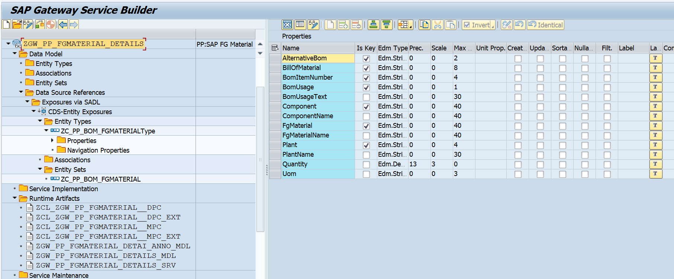

4.Testing API with Payload and Testing screen’s Screenshot.
Input
Plant (Plant)
BOM COMPONENT(Component)
Output
FG Header Material (FgMaterial) along with Other Details.

Gateway Level Testing
Case 1: Fetch all the details from Table.
API: /sap/opu/odata/sap/ZGW_PP_FGMATERIAL_DETAILS_SRV/ZC_PP_BOM_FGMATERIAL
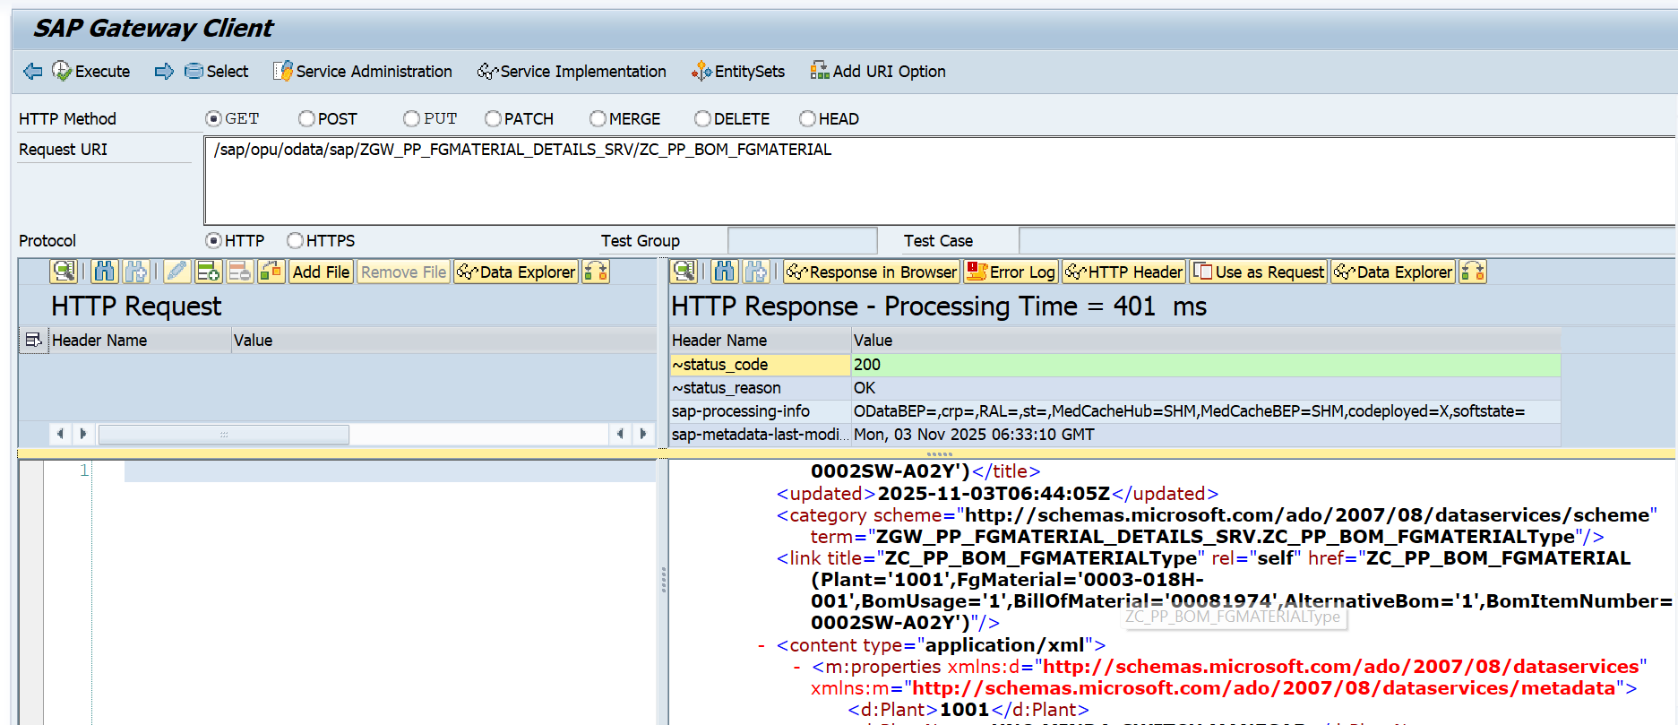

Case 2: Fetch the header FG material details from Table base on following criteria.
Component: “0001-0002SW-A02Y”
Plant:”1001”

API: /sap/opu/odata/sap/ZGW_PP_FGMATERIAL_DETAILS_SRV/ZC_PP_BOM_FGMATERIAL?$filter=Component eq '0001-0002SW-A02Y' and Plant eq '1001'
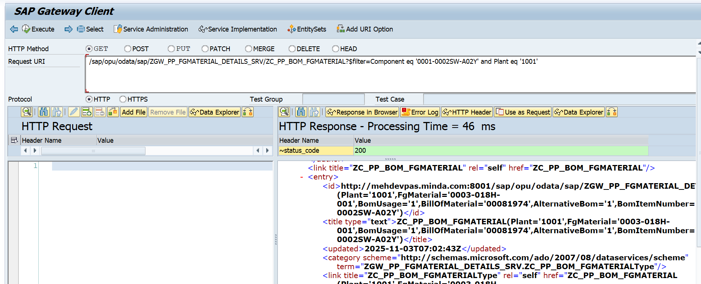
Check Number of Record.
API: /sap/opu/odata/sap/ZGW_PP_FGMATERIAL_DETAILS_SRV/ZC_PP_BOM_FGMATERIAL/$count?$filter=Component eq '0001-0002SW-A02Y' and Plant eq '1001'
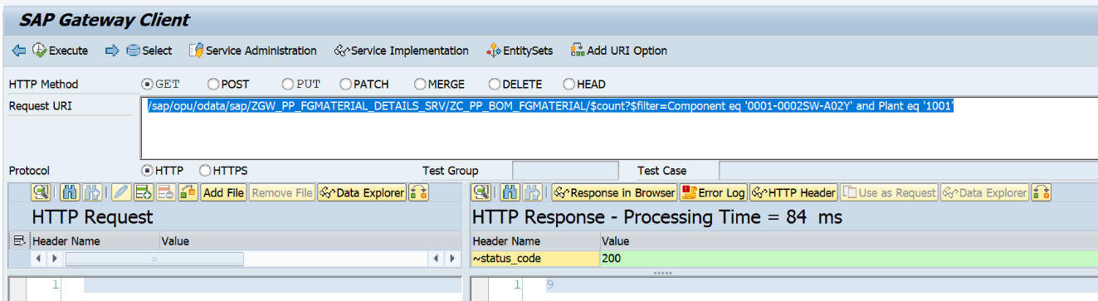

Database check:
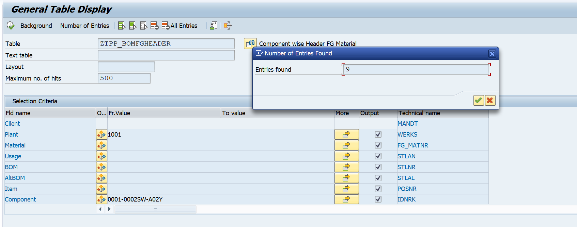

Postman Level Testing
Fetch all record
API: http://mehdevpas.minda.com:8001/sap/opu/odata/sap/ZGW_PP_FGMATERIAL_DETAILS_SRV/ZC_PP_BOM_FGMATERIAL
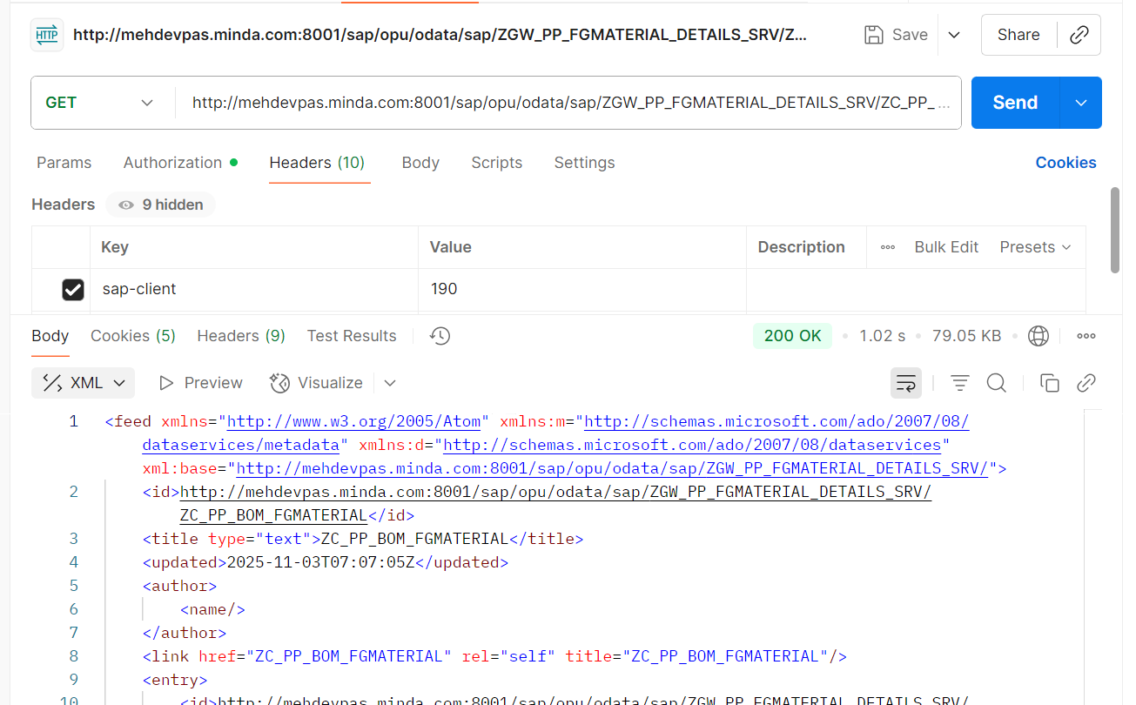

Fetch Record based on Following Criteria:
Component: “0001-0002SW-A02Y”
Plant:”1001”
API:
http://mehdevpas.minda.com:8001/sap/opu/odata/sap/ZGW_PP_FGMATERIAL_DETAILS_SRV/ZC_PP_BOM_FGMATERIAL?$filter=Component eq '0001-0002SW-A02Y' and Plant eq '1001'
