Technical Specification Document
SAP PP Routing Cost Center Details
Prepared By: Debidutta Swain

Technical Specification Document Content:
- Business Requirement
- Development Object used
- Development Approach
- Testing API with Payload and Testing screen’s Screenshot.

1.Business Requirement.
To design and implement a GET API using SAP OData that efficiently retrieves cost centre-related pricing data by navigating through a sequence of interconnected SAP tables: CRHD → CRCO → CSSL → COST.
📥 Input Parameters
- Plant: Retrieved from CRHD-WERKS
🗂️ Data Flow and Table Relationships
1. CRHD Table
Purpose: Initial data extraction
Fields to Retrieve:
OBJTYP (constant value: 'A'), OBJID, WERKS, BEGDA, ENDDA, ARBPL, VERWE
2. CRCO Table
Join Criteria:
Pass OBJID and OBJTYP from CRHD to CRCO.OBJID and CRCO.OBJTY
Fields to Retrieve: (Select the first index row or any valid single row)
OBJTY, OBJID, KOKRS, KOSTL
3. CSSL Table
Join Criteria:
Pass KOKRS and KOSTL from CRCO to CSSL.KOKRS and CSSL.KOSTL
Fields to Retrieve: (Select the first index row based on the combination of KOKRS, KOSTL, LSTAR, and OBJNR)
KOKRS, KOSTL, LSTAR, OBJNR
4. COST Table
Join Criteria:
Pass OBJNR from CSSL to COST.OBJNR
Fields to Retrieve:
OBJNR, GJAHR, TKF001 to TKF012

Note: This is the Functional Specification Details, based on which all the Development was done.

2.Development Object used.
For development I used the following sap Tools/tcode:
- CDS View
Here CDS View used for Crete an Entity for OData Project.
Business Tool: Eclips
- Interface/Basic CDS view:
Created on top of Required Database. Naming convention: ZI_*****
- Composite CDS view:
Created on top of Interface basic view for join/association. Naming convention: ZCO_*****
- Consumption view:
Expose only those field required for Business Requirement. Naming convention: ZC_*****

- OData Project
Creating an OData (Open Data Protocol) project is essential for building and consuming standardized, RESTful APIs that allow applications to exchange data seamlessly over the web. The project defines the data model and the interface for performing create, read, update, and delete (CRUD) operations on server-side data.
Tcode: SEGW

- OData service Registration
Tcode:/N/IWFND/MAINT_SERVICE

- OData API Testing
Here for testing the OData API’s, we have to use the tcode /N/IWFND/MAINT_SERVICE or /N/IWFND/GW_CLIENTG in order to test whether it’s working as per our expectation or not.

3.Development Approach step by step.
- Table:
- CRHD: Work Centre Header
- CRCO: Assignment of Work Center to Cost Center
- CSSL: Cost Center/Activity Type
- COST: CO Object: Price Totals

- CDS Data Definition:
- Basic CDS View:
As I am following the VDM modelling in this development, I had created Basic CDS view on top of Database table and the source of Basic View Should be a Database View or Standard CDS view.

- CDS view name: ZI_PP_CRHD_WORKCENTERHEADER
- Table: CRHD
- //---------------------------------------------------------------//
- //Creted By : Debidutta Swain(9000Rupesh)-@AIRDIT
- //Creted On : 11-11-2025
- //--------------------------------------------------------------//
- @AbapCatalog.sqlViewName: 'ZI_CRHD'
- @AbapCatalog.compiler.compareFilter: true
- @AbapCatalog.preserveKey: true
- @AccessControl.authorizationCheck: #NOT_REQUIRED
- @EndUserText.label: 'Basic view:CRHD:Work Center Header'
- @VDM.viewType: #BASIC
- define view ZI_PP_CRHD_WORKCENTERHEADER
- as select from crhd
- {
- key objty as ObjectType,
- key objid as ObjectID,
- werks as Plant,
- begda as StartDate,
- endda as EndDate,
- arbpl as WorkCenter,
- verwe as WorkCenterCatagory
- }

- CDS view name: ZI_PP_CRCO_WORKCOSTCENTER
- Table:CRCO
- //---------------------------------------------------------------//
- //Creted By : Debidutta Swain(9000Rupesh)-@AIRDIT
- //Creted On : 11-11-2025
- //--------------------------------------------------------------//
- @AbapCatalog.sqlViewName: 'ZICRCO'
- @AbapCatalog.compiler.compareFilter: true
- @AbapCatalog.preserveKey: true
- @AccessControl.authorizationCheck: #NOT_REQUIRED
- @EndUserText.label: 'Basic view:CRCO:Assignment of Work to Cost Center'
- @VDM.viewType: #BASIC
- define view ZI_PP_CRCO_WORKCOSTCENTER
- as select distinct from crco
- {
- key objty as ObjectType,
- key objid as ObjectID,
- kokrs as COArea,
- kostl as CostCenter
- }

- CDS view name: ZI_PP_CSSL_COCENACTIVITYTYPE
- Table:CSSL
- //---------------------------------------------------------------//
- //Creted By : Debidutta Swain(9000Rupesh)-@AIRDIT
- //Creted On : 11-11-2025
- //--------------------------------------------------------------//
- @AbapCatalog.sqlViewName: 'ZICSSL'
- @AbapCatalog.compiler.compareFilter: true
- @AbapCatalog.preserveKey: true
- @AccessControl.authorizationCheck: #NOT_REQUIRED
- @EndUserText.label: 'Basic view:CSSL:Cost Center/Activity Type'
- @VDM.viewType: #BASIC
- define view ZI_PP_CSSL_COCENACTIVITYTYPE
- as select distinct from cssl
- {
- key kokrs as COArea,
- key kostl as CostCenter,
- key lstar as ActivityType,
- objnr as ObjectNumber
- }

- CDS view name: ZI_PP_COST_COOBJPRICETOTAL
- Table:CSSL
- //---------------------------------------------------------------//
- //Creted By : Debidutta Swain(9000Rupesh)-@AIRDIT
- //Creted On : 11-11-2025
- //--------------------------------------------------------------//
- @AbapCatalog.sqlViewName: 'ZICSSL'
- @AbapCatalog.compiler.compareFilter: true
- @AbapCatalog.preserveKey: true
- @AccessControl.authorizationCheck: #NOT_REQUIRED
- @EndUserText.label: 'Basic view:CSSL:Cost Center/Activity Type'
- @VDM.viewType: #BASIC
- define view ZI_PP_CSSL_COCENACTIVITYTYPE
- as select distinct from cssl
- {
- key kokrs as COArea,
- key kostl as CostCenter,
- key lstar as ActivityType,
- objnr as ObjectNumber
- }

- Composite CDS view
As I am following the VDM modelling in this development, I had created Composite CDS view on top of Basic View where I will do all the necessary Joins/association needed for the Current Business Requirement.

CDS View Name: ZCO_PP_Routing_CostCenter
- //---------------------------------------------------------------//
- //Creted By : Debidutta Swain(9000Rupesh)-@AIRDIT
- //Creted On : 11-11-2025
- //--------------------------------------------------------------//
- @AbapCatalog.sqlViewName: 'ZROUTINGCC'
- @AbapCatalog.compiler.compareFilter: true
- @AbapCatalog.preserveKey: true
- @AccessControl.authorizationCheck: #NOT_REQUIRED
- @EndUserText.label: 'Composite View:RoUting Cost Center'
- @VDM.viewType: #COMPOSITE
- define view ZCO_PP_Routing_CostCenter
- as select from ZI_PP_CRHD_WORKCENTERHEADER as CRHD

- //--> Plant name
- left outer join t001w on t001w.werks = CRHD.Plant

- //--> Work Center catagory desc.
- left outer join tc30t on tc30t.verwe = CRHD.WorkCenterCatagory
- and tc30t.spras = $session.system_language

- //--> Assignment of Work to Cost Center
- left outer join ZI_PP_CRCO_WORKCOSTCENTER as CRCO on CRCO.ObjectID = CRHD.ObjectID
- and CRCO.ObjectType = CRHD.ObjectType

- //--> Assignment of Cost center Type with Object Number
- left outer join ZI_PP_CSSL_COCENACTIVITYTYPE as CSSL on CSSL.COArea = CRCO.COArea
- and CSSL.CostCenter = CRCO.CostCenter

- //--> Assignment of CO Object Price Total
- left outer join ZI_PP_COST_COOBJPRICETOTAL as cost on cost.ObjectNumber = CSSL.ObjectNumber

- {
- key CRHD.ObjectType,
- key CRHD.ObjectID,
- CRHD.Plant,
- t001w.name1 as PlantName,
- CRHD.StartDate,
- CRHD.EndDate,
- CRHD.WorkCenter,
- CRHD.WorkCenterCatagory,
- tc30t.ktext as WorkCenterCatagoryText,
- CRCO.COArea,
- CRCO.CostCenter,
- CSSL.ActivityType,
- CSSL.ObjectNumber,
- cost.FiscalYear,
- cost.FixedPriceFD1,
- cost.FixedPriceFD2,
- cost.FixedPriceFD3,
- cost.FixedPriceFD4,
- cost.FixedPriceFD5,
- cost.FixedPriceFD6,
- cost.FixedPriceFD7,
- cost.FixedPriceFD8,
- cost.FixedPriceFD9,
- cost.FixedPriceFD10,
- cost.FixedPriceFD11,
- cost.FixedPriceFD12
- }
- where
- CRHD.ObjectType = 'A'

- Consumption CDS view
As I am following the VDM modeling in this development, I had created Consumption CDS view on top of Composite CDS View where I had added all the field which are need to Expose as per the Business Requirement.

CDS View name: ZC_PP_ROUTING_COSTCENTER
- //---------------------------------------------------------------//
- //Creted By : Debidutta Swain(9000Rupesh)-@AIRDIT
- //Creted On : 11-11-2025S
- //--------------------------------------------------------------//
- @AbapCatalog.sqlViewName: 'ZCRCOCENTER'
- @AbapCatalog.compiler.compareFilter: true
- @AbapCatalog.preserveKey: true
- @AccessControl.authorizationCheck: #NOT_REQUIRED
- @EndUserText.label: 'Consumption view:Routing Center'
- @VDM.viewType: #CONSUMPTION
- define view ZC_PP_ROUTING_COSTCENTER
- as select from ZCO_PP_Routing_CostCenter
- {
- key ObjectType,
- key ObjectID,
- Plant,
- PlantName,
- StartDate,
- EndDate,
- WorkCenter,
- WorkCenterCatagory,
- WorkCenterCatagoryText,
- COArea,
- CostCenter,
- ActivityType,
- ObjectNumber,
- FiscalYear,
- FixedPriceFD1,
- FixedPriceFD2,
- FixedPriceFD3,
- FixedPriceFD4,
- FixedPriceFD5,
- FixedPriceFD6,
- FixedPriceFD7,
- FixedPriceFD8,
- FixedPriceFD9,
- FixedPriceFD10,
- FixedPriceFD11,
- FixedPriceFD12
- }

- CDS Access Control:
CDS View in which DCL used: ZC_PP_ROUTING_COSTCENTER
CDS Access Control Name: ZDCL_PP_ROUTINGCOSTCENTER
- @EndUserText.label: 'DCL for Routing cost center Details validation'
- @MappingRole: true
- define role ZDCL_PP_ROUTINGCOSTCENTER {
- grant
- select
- on
- ZC_PP_ROUTING_COSTCENTER
- where
- (Plant) = aspect pfcg_auth(ZPLANTS,WERKS);

- }

- SEGW OData Project
Project Name: ZGW_PP_ROUTING_COST_CENTER
Project Service Name: ZGW_PP_ROUTING_COST_CENTER_SRV
Entity Type: ZC_PP_ROUTING_COSTCENTERType
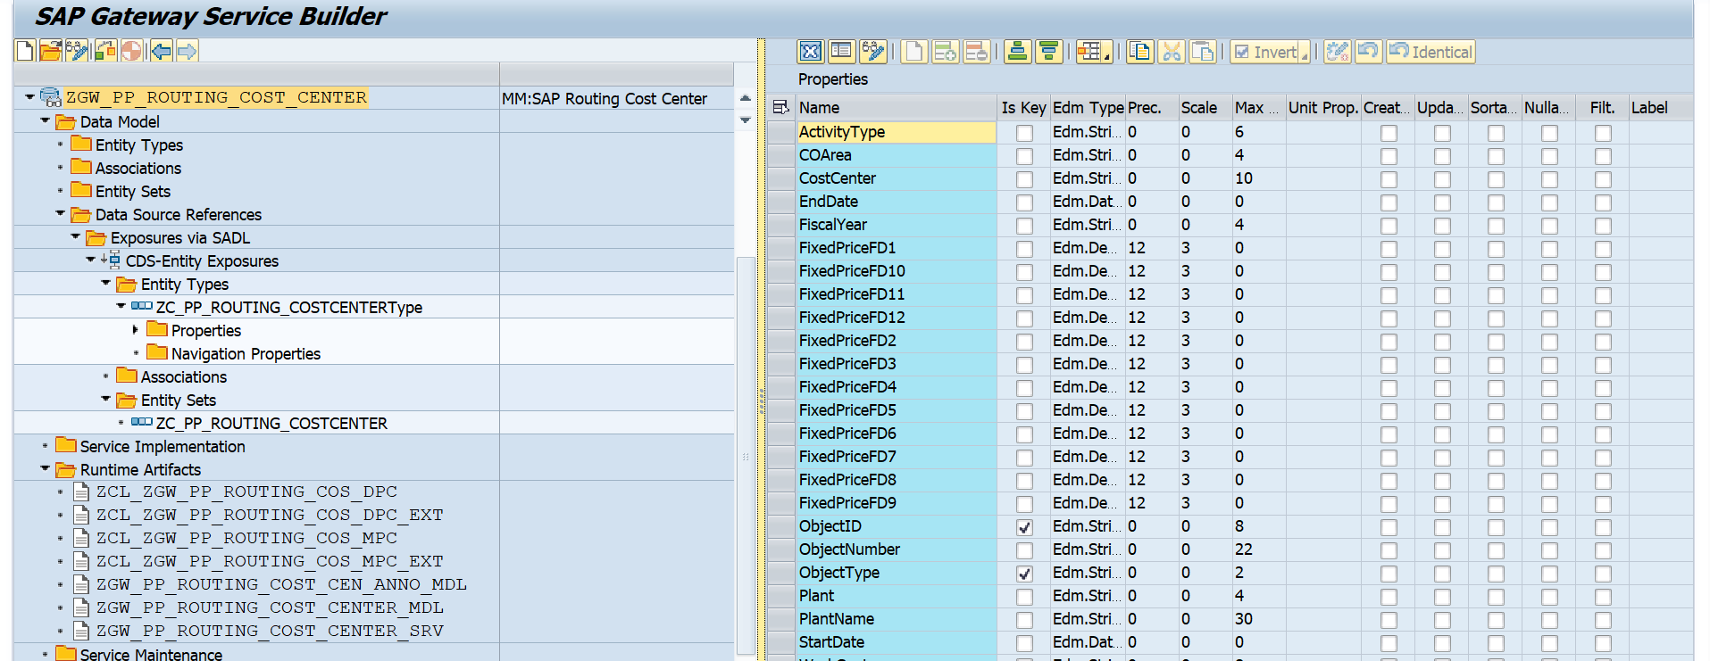
Entity Sets: ZC_PP_ROUTING_COSTCENTER

4.Testing API with Payload and Testing screen’s Screenshot.
Test scenarios in SAP Gateway Server:
Case 1: Fetch all the existing Details From SAP.
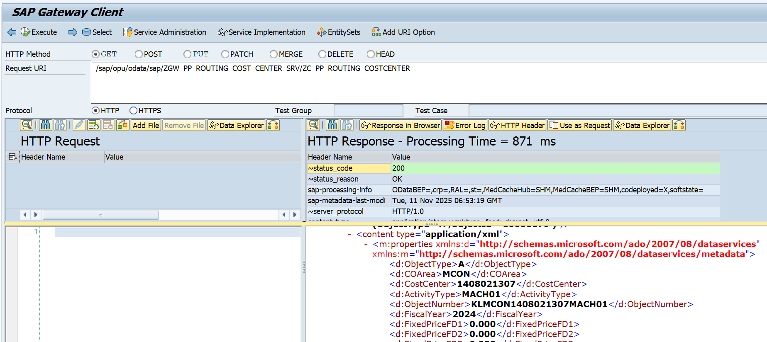
API: /sap/opu/odata/sap/ZGW_PP_ROUTING_COST_CENTER_SRV/ZC_PP_ROUTING_COSTCENTER

Case 2: Fetch based on Plant.
2.1: Based on Single Plant Criteria.
Plant (Plant) = 3001
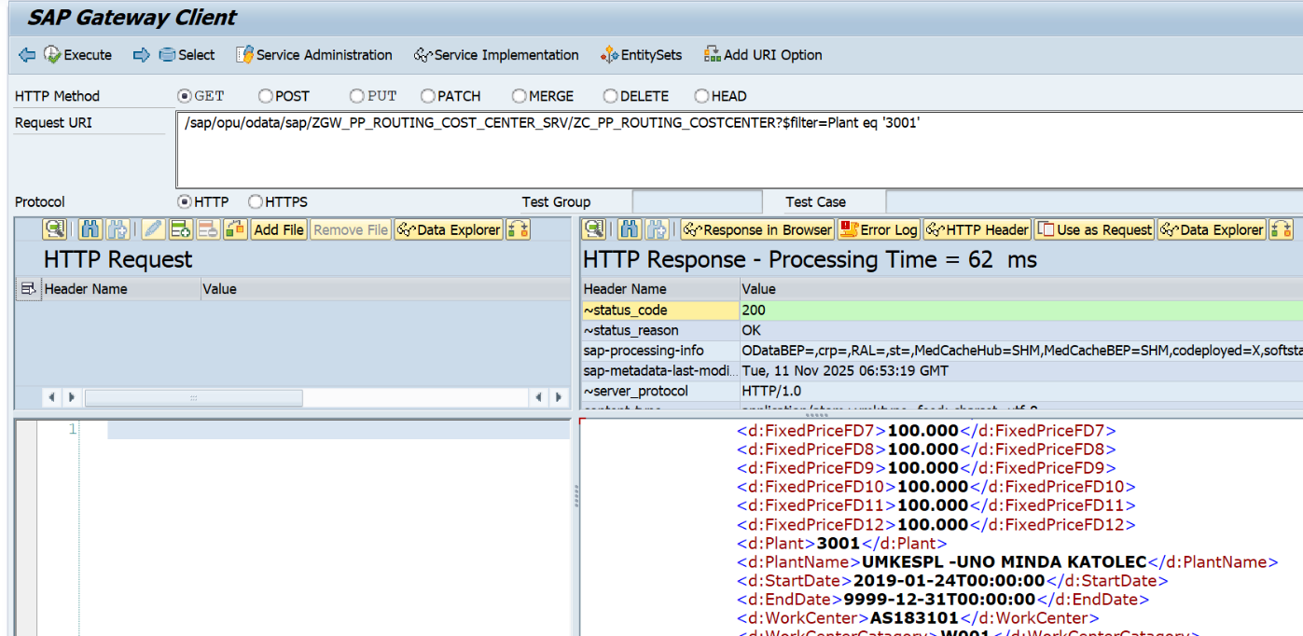
API: /sap/opu/odata/sap/ZGW_PP_ROUTING_COST_CENTER_SRV/ZC_PP_ROUTING_COSTCENTER?$filter=Plant eq '3001'

2.2: Based on Multiple Plant Input.
Plant = 3001,1715,1502
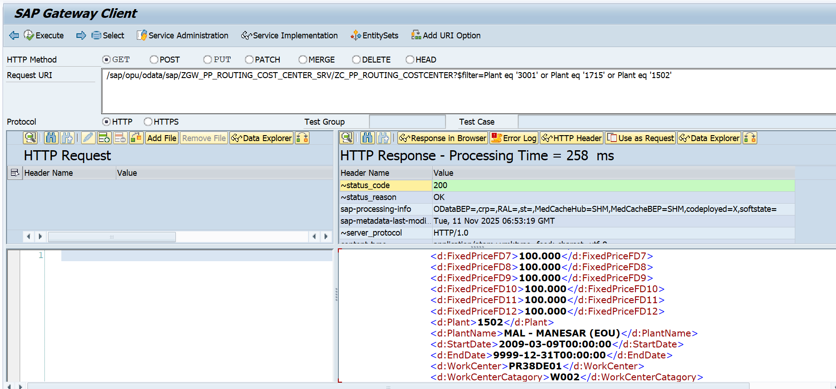
API: /sap/opu/odata/sap/ZGW_PP_ROUTING_COST_CENTER_SRV/ZC_PP_ROUTING_COSTCENTER/$count?$filter=Plant eq '3001' or Plant eq '1715' or Plant eq '1502'

2.3: Based on Range Plant Input.
Plant = From 1715 to 3001
API: /sap/opu/odata/sap/ZGW_PP_ROUTING_COST_CENTER_SRV/ZC_PP_ROUTING_COSTCENTER?$filter=Plant ge '1715' and Plant le '3001'
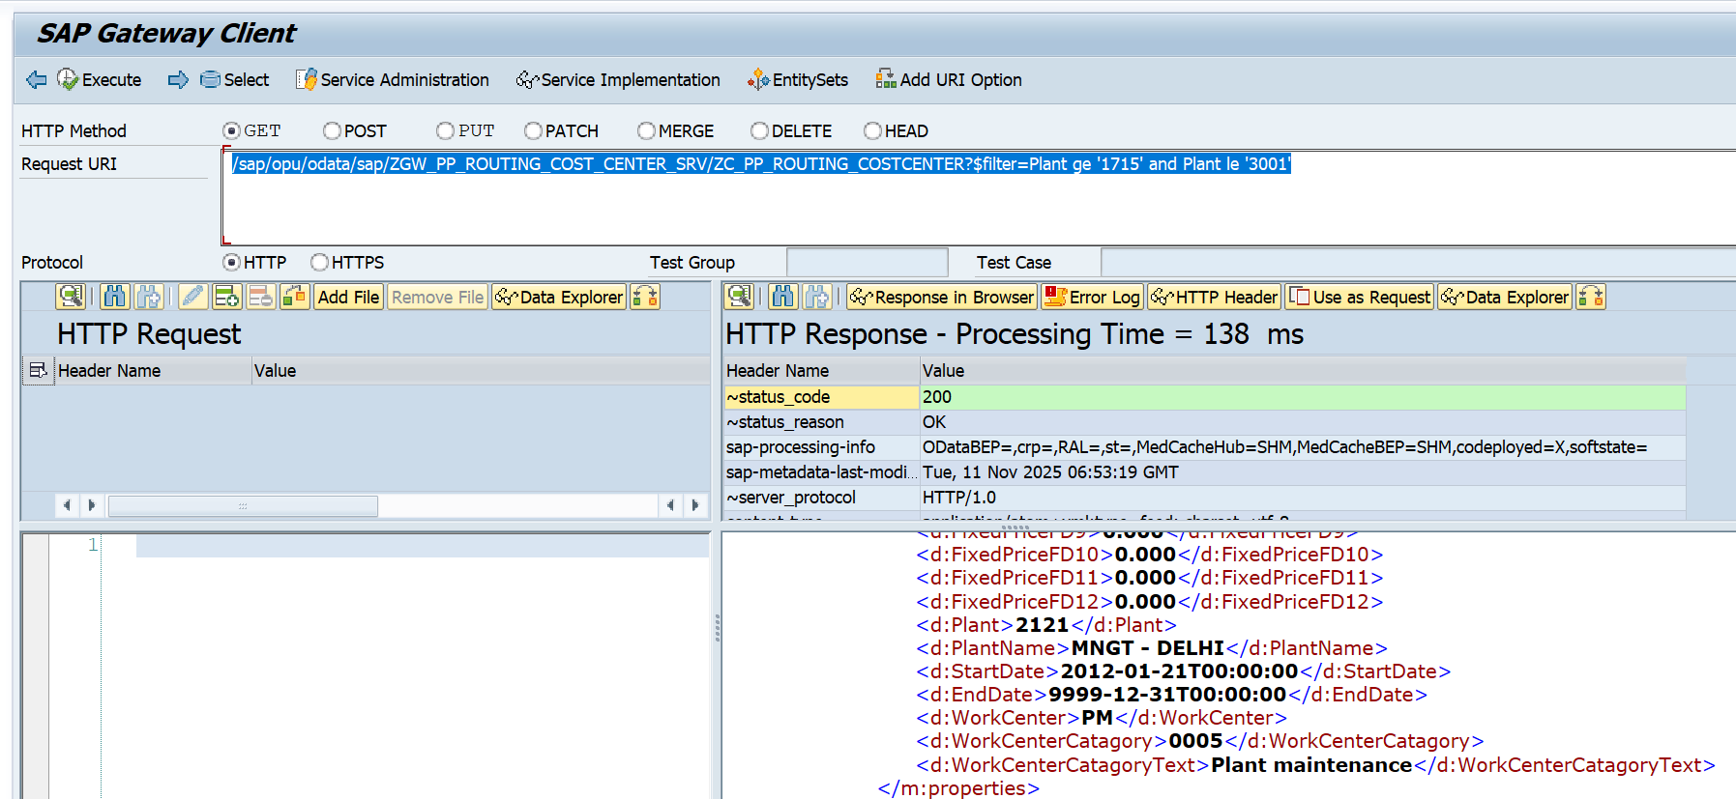

Test scenarios in Postman:
When we are trying to deal with SAP API’S in postman, we have to Maintain the SAP user is & password in Authorization section’s Basic auth in order to avoid the Unauthorized error. Some time you have passed correct user id and password and still you are getting the same issue then maintain sap-client & client value in below format to avoid such kind of error.
User id & password
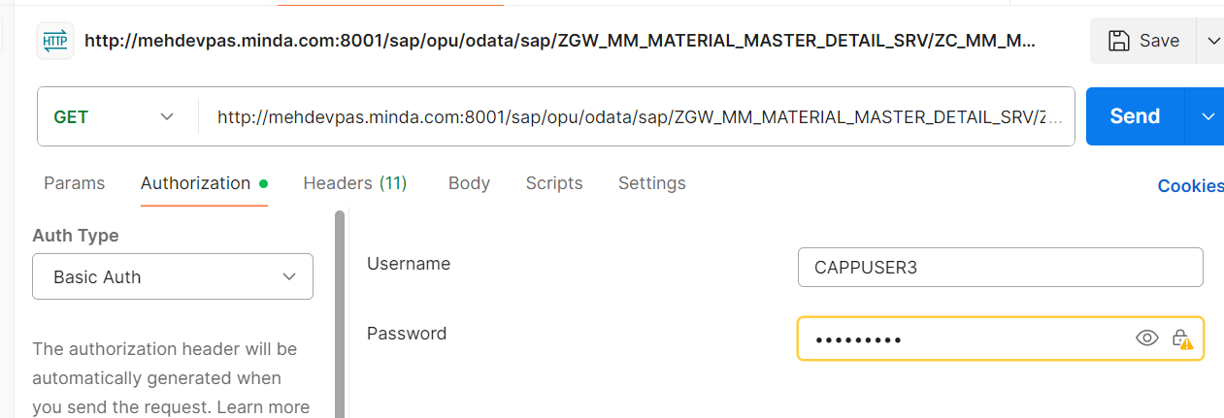

SAP client also for fetch CSRF Token used for CUD operation.
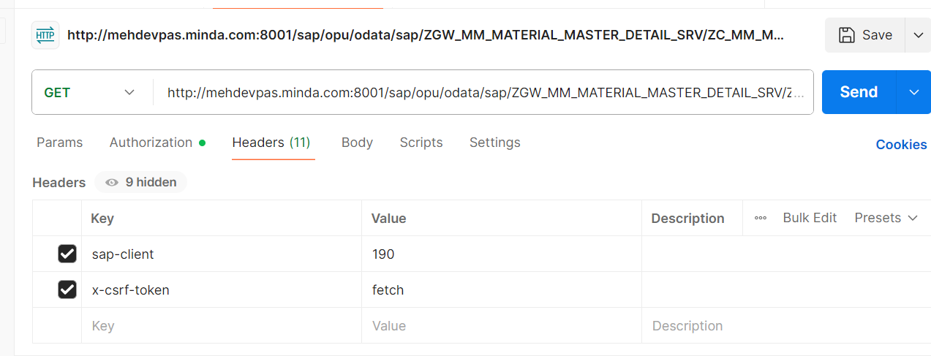

Case 1: Fetch all the existing Details From SAP.
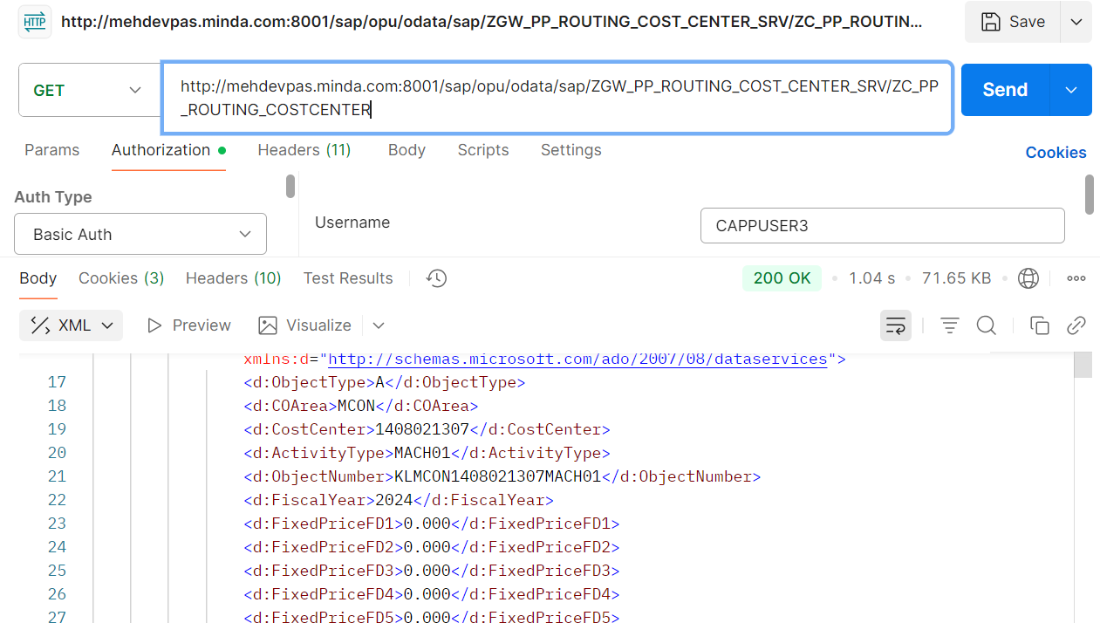
API: http://mehdevpas.minda.com:8001/sap/opu/odata/sap/ZGW_PP_ROUTING_COST_CENTER_SRV/ZC_PP_ROUTING_COSTCENTER

Case 2: Fetch based on Plant.
2.1: Based on Single Plant Criteria.
Plant (Plant) = 3001
API: http://mehdevpas.minda.com:8001/sap/opu/odata/sap/ZGW_PP_ROUTING_COST_CENTER_SRV/ZC_PP_ROUTING_COSTCENTER?$filter=Plant eq '3001'
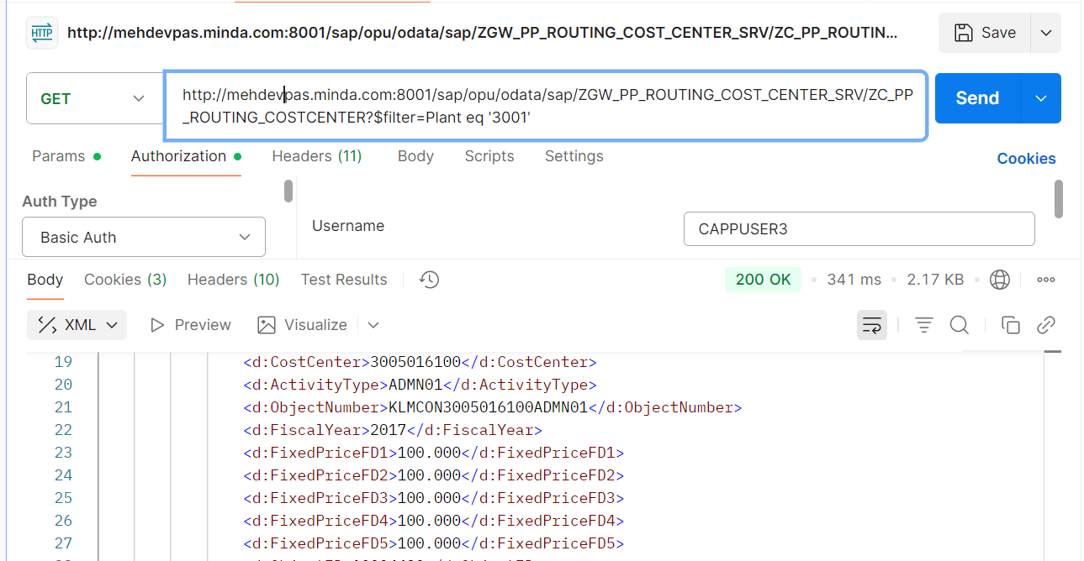
2.2: Based on Multiple Plant Input.
Plant = 3001,1715,1502
API: http://mehdevpas.minda.com:8001/sap/opu/odata/sap/ZGW_PP_ROUTING_COST_CENTER_SRV/ZC_PP_ROUTING_COSTCENTER?$filter=Plant eq '3001' or Plant eq '1715' or Plant eq '1502'
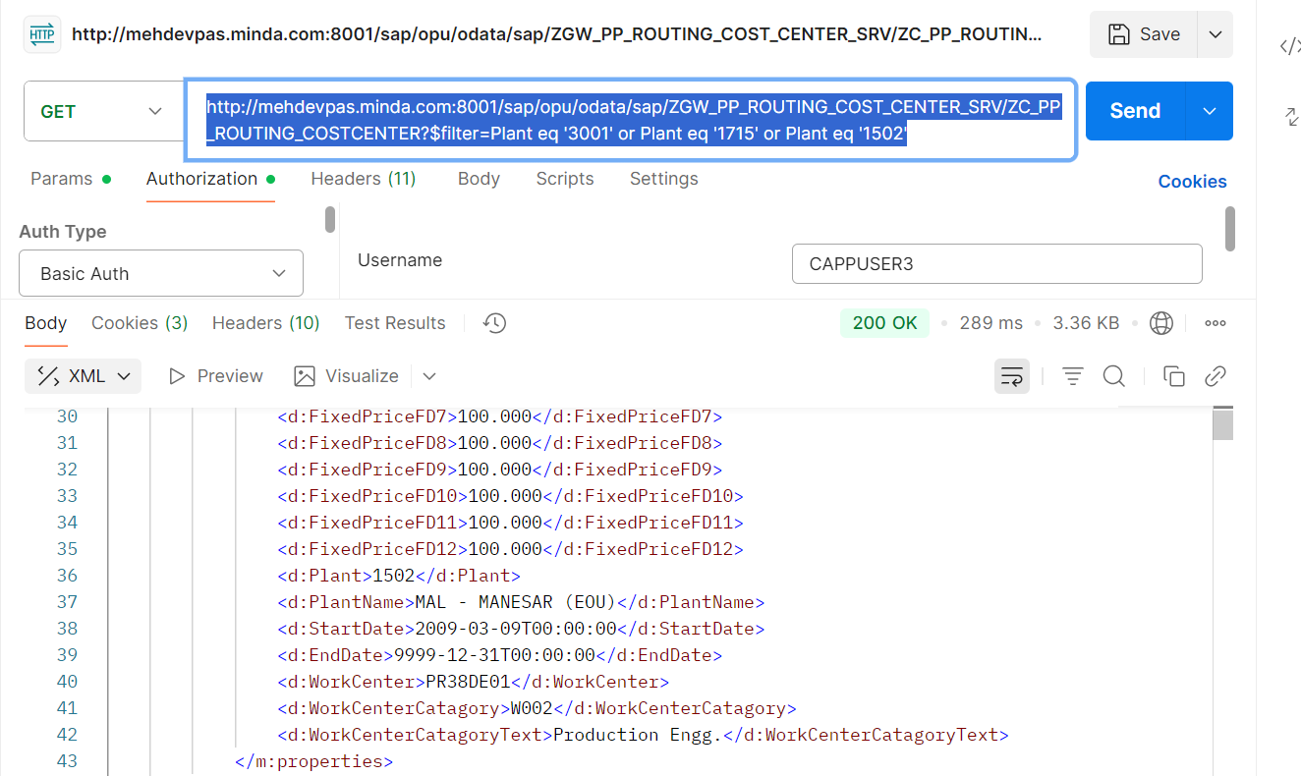
2.3: Based on Range Plant Input.
Plant = From 1715 to 3001
API: http://mehdevpas.minda.com:8001/sap/opu/odata/sap/ZGW_PP_ROUTING_COST_CENTER_SRV/ZC_PP_ROUTING_COSTCENTER?$filter=Plant ge '1715' and Plant le '3001'
