Technical Specification Form
SAP QM Defect Type Data Integration from SAP to Third-Party Application API

Prepared By: Sayan Chakraborty (AIRDIT Software Solutions)

Technical specification content

- Business Requirement
- Development Tools
- Development Objects
- Table.
- CDS Data Definition.
- CDS Access Control
- SEGW – OData Project.
Business API / OData API and Output Screen

- Business Requirement:
Develop an Odata GET API for Defect Type Data Integration from SAP to Third-Party Application, where end user can pass the field KATALOGART = “9 constant” and the Date on Which Data Record Was Created (in range) as input and Get the Corresponding details.

Here in this development object, no need of authorization objects.

The following Details provided by Functional consultant in order to develop API:
Input parameters
KATALOGART= “9 constant”
E_DATUM= “date range”

Technical name | Description | Type | Length | Logic
KATALOGART | Catalog | CHAR | 1 | Fetch the data from QPCD table
CODEGRUPPE | Code Group | CHAR | 8 | Fetch the data from QPCD table
CODE | Code | CHAR | 4 | Fetch the data from QPCD table
VERSION | Version | CHAR | 6 | Fetch the data from QPCD table
GUELTIGAB | Valid From | DATS | 10 | Fetch the data from QPCD table
FEHLKLASSE | Defect Class | CHAR | 2 | Fetch the data from QPCD table
ERSTELLER | Created By | CHAR | 12 | Fetch the data from QPCD table
E_DATUM | Created On | DATS | 10 | Fetch the data from QPCD table
AENDERER | Changed By | CHAR | 12 | Fetch the data from QPCD table
A_DATUM | Changed On | DATS | 10 | Fetch the data from QPCD table
INAKTIV | Record inactive | CHAR | 1 | Fetch the data from QPCD table
VERWENDUNG | Record Used | CHAR | 1 | Fetch the data from QPCD table
GELOESCHT | Deleted record | CHAR | 1 | Fetch the data from QPCD table
FOLGEAKTI | Follow-Up Actn | CHAR | 8 | Fetch the data from QPCD table
GUELTIGAB | Valid From | DATS | 10 | Fetch the data from QPCD table
KURZTEXT | Short Text | CHAR | 40 | Fetch the data from QPCD table
LTEXTV | Long Text | CHAR | 1 | Fetch the data from QPCD table
INAKTIV | Record inactive | CHAR | 1 | Fetch the data from QPCD table
GELOESCHT | Deleted record | CHAR | 1 | Fetch the data from QPCD table

SAP Technical Cum Functional Specification Form

- User Story ID # |  | - Module | - QM
- Date | 13.11.2025 | - SL User
- Consultant | Bhaskar Joshi | - Developer
- Priority | - ☐Urgent ☒High ☐Medium ☐Low
- Application Type | ☐Report ☐Form ☐Interface ☒Enhancement/Change ☐Others
- Execute Model | - ☐Batch ☐ Foreground ☐Manual ☐Quarterly ☐Monthly  - ☐Weekly ☒ Daily ☐Real time
- Output Type | - ☐Message ☐Dialog Screen ☐ABAP List ☒ALV List ☐ALV Grid
- Remarks | - SAP QM Defect Type Data Integration from SAP to Third-Party Application

2.Development Status & Tools
For development these are the following tool used :
- Eclipse for ABAP /ADT(ABAP Development Tool)
- Interface/Basic CDS view:
Created on top of Required Database. Naming convention: ZI_*****
- Composite CDS view:
Created on top of Interface basic view for join/association. Naming convention: ZCO_*****
- Consumption view:
Expose only those field required for Business Requirement. Naming convention: ZC_*****

- SEGW OData Project
- Created OData project with “Data Source Reference” Using the consumption CDS view. Here in this CDS association has been done due to which in ODATA project all the association and navigation property generate automatically.
- For Service Registration used Tcode : /N/IWFND/MAINT_SERVICE.
- To Check the final data at Gateway Client used Tcode :/N/IWFND/GW_CLIENT.

3.Development Objects
- Table:
- QPCD: Inspection catalog codes
- QPCT: Code texts

- CDS Data Definition:
- Basic CDS View:
As I am following the VDM modeling in this development, I had created Basic CDS view on top of Database table and the source of Basic View Should be a Database View or Standard CDS view.
- Table: QPCD: Inspection catalog codes
- CDS View Name: ZI_QM_DEFECTTYPEDATA
- //---------------------------------------------------------------//
- //Created By: Sayan Chakraborty(9000Rupesh): AIRDIT Software
- //--------------------------------------------------------------//
- @AbapCatalog.sqlViewName: 'ZIQPCD'
- @AbapCatalog.compiler.compareFilter: true
- @AbapCatalog.preserveKey: true
- @AccessControl.authorizationCheck: #NOT_REQUIRED
- @EndUserText.label: 'Basic view:QPCD:Defective Type Data'
- @Metadata.ignorePropagatedAnnotations: true
- @VDM.viewType: #BASIC
- @ObjectModel.usageType: {
- serviceQuality: #X,
- sizeCategory: #S,
- dataClass: #MIXED
- }
- define view ZI_QM_DEFECTTYPEDATA
- as select from qpcd
- {
- key katalogart as katalogart,
- key codegruppe as CodeGroup,
- key code as Code,
- key version as Version,
- gueltigab as ValidFrom,
- fehlklasse as DefectClass,
- ersteller as CreatedBy,
- e_datum as CreatedOn,
- aenderer as ChangedBy,
- a_datum as ChangedOn,
- inaktiv as Recordinactive,
- verwendung as RecordUsed,
- geloescht as Deletedrecord,
- folgeakti as FollowUpActn

- }

- Composite CDS view
As I am following the VDM modeling in this development, I had created Composite CDS view on top of Basic View where I will do all the necessary Joins/association needed for the Current Business Requirement.

- CDS Name: ZCO_QM_DEFECTTYPEDATA
- Description: Composite View: Defect Type Data
- //---------------------------------------------------------------//
- //Created By: Sayan Chakraborty(9000Rupesh): AIRDIT Software
- //--------------------------------------------------------------//
- @AbapCatalog.sqlViewName: 'ZCOQCPD'
- @AbapCatalog.compiler.compareFilter: true
- @AbapCatalog.preserveKey: true
- @AccessControl.authorizationCheck: #NOT_REQUIRED
- @EndUserText.label: 'Composite View:Defect Type Data'
- @Metadata.ignorePropagatedAnnotations: true
- @VDM.viewType: #COMPOSITE

- define view ZCO_QM_DEFECTTYPEDATA
- as select from ZI_QM_DEFECTTYPEDATA
- left outer join qpct as QPCT on QPCT.katalogart = ZI_QM_DEFECTTYPEDATA.katalogart
- and QPCT.codegruppe = ZI_QM_DEFECTTYPEDATA.CodeGroup
- and QPCT.code = ZI_QM_DEFECTTYPEDATA.Code
- and QPCT.version = ZI_QM_DEFECTTYPEDATA.Version
- and QPCT.sprache = $session.system_language

- {
- key ZI_QM_DEFECTTYPEDATA.katalogart,
- key ZI_QM_DEFECTTYPEDATA.CodeGroup,
- key ZI_QM_DEFECTTYPEDATA.Code,
- key ZI_QM_DEFECTTYPEDATA.Version,
- ZI_QM_DEFECTTYPEDATA.ValidFrom,
- ZI_QM_DEFECTTYPEDATA.DefectClass,
- ZI_QM_DEFECTTYPEDATA.CreatedBy,
- ZI_QM_DEFECTTYPEDATA.CreatedOn,
- ZI_QM_DEFECTTYPEDATA.ChangedBy,
- ZI_QM_DEFECTTYPEDATA.ChangedOn,
- ZI_QM_DEFECTTYPEDATA.Recordinactive,
- ZI_QM_DEFECTTYPEDATA.RecordUsed,
- ZI_QM_DEFECTTYPEDATA.Deletedrecord,
- ZI_QM_DEFECTTYPEDATA.FollowUpActn,
- QPCT.kurztext as ShortText,
- QPCT.ltextv as LongText
- }

- Consumption CDS view
As I am following the VDM modeling in this development, I had created Consumption CDS view on top of Composite CDS View where I had added all the field which are need to Expose as per the Business Requirement.

- CDS View name: ZC_QM_DEFECTTYPEDATA
- Description: Consumption View:Defect Type Data'
- //---------------------------------------------------------------//
- //Created By: Sayan Chakraborty(9000Rupesh): AIRDIT Software
- //--------------------------------------------------------------//
- @AbapCatalog.sqlViewName: 'ZCQCPD'
- @AbapCatalog.compiler.compareFilter: true
- @AbapCatalog.preserveKey: true
- @AccessControl.authorizationCheck: #NOT_REQUIRED
- @EndUserText.label: 'Consumption view:Defect Type Data'
- @Metadata.ignorePropagatedAnnotations: true
- @VDM.viewType: #CONSUMPTION
- define view ZC_QM_DEFECTTYPEDATA
- as select from ZCO_QM_DEFECTTYPEDATA
- {
- key katalogart,
- key CodeGroup,
- key Code,
- key Version,
- ValidFrom,
- DefectClass,
- CreatedBy,
- CreatedOn,
- ChangedBy,
- ChangedOn,
- Recordinactive,
- RecordUsed,
- Deletedrecord,
- FollowUpActn,
- ShortText,
- LongText
- }

- SEGW OData Project
Project Name: ZGW_QM_DEFECT_TYPE_DATA
Project Service Name: ZGW_QM_DEFECT_TYPE_DATA_SRV

Entity Type: ZC_QM_DEFECTTYPEDATAType
Entity Sets: ZC_QM_DEFECTTYPEDATA
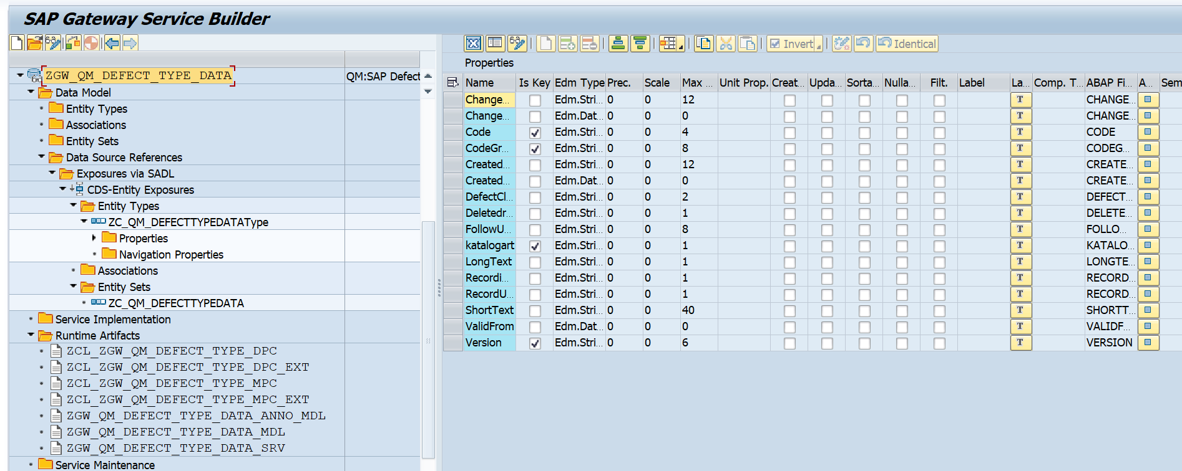

4.Business API / OData API and Output Screen
Based on FS I have added filter condition based on KATALOGART = “9 constant” and E_Datum (the Date on Which Data Record Was Created ) and below are the technical name at Entity Type
- Katalogart
- CreatedOn

Test Case
Here all the test case tested with a Date range from 02.12.2024 to 03.12.2025.
Case 1: Date Range 02.12.2024 to 03.12.2025.
API: /sap/opu/odata/sap/ZGW_QM_DEFECT_TYPE_DATA_SRV/ZC_QM_DEFECTTYPEDATA?$filter=katalogart eq '9' and CreatedOn ge datetime'2024-12-02T00:00:00' and CreatedOn le datetime'2025-12-03T00:00:00'

Postman API :
http://mehdevpas.minda.com:8001/sap/opu/odata/sap/ZGW_QM_DEFECT_TYPE_DATA_SRV/ZC_QM_DEFECTTYPEDATA?$filter=katalogart eq '9' and CreatedOn ge datetime'2024-12-02T00:00:00' and CreatedOn le datetime'2025-12-03T00:00:00'

GUI Screen
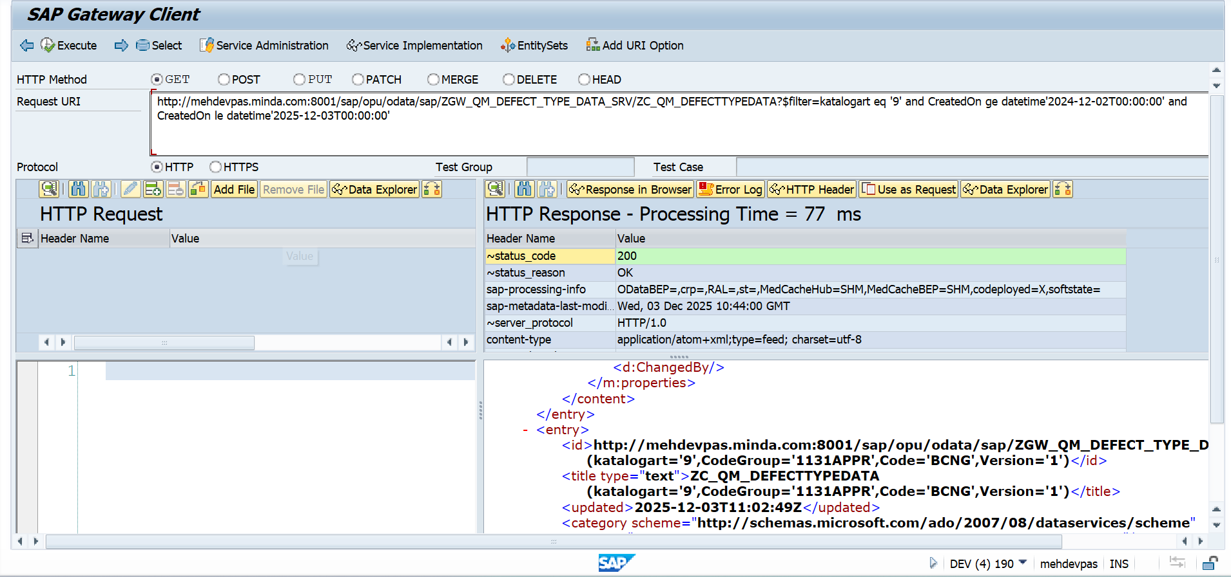

Number of Records For the API
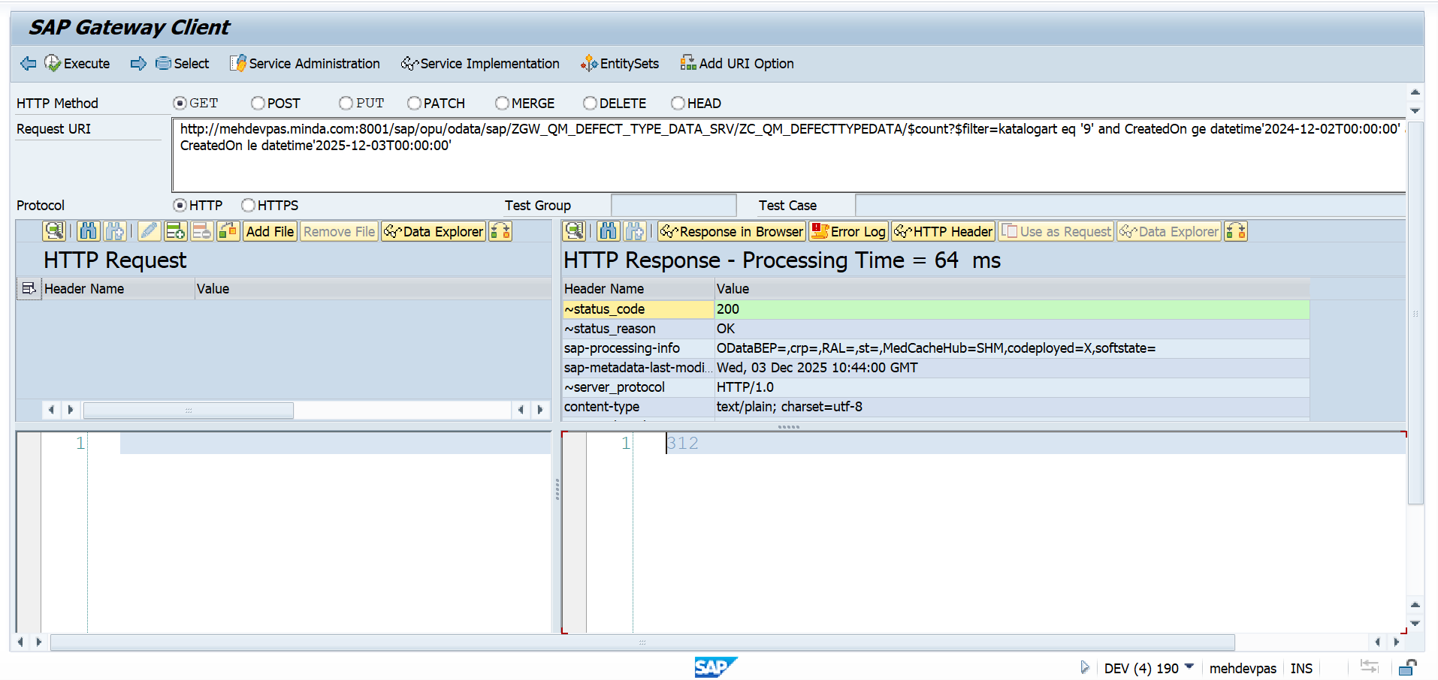

Database Level Check :
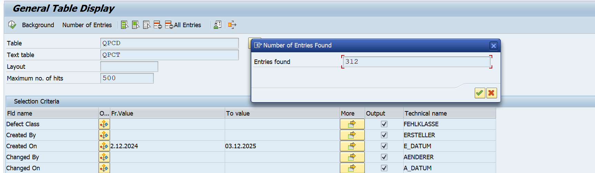

Case 2: Single Date

CreatedOn : 02.12.2024

Gateway API:
/sap/opu/odata/sap/ZGW_QM_DEFECT_TYPE_DATA_SRV/ZC_QM_DEFECTTYPEDATA/$count?$filter=katalogart eq '9' and CreatedOn eq datetime'2024-12-02T00:00:00'

Postman API:
http://mehdevpas.minda.com:8001/sap/opu/odata/sap/ZGW_QM_DEFECT_TYPE_DATA_SRV/ZC_QM_DEFECTTYPEDATA?$filter=katalogart eq '9' and CreatedOn eq datetime'2024-12-02T00:00:00'

Database Level:
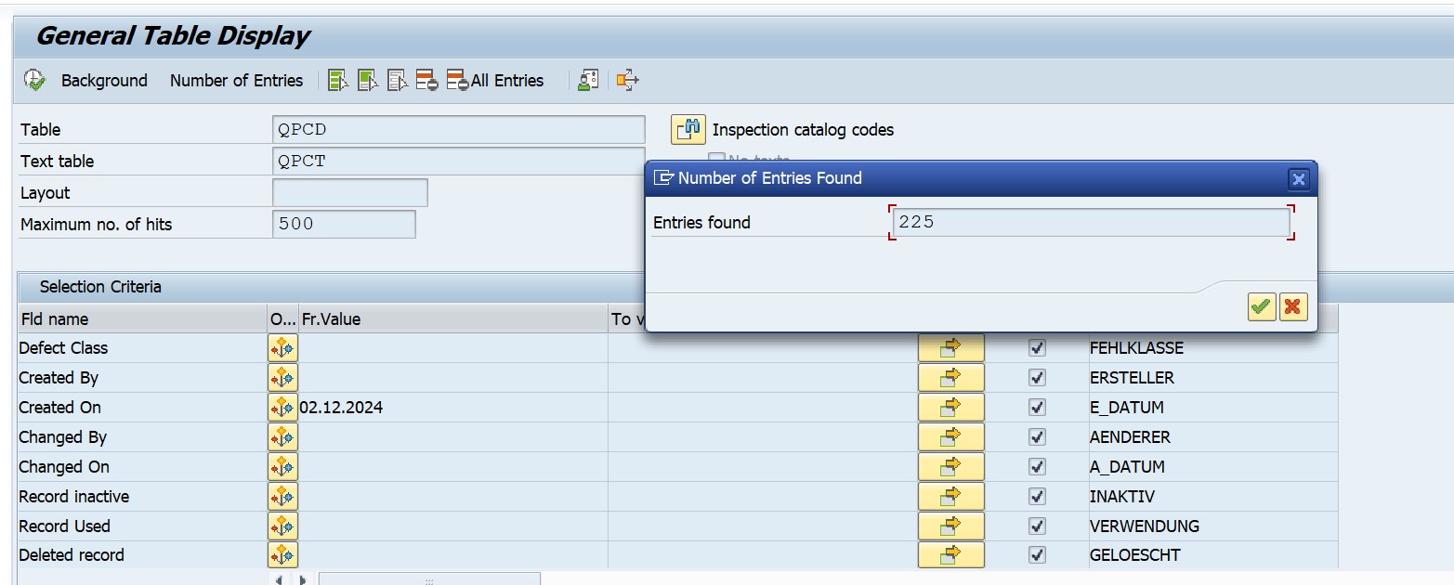

Gateway Level
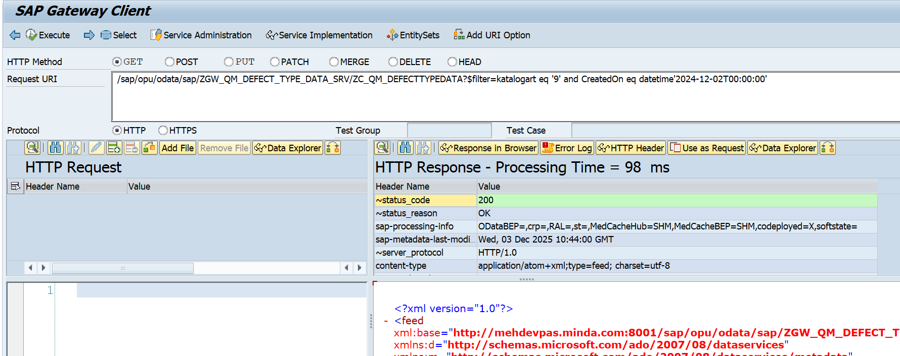

Postman Screen

