Technical Specification Form
PROJECT: SAP PURCHASE ORDER GOODS RECIEPT

SAP Technical Specification Form

- User Story ID # | - 9000RUPESH | - Module | - PP
- Date | 24-11-2025 | - SL User
- Consultant |  | - Developer | - Debidutta swain
- Priority | - ☐Urgent ☐High ☒Medium ☐Low
- Application Type | ☐Report ☐Form ☐Interface ☒ODATA ☐Others
- Execute Model | - ☐Batch ☐ Foreground ☐Manual ☐Quarterly ☐Monthly  - ☐Weekly ☐ Daily ☒Real time
- Output Type | - ☐Message ☐Dialog Screen ☐ABAP List ☒List View ☐ALV Grid
- Remarks | - SAP PURCHASE ORDER GOODS RECIEPT

Technical specification content

- Business Requirement
- Development Tools
- Development Objects
- Function Module
- DDIC Structure
- SEGW – OData Project.
- Business API / OData API with Payload
- Positive and Negative Testing Screenshot

- Business Requirement:
Develop an OData POST API to perform SAP purchase order goods receipt.

Based on this following FS detail, I have done the Object Development to Meet Business requirement.
1: Conditions check: This field used in case of production order transfer posting

If following data not available system will give the error “Gate entry data mismatched”
1: Gate Entry No
2: Gate entry year
4: Amount

2: If data available then system run following BAPI
Run the BAPI: BAPI_GOODSMVT_CREATE

GOODSMVT_HEADER = PSTNG_DATE = “System date”
DOC_DATE= “System Date”
REF_DOC_NO = “INVOICE NUMBER”
HEADER_TXT = “CONSTANT= MES POSTING”
GOODSMVT_CODE = “01”

Tables:

GOODSMVT_ITEM: PLANT = " MES GIVE "

STGE_LOC = " MES GIVE"
MOVE_TYPE = "Constant= 101"
ENTRY_QNT = " MES GIVE "

ENTRY_UOM = "MES GIVE"
PO_NUMBER = "MES GIVE”
PO_ITEM = "MES GIVE
MVT_IND = " Constant= B"
PROD_DATE = “ Posting date”
STK_SEGMENT = “ MES GIVEN”

3: After commit SAVE the following data in table ZTMM01003_MIGO

Material Document, Material Doc. Year, Gate Entry No, Gate entry year, Plant, Amount

2.Development Tools :
For development these are the following tool used:
- OData Project
- Created OData project with SEGW T-code. Here I have used IMPORT from DDIC structure for Data modeling and Redefine the Create Deep Entities Method to Achieve our Business Requirement .
- For Service Registration used T-code: /O/IWFND/MAINT_SERVICE
- To Check the final data at Gateway Client used T-code :/O/IWFND/GW_CLIENT

3.Development Objects :

- Function Module:
1.BAPI Name: BAPI_GOODSMVT_CREATE
Description: Post Goods Movements with MB_CREATE_GOODS_MOVEMENT

2. BAPI_TRANSACTION_COMMIT

- DDIC Structure:
Header
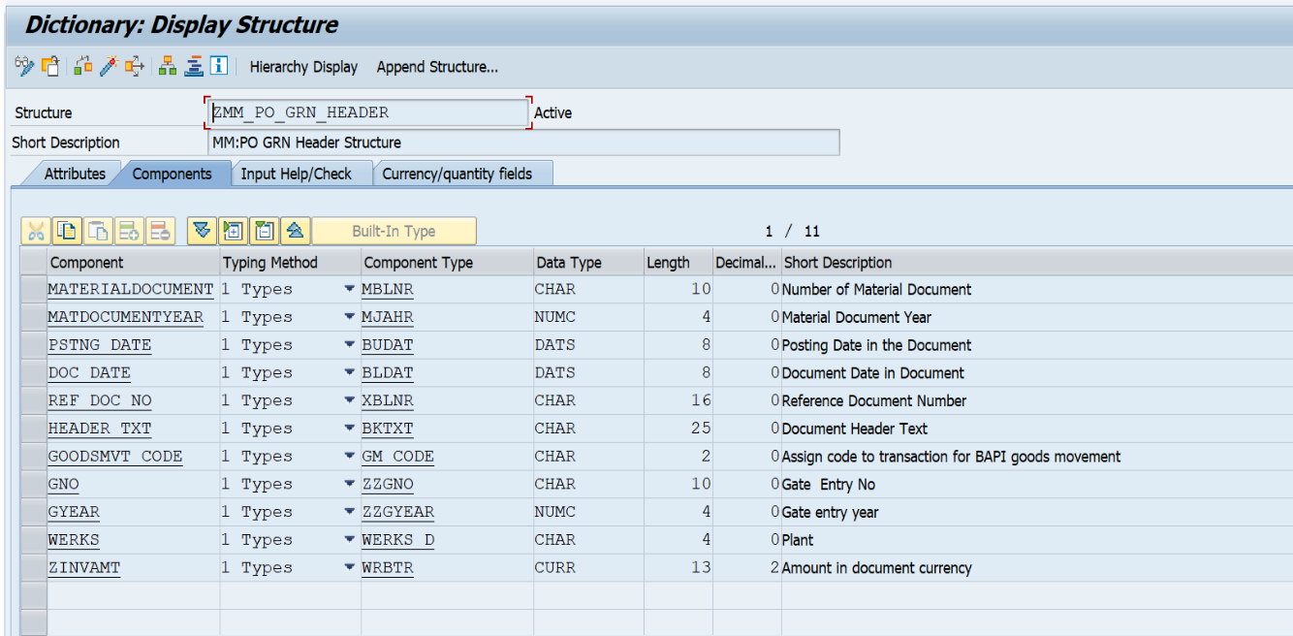
Structure Name: ZMM_PO_GRN_HEADER
Description: MM:PO GRN Header Structure

ITEM
Structure name: ZMM_PO_GRN_ITEM
Description: MM:PO GRN Item Structure
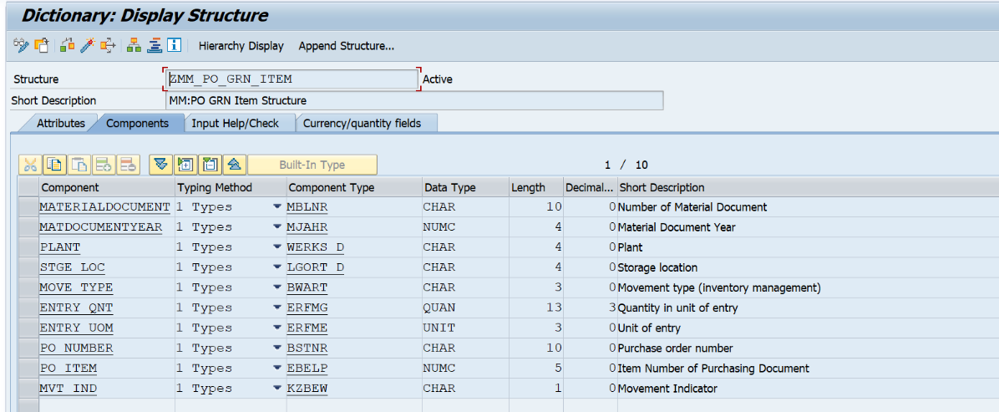

- SEGW – OData Project:
Project Name: ZGW_MM_PO_GR_POSTING
Service Name: ZGW_MM_PO_GR_POSTING_SRV
Entities Type:
- POHeader
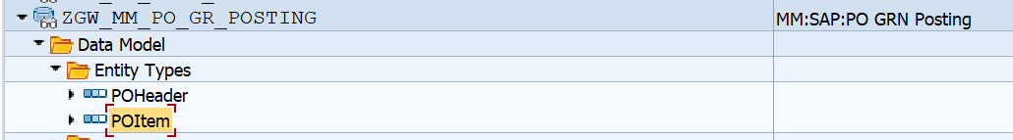
- POItem

Entity sets:
- POHeaderSet
- POItemSet
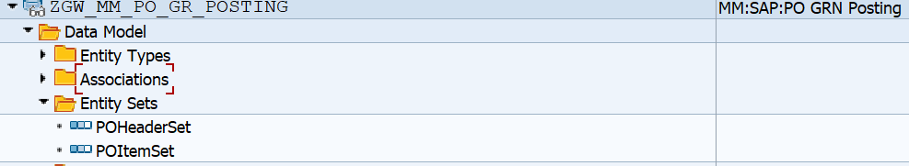
Association:
Basically, Association is done in ODATA to create the relationship in between header and item Entity.
For more idea about how to create association please click here and check the step from 1 to 5.
Association Name: HeaderToItem
Referential Constraints: Materialdocument & Matdocumentyear
Navigation Properties: to_item

Note: Referential Constraints means based on Which Relation is Established in between Header and Item Entity Set.
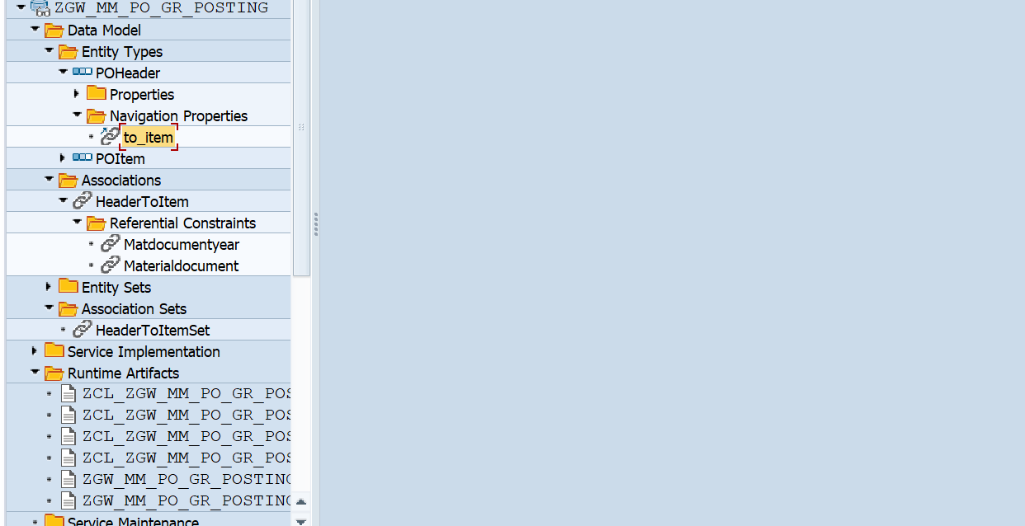

Navigation Properties:

When we do Parent child relation in SEGW Odata project, one Navigation property also got created at the time of Create Association and this navigation property will help us to:
- navigate from Header details to Item details at the time of GET operation
- Carries item details with header details at the time of POST operation.


Also, it is needed at the time of deep entity modeling at MPC_EXT Class, otherwise it will not Carrey the item detail from outside sap system. Always navigation Property comes under Header Entity after successfully creation of Association.

Runtime Artifacts
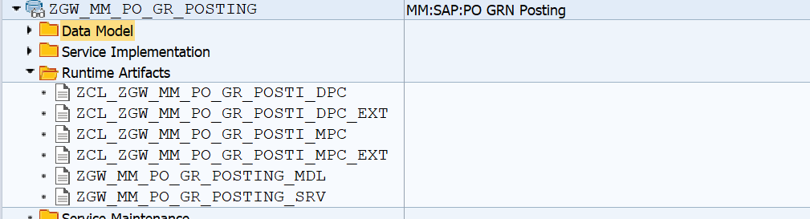
Here 6 Runtime Artifices to create after Generating the Project.

Here the operation is handled through “CREATE_DEEP_ENTITY”. so, for that I had followed the following steps:

step: 1

- Go to Runtime Artifacts node, open the ZCL_ZGW_MM_PO_GR_POSTI_MPC_EXT class in ABAP Workbench & click on the Types tab.
- Click on Change button for edit.
- Click on the Direct Type Entity Button. Then create deep entity & activate.
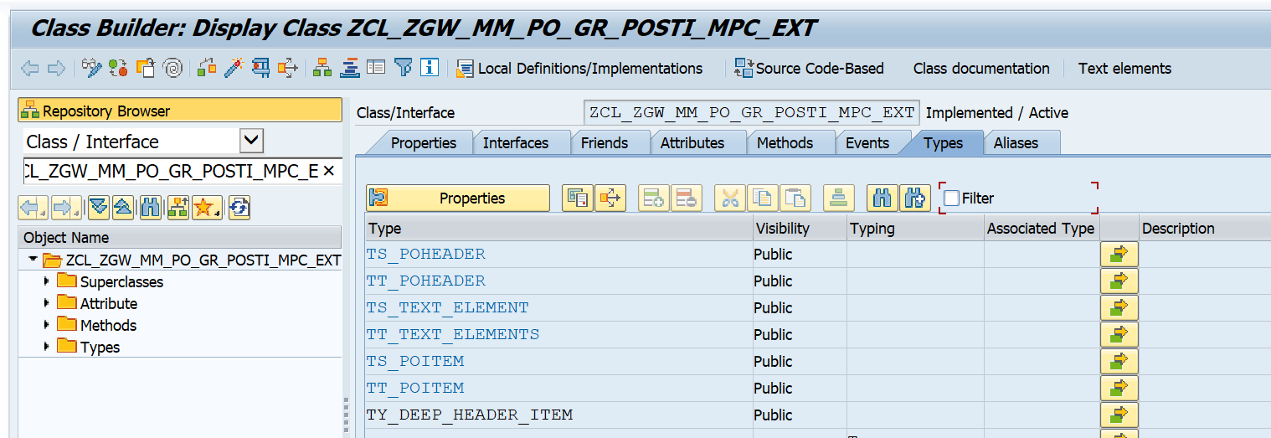

Business Logic:

- CLASS zcl_zgw_mm_po_gr_posti_mpc_ext DEFINITION
PUBLIC
INHERITING FROM zcl_zgw_mm_po_gr_posti_mpc
CREATE PUBLIC .
PUBLIC SECTION.
TYPES:BEGIN OF ty_deep_header_item ,
materialdocument TYPE mblnr,
matdocumentyear TYPE mjahr,
pstng_date TYPE budat,
doc_date TYPE bldat,
ref_doc_no TYPE xblnr,
header_txt TYPE bktxt,
goodsmvt_code TYPE gm_code,
gno TYPE zzgno,
gyear TYPE zzgyear,
werks TYPE werks_d,
zinvamt TYPE wrbtr,
* Navigation property name should be used otherwise empty records will be shown In all API operations
to_item TYPE TABLE OF ts_poitem WITH DEFAULT KEY,
END OF ty_deep_header_item.
METHODS define
REDEFINITION .

Step: 2

Redefine the DEFINE method of the ZCL_ZGW_MM_PO_GR_POSTI_MPC_EXT and Enter the below code.
Business Logic Under Define Method.
METHOD define.
super->define( ).
DATA:lo_entity_type TYPE REF TO /iwbep/if_mgw_odata_entity_typ.
lo_entity_type = model->get_entity_type( iv_entity_name = 'POHeader' ).
lo_entity_type->bind_structure(
EXPORTING
iv_structure_name = 'ZCL_ZGW_MM_PO_GR_POSTI_MPC_EXT=>TY_DEEP_HEADER_ITEM'
).
ENDMETHOD.

Step: 3

Go to the ZCL_ZGW_MM_PO_GR_POSTI_DPC_EXT class & redefine the method: CREATE_DEEP_ENTITY

- METHOD /iwbep/if_mgw_appl_srv_runtime~create_deep_entity.
IF iv_entity_name = 'POHeader'.
DATA: ls_dataprovider TYPE zcl_zgw_mm_po_gr_posti_mpc_ext=>ty_deep_header_item,
ls_poheader TYPE zcl_zgw_mm_po_gr_posti_mpc_ext=>ts_poheader,
lt_poitem TYPE TABLE OF zcl_zgw_mm_po_gr_posti_mpc_ext=>ts_poitem.
DATA: ls_ztmm01003_migo TYPE ztmm01003_migo.
DATA:ls_goodsmvt_header TYPE bapi2017_gm_head_01,
ls_goodsmvt_code TYPE bapi2017_gm_code,
ls_goodsmvt_item TYPE bapi2017_gm_item_create,
lt_goodsmvt_item TYPE TABLE OF bapi2017_gm_item_create,
lt_return TYPE TABLE OF bapiret2,
ls_return TYPE bapiret2,
ls_goodsmvt_headret TYPE bapi2017_gm_head_ret,
lv_materialdocument TYPE bapi2017_gm_head_ret-mat_doc,
lv_matdocumentyear TYPE bapi2017_gm_head_ret-doc_year,
lv_success_message TYPE bapi_msg.
DATA: lo_message TYPE REF TO /iwbep/if_message_container.
lo_message = mo_context->get_message_container( ).
CONSTANTS: lc_goodsmvt_code TYPE bapi2017_gm_code VALUE '01',
lc_movetype TYPE bwart VALUE '101',
lc_mvt_ind TYPE kzbew VALUE 'B',
lc_header_txt TYPE bktxt VALUE 'MES Posting'.
CLEAR: ls_dataprovider,ls_goodsmvt_code,ls_goodsmvt_header,ls_goodsmvt_item,
ls_goodsmvt_headret,lv_matdocumentyear,lv_materialdocument,ls_return,
lv_success_message.
REFRESH :lt_poitem,lt_return,lt_goodsmvt_item.
"--> Get the Requested Payload Details.
io_data_provider->read_entry_data(
IMPORTING
es_data = ls_dataprovider ).
IF ls_dataprovider IS NOT INITIAL.
"--> Check the validation "Gate entry data mismatched".
IF ls_dataprovider-gno IS NOT INITIAL AND ls_dataprovider-gyear IS NOT INITIAL AND
ls_dataprovider-werks IS NOT INITIAL AND ls_dataprovider-zinvamt IS NOT INITIAL.
ls_goodsmvt_header = CORRESPONDING #( ls_dataprovider ).
ls_goodsmvt_header-header_txt = lc_header_txt.
ls_goodsmvt_code = lc_goodsmvt_code.
lt_poitem = CORRESPONDING #( ls_dataprovider-to_item ).
LOOP AT lt_poitem INTO DATA(ls_poitem).
ls_goodsmvt_item = CORRESPONDING #( ls_poitem ).
ls_goodsmvt_item-move_type = lc_movetype.
ls_goodsmvt_item-mvt_ind = lc_mvt_ind.
APPEND ls_goodsmvt_item TO lt_goodsmvt_item.
ENDLOOP.
CALL FUNCTION 'BAPI_GOODSMVT_CREATE'
EXPORTING
goodsmvt_header = ls_goodsmvt_header
goodsmvt_code = ls_goodsmvt_code
IMPORTING
goodsmvt_headret = ls_goodsmvt_headret
materialdocument = lv_materialdocument
matdocumentyear = lv_matdocumentyear
TABLES
goodsmvt_item = lt_goodsmvt_item
return = lt_return.
IF ls_goodsmvt_headret IS NOT INITIAL.
CALL FUNCTION 'BAPI_TRANSACTION_COMMIT'
EXPORTING
wait = abap_true
IMPORTING
return = ls_return.
IF ls_return IS INITIAL.
"--> Cretae Record in ZTMM01003_MIGO table.
ls_ztmm01003_migo-mandt = sy-mandt.
ls_ztmm01003_migo-mblnr = lv_materialdocument.
ls_ztmm01003_migo-mjahr = lv_matdocumentyear.
ls_ztmm01003_migo-gno = ls_dataprovider-gno.
ls_ztmm01003_migo-gyear = ls_dataprovider-gyear.
ls_ztmm01003_migo-werks = ls_dataprovider-werks.
ls_ztmm01003_migo-zinvamt = ls_dataprovider-zinvamt.
IF ls_ztmm01003_migo IS NOT INITIAL.
INSERT ztmm01003_migo FROM ls_ztmm01003_migo.
ENDIF.
ls_dataprovider-materialdocument = lv_materialdocument.
ls_dataprovider-matdocumentyear = lv_matdocumentyear.
LOOP AT ls_dataprovider-to_item ASSIGNING FIELD-SYMBOL(<fs_data>).
<fs_data>-materialdocument = lv_materialdocument.
<fs_data>-matdocumentyear = lv_matdocumentyear.
ENDLOOP.
copy_data_to_ref(
EXPORTING
is_data = ls_dataprovider
CHANGING
cr_data = er_deep_entity ).
lv_success_message = |Material Document '{ lv_materialdocument }' Cretaed Successfully.|.
lo_message->add_message_text_only(
EXPORTING
iv_msg_type = /iwbep/cl_cos_logger=>success " Message Type
iv_msg_text = lv_success_message " MESSAGE TEXT
iv_add_to_response_header = abap_true " Add the message to the header
).
ENDIF.
ELSE.
IF lt_return IS NOT INITIAL.
lo_message->add_messages_from_bapi(
EXPORTING
it_bapi_messages = lt_return
).
RAISE EXCEPTION TYPE /iwbep/cx_mgw_busi_exception
EXPORTING
textid = /iwbep/cx_mgw_busi_exception=>business_error
message_container = lo_message.
ENDIF.
ENDIF.
ELSE.
lo_message->add_message_text_only(
EXPORTING
iv_msg_type = /iwbep/cl_cos_logger=>error " Message Type
iv_msg_text = 'Gate entry data Missing/mismatched.' " MESSAGE TEXT
).
RAISE EXCEPTION TYPE /iwbep/cx_mgw_busi_exception
EXPORTING
textid = /iwbep/cx_mgw_busi_exception=>business_error
message_container = lo_message.
ENDIF.
ENDIF.
ENDIF.
ENDMETHOD.

4.Business API / OData API with Payload
API: /sap/opu/odata/sap/ZGW_MM_PO_GR_POSTING_SRV/POHeaderSet
Payload:
{
"Materialdocument": "",
"Matdocumentyear": "",
"PstngDate": "Todays date in JSON Format(/Date(0000000000000)/)",
"DocDate": " Todays date in JSON Format(/Date(0000000000000)/)",
"RefDocNo": "User Input",
"HeaderTxt": "UNO MINDA(Constant)",
"GoodsmvtCode": "01(Constant)",
"Gno": "User Input",
"Gyear": "User Input",
"Werks": "User Input",
"Zinvamt": "User Input",
"to_item": {
"results": [
{
"Materialdocument": "",
"Matdocumentyear": "",
"Plant": "User Input",
"StgeLoc": "User Input",
"MoveType": "101(Constant)",
"EntryQnt": "User Input",
"EntryUom": "User Input",
"PoNumber": "User Input",
"PoItem": "User Input",
"MvtInd": "B(Constant)"
},
{
"Materialdocument": "",
"Matdocumentyear": "",
"Plant": "User Input",
"StgeLoc": "User Input",
"MoveType": "101(Constant)",
"EntryQnt": "User Input",
"EntryUom": "User Input",
"PoNumber": "User Input",
"PoItem": "User Input",
"MvtInd": "B(Constant)"
}
]
}
}

5.Positive and Negative Testing Screenshot:
Gateway Level Testing
Used T-code: /N/IWFND/GW_CLIENT
Positive Testing Screen:
API: /sap/opu/odata/sap/ZGW_MM_PO_GR_POSTING_SRV/POHeaderSet

Used Payload for testing
- Please ignore and use your Test case(while you are trying to testing User Your own test case)
{
"Materialdocument": "",
"Matdocumentyear": "",
"PstngDate": "/Date(1763424000000)/",
"DocDate": "/Date(1763424000000)/",
"RefDocNo": "21",
"HeaderTxt": "UNO MINDA",
"GoodsmvtCode": "01",
"Gno": "1000000095",
"Gyear": "2025",
"Werks": "1001",
"Zinvamt": "200.00",
"to_item": {
"results": [
{
"Materialdocument": "",
"Matdocumentyear": "",
"Plant": "1001",
"StgeLoc": "M011",
"MoveType": "101",
"EntryQnt": "2",
"EntryUom": "NO",
"PoNumber": "4500056030",
"PoItem": "10",
"MvtInd": "B"
},
{
"Materialdocument": "",
"Matdocumentyear": "",
"Plant": "1001",
"StgeLoc": "M011",
"MoveType": "101",
"EntryQnt": "4",
"EntryUom": "EA",
"PoNumber": "4500056030",
"PoItem": "20",
"MvtInd": "B"
},
{
"Materialdocument": "",
"Matdocumentyear": "",
"Plant": "1001",
"StgeLoc": "M011",
"MoveType": "101",
"EntryQnt": "2",
"EntryUom": "NO",
"PoNumber": "4500056030",
"PoItem": "30",
"MvtInd": "B"
}
]
}
}
- Click on Execute Button,
- If record Successfully created on SAP, then you will get a success response with status code 201(Created).
- If you want to Check the Created GRN Document Number/Material Document Number in sap, that detail I am sending as a response in both Header and Body section.
- In the response header’s message section you will get the document number as message format.
- In the Response Body’s section, you will get the Material Document Number & Material Document year in Header and Item Entity.

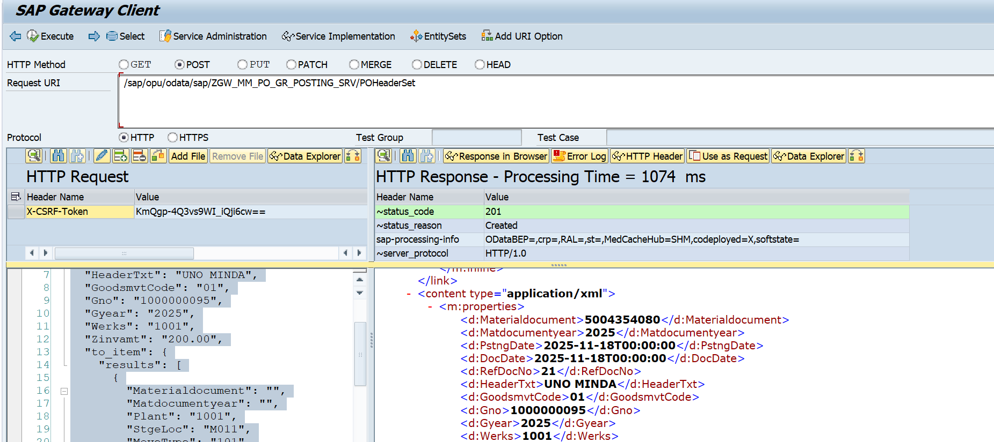

Checking Created data in sap for Confirmation.
Checking in MKPF (Material: Header Document)
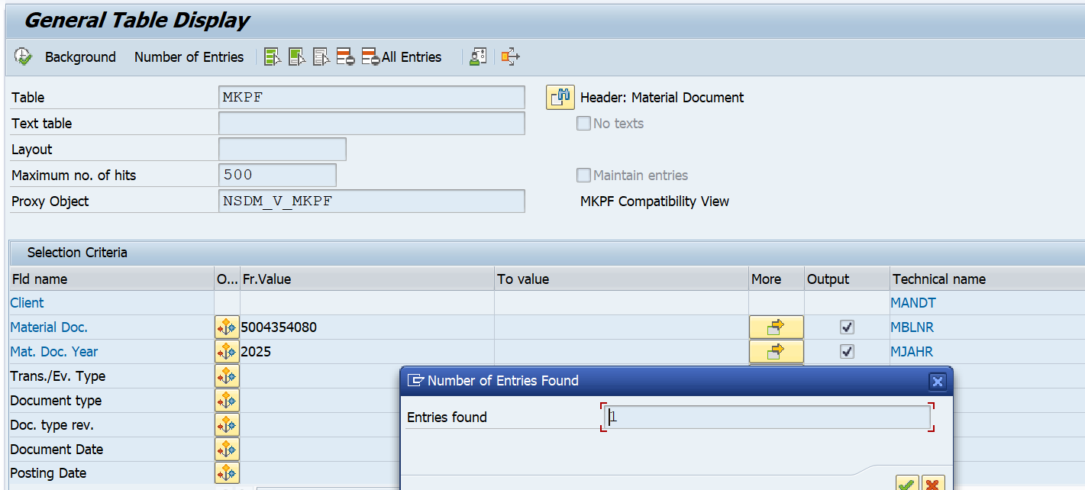
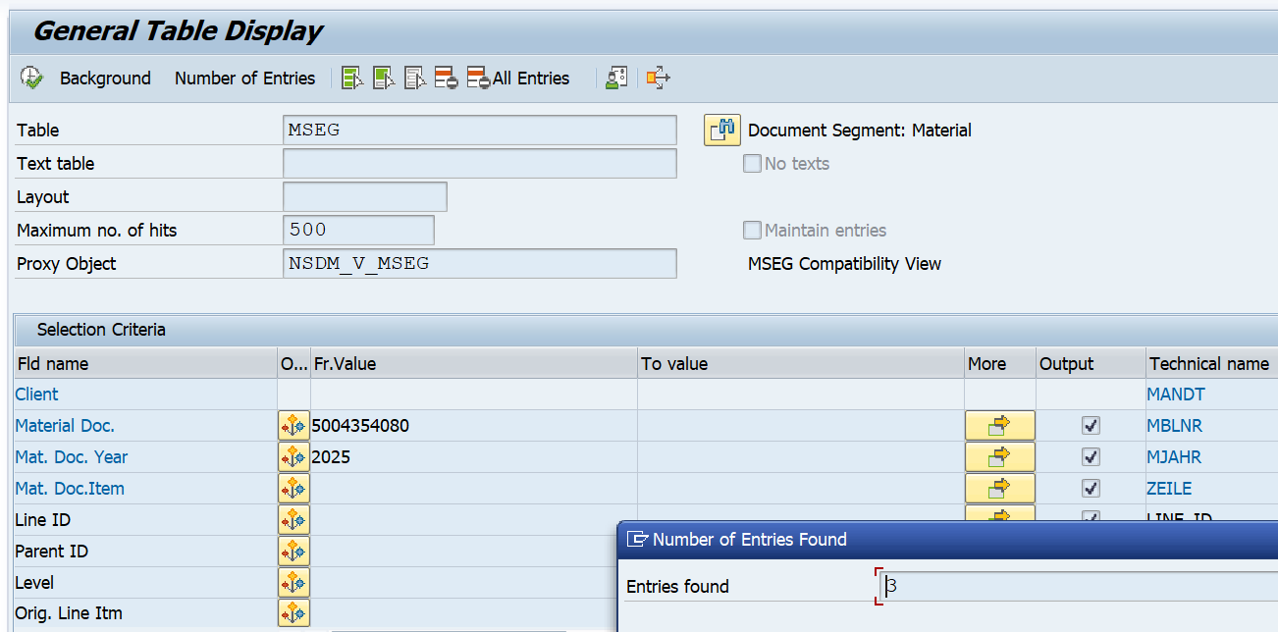
Checking In MSEG (Document Segment: Material)

Checking Record in ZTMM01003_MIGO
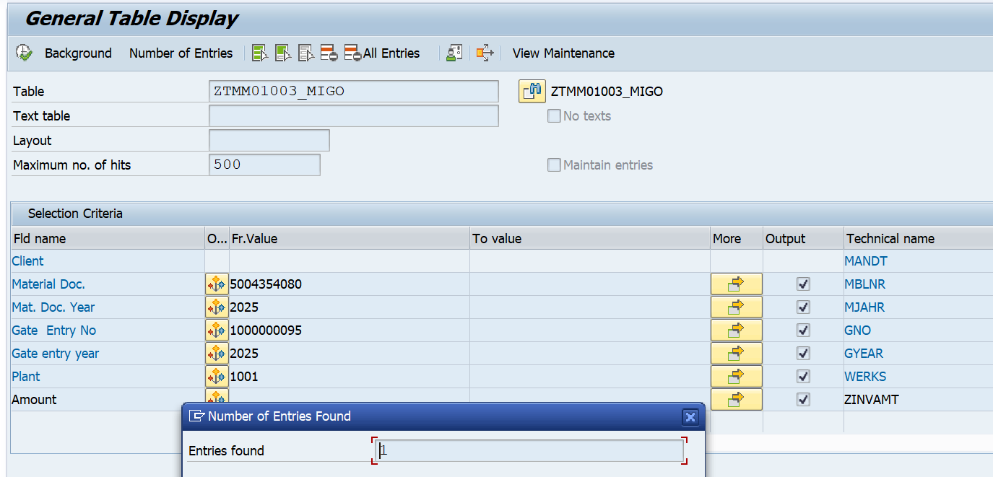

Negative Testing Screen:
Case 1
If following data not available system will give the error “Gate entry data Missing/mismatched”
1: Gate Entry No
2: Gate entry year
4: Amount

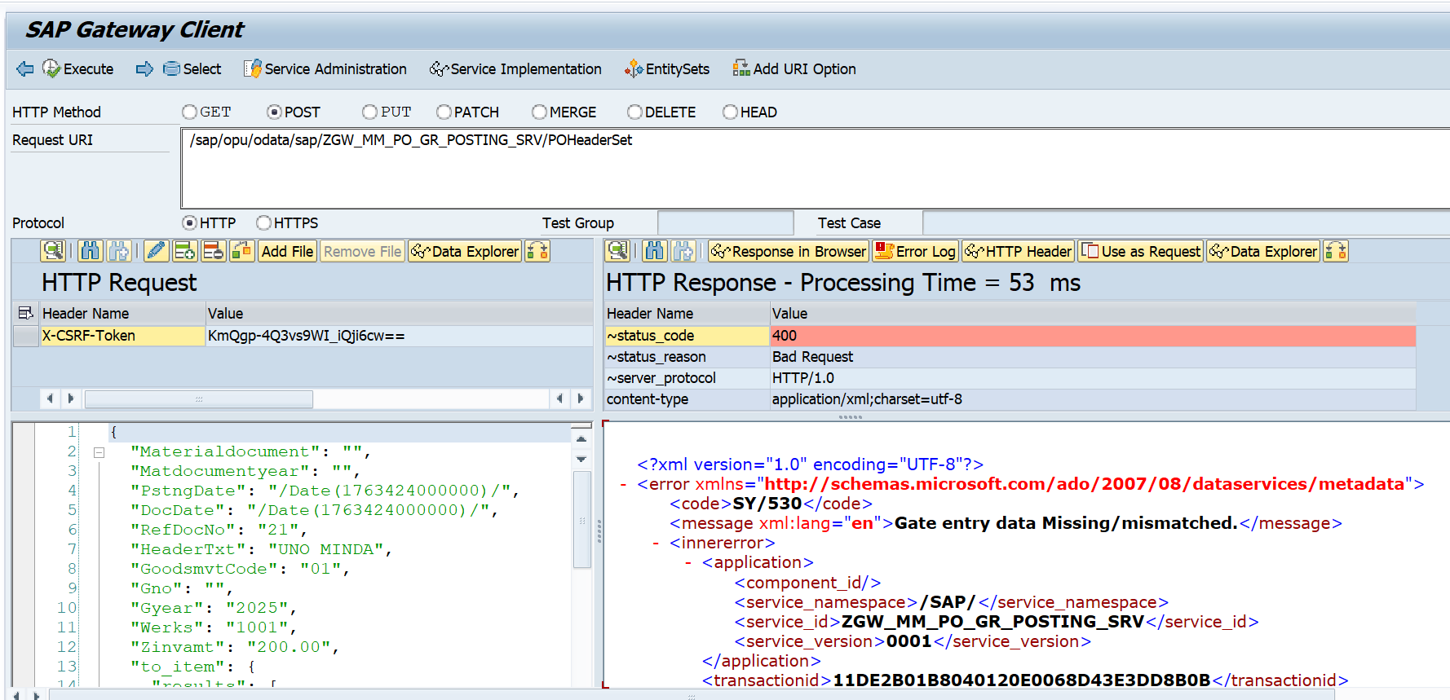
Here in the payload, Suppose I forgot to pass Gate Entry Number. Then,

Case 2

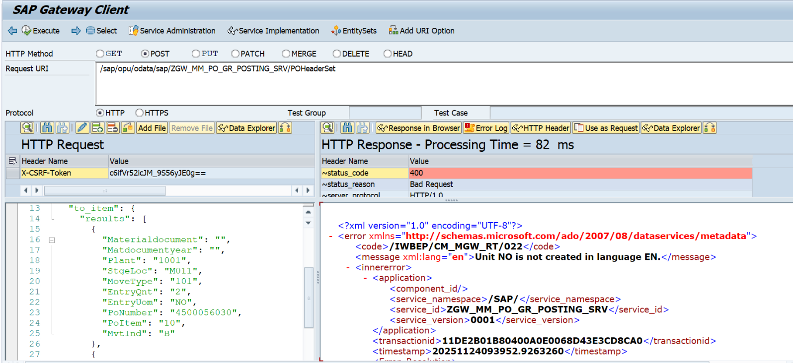
Here Suppose user trying to enter any wrong UOM.

Postman Level Testing

Note:
While you going to test a Post call through Postman, you must have the following details with you.
1. A valid SAP user id & Password for Authorization Check.
2. CSRK Token for post, a unique, session-based security token used to prevent attackers from executing
unwanted commands on behalf of an authenticated user.

How to Get CSRF Token?
Follow the below steps:
1.Go to postman
2.Pass the URL & pass Request Method as ‘GET’.
API: http://mehdevpas.minda.com:8001/sap/opu/odata/sap/ZGW_MM_PO_GR_POSTING_SRV/POHeaderSet

3.pass the Authorization detail (Authorization->Auth Type->Basic auth->SAP User ID & Password).
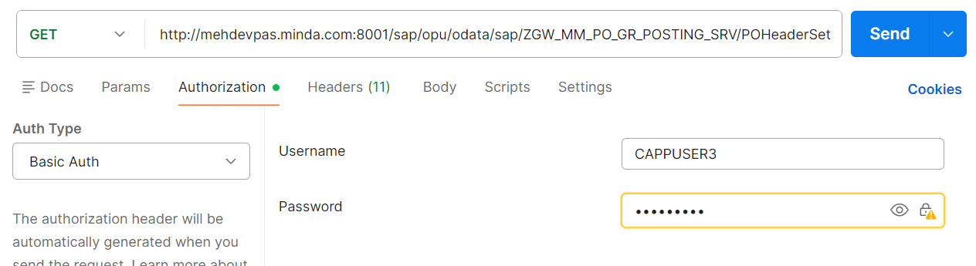

4.Then in the request Header section Pass the KEY = “x-csrf-token”& Value = ‘fetch’
Here I passed Client 190 because, Development server have Two client 120 & 190, so i passed “sap-client” as 190 Value.

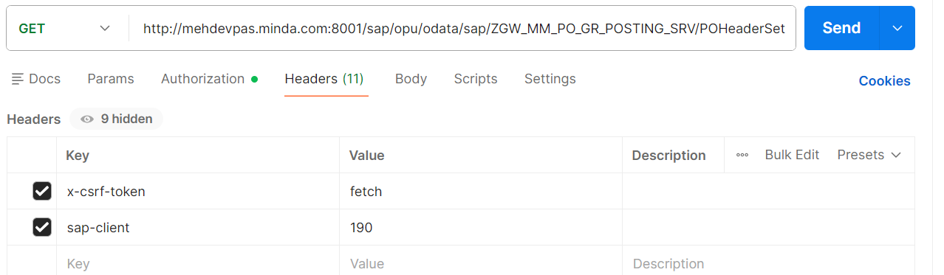

5.Click on Send.
6.IF the Response is 200 OK (Request successful. The server has responded as required.), then go to the Response Header and check the “x-csrf-token” Value and use that value during all the Create/Update/Delete Operation.

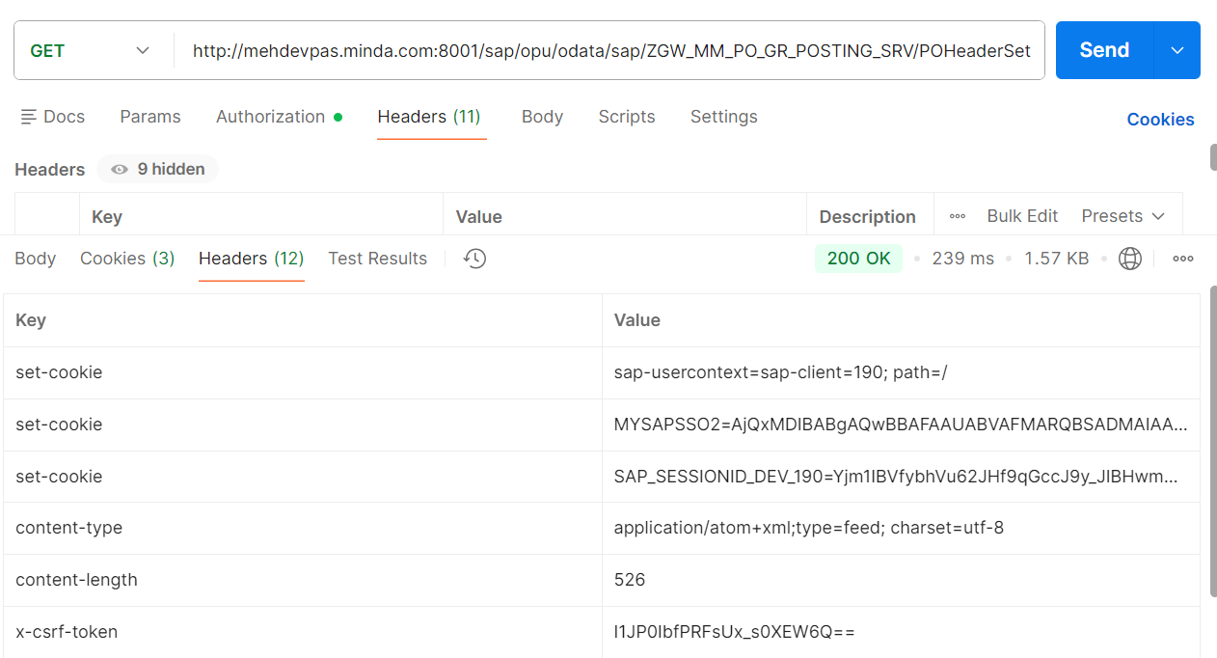

Handle Crete Operation Through Postman:
Step 1: Pass the URL & set Request method as “POST”.
API: http://mehdevpas.minda.com:8001/sap/opu/odata/sap/ZGW_MM_PO_GR_POSTING_SRV/POHeaderSet

Step 2: Handel the Authorization detail (Authorization->Auth Type->Basic auth->SAP User ID & Password).

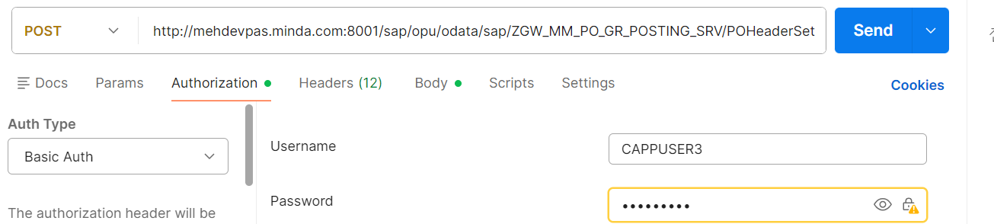

Step 3: Pass the CSRF Token, which was fetch by the Above process.
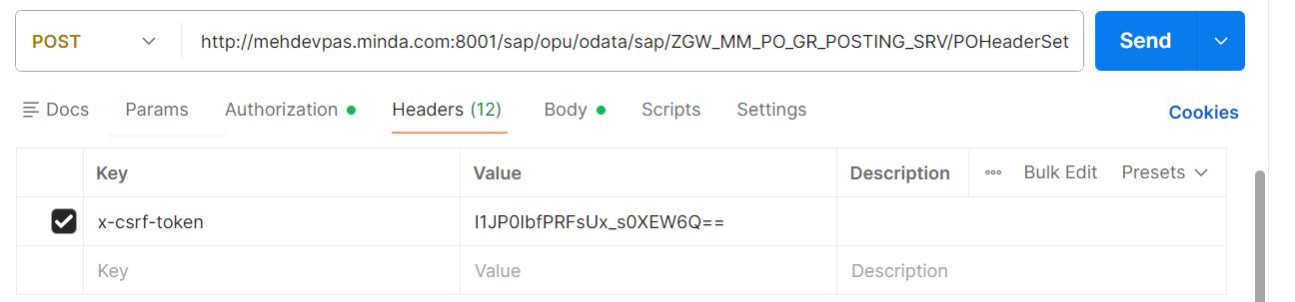
Step 4: Step 4: Pass the Payload in Json Format (Header Requestbodyraw section)
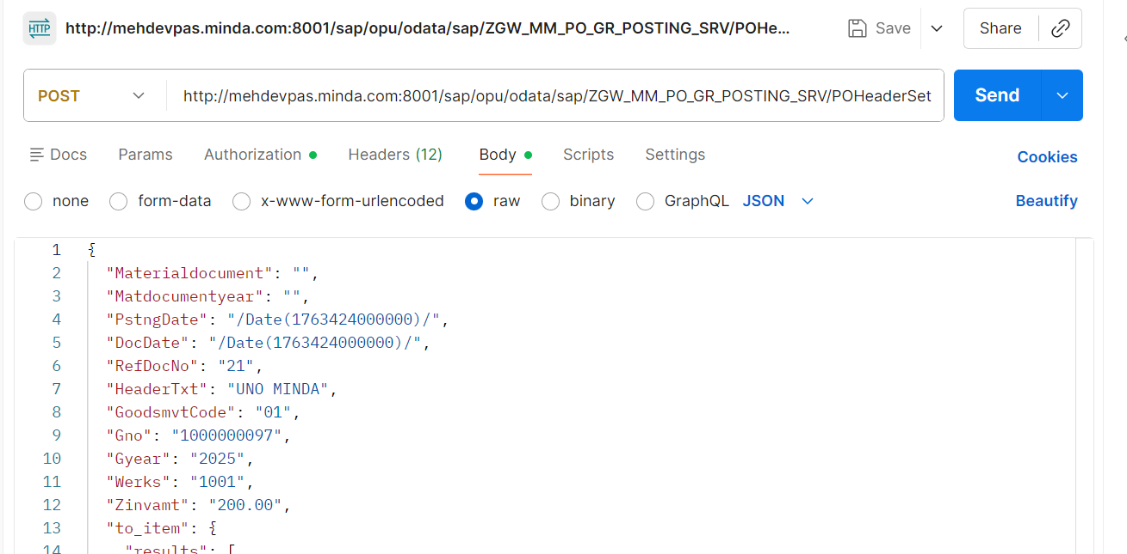

Step 5: click on Send.
Step 6: if response status is 201, then record successfully created.

