Class Activity – 2

Scenario-01: Smart City Air Quality Monitoring
Python Code:
import pandas as pd
import matplotlib.pyplot as plt
data = pd.read_excel("Scenario01.xlsx")
plt.figure(figsize=(8,6))
scatter = plt.scatter(
data["X_Coordinate"],
data["Y_Coordinate"],
c=data["PM2.5"],
cmap="YlOrRd",
s=120,
edgecolor="black"
)
plt.colorbar(scatter,label="PM2.5")
plt.title("Sequential Color Scale (PM2.5)")
plt.xlabel("X Coordinate")
plt.ylabel("Y Coordinate")
plt.grid(True)
plt.show()
plt.figure(figsize=(8,6))
scatter = plt.scatter(
data["X_Coordinate"],
data["Y_Coordinate"],
c=data["Temperature"],
cmap="coolwarm",
s=120,
edgecolor="black"
)
plt.colorbar(scatter,label="Temperature (°C)")
plt.title("Diverging Color Scale (Temperature)")
plt.xlabel("X Coordinate")
plt.ylabel("Y Coordinate")
plt.grid(True)
plt.show()
def pollution_level(pm):
if pm < 50:
return "Good"
elif pm < 100:
return "Moderate"
else:
return "High"
data["Pollution_Level"] = data["PM2.5"].apply(pollution_level)
colors = {
"Good":"green",
"Moderate":"orange",
"High":"red"
}
plt.figure(figsize=(8,6))
for level in colors:
subset = data[data["Pollution_Level"]==level]
plt.scatter(
subset["X_Coordinate"],
subset["Y_Coordinate"],
color=colors[level],
label=level,
s=120,
edgecolor="black"
)
plt.title("Qualitative Color Scale (Pollution Categories)")
plt.xlabel("X Coordinate")
plt.ylabel("Y Coordinate")
plt.legend(title="Pollution Level")
plt.grid(True)
plt.show()
Output:
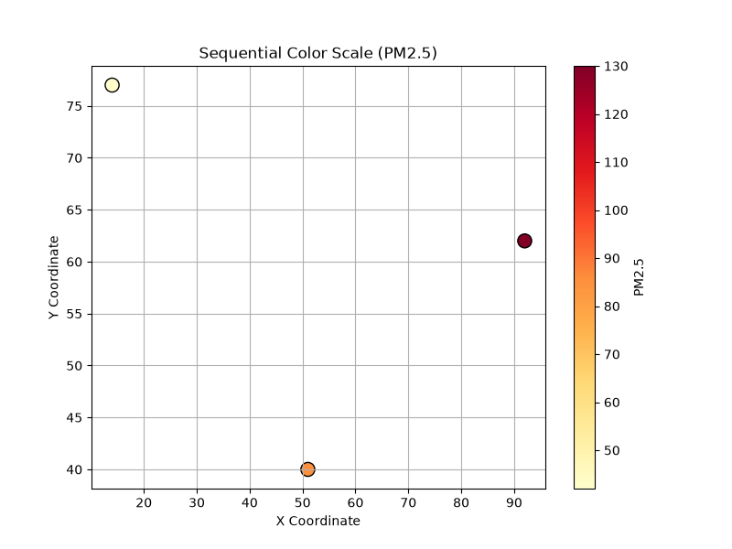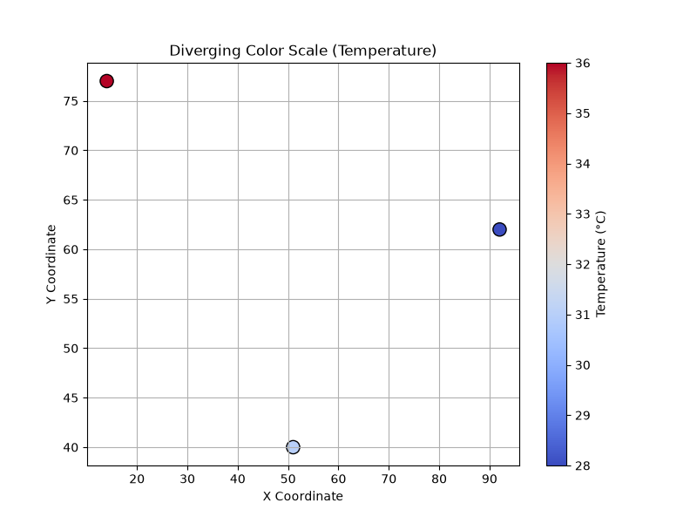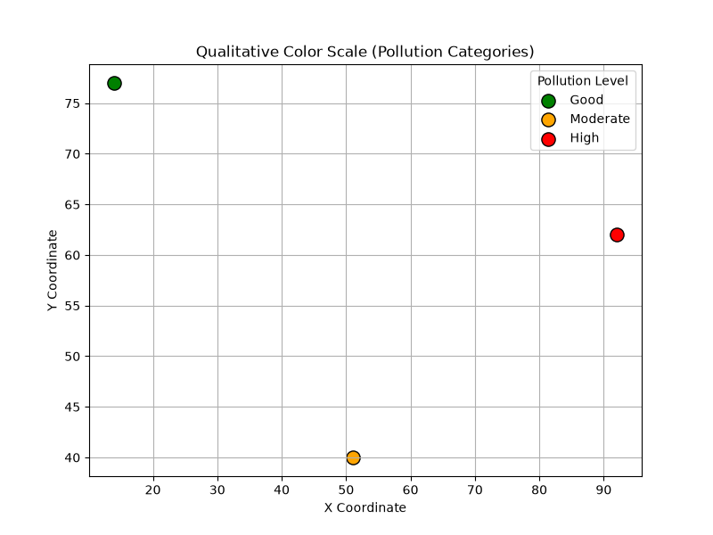

R code:
library(ggplot2)
library(RColorBrewer)
# Create Dataset
air_data <- data.frame(
X_Coordinate = c(10,20,30,40,50,60,70,80,90,100),
Y_Coordinate = c(15,25,35,45,55,65,75,85,95,105),
PM25 = c(25,45,60,80,95,110,130,150,170,190),
NO2 = c(18,22,28,35,40,48,52,60,68,75),
CO = c(0.6,0.8,1.0,1.2,1.5,1.8,2.0,2.3,2.5,2.8),
Temperature = c(28,29,30,31,32,33,34,35,36,37),
Humidity = c(70,68,66,64,62,60,58,56,54,52)
)
print(air_data)

# Sequential Palette
ggplot(air_data,
aes(X_Coordinate, Y_Coordinate, color = PM25)) +
geom_point(size = 5) +
scale_color_gradient(low = "yellow", high = "red") +
ggtitle("Sequential Palette - PM2.5") +
theme_minimal()

# Diverging Palette
ggplot(air_data,
aes(X_Coordinate, Y_Coordinate, color = Temperature)) +
geom_point(size = 5) +
scale_color_gradient2(low = "blue",
mid = "white",
high = "red",
midpoint = mean(air_data$Temperature)) +
ggtitle("Diverging Palette - Temperature") +
theme_minimal()

# Qualitative Palette
air_data$Pollution_Level <- cut(
air_data$PM25,
breaks = c(0,50,100,200),
labels = c("Good","Moderate","High")
)

ggplot(air_data,
aes(X_Coordinate, Y_Coordinate, color = Pollution_Level)) +
geom_point(size = 5) +
scale_color_brewer(palette = "Set1") +
ggtitle("Qualitative Palette") +
theme_minimal()
Output:
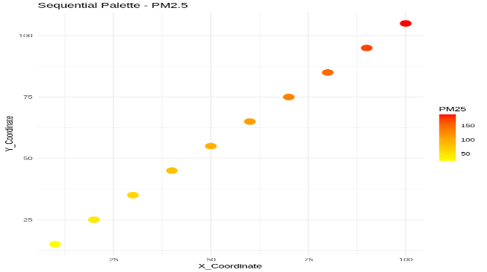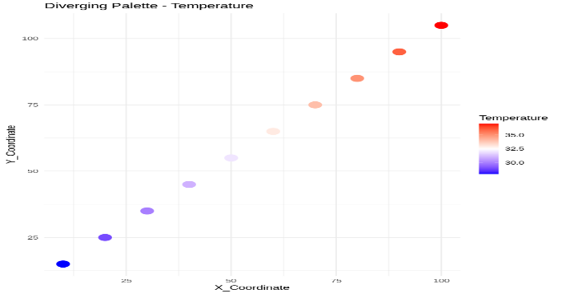
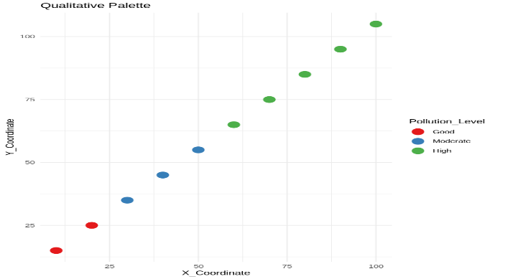
Scenario-02: Earthquake Risk Analysis
Python Code:
import pandas as pd
import matplotlib.pyplot as plt
data = pd.read_excel("scenario02.xlsx")
plt.figure(figsize=(8,6))
plt.scatter(
data["Magnitude"],
data["Aftershocks"],
color="blue",
s=100
)
plt.title("Earthquake Magnitude vs Aftershocks (Linear Scale)")
plt.xlabel("Magnitude")
plt.ylabel("Aftershocks")
plt.grid(True)
plt.show()
plt.figure(figsize=(8,6))
plt.scatter(
data["Magnitude"],
data["Aftershocks"],
color="red",
s=100
)
plt.yscale("log")
plt.title("Earthquake Magnitude vs Aftershocks (Logarithmic Scale)")
plt.xlabel("Magnitude")
plt.ylabel("Aftershocks (Log Scale)")
plt.grid(True)
plt.show()
plt.figure(figsize=(8,6))
scatter = plt.scatter(
data["Longitude"],
data["Latitude"],
c=data["Magnitude"],
cmap="hot",
s=120
)
plt.colorbar(scatter, label="Magnitude")
plt.title("Earthquake Locations")
plt.xlabel("Longitude")
plt.ylabel("Latitude")
plt.grid(True)
plt.show()
Output:
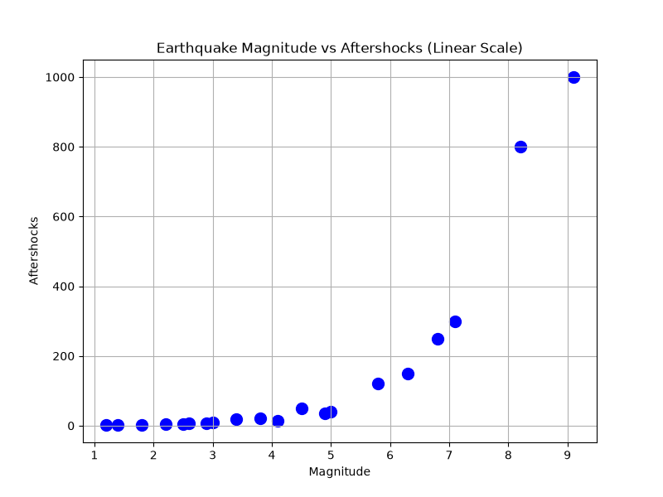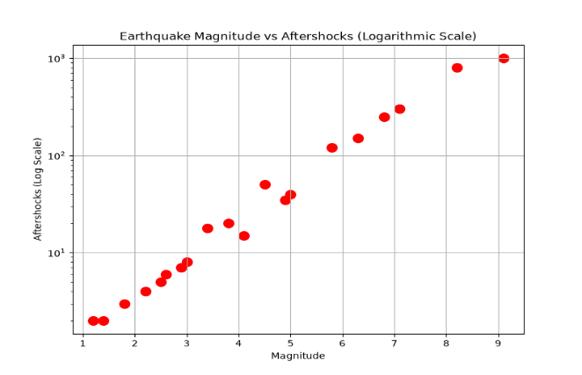
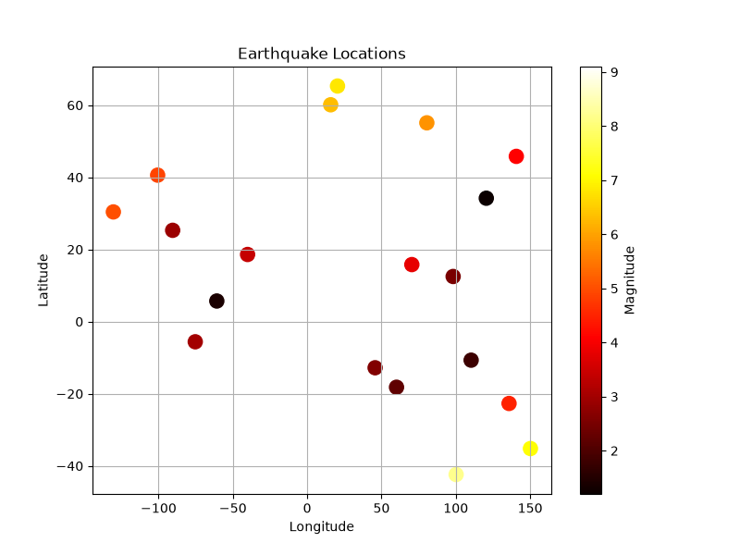
R code:
library(ggplot2)
earthquake_data <- data.frame(
Magnitude = c(2.1,2.8,3.4,4.2,4.8,5.5,6.2,6.9,7.5,8.1),
Depth = c(15,30,45,60,90,120,180,250,350,500),
Latitude = c(10,12,15,18,20,24,28,32,36,40),
Longitude = c(72,74,76,78,80,82,84,86,88,90),
Aftershock_Frequency = c(2000,1500,1000,600,300,150,80,40,20,10)
)
print(earthquake_data)
# Cartesian Plot
ggplot(earthquake_data,
aes(Magnitude, Aftershock_Frequency)) +
geom_point(color = "blue", size = 5) +
ggtitle("Linear Scale") +
theme_minimal()
# Logarithmic Scale
ggplot(earthquake_data,
aes(Magnitude, Aftershock_Frequency)) +
geom_point(color = "red", size = 5) +
scale_y_log10() +
ggtitle("Logarithmic Scale") +
theme_minimal()
# Earthquake Locations
ggplot(earthquake_data,
aes(Longitude, Latitude, color = Magnitude)) +
geom_point(size = 5) +
scale_color_gradient(low = "yellow", high = "red") +
ggtitle("Earthquake Locations") +
theme_minimal()

# Depth vs Magnitude
ggplot(earthquake_data,
aes(Depth, Magnitude, color = Magnitude)) +
geom_point(size = 5) +
scale_color_gradient(low = "green", high = "red") +
ggtitle("Depth vs Magnitude") +
theme_minimal()
Output:

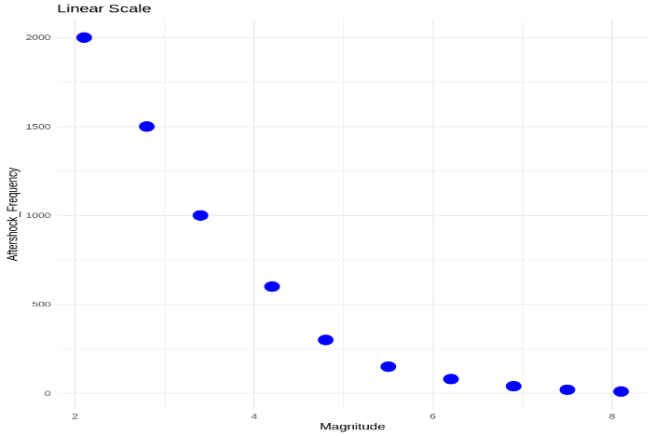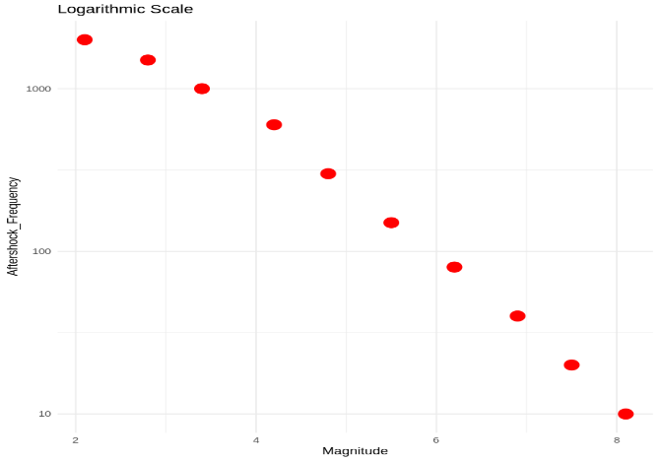

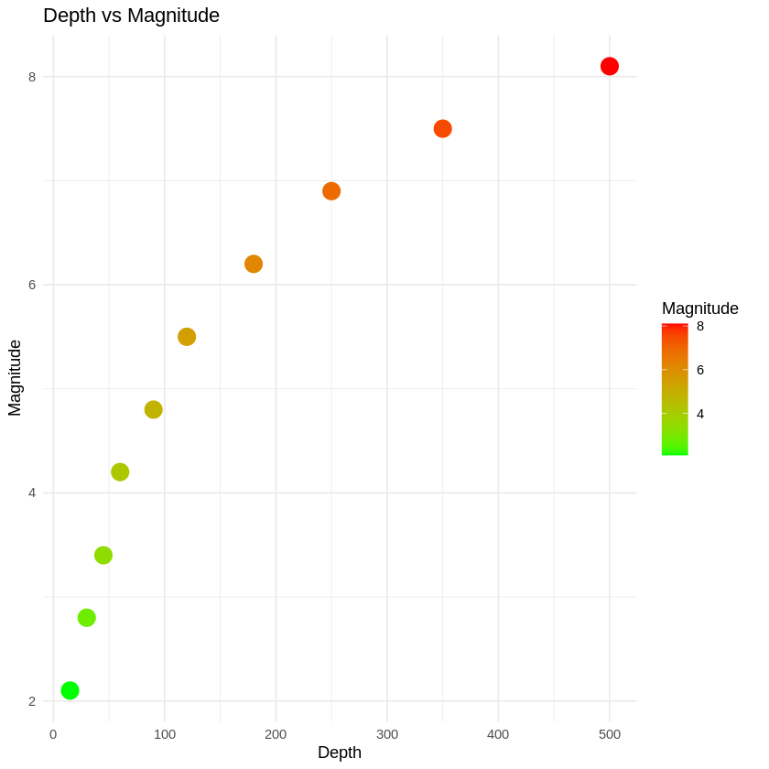

Scenario-03: Wind Direction Analysis for Airport Operations
Python Code:
import pandas as pd
import matplotlib.pyplot as plt
import numpy as np
# Read Excel file
data = pd.read_excel("scenario3.xlsx")
plt.figure(figsize=(8,6))
plt.scatter(
data["Wind_Direction"],
data["Wind_Speed"],
color="blue",
s=80
)
plt.title("Wind Speed vs Wind Direction (Cartesian Plot)")
plt.xlabel("Wind Direction (Degrees)")
plt.ylabel("Wind Speed (km/h)")
plt.grid(True)
plt.show()
theta = np.deg2rad(data["Wind_Direction"])
r = data["Wind_Speed"]
plt.figure(figsize=(8,8))
ax = plt.subplot(111, projection='polar')
bars = ax.bar(
theta,
r,
width=np.deg2rad(10),
bottom=0,
alpha=0.7,
color="green",
edgecolor="black"
)
ax.set_theta_zero_location("N")
ax.set_theta_direction(-1)
plt.title("Wind Rose (Polar Coordinate Visualization)")
plt.show()
Output:
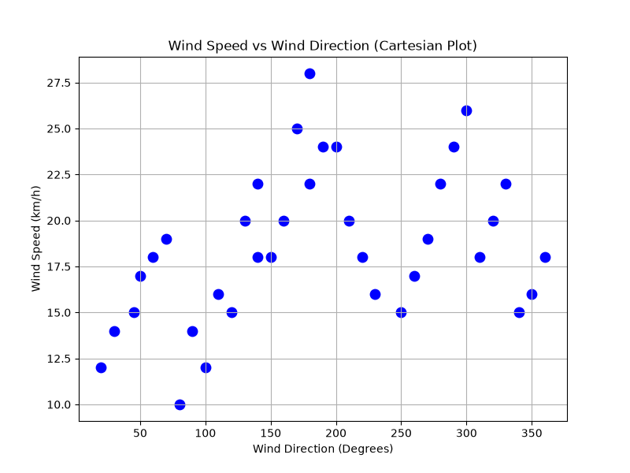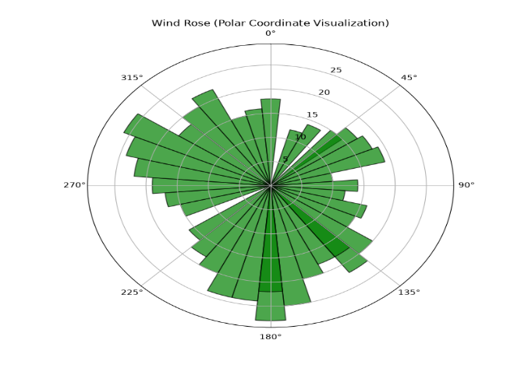
R code:
library(ggplot2)
wind_data <- data.frame(
Wind_Speed = c(12,15,18,20,22,16,14,19,21,17,13,15),
Wind_Direction = c(0,30,60,90,120,150,180,210,240,270,300,330)
)
print(wind_data)
# Cartesian Plot
ggplot(wind_data,
aes(Wind_Direction, Wind_Speed)) +
geom_point(color="blue", size=4) +
geom_line(color="darkgreen") +
labs(title="Wind Speed vs Wind Direction",
x="Wind Direction (Degrees)",
y="Wind Speed (km/h)") +
theme_minimal()
# Polar Plot (Wind Rose)
ggplot(wind_data,
aes(factor(Wind_Direction), Wind_Speed, fill=Wind_Speed)) +
geom_bar(stat="identity") +
coord_polar() +
scale_fill_gradient(low="lightblue", high="darkblue") +
labs(title="Wind Rose") +
theme_minimal()
Output:
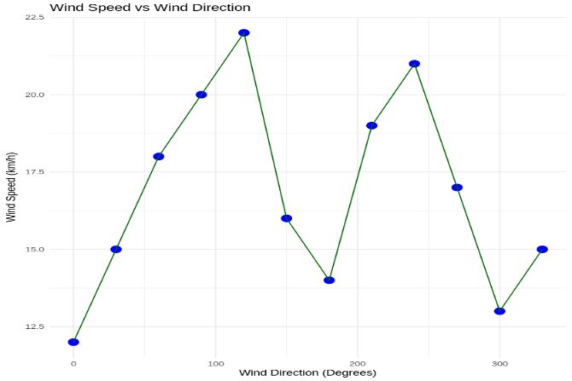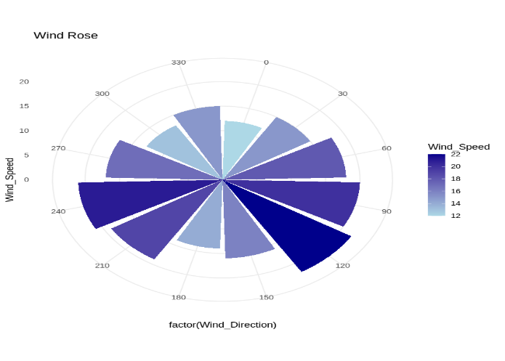

Scenario-04: Hospital Patient Monitoring Dashboard
Python Code:
import pandas as pd
import matplotlib.pyplot as plt
data = pd.read_excel("scenario4.xlsx")
def get_color(hr):
if hr < 60 or hr > 120:
return "red" # Critical
elif hr < 70 or hr > 100:
return "orange" # Warning
else:
return "green" # Normal
colors = data["Heart_Rate"].apply(get_color)
plt.figure(figsize=(14,8))
plt.subplot(2,3,1)
plt.bar(data["Patient_ID"], data["Heart_Rate"], color=colors)
plt.title("Heart Rate")
plt.xticks(rotation=90)
plt.subplot(2,3,2)
plt.bar(data["Patient_ID"],
data["Oxygen_Saturation"],
color=["red" if x<92 else "orange" if x<95 else "green"
for x in data["Oxygen_Saturation"]])
plt.title("Oxygen Saturation")
plt.xticks(rotation=90)
plt.subplot(2,3,3)
plt.bar(data["Patient_ID"],
data["Blood_Pressure"],
color=["red" if x>140 else "orange" if x>130 else "green"
for x in data["Blood_Pressure"]])
plt.title("Blood Pressure")
plt.xticks(rotation=90)
plt.subplot(2,3,4)
plt.bar(data["Patient_ID"],
data["Respiration_Rate"],
color=["red" if x>24 or x<12 else "orange" if x>20 else "green"
for x in data["Respiration_Rate"]])
plt.title("Respiration Rate")
plt.xticks(rotation=90)
plt.subplot(2,3,5)
plt.bar(data["Patient_ID"],
data["Temperature"],
color=["red" if x>=39 else "orange" if x>=37.5 else "green"
for x in data["Temperature"]])
plt.title("Temperature")
plt.xticks(rotation=90)
plt.suptitle("Hospital Patient Monitoring Dashboard", fontsize=16)
plt.tight_layout()
plt.show()
Output:
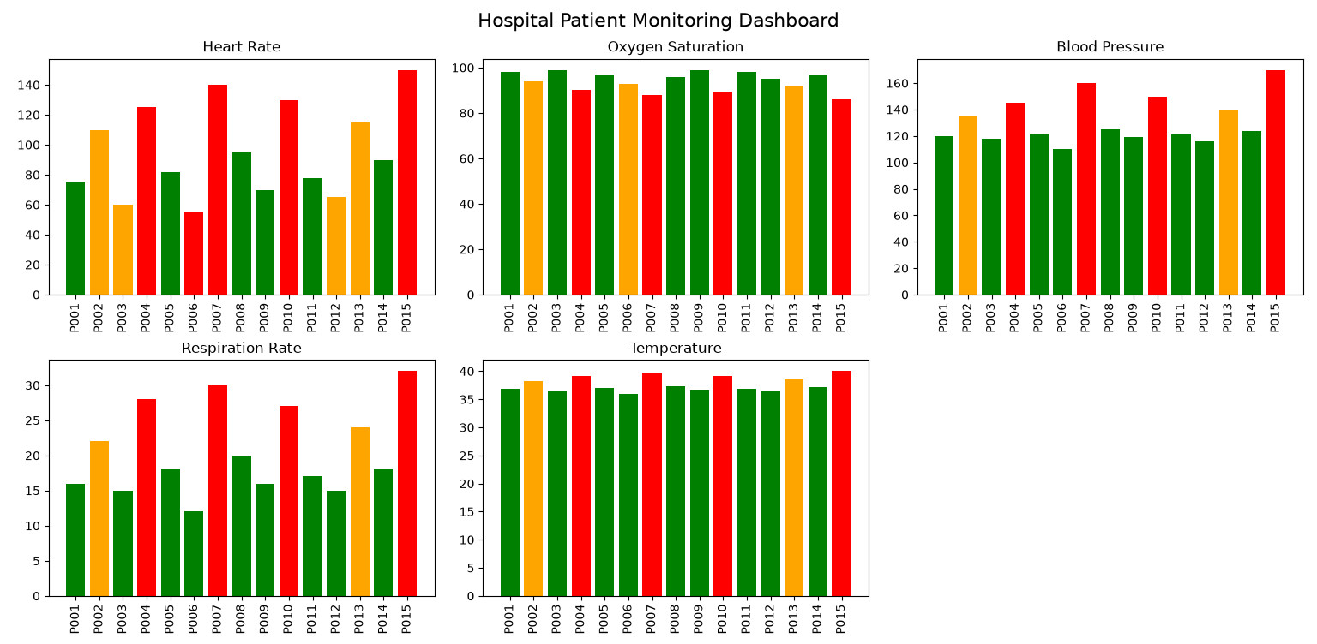
R code:
library(ggplot2)
# Create Dataset
hospital_data <- data.frame(
Patient_ID = paste("P",1:10,sep=""),
Heart_Rate = c(72,85,95,110,130,78,88,125,100,65),
Oxygen_Saturation = c(98,97,95,92,85,99,96,88,94,97),
Blood_Pressure = c(120,125,130,135,145,118,122,150,128,115),
Respiration = c(16,18,20,22,26,17,19,24,21,15),
Temperature = c(36.8,37.1,37.5,38.2,39.1,36.9,37.3,38.8,37.6,36.7)
)
print(hospital_data)
hospital_data$Status <- ifelse(
hospital_data$Heart_Rate > 120 | hospital_data$Oxygen_Saturation < 90,
"Critical",
ifelse(hospital_data$Heart_Rate > 100,
"Warning",
"Normal")
)
# Heart Rate Dashboard
ggplot(hospital_data,
aes(Patient_ID, Heart_Rate, fill=Status)) +
geom_col() +
scale_fill_manual(values=c(
"Normal"="green",
"Warning"="orange",
"Critical"="red")) +
labs(title="Heart Rate Dashboard") +
theme_minimal()
# Oxygen Saturation Dashboard
ggplot(hospital_data,
aes(Patient_ID, Oxygen_Saturation, fill=Status)) +
geom_col() +
scale_fill_manual(values=c(
"Normal"="green",
"Warning"="orange",
"Critical"="red")) +
labs(title="Oxygen Saturation Dashboard") +
theme_minimal()

Output:
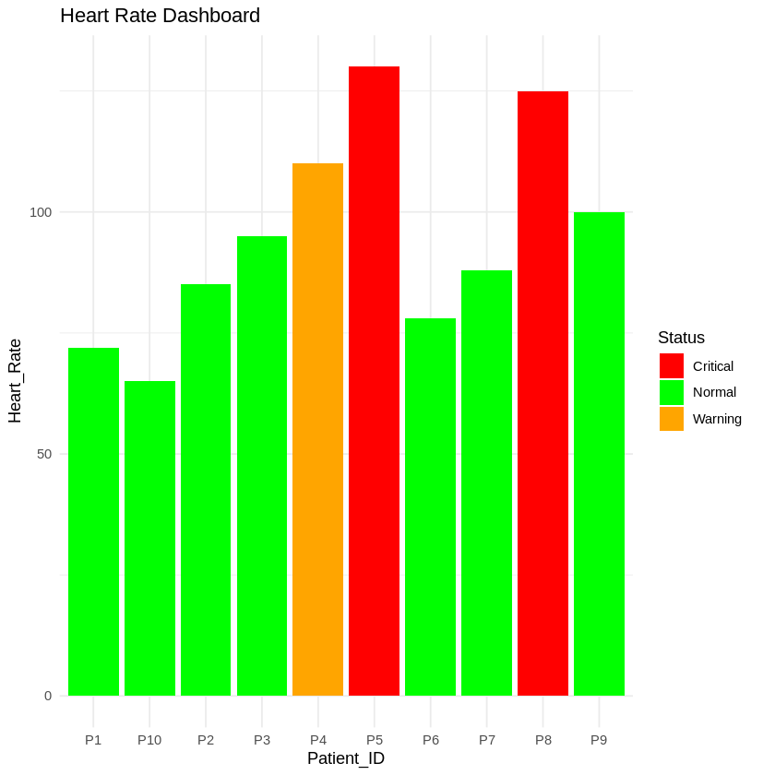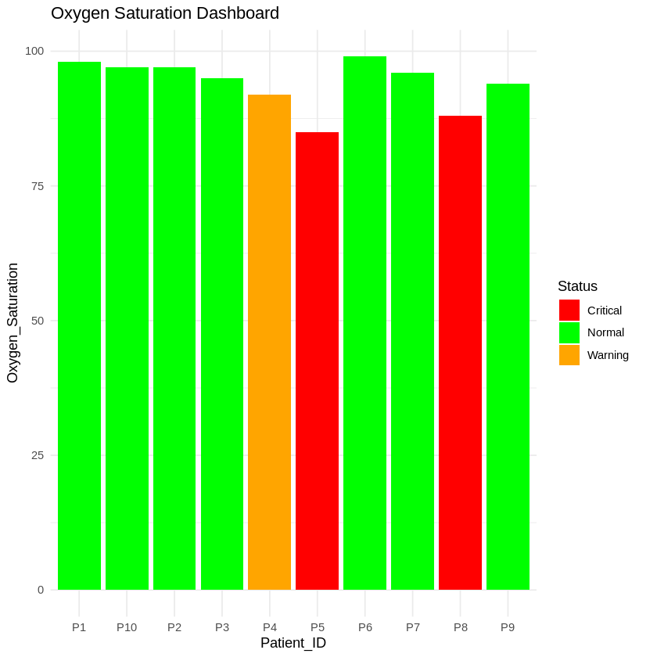

Scenario-05: Global Climate Change Study
Python Code:
import pandas as pd
import matplotlib.pyplot as plt
data = pd.read_excel("scenario5.xlsx")
heatmap_data = data.pivot(index="Country",
columns="Year",
values="Temperature_Anomaly")
plt.figure(figsize=(8,6))

plt.imshow(heatmap_data,
cmap="coolwarm",
aspect="auto")
plt.colorbar(label="Temperature Anomaly (°C)")
plt.xticks(range(len(heatmap_data.columns)), heatmap_data.columns)
plt.yticks(range(len(heatmap_data.index)), heatmap_data.index)
plt.title("Heatmap using Coolwarm Palette")
plt.show()
plt.figure(figsize=(8,6))

plt.imshow(heatmap_data,
cmap="RdBu_r",
aspect="auto")
plt.colorbar(label="Temperature Anomaly (°C)")
plt.xticks(range(len(heatmap_data.columns)), heatmap_data.columns)
plt.yticks(range(len(heatmap_data.index)), heatmap_data.index)
plt.title("Heatmap using RdBu Palette")
plt.show()
plt.figure(figsize=(8,6))
plt.imshow(heatmap_data,
cmap="PiYG",
aspect="auto")
plt.colorbar(label="Temperature Anomaly (°C)")
plt.xticks(range(len(heatmap_data.columns)), heatmap_data.columns)
plt.yticks(range(len(heatmap_data.index)), heatmap_data.index)
plt.title("Heatmap using PiYG Palette")
plt.show()
Output:
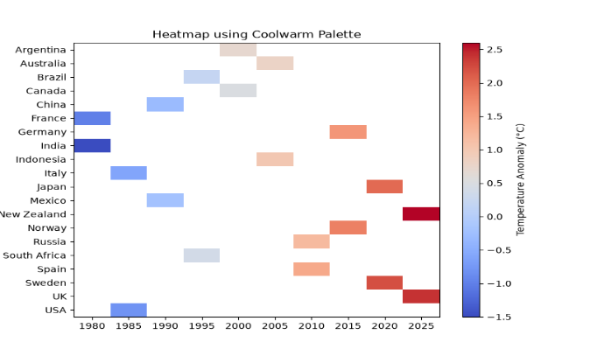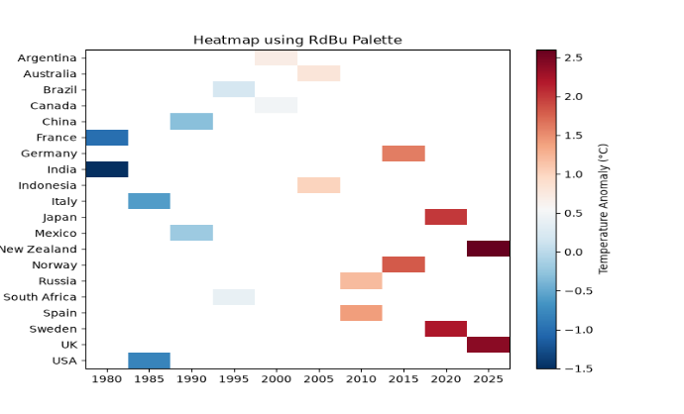
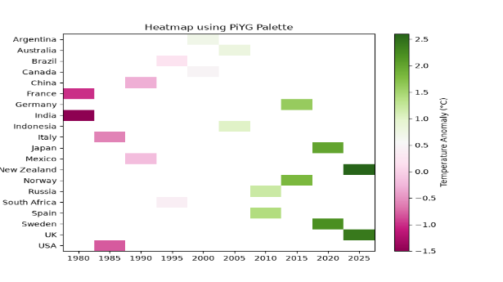
R code:
library(ggplot2)
library(RColorBrewer)
# Create Dataset
climate_data <- data.frame(
Country = rep(c("India","USA","China","Brazil","Australia"), each=5),
Year = rep(c(2021,2022,2023,2024,2025),5),
Temperature_Anomaly = c(
0.5,0.7,0.9,1.1,1.3,
-0.3,-0.1,0.2,0.4,0.6,
0.8,1.0,1.2,1.4,1.6,
-0.5,-0.2,0.1,0.3,0.5,
0.2,0.4,0.6,0.8,1.0
)
)
print(climate_data)
# Heatmap 1 - Blue White Red
ggplot(climate_data,
aes(factor(Year), Country,
fill=Temperature_Anomaly)) +
geom_tile(color="white") +
scale_fill_gradient2(low="blue",
mid="white",
high="red",
midpoint=0) +
labs(title="Blue-White-Red Palette") +
theme_minimal()
# Heatmap 2 - RdBu
ggplot(climate_data,
aes(factor(Year), Country,
fill=Temperature_Anomaly)) +
geom_tile(color="white") +
scale_fill_distiller(
palette="RdBu",
direction=-1) +
labs(title="RdBu Palette") +
theme_minimal()
# Heatmap 3 - PiYG
ggplot(climate_data,
aes(factor(Year), Country,
fill=Temperature_Anomaly)) +
geom_tile(color="white") +
scale_fill_distiller(
palette="PiYG") +
labs(title="PiYG Palette") +
theme_minimal()
Output:
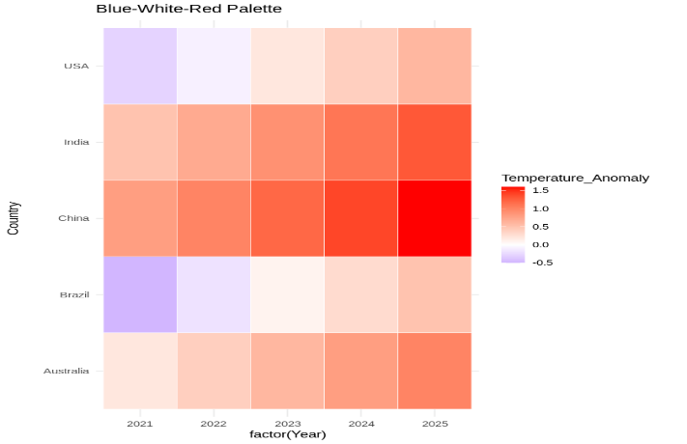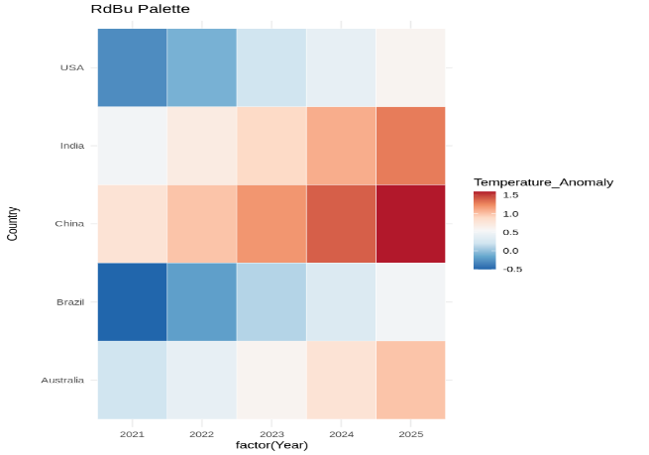
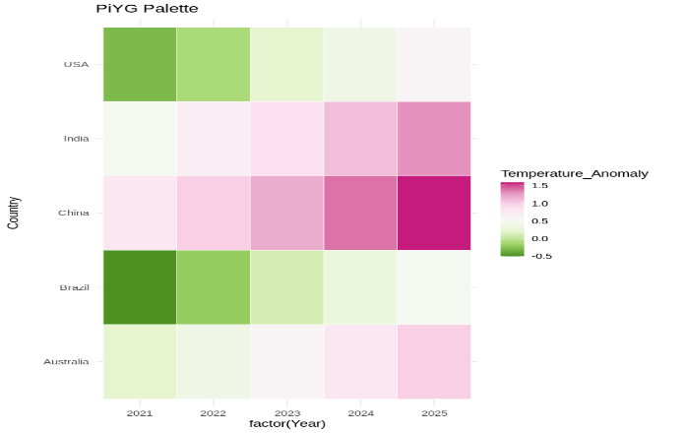
Scenario-06: E-Commerce Sales Analytics
Python Code:
import pandas as pd
import matplotlib.pyplot as plt
data = pd.read_excel("scenario6.xlsx")
category_colors = {
"Electronics": "blue",
"Clothing": "green",
"Furniture": "orange",
"Grocery": "red"
}
plt.figure(figsize=(9,6))
for category in data["Category"].unique():
subset = data[data["Category"] == category]
plt.scatter(
subset["Region"],
subset["Sales"],
s=subset["Sales"]/500,
color=category_colors[category],
alpha=0.7,
edgecolors="black",
label=category
)
plt.title("Sales by Region and Product Category")
plt.xlabel("Region")
plt.ylabel("Sales")
plt.legend(title="Category")
plt.grid(True)
plt.show()
plt.figure(figsize=(9,6))
scatter = plt.scatter(
data["Region"],
data["Category"],
c=data["Sales"],
cmap="viridis",
s=220,
edgecolors="black"
)
plt.colorbar(scatter, label="Sales")
plt.title("Sales Volume Using Color Intensity")
plt.xlabel("Region")
plt.ylabel("Category")
plt.show()
Output:
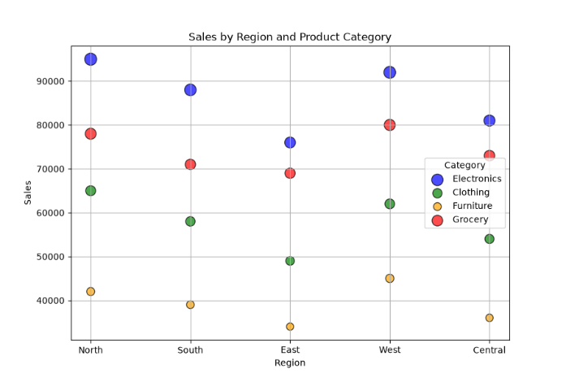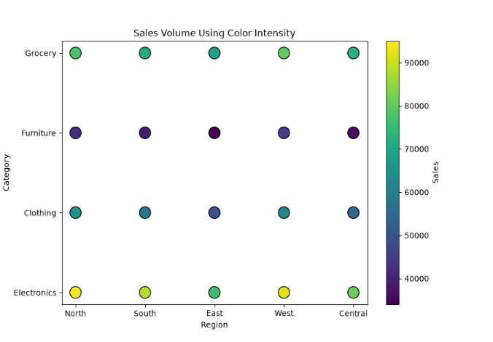
R code:
library(ggplot2)
# Create Dataset
sales_data <- data.frame(
Category = c("Electronics","Clothing","Furniture","Groceries","Sports",
"Books","Beauty","Toys","Jewelry","Footwear"),
Region = c("North","South","East","West","North",
"South","East","West","North","South"),
Sales = c(85000,42000,60000,35000,50000,
28000,45000,32000,55000,40000)
)
print(sales_data)
# Bar Chart
ggplot(sales_data,
aes(Category, Sales, fill=Category)) +
geom_col() +
labs(title="Sales by Category") +
theme_minimal()
# Bubble Chart
ggplot(sales_data,
aes(Region, Sales,
color=Category,
size=Sales)) +
geom_point(alpha=0.8) +
labs(title="Sales by Region") +
theme_minimal()
Output:

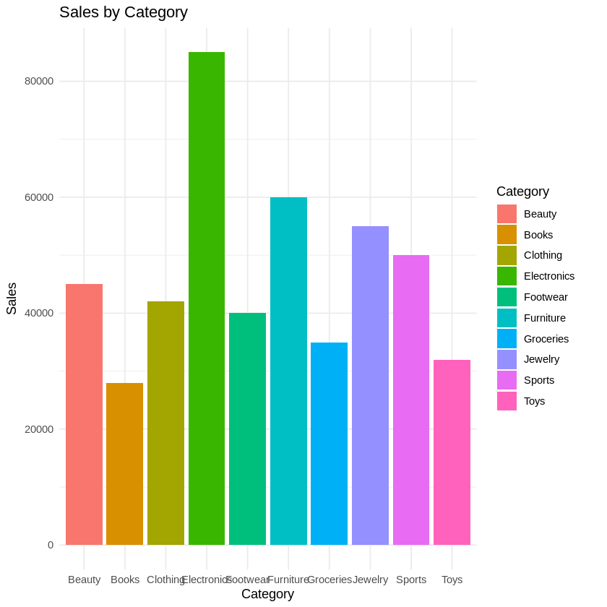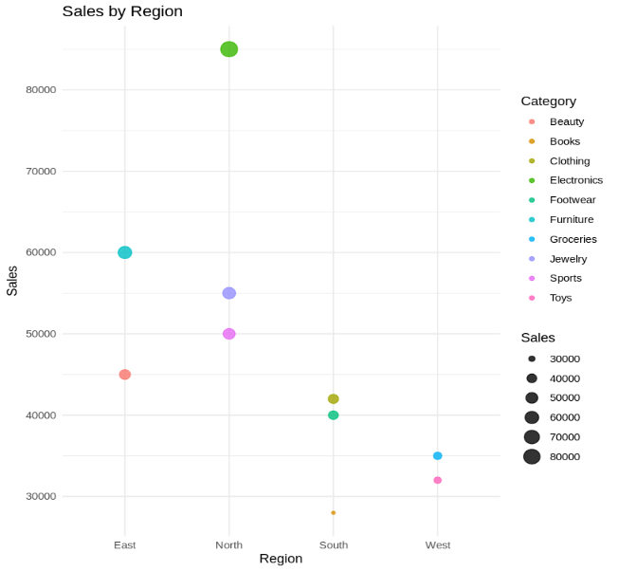

Scenario-07: Satellite Image Vegetation Analysis
Python Code:
import pandas as pd
import matplotlib.pyplot as plt
data = pd.read_excel("scenario7.xlsx")
plt.figure(figsize=(8,6))
scatter = plt.scatter(
data["X"],
data["Y"],
c=data["NDVI"],
cmap="Greens",
s=180,
edgecolors="black"
)
plt.colorbar(scatter, label="NDVI")
plt.title("NDVI using Sequential Palette (Greens)")
plt.xlabel("X Coordinate")
plt.ylabel("Y Coordinate")
plt.grid(True)
plt.show()
plt.figure(figsize=(8,6))
scatter = plt.scatter(
data["X"],
data["Y"],
c=data["NDVI"],
cmap="YlGn",
s=180,
edgecolors="black"
)
plt.colorbar(scatter, label="NDVI")
plt.title("NDVI using Sequential Palette (YlGn)")
plt.xlabel("X Coordinate")
plt.ylabel("Y Coordinate")
plt.grid(True)
plt.show()
plt.figure(figsize=(8,6))
scatter = plt.scatter(
data["X"],
data["Y"],
c=data["NDVI"],
cmap="RdYlGn",
s=180,
edgecolors="black"
)
plt.colorbar(scatter, label="NDVI")
plt.title("NDVI using Diverging Palette (RdYlGn)")
plt.xlabel("X Coordinate")
plt.ylabel("Y Coordinate")
plt.grid(True)
plt.show()
Output:
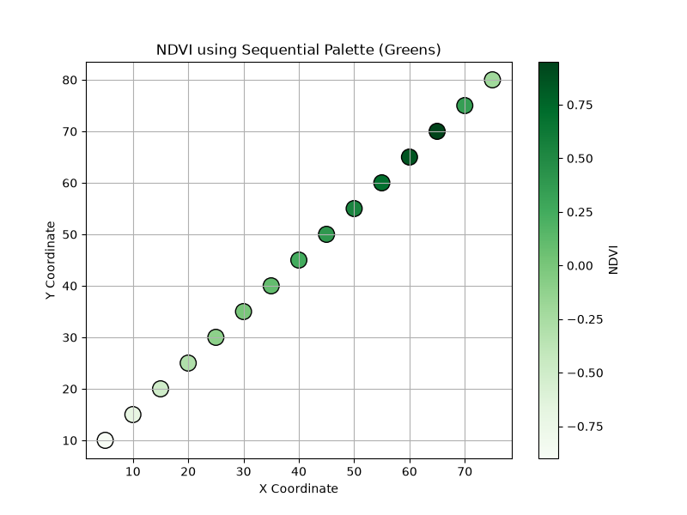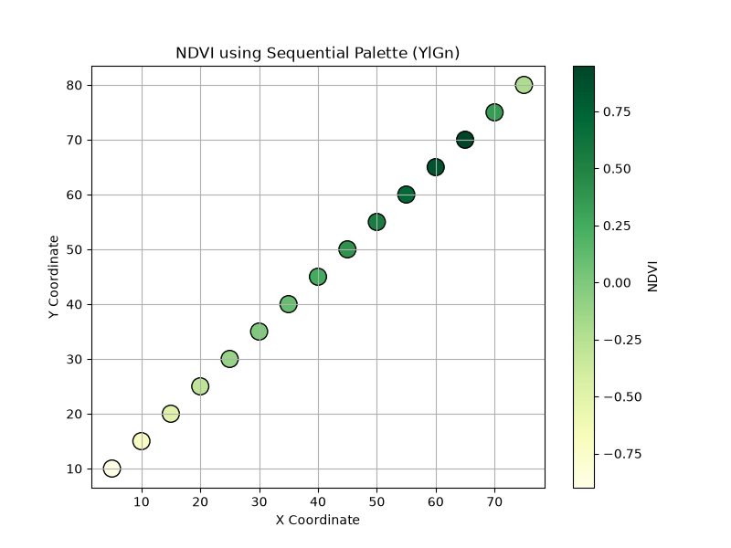
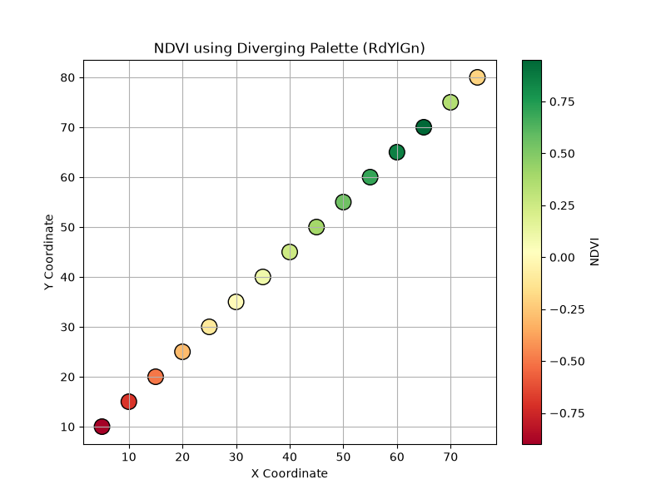
R code:
library(ggplot2)
# Create Dataset
ndvi_data <- data.frame(
Location = paste("L",1:10,sep=""),
NDVI = c(-0.8,-0.3,0.0,0.2,0.4,0.5,0.6,0.7,0.8,0.9)
)
print(ndvi_data)
# Sequential Palette
ggplot(ndvi_data,
aes(Location, NDVI, fill=NDVI)) +
geom_col() +
scale_fill_gradient(low="yellow",
high="darkgreen") +
labs(title="Sequential NDVI Palette") +
theme_minimal()
# Diverging Palette
ggplot(ndvi_data,
aes(Location, NDVI, fill=NDVI)) +
geom_col() +
scale_fill_gradient2(low="blue",
mid="white",
high="green",
midpoint=0) +
labs(title="Diverging NDVI Palette") +
theme_minimal()
Output:
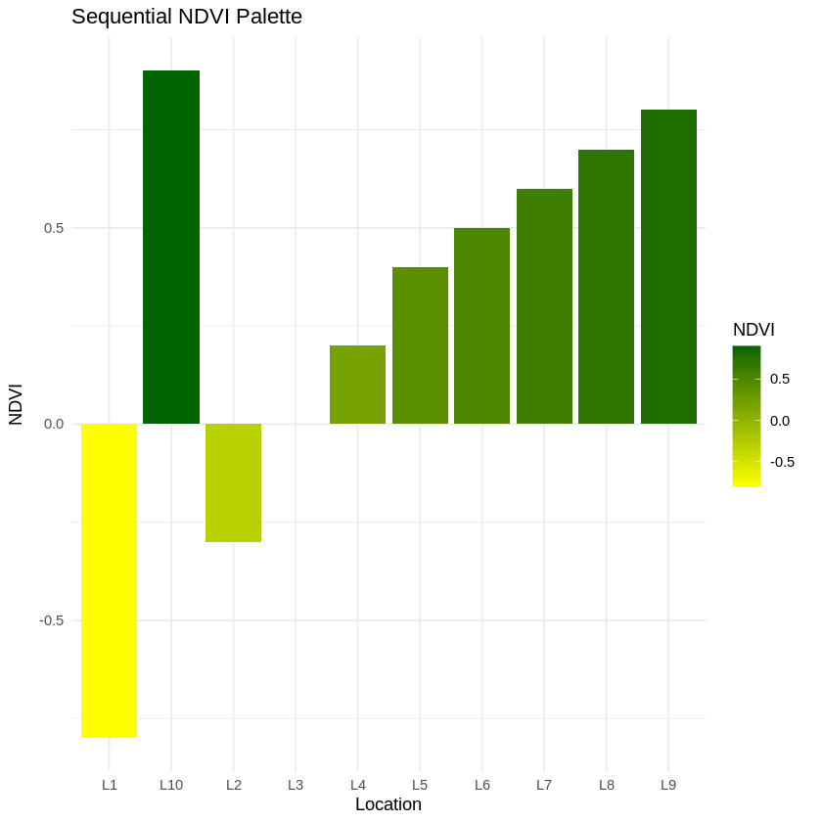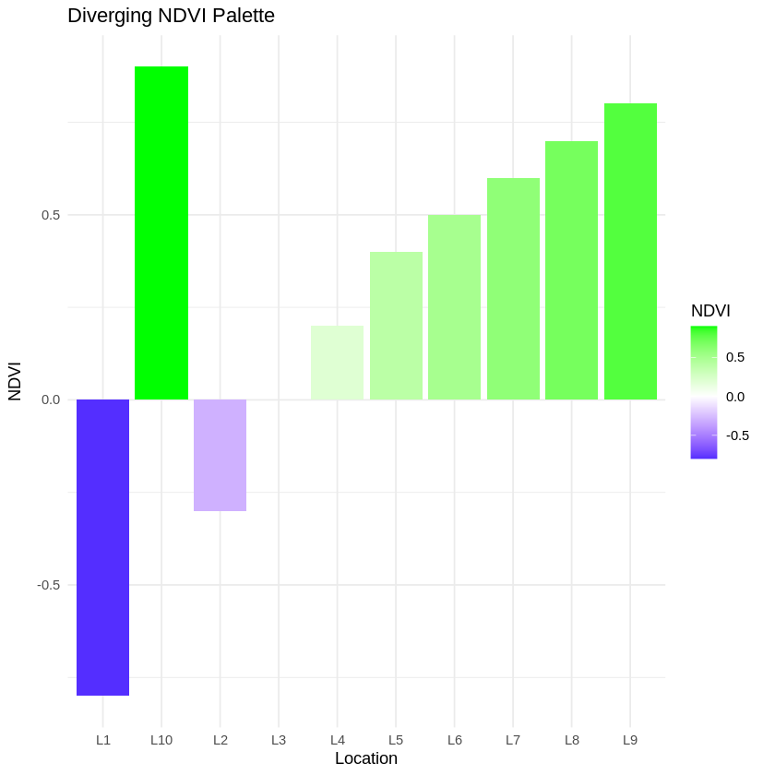

Scenario-08: Cryptocurrency Market Volatility
Python Code:
import pandas as pd
import matplotlib.pyplot as plt
data = pd.read_excel("scenario8.xlsx")
plt.figure(figsize=(10,6))
plt.plot(data["Date"], data["Bitcoin"], marker='o', color='orange', label='Bitcoin')
plt.plot(data["Date"], data["Ethereum"], marker='o', color='blue', label='Ethereum')
plt.plot(data["Date"], data["Solana"], marker='o', color='green', label='Solana')
plt.plot(data["Date"], data["Cardano"], marker='o', color='red', label='Cardano')
plt.title("Cryptocurrency Prices (Cartesian Scale)")
plt.xlabel("Date")
plt.ylabel("Price (USD)")
plt.xticks(rotation=45)
plt.legend()
plt.grid(True)
plt.show()
plt.figure(figsize=(10,6))
plt.plot(data["Date"], data["Bitcoin"], marker='o', color='orange', label='Bitcoin')
plt.plot(data["Date"], data["Ethereum"], marker='o', color='blue', label='Ethereum')
plt.plot(data["Date"], data["Solana"], marker='o', color='green', label='Solana')
plt.plot(data["Date"], data["Cardano"], marker='o', color='red', label='Cardano')
plt.yscale('log')
plt.title("Cryptocurrency Prices (Logarithmic Scale)")
plt.xlabel("Date")
plt.ylabel("Price (Log Scale)")
plt.xticks(rotation=45)
plt.legend()
plt.grid(True, which="both")
plt.show()
Output:
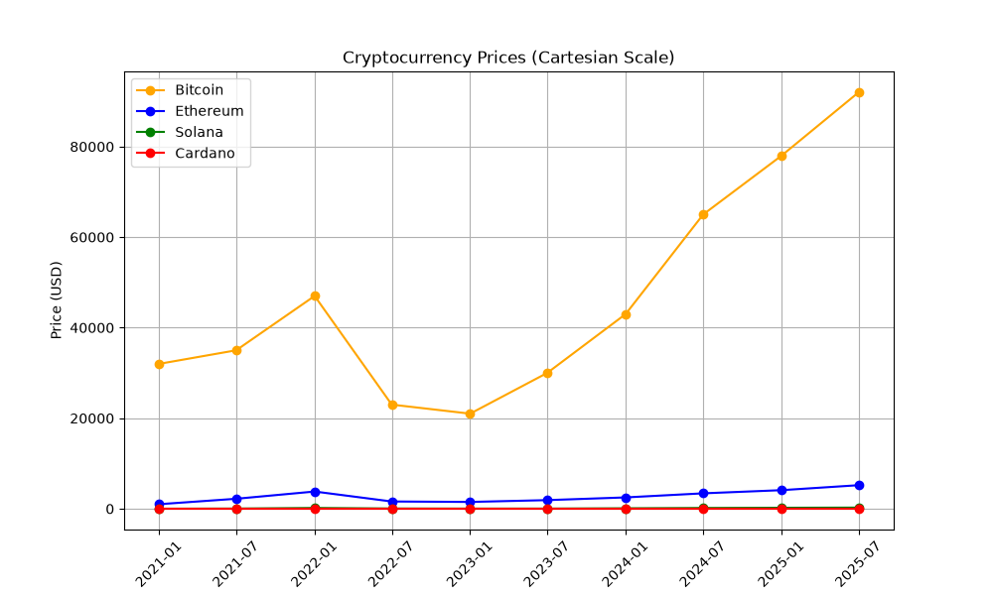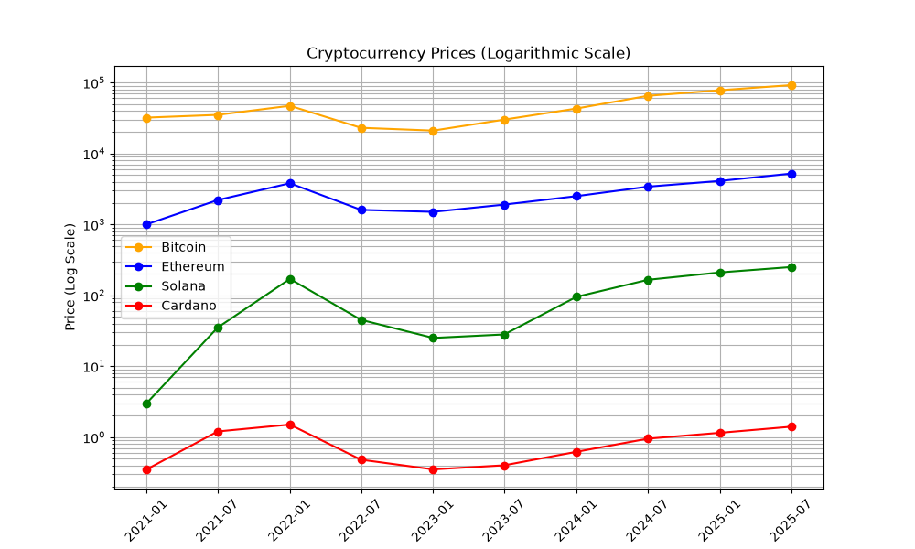
R code:
library(ggplot2)
# Create Dataset
crypto_data <- data.frame(
Day = 1:10,
Bitcoin = c(60000,61000,62000,59000,64000,65000,67000,66000,68000,70000),
Ethereum = c(3000,3100,3200,3050,3300,3400,3500,3450,3600,3700),
Solana = c(120,125,130,128,140,145,150,148,155,160),
Cardano = c(1.2,1.3,1.4,1.35,1.5,1.6,1.7,1.65,1.8,1.9)
)
print(crypto_data)
# Linear Plot
ggplot(crypto_data, aes(Day, Bitcoin)) +
geom_line(color="orange", linewidth=1) +
geom_line(aes(y=Ethereum), color="blue", linewidth=1) +
geom_line(aes(y=Solana*300), color="green", linewidth=1) +
geom_line(aes(y=Cardano*30000), color="red", linewidth=1) +
labs(title="Linear Scale Comparison",
y="Adjusted Price") +
theme_minimal()
# Log Scale
ggplot(crypto_data, aes(Day, Bitcoin)) +
geom_line(color="orange", linewidth=1) +
geom_line(aes(y=Ethereum), color="blue", linewidth=1) +
geom_line(aes(y=Solana), color="green", linewidth=1) +
geom_line(aes(y=Cardano), color="red", linewidth=1) +
scale_y_log10() +
labs(title="Logarithmic Scale Comparison") +
theme_minimal()

Output:
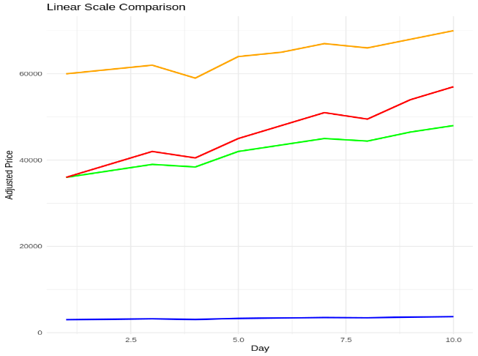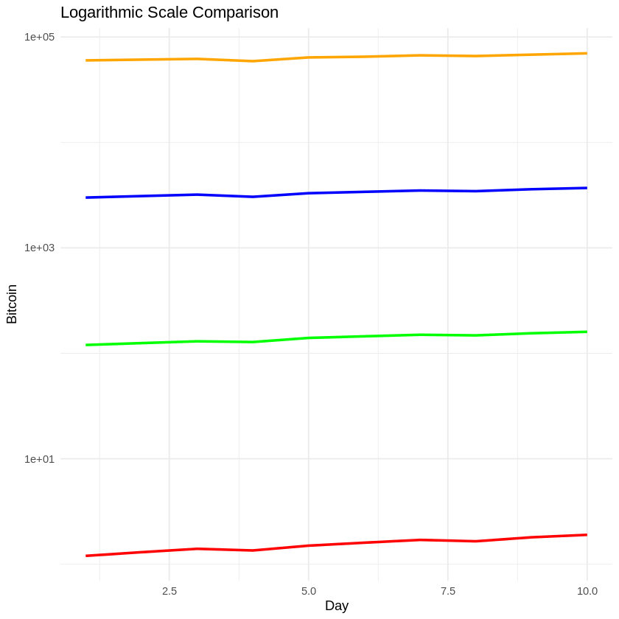

Scenario-09: Marathon Runner Performance Analysis
Python Code:
import pandas as pd
import matplotlib.pyplot as plt
import numpy as np
data = pd.read_excel("scenario9.xlsx")
plt.figure(figsize=(9,6))
scatter = plt.scatter(
data["Distance (km)"],
data["Heart_Rate (bpm)"],
c=data["Speed (km/h)"],
cmap="viridis",
s=120,
edgecolors="black"
)
plt.colorbar(scatter, label="Speed (km/h)")
plt.title("Heart Rate vs Distance")
plt.xlabel("Distance Covered (km)")
plt.ylabel("Heart Rate (bpm)")
plt.grid(True)
plt.show()
theta = np.deg2rad(data["Direction (°)"])
r = data["Distance (km)"]
plt.figure(figsize=(8,8))
ax = plt.subplot(111, projection='polar')
scatter = ax.scatter(
theta,
r,
c=data["Speed (km/h)"],
cmap="viridis",
s=120,
edgecolors="black"
)
plt.colorbar(scatter, label="Speed (km/h)")
ax.set_theta_zero_location("N")
ax.set_theta_direction(-1)
ax.set_title("Runner Direction and Distance (Polar Coordinates)")
plt.show()
Output:
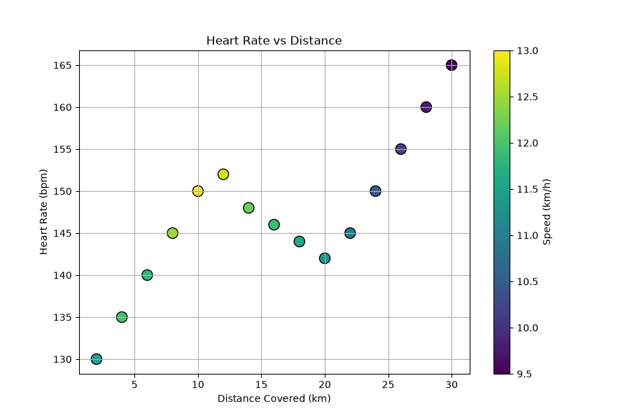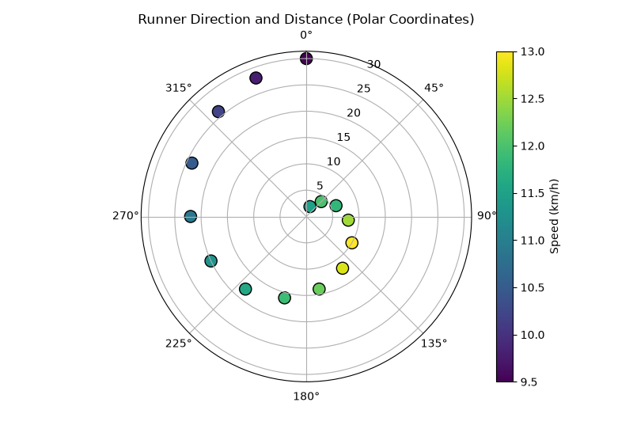

R code:
library(ggplot2)
# Create Dataset
runner_data <- data.frame(
Distance = c(5,10,15,20,25,30,35,40),
Speed = c(12,11.5,11,10.8,10.5,10.2,9.8,9.5),
Heart_Rate = c(120,130,138,145,150,155,160,168),
Direction = c(0,45,90,135,180,225,270,315)
)
print(runner_data)
# Cartesian Plot
ggplot(runner_data,
aes(Distance, Speed,
color=Heart_Rate)) +
geom_point(size=5) +
geom_line() +
scale_color_gradient(low="green",
high="red") +
labs(title="Runner Speed") +
theme_minimal()
# Polar Plot
ggplot(runner_data,
aes(factor(Direction),
Speed,
fill=Speed)) +
geom_bar(stat="identity") +
coord_polar() +
scale_fill_gradient(low="yellow", high="red") +
labs(title="Running Direction") +
theme_minimal()
Output:
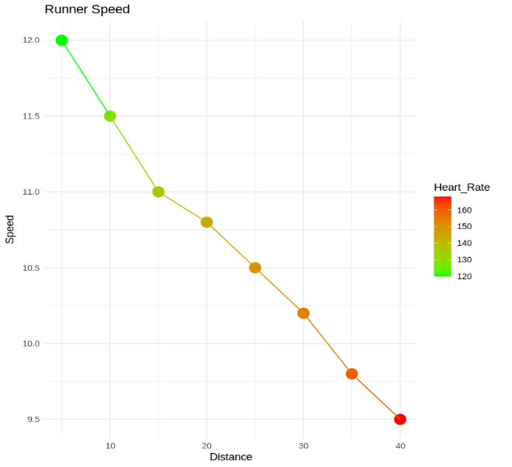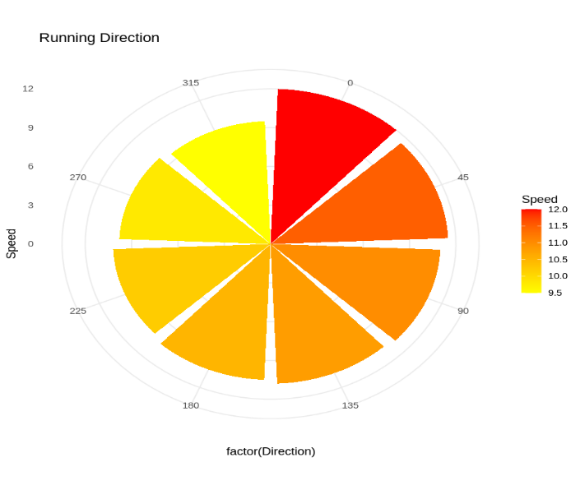
Scenario-10: COVID-19 Vaccination Campaign Dashboard
Python Code:
import pandas as pd
import matplotlib.pyplot as plt
data = pd.read_excel("scenario10.xlsx")
plt.figure(figsize=(9,6))
scatter = plt.scatter(
data["District"],
data["Age_Group"],
c=data["Vaccination_Rate"],
cmap="YlGn",
s=250,
edgecolors="black"
)
plt.colorbar(scatter, label="Vaccination Rate (%)")
plt.title("Vaccination Dashboard - Policymakers")
plt.xlabel("District")
plt.ylabel("Age Group")
plt.show()
def get_color(rate):
if rate >= 90:
return "green"
elif rate >= 80:
return "gold"
else:
return "red"
colors = data["Vaccination_Rate"].apply(get_color)
plt.figure(figsize=(9,6))
plt.scatter(
data["District"],
data["Age_Group"],
c=colors,
s=250,
edgecolors="black"
)
plt.title("Vaccination Dashboard - General Public")
plt.xlabel("District")
plt.ylabel("Age Group")
from matplotlib.lines import Line2D
legend_elements = [
Line2D([0],[0], marker='o', color='w', label='High (≥90%)',
markerfacecolor='green', markersize=10),

Line2D([0],[0], marker='o', color='w', label='Medium (80-89%)',
markerfacecolor='gold', markersize=10),

Line2D([0],[0], marker='o', color='w', label='Low (<80%)',
markerfacecolor='red', markersize=10)
]
plt.legend(handles=legend_elements)
plt.grid(True)
plt.show()

plt.show()
Output:
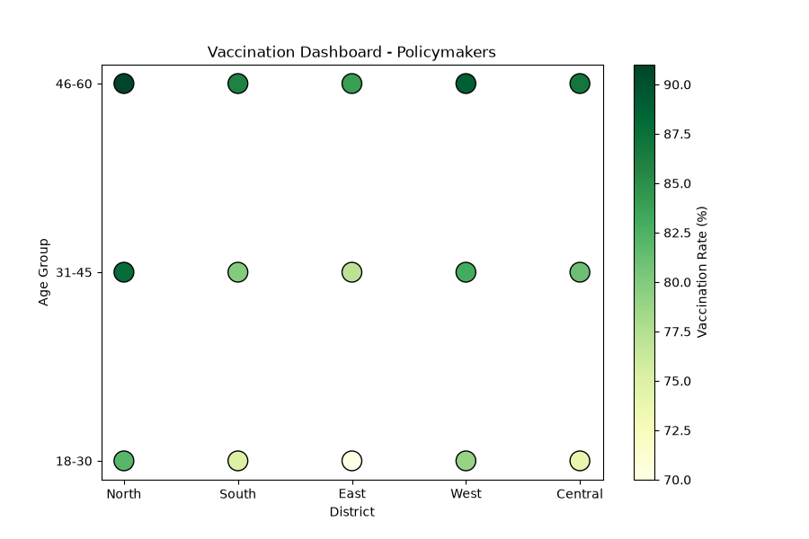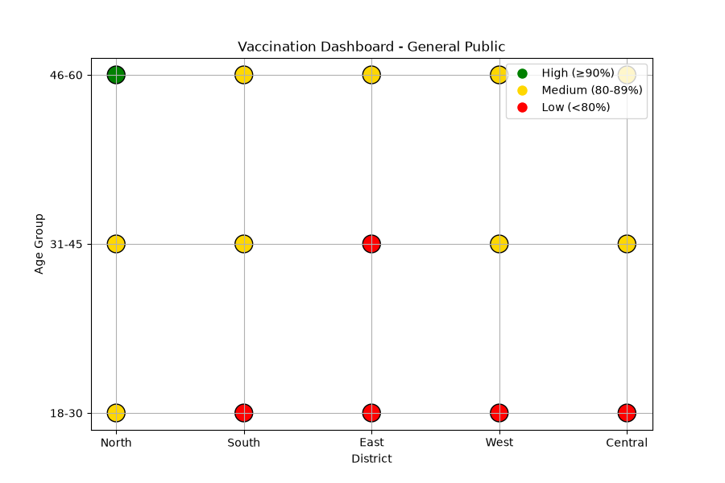
R code:
library(ggplot2)
# Create Dataset
vaccination_data <- data.frame(
District = c("A","B","C","D","E","F","G","H"),
Vaccination_Rate = c(92,84,76,68,95,82,74,88),
Vaccine_Type = c("Covaxin","Covishield","Covaxin","Covishield",
"Covaxin","Covishield","Covaxin","Covishield")
)
print(vaccination_data)
# Version 1
ggplot(vaccination_data,
aes(District,
Vaccination_Rate,
fill=Vaccination_Rate)) +
geom_col() +
scale_fill_gradient(low="yellow",
high="green") +
labs(title="Vaccination Rates") +
theme_minimal()
# Version 2
ggplot(vaccination_data,
aes(District,
Vaccination_Rate,
fill=Vaccine_Type)) +
geom_col() +
scale_fill_brewer(palette="Set2") +
labs(title="Vaccination by Vaccine Type") +
theme_minimal()
Output:

