**eZoo**

Configuration Document

Table of Contents

Table of Contents 2

1. Importing the Starter Kit into Eclipse 3

2. Importing the Database 7

3. Deploying the Starter Kit 10

# 1. Importing the Starter Kit into Eclipse

1. Download the starter kit from the master branch
2. Open Eclipse to the desired workspace
3. Right-click the Package Explorer, and select “Import” -> “Import…”

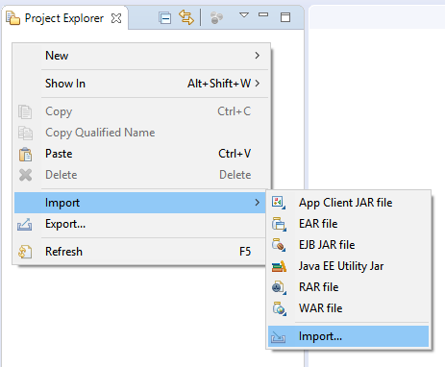

1. In the Import Wizard, search for and select “Projects from Folder or Archive.” Then, click next.

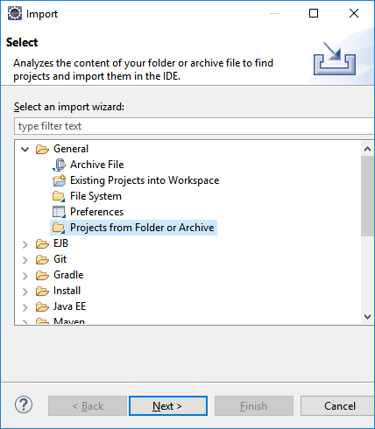

1. In the “Import Projects from File System or Archive” window, uncheck the “Detect and configure project natures” box. Then click the “Directory” button and select the root directory of the starter kit. Finally, click “Finish.”

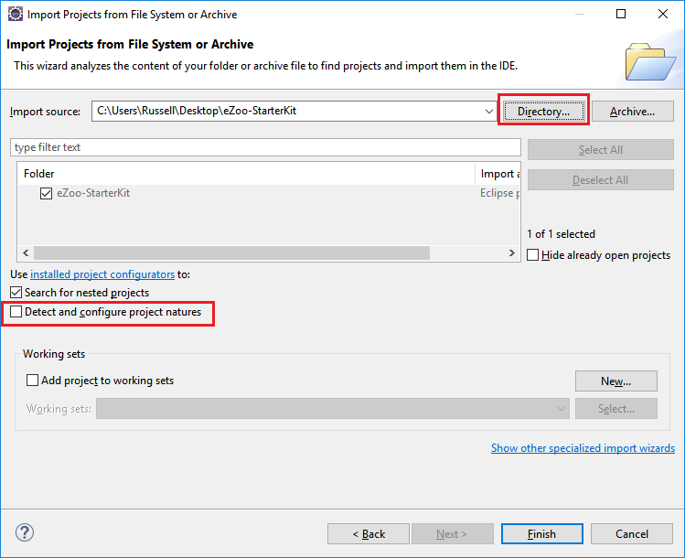

1. You should now have the Starter Kit added to your package explorer.
2. Open com.examples.eZoo.dao.DAOUtilities.java, and change the CONNECTION_PASSWORD and CONNECTION_USERNAME variables to match your PostgreSQL Database login information.

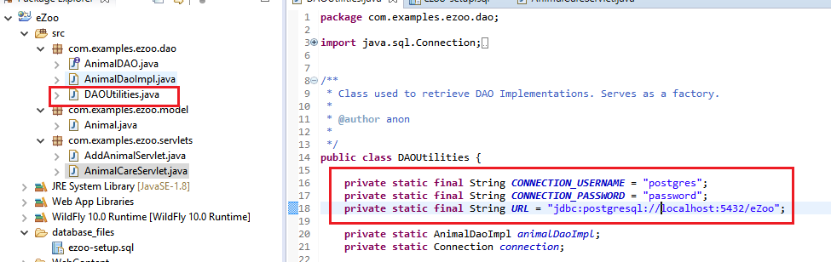

1. Lastly, right-click your project and select “Build Path”, then select “Configure Build Path…”

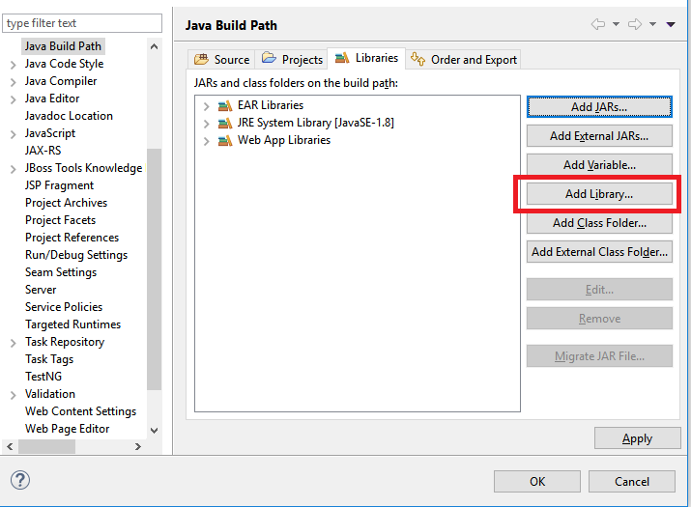

1. Click “Add Library”
2. Select “Server Runtime” and click “Next”

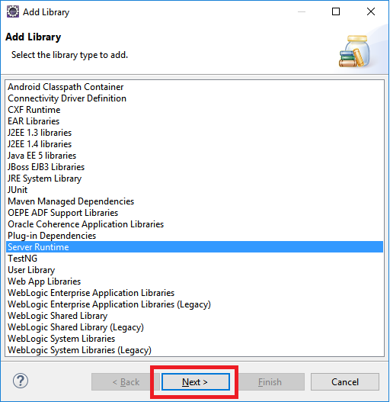

1. Select your WildFly runtime and click “Finish”

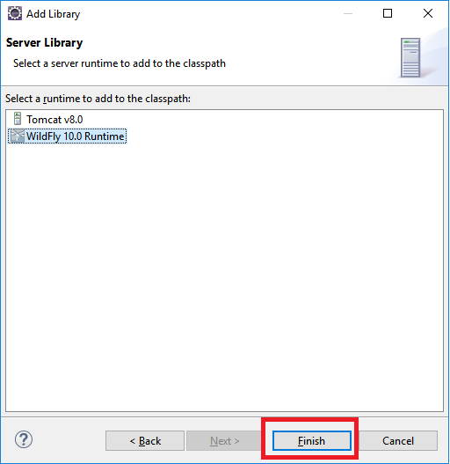

1. On the Java Build Path window, click “Ok”

# 2. Importing the Database

1. Open PgAdmin, and expand your PostgreSQL database

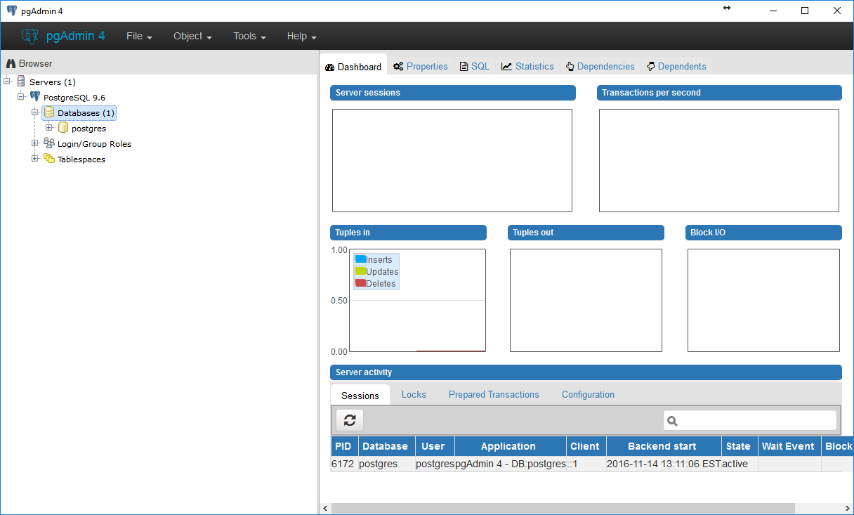

1. Right-click “Databases,” and select “Create” -> “Database…” Name it “eZoo.”

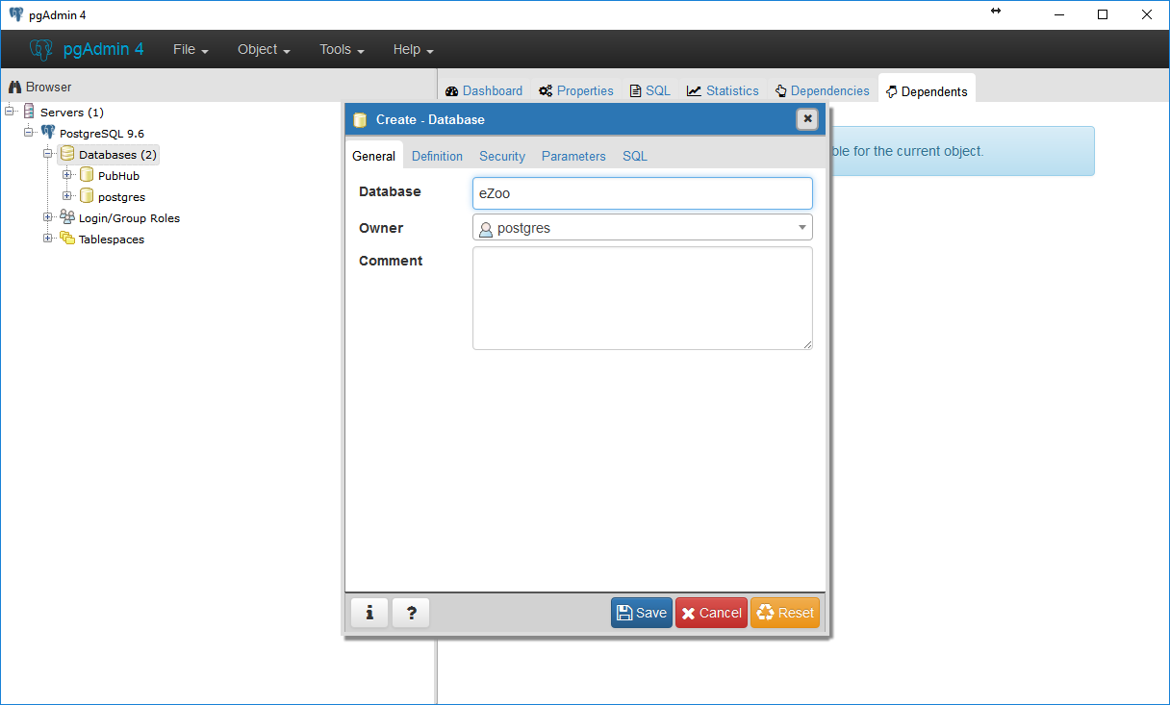

1. Click “Save.” This operation might take a few seconds. Then, right-click your new database, and select “Query Tool…”:

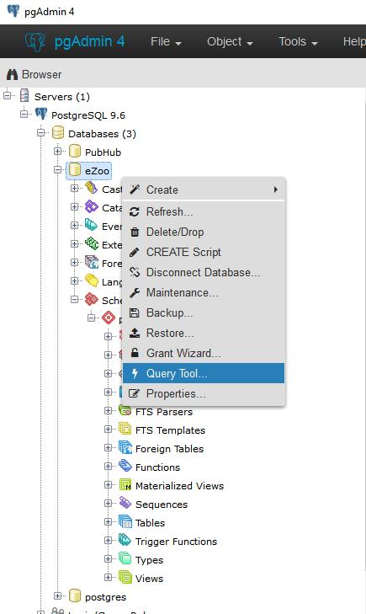

1. In the new SQL query window, open the SQL script located at “*...\<project template>\database_files\ezoo-setup.sql*”

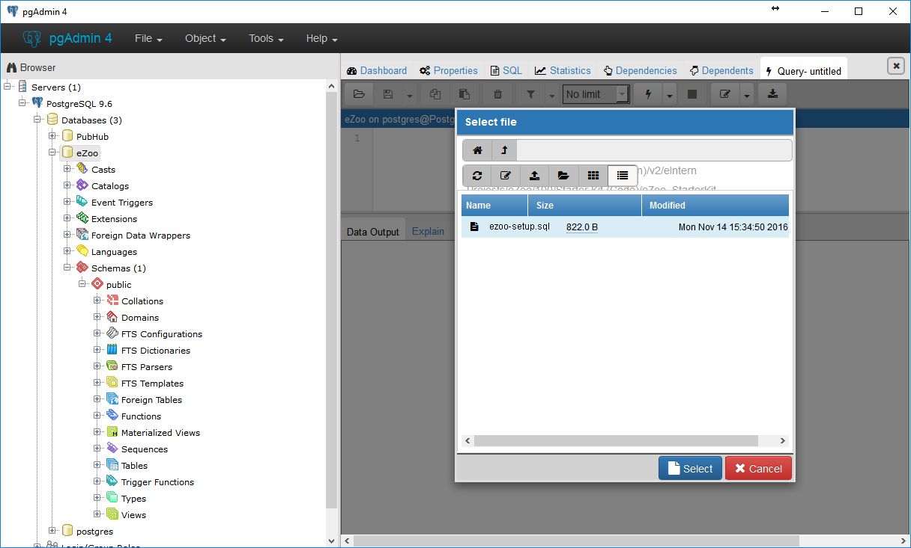

1. Click the lightning bolt button or hit F5 to execute the query:

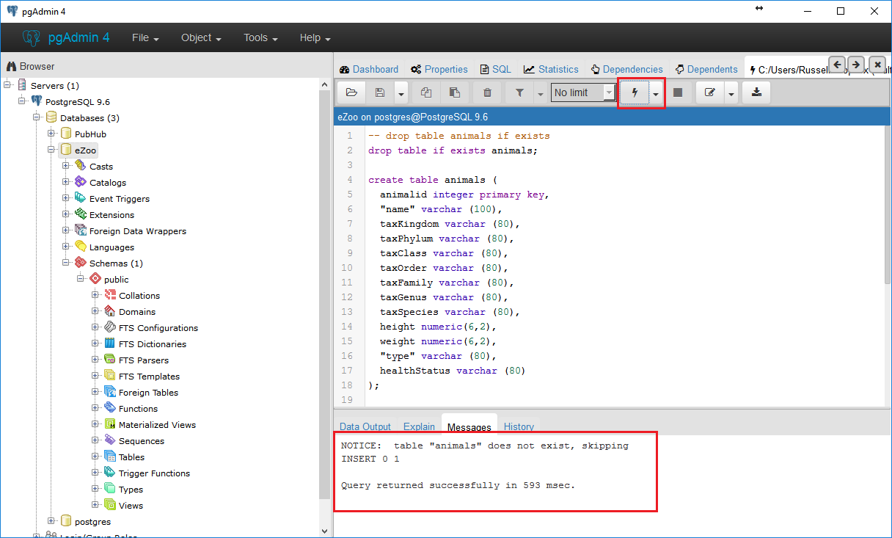

1. Verify that the script has successfully created the tables and inserted some appropriate dummy data:

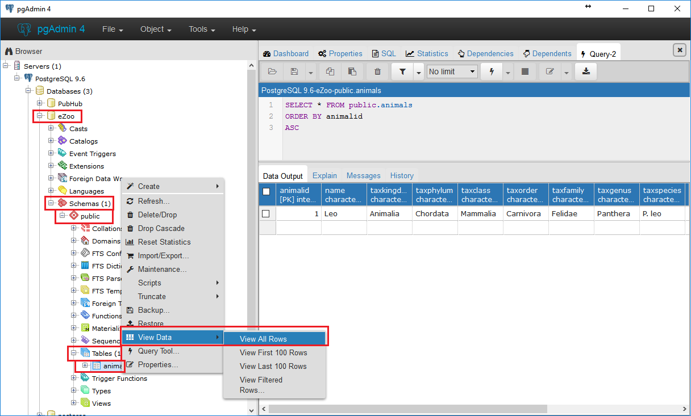

# 3. Deploying the Starter Kit

1. Right-click your application server in Eclipse, and select “Add and Remove…”

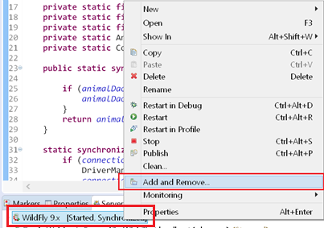

1. Select “eZoo” from the list of valid projects on the left, and click “Add.” Click “Finish” to close the window

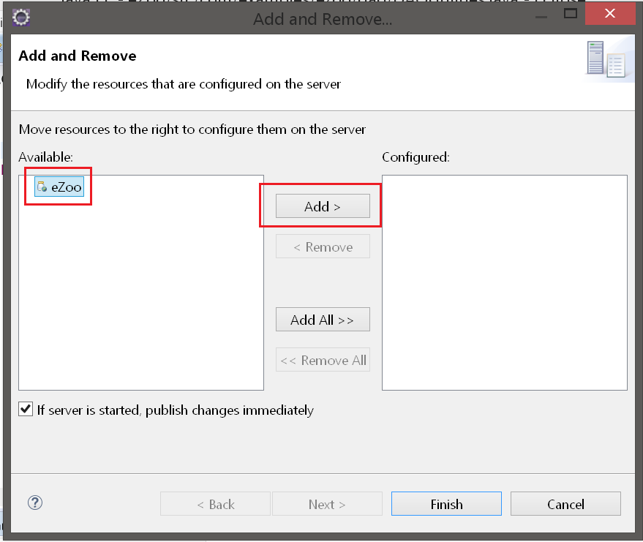

1. Right-click your application server again, and select “Start.” If you make any further changes to your application, you will need to restart the application server.

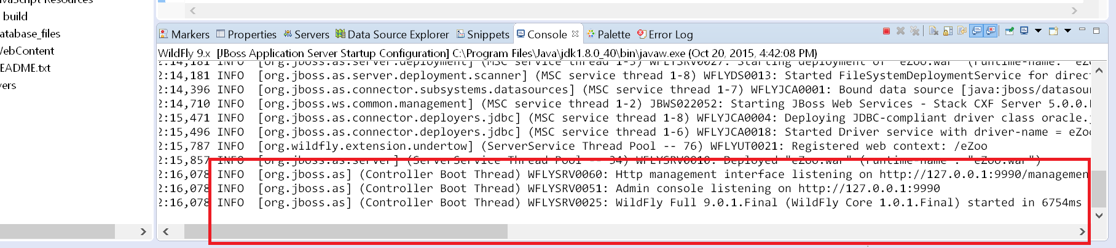

1. Congratulations! Your application template has been set up on your local machine, and you are free to make changes as per your project requirements. While your application server is running, you can access your project at <http://localhost:8080/eZoo>. Any changes you make to your application may require you to restart your application server to take effect.