UCD 514.18
N.M. AUSHEVA, Doctor of Engineering Sciences, Professor, National Technical University
of Ukraine “Igor Sikorsky Kyiv Polytechnic Institute”, Beresteyskyi Avenue, 37, Kyiv, 03056,
Ukraine, ORCID: https://orcid.org/0000-0003-0816-2971,
nataauscheva@gmail.com
O.S. KALENIUK, PhD (eng.), National Technical University of Ukraine “Igor Sikorsky Kyiv Polytechnic Institute”, Beresteyskyi Avenue, 37, Kyiv, 03056, Ukraine, ORCID: https://orcid.org/0009-0009-3141-4840,
akalenuk@gmail.com
Iu.V. SYDORENKO, PhD (eng.), Assistant Professor, National Technical University
of Ukraine “Igor Sikorsky Kyiv Polytechnic Institute”, Beresteyskyi Avenue, 37, Kyiv, 03056,
Ukraine, ORCID: https://orcid.org/0000-0002-1953-0410,
suliko3@ukr.net

USING EXPONENTIAL COMPLEX POLYNOMIALS FOR CONSTRUCTING CLOSED CURVES WITH GIVEN PROPERTIES
In this paper, we present a method to compute the coefficients of a complex exponential polynomial of real argument that, while being decomposed into real and imaginary parts by Euler’s formula, obtains required interpolating and differential properties at any given points of its real graph. Moreover, imaginary components in its nodes of interpolation and differentiation serve as additional control tool that shapes the polynomial appearance. Although the impact of these components is not yet studied extensively, we can still use them to achieve useful properties, e. g. we can minimize the total height of the polynomial graph.
From the geometry standpoint, having these properties implies that the parametric curves constructed with such polynomials can go through given points, have predetermined tangent vectors in those or other points, and retain enough variability to have additional useful properties, for instance, the total length of these curves, or their maximal curvature can also be minimized within limits.
Keywords: exponential complex polynomial, periodic interpolation, closed curve, mathematical optimization, total length minimization.

Introduction
Computing a trigonometric periodic interpolating polynomial analogous to interpolating Lagrange algebraic polynomial is a long-solved problem. The first implementation was proposed in 1948 by H. E. Salzer [1]. However, while the application of algebraic polynomials for geometric problems has been developing heavily through the XX century: Bezier curves, basis splines, rational Bezier, and NURBS – all stem from algebraic and not trigonometric polynomials, and all took their place in computer-aided design systems, the development of trigonometric polynomials application seems to pause until the XXI century. Trigonometric Bezier curves were only presented in 2009 by J. Sánchez-Reyes [2], and rational trigonometric Bezier curves in 2023 by A. Ramanantoanina and K. Hormann [3].
The main motivation for the introduction of rational trigonometric Bezier curves was supplying them with more shape control tools. By converting trigonometric rational Bezier curves into barycentric form, Ramanantoanina and Hormann achieve the same effect as with analytic rational Bezier curves in their earlier work [4] while making the resulting curve closed. This conversion allows them to add more than 2 guiding points that the curve goes through explicitly.
In this paper, we present a curve that also allows adding an arbitrary number of guiding points that the curve goes through. Additionally, the curve can have tangent vectors set explicitly in an arbitrary set of points. This already gives us a level of shape control similar to the rational periodic Bezier curves in the barycentric form Ramanantoanina and Hormann propose. But on top of that, the shape of the curves constructed with the exponential polynomial showcased in our work still remain variative enough so that additional optimizations like minimization of its total length could be conducted.

Problem Setting
Even though constructing closed curves with periodic polynomials is technically a solved problem, every periodic polynomial Pperiodic(t) forms a closed parametric curve (Px(t), Py(t)) on a plane, and (Px(t), Py(t), Pz(t)) in a 3D space, shape control of such curves: supplying them with given points and tangent vectors, minimizing their total curvature, length, etc. remains an open problem after all.
Let’s say we have m points on a plane: (x_{i}, y_{i}), i = 1..m, and p vectors on the same plane (dx_{j}, dy_{j}), j = 1..p. We want to build a closed smooth and continuous parametric curve that goes through points (x_{i}, y_{i}) and, in some points also has tangent vectors (dx_{j}, dy_{j}). Also, we want to have enough control over the shape of that curve so that even within given constraints (points and tangent vectors), the shape of the curve could still be optimized by select criteria using numeric methods of mathematical optimization.
To build such a curve, we use the complex exponential polynomial of a rational argument.

Complex exponential polynomial of a real argument
A complex exponential polynomial of a real argument is:
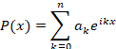

The x is a real number, a_{k} is, however, a complex number. The k is an integer number which is the degree of a corresponding member. Then ikx is also an imaginary number, and this allows us to rely on Euler’s formula to split each member of the polynomial into a real cosinusoid and an imaginary sinusoid.
This seemingly turns the complex exponential polynomial of a real argument into a weighted sum of cosinusoids in the real numbers as well. However, given that the polynomial coefficients a_{k} are complex and not real, the sinusoids also show up in the real numbers when being multiplied by the imaginary components of the complex coefficients. This adds variability to the polynomial. We can set its real value in some real points, and set real derivatives in real points as well, while every condition will raise the degree of polynomial by one. Meanwhile, the complex components of the given values and derivatives will remain orthogonal to the requested properties while still influencing the shape of the function.

Interpolating a point set by the complex exponential polynomial of a real argument
To determine the coefficients a_{k} of an interpolating complex polynomial of a real argument that passes through n points in the real numbers (x_{i}, y_{i}), i = 1..n, we should solve a system of n linear equations with a_{k,} k = 1..n being a solution:
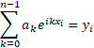
The number of equations in a linear system n implies that the degree of the polynomial should be n-1. Then there will be n equations and n coefficients a_{k} as well. The solution of this system gives us the polynomial that goes through the given set of points (figure 1.).
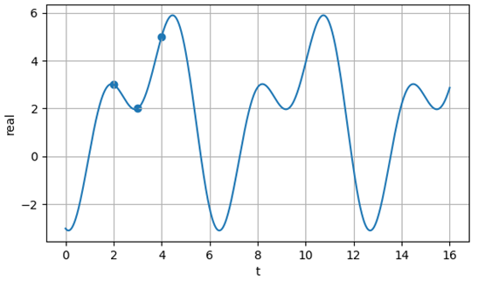
Fig 1. An example of a periodic interpolating complex exponential polynomial of a real argument in real numbers

Interpolating a point set by the complex exponential polynomial of a real argument while setting the derivative values in points
Just like for the interpolation alone, the coefficients of the interpolating polynomial that goes through m points (x_{i}, y_{i}), i = 1..m and has given derivatives in p x_{j} points dy_{j}, j = 1..p can be computed by solving a system of equations that consists of two types of equations. Those that satisfy the “function has value y in x” conditions:
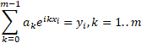
And “function has derivative dy in x” conditions:
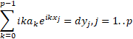
The degree of the resulting polynomial should correspond to the total amount of equations of both types p+m = n.
When m = 2, p = 2, and the points of interpolation also have derivatives set in them, the polynomial obtains properties similar to what cubic Bezier has (figure 2). Of course, in our case, instead of setting additional control points outside of the curve, we set derivatives in points explicitly.
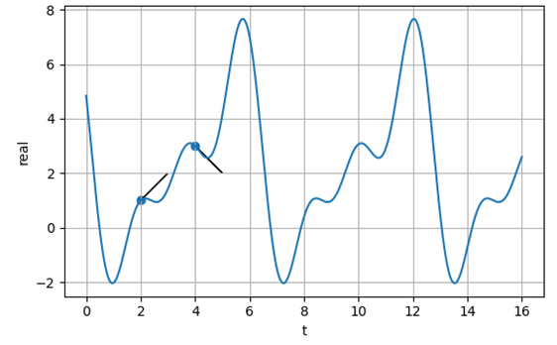
Fig 2. An example of interpolating complex polynomial of a real argument that has derivatives explicitly set in the interpolation points

Since the polynomial consists of exponential members, it is infinitely differentiable on its whole range. Therefore, analogous to the first order derivatives, we can set derivatives of any order and at any point too.

Mathematical optimization of a polynomial shaping target function in the space of imaginary components of points’ values and derivatives
So far we have set all the interpolation points and derivatives in points in real numbers. The interpolation method sets no constraints on the imaginary components of the input data. However, as has been stated before, the choice of these imaginary components affects the shape of the resulting polynomial. This means that we can choose them in a way that benefits us in one way or another.
Although the exact impact of imaginary components of the input data on the real function is not yet thoroughly studied, we can still use methods of mathematical optimization and optimize some prdefined target function in the space of the imaginary components without knowing the exact mechanism of their impact.
The generic algorithm of such optimization looks like this:
- Set the initial values of the imaginary parts of every interpolation value y_{i} or a derivative dy_{j}. This choice could be made arbitrary, until the problem of initial values is studied further, setting them all to 0 could be considered a good start.
- Compute the polynomial coefficients by solving a corresponding system of equations.
- Compute a target function for the freshly computed polynomial.
- If a function has not reached its optimum, change the imaginary parts of interpolation values and derivatives towards the gradient of the target function, go to step 2.
The choice of a specific algorithm of mathematical optimization for every particular problem goes far beyond this paper. However, in all the examples shown below, we use the Broyden–Fletcher–Goldfarb–Shanno algorithm algorithm (BFGS) [5].
For instance, if we chose the target function to be the total length of the graph on [0; 2π] and set the initial data exactly as we did in Figure 2, the polynomial optimized by this target function with the BFGS algorithm will look like in figure 3.
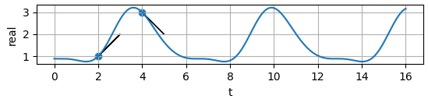
Fig 3. The same input data as in Figure 3, but the polynomial’s total graph length has been optimized in the space of the imaginary components of input data values

Closed curves construction
To construct a parametric curve on a plane, we should specify two functions of the shared parameter t. In our case, the functions will be complex exponential polynomials of a real argument: Px(t) and Py(t). If the periods of the functions coincide, and in our case they are, the set of points (Px(t), Py(t)) will form a closed curve.
We can make the curve go through a set of points (x_{i}, y_{i}) if we compute the coefficients for the polynomials from the corresponding equations for Px(t_{i}) = x_{i} and Py(t_{i}) = y_{i}. We can also set tangent vectors (dx_{j}, dy_{j}) into correspondence with parameter values t_{j}. The parameter values for the set curve points and tangent vectors may or may not coincide.
If, for instance, they do, and we set two points and two tangent vectors in those very points, then the closed curve will produce a section with defined ends and tangent vectors in these ends that can be then smoothly conjoined with an analogously built curve that shares a point and a tangent vector inverted direction in that point. This makes the case of setting points and tangent vectors in those points particularly interesting. An example of such a curve is shown in Figure 4.
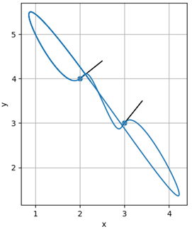
Fig 4. A closed curve that runs through two predefined points and follows the predefined tangent vectors

As we can see from Figure 4, the default shape of the curve that follows the set properties may not always be applicable to solving a particular problem. We still retain, however, the control over imaginary components of the points’ and tangent vectors’ coordinates. We can exploit these components to give the curve a desired shape.
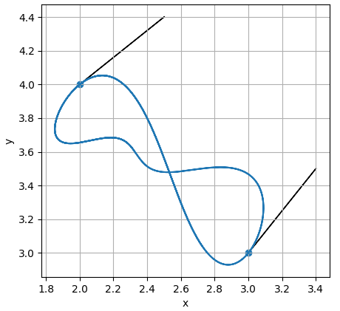
For instance, by minimizing the curve’s total length in the space of the complex components of its predefined points and tangent vectors, we can construct a shorter curve as shown in Figure 5, that still goes through the predefined points (we haven’t changed their coordinates in real numbers) and still follows the tangent vectors (in real numbers, these also remain intact as the optimization commences).

Fig 5. The curve goes through the same points as in Figure 4 and follows the same tangents but is now shorter

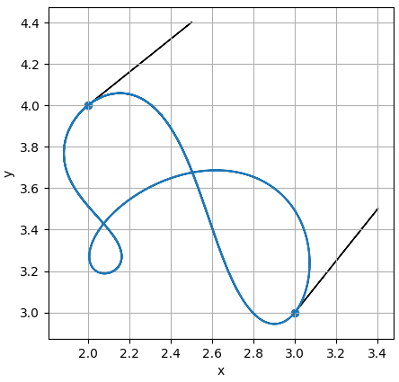
Similar to the total length minimization, we can minimize the largest length of the second derivative vector which corresponds to the curve’s maximal absolute curvature, as in Figure 6.
Fig 6. The curve goes through the same points as in Figure 4 and with the same tangent vectors set but the maximal curvature of this curve is now minimized

Conclusion
Using a complex exponential polynomial for construcing a closed curve allows us not only to set points for the curve to go through, and tangent vectors to follow in real numbers but also to use complex components of the input data to optimize the curve by any select target function by using methods of mathematical optimization.
Future development of this method may include using a rational exponential function instead of a polynomial, mixing members of exponential and analytical polynomials in an interpolating function, and also generalizing the polynomial to the multivariate case for modeling not only curves but surfaces, manifolds, and fields.

REFERENCE
- H. E. Salzer. Coefficients for facilitating trigonometric interpolation. Journal of Mathematics and Physics, 27(1–4):274–278, Apr. 1948.
- J. Sánchez-Reyes. Periodic Bézier curves. Computer Aided Geometric Design, 26(9):989–1005, Dec. 2009.
- A. Ramanantoanina, K. Hormann. Shape control tools for periodic Bézier curves. Computer Aided Geometric Design, 103:, Article 102193, 12 pages, June 2023.
- A. Ramanantoanina, K. Hormann. New shape control tools for rational Bézier curve design. Computer Aided Geometric Design, 88:, Article 102003, 2021.
- R. Fletcher. Practical methods of optimization. – NY : Wiley, 1988. – 456 p.

ЛІТЕРАТУРА
- H. E. Salzer. Coefficients for facilitating trigonometric interpolation. Journal of Mathematics and Physics, 27(1–4):274–278, Apr. 1948.
- J. Sánchez-Reyes. Periodic Bézier curves. Computer Aided Geometric Design, 26(9):989–1005, Dec. 2009.
- A. Ramanantoanina, K. Hormann. Shape control tools for periodic Bézier curves. Computer Aided Geometric Design, 103:, Article 102193, 12 pages, June 2023
- A. Ramanantoanina, K. Hormann. New shape control tools for rational Bézier curve design. Computer Aided Geometric Design, 88:, Article 102003, 2021
- R. Fletcher. Practical methods of optimization. – NY : Wiley, 1988. – 456 p.

Н.М. Аушева, доктор технічних наук, професор, Національний технічний університет України «Київський політехнічний інститут імені Ігоря Сікорського», просп. Берестейський, 37, Київ, 03056, Україна,
nataauscheva@gmail.com
О.С. Каленюк, кандидат технічних наук, Національний технічний університет України «Київський політехнічний інститут імені Ігоря Сікорського», просп. Берестейський, 37, Київ, 03056, Україна,
akalenuk@gmail.com
Ю.В. Сидоренко, кандидат технічних наук, доцент, Національний технічний університет України «Київський політехнічний інститут імені Ігоря Сікорського», просп. Берестейський, 37, Київ, 03056, Україна,
ПОБУДОВА ЗАМКНЕНИХ КРИВИХ ІЗ НАПЕРЕД ЗАДАНИМИ ВЛАСТИВОСТЯМИ ЕКСПОНЕНЦІАЛЬНИМ КОМПЛЕКСНИМ ПОЛІНОМОМ ДІСНОГО АРГУМЕНТА
Вступ. Не зважаючи на те, що застосування періодичних поліномів для побудови замкнених кривих є технічно вирішеною задачею, будь-який періодичний поліном Pперіодичний(t) формує замкнену параметричну криву (Px(t), Py(t)) на площині і (Px(t), Py(t), Pz(t)) у просторі, проблема керування видом і властивостями таких кривих лишається відкритою. До способів керування видом кривих можемо віднести задання контрольних точок, дотичних векторів, а також мінімізацію глобальних властивостей, наприклад, довжини кривої, або максимальної її кривини.
Мета статті. У даній роботі наводиться способ обчислення коефіцієнтів комплексного експоненціального полінома дійсного аргумента, який, при розкладенні його за формулою Ейлера на дійсну і комплексну частки, матиме у дійсному просторі наперед задані інтерполяційні і диференційні властивості. При тому уявні складові точок у вузлах інтерполяції і диференціації матимуть додатковий вплив на вид полінома. У роботі показано, що навіть зважаючи на те, що цей вплив досі не вивчено, ми можемо використовувати його для надання поліномові бажаних якостей, наприклад, для мінімізації висоти його графа. Відповідно, при побудові замкненої кривої таким поліномом, ми можемо задавати точки, через які проходить крива, дотичні у цих (чи інших) точках, а також оптимізовувати коефіцієнти покоординатних поліномів у просторі уявних складових вхідних точок і дотичних для надання кривій бажаних якостей, наприклад, мінімізації її довжини чи загальної кривини.
Методи. Математичний аналіз, обчислювальний експеримент.
Результати. Показано спосіб побудови періодичних експоненціальних поліномів у дійсному просторі із наперед задатими властивостями: інтерполяційними точками і похідними у точках. Наведений загальний алгоритм оптимізації такого полінома за зхаданим критерієм. Продемонстровано застосування оптимізованого полінома із наперед заданими властивостями для побудови замкнених кривих, які проходять через контрольні точки, мають визначені дотичні вектори і при тому є оптимізованими за певним наперед заданим критерієм.
Висновки. Застосування експоненціального комплексного полінома дійного аргумента дозволяєть поєднувати аналітичні і чисельні методи при розв’язанні однієї і тієї ж задачі, що, в свою чергу, дозволяє будувати замкнені криві із наперед заданними певними обмеженнями і із властивостями, які оптимізуються чисельними методами не порушуючи наперед заданих обмежень.
Ключові слова: експоненційний комплексний поліном, періодична інтерполяція, замкнена крива, математична оптимізація, мінімізація задальної довжини.

ВІДОМОСТІ ПРО АВТОРІВ

Контактний автор:
Аушева Наталія Миколаївна (Ausheva Natalia M.) — доктор технічних наук, професор, Національний технічний університет України «Київський політехнічний інститут імені Ігоря Сікорського», просп. Берестейський, 37, Київ, 03056, Україна, ORCID: https://orcid.org/0000-0003-0816-2971, e-mail: nataauscheva@gmail.com.
Каленюк Олександр Сергійович (Kaleniuk Oleksandr) — кандидат технічних наук, Національний технічний університет України «Київський політехнічний інститут імені Ігоря Сікорського», просп. Берестейський, 37, Київ, 03056, Україна, ORCID: https://orcid.org/0009-0009-3141-4840, e-mail: akalenuk@gmail.com.
Сидоренко Юлія Всеволодівна (Sydorenko Iuliya V.) — кандидат технічних наук, доцент, Національний технічний університет України «Київський політехнічний інститут імені Ігоря Сікорського», просп. Берестейський, 37, Київ, 03056, Україна, ORCID: https://orcid.org/0000-0002-1953-0410, e-mail: suliko3@ukr.net.

