UDC 364.2:331
O.V. TUTOVA, PhD Econ. Sciences , Senior Research Associate, International Research and Training Centre of Information Technologies and Systems of the NAS and MES of Ukraine, Glushkov ave., 40, Kyiv, 03187, Ukraine,
olenatutova@gmail.com
Ye.A. SAVCHENKO, PhD Ehg. Sciences , Senior Research Associate, International Research and Training Centre of Information Technologies and Systems of the NAS and MES of Ukraine, Glushkov ave., 40, Kyiv, 03187, Ukraine,
Savchenko_e@meta.ua

UKRAINE IN THE INFORMATION AND COMMUNICATION TECHNOLOGY
DEVELOPMENT RANKING
This paper considers the level and evolution of information and communication technology developments in Ukraine and its experience relative to other Eastern European and post-Soviet countries based on the Information and Communication Technology Development Index over 2002–2017. Also the digital divide and development potential of information and communication technologies and the extent to which Ukraine can make use of them to enhance growth and development in the context of available capabilities and skills are examined here based on the analysis of evolution of the sub-indices and their components over 2002–2017 and the telecommunication market in Ukraine over 2014–2016; the key features of information and communication technology development in Ukraine in 2016, and the connection between GNI and this index.
Keywords: Information and Communication Technology Development Index, digital divide, global development indices, Digital Agenda of Ukraine.

Introduction
On January 17 2018 the government of Ukraine passed its Decree № 67-p “About Adoption of the Concept For Development Of Digital Economy and Society For 2018–2020“ and approved a plan of steps to put the Concept into practice. The Ministry of Economic Development and Trade is appointed to be responsible for the fulfilment of this program. The main goal of this document is to see fulfilled the initiatives of the “Digital Agenda of Ukraine 2020” (Digital Strategy) to remove barriers on the way of digital transformation of Ukraine in the most prospective fields [1, 2].
According to the decree, putting into practice the measures of this concept should help to stimulate economic development, and to attract investments, to make Ukrainian industry competitive and efficient thanks to its “digitalization”. Furthermore it aims to decrease “digital divide”, bring digital technologies closer to people, create new opportunities for human capital realization, develop innovative, creative and digital industries and businesses and to promote export of digital products and services (IT outsourcing).
Along with these main goals the “Digital Agenda of Ukraine 2020” also proclaims so called rating goals based on the global development indices, that is to become №40 in the Networked Readiness Index Rating by 2020 (Ukraine is on the 64 position by this index in 2016), №40 in the Global Innovation Index Rating (Ukraine is №56 there in 2016), №50 in the Global Competitiveness Index Rating (Ukraine is №85 there in 2016, the index is cumulative).
Also it should be added that every country defines the global development indices on which its rating goals are based according to its national strategies, priorities and preferences. For example, the Russian Federation included its position in the rating based on the Information and the Communication Technology Development Index built by the International Telecommunication Union into the set of control indicators of the “Information Society Development Strategy in the Russian Federation” and the State Program “Information Society in 2011–2020” [3, 4]. Kazakhstan also includes the Information and Communication Technology Development Index in its State Program “Digital Kazakhstan” adopted 12.12.2017 along with the E-government development rank and the Global Cybersecurity Index as a target indicator of digital transformation [5].
Since both Kazakhstan and the Russian Federation are among those countries which have achieved a remarkable progress in information technology development during in the resent decade it’s also important to take into account their experience. [6]

Problem Setting
In order to analyze the potential of Ukraine in order to achieve the rating goals defined in the “Digital Agenda of Ukraine 2020”, it is necessary to track the progress of Ukraine in global ratings from their first measurements till the last studies. There are also other important global indices that describe the level of development of information and communication technologies in the world. Since information and communication technologies are the base of the digital economy it is important to make a research of the progress of Ukraine in all these ratings for a better understanding of the prospect of digital economy and its instruments in Ukraine.
The ratings developed by the specialists of the United Nations (UN), the International Telecommunication Union (ITU), the World Economic Forum (WEF) and the World Bank (WB) are considered to be the most authoritative.
The purpose of this article is to analyze how Ukraine changed its position in the rating based on the Information and Communication Technology Development Index (IDI) built by the ITU. This index is chosen as the first indicator to be analyzed because the components of it haven’t been changed since as of the first report in 2002 till 2017.
The level and evolution over 2002–2017 of ICT developments in Ukraine and its experience, relative to other Eastern European- and post-Soviet countries based on IDI are pioneered in this article. Also for the first time the digital divide, i.e. differences between Ukraine and these countries in terms of their levels of Information and Communication Technology (ICT) development; as well as the development potential of ICTs and the extent to which Ukraine can make use of them to enhance growth and development in the context of available capabilities and skills are examined here, based on the analysis of evolution of IDI sub-indices and its components over 2002–2017, the key features of ICT development in Ukraine in 2016, the telecommunication market in Ukraine over 2014–2016, and the connection between GNI and IDI.
The goal of further studies is to conduct a research of how Ukraine succeeded in the Networked Readiness Index — (NRI) developed by the WEF, the E-government development rank built by the UN, the E-participation index (EPI) also developed by the UN, the Knowledge Economy Index (KEI) by the WB and the Global Innovation Index (GII) developed by Cornell University, INSEAD (European Institute of Business Administration) and the World Intellectual Property Organization.

ICT Development Index: Conceptual Framework
The ITU Information and Communication Technology Development Index (ICT Development Index, or IDI) brings together indicators concerned with ICT access, use and skills into a single comparative measure of development towards the information society. The IDI is a composite index that combines 11 indicators into one benchmark measure that can be used to monitor and compare developments in ICTs between countries and over time [7].
The main objectives of the IDI are to measure:
▪ the level and evolution over time of ICT developments within countries and of their experience relative to other countries;
▪ progress in ICT development in both developed and developing countries;
▪ the digital divide, i.e. differences between countries in terms of their levels of ICT development;
▪ the development potential of ICTs and the extent to which countries can make use of them to enhance growth and development in the context of available capabilities and skills.
The Index is designed to be global and reflect changes taking place in countries at different levels of ICT development. It therefore relies on a limited range of data sets which can be established with reasonable confidence in countries at all levels of development.
The ICT development process, and a country’s transformation to becoming an information society, can be depicted using the three-stage model illustrated in Fig. 1:
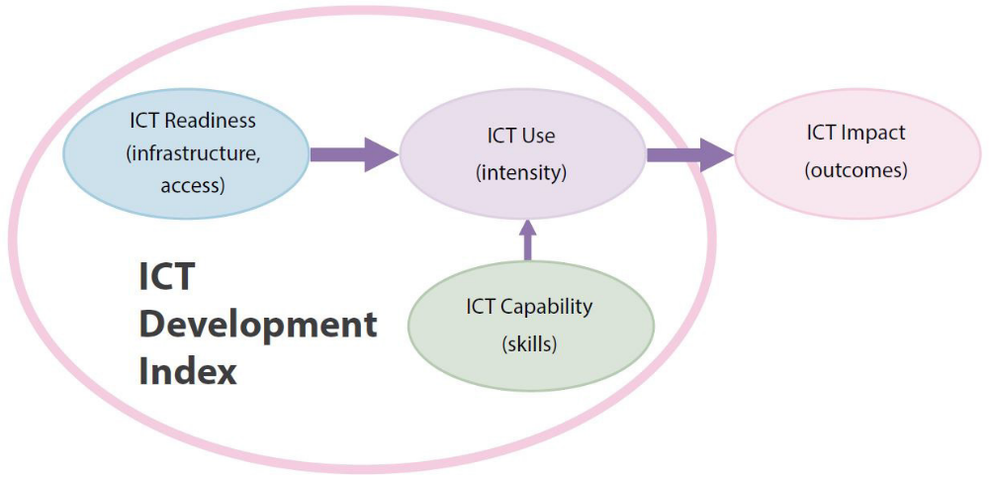
Fig. 1. Three stages in the evolution towards an information society
Based on this conceptual framework, the IDI is divided into the following three sub-indices illustrated with their component indicators in Fig. 2:
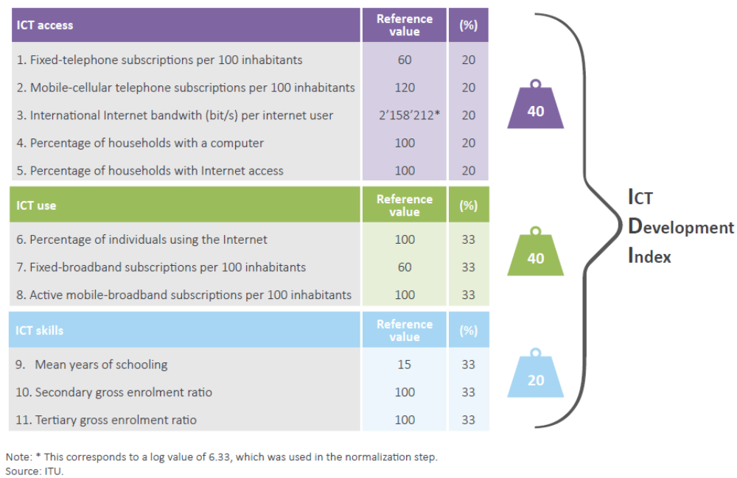
Fig. 2. ICT Development Index — indicators, reference values and weights

The term international Internet bandwidth refers to the total used capacity of international Internet bandwidth, in megabits per second (Mbit/s). The term computer refers to a desktop computer, laptop (portable) computer, tablet or similar handheld devices. Household with a computer means that the computer is available for use by all members of the household at any time. Data are obtained by countries through national household surveys and are either provided directly to ITU by national statistical offices (NSOs) or obtained by ITU through its own research.
The term individuals using the Internet refers to people who used the Internet from any location and for any purpose, irrespective of the device and network used, in the previous three months. The term fixed-broadband subscriptions refers to fixed subscriptions for high-speed access to the public Internet (a Transmission Control Protocol (TCP)/IP connection) at downstream speeds equal to or higher than 256 kbit/s. The term active mobile-broadband subscriptions refers to the sum of data and voice mobile-broadband subscriptions and data-only mobile-broadband subscriptions to the public Internet. It covers subscriptions actually used to access the Internet at broadband speeds, not subscriptions with potential access. Subscriptions must include a recurring subscription fee to access the Internet. It includes subscriptions to mobile-broadband networks that provide download speeds of at least 256 kbit/s (e.g. WCDMA, HSPA, CDMA2000 1x EV-DO, WiMAX IEEE 802.16e and LTE).
Data on gross secondary and tertiary enrolment ratios are collected by the United Nations Educational, Scientific and Cultural Organization Institute for Statistics (UIS).
Mean years of schooling is the average number of completed years of education of a country’s population, excluding years spent repeating individual grades. It is estimated using the distribution of the population by age group and the highest level of education attained in a given year, and time series data on the official duration of each level of education.
According to the UIS, the gross enrolment ratio (secondary and tertiary level) is “the total enrolment in a specific level of education, regardless of age, expressed as a percentage of the eligible official school-age population corresponding to the same level of education in a given school-year.”
A number of changes to the IDI will be made with effect of IDI 2018, as a result of decisions taken by an extraordinary meeting of the ITU Expert Group on Telecommunication/ICT Indicators and the ITU Expert Group on ICT Household Indicators. The extraordinary meeting adopted a total of 14 indicators to be included in the IDI with effect of IDI 2018, compared with the previous list of 11 indicators. Two existing indicators will be dropped from the IDI (both of which are currently in its access sub-index):
▪ fixed-telephone subscriptions per 100 inhabitants; and
▪ mobile-cellular subscriptions per 100 inhabitants.
Therefore, the way how Ukraine changed its positions in this ranking during 2002–2017 can be tracked because the changes in the indicators reviewed will be introduced only as of IDI 2018.

Ukraine In the Rating Based On the IDI
Ukraine was referred to as the region of Eastern Europe along with Belarus, Bulgaria, Czech Republic, Hungary, Moldova, Poland, Romania, Russia, and the Slovak Republic in the first report “Measuring the Information Society 2009”. [8]. Later the authors of the reports rearranged the list of the economies included in the IDI and categorized Ukraine with the group CIS (Commonwealth of Independent States) including Armenia, Azerbaijan, Belarus, Georgia, Kazakhstan, Kyrgyzstan, Moldova, Russia, and Uzbekistan.
The Commonwealth of Independent States (CIS) is the most homogeneous region in ICT development, reflecting its relative economic homogeneity. Only one country in the region, Belarus, is in the top quartile of the Index. The most dynamic countries in terms of IDI value were those at the bottom of the regional rankings — Ukraine, Uzbekistan and Kyrgyzstan in 2016–2017.
IDI values and rankings for the CIS region are set out in Fig. 3, where they are compared to the global average and with averages for developed and developing countries.
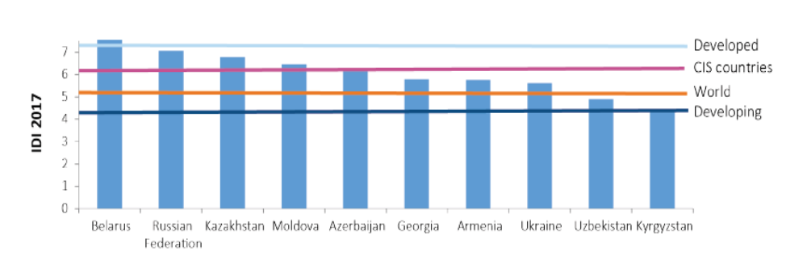
Fig. 3. IDI values, CIS region, IDI 2017
Ten of the 12 countries within the CIS region supply data for the IDI, the exceptions being Tajikistan and Turkmenistan. Four countries in the region (Belarus, Moldova, the Russian Federation and Ukraine) are categorized as developed countries, while the remainders are categorized as developing countries. Only one country in the region, Belarus, falls within the high quartile of the IDI for 2017, while a second, the Russian Federation, has slipped from this quartile into top position in the upper-middle quartile, joining six other countries in the region. Two countries (Uzbekistan and Kyrgyzstan) fall into the lower-middle quartile. The biggest improvements were made by Uzbekistan (up 0,42 points), Kyrgyzstan and Ukraine (both up 0,31 points) over 2016–2017. As in most other regions, the most substantial rate of improvement for any individual indicator in the CIS region was the one for mobile-broadband subscriptions, which rose by an average of 31,9 per cent over the year. This indicator rose most substantially – by over 175 percent — in Ukraine in 2016–2017 [9]. The values of all ICT component indicators for Ukraine in 2016 and 2017 are shown in Fig. 4.

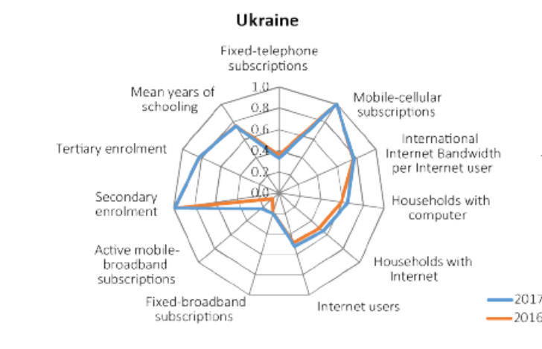
Fig. 4. IDI values, IDI 2017 and IDI 2016
The position of Ukraine in both groups in 2002–2017 is shown in Tables 1 and 2.
Both tables show that Ukraine has worsened its position I comparison with other countries of these groups since 2002. The IDI of Ukraine in 2002 was 2,50, that corresponded to the 59 place in the world’s IDI rating which included 154 countries. Thus Ukraine ranked 8 of 10 Eastern European countries being ahead of Romania (60) and Moldova (74) and 3 of 10 CIS countries being after the Russian Federation (52) and Belarus (57). Ukraine was outrun by Romania in 2007 and by Moldova in 2010. Therefore Ukraine has remained on the bottom of the group of Eastern European countries since 2010. Also in the CIS group Ukraine was overtaken by Kazakhstan in 2010, by Azerbaijan and Armenia in 2012, and by Georgia in 2015. It doesn’t mean that Ukraine didn’t progress in the IDI, I fact it did, because every year its IDI had increased but that progress was too slow in comparison with its neighbouring countries.

Conclusion
Because the methodology of calculating IDI will be changed in 2018, for first time since the initial report “Measuring the Information Society 2009” was published by ITU, it is important to analyze the dynamics of ICT development in Ukraine based on IDI in 2002–2017. Ukraine turned out to demonstrate rather negative dynamics; its progress was too slow especially in comparison with other Eastern European and CIS countries. The country lagged in development of new ICTs when other states benefited of introducing new technologies.
Anyway, since 2016 4G technology has been widely developing and the number of active mobile-broadband subscriptions grew constantly, hopefully Ukraine will decrease its digital divide with other countries of the region. Ukraine is featured as a country that has great potential for mobile and fixed-broadband market development. However, the slight pace of progress in IDI that Ukraine demonstrated in 2014–2016 is definitely not sufficient in order to outperform in ICT development in the nearest future. Efficient efforts of the government are necessary to be made in this field.

REFERENCE
- Tutova, O.V., Savchenko, Ye.A.“Ukraine in the Information and Communication Technology Development Ranking. I”. Control Systems and Computers, 2019, 3 (281), pp. 70-78.
- Human Development Data (1990-2017), [online]. Available at: <http://hdr.undp.org/en/data> [Accessed 06 Dec. 2018].
- Measuring the Information Society Report 2017 – V.2. ICT Country Profiles. International Telecommunication Union – Place des Nations CH-1211 Geneva Switzerland, 2017, pp. 199.
- Measuring the Information Society Report 2018 – V.1. International Telecommunication Union – Place des Nations CH-1211 Geneva Switzerland, 2018. 189 p.
- Savchenko, Ye.A., Tutova, O.V., 2016. “A Procedure for the Human Potential Development Level Data Analysis, Modeling and Forecasting for Countries of the World and Ukrainian Regions”. Upr. sist. mas., 4 (264), pp. 86-92.
- Tutova, O.V., Savchenko, Ye.A., 2018. “Assessment of Influence of Digital Economy Development on Social and Economic Environment”. Upr. sist. mas., 6 (278), pp. 81-92.pp. (In Ukrainian).
- Ivakhnenko, A.G., Savchenko, E.A., 2008. “Investigation of Efficiency of Additional Determination Method of the Model Selection in the Modeling Problems by Application of the GMDH Algorith. Journal of Automation and Information sciences”. Begell House. Inc. Publishers., 40 (3), pp. 47-58.
- Ivakhnenko, A.G., Stepashko, V.S., 1985. Noise-immunity of modeling. Kiev: Naukova dumka, 216 p. (In Russian).

ЛІТЕРАТУРА
- Tutova, O.V., Savchenko, Ye.A.“Ukraine in the Information and Communication Technology Development Ranking. I”. Control Systems and Computers, 2019, 3 (281), pp. 70-78.
- Human Development Data (1990-2017), [online]. Available at: <http://hdr.undp.org/en/data> [Accessed 06 Dec. 2018].
- Measuring the Information Society Report 2017 – V.2. ICT Country Profiles. International Telecommunication Union – Place des Nations CH-1211 Geneva Switzerland, 2017, pp. 199.
- Measuring the Information Society Report 2018 – V. 1. International Telecommunication Union - Place des Nations CH-1211 Geneva Switzerland, 2018. 189 p.
- Савченко Е.А., Тутова Е.В. Методика анализа данных, моделирования и прогнозирования уровня развития человеческого потенциала стран мира и регионов Украины. Управляющие системы и машины. 2016. № 4. C. 86-92.
- Тутова Е.В., Савченко Е.А. Оцінювання впливу розвитку цифрової економіки на соціально-економічне середовище. Управляющие системы и машины. 2018. 6 (278). C. 81-92.pp.
- Ивахненко А.Г., Савченко Е.А. Исследование эффективности метода доопределения выбора модели в задачах моделированием с применением МГУА. Проблемы управления и информатики, 2008, №2, C. 65 – 76.
- Ивахненко А.Г., Степашко В.С. Помехоустойчивость моделирования. Киев: Наук. думка, 1985. 215 с.

О.В. Тутова, кандидат економічних наук, старший науковий співробітник, Міжнародний
науково-навчальний центр інформаційних технологій та систем НАН та МОН України,
просп. Академіка Глушкова, 40, Київ, 03187, Україна,
olenatutova@gmail.com
Є.А. Савченко, кандидат техічних наук, старший науковий співробітник, Міжнародний науково-навчальний центр інформаційних технологій та систем НАН та МОН України, просп. Академіка Глушкова, 40, Київ, 03187, Україна,
Savchenko_e@meta.ua
УКРАЇНА У РЕЙТИНГУ РОЗВИТКУ ІНФОРМАЦІЙНО-КОМУНІКАЦІЙНИХ ТЕХНОЛОГІЙ
Вступ. Індекс розвитку інформаційно-комунікаційних технологій (ІКТ) — це комплексний, універсальний і загальновизнаний показник, що характеризує досягнення країни з точки зору розвитку ІКТ. Він розраховується Міжнародним союзом електрозв'язку. Цей індекс обраний такими країнами як Казахстан і Росія одним з контрольних для дослідження розвитку ІКТ у цих країнах. Оскільки ці країни досягли значного успіху у розвитку ІКТ за останні роки, то необхідно вивчати їхні підходи до вимірювання змін у цій сфері.
Мета статті. Для оцінювання рівня розвитку і прогресу України у розвитку ІКТ порівняно з іншими країнами Східної Європи і СНГ проведено дослідження того, як Україна змінювала свою позицію у рейтингу, розробленому на основі індексу розвитку ІКТ, у період з 2002 по 2017 рр. Також метою статті є дослідження шляхів для скорочення цифрового розриву, тобто різниці у рівні розвитку ІКТ, яка виникла між Україною та іншими країнами регіону, а також вивчення потенціалу подальшого розвитку ІКТ в Україні і ступеня, у якому Україна може скористатися ними для економічного зростання, виходячи з наявних інфраструктурних, технологічних і людських ресурсів.
Методи. Системний підхід, аналіз.
Результати. Проведено аналіз прогресу України у рейтингу, складеному на основі індексу розвитку ІКТ, у порівнянні з іншими країнами регіону, проведене дослідження динаміки підіндексів індексу розвитку ІКТ та їх компонентів у 2002–2017 рр., основні характеристики рівня розвитку ІКТ в Україні на 2016 рік, телекомунікаційного ринку України у 2014–2016 рр., а також проведено дослідження зв'язку між ВНД та індексом розвитку ІКТ.
Висновки. Результати цього дослідження показують, що починаючи з самого початку досліджуваного періоду, прогрес України у розвитку ІКТ був дуже повільним у порівнянні з іншими країнами регіону. Україна відстала від середнього рівня по регіону СНД майже за усіма показниками. В останні роки з’явилися позитивні тенденції, зокрема була запроваджена технологія 4G, збільшується кількість користувачів широкосмугового доступу, який є основним чинником зростання телекомунікаційного ринку.
Ключові слова: індекс розвитку інформаційних і комунікаційних технологій, цифровий розрив, показники глобального розвитку, цифровий порядок денний України.

ВІДОМОСТІ ПРО АВТОРІВ

Контактний автор:
Савченко Євгенія Анатоліївна (Savchenko Yevgeniya A .) — кандидат технічних наук, старший науковий співробітник, Міжнародний науково-навчальний центр інформаційних технологій та систем НАН та МОН України, 03187, м . Київ, просп . Акад . Глушкова, 40, Україна, ORCID: https://orcid .org/0000-0003-4851-9664, Scopus Author ID 7005758082; E-mail: savchenko_e@meta .ua, тел. 044-526-00-09.

Тутова Олена Валеріївна (Tutova Olena V .) — кандидат економічних наук, старший науковий співробітник, Міжнародний науково-навчальний центр інформаційних технологій та систем НАН та МОН України, 03187, м . Київ, просп . Акад . Глушкова, 40, Україна, E-mail: olenatutova@gmail .com

