**Getting Started:**

***Learn:***

Learn Linux/Bash shell basics: [Bash and GitBash for Beginners](https://www.freecodecamp.org/news/linux-command-line-tutorial/)

Learn Python basics: [Python Basics Course](https://www.youtube.com/watch?v=rfscVS0vtbw)

Learn Python Async IO: [AsyncIO Documentation](https://realpython.com/async-io-python/)

***Install:***

Install Git Bash shell: [GitBash for Windows](https://git-scm.com/downloads/win)

Install Python: [Python for Windows](https://www.python.org/downloads/)

Creating a Python virtual environment (GitBash in Windows):

1. **Navigate/create directory(folder) where the project is:**

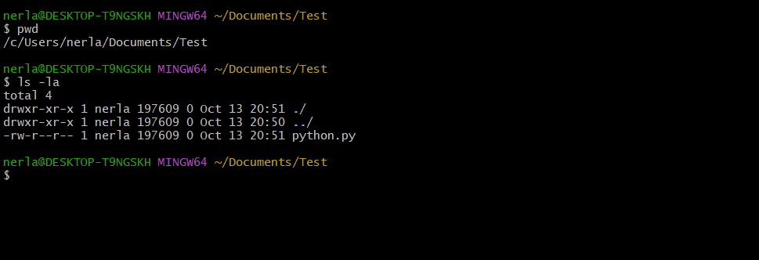

1. **Create the python virtual environment:**

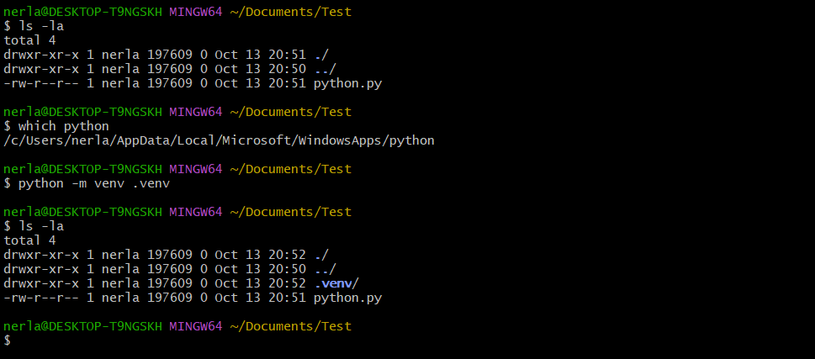

The command {python -m venv .venv} is used:

* -m option is used to run a specific python module
* venv is the python module that creates a virtual environment
* .venv is the name for the virtual environment directory

1. **Activate python virtual environment:**

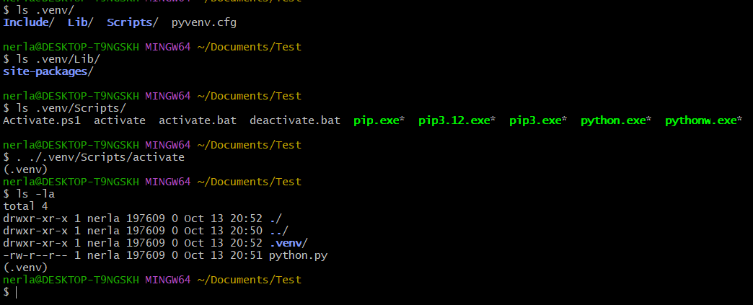

Within the project directory that is the parent to the .venv directory, use the command

{. ./.venv/Scripts/activate}.

* The period in the beginning is shorthand for the command {source}.
* ./ is used to run a bash script, represented by the script's relative directory.
* Activate is the name of the script that activates the virtual environment.
* You can now run commands and interact with the project.

The source command specifies for a script to be run in the current shell.

You can determine if you are using the virtual environment if you see “(.venv)”

above your command prompt.

1. **Using Python and Pip in a virtual environment:**

* Use the command ‘.venv/bin/pip’ and ‘.venv/bin/python to access the binaries within the virtual environment.

1. **Running the bot for the first time:**

* You must run the following commands to install dependencies
* (while inside the virtual environment)
* *.venv/bin/pip install httpx*
* *.venv/bin/pip install discord*
* *.venv/bin/pip install pyyaml*
* *.venv/bin/pip install audioop-lts*
* *.venv/bin/pip install apscheduler*
* If running the bot proceeds to give ‘module not found’ errors, attempt to install them with pip.

1. **Deactivating the virtual environment:**

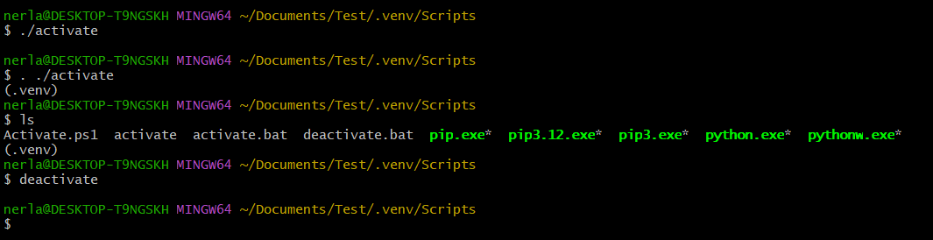

Navigate to the Scripts directory in .venv and enter {deactivate} to run the deactivate batch script (This is not a bash script which is why the syntax does not require a dot). If the “(.venv)” above your prompt disappears, the operation is successful.

1. **Creating a server and bot account:**

[Bot Account Creation Tutorial](https://www.upwork.com/resources/how-to-make-discord-bot)