**Task Management System**

User Manual

**Main Panel**

This is where the user will interact with the program and can select the following options:

* Manipulate Data
* Check a Task
* Sort by Time Needed To Complete
* Sort by Completed Tasks

**Manipulate Data**

User can then select what he wants to do the database

**Add Data**

User inputs the necessary data and saves it to the database

**Edit Data**

User can edit any part of each task in this screen and click the ‘Change’ button when finished typing

**Delete Data**

The user can multi-select Tasks and click the ‘Delete’ button when they are finished

**Check Task**

User can check a task to show that it is complete

**Sort by Time Needed To Complete**

This screen appears to show the Tasks sorted in longest time to shortest time to take to finish the task

**Sort by Completed Tasks**

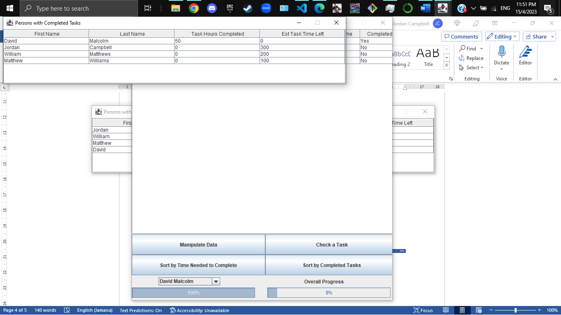

This screen appears which shows the tasks that are completed at the top