1. **Creating a Microsoft Azure Account:**

Azure is a cloud computing platform and set of services offered by Microsoft, providing a wide range of solutions for building, deploying, and managing applications and services through Microsoft-managed data centers. Create a free azure account [here](https://azure.microsoft.com/en-gb/free/search/?ef_id=_k_bd0de3760bcf188808db854d11bae5dd_k_&OCID=AIDcmm3bvqzxp1_SEM__k_bd0de3760bcf188808db854d11bae5dd_k_&msclkid=bd0de3760bcf188808db854d11bae5dd).

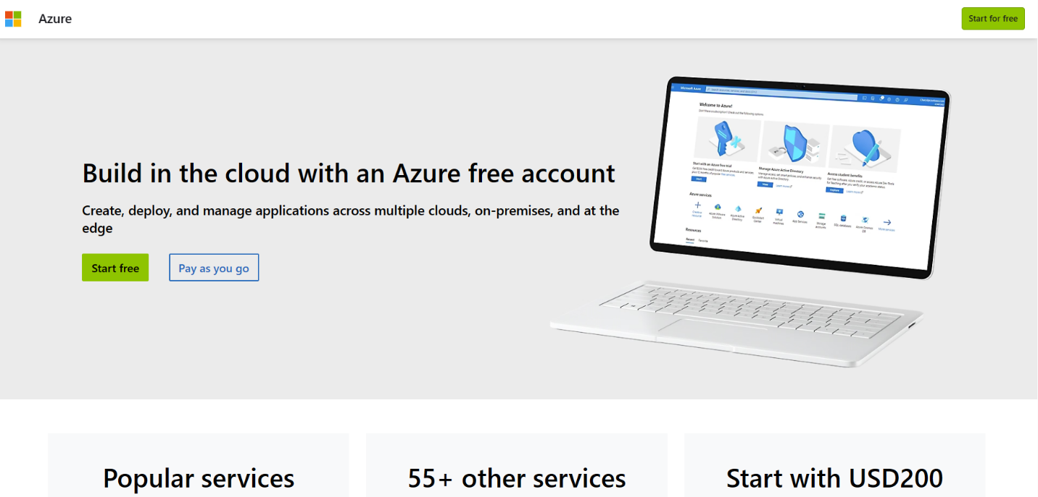

Fig. 1. How to create Azure account.

After creating the Microsoft Azure account, you activate the account and login. You are given a free Azure subscription for 3 month with $200 credits.

**1.1 Creating a Resource group and ML Workspace**

An Azure Resource Group is a logical container used to group Azure resources, such as virtual machines, databases, and web apps, that share the same lifecycle, permissions, and policies.

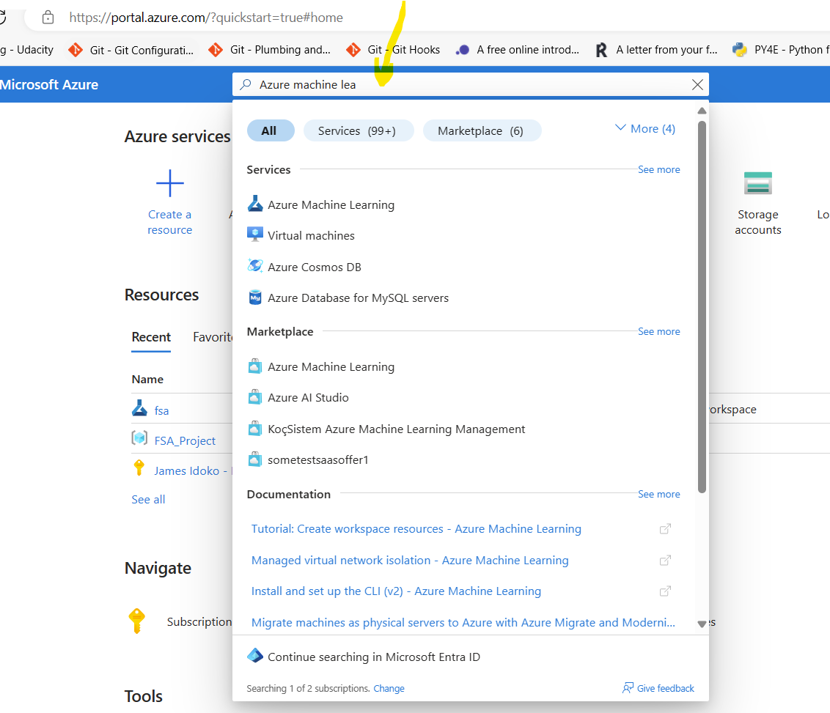

Fig. 2. Azure Portal

An Azure Machine Learning (ML) Workspace is a centralized place to work with all the artifacts you create when you use Azure Machine Learning. It provides a collaborative space for managing and tracking experiments, models, data, and compute resources.

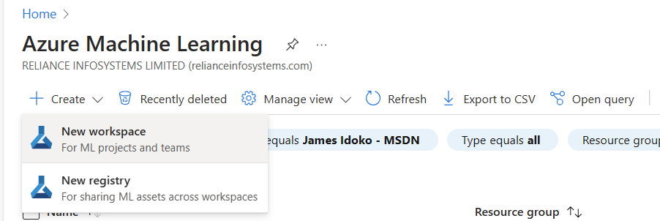

Fig. 3. Creating a New workspace

Click on create, then on New workspace to create an ML workspace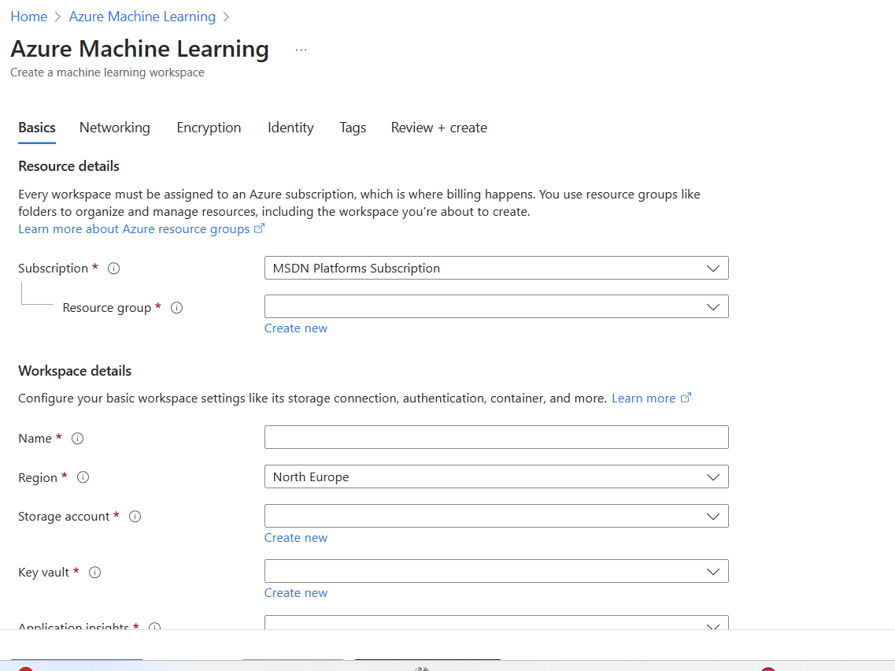

Fig. 4. Creating Workspace and Resource Group

You create a new resource group while creating the ML workspace

**1.2 Create a suitable compute instance**

An Azure compute instance refers to a virtual machine (VM) or container instance provisioned in the Azure cloud platform. These instances provide scalable computing resources for running applications, processing data, or hosting services without the need to manage physical hardware. Azure compute instances come in various sizes and types to cater to different workload requirements, offering flexibility, scalability, and reliability for computing tasks in the cloud.

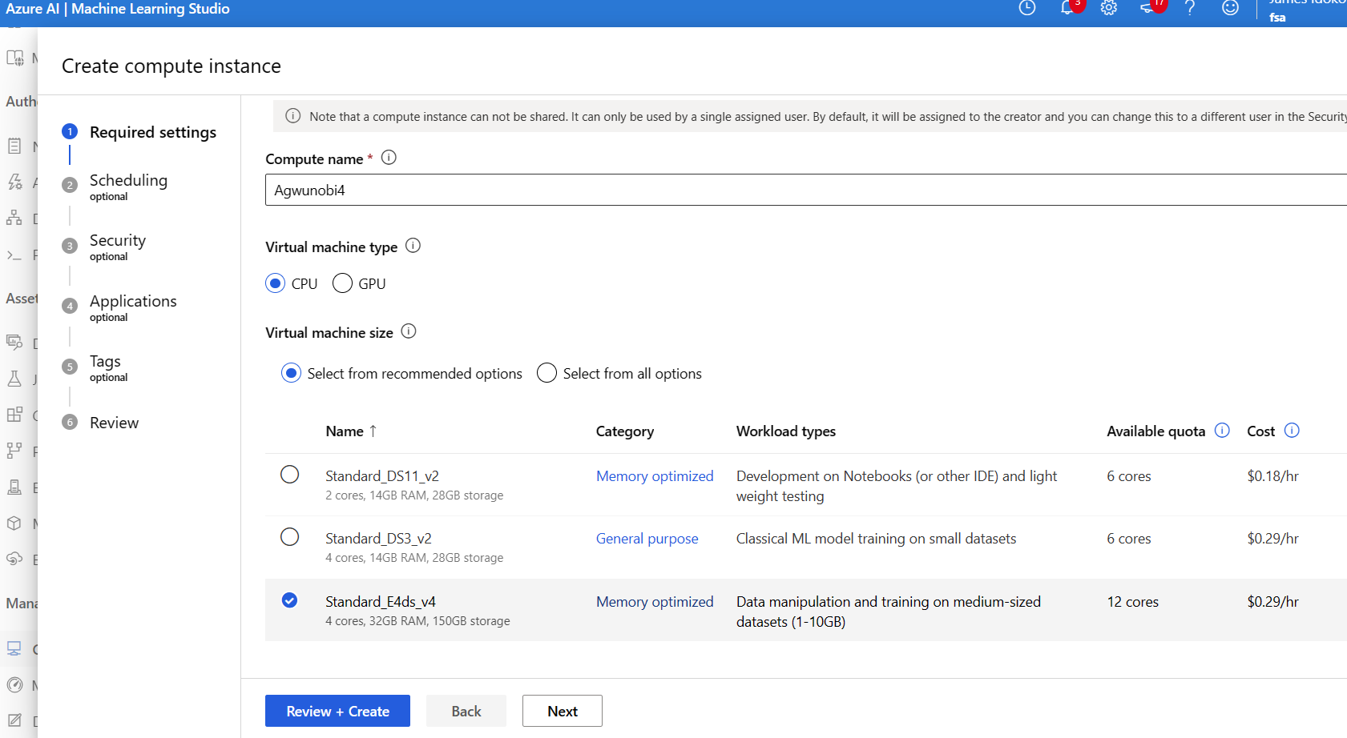

Fig. 5. Creating a Compute Instance

Select the suitable instance for your project.

**1.3 Launching a Azure ML Notebook from the Workspace**

An Azure ML notebook is a collaborative development environment provided by Azure Machine Learning service. It allows data scientists and developers to create, edit, and run Jupyter notebooks directly in the Azure cloud environment. These notebooks support various programming languages like Python, R, and Julia, enabling users to analyze data, build machine learning models, and deploy them to production seamlessly. With features such as integrated version control, data access, and scalable compute resources, Azure ML notebooks streamline the end-to-end machine learning workflow for teams working on AI projects.

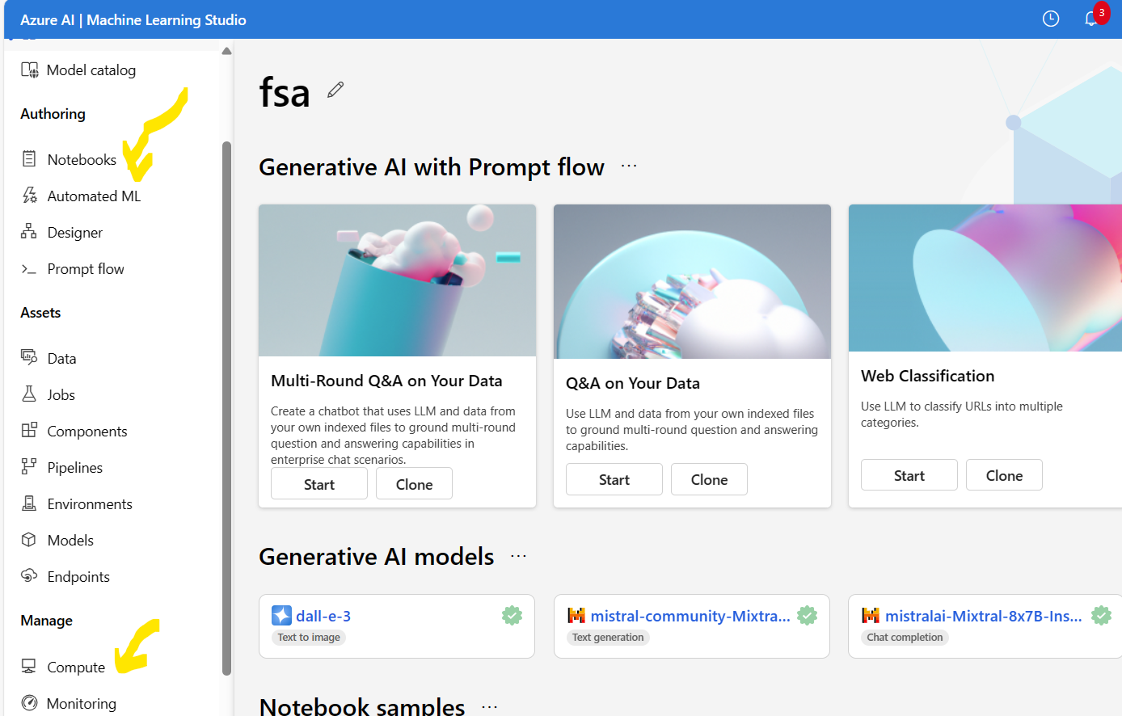

Fig. 6. Workspace Portal

**1.4 Connect the Kernel with the right python Environment/versions**

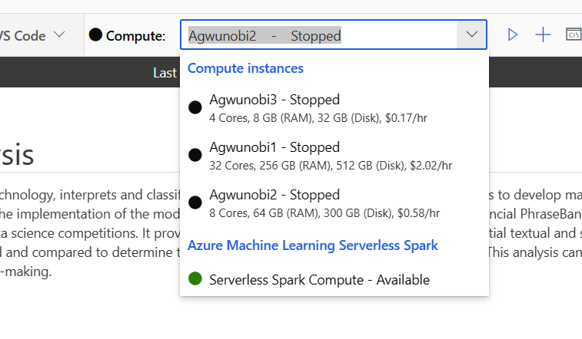

Fig. 7. Compute Instance

Here you can select the compute instance you have created. You can start and stop the instances as well. I utilized the 8 Cores, 64 GB (RAM), 300 GB (Disk) 80% of the time.

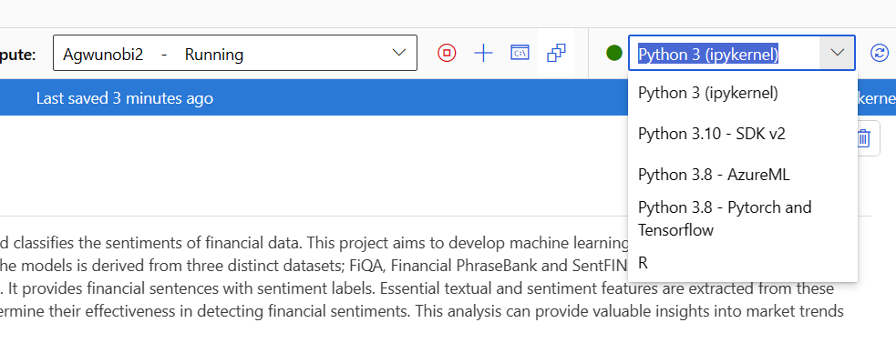

Fig. 8. Python Versions

Pick the right version of python.

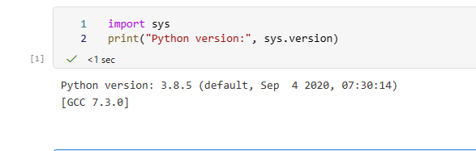

Fig. 9. Python Version

I ustilized the python 3.8.5 (ipykernel), which is more efficient with jupyter notebook.

**1.5 Create a folder for the data and upload your data to the workspace**

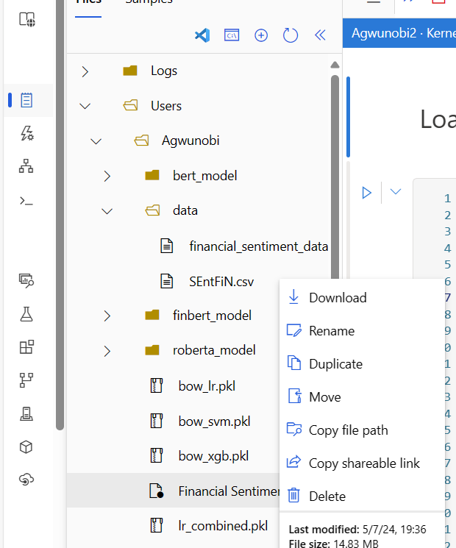

Fig. 10. Creating/Uploading Folder and Files

Under “User” > “Agwunobi” > “files” and “folders”, here you can upload your file and also create new folders.

* 1. **Import and Install all the necessary libraries and frameworks**

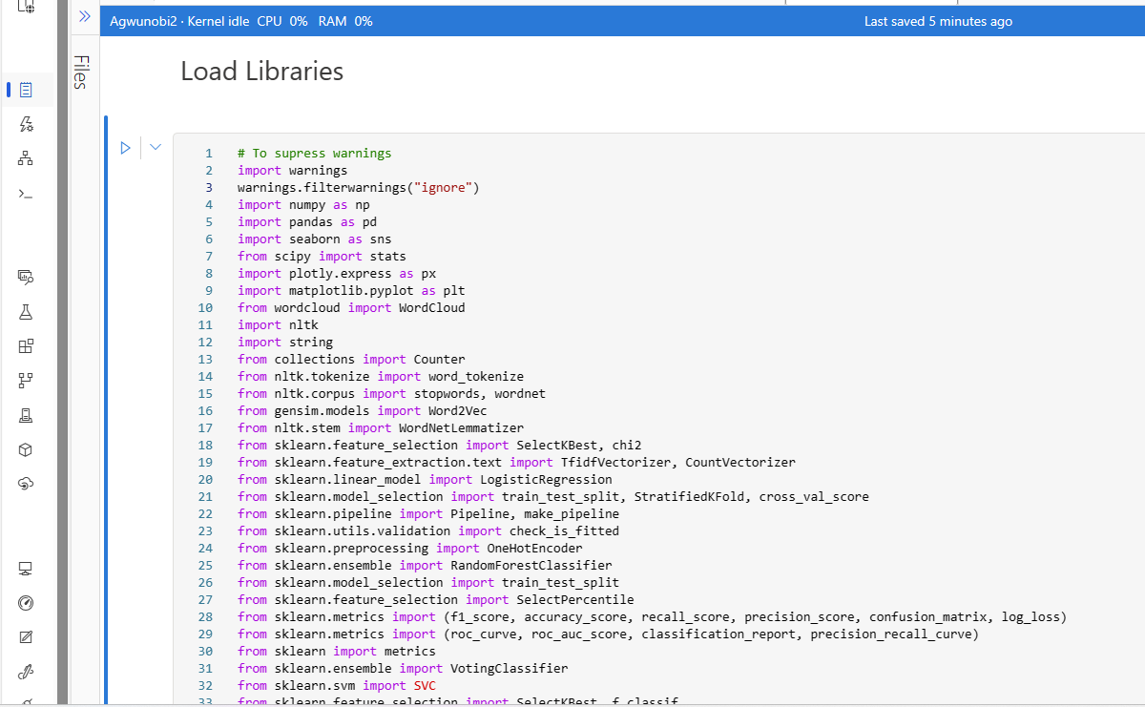

Fig. 11. Loading Libraries

All the libraries above were import in order to carry out the project.

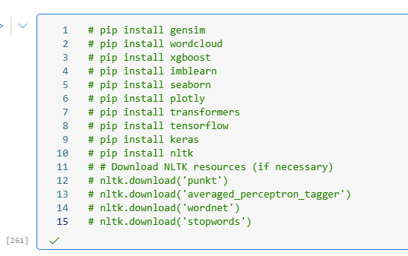

Fig. 12. Downloading and Installing Frameworks

These were also download and installed.

**2.0 Running the code and output Visaualization**

Below are some of the codes and visualizations that were carried out.

**2.1 Importing the dataset**

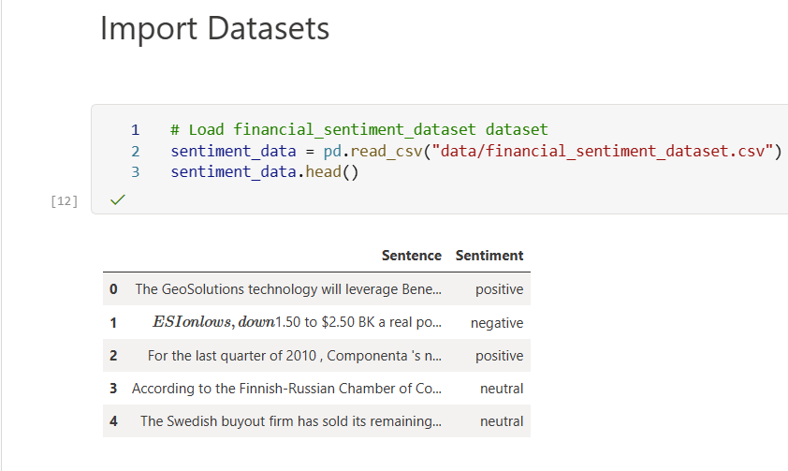

Fig. 13. Importing Dataset

**2.2 Data Info**

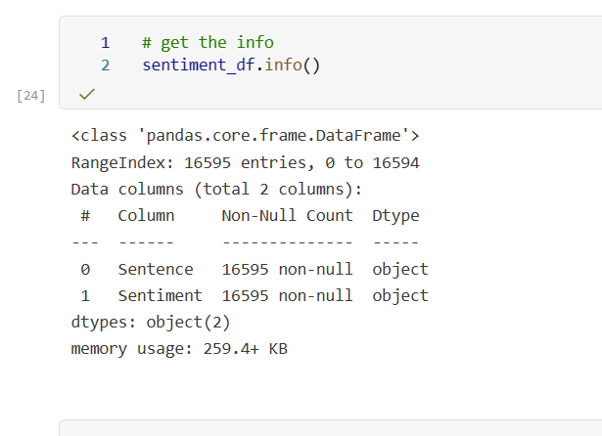

Fig. 14. Dataset Info

**2.3 Exploratory Data Analysis (EDA)**

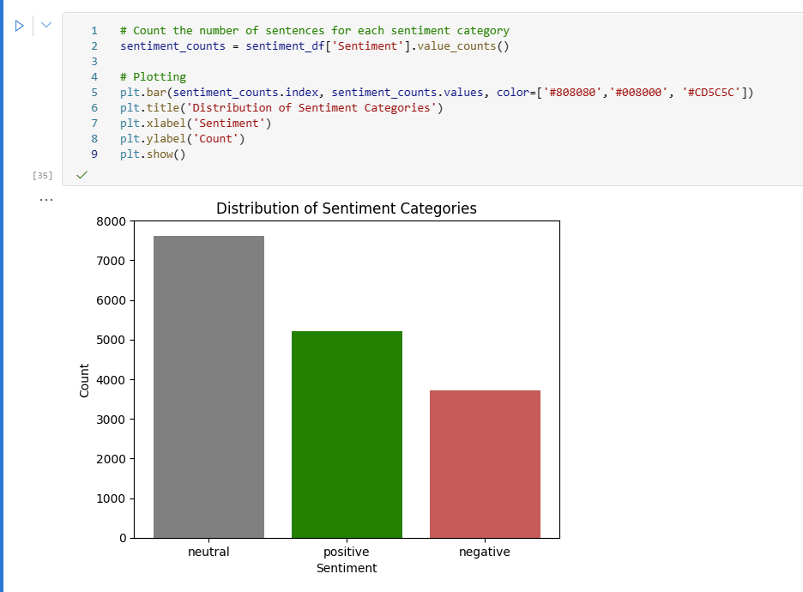

Fig. 15. Bar Plot showing the Sentiment Categories

**2.3 Training of the models**

**Logistic Regression**

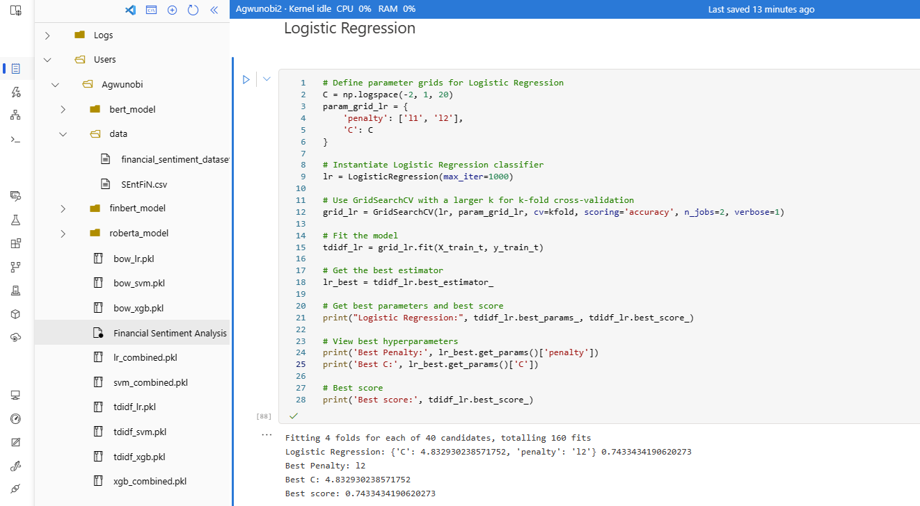

Fig. 16. Logistic Regression Model

**Support Vector Machine (SVM)**

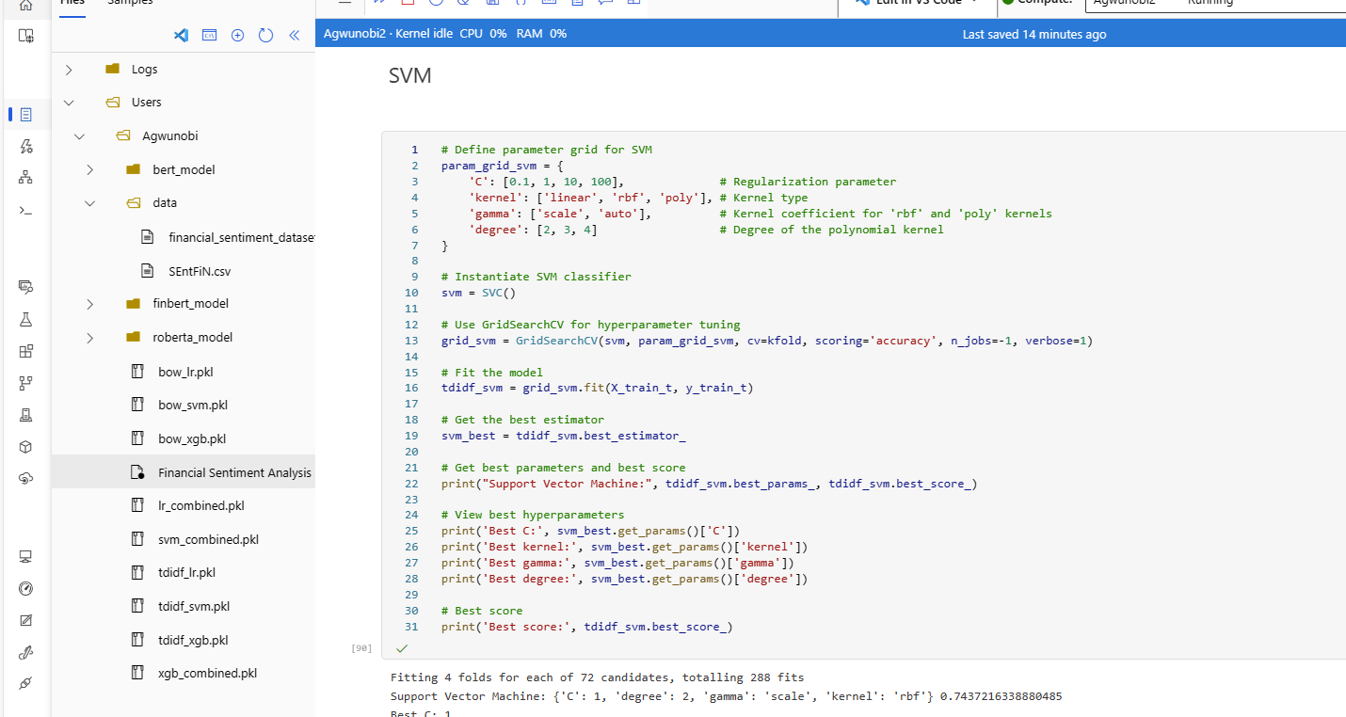

Fig. 17. SVM Model

**XGBoost**

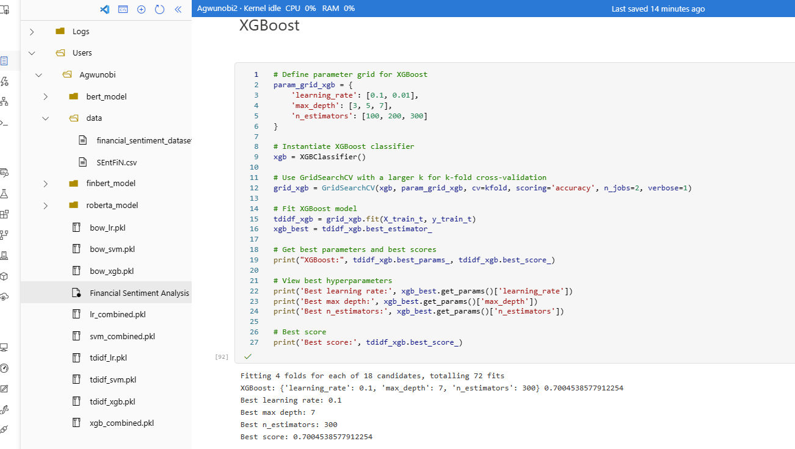

Fig. 18. XGBoost Model

**BERT**

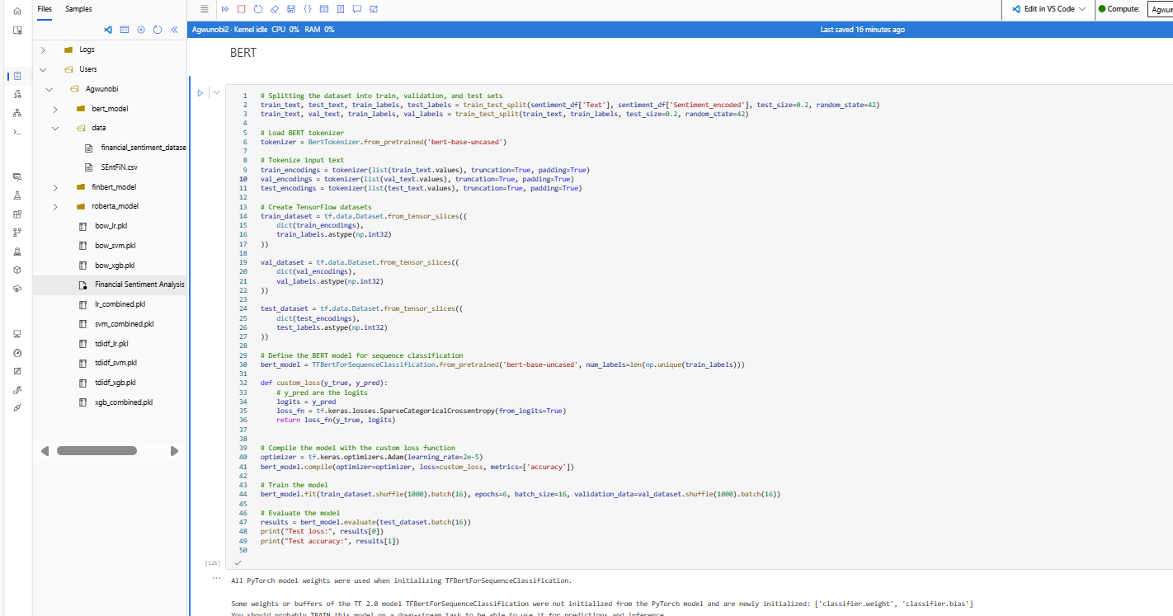

Fig. 19. BERT Model

**RoBERTa**

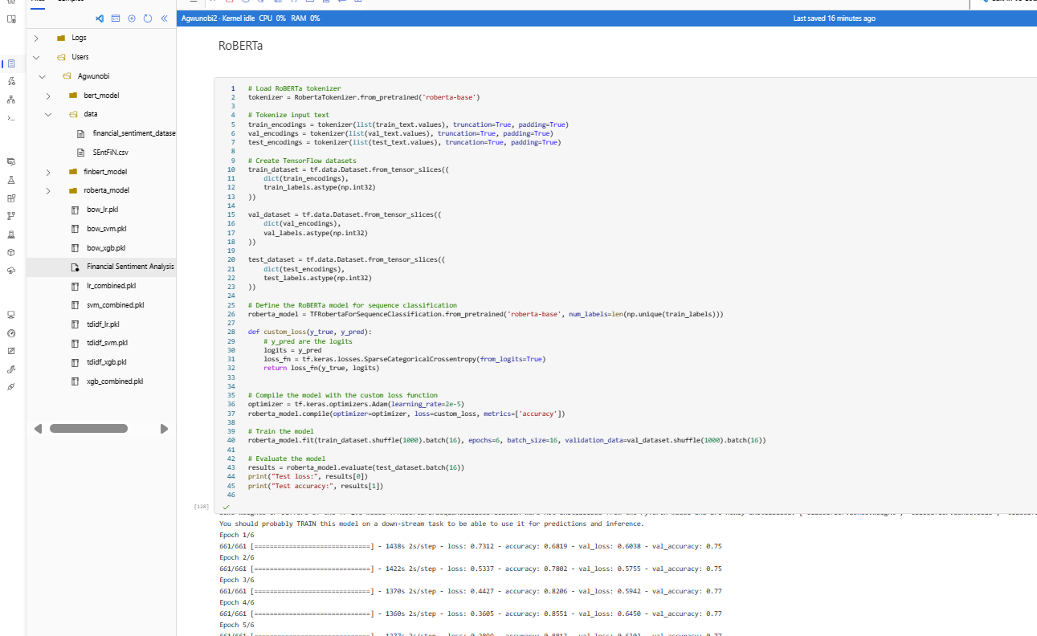

Fig. 20. RoBERTa Model

**FinBERT**

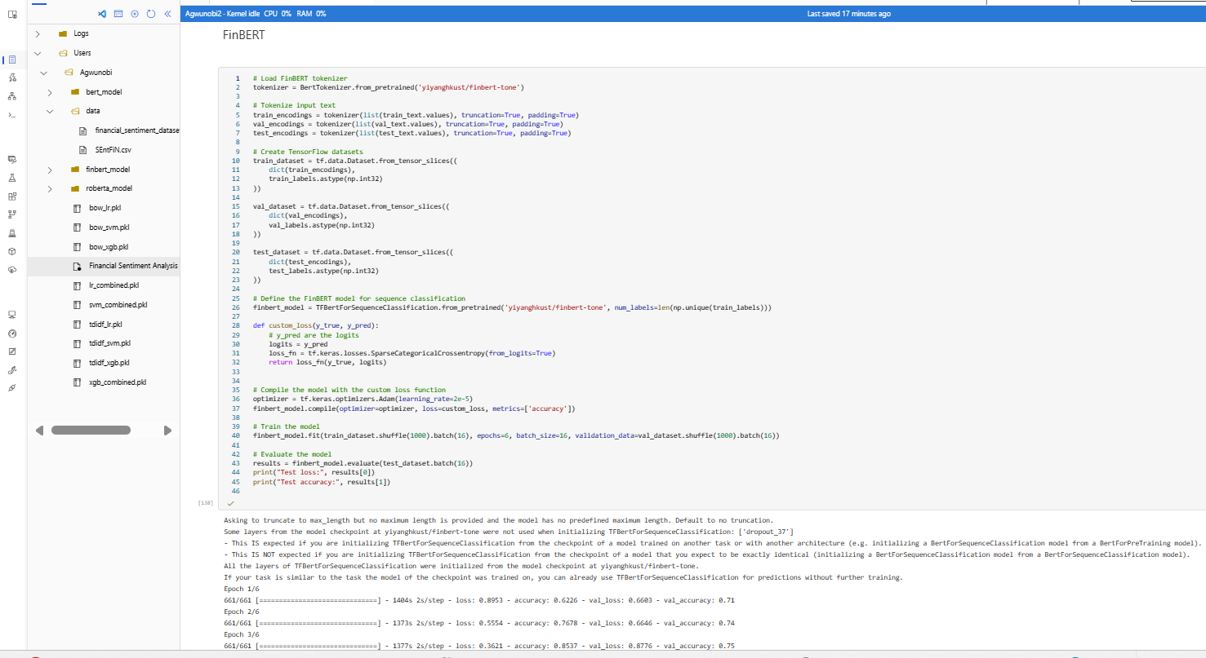

Fig. 21. FinBERT Model

**2.4 Evaluations of the models**

**Machine Learning (ML) Models**

**ML Metrics Comparison**

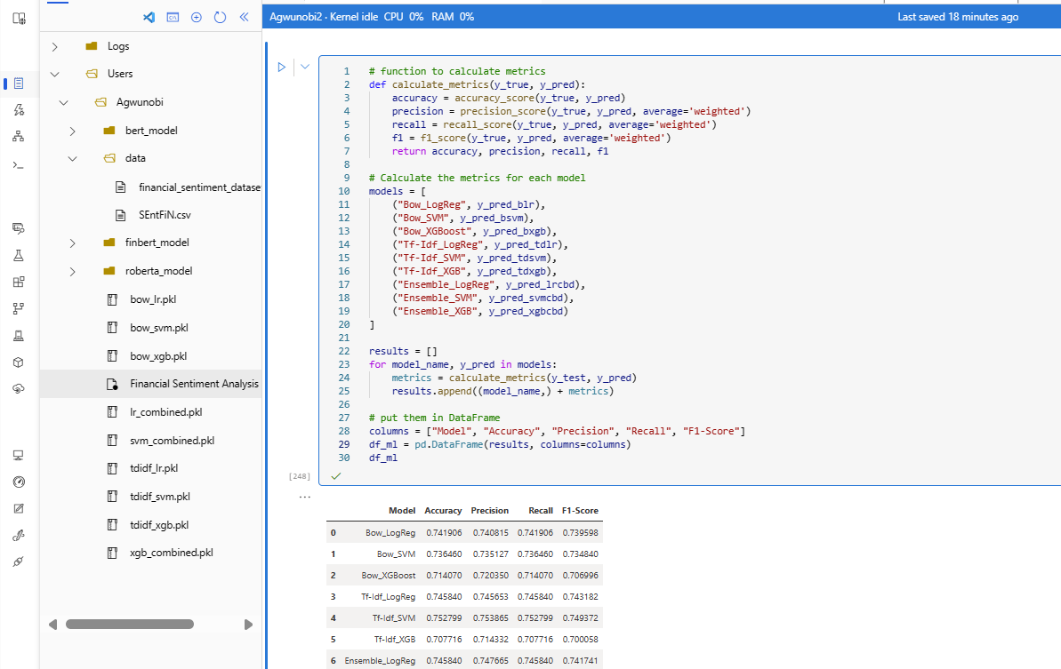

Fig. 22. ML Model Comparison

**ML Bar Plot**

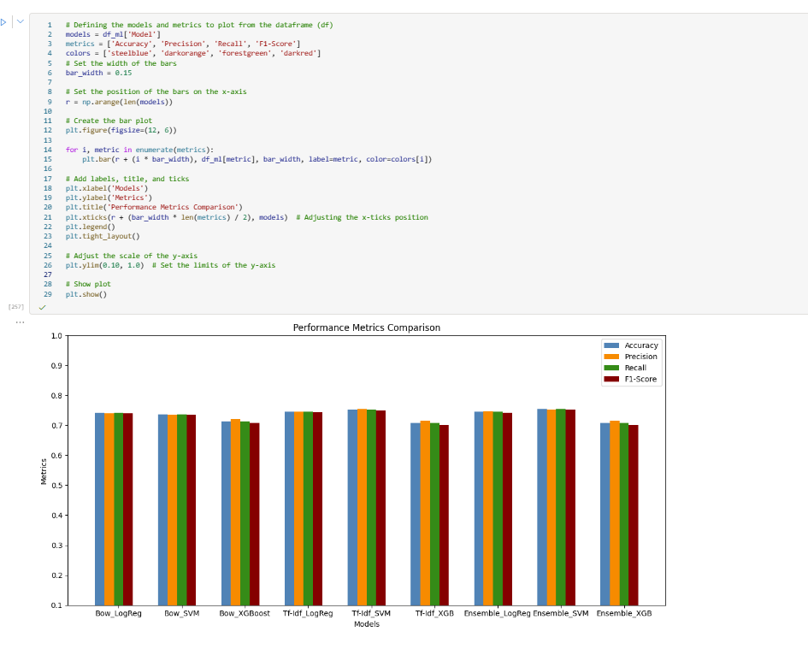

Fig. 23. ML Model Bar Plot

**Natural Language Processing (NLP) Comparison**

**NLP Metrics**

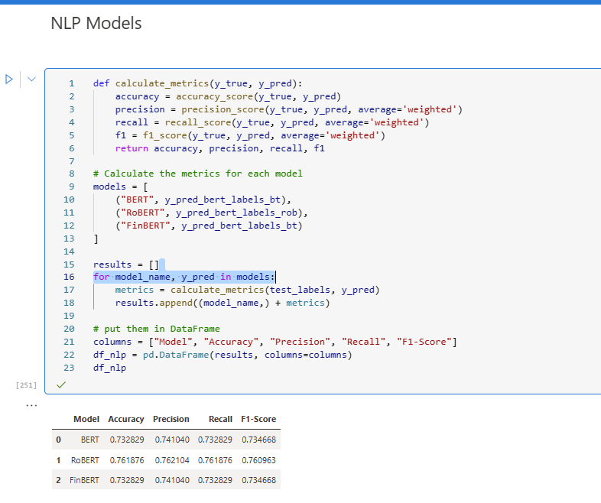

Fig. 24. NLP Model Comparison

**NLP Bar Plot**

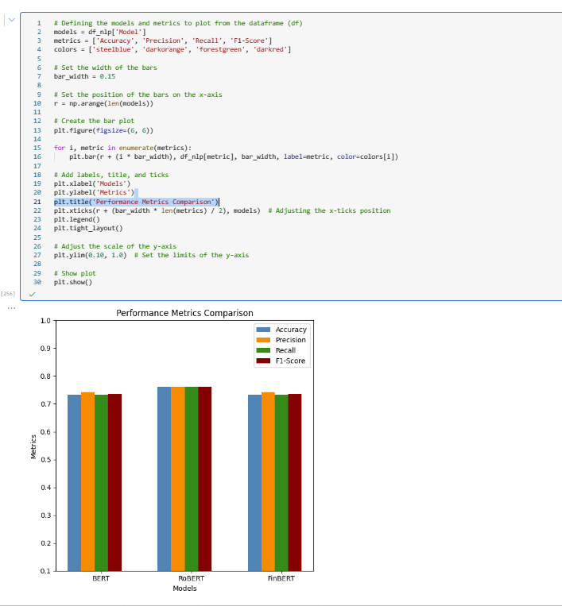

Fig. 25. NLP Model Bar Plot

**2.5 Explainability of the Models**

**SHAP**

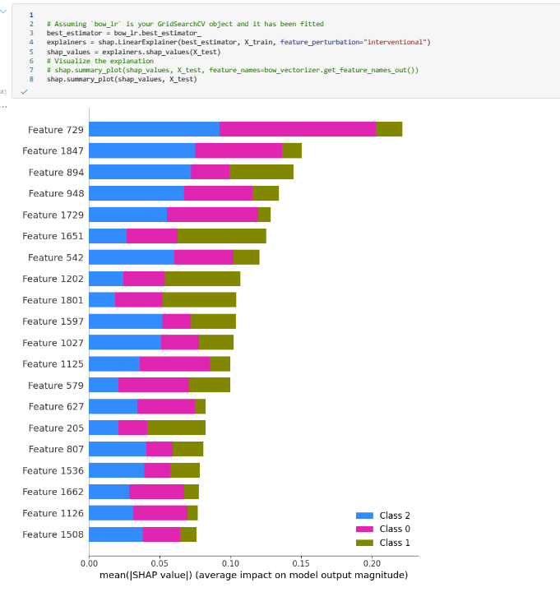

Fig. 26. ML SHAP Values

**LIME**

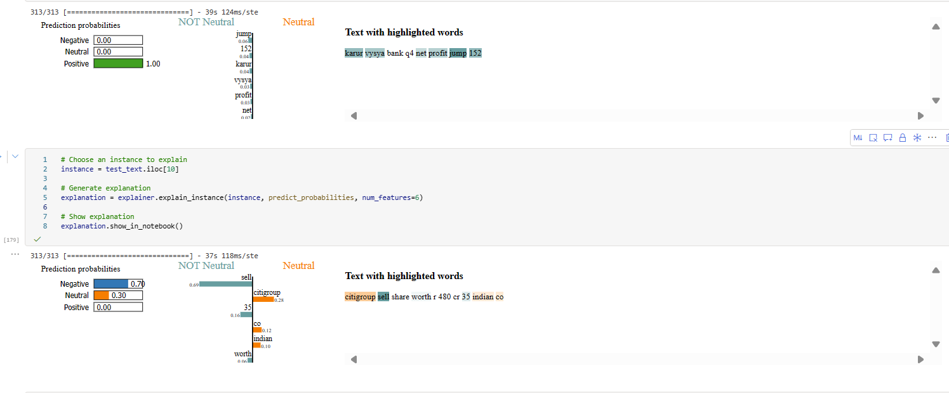

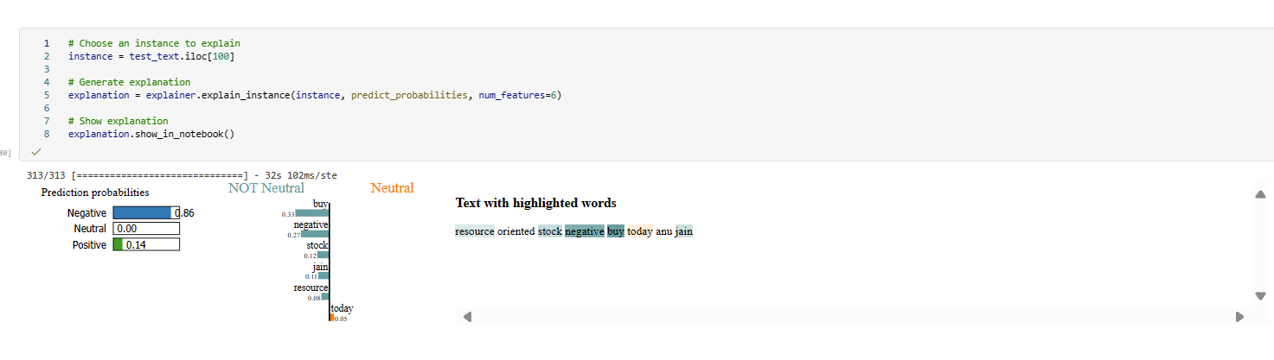

Fig. 27. NLP LIME Explainability

**2.6 Saving the Models for Deployment Purposes**

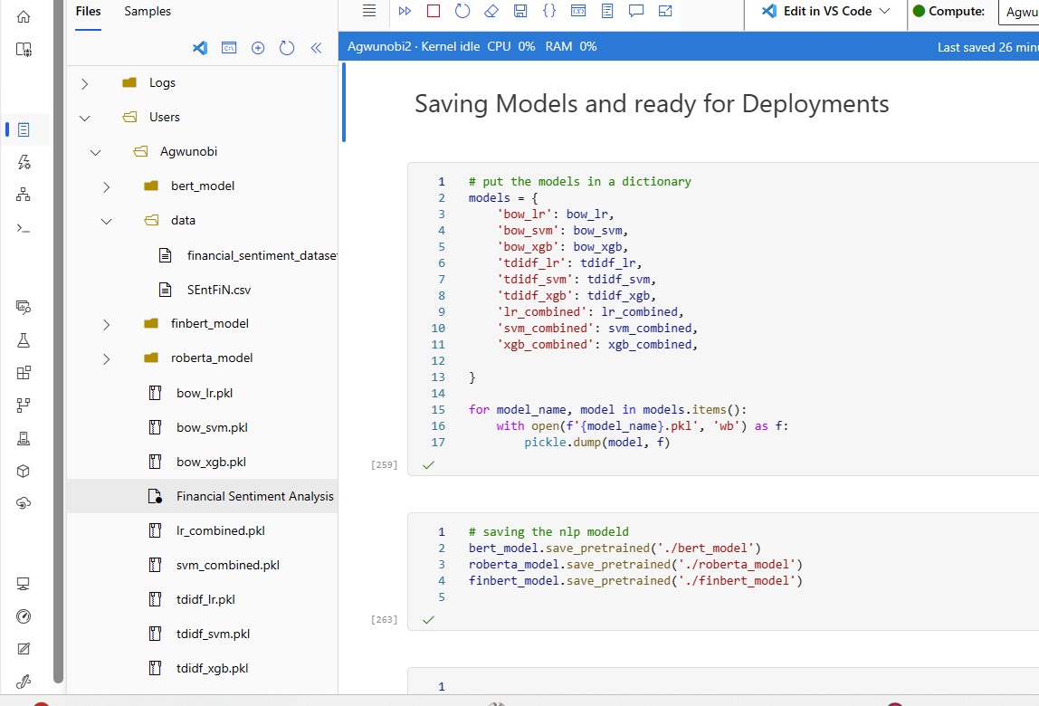

Fig. 28. Saving the Models

Under the “User” > “Agwunobi” are the saved models that can easily be deployment using Azure Container Instances (ACI) or Azure Kubernetes Service (AKS).