This is a guide to create a stack using AWS cloudformation for Elastic Load Balancing (ELB). This will deploy a classic load balancer along with a vSRX instance within an auto scaling group (ASG). Before using the cloud formation template, make sure you have the following things already in place on AWS –

1. Your VPC is created and ready to use (Subnets in 2,3, and 4 below must belong to this VPC)
2. Management subnet
3. External subnet (subnet for vSRX interface receiving traffic from ELB)
4. Internal subnet (subnet for vSRX interface sending traffic to workload)
5. AMI ID of the vSRX image you want to launch
6. User data (this is the vSRX configuration that needs to be committed before it can forward traffic to the workload. This is a base 64 encoded data not more than 4096 characters in length; you may use up to two user data fields if a single field data exceeds 4096 characters)
7. EC2 Key file
8. Get the lambda function file add_eni.zip from Juniper vSRX GitHub repository and upload it to your own S3 bucket. Use this information in the ‘Lambda S3 Location’ fields of the template.
9. Your AWS account should have permission to create Lambda functions on various resources in your region

**Steps to create an ELB-ASG stack** -

1. Log into your AWS account and make sure the region on the top right is the one you want to use. Go to AWS Console Home. Then under ‘All Services’, look for ‘Management & Governance’ section and click ‘CloudFormation’ under it.
2. Click the ‘Create Stack’ button on top right.

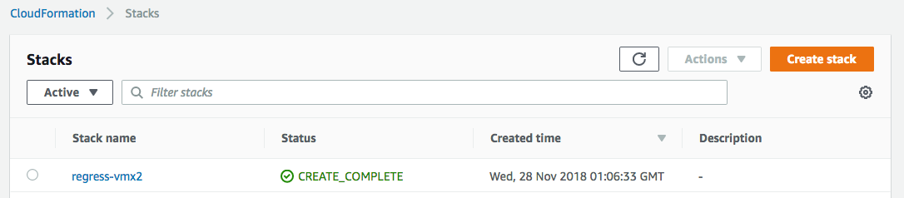

1. On the new page, select ‘Upload a template file’ radio button, click ‘Choose file’ button, select your template file and click ‘Next’.

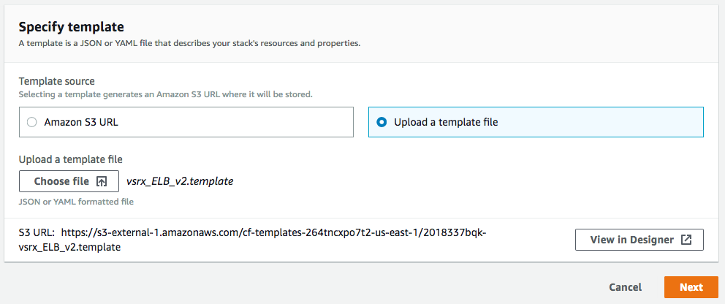

1. The next page that opens is a form created from the template. Some fields may already have a default value, that you may change if you need to. Enter a ‘Stack Name’, select the VPC ID, InstanceType, MgtSubnetID, ExternalSubnetID, InternalSubnetID, ImageID. Paste the Base64 encoded user data (which is the vSRX configuration to be committed; please refer to ‘vSRX configuration’ under the ‘Sample Data’ section in this document). If your Base64 encoded vSRX configuration exceeds 4096 bytes, you may use UserData2 field as needed.
2. Set DesiredASGInstances as 1 and MaxASGInstances as 3
3. Select your Amazon EC2 Key Pair file and click ‘Next’.

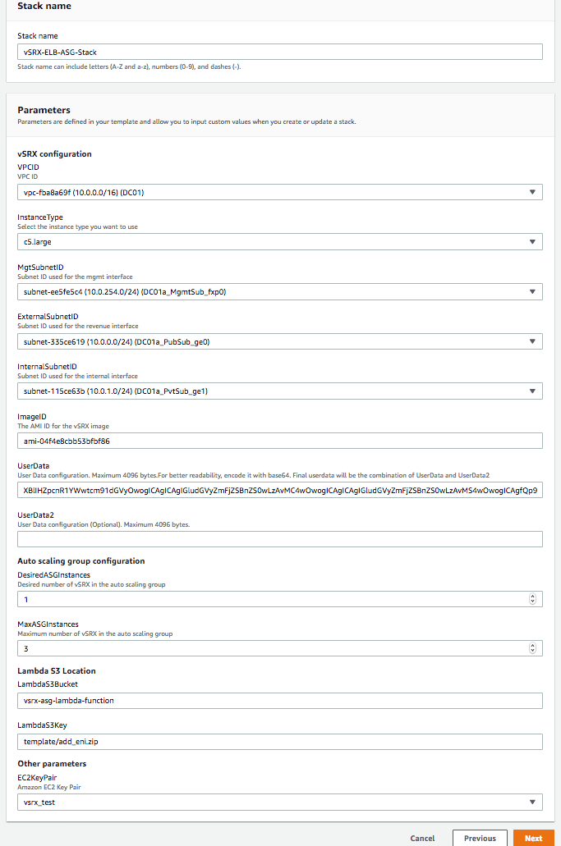

1. Skip the next page regarding ‘Configure stack options’ and ‘Advanced option’ and click ‘Next’. On the next page, you will be able to review and edit your stack creation details. Once reviewed, enable the ‘Capabilities’ acknowledgement check box and click ‘Create stack’ button on the bottom right.
2. On the next page, wait for the stack creation to be completed. If there are any errors in the stack creation, they will be displayed on this page. You will need to rectify those errors and recreate the stack using the above steps.
3. Once the stack is successfully created, click ‘Services’ 🡪 ‘EC2’ and then ‘Auto Scaling Groups’ on the left-hand side menu. On the right-hand side of the page, you should see an auto scaling group (ASG) with your stack’s name as part of its name. Selecting that ASG will show its details at the bottom of the page. Click the ‘Scaling Policies’ tab to create a scaling policy for this ASG as per your needs, to maintain a set number of vSRXs in the ASG to cater to user requests. Please refer to ‘Scaling policy example’ under the ‘Sample Data’ section in this document.

Auto Scaling Group will monitor the state of the vSRX instances. It will automatically respawn a new instance if it detects any vSRX failure. You can find more information in the ‘Activity History’ tab of the ASG and in the Cloudwatch logs.

**Sample Data**

1. **vSRX configuration**: Below is a vSRX configuration to cater to HTTP traffic from external load balancer to a web server workload. You need to have your DNS server IP and your Web Server IP (or if your web server is behind a load balancer, then use that load balancer’s IP address below instead of the Web Server IP). After using your IP addresses in the below configuration, convert this configuration into Base 64 format (refer to: <https://www.base64encode.org/>) and then paste the converted configuration into the UserData field. Doing so will apply the below configuration to the existing default configuration on a vSRX launched in AWS, during the stack creation process.

#load_balancer=true

#junos-config

system {

name-server {

<***Your DNS Server IP***>;

}

syslog {

file messages {

any any;

}

}

}

security {

address-book {

global {

address websrv <***Your Web Server IP***>/32;

}

}

nat {

source {

rule-set src-nat {

from interface ge-0/0/0.0;

to zone trust;

rule rule1 {

match {

source-address 0.0.0.0/0;

destination-port {

80;

}

}

then {

source-nat {

interface;

}

}

}

}

}

destination {

pool pool1 {

address <***Your Web Server IP***>/32;

}

rule-set dst-nat {

from interface ge-0/0/0.0;

rule rule1 {

match {

destination-address 0.0.0.0/0;

destination-port {

80;

}

}

then {

destination-nat {

pool {

pool1;

}

}

}

}

}

}

}

policies {

from-zone untrust to-zone trust {

policy mypol {

match {

source-address any;

destination-address any;

application any;

}

then {

permit;

}

}

}

}

zones {

security-zone trust {

host-inbound-traffic {

system-services {

any-service;

}

protocols {

all;

}

}

interfaces {

ge-0/0/1.0;

}

}

security-zone untrust {

host-inbound-traffic {

system-services {

any-service;

}

protocols {

all;

}

}

interfaces {

ge-0/0/0.0;

}

}

}

}

interfaces {

ge-0/0/0 {

unit 0 {

family inet {

dhcp;

}

}

}

ge-0/0/1 {

unit 0 {

family inet {

dhcp;

}

}

}

}

routing-instances {

ELB_RI {

instance-type virtual-router;

interface ge-0/0/0.0;

interface ge-0/0/1.0;

}

}

1. **Scaling policy example**: As mentioned in step (10) above, click on ‘Add policy’ on the ‘Scaling Policies’ tab of your Auto Scaling Group (ASG). Give a ‘Name’ to the policy. Select a ‘Metric type’ from the drop down list, for e.g. ‘Average CPU Utilization’, enter a ‘Target value’, say 75. Add 30 seconds warm-up time the vSRX instances need and leave ‘Disable scale-in’ unchecked. Click ‘Create’ to add this policy to the ASG. The ASG will execute the policy as required to maintain ‘Average CPU Utilization’ at 75.