VENKATESH C H
1NT19IS184

mongo version

MongoDB server version: 5.0.1

mongo

1) CREATE DATABASE

->use venkatesh



2) BASIC CRUD OPERATIONS

- To check the current database
->show dbs

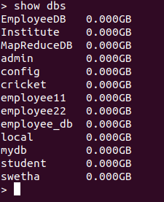

II. To insert one record
->db.venkatesh.insertOne({name:"venkatesh",dept:"ise"})
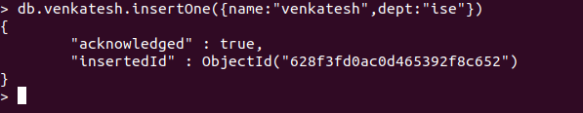
III.To insert many records
->db.venkatesh.insertMany([{name:"suhas",dept:"ise"}, {name:"surya",dept:"cse"}]);

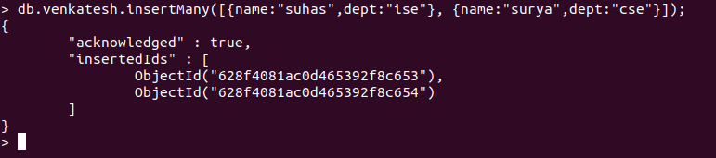

IV. To show the collection of records
->db.venkatesh.find()

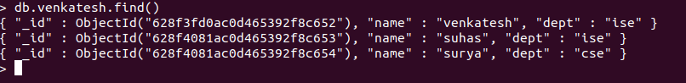

V. To show all the details
->db.venkatesh.find().pretty();
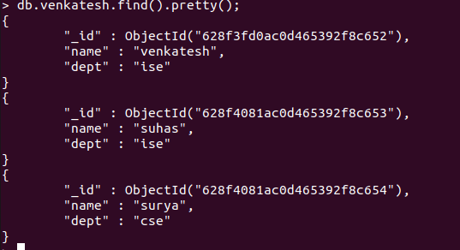

VI.UPDATE METHOD
->db.venkatesh.updateOne({"name":"surya"},{$set:{"dept":"eee"}}
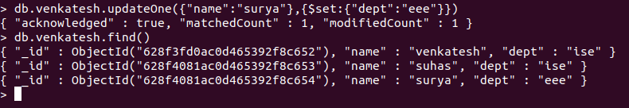

VII.Update with unset
db.venkatesh.update({"name":"kohli"},{$unset:{"dept":""}})

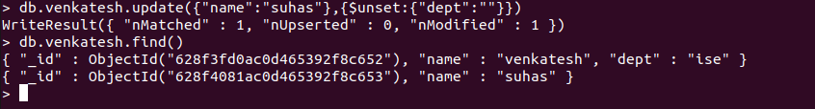

IX.update with set
->db.venkatesh.update({"name":"suhas"},{$set:{"dept":"ece"}})

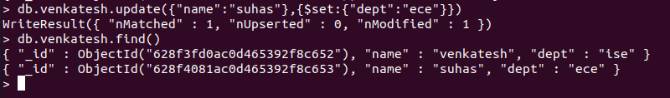

X.To delete One record

> db.venkatesh.deleteOne({name:"surya"})
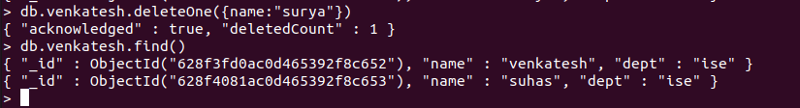

3).AGGREGATE FUNCTIONS
OR OPERATION
->db.venkatesh.find({$or:[{"dept":"ise"},{"dept":"cse"}]}).pretty()

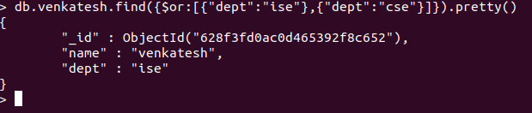

AND OPERATION
->db.venkatesh.find({$and:[{"dept":"ise"}]}).pretty()
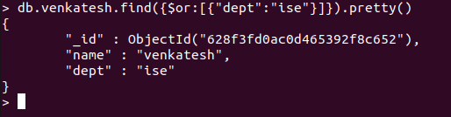

CREATING AGGERATE PIPELINE

Count:
Count the number of students with age :23
->db.venkatesh.aggregate([{$match:{age:23}},{$count:"Number of students with age:23"}])

SUM:

Sum of ages of male
->db.venkatesh.aggregate([{$match:{gender:"M"}},{$group:{_id:null,sum:{$sum:"$age"}}}]

Sum of ages of female
db.venkatesh.aggregate([{$match:{gender:"F"}},{$group:{_id:null,sum:{$sum:"$age"}}}]

Average

Avereage of all the ages
db.venkatesh.aggregate([{$match:{}},{$group:{_id:null,avg:{$avg:"$age"}}}])

MAX and MIN
To find maximum age:
db.venkatesh.aggregate([{$group:{_id:"age",aggregate_age:{$max:"$age"}}}])
To find minimum age:

db.venkatesh.aggregate([{$group:{_id:"age",aggregate_age:{$min:"$age"}}}])

First and Last values

find the first name in database
db.venkatesh.aggregate([{$group:{_id:"name",aggregate_name:{$first:"$name"}}}])

To find last name in the database

db.venkatesh.aggregate([{$group:{_id:"Name",aggregate_Name:{$last:"$Name"}}}])

MAP REDUCE FUNCTIONS

AVERAGE
> var map=function(){emit(this.Name,this.age)};
> var reduce=function(Name,age){return Array.avg(age);};
> db.venkatesh.mapReduce(map,reduce,{out:"newcollection"});
{ "result" : "newcollection", "ok" : 1 }
> db.venkatesh.find().pretty()

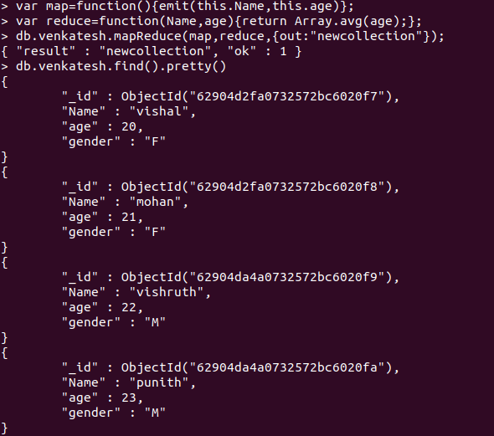

SUM:

> var map=function(){emit(this.Name,this.age)};
> var reduce=function(Name,age){return Array.sum(age);};
> db.venkatesh.mapReduce(map,reduce,{out:"newcollection"});
{ "result" : "newcollection", "ok" : 1 }
> db.venkatesh.find()

