1NT19IS184
Venkatesh CH
Tasks To complete
To start with hadoop

hadoop version
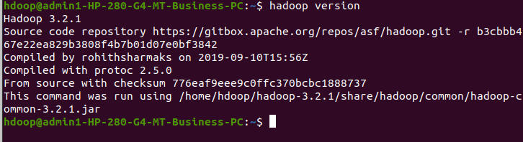
start-dfs.sh
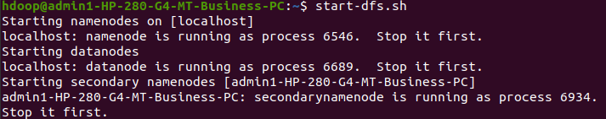
1. Create a directory named by your name
hadoop fs -mkdir /venkatesh
hadoop fs -ls /

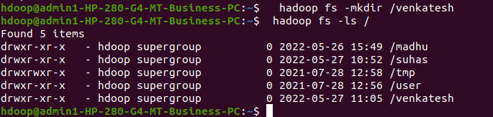

2. Add two empty files into it
hadoop fs -touchz /venkatesh/one.txt
hadoop fs -touchz /venkatesh/two.txt

3. List all the files in the directory that you have created
hadoop fs -ls /venkatesh
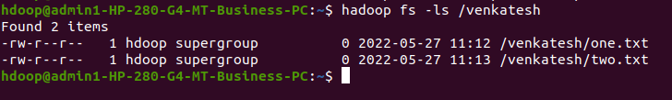

4. Create one more directory by your usn and put that inside the directory of your name
hadoop fs -mkdir /venkatesh/1NT19IS184
hadoop fs -ls /venkatesh

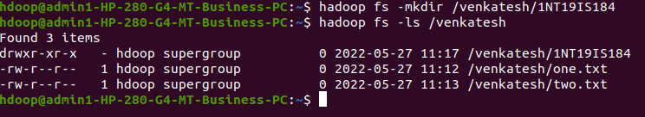

5. Create a file in your local system by the name_usn.txt and add the contents as "Syntax to list Is command is hadoop fs -Is "
cat > madhu_1NT19IS184.txt
"Syntax to list ls command is hadoop fs -ls"

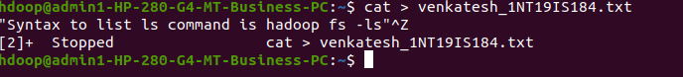

6. Put the file usn_name.txt in your hdfs directory called usn
hadoop fs -touchz /venkatesh/1NT19IS184/1NT19IS184_venkatesh.txt
hadoop fs -ls /venkatesh/1NT19IS184

7. Put empty file of hdfs into the local file system
hadoop fs -copyToLocal /venkatesh/1NT19IS184/1NT19IS184_venkatesh.txt
ls

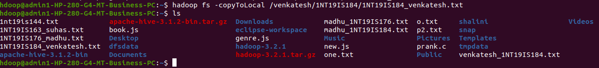

8. Use mv command to move files from local file system and hdfs file system
hadoop fs -mv /venkatesh/two.txt /venkatesh/1NT19IS184
hadoop fs -ls /venkatesh/1NT19IS184

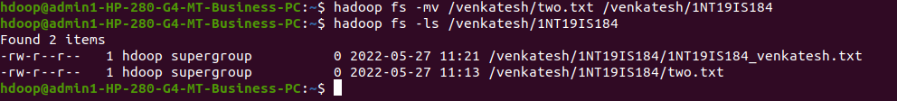

9. Experiment of cp command
hadoop fs -cp /venkatesh/one.txt /venkatesh/1NT19IS184
hadoop fs -ls /venkatesh/1NT19IS184

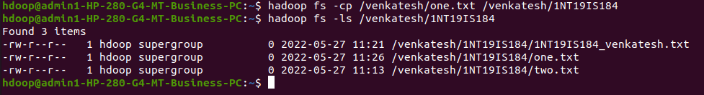

10. Display the total size of all the files in name directory
hadoop fs -moveFromLocal madhu_1NT19IS176.txt /madhu
hadoop fs -du /venkatesh
hadoop fs -du -s /venkatesh

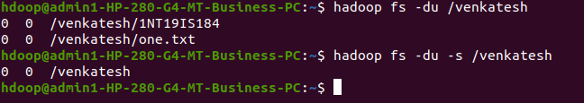

11. Display each file size in usn directory Use stat command on name and usn directories
hadoop fs -du /madhu/1NT19IS184

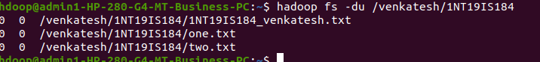
12. Illustrate the use of append command
cat > one.txt
Hello
^Z
[2]+ Stopped cat > one.txt

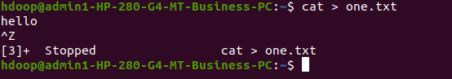

hadoop fs -appendToFile one.txt /venkatesh/1NT19IS184/two.txt
hadoop fs -cat /venkatesh/1NT19IS184/two.txt

