**LAB REPORT Observing Linux Behavior**

CSCI411 Lab

# **Submission Requirements**

Submit to Blackboard

* This report
* Source file built in Part B

**Introduction**

The Linux kernel is a collection of data structure instances (*kernel variables)* and functions. The collective kernel variables define the kernel’s perspective of the state of the entire computer system. Each externally invoked function – a system call or an IRQ (interrupt request) – provides a prescribed service and causes the system state to be changed by having the kernel code changed its kernel variables. If you could inspect the kernel variables, then you could infer the state of the entire computer system.

This report demonstrates your knowledge of the observations obtained about kernel and its status.

**Lab Environment**

Describe the /proc directory

The proc directory contains lots of directories, most of which are named numbers. It also contains files with information on the system hardware and any processes running. The proc directory also provides files that detail the state of the kernel.

Describe/explain why the /proc directory is often referred to as a *virtual file system.* You will have to define what a virtual file system is, too.

A virtual file system is an abstraction layer for a file system that provides a way for a user to access different types of file systems. The /proc directory is referred to as this because it contains a kind of file that is not text or binary; it contains files whose type is a virtual file. Virtual files are shown to be zero bytes but contain lots of information and certain virtual files are constantly updated to provide current information.

**Interactive Observation Questions**

Answer the following questions about the Linux machine that you used to do these exercises. Include the program/command or other method you used to obtain the information. For each, give a brief explanation the information provided.

1. What is the system hostname?

abernathy

* + What commands did you use to get this information?

cat /proc/sys/kernel/hostname

* + Give a brief explanation of the information provided.

The hostname of the system is Abernathy and the command given above displays the hostname from the location in the /proc directory. The file hostname in the kernel directory only contains the hostname for the system and nothing else.

1. **What version of the Linux kernel is being used**

Linux version 4.4.0-101-generic (buildd@lcy01-amd64-006) (gcc version 5.4.0 20160609 (Ubuntu 5.4.0-6ubuntu1~16.04.5) ) #124-Ubuntu SMP Fri Nov 10 18:29:59 UTC 2017

* + What commands did you use to get this information?

cat /proc/version

1. **How many processors are on this system?**

There are two processors on this system.

* + What commands did you use to get this information?

cat /proc/cpuinfo

1. **For each processor: list the CPU Vendor, model number and model name.**

Processor 0:

CPU Vendor – GenuineIntel

Model Number – 45

Model Name – Intel(R) Xeon(R) CPU E5-2630 v3 @ 2.40GHz

Processor 1:

CPU Vendor – GenuineIntel

Model Number – 45

Model Name – Intel(R) Xeon(R) CPU E5-2630 v3 @ 2.40GHz

* + What commands did you use to get this information?

cat /proc/cpuinfo

1. **How much memory is on the machine? How much if currently free?**

MemTotal: 16432752 kB

MemFree: 2602320 kB

* + What commands did you use to get this information?

cat /proc/meminfo

1. **How long in seconds has the system been up (since last boot)?**

3479307.58 seconds

* + What commands did you use to get this information?

cat /proc/uptime

* + Provide a screen shot of your output

C:\Users\chili\AppData\Local\Microsoft\Windows\INetCache\Content.Word\Screen1.png

1. **How much of that time was spent idle, in seconds?**

6213189.69 seconds

* + What commands did you use to get this information?

cat /proc/uptime

1. **For each processor, how much of the total CPU time has been spent executing in user mode? System mode? Idle?**

User Mode: 71496034 jiffies or 714960.34 seconds

System Mode: 1455431 jiffies or 14554.31 seconds

Idle: 653536730 jiffies or 6535367.3 seconds

* + What commands did you use to get this information?

cat /proc/stat

* + 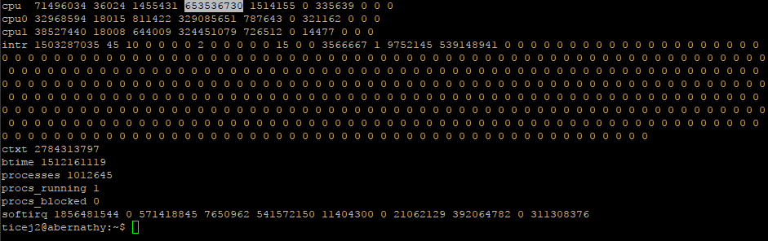Provide a screen shot of your output
  + Give a brief explanation of what is provided in this file and how the data is interpreted to discover the answer

What is provided in this file is a bunch of different statistics about the system since it was last restarted. The answer was obtained through the first line in the file which gives information on the number of jiffies (1/100 of a second) the system has been in different modes. Each number is separated by a space the first number is user mode followed by user mode with low priority, system mode, idle task, I/O wait, IRQ, and softirq.

1. **How many context switches has the kernel performed across all CPUs?**

2787430457 context switches have been preformed

* + What commands did you use to get this information?

cat /proc/stat

* + Provide a screen shot of your output

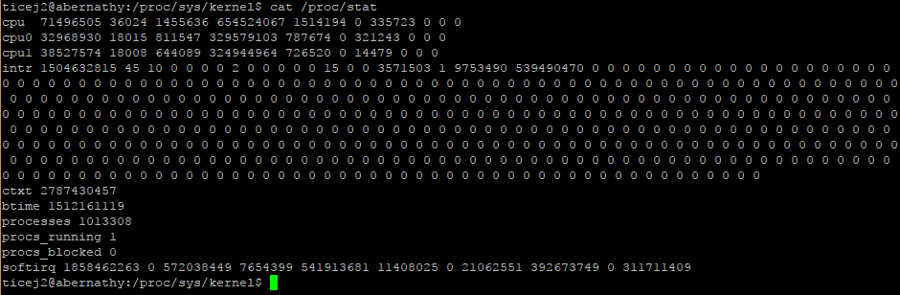

1. **How many context switches has your bash process performed?**

3053193616

* + What commands did you use to get this information?

cat /proc/stat

* + 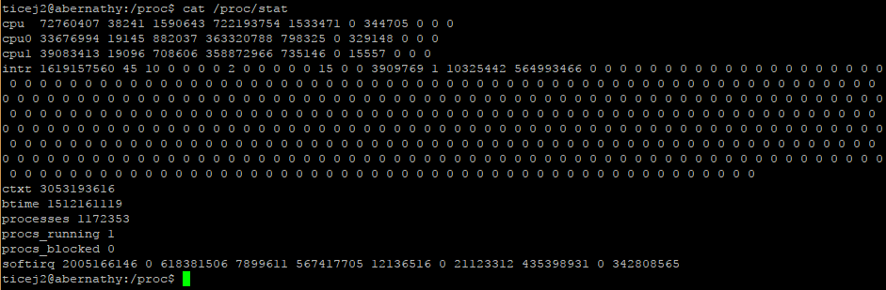Provide a screen shot
  + Give a brief explanation of the information provided.

The line starting with ctxt followed by a number in the file stat gives the number of context switches preformed across all cpu’s.

1. **How many processes have been created since the system was booted?**

1013308 processes have been created

* + What commands did you use to get this information?

cat /proc/stat

1. **Provide A list of load averages**

Average In 1 Minute:0.02

Average In 5 Minute:0.05

Average In 10 Minute:0.01

Currently Running Processes: 1 out of 1791

Last Process ID used:28751

* + What commands did you use to get this information?

cat /proc/loadavg

* + Give a brief explanation of load averages.

A system load is a measurement of the computational work the system is doing for that split second so we have load averages to give a better into how much work is being done. They show the average work the computer is doing over different periods of time. For example, an idle computer would have a load average of 0 because no work is being done.

1. **Find the number of disk read requests made on the system for one disk block device**

7161119 for sda

* + What commands did you use to get this information?

cat /proc/diskstats

* + Provide a screen shot

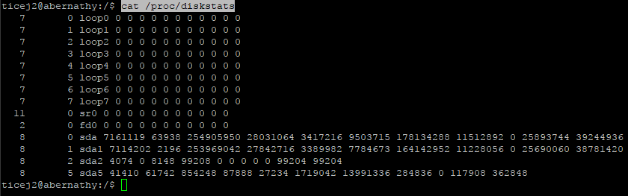

**Part B**

Provide screen shot or cut and paste

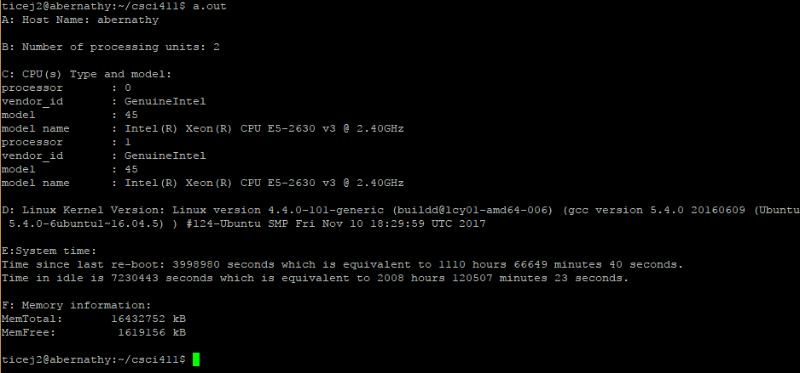Attach your source file separately