Charlie Hill

Professor Rivas

Artificial Intelligence

26 September 2016

Homework 2

2.1

This problem was pretty straightforward. All that has to be done is using the equation given, is plug in the correct values and then solve for N.

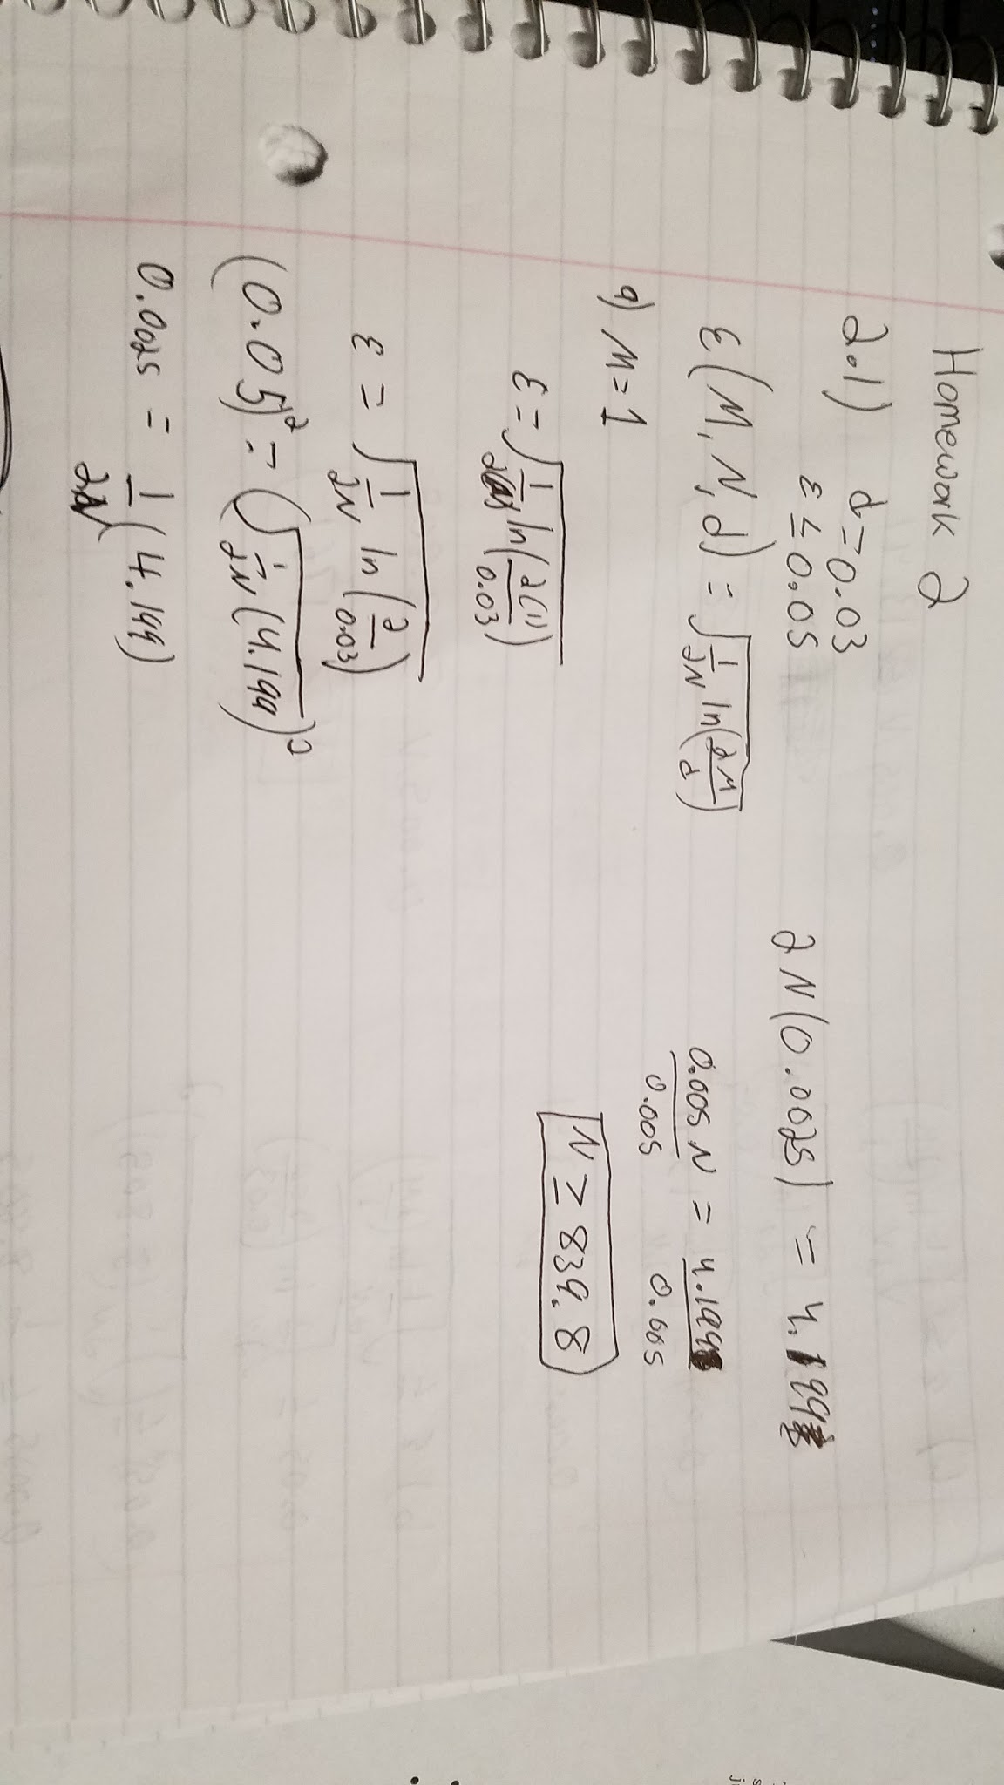

For the first scenario we have M as 1. This would mean that we would need at least 839.8 data samples to get the confidence we want.

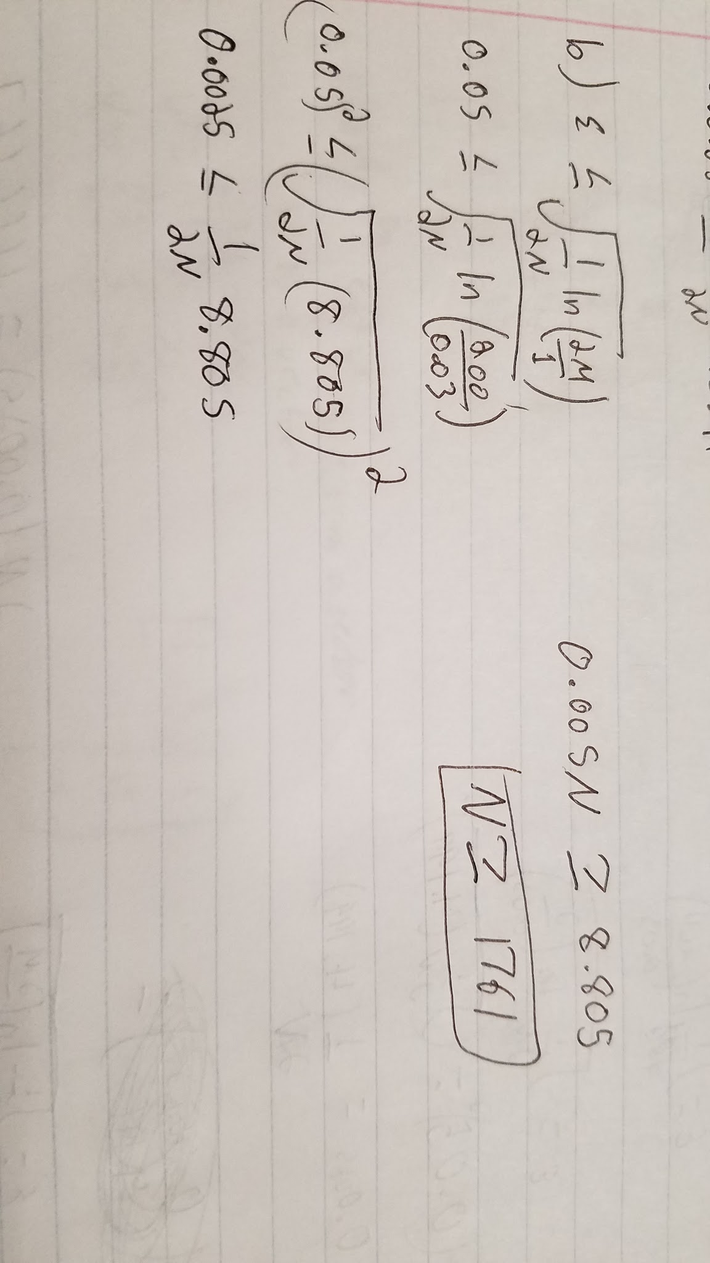

For the second scenario we have an M as 100. This means that we would need at least 1761 data samples to get the confidence we want.

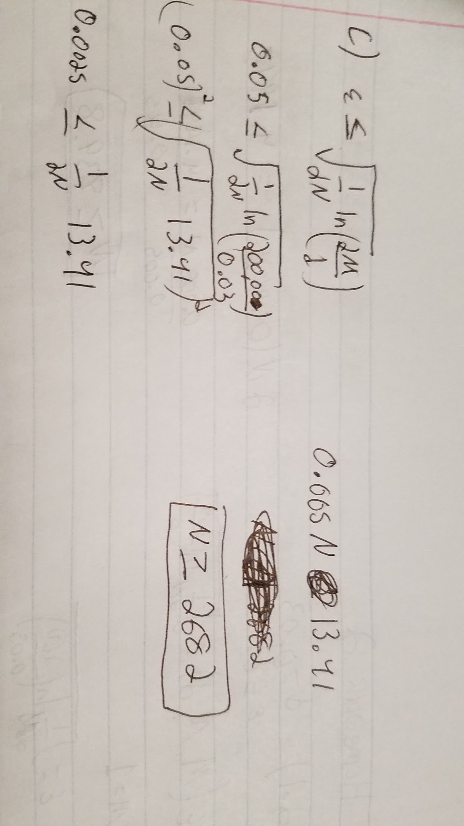

For the third scenario M was set to 10,000. This means that we would need at least 2682 data samples for the desired confidence.

2.11

This problem is similar to the first one. We are given an equation and values to plug in to solve for a variable. In this case we are estimating the expected output error.

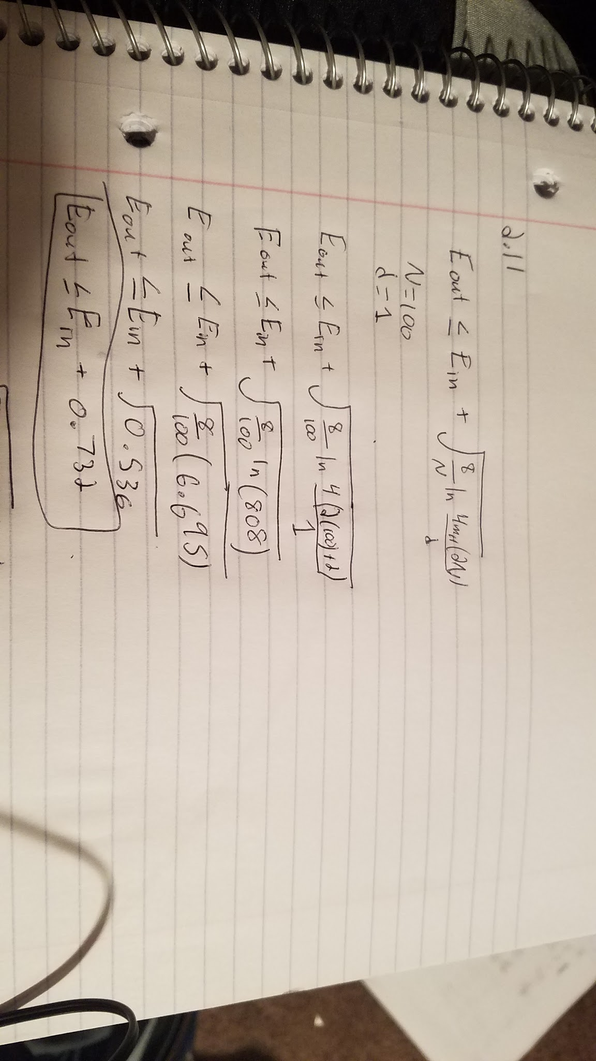

In this scenario our N (sample size) is 100. The equation would provide us with an expected error output of no more than 0.732.

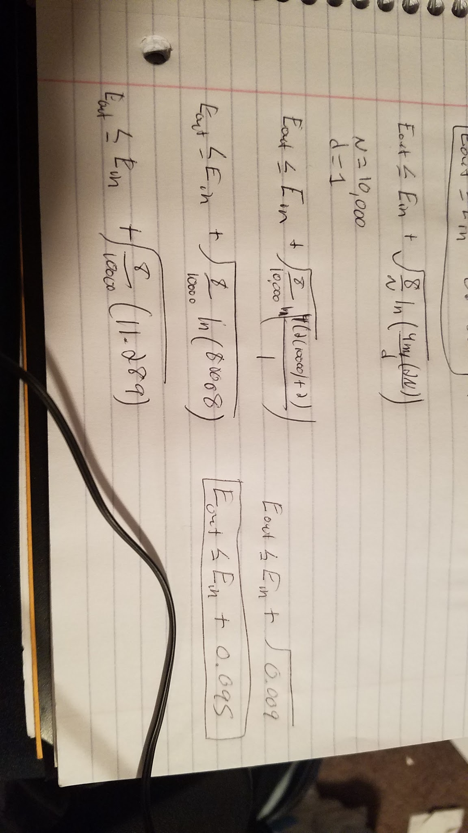

In this scenario our N (sample size) is 10,000. The equation would provide us with an expected error output of no more than 0.095. Increasing our sample size seems to reduce the expected error output.

2.12

For this problem we are trying to estimate the sample size need to acquire the confidence we need.

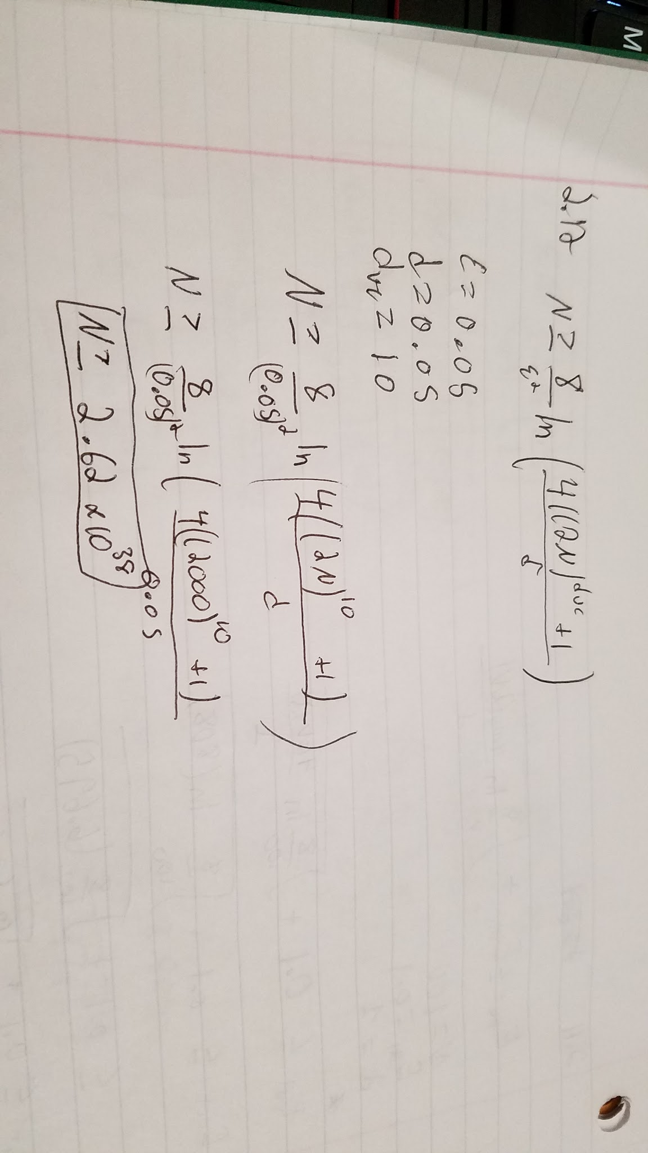

Using 1000, as the book recommends for a starting guess. This provides use with an estimated sample size of 2.62 x 1038. This is a large sample size most likely occurs from dvc being 10.

3.1

For this problem we had to graph two semi circles using python. From there we would run the perceptron on the data. The 2000 data points causes the program to run slowly. However, the perceptron seems to find the solution in very few iterations. Of all the times I ran the program, it found it within 10 iterations. In the screenshot below, the green line represents the perceptron. The grey line represents the answer found from linear regression.

