Charlie Hill

Professor Rivas

Artificial Intelligence

31 October 2016

Homework 4

I was able to successfully download and run the code we had from class. I used the same data sets and it worked perfectly. I then tried implementing the new dataset and could not seem to get it to work. At first the error occurred because the returned X and y did not match up with our previous ideas of X and y. I had to concatenate and reshape the data. I shaped the arrays to be the same shape as the previous working data. I also made sure all the datatypes were the same as the previous working data. Despite massaging the data I was not able to get the program to work. I was able to plot the data but I could not get nearest neighbor working.

Here is the plot:

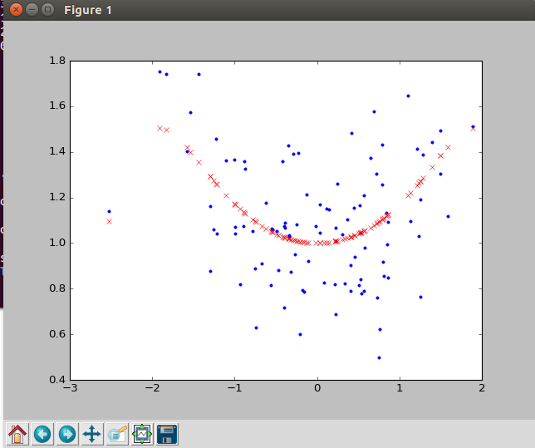

Here is the error I was getting:

