Charlie Hill

Pablo Rivas

Artificial Intelligence

14 November 2016

Homework 5

1.e.i.) Altering the n_colors value changes the amount of colors available to choose from. The higher the value, the larger selection of the colors. The picture also takes longer to generate when the number of n_colors is larger.

ii.) This can be applicable in image compression. The lower number of n_colors means that there is less data required for the picture to be saved. Therefore we can sacrifice image quality in order to saved data.

iii.) The resulting picture at the end was funny due to the fact that image gets so compressed. It essentially becomes colorless and blurry. Many of the details in the picture where blended together. The picture ends up looking fake and completely different.

This is my picture at 8 colors

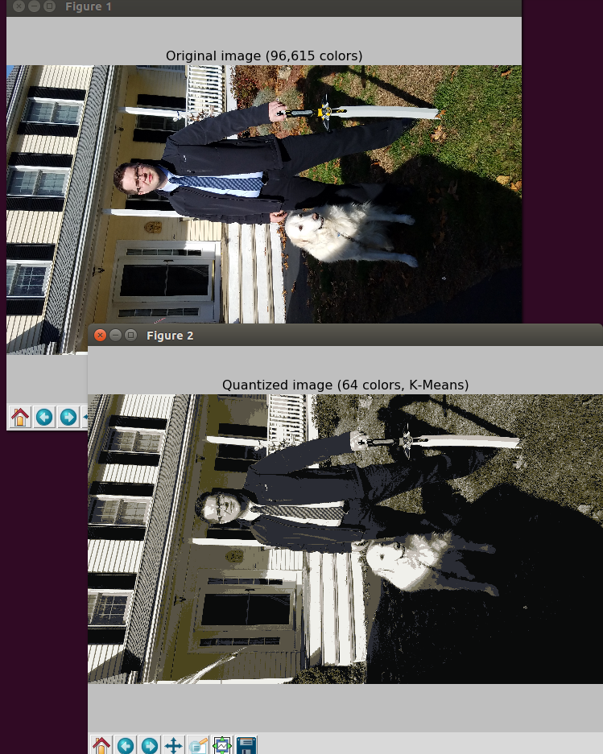

This is my picture at 4 colors

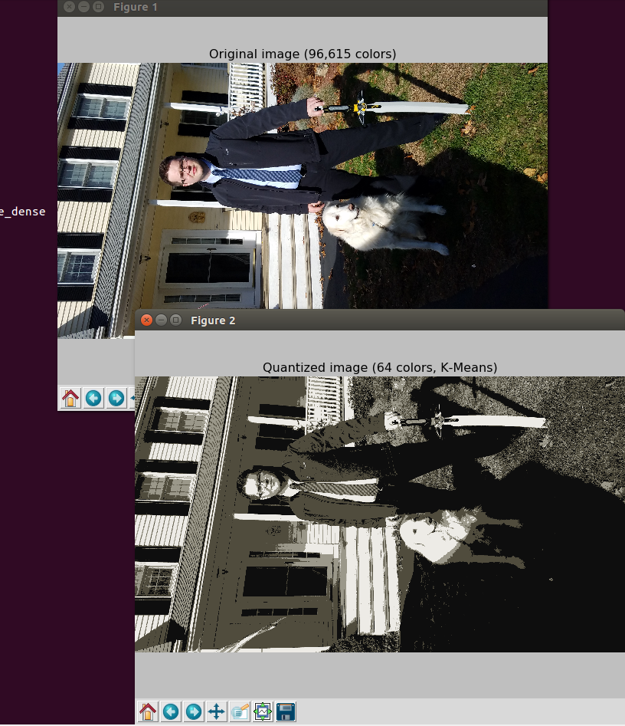

2.d.) The first time I ran it I only got 41 neurons. This did not seem like a large amount so I ran it again and got 98 neurons. The larger number of neurons seem to mean that the network is much more accurate. At 41 neurons the graph was all over the place but at 98 neurons it seemed much more condensed and closer to the true value. With more neurons the network is better.

41 neurons

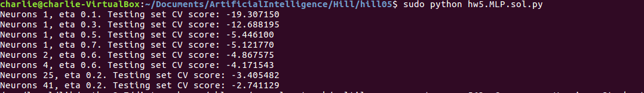

98 neurons

