Charles Hill

Artificial Intelligence

Professor Rivas

12 October 2016

Midterm

1.a.) Running the pocket perceptron on this dataset took an incredible amount of time. This is because there were 7291 data points. The data was not linearly separable, therefore the perceptron would run forever and not find a solution.The best error after 1000 of the weights are the same consecutively is 0.107118365. Changing the dataset does not cause a noticeable difference other than the data points being different colors. The best error from the second set after 1000 of the weights are the same consecutively is 0.012069675.

These are the weights from the first set where the weight is zero. The pocket has to have the same weight for 1000 times before ending. (All these .pngs are on my Github as well).

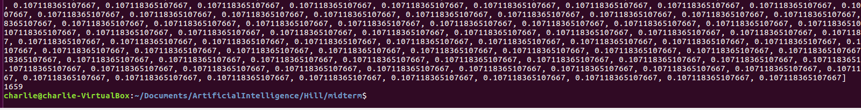

The weights from 1000 consecutive saved weights. This is from the second set.

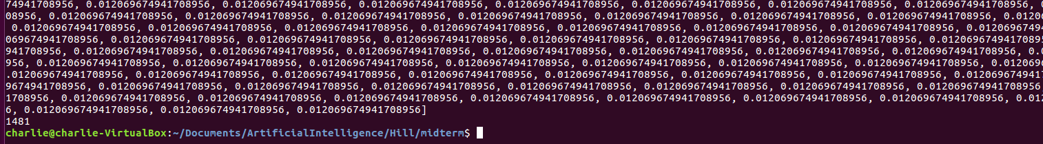

b.) The linear regression worked well on my VM. The line was created with the first iteration and goes right through the datapoints. Linear regression is strong here because it does not care if the data is not linearly separable. Changing the points sign altered the linear regression line. The line is based mathematically off the points so therefore it still finds the best possible solution despite the data not being linearly separable.

c.) Having the pocket algorithm start from the linear regression made a little bit difference from the weight starting at zero. The error starts off smaller but doesn’t seem to get to much smaller from that point. This is because the data is not linearly separable and therefore the pocket algorithm will iterate indefinitely until it is told to break. The best error after 1000 of the weights are the same consecutively is 0.106158277. Changing the dataset does not cause a noticeable difference other than the data points being different colors. The best error from the second set after 1000 of the weights are the same consecutively is 0.0123439857.

These are the weights from the first set where the weight starts from the linear regression. The pocket has to have the same weight for 1000 times before ending.

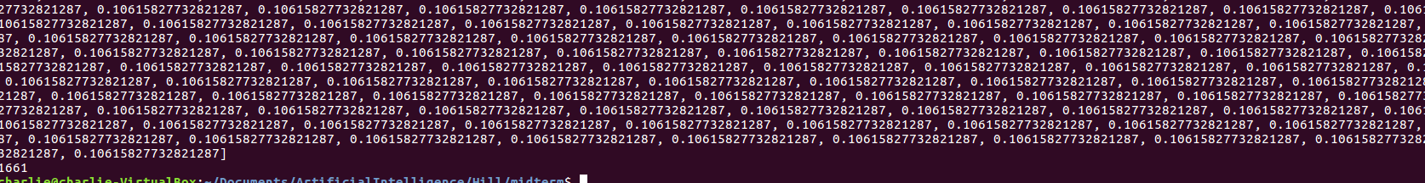

These are the weights from the second set where the weight starts from the linear regression. The pocket has to have the same weight for 1000 times before ending.

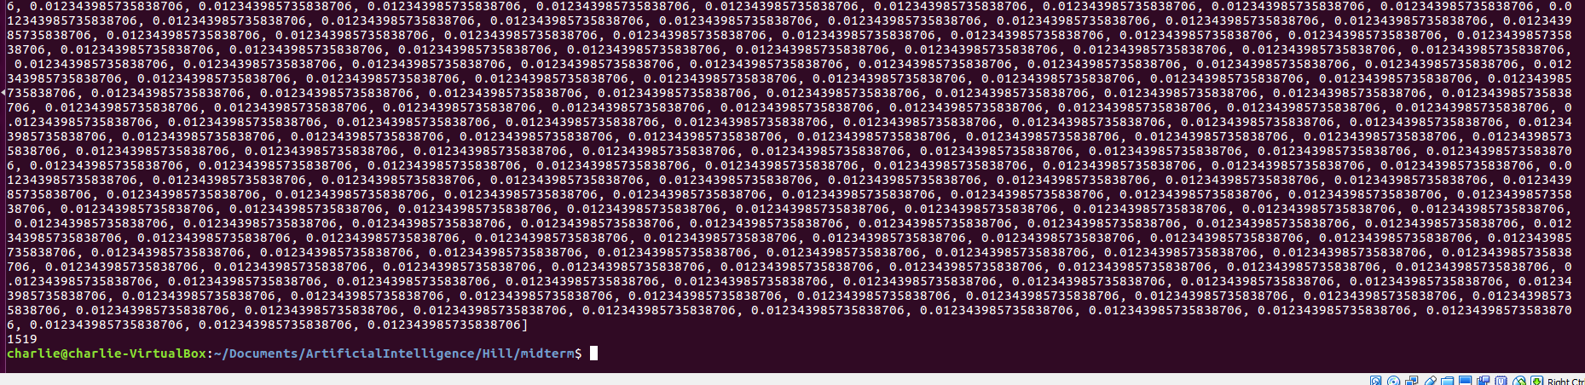

This is the pocket algorithm running with the altered dataset and the weight starting from zero. It made it to the third iteration before crashing. Plotting the 7291 data points over and over again crashes my VM rather quickly.

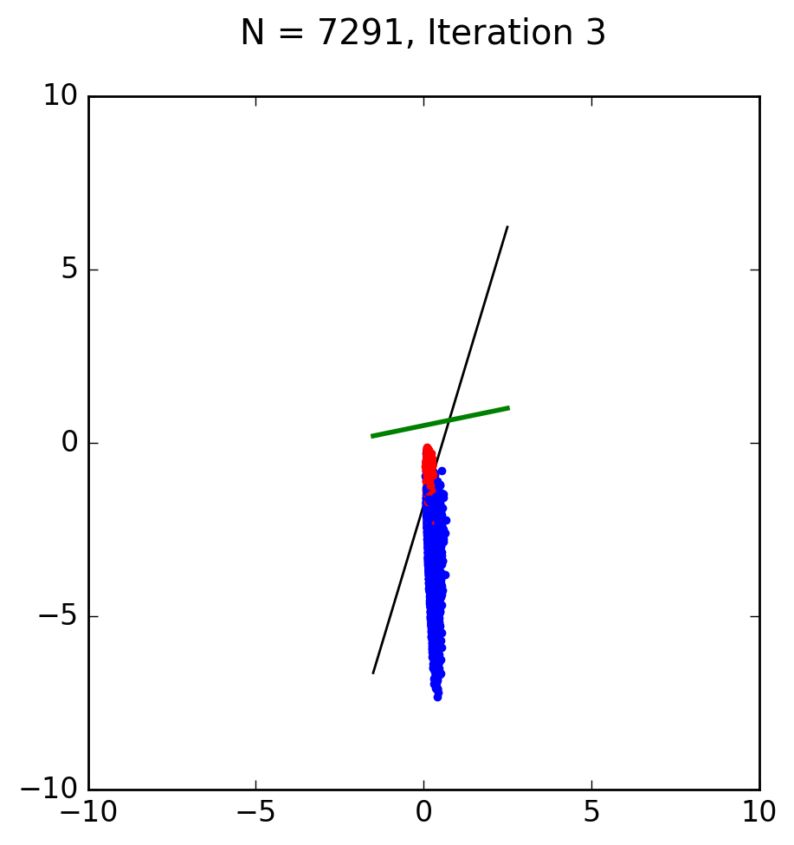

2.) After 10 iterations the answer to Problem 2.12 is about 452957 samples that are needed. This was found using my midtermpt2.py file. This program runs the equation 10 times. Each time it takes the newly found N and solves the equation with it. After about 10 iterations the difference in iterations is not significant.

