hotel_pricing_summary_report

tavva_prudhvith

January 29, 2018

## 1.INTRODUCTION

## When was the First time you went to a Hotel..??

Here we talk about the most common economies in india “Hotel Proicing In Indian Market”.We all keep going to tours and Some tourist places with our family and indeed we rest in some hotel.Now,we will be discussing about the Pricing System Of Hotels.But before we tackle the specifics of segment-based pricing, we need to establish a foundation for the pricing structure,which over time will reveal how high or low a property can go in those segment prices.With this in mind, segment-specific pricing can now be implemented for defined segments with corresponding rate plans. These can include ;Best available rate,a negotiated rate and tour operator rate.

## 2.OVERVIEW OF THE STUDY

Our field stusy concerns about the hotel pricing in the indian market system.We already knew about the hotels and thir pricing with respect to some factors.Now,how hotels depend upon the price strategy is given by (<http://blog.snapshot.travel/how-hotels-can-determine-the-right-pri(cing-strategy)>.

## AN EMPIRICAL STUDY OF HOTEL ROOM PRICING IN THE INDIAN MARKET.

## 3.1OVERVIEW

The purpose of this project is to analyse the pricing strategy of hotels in the Indian hotel industry. Many factors drive hotel room prices. The objective of this project is to identify the factors that matter the most. Think about the following problem: Room Rent = FUNCTION ( Date(s); Hotel Features; External Factors) Now,from the regression models we can show the factors dependent upon the Room rent.

## 3.2 DATA

In this case study we are going to compare the hotel pricing in indian market system with the dataset avalilabe from (<https://in.hotels.com/>) October 2016.Here,we have 42 cities in the above dataset with 13232 Rows and 19 columns.Notice that the dataset tracks hotel prices on 8 different dates at different hotels across different cities.

RoomRent(Dependent Variable) -> Rent for the cheapest room, double occupancy, in Indian Rupees. Some hotels have more than one type of double occupancy room. For simplicity, we picked the cheapest room with double occupancy.

EXternal Factors: Many external factors can potentially influence the RoomRent. The dataset captures some of these external factors, as explained below.

Date,IsWeekend,IsNewYearEve,CityName,Population,CityRank,IsMetroCity,IsTouristDestination.

Internal Factors: Many Hotel Features can influence the RoomRent. The dataset captures some of these internal factors, as explained below.

HotelName,StarRating,Airport,HotelAddress,HotelPincode,HotelDescription,FreeWifi,FreeBreakfast,HoteCapacity,HasSwimmingPool.

## DESCRIPTIVE STATISTICS

hotel<-read.csv(file.choose(),header=T)  
summary(hotel)

## CityName Population CityRank IsMetroCity   
## Delhi :2048 Min. : 8096 Min. : 0.00 Min. :0.0000   
## Jaipur : 768 1st Qu.: 744983 1st Qu.: 2.00 1st Qu.:0.0000   
## Mumbai : 712 Median : 3046163 Median : 9.00 Median :0.0000   
## Bangalore: 656 Mean : 4416837 Mean :14.83 Mean :0.2842   
## Goa : 624 3rd Qu.: 8443675 3rd Qu.:24.00 3rd Qu.:1.0000   
## Kochi : 608 Max. :12442373 Max. :44.00 Max. :1.0000   
## (Other) :7816   
## IsTouristDestination IsWeekend IsNewYearEve Date   
## Min. :0.0000 Min. :0.0000 Min. :0.0000 Dec 21 2016:1611   
## 1st Qu.:0.0000 1st Qu.:0.0000 1st Qu.:0.0000 Dec 24 2016:1611   
## Median :1.0000 Median :1.0000 Median :0.0000 Dec 25 2016:1611   
## Mean :0.6972 Mean :0.6228 Mean :0.1244 Dec 28 2016:1611   
## 3rd Qu.:1.0000 3rd Qu.:1.0000 3rd Qu.:0.0000 Dec 31 2016:1611   
## Max. :1.0000 Max. :1.0000 Max. :1.0000 Dec 18 2016:1608   
## (Other) :3569   
## HotelName RoomRent StarRating   
## Vivanta by Taj : 32 Min. : 299 Min. :0.000   
## Goldfinch Hotel : 24 1st Qu.: 2436 1st Qu.:3.000   
## OYO Rooms : 24 Median : 4000 Median :3.000   
## The Gordon House Hotel: 24 Mean : 5474 Mean :3.459   
## Apnayt Villa : 16 3rd Qu.: 6299 3rd Qu.:4.000   
## Bentleys Hotel Colaba : 16 Max. :322500 Max. :5.000   
## (Other) :13096   
## Airport   
## Min. : 0.20   
## 1st Qu.: 8.40   
## Median : 15.00   
## Mean : 21.16   
## 3rd Qu.: 24.00   
## Max. :124.00   
##   
## HotelAddress   
## The Mall, Shimla : 32   
## #2-91/14/8, White Fields, Kondapur, Hitech City, Hyderabad, 500084 India: 16   
## 121, City Terrace, Walchand Hirachand Marg, Mumbai, Maharashtra : 16   
## 14-4507/9, Balmatta Road, Near Jyothi Circle, Hampankatta : 16   
## 144/7, Rajiv Gandi Salai (OMR), Kottivakkam, Chennai, Tamil Nadu : 16   
## 17, Oliver Road, Colaba, Mumbai, Maharashtra : 16   
## (Other) :13120   
## HotelPincode HotelDescription FreeWifi FreeBreakfast   
## Min. : 100025 3 : 120 Min. :0.0000 Min. :0.0000   
## 1st Qu.: 221001 Abc : 112 1st Qu.:1.0000 1st Qu.:0.0000   
## Median : 395003 3-star hotel: 104 Median :1.0000 Median :1.0000   
## Mean : 397430 3.5 : 88 Mean :0.9259 Mean :0.6491   
## 3rd Qu.: 570001 4 : 72 3rd Qu.:1.0000 3rd Qu.:1.0000   
## Max. :7000157 (Other) :12728 Max. :1.0000 Max. :1.0000   
## NA's : 8   
## HotelCapacity HasSwimmingPool   
## Min. : 0.00 Min. :0.0000   
## 1st Qu.: 16.00 1st Qu.:0.0000   
## Median : 34.00 Median :0.0000   
## Mean : 62.51 Mean :0.3558   
## 3rd Qu.: 75.00 3rd Qu.:1.0000   
## Max. :600.00 Max. :1.0000   
##

library(psych)

## Warning: package 'psych' was built under R version 3.4.3

describe(hotel)

## vars n mean sd median trimmed  
## CityName* 1 13232 18.07 11.72 16 17.29  
## Population 2 13232 4416836.87 4258386.00 3046163 4040816.22  
## CityRank 3 13232 14.83 13.51 9 13.30  
## IsMetroCity 4 13232 0.28 0.45 0 0.23  
## IsTouristDestination 5 13232 0.70 0.46 1 0.75  
## IsWeekend 6 13232 0.62 0.48 1 0.65  
## IsNewYearEve 7 13232 0.12 0.33 0 0.03  
## Date* 8 13232 14.30 2.69 14 14.39  
## HotelName* 9 13232 841.19 488.16 827 841.18  
## RoomRent 10 13232 5473.99 7333.12 4000 4383.33  
## StarRating 11 13232 3.46 0.76 3 3.40  
## Airport 12 13232 21.16 22.76 15 16.39  
## HotelAddress* 13 13232 1202.53 582.17 1261 1233.25  
## HotelPincode 14 13232 397430.26 259837.50 395003 388540.47  
## HotelDescription* 15 13224 581.34 363.26 567 575.37  
## FreeWifi 16 13232 0.93 0.26 1 1.00  
## FreeBreakfast 17 13232 0.65 0.48 1 0.69  
## HotelCapacity 18 13232 62.51 76.66 34 46.03  
## HasSwimmingPool 19 13232 0.36 0.48 0 0.32  
## mad min max range skew  
## CityName* 11.86 1.0 42 41.0 0.48  
## Population 3846498.95 8096.0 12442373 12434277.0 0.68  
## CityRank 11.86 0.0 44 44.0 0.69  
## IsMetroCity 0.00 0.0 1 1.0 0.96  
## IsTouristDestination 0.00 0.0 1 1.0 -0.86  
## IsWeekend 0.00 0.0 1 1.0 -0.51  
## IsNewYearEve 0.00 0.0 1 1.0 2.28  
## Date* 2.97 1.0 20 19.0 -0.77  
## HotelName* 641.97 1.0 1670 1669.0 0.01  
## RoomRent 2653.85 299.0 322500 322201.0 16.75  
## StarRating 0.74 0.0 5 5.0 0.48  
## Airport 11.12 0.2 124 123.8 2.73  
## HotelAddress* 668.65 1.0 2108 2107.0 -0.37  
## HotelPincode 257975.37 100025.0 7000157 6900132.0 9.99  
## HotelDescription* 472.95 1.0 1226 1225.0 0.11  
## FreeWifi 0.00 0.0 1 1.0 -3.25  
## FreeBreakfast 0.00 0.0 1 1.0 -0.62  
## HotelCapacity 28.17 0.0 600 600.0 2.95  
## HasSwimmingPool 0.00 0.0 1 1.0 0.60  
## kurtosis se  
## CityName* -0.88 0.10  
## Population -1.08 37019.65  
## CityRank -0.76 0.12  
## IsMetroCity -1.08 0.00  
## IsTouristDestination -1.26 0.00  
## IsWeekend -1.74 0.00  
## IsNewYearEve 3.18 0.00  
## Date* 1.92 0.02  
## HotelName* -1.25 4.24  
## RoomRent 582.06 63.75  
## StarRating 0.25 0.01  
## Airport 7.89 0.20  
## HotelAddress* -0.88 5.06  
## HotelPincode 249.76 2258.86  
## HotelDescription* -1.25 3.16  
## FreeWifi 8.57 0.00  
## FreeBreakfast -1.61 0.00  
## HotelCapacity 11.39 0.67  
## HasSwimmingPool -1.64 0.00

## 3.3 MODEL

In order to test the regression models, we proposed the following model:

reg2<-lm(RoomRent ~ IsTouristDestination + IsNewYearEve + IsMetroCity + HasSwimmingPool,data=hotel)  
summary(reg2)

##   
## Call:  
## lm(formula = RoomRent ~ IsTouristDestination + IsNewYearEve +   
## IsMetroCity + HasSwimmingPool, data = hotel)  
##   
## Residuals:  
## Min 1Q Median 3Q Max   
## -9239 -2403 -859 961 313036   
##   
## Coefficients:  
## Estimate Std. Error t value Pr(>|t|)   
## (Intercept) 2722.5 120.2 22.648 < 2e-16 ***  
## IsTouristDestination 2018.6 132.4 15.248 < 2e-16 ***  
## IsNewYearEve 855.3 181.3 4.718 2.41e-06 ***  
## IsMetroCity -1557.2 134.8 -11.553 < 2e-16 ***  
## HasSwimmingPool 4722.6 125.1 37.753 < 2e-16 ***  
## ---  
## Signif. codes: 0 '***' 0.001 '**' 0.01 '*' 0.05 '.' 0.1 ' ' 1  
##   
## Residual standard error: 6882 on 13227 degrees of freedom  
## Multiple R-squared: 0.1195, Adjusted R-squared: 0.1192   
## F-statistic: 448.7 on 4 and 13227 DF, p-value: < 2.2e-16

reg2$coefficients

## (Intercept) IsTouristDestination IsNewYearEve   
## 2722.4919 2018.5542 855.2761   
## IsMetroCity HasSwimmingPool   
## -1557.1643 4722.5653

## RESULTS

As Y=F(x) y=Room Rent x1,x2,x3,… are exploratory variables dependnt upon the room rent i.e the factors. Room rent =b0 +b1 *ISTouristDestination+ b2*IsNewYearEve +b3*IsMetroCity +b4*hasswimmingpool From the fitted coefficients,then b0=-1 (let us assume) b1=2018,5542 b2=855.2761 b3=-1557.1643 b4=4722.5653 The Conclusion will be Room rent =b0 +2018.5542 *ISTouristDestination+ 855.2761*IsNewYearEve +(-1557.1643)*IsMetroCity +4722.5653*hasswimmingpool

## CONCLUSION

This paper was motivated by the need for research that could improve our understanding of how HOTEL PRICING IN INDIAN MARKET influences the pricing strategies in the hotel industry. The unique contribution of this paper is that we investigated the price strategies by hotel management anf the factors that the people come to the hotels. Now,the factors that the room rent depends is “IstouristDetination”,“Inewyeareve”,“IS metrocity”,“Swimmingpool”

## APPENDIX 1

## AVERAGE ROOM RENT CORRESPONDING TO DIFERENT FACTORS.

aggregate(hotel$RoomRent, by=list(freewifi = hotel$FreeWifi, freeBreakfast = hotel$FreeBreakfast, swimmingPool = hotel$HasSwimmingPool,Touristplace=hotel$IsTouristDestination), mean)

## freewifi freeBreakfast swimmingPool Touristplace x  
## 1 0 0 0 0 2961.188  
## 2 1 0 0 0 2788.815  
## 3 0 1 0 0 4108.600  
## 4 1 1 0 0 3286.387  
## 5 0 0 1 0 7185.167  
## 6 1 0 1 0 6675.889  
## 7 0 1 1 0 5079.913  
## 8 1 1 1 0 5517.907  
## 9 0 0 0 1 3677.939  
## 10 1 0 0 1 3257.897  
## 11 0 1 0 1 5909.478  
## 12 1 1 0 1 4395.936  
## 13 0 0 1 1 7446.194  
## 14 1 0 1 1 10818.984  
## 15 0 1 1 1 5240.216  
## 16 1 1 1 1 9215.152

## TWO-WAY CONTINGENCY TABLES

table6<-xtabs(~hotel$StarRating + hotel$IsMetroCity)  
table6

## hotel$IsMetroCity  
## hotel$StarRating 0 1  
## 0 16 0  
## 1 8 0  
## 2 344 96  
## 2.5 456 176  
## 3 4336 1617  
## 3.2 8 0  
## 3.3 16 0  
## 3.4 8 0  
## 3.5 1312 440  
## 3.6 0 8  
## 3.7 24 0  
## 3.8 16 0  
## 3.9 32 0  
## 4 1696 767  
## 4.1 24 0  
## 4.3 16 0  
## 4.4 8 0  
## 4.5 288 88  
## 4.7 8 0  
## 4.8 16 0  
## 5 840 568

table7<-xtabs(~hotel$StarRating + hotel$IsTouristDestination)  
table7

## hotel$IsTouristDestination  
## hotel$StarRating 0 1  
## 0 0 16  
## 1 0 8  
## 2 64 376  
## 2.5 152 480  
## 3 1888 4065  
## 3.2 0 8  
## 3.3 0 16  
## 3.4 0 8  
## 3.5 448 1304  
## 3.6 0 8  
## 3.7 8 16  
## 3.8 16 0  
## 3.9 16 16  
## 4 839 1624  
## 4.1 0 24  
## 4.3 16 0  
## 4.4 8 0  
## 4.5 128 248  
## 4.7 8 0  
## 4.8 0 16  
## 5 416 992

## BOXPLOTS

#Boxplot for Room rent and Weekends.  
boxplot(hotel$RoomRent ~ hotel$IsWeekend,  
 horizontal=T,  
 main="Room rent Vs IS weekend",  
 xlab="Room Rents",  
 ylab="Is Weekend",  
col=c("pink","yellow"))

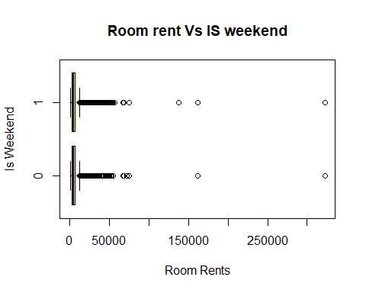

#Boxplots For Capacity and rating OF th Hotels.  
boxplot(hotel$HotelCapacity ~ hotel$StarRating,  
 horizontal=T,  
 main="Hotel Capacity vs Star rating",  
 xlab="Capacities",  
 ylab="Ratings")

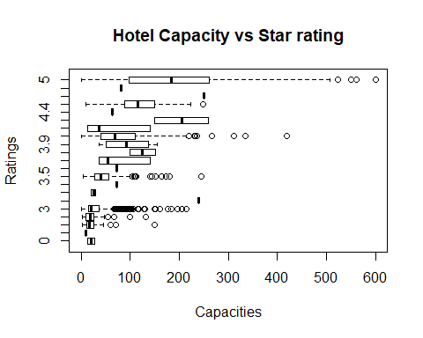

## HISTOGRAMS

# Histograms for Distance Between Hotel to Airport.  
hist(hotel$Airport,  
 main="Histogram For Distance From Hotel to Airport",  
 xlab="Airport Distance in Km")

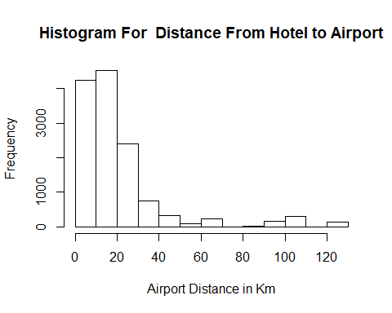

# Using Histogram command using lattice package to find the distributions of Date variable.  
table(hotel$Date)

##   
## 04-Jan-16 04-Jan-17 08-Jan-16 08-Jan-17 18-Dec-16 21-Dec-16   
## 31 13 31 13 44 44   
## 24-Dec-16 25-Dec-16 28-Dec-16 31-Dec-16 Dec 18 2016 Dec 21 2016   
## 44 44 44 44 1608 1611   
## Dec 24 2016 Dec 25 2016 Dec 28 2016 Dec 31 2016 Jan 04 2017 Jan 08 2017   
## 1611 1611 1611 1611 1548 1542   
## Jan 4 2017 Jan 8 2017   
## 60 67

library(lattice)  
histogram(~Date,data=hotel,  
 main="Distribution Of Dates",  
 xlab="Dates",  
 col="yellow")

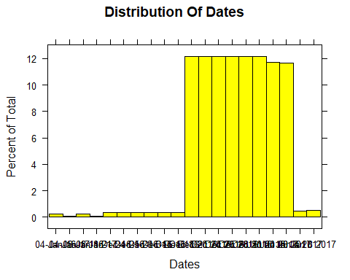

## ORRGRAMS FOR THE DATA

library(corrgram)

## Warning: package 'corrgram' was built under R version 3.4.3

corrgram(hotel,main="Corrgram for the Attributes(columns)",  
 lower.panel = panel.shade,  
 upper.panel=panel.pie,  
 order=T,  
 text.panel = panel.txt)

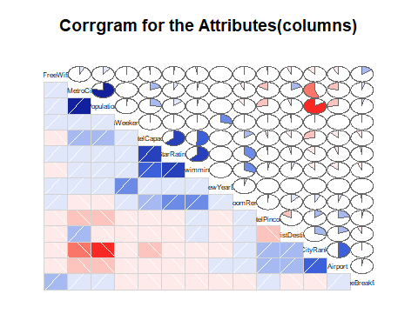

## T- TESTS FOR THE GIVEN DATA TO FIND THE FACTORS FOR THE ROOM RENT

t.test(hotel$RoomRent,hotel$IsTouristDestination)

##   
## Welch Two Sample t-test  
##   
## data: hotel$RoomRent and hotel$IsTouristDestination  
## t = 85.856, df = 13231, p-value < 2.2e-16  
## alternative hypothesis: true difference in means is not equal to 0  
## 95 percent confidence interval:  
## 5348.337 5598.253  
## sample estimates:  
## mean of x mean of y   
## 5473.9918380 0.6971735

t.test(RoomRent~IsNewYearEve,data=hotel)

##   
## Welch Two Sample t-test  
##   
## data: RoomRent by IsNewYearEve  
## t = -4.1793, df = 2065, p-value = 3.046e-05  
## alternative hypothesis: true difference in means is not equal to 0  
## 95 percent confidence interval:  
## -1256.5297 -453.9099  
## sample estimates:  
## mean in group 0 mean in group 1   
## 5367.606 6222.826

t.test(RoomRent~HasSwimmingPool,data=hotel)

##   
## Welch Two Sample t-test  
##   
## data: RoomRent by HasSwimmingPool  
## t = -29.013, df = 5011.3, p-value < 2.2e-16  
## alternative hypothesis: true difference in means is not equal to 0  
## 95 percent confidence interval:  
## -5096.030 -4450.942  
## sample estimates:  
## mean in group 0 mean in group 1   
## 3775.566 8549.052

t.test(RoomRent~IsMetroCity,data=hotel)

##   
## Welch Two Sample t-test  
##   
## data: RoomRent by IsMetroCity  
## t = 10.721, df = 13224, p-value < 2.2e-16  
## alternative hypothesis: true difference in means is not equal to 0  
## 95 percent confidence interval:  
## 888.0308 1285.4102  
## sample estimates:  
## mean in group 0 mean in group 1   
## 5782.794 4696.073

CONCLUSION: THE ROOM RENT DEPENDS UPON THE FOLLOWING FACTORS:-

1.TOURIST DESTINATION 2.NEWYEAREVE 3.SWIMMINGPOOL 4.METRO CITY

We know that people are always addicted to the gadgets and phones these days.So,mainly the people whpo come from the states prefer the hotels that are not far away from thr airport as it will be easier for them to go to the airport without any delay.

Asmetro cities will have number of graduates and families they prefer to stay in the hotels that are 3 star and 5 star rating .

These days having swimming pool ,free wifi and breakfast can also be the main factor for the room rent as these factors mainly dependent on room rent.