Go to Start | Control Panel | Administrative Tools | Internet Information Services

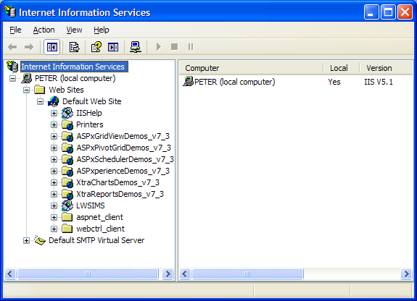

Go to your Default Website and Right click, Properties

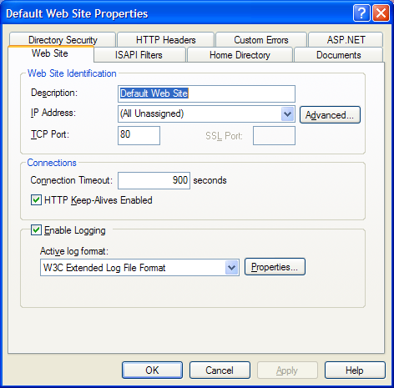

Go to Home Directory tab:

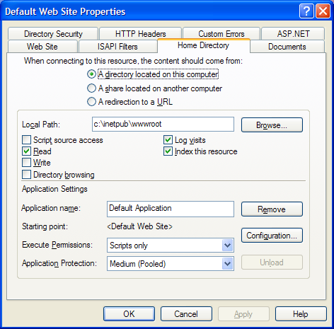

Click the Configuration button:

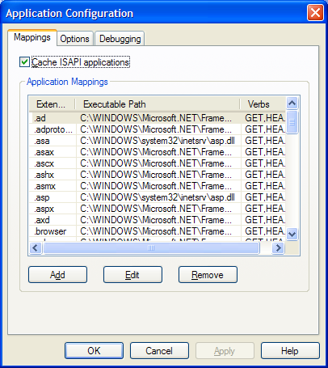

Select .aspx and click Edit

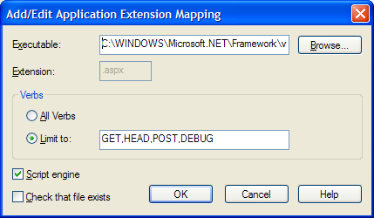

Select the contents of the “Executable” text box and Right click, Copy (Ctrl C doesn’t work)

Click Cancel and then back at the Application Configuration screen click Add:

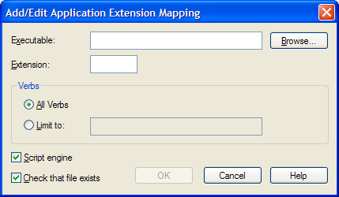

Now paste in the value you copied (use the mouse right click, Ctrl V doesn’t work) into the Executable field. Into the extension field type “.wgx”. Uncheck the “Check that file exists option”:

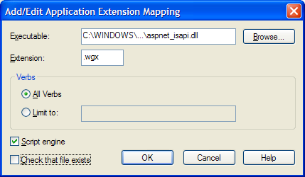

Click OK, then OK, then OK. Restart IIS (right click local computer, select All Tasks, then Restart IIS, then OK)