HW5
Algorithms Analysis 03
22100487 이경민

Given a graph.
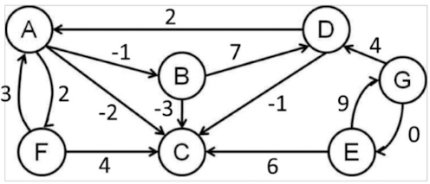

Fill the adjacency matrix below.
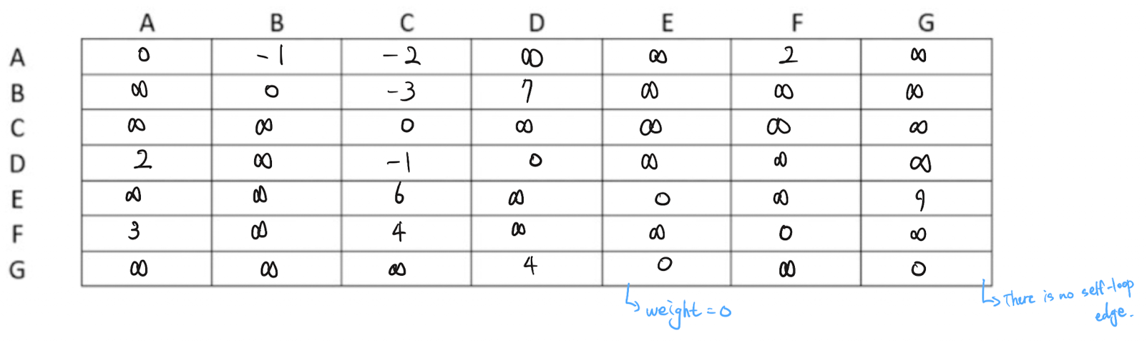
G -> (E, weight = 0)
Vertices like (A,A), …, (G,G) are not included in the adjacency list, not because their weight is 0, but because there are no self-loop edges.

Write(Draw) the array of adjacency list in alphabetical order.
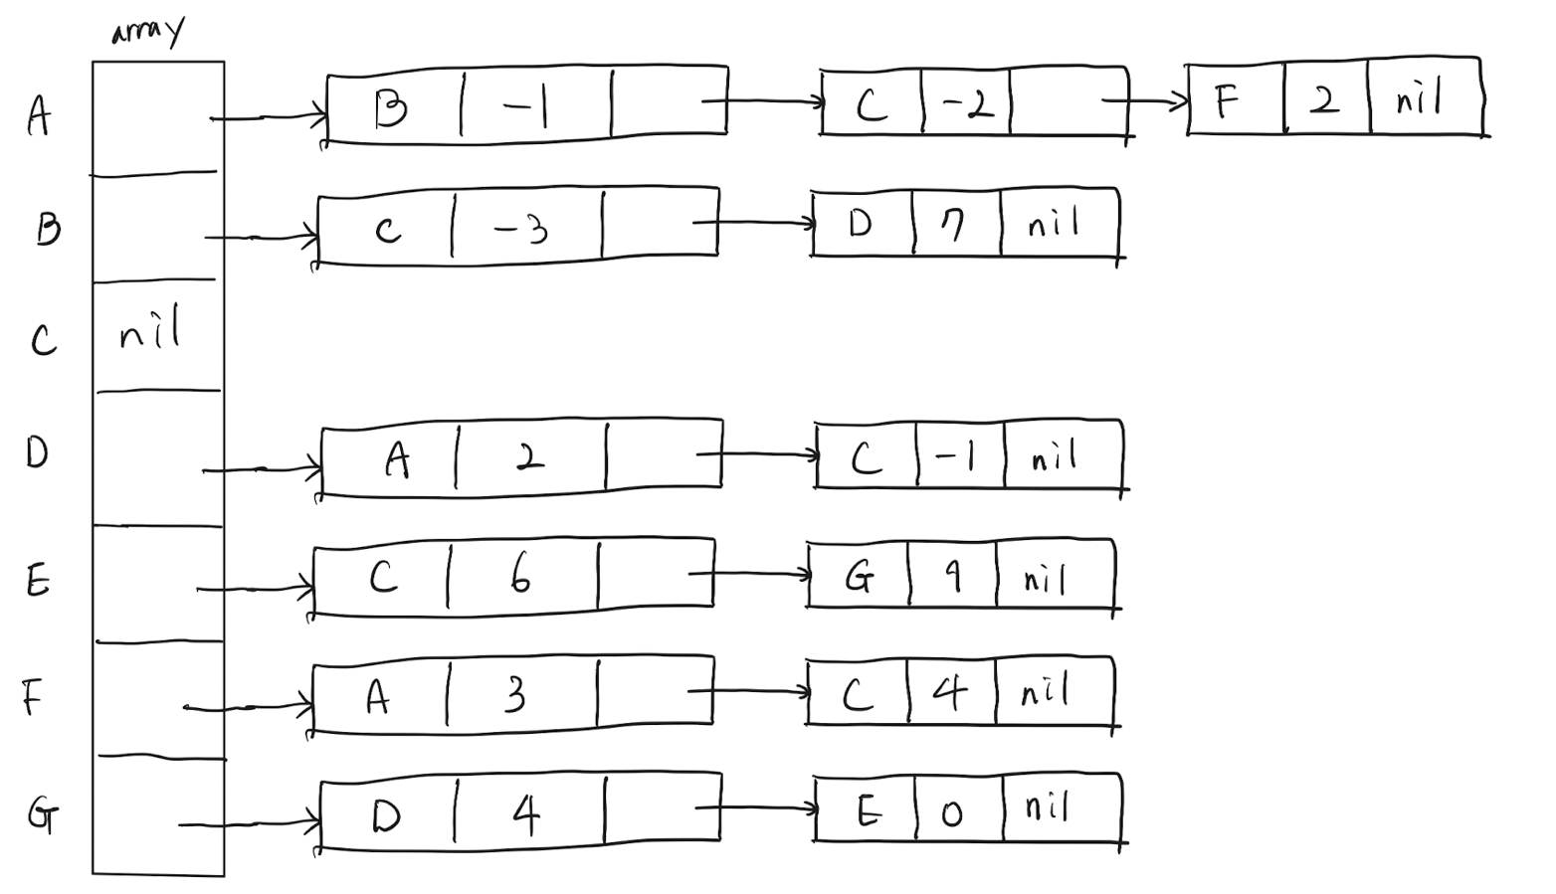
Vertex C has no outgoing edges.
All vertices other than C are connected to at least one neighbor.
Vertex A has outgoing edges to B, C, and F.
Vertex B has outgoing edges to C, and D.
Vertex D has outgoing edges to A, and C.
Vertex E has outgoing edges to C, and G.
Vertex F has outgoing edges to A, and C.
Vertex G has outgoing edges to D, and E.
And Each node in the adjacency list stores a weight value for that specific edge.

Transparency
- I verified through AI whether it is correct to add it to the adjacency list even when the weight is 0.
- https://chatgpt.com/share/69ec4003-579c-8322-9778-224988191fc4

