How to Run the Library Management Database from Ground Zero

By Ivan Ko, Trung Nguyen, Chime Nguyen

CSE 3330-004

11/28/2024

# Table Of Contents

Introduction ……………………………………………………………………………Page 2

Download the Code and Databases ……………………………………………………Page 3

Installing Python with Tkinter ……………………………………………………Page 4

Locating the Folder and Running the Program …………………………………… Page 8

Using the Application ……………………………………………………………………Page 10

Example Workflow ……………………………………………………………………Page 14

# Introduction

Welcome to the user installation guide for the LMS Application made using Python and the Tkinter library. The application requires some prerequisite installations to work and this document aims to provide a clear and concise set of instructions on how to get the application running. In this guide, you will find step-by-step instructions on making sure you have Python installed on your computer, where to get the application dependencies, and most importantly, how to get it running as well as some steps to get you started using it. By following the outlined steps, you will be able to successfully install and run the application. Thank you for trying our project!

# Download the Code and Databases

1. Navigate to the following GitHub repository below:  
   <https://github.com/Chime-txt/Project-2-Library-Management-System>

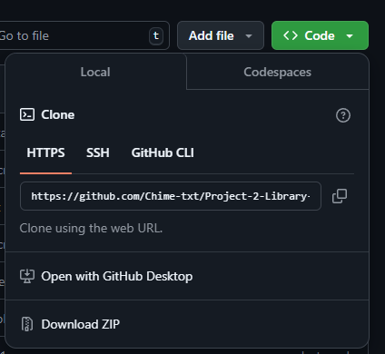

Step 1

1. On the GitHub page, click on the {<> Code} dropdown and select.



Step 2

1. Once the download completes, locate it, and extract the zip file with an archive tool like 7zip or WinRAR into a folder you can easily access (you will need to get the folder’s location for a later step in the installation process)

*If you are trying to install from the submission through Canvas, you’ll need to extract it and find the folder location for a later step in the installation process.*

# Installing Python with Tkinter

Installing Through Python’s Website

1. Go to the Python’s downloads page. This page will automatically detect your Operating System (OS) if you are running in a different OS than Windows. For this tutorial, we will use Windows, but the same steps should still apply. <https://www.python.org/downloads/>

1. Either click on Download Python or scroll down to the section “Looking for a specific release” and install any version that is at least Python 3.7. Although Tkinter is included in Python starting in Python 2.2, older versions may contain vulnerabilities and bugs that newer versions include as well as the possibility of the code being incompatible. Additionally, Python 3.7 should have most of the features that we used in Tkinter.

1. Run the Python executable which should take you to the installation setup wizard.
2. On this page, click on the option to “Use admin privileges when installing Python” and “Add python.exe to PATH”. This is important as it is required to run Python. In the case that you have installed Python with admin permissions before, and did not remove the Python Launcher, it will be grayed out, stating that the “Python Launcher is already installed”. Then press on the second option “Customize Installation”.

1. It will show the “Optional Features” page where the Tcl/Tk option should be automatically selected. If it is not, select Tcl/Tk to enable Tkinter. The other options are optional but may be convenient. Then click on Next.

1. In the Advanced Options, check to make sure that Python is set as an environment variable. Then, if you want to let all users use Python, click on the option to “Install Python for all users”, then click on Install.

1. After installing and clicking on some Administrator prompts, the setup is complete. However, there may be an additional prompt that will ask you if you want to disable the path size limit. You can disable the prompt if you need to. At any time as long as you have the exact version of the Python installation executable, you can rerun the executable and modify the settings in steps 5 and 6 to enable Tkinter and the environment variable if you forget to enable it earlier.

If you have already disabled the path length limit before, then this option will disappear.

1. Congratulations, you have successfully installed Python.

This process should work for most OSs, but if your OS is not included in the list of downloads, check the Alternative Help section below.

Alternative Help

* Using the Command Line to install Python
  + To install via command line, open up the Terminal (or equivalent Command Line Interface). This is what the Terminal may look like in Windows.

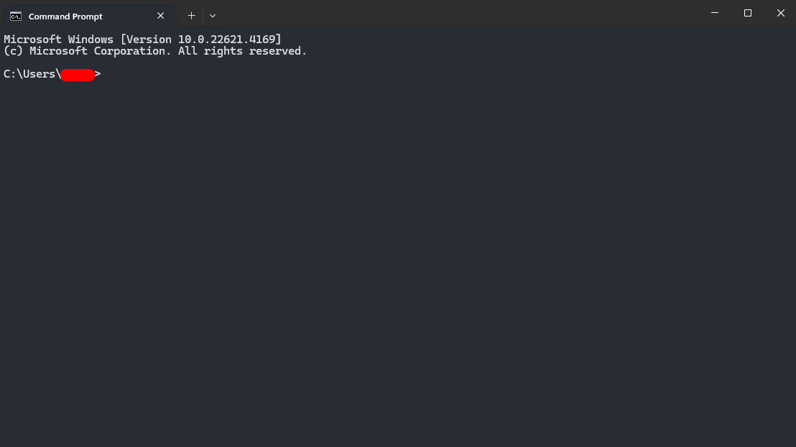

* + Afterwards, it is best to refer to the OS’s package manager as well as search up how to install Python with Tkinter on your OS as they may have a different way of installing Python which has Tkinter included.  
    Note: Installing Tkinter in this way is not generally recommended as it may not work depending on how Tkinter is installed locally
* Using the Command Line to check for other possible Python installations
  + To check what version of Python you have, type **py --list**. If it throws an exception, it is likely because Python is not installed on your device. If it doesn’t, then it will show all the versions of Python that are installed on the computer up to Python 3.12.X without going into Python’s editor. As for checking the current version of Python you are using, use the **python --version**.

* Using the Command Line to check for Tkinter
  + Then to test what version of Tkinter you have, type in **python -m tkinter**. If Tkinter is not installed, then there will likely be an error. If Tkinter is installed, a window will pop up and show the version number next to it.

# Locating the Folder and Running the Program

1. Locate and open the folder you extracted the zip file into. It should have the folder named ‘Project-2-Library-Management-System-main'
2. Open the folder then right-click anywhere in the folder and select ‘Properties’

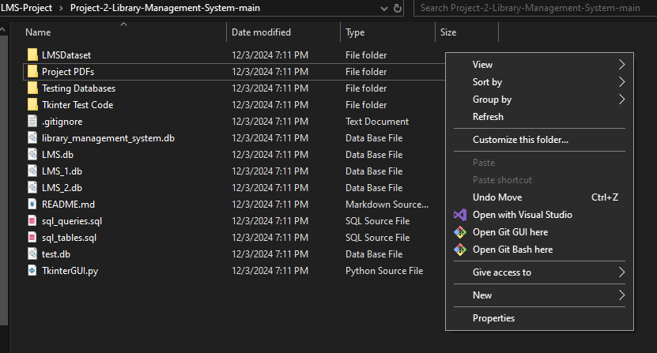

1. A window will pop up like this and the boxed area is the location of the folder:

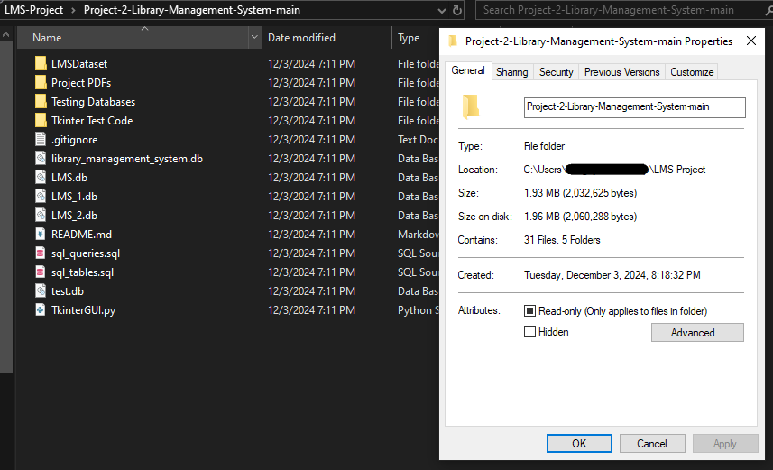

1. Now that you know the location of your folder open Powershell or cmd prompt and enter ‘cd C:\Users\Location-of-the-folder\LMS-Project\’
   1. Example: ‘cd C:\Users\JohnSmith\Desktop\LMS-Project\’
2. Now that you’ve redirected the terminal into the folder run a cd command once more:   
   ‘cd .\Project-2-Lobrary-Management-System-main\’
   1. To check if you’ve successfully entered into the correct folder run a ‘dir’ or ‘ls’ command and the output should look like this:

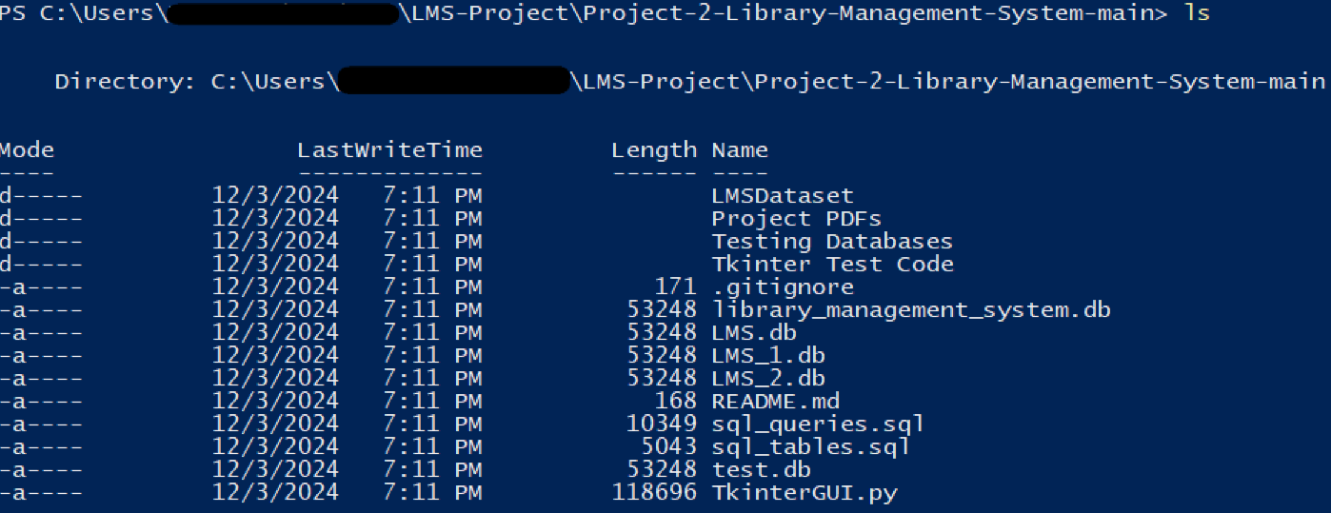

1. From here, run the following command to open the LMS application:  
   ‘python .\TkinterGUI.py’
2. If everything has been successful thus far, you should get the following output in the terminal and the application should now be open

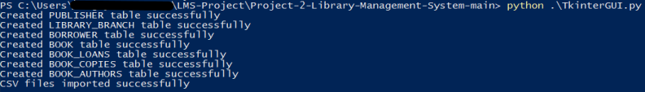

# Using the Application

From the previous step, the application should now be opened as follows: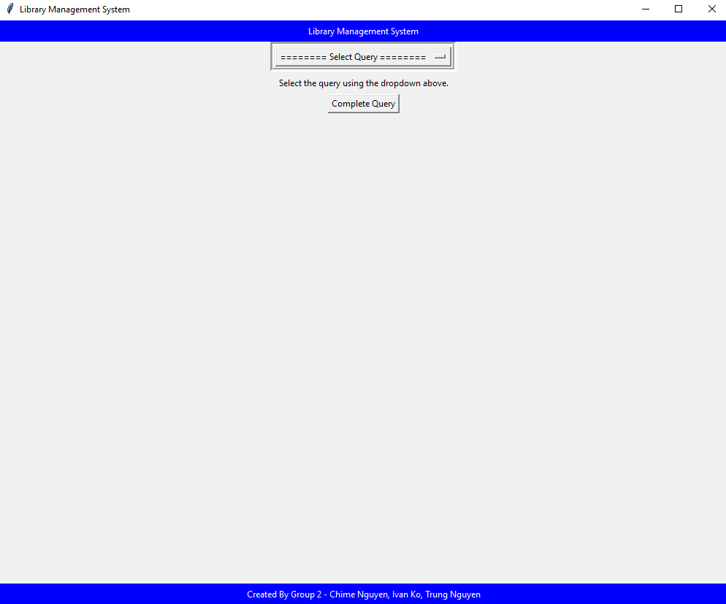

Click on the “Select Query” button at the top to open the dropdown menu. This button can be clicked at any time to change the query as well.

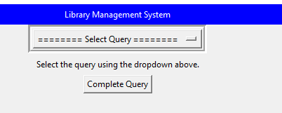

Once clicked, a menu with all queries can be seen. They are separated into their respective phases. The requirements for phase 3 are listed under the Requirements Header of the dropdown menu. Click on the query you want to run.

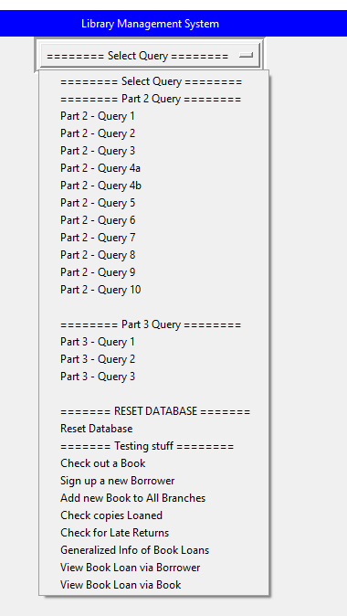

Below the dropdown menu button is a small description of what the query will accomplish. Some queries require input from the user. Type your input into each of the white boxes with respect to the wanted data shown to the left of the box.

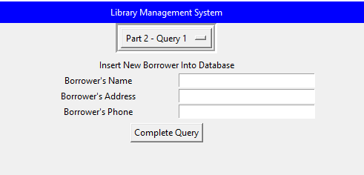

Wanted Data

Input Boxes

Description

After inputting your data, click the “Complete Query” button to run the query with your data.

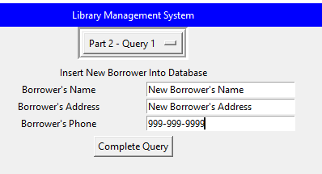

Note: All input box entries must be filled in unless otherwise stated. If a query does not state that some boxes may be left blank, and some boxes are left blank, then clicking the complete query button will not be able to execute the query. Upon entering the wrong data (e.g., entering the address into the phone entry), the function will be unable to execute the query.

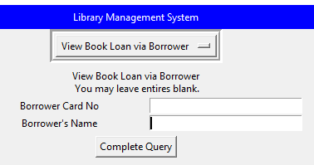

Some queries do not require input so clicking the “Complete Query” button will be the only thing you have to do.

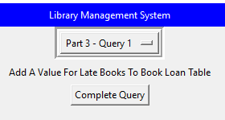

Once a query is completed, it will show the resulting table of the query.

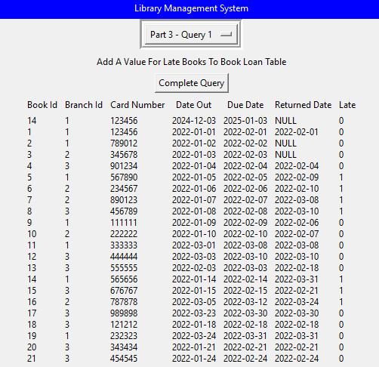

Re-click the dropdown menu button to continue using different queries

# Example Workflow

Example Workflow of using the Program

1. Selecting an Option from dropdown menu
   1. Select “View Book Loan via Book” from the options

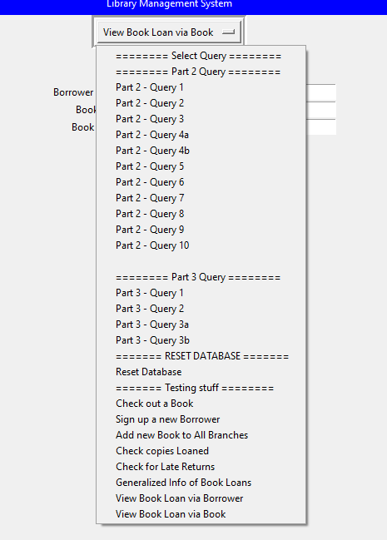

1. Entering Inputs
   1. Enter the borrower ID into the corresponding input field
   2. Optionally enter book ID or part of a book title to filter by

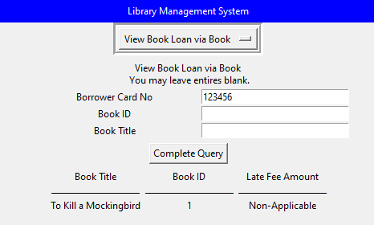

1. Running the Query
   1. Click on the “Complete Query” button
   2. The program will run the query and display the results into the GUI interface



1. Viewing the Results
   1. There will now be labels for Book titles, IDs, and any applicable late fees associated with the inputted borrower ID (e.g., “Book Title, “Book ID”, “Late Fee Amount”)
   2. Below these labels, you should see data (if any) retrieved from the database from your inputs