PROGRAMMING METHODOLOGY

CSF 101

ASSIGNMENT 1

Chhimi Zangmo

02240116

1ECE

Due date – 15/3/2015

**PART A**

1) Finding the sum of prime numbers between two ranges. (Sum of prime number calculator).

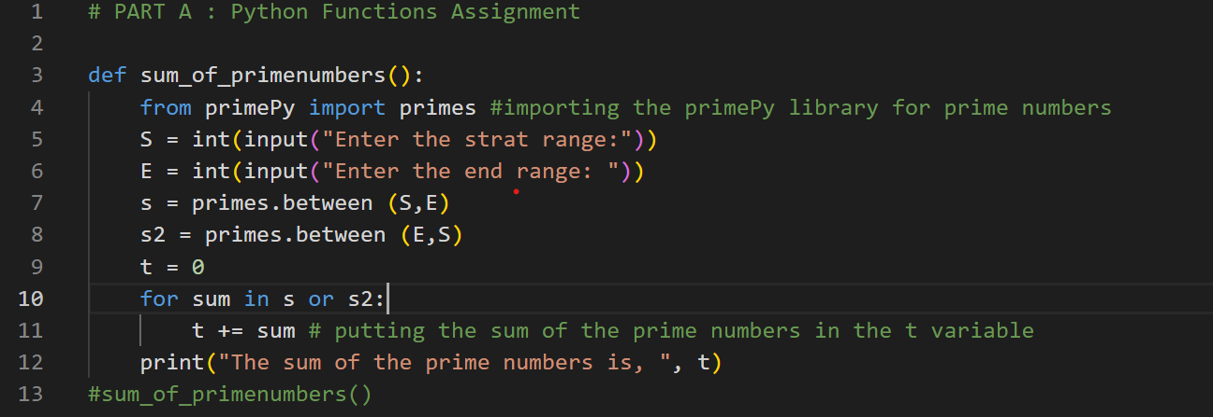

2) Length Unit Converter (Converting form meter to feet and feet to meter).

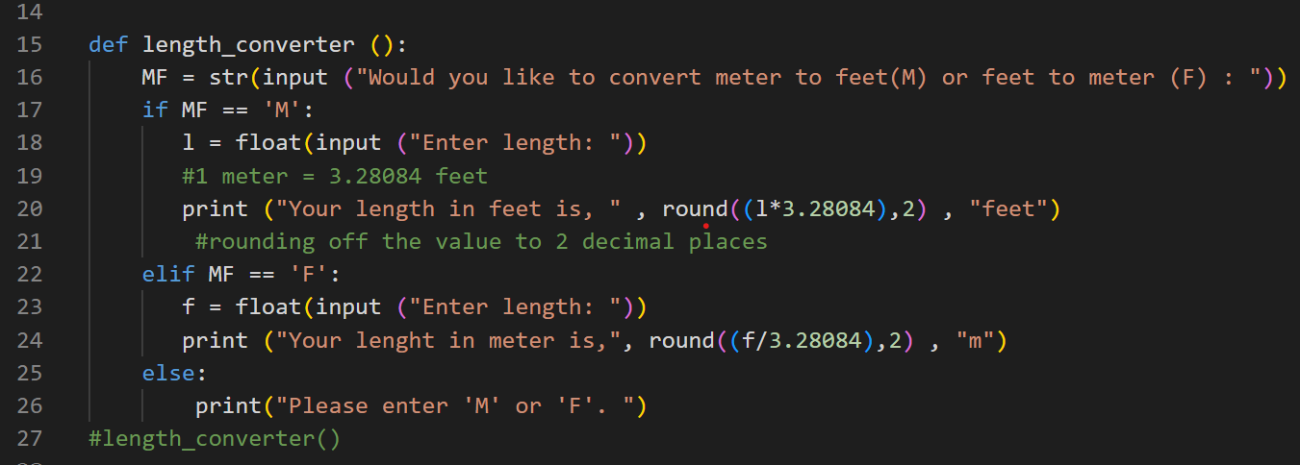

3) Consonant Counter (Counting the number of consonants present in a string)

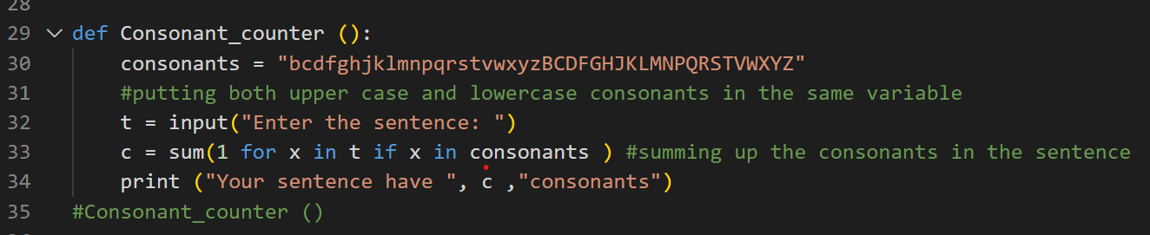

4) Min-Max Number Finder (Finding the largest and smallest number from a given set of numbers)

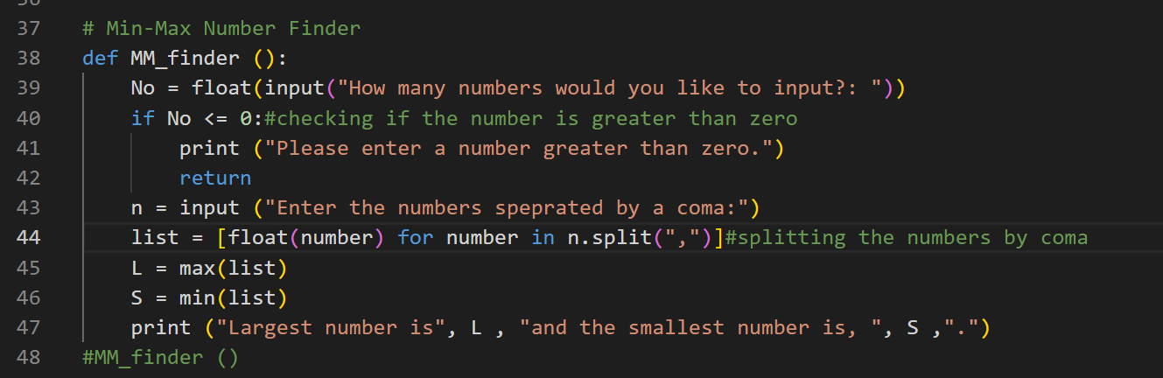

5) Palindrome Checker

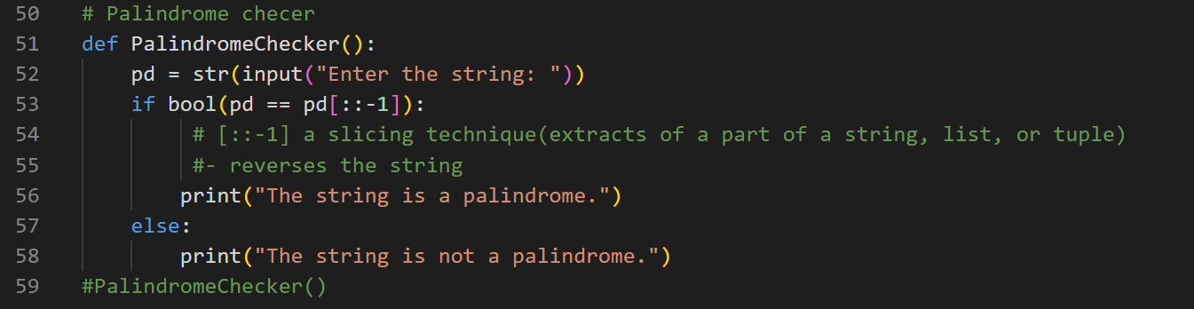

6) Word Counter

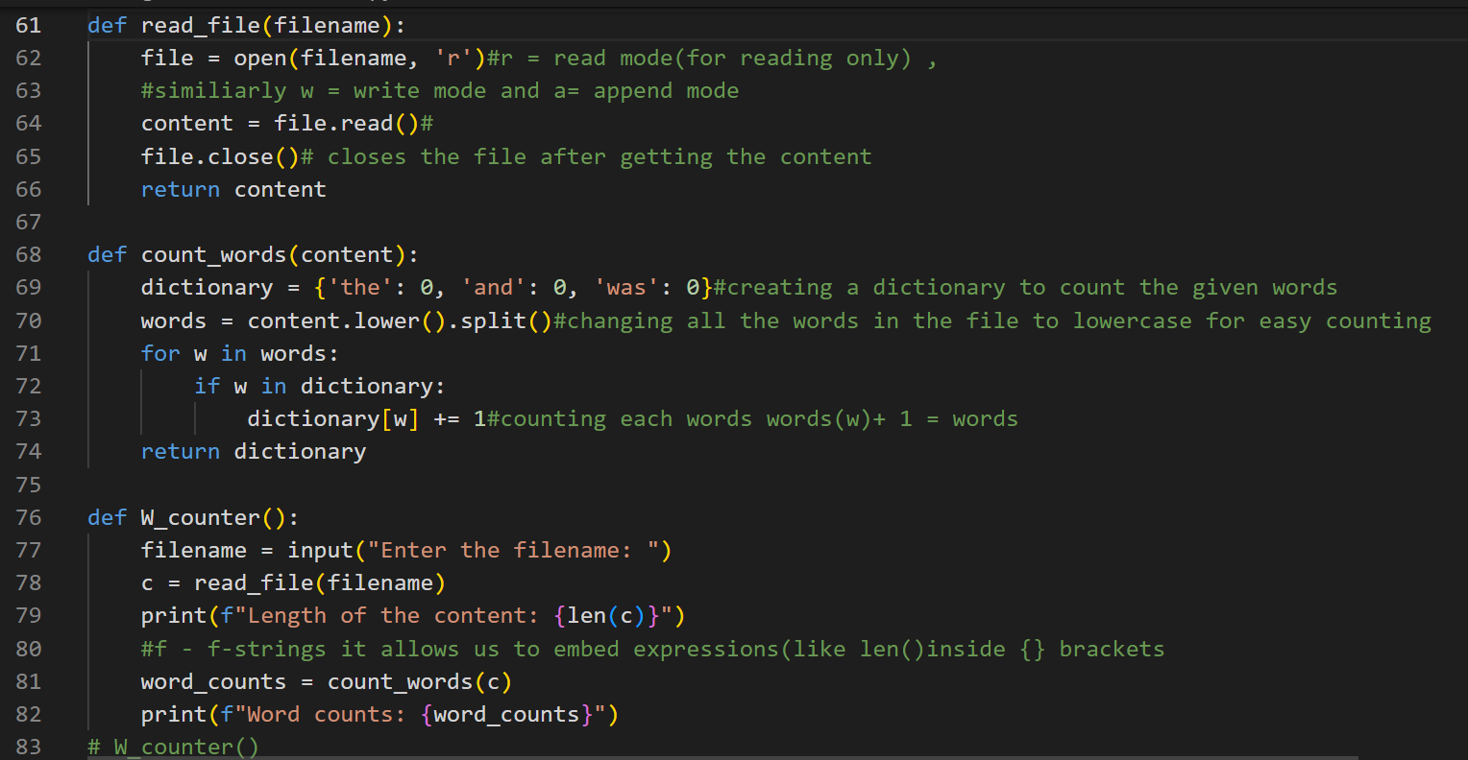

**Defining a menu.**

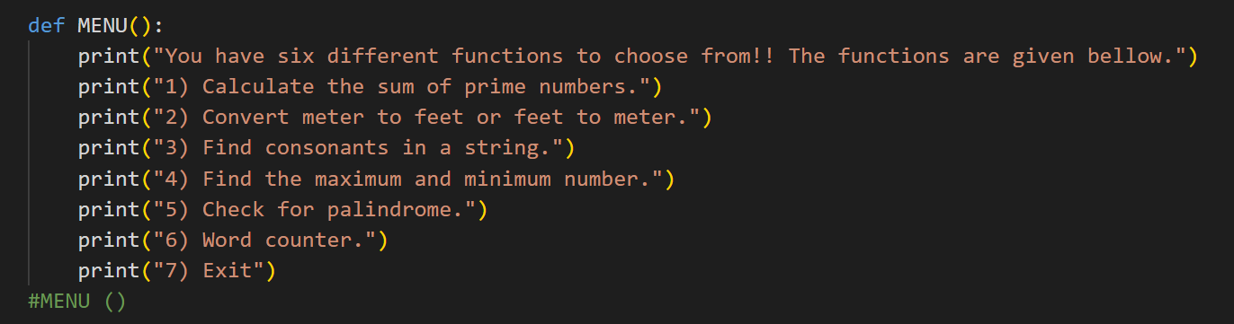

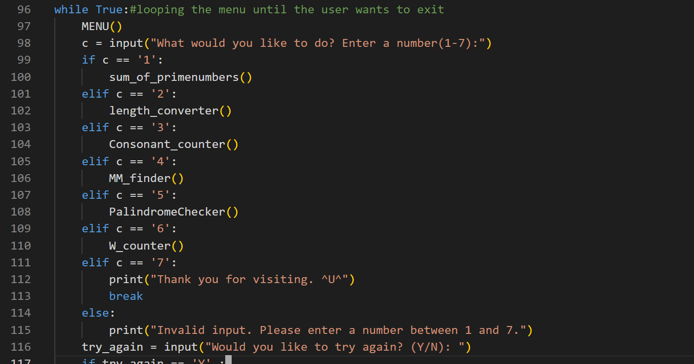

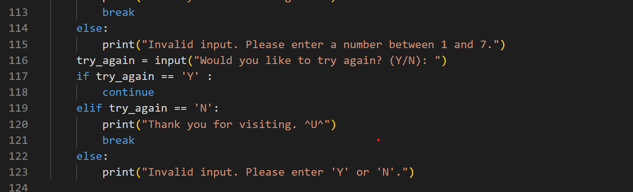

**Running the code (Result)**

Menu display..

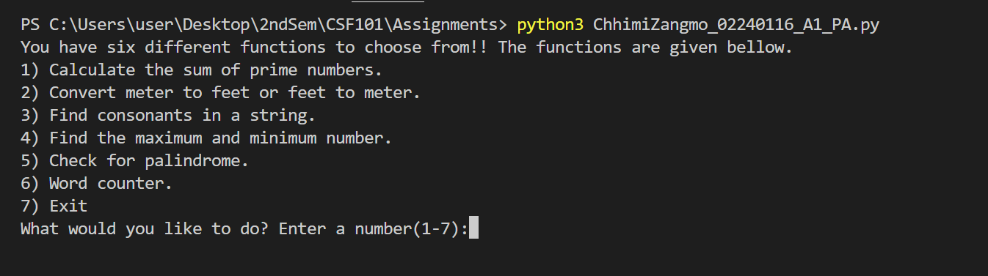

Running the first function (calculating the sum of prime numbers).

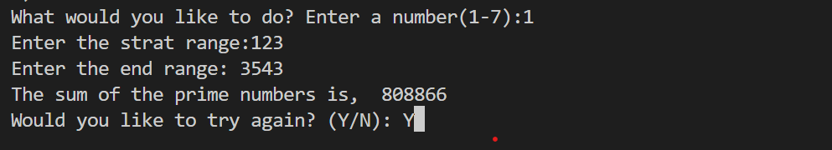

Running the second function (Converting units)

1. Converting Meter to Feet.

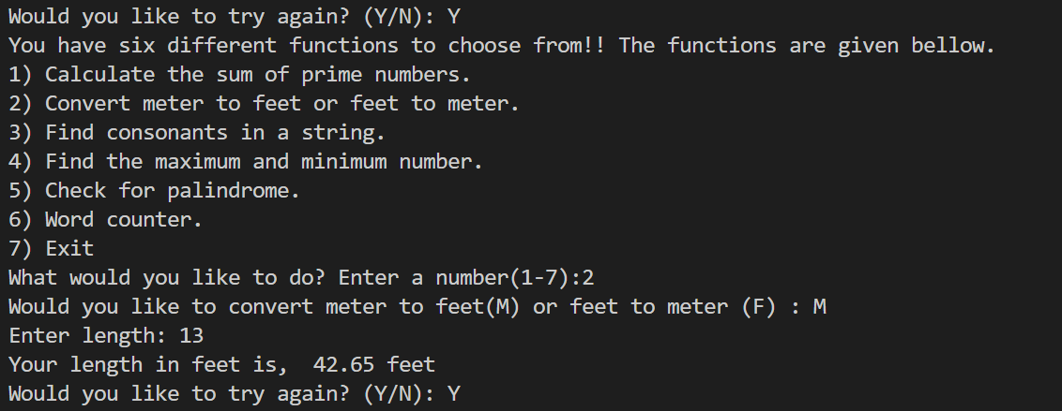

2. Converting Feet to Meter.

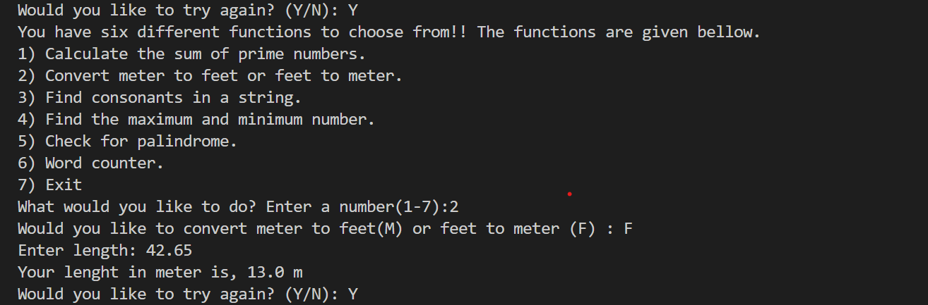

Running the third function (Consonant Counter)

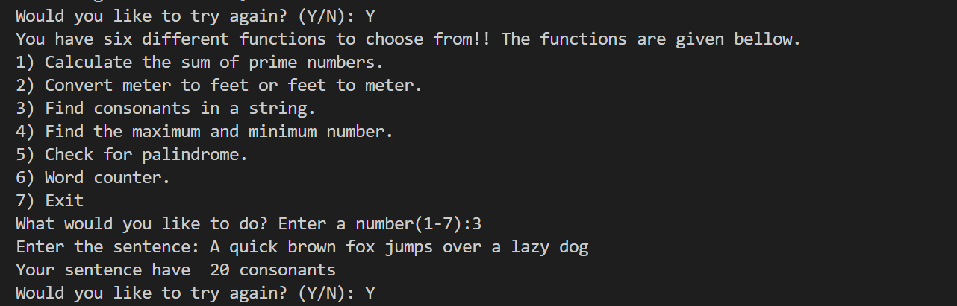

Running the fourth function (Finding maximum and minimum numbers)

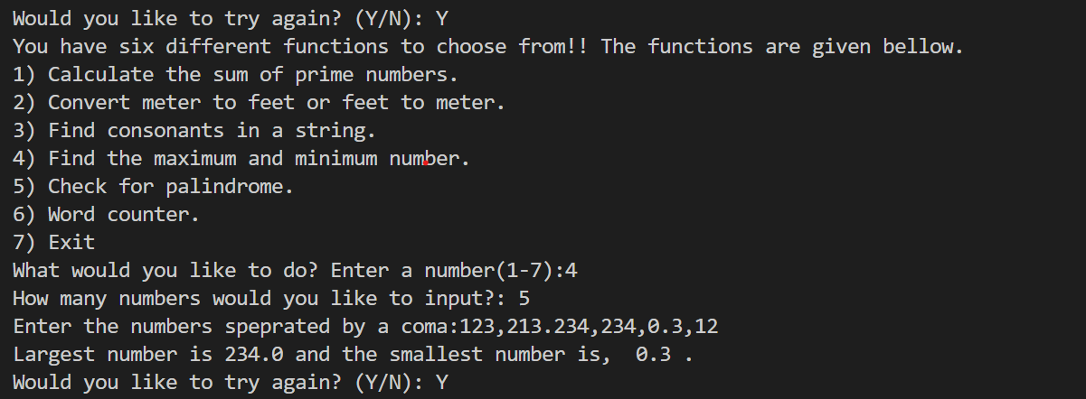

Fifth function (Palindrome checker)

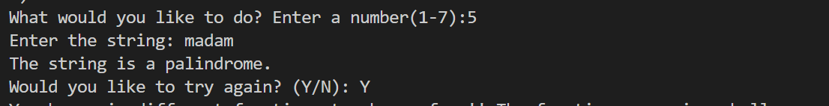

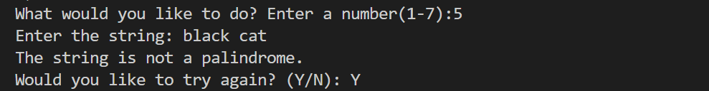

Sixth Function (Word Counter)

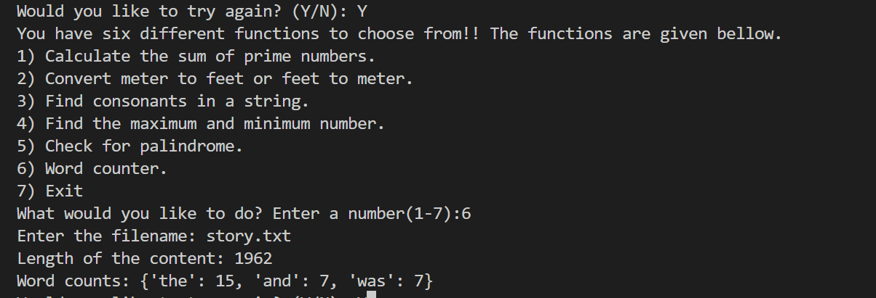

Exiting..

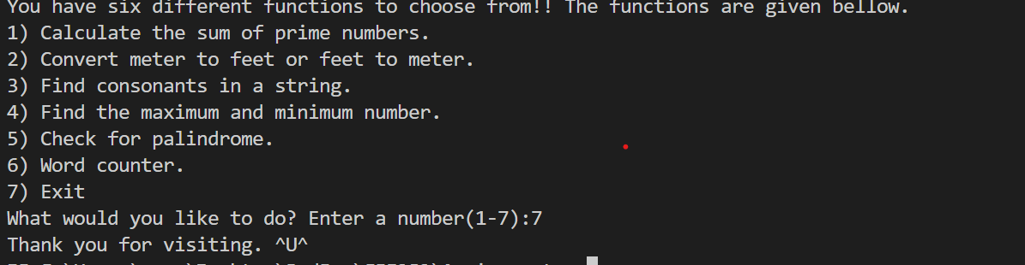

**PART B (GAMES)**

**Defining Menu**

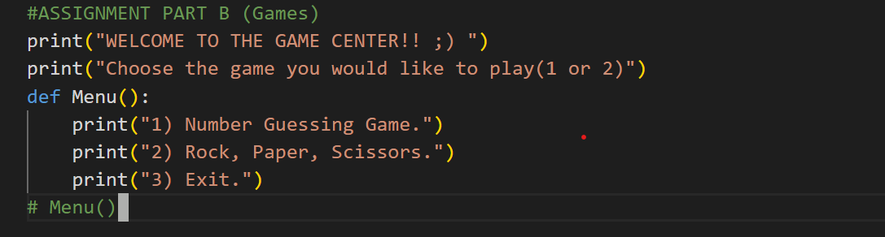

**1) Number Guessing Game**

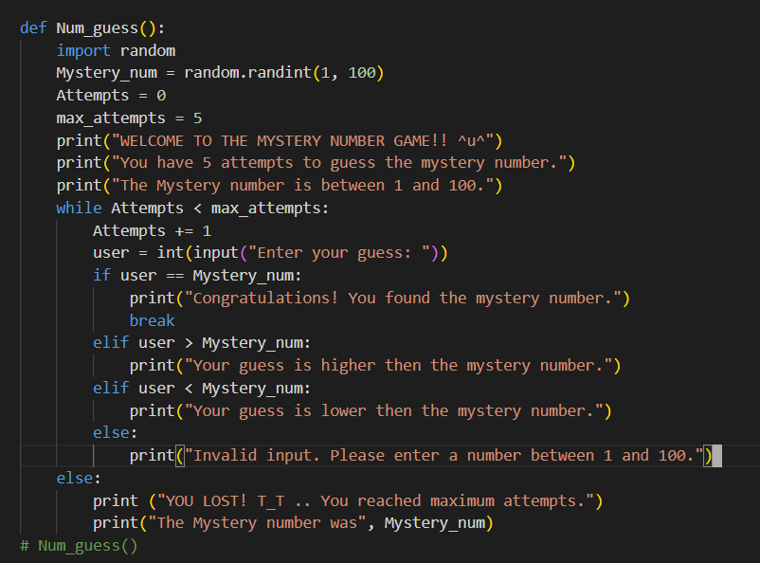

**2) Rock, Paper and Scissor**

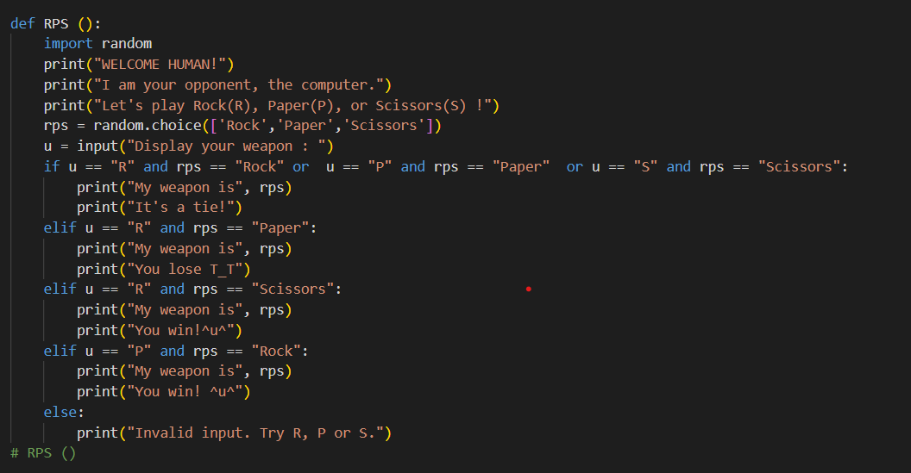

**Combining the Functions**

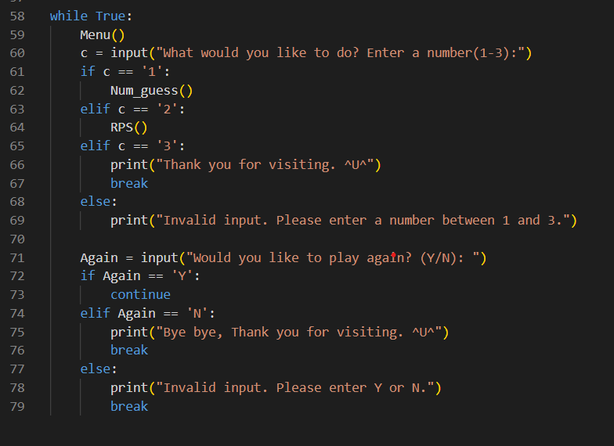

**Output**

**Menu display.**

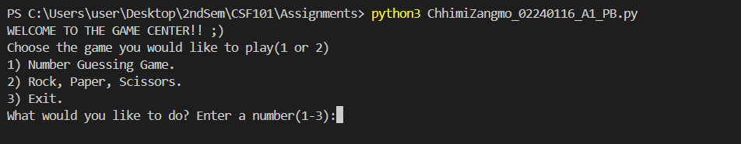

**Number guessing game output:**

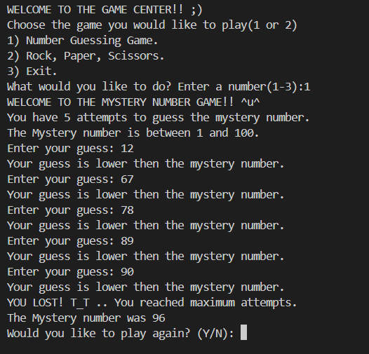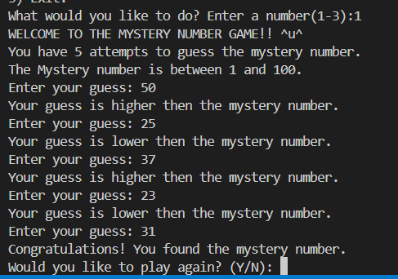

**Rock, Paper and Scissors game output:**

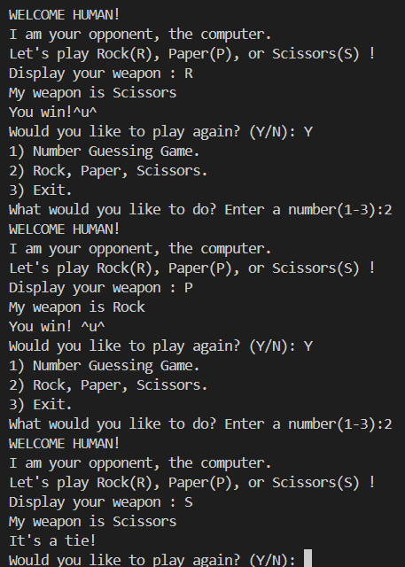

Exiting the game:

