GO-SLOW
A Nigerian Daily-Life Survival Sim
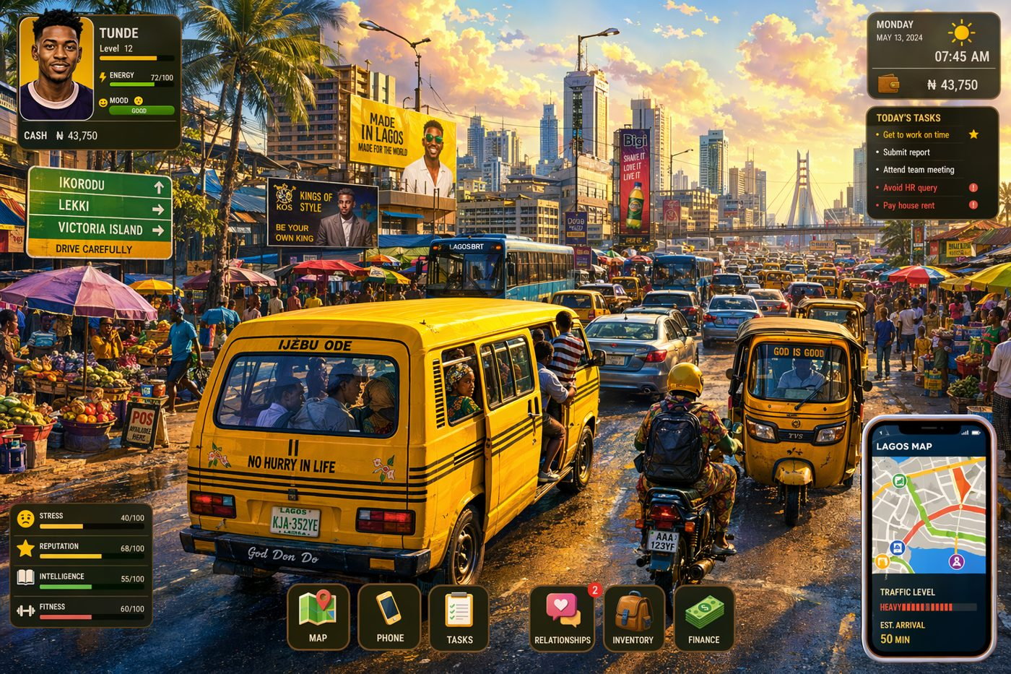
Game Design Document · v0.1
Prepared for Chiamaka Nwabulue · Built entirely with free tools (Godot 4)

Contents

1. Game Concept & Vision
The pitch. You are a young professional in Lagos trying to keep your job, your money, and your sanity through one brutal working month. Every morning is a gamble: beat the go-slow, survive the flood, dodge the HR query, keep the lights on. Between the chaos you build friendships, chase romance, and slowly uncover a quiet office scandal. Survive the month and you climb. Fall behind and you spiral.
Design pillars
- Relatable, not fantastical — every mechanic is a real Nigerian daily-life pressure (traffic, flooding, NEPA, fuel, landlord wahala).
- Every day is a fresh gamble — light roguelike randomness keeps mornings tense and replayable.
- Your relationships ARE the gameplay — people you befriend unlock clues, help, and story.
- Bright and warm — a cheerful danfo-yellow world, realistic human characters, gentle humour over doom.
At a glance
Field | Detail
Genre | Life simulation + light roguelike + social/mystery
Engine | Godot 4 (free, no royalties)
Platform | PC first (Windows/Linux/Mac); mobile later
View | 2D, screen-based, character portraits
Session length | One in-game day = 5–10 minutes; one 'run' = one month
Audience | 16+, players who love life sims and see themselves in the setting
Art direction | Bright, saturated colours; danfo yellow as the signature theme

2. Core Gameplay Loop
A run is one working month. Each day flows through five phases. Survive to month-end with your job intact and bills paid.
Phase | What happens | Key decision
1. Morning | Wake up. Check the weather, your fuel and your power status. | When do I leave? Earlier = safer but costs sleep/energy.
2. Commute | The signature mini-game. Pick transport, ride out random events. | Danfo, keke, okada, Bolt or your own car?
3. Work | Do tasks, please the oga, dodge queries, reach month-end salary. | Hustle for a bonus or coast to save energy?
4. Evening | Home life: light or NEPA, cook, rest, socialise, romance. | Run the gen (spend) or manage in the dark (save)?
5. Night | Pay any bills, bank your progress, sleep, roll tomorrow's weather. | Sleep early (energy) or grind a side hustle (money)?
Win & lose conditions
- WIN the month: reach payday still employed and with rent covered — unlock promotions, a better area, maybe a car.
- LOSE the run: collect 3 HR queries (sacked), or miss rent (evicted). A loss is a setback/restart, told with humour, not a hard fail.

3. Game Systems
3.1 Time & Energy
A clock drives every day. Actions cost minutes; some cost Energy. Energy caps what you can do — run out and you make mistakes (oversleep, snap at your oga). Sleep restores it; stress drains it.
- Clock: the morning runs on real in-game minutes; being at your desk after 8:00 AM triggers lateness.
- Energy: 0–100. Spent on commuting in the rain, overtime, and side hustles; restored by sleep and good meals.
3.2 The Commute System (your signature mechanic)
Each morning you choose how to travel. Every option trades cost against speed and risk. Then the road rolls a random event (see the event tables).
Option | Cost | Speed | Risk | Notes
Trek / walk | Free | Very slow | Low | Only works if you live close; costs Energy
Danfo / BRT | Low | Medium | Medium | Conductor wahala, 'no change', packed
Keke napep | Low-mid | Medium | Medium | Nimble in traffic, exposed to rain
Okada | Mid | Fast | High | Beats go-slow but accident risk, esp. wet roads
Bolt / Uber | High | Fast | Low | Reliable but eats your salary
Own car | Fuel + upkeep | Slow in hold-up | Medium | Comfort & status; stuck in go-slow and floods
3.3 HR, Queries & Job Security
Punctuality and performance feed a hidden standing score. Lateness earns a query letter; three queries and you are sacked.
- Arrive after 8:00 AM → an HR query (strike). Queries show as three warning pips.
- Good work, covering for colleagues, and pleasing the oga can clear a query or earn goodwill.
- Standing affects promotion chances at month-end.
3.4 Economy & Money
Salary lands once a month; expenses bleed every day. The squeeze is the game.
- Income: monthly salary, occasional bonus, optional side hustle at night.
- Daily outflow: transport, fuel, generator diesel, food, data/airtime.
- Big shocks: annual rent, black tax (family requests), sudden owambe you must attend.
3.5 Housing & Landlord Wahala
At the start of a run you choose where to live. Rent is paid a full year up front (as in real Nigeria), and the floor you pick changes how the rainy season treats you.
Floor | Rent | Rainy-season effect | Verdict
Ground floor | Cheapest | FLOODS. Water enters the flat, ruins items, blocks your exit (miss work), raises malaria risk. | Risky — save money, pay in wahala
Middle floor | Moderate | Just right. Dry and safe through the rains. | The safe pick
Top / penthouse | Priciest, status | ROOF LEAKS. Buckets everywhere, damaged ceiling, repair costs — and the landlord ignores you. | Prestige, but slow-bleed damage
Landlord wahala. Independent of the floor, the landlord can spring surprise rent hikes, agent/'caution' fees, lock the gate over a dispute, or serve a quit notice — random pressure events that force money and social decisions.
3.6 Weather & Seasons
The calendar swings between two seasons that reskin the risk tables.
- Rainy season: frequent rain days spike flooding and go-slow; ground-floor flats flood, top-floor roofs leak.
- Dry season / harmattan: hot, dusty, hazy; lower flood risk but higher water/health costs and fuel demand.
3.7 Power (NEPA) & Fuel
Light is never guaranteed. When NEPA 'takes light', you either sit in darkness or burn money running the gen.
- Power status rolls daily: light / no light. No light + gen = spend on diesel; no gen = evening actions limited.
- Fuel scarcity weeks: queues at the station cost time (and can make you late) or money for black-market fuel.
3.8 Relationships & Romance
A small cast of adult characters (colleagues, a friend, love interests) each has a personality, a schedule and a relationship meter. Dialogue choices deepen or damage bonds.
- Spend limited evening time with people to raise affinity.
- Higher affinity unlocks help (a lift to work, a loan, cover at the office) and story beats.
- Romance is tasteful and character-driven — connection and story, never explicit.
3.9 Mystery & Clues (the hook)
Under the daily grind runs a quiet office scandal — say, missing departmental funds. You gather clues by being in the right place and earning people's trust, then piece them together on an evidence board.
- Clues drop from conversations, overheard gossip, and documents you happen upon.
- An evidence-board UI lets you link clues and form theories.
- Crucially, dating and befriending people is HOW you unlock clues — the two systems feed each other.
3.10 Stats & Progression
- Core stats: Charm, Intellect, Fitness — grown through activities, gating options and outcomes.
- Progression across runs: promotions, moving closer to work, buying a car, upgrading your life.

4. Daily Event Tables
Each phase draws from a weighted table. Roll a d10 (or use weighted random). These are starter values — tune them as you playtest. Rainy season shifts weight toward flood/traffic events.
4.1 Commute events (roll d10)
Roll | Event | Effect
1 | Free flow — the road is clear | Arrive early: +5 Energy, small mood boost
2–3 | Go-slow on the bridge | +20–40 mins travel time
4 | Flooded road, forced detour | +30 mins and a small extra cost (rainy season only)
5 | Fuel queue | Car/okada: +25 mins or pay black-market premium
6 | Danfo conductor 'no change' | Lose a little money or argue (mood/time)
7 | Police checkpoint | +10 mins; small chance of a 'settlement' cost
8 | Okada near-miss | -10 Energy; higher chance on wet roads
9 | Pickpocket in the hold-up | Lose a small amount of cash
10 | Breakdown / conductor drops you midway | Big time loss; may cause lateness
4.2 Work events (roll d10)
Roll | Event | Effect
1 | Quiet day | Bank a little Energy
2–3 | Deadline task | Intellect check → praise or pressure
4 | Oga calls a sudden meeting | Costs time; chance to impress
5 | Colleague gossip | Drops a CLUE
6 | Office power cut | Work stalls; mood dip
7 | Cover for a colleague | -Energy, +affinity and goodwill
8 | Overtime offered | -Energy, +money
9 | Praise / small bonus | +money, +standing (if performing well)
10 | Query issued | Strike (usually from lateness)
4.3 Home & evening events (roll d10)
Roll | Event | Effect
1 | Peaceful evening | +Energy, choose an activity freely
2–3 | NEPA takes light | Run gen (spend diesel) or limited evening
4 | Ground-floor flood | Lose items, possible missed morning (rainy season, ground floor)
5 | Roof leak | Repair cost, mood dip (rainy season, top floor)
6 | Landlord visit / rent hike | Money & social decision
7 | Family calls for money (black tax) | Give (−money, +family bond) or decline (guilt)
8 | Neighbour owambe next door | Noise: −rest, or join for +affinity
9 | You cook a great meal | +Energy, +mood
10 | Data/airtime finished | Side hustle blocked until you buy more

5. Character List
A tight, memorable cast. Each is an adult with a clear personality and a story hook. Portraits are rendered as realistic 2D images (see Section 8).

Sample character portrait — the realistic 2D style for the cast
Character | Role | Personality & story hook
You (the player) | New-ish staff, SME desk | Customisable name/look; the person trying to survive the month
Oga / Line Manager | Your boss | Demanding but fair; pleasing them clears goodwill, crossing them risks queries
Mrs. HR | HR officer | Issues the queries; also a soft heart if you earn her trust — a clue source
Chidi | Desk-mate & friend | Warm, gossipy, always broke; your easiest ally and comic relief
Ada / Tunde | Love interest(s) | Two contrasting romance paths; their trust unlocks key clues
The Landlord | Your landlord | Source of housing wahala — hikes, gate locks, quit notices
Conductor Baba | Danfo conductor | Recurring road character; small favours and 'no change' standoffs
The Auditor | Mystery figure | Ties to the missing-funds scandal at the heart of the story

6. Art Direction & UI
Bright, warm, saturated. Danfo yellow is the signature colour, paired with black stripes (a nod to the buses) and a few punchy accents. Realistic human portraits sit against clean, colourful UI panels.
Core palette
Colour | Hex | Used for
Danfo Yellow | #F7C948 | Primary theme, headers, key buttons
Danfo Black | #1A1A1A | Stripes, text, outlines
Hot Orange | #E8590C | Highlights, alerts, the logo
Go Green | #16A34A | Positive outcomes, money gained
Stop Red | #DC2626 | Queries, danger, money lost
Sky Blue | #2563EB | Info, calm, water/rain motifs
Warm White | #FFFDF5 | Panels and cards
UI notes
- Top status bar always visible: day/date, clock, ₦ balance, Energy bar, query pips.
- Big, tappable choice cards (great for a later mobile port).
- Event pop-ups slide in with a bold headline and a clear effect line.

7. Screen-by-Screen Build Order
Golden rule: stay playable. Build in this order so you always have a game you can run and test. Each milestone adds one system on top of a working base.
Milestone | Goal | Key Godot pieces
M0 — Skeleton | Project set up; a global game state that tracks day, time, money, energy. | Autoload singleton (GameState.gd); main scene
M1 — Morning screen | Show the clock and let the player choose when to leave. | Control UI nodes, Labels, Buttons
M2 — Commute (core) | Pick transport; roll a random event; advance the clock. | RandomNumberGenerator, weighted event table, scene swap
M3 — Work & queries | Arrive on time or get a query; three queries = sacked. | Signals, a Queries counter, game-over screen
M4 — Economy | Daily costs vs monthly salary; survive the month. | GameState money, month-end payday event
M5 — Housing & weather | Choose a floor; rainy season floods/leaks accordingly. | Season state, housing variable, conditional events
M6 — NEPA & fuel | Daily power/fuel rolls that cost time or money. | More weighted rolls into the evening phase
M7 — Relationships | A small cast, affinity meters, dialogue choices. | Dialogic plugin, character resources
M8 — Mystery board | Collect clues; link them on an evidence board. | Clue resources, a board UI scene
M9 — Art & polish | Real portraits, sound, save/load, balancing. | MakeHuman art, Resources for save, audio

8. How to Make Your First Realistic Character (Free)
This pipeline gives you genuinely realistic, human-like characters without any paid software and without fighting live 3D animation. You build a 3D human once, then render still portraits for the game.
Step by step
- 1. MakeHuman (free): create a realistic human — adjust face, body, skin tone, hair and clothes. Export as .obj or .fbx.
- 2. Blender (free): import the model. Set up a simple 3-point light and a neutral background.
- 3. Pose expressions: pose the face/body for each mood you need — neutral, happy, worried, angry.
- 4. Render: render each expression to a PNG image (this is your portrait sheet).
- 5. GIMP or Krita (free): crop to a clean head-and-shoulders frame, tidy edges, match sizes.
- 6. Godot / Dialogic: drop the portraits in and swap expressions during dialogue.
Why stills, not live 3D? Pre-rendered 2D portraits look far more polished than a solo-made real-time 3D human, dodge the 'uncanny valley', and cost a fraction of the effort — perfect for a portrait-driven life sim.

9. Free Toolkit & Godot Node Map
Everything you need — all free
Job | Free tool
Game engine | Godot 4 — free, open-source, no royalties
Realistic humans | MakeHuman (game-safe CC0 output)
Posing / rendering / touch-up | Blender
Dialogue & story | Dialogic plugin for Godot
Image editing / portraits | GIMP or Krita
Animations (if 3D) | Mixamo (free auto-rig + humanoid clips)
Sound & music | Audacity + freesound.org, OpenGameArt, Kenney.nl
System → Godot mapping
System | Godot node / feature
Time, money, energy, job status | Autoload singleton (GameState.gd)
Home / road / office screens | Separate scenes; TileMap or background art
Commute events & HR scenes | Dialogic + RandomNumberGenerator + weighted tables
Dashboard (clock, ₦, energy, pips) | Control nodes (Label, ProgressBar, TextureRect)
Save / load your progress | Godot Resources (.tres)
Random daily events | RandomNumberGenerator with weighted arrays
Realistic character portraits | TextureRect fed by MakeHuman → Blender renders

Now go build it. One playable milestone at a time. 🚌

