Econ123_Final_Code
Kim Her
2022-12-06
Set up the workspace:
library(readr)
## Warning: package 'readr' was built under R version 4.2.2
test <- read_csv("Econ123_projdata.csv")
## Rows: 100 Columns: 14
## ── Column specification ────────────────────────────────────────────────────────
## Delimiter: ","
## chr (1): state
## dbl (13): math, reading, comp, year1, income, year2, white, black, latin, ho...
##
## ℹ Use `spec()` to retrieve the full column specification for this data.
## ℹ Specify the column types or set `show_col_types = FALSE` to quiet this message.
View(test)
options(scipen = 999)

Summary Statistics of Relevant Variables
library(psych)
## Warning: package 'psych' was built under R version 4.2.2
names(test)
## [1] "state" "math" "reading" "comp" "year1"
## [6] "income" "year2" "white" "black" "latin"
## [11] "home" "highgrad" "collegegrad" "poverty"
describe(test$comp)
## vars n mean sd median trimmed mad min max range skew kurtosis se
## X1 1 100 545.22 11.87 547 545.54 11.86 516 573 57 -0.26 -0.49 1.19
describe(test$income)
## vars n mean sd median trimmed mad min max range skew
## X1 1 100 68210.08 11997.08 66323.5 67562.26 12602.84 44404 101283 56879 0.43
## kurtosis se
## X1 -0.37 1199.71
describe(test$home)
## vars n mean sd median trimmed mad min max range skew kurtosis se
## X1 1 100 67.81 4.72 68.3 68.21 3.93 54.1 79 24.9 -0.8 0.88 0.47
describe(test$highgrad)
## vars n mean sd median trimmed mad min max range skew kurtosis se
## X1 1 100 88.51 3.65 88.95 88.76 3.34 76.6 96.5 19.9 -0.64 0.14 0.36
describe(test$black)
## vars n mean sd median trimmed mad min max range skew kurtosis se
## X1 1 100 10.72 9.55 7.75 9.31 8.45 0.4 38 37.6 1.08 0.3 0.95
describe(test$latin)
## vars n mean sd median trimmed mad min max range skew kurtosis se
## X1 1 100 15.47 17.53 9.1 11.61 6.97 1.2 92.5 91.3 2.31 5.45 1.75

Relevent Plots
Effect of Income on Test Score
plot(test$income,test$comp, xlab = "Real Median Income", ylab = "NAEP Test Score", main = "Effect of Income on Test Score", col="violet", pch=20)
ols1 <- lm(test$comp~test$income)
abline(ols1)
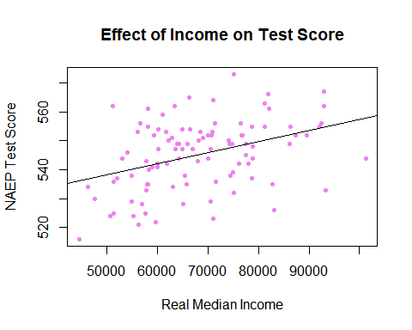 Effect of Race on Education
plot(test$black,test$comp, xlab = "Percentage of Population (Black)", ylab = "NAEP Test Score", main = "Effect of Race on Test Score", col="green", pch=20)
ols3 <- lm(test$comp~test$black)
abline(ols3)
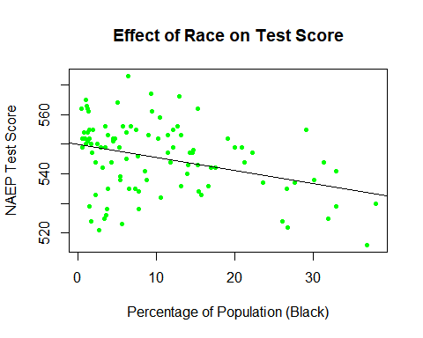
plot(test$white,test$comp, xlab = "Percentage of Population (Latino/Hispanic)", ylab = "NAEP Test Score", main = "Effect of Race on Test Score", col="blue", pch=20)
ols4 <- lm(test$comp~test$latin)
abline(ols4)
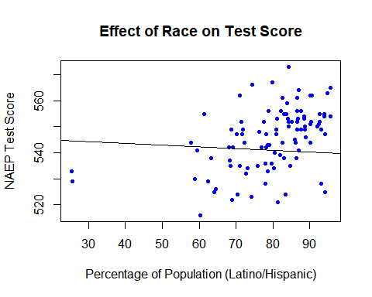 Effect of Community Educational Achievement on Test Score
plot(test$highgrad,test$comp, xlab = "Percentage of Population (High School Graduates)", ylab = "NAEP Test Score", main = "Effect of Community Educational Achievement on Test Score", col="red", pch=10)
ols5 <- lm(test$comp~test$highgrad)
abline(ols5)
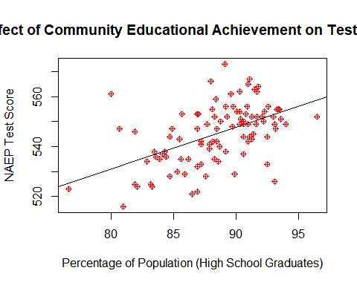
Effect of Housing Stability on Test Scores
plot(test$home,test$comp, xlab = "Percentage of Population (Homeowners)", ylab = "NAEP Test Score", main = "Effect of Homeownership on Test Score", col="violet", pch=15)
ols7 <- lm(test$comp~test$home)
abline(ols7)
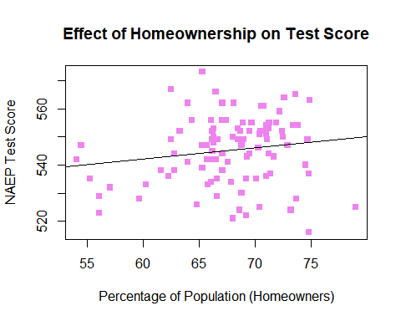

Model Testing
Test Scorei = β0 + β1 Incomei + εi
olsi <- lm(test$comp~test$income)
summary(olsi)
##
## Call:
## lm(formula = test$comp ~ test$income)
##
## Residuals:
## Min 1Q Median 3Q Max
## -24.9439 -7.0446 0.7379 6.8654 25.1054
##
## Coefficients:
## Estimate Std. Error t value Pr(>|t|)
## (Intercept) 518.96213614 6.37457312 81.411 < 0.0000000000000002 ***
## test$income 0.00038496 0.00009206 4.182 0.000063 ***
## ---
## Signif. codes: 0 '***' 0.001 '**' 0.01 '*' 0.05 '.' 0.1 ' ' 1
##
## Residual standard error: 10.99 on 98 degrees of freedom
## Multiple R-squared: 0.1514, Adjusted R-squared: 0.1428
## F-statistic: 17.49 on 1 and 98 DF, p-value: 0.00006301
Test Scorei = β0 + β1 Incomei + β2 Homei+ β3 Blacki + β4 Latini + β5 Highi + εi
olsit <- lm(test$comp~test$income+test$home+test$black+test$latin+test$highgrad)
summary(olsit)
##
## Call:
## lm(formula = test$comp ~ test$income + test$home + test$black +
## test$latin + test$highgrad)
##
## Residuals:
## Min 1Q Median 3Q Max
## -28.2991 -6.1192 -0.8886 5.4601 24.9564
##
## Coefficients:
## Estimate Std. Error t value Pr(>|t|)
## (Intercept) 420.5728561 28.8761712 14.565 < 0.0000000000000002 ***
## test$income 0.0003141 0.0001091 2.880 0.00493 **
## test$home 0.5393308 0.2334620 2.310 0.02307 *
## test$black -0.2436331 0.1112540 -2.190 0.03101 *
## test$latin -0.0802399 0.0586961 -1.367 0.17487
## test$highgrad 0.7965432 0.3553960 2.241 0.02736 *
## ---
## Signif. codes: 0 '***' 0.001 '**' 0.01 '*' 0.05 '.' 0.1 ' ' 1
##
## Residual standard error: 9.71 on 94 degrees of freedom
## Multiple R-squared: 0.3644, Adjusted R-squared: 0.3306
## F-statistic: 10.78 on 5 and 94 DF, p-value: 0.0000000328

Multicollinearity Testing
library(car)
## Warning: package 'car' was built under R version 4.2.2
## Loading required package: carData
## Warning: package 'carData' was built under R version 4.2.2
##
## Attaching package: 'car'
## The following object is masked from 'package:psych':
##
## logit
vif(olsit)
## test$income test$home test$black test$latin test$highgrad
## 1.798027 1.276976 1.184269 1.112215 1.764524
(mean(vif(olsit)))
## [1] 1.427202

F-Test
Unrestricted Model:
Test Scorei = β0 + β1 Incomei + β2 Homei+ β3 Blacki + β4 Latini + β5 Highi + εi
summary(olsit)
##
## Call:
## lm(formula = test$comp ~ test$income + test$home + test$black +
## test$latin + test$highgrad)
##
## Residuals:
## Min 1Q Median 3Q Max
## -28.2991 -6.1192 -0.8886 5.4601 24.9564
##
## Coefficients:
## Estimate Std. Error t value Pr(>|t|)
## (Intercept) 420.5728561 28.8761712 14.565 < 0.0000000000000002 ***
## test$income 0.0003141 0.0001091 2.880 0.00493 **
## test$home 0.5393308 0.2334620 2.310 0.02307 *
## test$black -0.2436331 0.1112540 -2.190 0.03101 *
## test$latin -0.0802399 0.0586961 -1.367 0.17487
## test$highgrad 0.7965432 0.3553960 2.241 0.02736 *
## ---
## Signif. codes: 0 '***' 0.001 '**' 0.01 '*' 0.05 '.' 0.1 ' ' 1
##
## Residual standard error: 9.71 on 94 degrees of freedom
## Multiple R-squared: 0.3644, Adjusted R-squared: 0.3306
## F-statistic: 10.78 on 5 and 94 DF, p-value: 0.0000000328
Restircted Model: Case 1: B1=B2=0
Test Scorei = β0 + β3 Blacki + β4 Latini + β5 Highi + εi
olsf1 <- lm(test$comp~test$black+test$latin+test$highgrad)
summary(olsf1)
##
## Call:
## lm(formula = test$comp ~ test$black + test$latin + test$highgrad)
##
## Residuals:
## Min 1Q Median 3Q Max
## -27.8255 -5.8854 0.0129 5.6561 27.4982
##
## Coefficients:
## Estimate Std. Error t value Pr(>|t|)
## (Intercept) 422.59714 27.30350 15.478 < 0.0000000000000002 ***
## test$black -0.23031 0.11533 -1.997 0.0487 *
## test$latin -0.05432 0.05793 -0.938 0.3508
## test$highgrad 1.42282 0.30205 4.711 0.00000833 ***
## ---
## Signif. codes: 0 '***' 0.001 '**' 0.01 '*' 0.05 '.' 0.1 ' ' 1
##
## Residual standard error: 10.1 on 96 degrees of freedom
## Multiple R-squared: 0.2979, Adjusted R-squared: 0.2759
## F-statistic: 13.58 on 3 and 96 DF, p-value: 0.0000001868
((0.3644-0.2979)/2)/((1-0.3644)/94)
## [1] 4.917401
qf(1-0.05,2,94)
## [1] 3.093266
Case 2: B1=B2 Test Scorei = β0 + β1 (Incomei + Homei)+ β3 Blacki + β4 Latini + β5 Highi + εi
test$mincome <- mean(test$income)
test$mhome <- mean(test$home)
test$inchom <- (test$income-test$mincome)+(test$home-test$mhome)
olsf2 <- lm(test$comp~test$inchom+test$black+test$latin+test$highgrad)
summary(olsf2)
##
## Call:
## lm(formula = test$comp ~ test$inchom + test$black + test$latin +
## test$highgrad)
##
## Residuals:
## Min 1Q Median 3Q Max
## -29.5792 -6.5577 -0.3235 5.8054 24.1727
##
## Coefficients:
## Estimate Std. Error t value Pr(>|t|)
## (Intercept) 454.8973544 31.0219342 14.664 < 0.0000000000000002 ***
## test$inchom 0.0002117 0.0001019 2.077 0.04047 *
## test$black -0.2240228 0.1134307 -1.975 0.05117 .
## test$latin -0.0920925 0.0597897 -1.540 0.12682
## test$highgrad 1.0637229 0.3436125 3.096 0.00258 **
## ---
## Signif. codes: 0 '***' 0.001 '**' 0.01 '*' 0.05 '.' 0.1 ' ' 1
##
## Residual standard error: 9.929 on 95 degrees of freedom
## Multiple R-squared: 0.3284, Adjusted R-squared: 0.3001
## F-statistic: 11.61 on 4 and 95 DF, p-value: 0.0000001019
(0.3644-0.3284)/((1-0.3644)/94)
## [1] 5.324103
qf(1-0.05,1,94)
## [1] 3.942303

Adjusted Model
Test Scorei = β0 + β1 Incomei + β2 Blacki + β3 Latini + β4 Highi + εi
olsa <- lm(test$comp~test$income+test$black+test$latin+test$highgrad)
summary(olsa)
##
## Call:
## lm(formula = test$comp ~ test$income + test$black + test$latin +
## test$highgrad)
##
## Residuals:
## Min 1Q Median 3Q Max
## -29.5789 -6.5574 -0.3227 5.8063 24.1731
##
## Coefficients:
## Estimate Std. Error t value Pr(>|t|)
## (Intercept) 440.4455684 28.1872125 15.626 < 0.0000000000000002 ***
## test$income 0.0002115 0.0001019 2.076 0.04056 *
## test$black -0.2240180 0.1134332 -1.975 0.05118 .
## test$latin -0.0920796 0.0597916 -1.540 0.12688
## test$highgrad 1.0639944 0.3435944 3.097 0.00257 **
## ---
## Signif. codes: 0 '***' 0.001 '**' 0.01 '*' 0.05 '.' 0.1 ' ' 1
##
## Residual standard error: 9.929 on 95 degrees of freedom
## Multiple R-squared: 0.3284, Adjusted R-squared: 0.3001
## F-statistic: 11.61 on 4 and 95 DF, p-value: 0.0000001021
Multicollinearity Test for Adjusted
library(car)
vif(olsa)
## test$income test$black test$latin test$highgrad
## 1.499806 1.177371 1.103735 1.577278
mean(vif(olsa))
## [1] 1.339548

