

Republic of the Philippines
UNIVERSITY OF ANTIQUE
Tario-Lim Memorial Campus
Tibiao, Antique

COLLEGE OF COMPUTER STUDIES

Bugasong Legislative Tracking System

A Capstone Project
Presented to the
Faculty of the College of Computer Studies
University of Antique
Tario-Lim Memorial Campus
Tibiao, Antique

In Partial Fulfillment
Of the Requirements for the Degree of
Bachelor of Science in Information Technology (BSIT)
by
Rosevic J. Fortin
Jhunnafel A. Maano
Jerolette A. Domingo
Al Francis G. Javison
Angel Rea D. Orcasitas
March 2025
Republic of the Philippines
UNIVERSITY OF ANTIQUE
Tario-Lim Memorial Campus
Tibiao, Antique

COLLEGE OF COMPUTER STUDIES

------------------------------------------------------------------------------------------------
PANEL’S APPROVAL SHEET

This Capstone Project Titled
Bugasong Legislative Tracking System
developed by
Rosevic J. Fortin
Jhunnafel A. Maano
Jerolette A. Domingo
Al Francis G. Javison
Angel Rea D. Orcasitas
After having been presented is hereby approved by the following members of the panel with a rating of
PASSED.
LEVI JOHN A. BERNISTO, MIS NOLAN M. YUMEN, MIS
Panelist Panelist

IRENE ROBLES, MIS MAY LYNN M. FARREN, Ph.D.TM
Panelist Panelist

JESSIE H. TACUYAN
Adviser

March 2025
Republic of the Philippines
UNIVERSITY OF ANTIQUE
Tario-Lim Memorial Campus
Tibiao, Antique

COLLEGE OF COMPUTER STUDIES

------------------------------------------------------------------------------------------------
ADVISER’S RECOMMENDATION SHEET

This Capstone Project Titled
Bugasong Legislative Tracking System
developed by
Rosevic J. Fortin
Jhunnafel A. Maano
Jerolette A. Domingo
Al Francis G. Javison
Angel Rea D. Orcasitas

After having checked and reviewed is hereby recommended for Final Defense.

JESSIE H. TACUYAN
Adviser

March 2025
Republic of the Philippines
UNIVERSITY OF ANTIQUE
Tario-Lim Memorial Campus
Tibiao, Antique

COLLEGE OF COMPUTER STUDIES

------------------------------------------------------------------------------------------------
INSTRUCTOR’S RECOMMENDATION SHEET

This Capstone Project Titled
Bugasong Legislative Tracking System
developed by
Rosevic J. Fortin
Jhunnafel A. Maano
Jerolette A. Domingo
Al Francis G. Javison
Angel Rea D. Orcasitas

After having checked for revisions is hereby recommended by the Instructor and Associate Dean for binding.

GLADYS MAYETTE PATRICIO
Instructor

MAY LYNN M. FARREN, Ph.D.TM
Associate Dean

March 2025
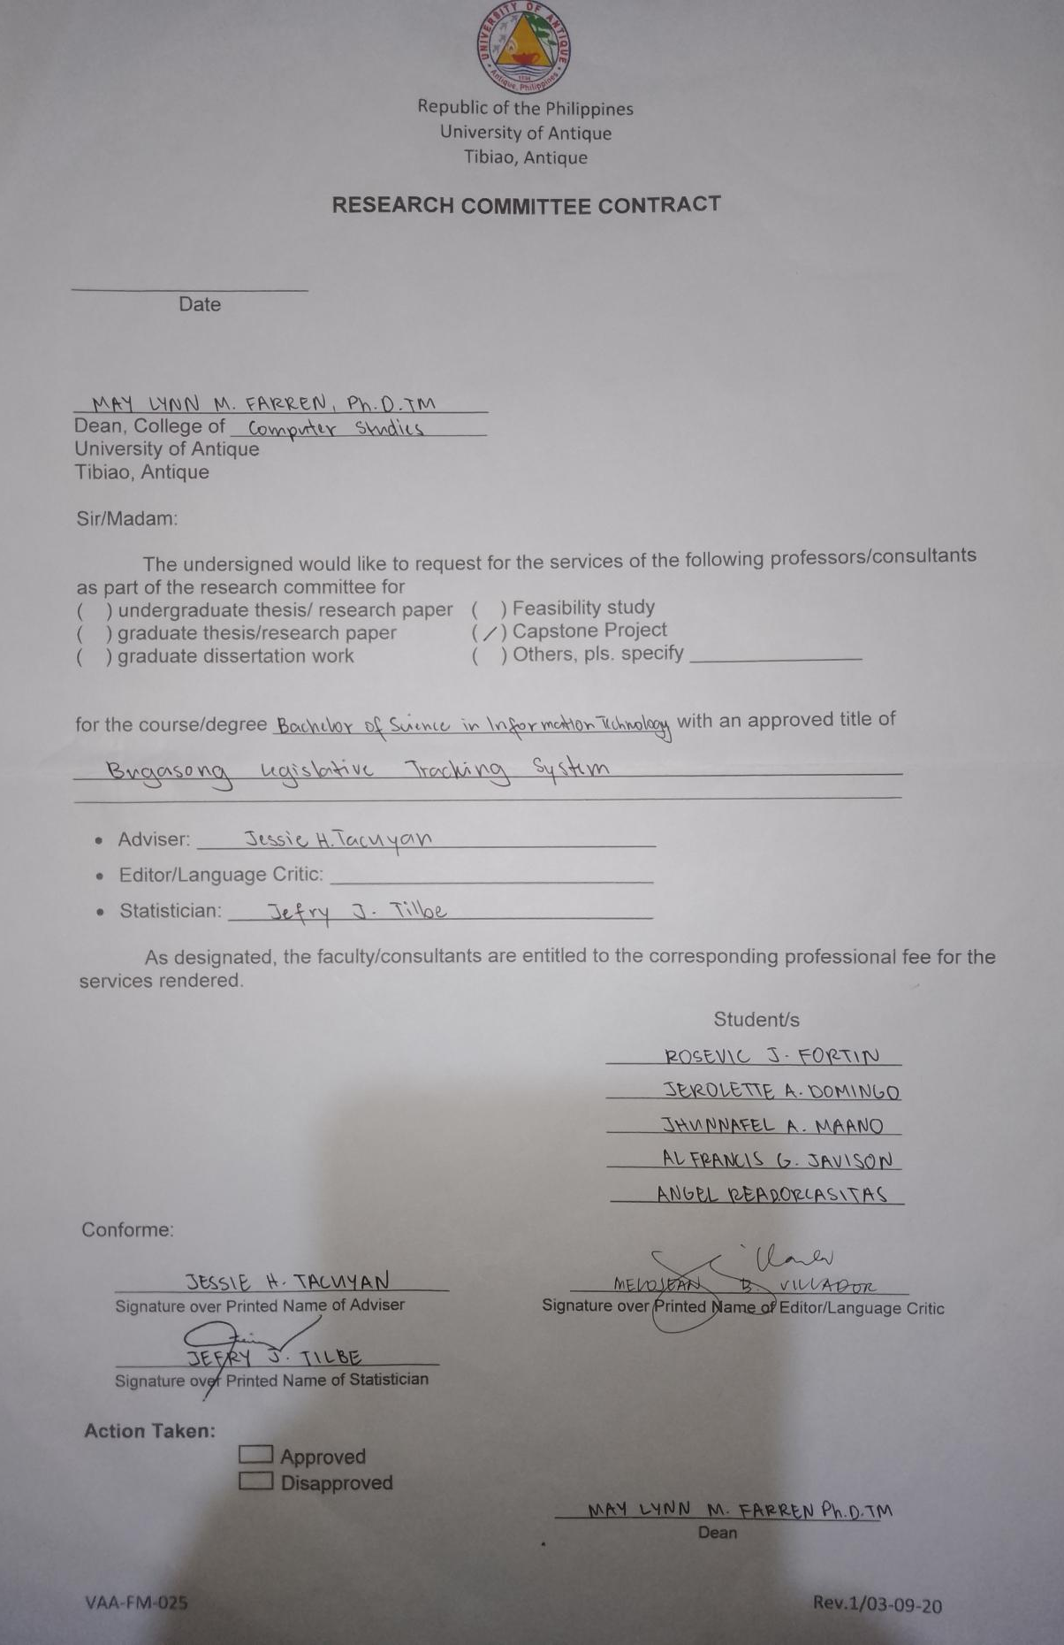
Research Committee Contract
ACKNOWLEDGEMENT

The researchers would like to express their sincere gratitude to all those who have contributed to the success of their capstone project.
First and foremost, the researchers would like to thank the Almighty God for guiding them through all difficulties. He was truly the source of their strength and wisdom. His guidance, as the days passed, did not allow them to give up because they firmly believed that with God, everything was possible.
The researchers would like to express their deepest gratitude to their adviser, Mr. Jessie H. Tacuyan, whose invaluable guidance, leadership, and expertise were instrumental in the success of this project. His insightful advice and suggestions were incredibly helpful throughout the completion of the project. In this regard, the researchers are eternally grateful and truly blessed to have had him as their adviser.
The researchers would also like to acknowledge and extend their wholehearted appreciation to their panelists, Dr. May Lynn M. Farren, Mr. Nolan M. Yumen, MIS, Mrs. Irene Robles, MIS, and Mr. Levi John A. Bernisto, MIS, as well as to their Capstone Instructor, Mrs. Gladys Mayette S. Patricio, for their encouragement, insightful comments, constructive criticism, and valuable feedback, all of which contributed to enhancing the quality of this research.
Furthermore, the researchers would like to express their heartfelt gratitude to the Sangguniang Bayan staff for their invaluable cooperation and for graciously accepting their system. The researchers are deeply appreciative of their unwavering patience in responding to their inquiries and for warmly welcoming them to their office.
Finally, the researchers would like to acknowledge their friends and family who supported them, for their patience and understanding. The financial and moral support they received contributed significantly to the success of the study. All of them were also a source of motivation, making the research truly meaningful and memorable.

ABSTRACT

This project aimed to develop a digital repository system to replace physical archives and enhance the management and tracking of legislative documents in the Local Government Unit of Bugasong, Antique. Interviews identified several issues in the Sangguniang Bayan office, such as difficulties in retrieving hard copies of ordinances and resolutions, challenges in document searches, limited public dissemination, trouble converting files to digital text, and the absence of a platform for resident feedback.
To address these issues, the researchers used Agile Methodology to develop a secure platform for storing resolutions and ordinances, featuring a user-friendly search function and a transparent public access platform. The system integrated Optical Character Recognition (OCR) to convert scanned documents into searchable text, allowing users to easily locate keywords. The accuracy of the OCR depended on the quality of the scanned text. Sentiment analysis was also integrated into the system to effectively assess and determine whether the feedback or insights shared in the forum regarding local laws were appropriate or not. This feature helped ensure that comments and discussions were appropriately classified, fostering more meaningful and constructive dialogue within the community.
The system was evaluated by IT experts, Sangguniang Bayan staff, and community members using ISO 25010 to assess its software quality. The thirty (30) evaluators, composed of fifteen (15) IT experts, eight (8) Sangguniang Bayan members or staff, and seven (7) community members, rated the system “Very Satisfactory” in all eight quality characteristics, with an overall mean of 4.69. The results showed that the Bugasong Legislative Tracking System with OCR effectively improved the tracking, management, and public access to ordinances and resolutions.
Keywords: legislative tracking system, optical character recognition, sentiment analysis, e-governance, ISO/IEC 25010

TABLE OF CONTENTS

PRELIMINARY PAGES Pages
Title Page i
Panel’s Approval Sheet ii Adviser’s Recommendation Sheet iii
Instructor’s Recommendation Sheet iv
Research Committee Contract v
Acknowledgement vi
Abstract viii

CHAPTER 1 - INTRODUCTION
Background of the Study 1
Statement of the Problem 2
Objectives of the Study 3
Conceptual Framework 4
Definition of Terms 6
Significance of the Study 8
Scope and Limitations 9

CHAPTER 2 - REVIEW OF RELATED LITERATURE
Legislation Information System 11
eGaz: Enhanced Search Engine for gazette publication 11
Using OCR Framework and Information Extraction for
Thai Documents Digitization 12
LeMTrac: Legislative Management Tracking System 13
OCR Based Document Archiving and Indexing Using
PyTesseract: A OCR Based Management System
for DSWD Caraga, Philippines 13
OCR System Evaluation Method, Apparatus and
Device, and Readable Storage Medium 14
System For Optical Character Recognition (OCR) 15
Extract Data From A True PDF Page 16
Summary 17
Overview of the Reviewed Sources 21
Summary of Features 23

CHAPTER 3 - Research Methodology
Project Description 24
Development Process 25
Project Evaluation 38
Respondents of the Study 38
Evaluation Instruments 39
Evaluation Procedure 40
Statistical Treatment of Data 40

CHAPTER 4 - Results and Discussion
Development of Bugasong Legislative Tracking System 42
User Interface 43
Level of Functional Suitability of the Bugasong Legislative
Tracking System 54
Level of Reliability of the Bugasong Legislative Tracking System 56
Level of Usability of the Bugasong Legislative Tracking System 59
Level of Efficiency of the Bugasong Legislative Tracking System 62

Level of Maintainability of the Bugasong Legislative Tracking
System 64
Level of Portability of the Bugasong Legislative Tracking System 66
Level of Security of the Bugasong Legislative Tracking System 68
Level of Compatibility of the Bugasong Legislative Tracking
System 70
Perception of the Evaluators When Taken as a Whole 72
Results of the Mean Average for Bugasong Legislative
Tracking System When the Entire Group is considered. 76

CHAPTER 5 - Summary, Findings, Conclusion, and Recommendation
Summary 79
Findings 80
Conclusion 82
Recommendation 83

List of Tables

Table 1: Overview of the Reviewed Source 22
Table 2: Summary of Features 23
Table 3: Hardware and Software Requirements 29
Table 4: Summary of the Evaluators 39
Table 5: 5- point Likert Scale 41
Table 6 Level of Functional Suitability 54
Table 7 Level of Reliability 56
Table 8 Level of Usability 59
Table 9 Level of Efficiency 62
Table 10 Level of Maintainability 64
Table 11 Level of Portability 66
Table 12 Level of Security 68
Table 13 Level of Compatibility 70
Table 14 Perception of the Evaluators 72
Table 15 Results of the Mean Average 76

List of Figures

Figure 1: Conceptual Framework Diagram 5
Figure 2: Diagram of Scrum Methodology 26
Figure 3: Use Case Diagram 29
Figure 4: System Architecture Diagram 30
Figure 5: Data Flow Diagram 31
Figure 6: Flow Chart Diagram 32
Figure 7: Wireframe 33
Figure 8: Burn-down Chart 35
Figure 9: Log in Panel 43
Figure 10: Home Page 44
Figure 11: Admin Dashboard 44
Figure 12: Upload Documents 45
Figure 13: Publish Documents 46
Figure 14: Categories 47
Figure 15: Forum Management 47
Figure 16: User Management 48
Figure 17: System Settings 49
Figure 18: Generate Report 51
Figure 19: Citizens User Panel 52
Figure 20: Posting Feedback 52
Figure 21: List of Legislatives 53

