APPENDICES

APPENDIX A
LETTERS







APPENDIX B
SYSTEM PROJECT SCHEDULE/TIMELINE

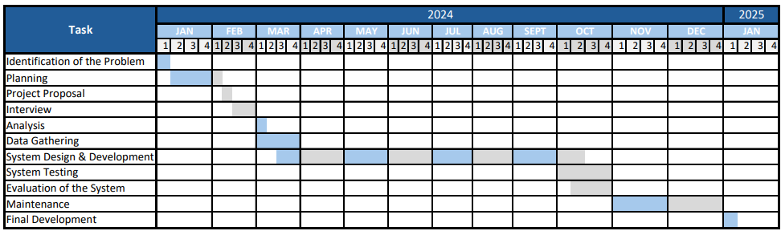

APPENDIX C
SAMPLE SOURCE CODE

<?php
@include('header.php');

redirectNotLogin();

?>

<!-- Content Wrapper -->
<div id="content-wrapper" class="d-flex flex-column">

<!-- Main Content -->
<div id="content">

<!-- Topbar -->
<?php @include('top_navbar.php'); ?>
<!-- End of Topbar -->

<?php if (isAdmin()) : ?>

<!-- Begin Page Content -->
<div class="container-fluid">
<!-- Page Heading -->
<div class="d-sm-flex align-items-center justify-content-between mb-4">
<h1 class="h3 mb-0 text-gray-800">Add Ordinance</h1>
</div>
<div class="back-button mb-3">
<a href="admin_ordinance.php?manage" class="btn btn-primary m-1">Back</a>
</div>

<!-- Content Row -->
<div class="row">
<div class="form-container col-4">
<div class="card shadow mb-3">
<div class="card-header py-3">
<h6 class="m-0 font-weight-bold text-primary">Upload files for OCR</h6>
</div>
<div class="card-body">
<form id="uploadForm" method="post" enctype="multipart/form-data">
<label class="mt-2" for="uploadedFiles">Choose files to upload:</label>
<input class="form-control-file text-gray-800" type="file" multiple name="uploadedFiles[]" id="uploadedFiles">
<div class="mb-0 mt-2 d-flex justify-content-end">
<input type="submit" class="btn btn-primary" name="uploadBtn" value="Upload">
</div>
</form>
</div>
</div>
<div class="card shadow mb-4">
<div class="card-header py-3">
<h6 class="m-0 font-weight-bold text-primary">Ordinance Information</h6>
</div>
<div class="card-body">
<div id="ocrResults">
<form id="ordinanceForm" action="../actions/admin_add.php" method="POST" enctype="multipart/form-data">
<label class="mt-2" for="ordinance_category">Category:</label>
<select class="form-control text-gray-800" name="ordinance_category" id="ordinance_category">
<option value="">Select option:</option>
<?php foreach (getAllOrdinanceCategoryAsc('ordinance_category_name', null) as $ordinance_category) : ?>
<option value="<?php echo $ordinance_category['ordinance_cat_id']; ?>" <?php if (getValue('ordinance_category') === $ordinance_category['ordinance_cat_id']) echo ' selected'; ?>><?php echo $ordinance_category['ordinance_category_name']; ?> </option>
<?php endforeach; ?>
</select>

<label class="mt-2" for="ordinanceNo">Ordinance No:</label>
<textarea rows="1" class="form-control text-gray-800" id="ordinanceNo" name="ordinanceNo"><?php echo getValue('ordinanceNo'); ?></textarea>
<?php if (showError('ordinanceNo')) : ?>
<p class="error text-danger text-start m-0" style="font-size: 12px;"><?php echo showError('ordinanceNo'); ?></p>
<?php endif; ?>

<label class="mt-2" for="title">Title:</label>
<textarea rows="3" class="form-control text-gray-800" id="title" name="title"><?php echo getValue('title'); ?></textarea>
<?php if (showError('title')) : ?>
<p class="error text-danger text-start m-0" style="font-size: 12px;"><?php echo showError('title'); ?></p>
<?php endif; ?>

<label class="mt-2" for="preamble">Preamble:</label>
<textarea rows="10" class="form-control text-gray-800" id="preamble" name="preamble"><?php echo getValue('preamble'); ?></textarea>
<?php if (showError('preamble')) : ?>
<p class="error text-danger text-start m-0" style="font-size: 12px;"><?php echo showError('preamble'); ?></p>
<?php endif; ?>

<label class="mt-2" for="enactingClause">Enacting Clause:</label>
<textarea rows="10" class="form-control text-gray-800" id="enactingClause" name="enactingClause"><?php echo getValue('enactingClause'); ?></textarea>
<?php if (showError('enactingClause')) : ?>
<p class="error text-danger text-start m-0" style="font-size: 12px;"><?php echo showError('enactingClause'); ?></p>
<?php endif; ?>

<label class="mt-2" for="body">Body:</label>
<textarea rows="10" class="form-control text-gray-800" id="body" name="body"><?php echo getValue('body'); ?></textarea>
<?php if (showError('body')) : ?>
<p class="error text-danger text-start m-0" style="font-size: 12px;"><?php echo showError('body'); ?></p>
<?php endif; ?>

<label class="mt-2" for="repealingClause">Repealing Clause:</label>
<textarea rows="10" class="form-control text-gray-800" id="repealingClause" name="repealingClause"><?php echo getValue('repealingClause'); ?></textarea>
<?php if (showError('repealingClause')) : ?>
<p class="error text-danger text-start m-0" style="font-size: 12px;"><?php echo showError('repealingClause'); ?></p>
<?php endif; ?>

<label class="mt-2" for="effectivityClause">Effectivity Clause:</label>
<textarea rows="10" class="form-control text-gray-800" id="effectivityClause" name="effectivityClause"><?php echo getValue('effectivityClause'); ?></textarea>
<?php if (showError('effectivityClause')) : ?>
<p class="error text-danger text-start m-0" style="font-size: 12px;"><?php echo showError('effectivityClause'); ?></p>
<?php endif; ?>

<label class="mt-2" for="enactmentDetails">Enactment Details:</label>
<textarea rows="10" class="form-control text-gray-800" id="enactmentDetails" name="enactmentDetails"><?php echo getValue('enactmentDetails'); ?></textarea>
<?php if (showError('enactmentDetails')) : ?>
<p class="error text-danger text-start m-0" style="font-size: 12px;"><?php echo showError('enactmentDetails'); ?></p>
<?php endif; ?>

<div class="mb-0 mt-2 d-flex justify-content-end">
<input type="hidden" name="file" id="file" value="<?php echo getValue('file'); ?>">
<input type="hidden" name="user_id" value="<?php echo user_id(); ?>">
<button type="submit" name="add_ordinance" class="btn btn-primary" value="add_ordinance">Submit</button>
</div>
</form>
</div>
</div>
</div>
</div>

<div class="col-8 p-0">
<div class="card shadow mb-3">
<div class="card-header">
<h6 class="m-0 font-weight-bold text-primary">Extracted File</h6>
</div>
<div class="card-body">
<div class="ocr-result-container">
<div id="ocrResultsFile"></div>
</div>
</div>
</div>
<div class="card shadow mb-3">
<div class="card-header">
<h6 class="m-0 font-weight-bold text-primary">Extracted Text</h6>
</div>
<div class="card-body">
<div class="ocr-result-container">
<div id="ocrResultsText"></div>
</div>
</div>
</div>
</div>
</div>
</div>
<!-- /.container-fluid -->

<?php else : redirect('dashboard', ''); ?>
<?php endif; ?>

</div>
<!-- End of Main Content -->

<!-- Loading screen -->
<div id="loadingScreen" style="display: none;">
<div class="spinner-border text-primary" role="status">
<span class="sr-only">Loading...</span>
</div>
</div>

<!-- Footer -->
<footer class="sticky-footer bg-white">
<div class="container my-auto">
<div class="copyright text-center my-auto">
<span>Copyright &copy; Bugasong Legislative Tracking System 2024</span>
</div>
</div>
</footer>
<!-- End of Footer -->

</div>
<!-- End of Content Wrapper -->

<?php
@include('footer.php');
?>

<?php
// Check if there is an error message in the URL parameter
if (isset($_GET['failed'])) {
// Set the error message in the session
$_SESSION['errorMessage'] = urldecode($_GET['failed']);
// Redirect to the same page without the error message in the URL parameter
header('Location: ' . strtok($_SERVER['REQUEST_URI'], '?'));
exit();
}

// Check if there is an error message in the session
if (isset($_SESSION['errorMessage'])) {
// Display error message
echo '<div class="alert alert-danger">' . $_SESSION['errorMessage'] . '</div>';
// Clear session message
unset($_SESSION['errorMessage']);
}

?>

<script>
document.getElementById('uploadForm').addEventListener('submit', function(event) {
event.preventDefault();

// Show loading screen
document.getElementById('loadingScreen').style.display = 'flex';

var formData = new FormData(this);
fetch('../actions/upload_ordinance.php', {
method: 'POST',
body: formData
})
.then(response => response.json())
.then(data => {
// Hide loading screen
document.getElementById('loadingScreen').style.display = 'none';
if (data.success) {
// Populate Ordinance Information form
document.getElementById('ordinanceNo').value = data.ordinanceData.ordinanceNo;
document.getElementById('title').value = data.ordinanceData.title;
document.getElementById('preamble').value = data.ordinanceData.preamble;
document.getElementById('enactingClause').value = data.ordinanceData.enactingClause;
document.getElementById('body').value = data.ordinanceData.body;
document.getElementById('repealingClause').value = data.ordinanceData.repealingClause;
document.getElementById('effectivityClause').value = data.ordinanceData.effectivityClause;
document.getElementById('enactmentDetails').value = data.ordinanceData.enactmentDetails;

// Show Ordinance Information
document.getElementById('ocrResults').style.display = 'block';

// Update file input with URLs
var fileInput = document.getElementById('file');
fileInput.value = data.uploadedFileUrls;

// Populate Extracted File section
var ocrResultsFileDiv = document.getElementById('ocrResultsFile');
var extractedImagesHtml = '';
data.uploadedFileUrls.forEach(function(url) {
if (url.endsWith('.jpg') || url.endsWith('.jpeg') || url.endsWith('.png')) {
extractedImagesHtml += '<img src="' + url + '" alt="Scanned Image" class="img-thumbnail" style="max-width: 100%; height: auto; margin-bottom: 10px;">';
} else if (url.endsWith('.pdf')) {
extractedImagesHtml += '<iframe src="' + url + '" type="application/pdf" frameborder="0" marginheight="0" marginwidth="0" width="100%" height="500px" scrolling="auto" style="margin-bottom: 10px;"></iframe>';
}
});
ocrResultsFileDiv.innerHTML = extractedImagesHtml;

// Populate Extracted Text section
var ocrResultsTextDiv = document.getElementById('ocrResultsText');
ocrResultsTextDiv.innerHTML = '<pre style="white-space: pre-wrap; word-wrap: break-word;">' + data.extractedText + '</pre>';
} else {
// Display error message as a flash message
Swal.fire({
icon: 'warning',
iconColor: 'red',
title: data.message,
confirmButtonColor: '#4e73df',
showConfirmButton: true,
});
}
})
.catch(error => {
// Hide loading screen
document.getElementById('loadingScreen').style.display = 'none';

console.error('Error:', error);
});
});
</script>

APPENDIX D
EVALUATION INSTRUMENT

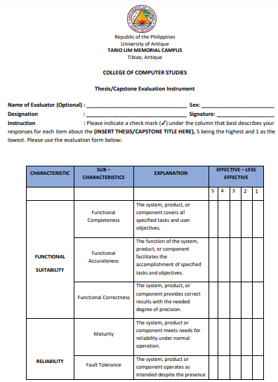
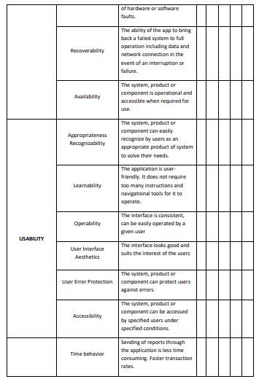

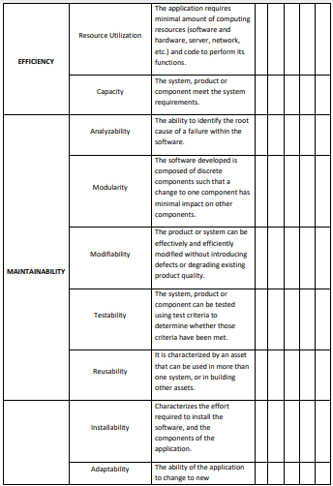

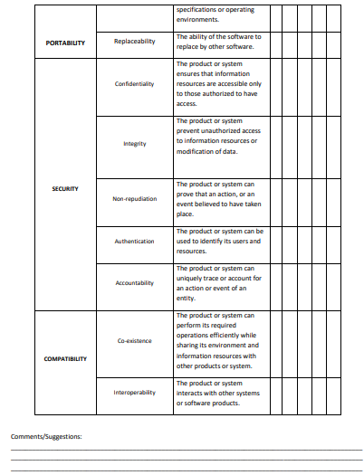

APPENDIX E
SAMPLE FILLED-IN EVALUATION FORM

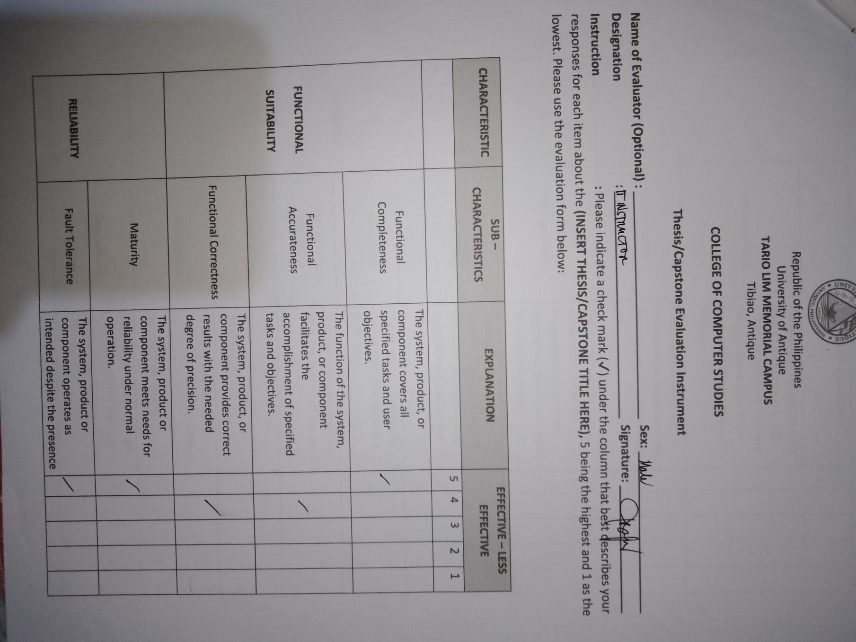
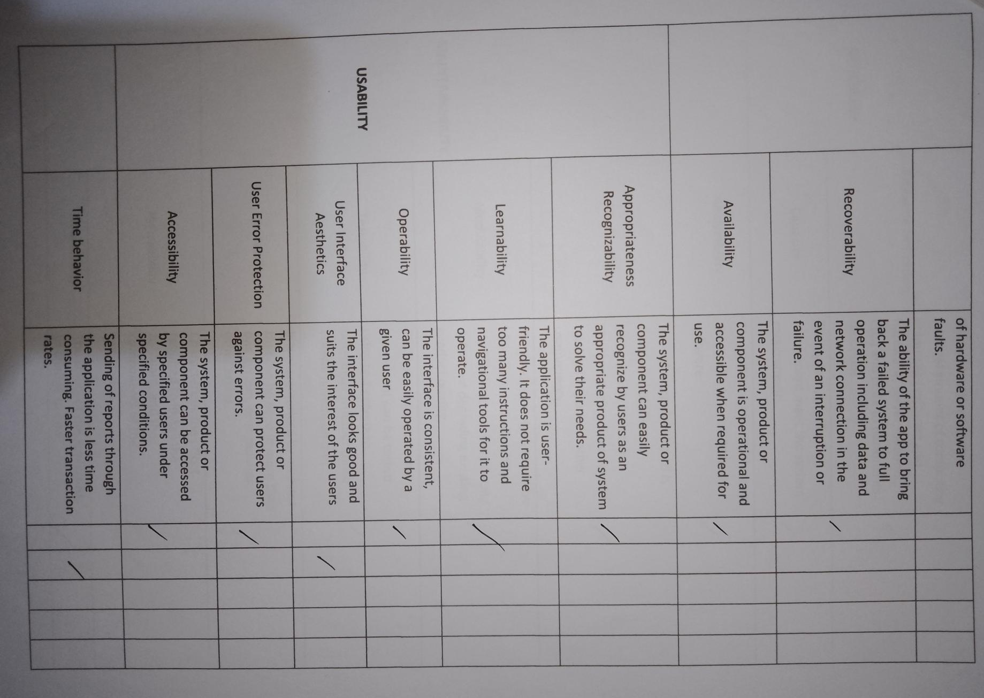

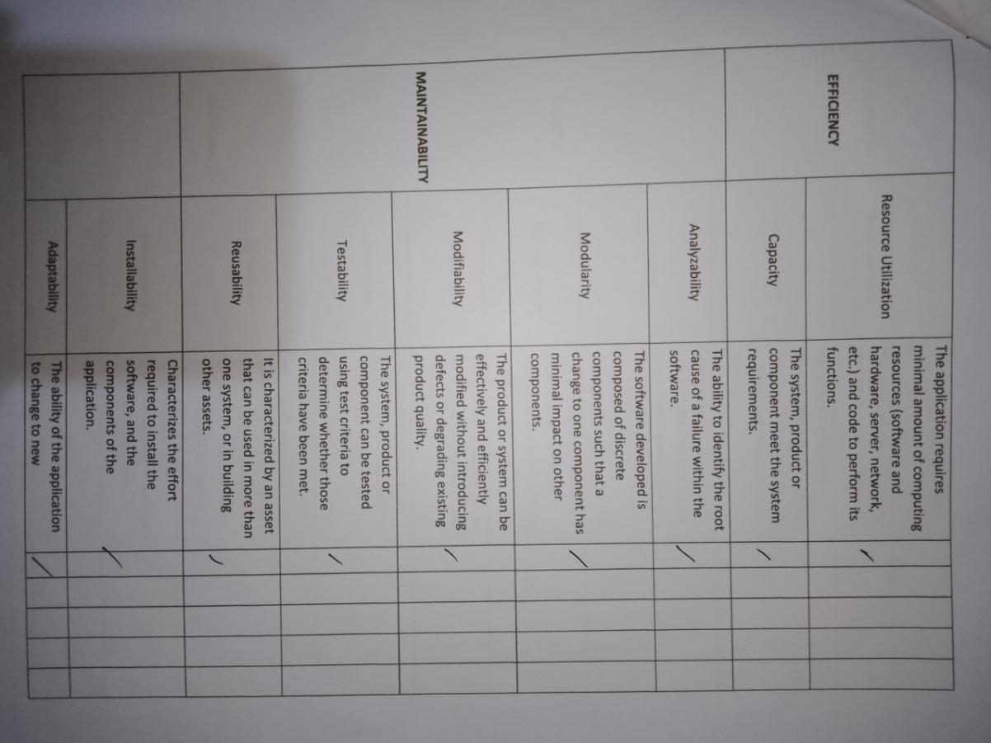

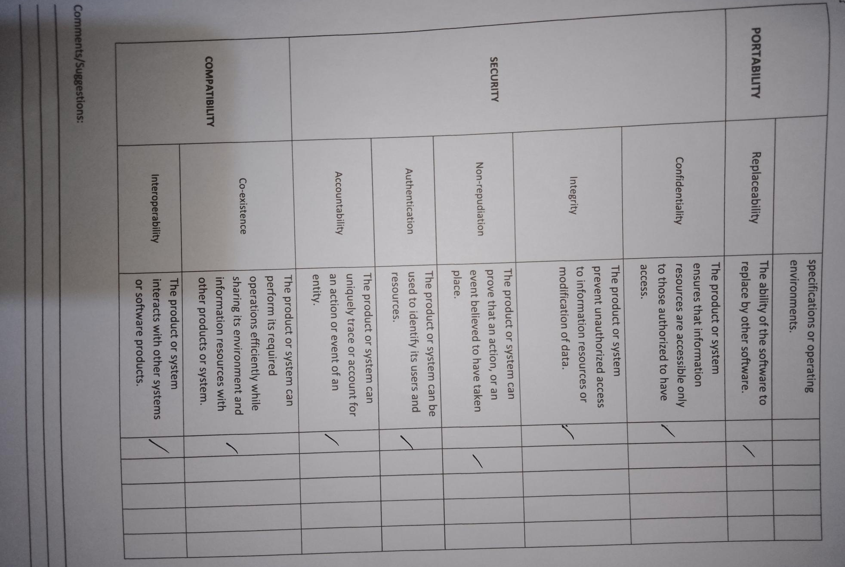
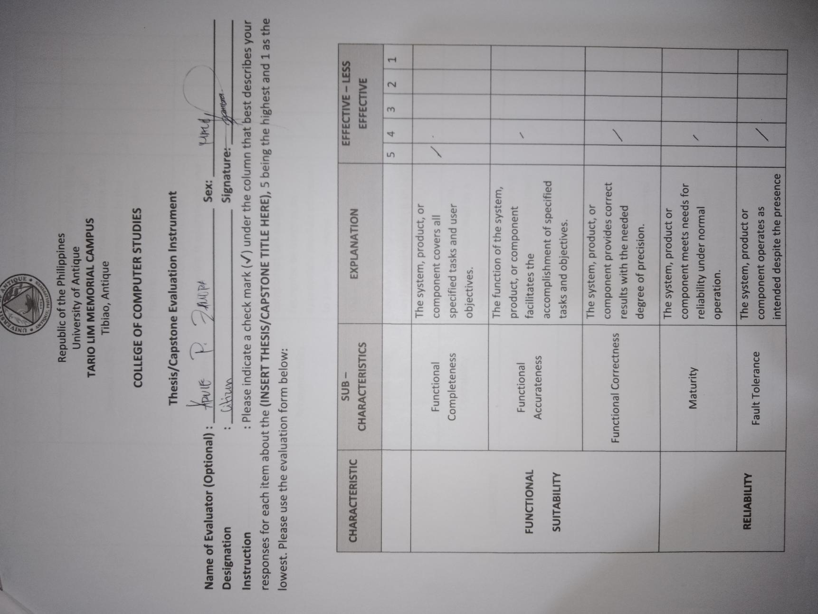
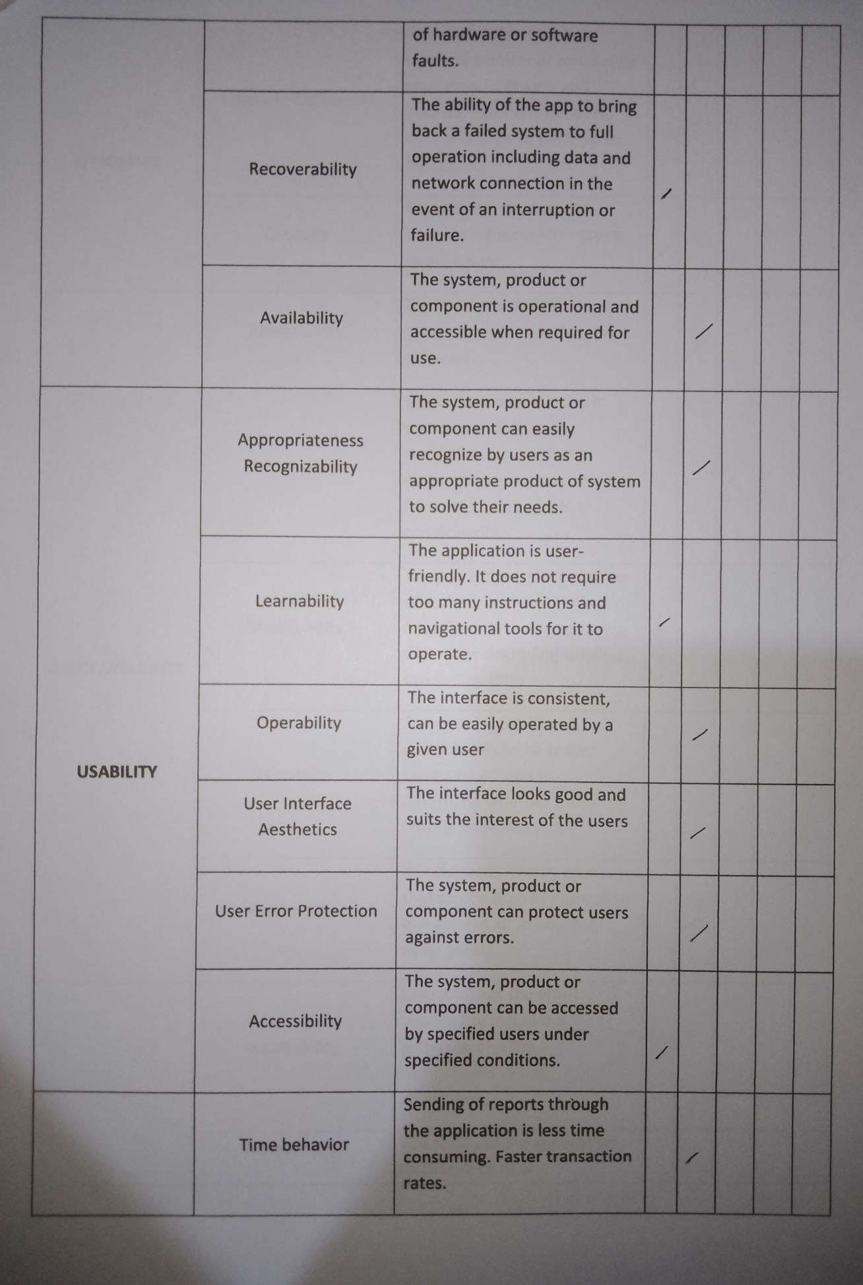

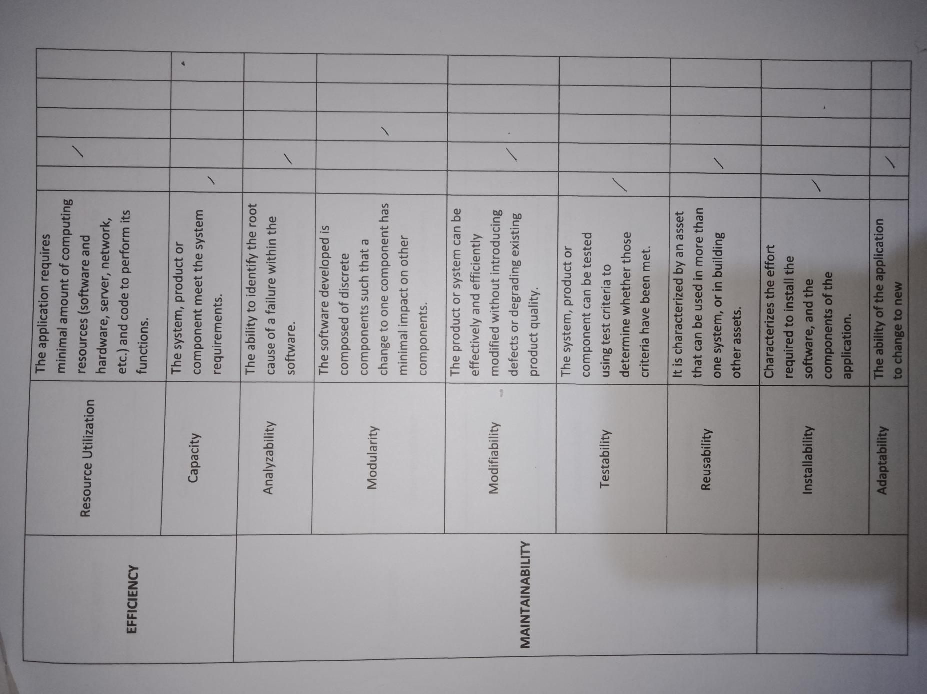

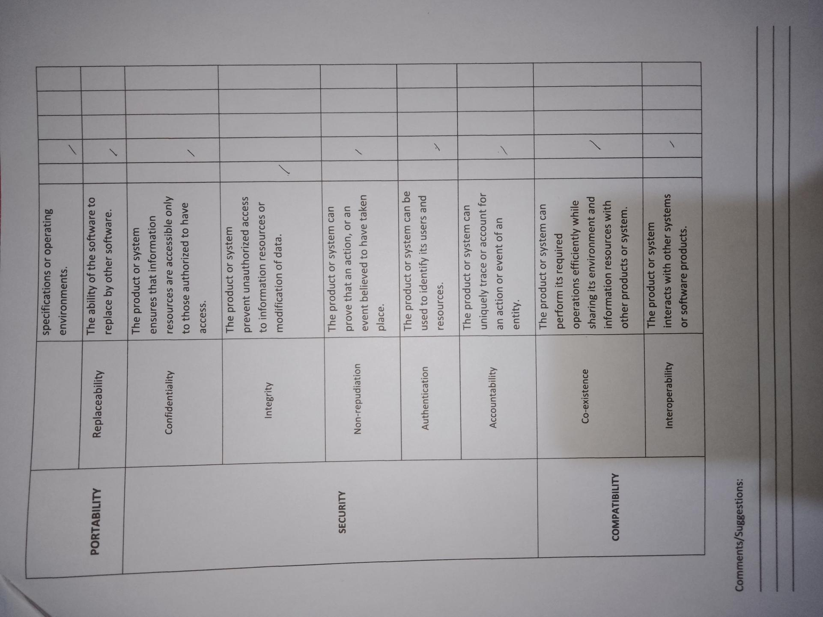

APPENDIX F
USE CASE

Use Case

A use case is a concept utilized in software development, product design and various fields to explain how a system can be used to.

- 1. Browsing the System
Use Case Name | Browsing the System
Participating Actor | System Users
Description | This use case enables the actor to browse the system online using a web browser.
Basic Flow of Events | This use case begins when the actors attempt to open a web browser and enter the Uniform Resource Locator (URL) of the system in the address bar.

- 2. Login
Use Case Name | Login
Participating Actor | Users
Description | This use case enables the actor to log in to the system using their credentials.
Basic Flow of Events | This use case begins when the actors attempt to log in to the system by entering the username and password. The system will then verify the log in details and allows the actor to log to the system.
Exceptional Flow of Event | An invalid Username and password entered. The user may either re-enter the Username and Password or register new account.

- 3. Viewing documents
Use Case Name | Viewing Documents
Participating Actor | Users
Description | This use case enables the actor to access and view documents.
Basic Flow of Events | This use case begins when the actors search for any category, keywords, date of resolutions and ordinances they want to access and view.

- 4. Adding User Account
Use Case Name | Adding User Account
Participating Actor | Admin
Description | This use case enables the admin to add user account in the system. It will allow the users to log in and utilize the system.
Basic Flow of Events | This use case begins when the admin select the “User Management” and click the “Add User” then fill out the form to register the citizens. By clicking the “Save” button, the system will save the data.

- 5. Uploading Resolutions and Ordinances
Use Case Name | Uploading Resolutions and Ordinances
Participating Actor | Admin
Description | This use case enables the admin to upload scanned documents of resolution and ordinance using Optical Character Recognition (OCR). It will extract the text to make the documents searchable and editable.
Basic Flow of Events | This use case begins when the admin select the “Manage Documents” and click the “Add Resolution” or “Add Ordinance” then choose files from local storage. By clicking the “Submit” button, the system will save the data.

- 6. Posting feedback or Insights
Use Case Name | Posting Feedback or Insights
Participating Actor | System Users
Description | This use case enables the users to post feedback or insights in a forum section of a system.
Basic Flow of Events | This use case begins when the users creating post topic and message regarding municipal laws concerns. By clicking the “Submit” button, the system will notify the user if the post is appropriate to publish or not.

- 7. Generate Report
Use Case Name | Generate Report
Participating Actor | Admin
Description | This use case enables the admin to generate report in the system
Basic Flow of Events | This use case begins when the admin select the “Report” and choose from “Document Report”, “Views Report”, and “Forum Report” button. By clicking the “Print” button, the system will download the report.

APPENDIX G
USER INTERFACE

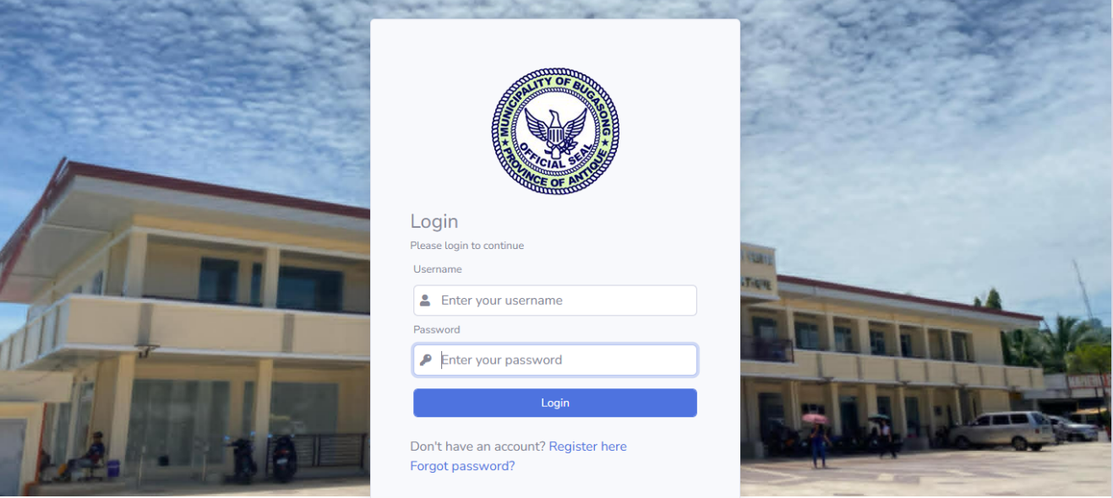
Log in Panel (User)
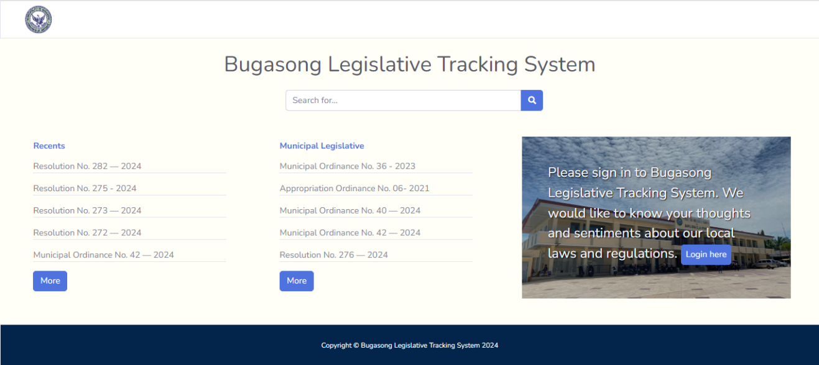
Homepage
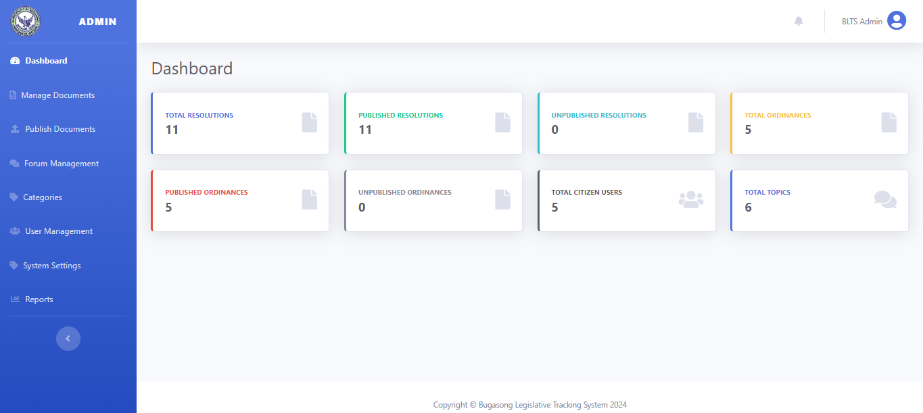Admin Panel
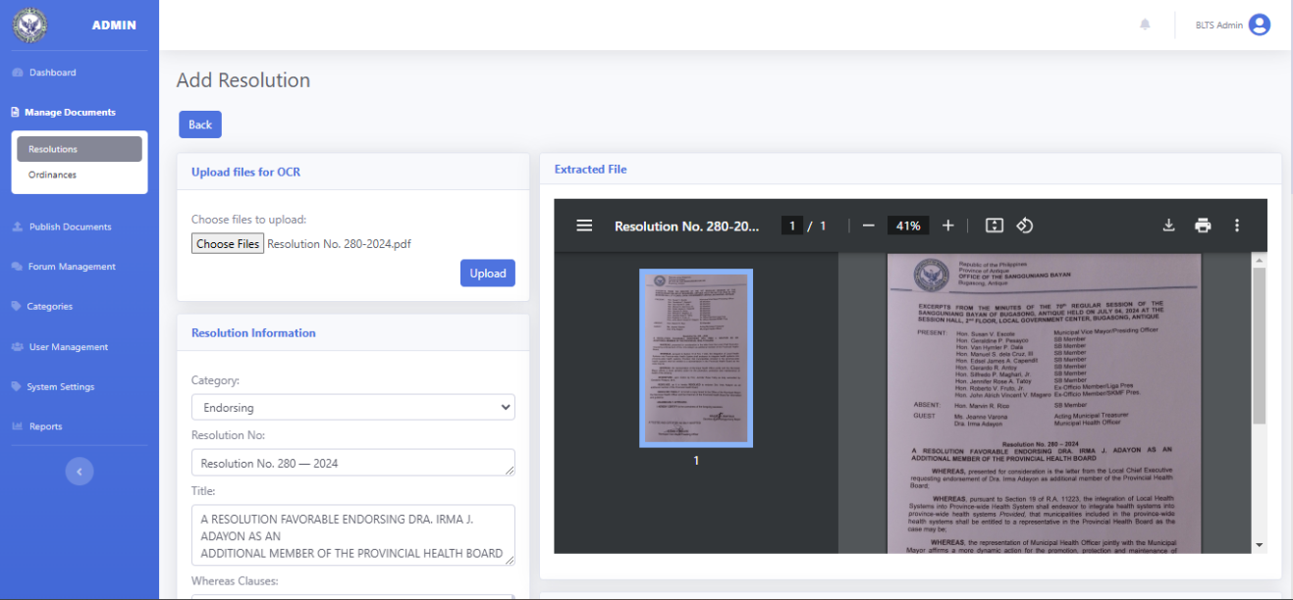 Upload Documents
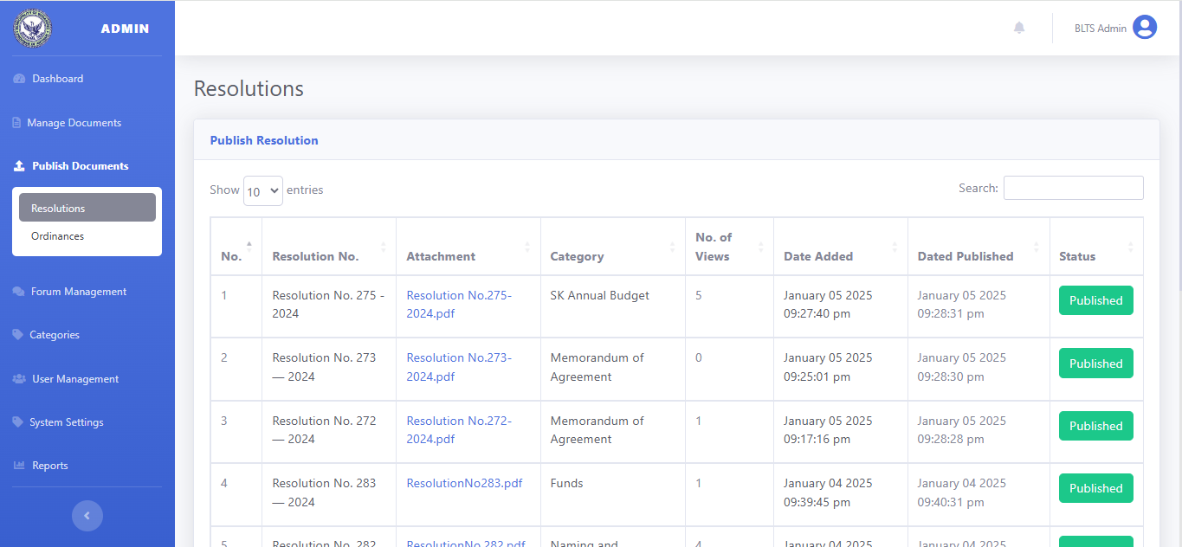 Publish Documents
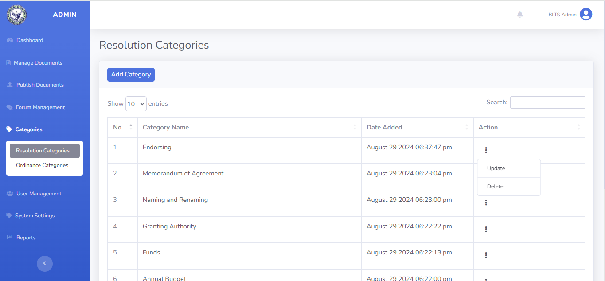Categories


Forum Management
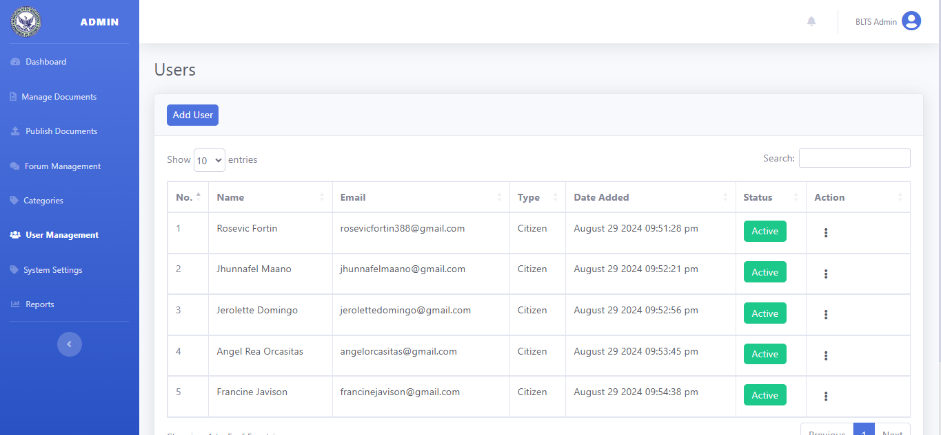

User Management
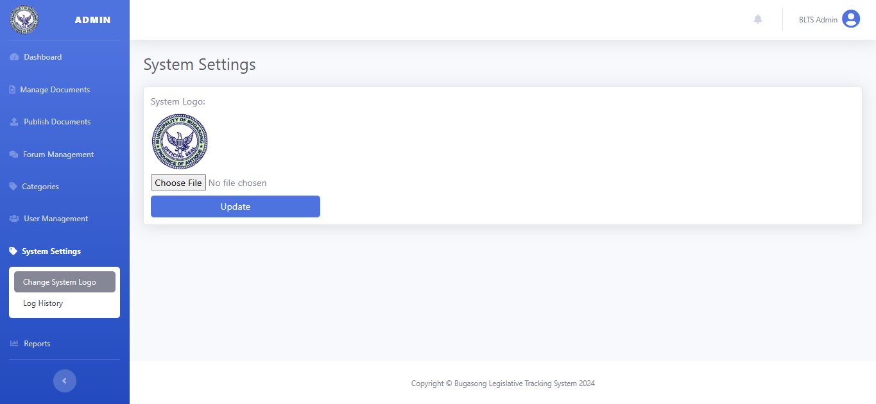
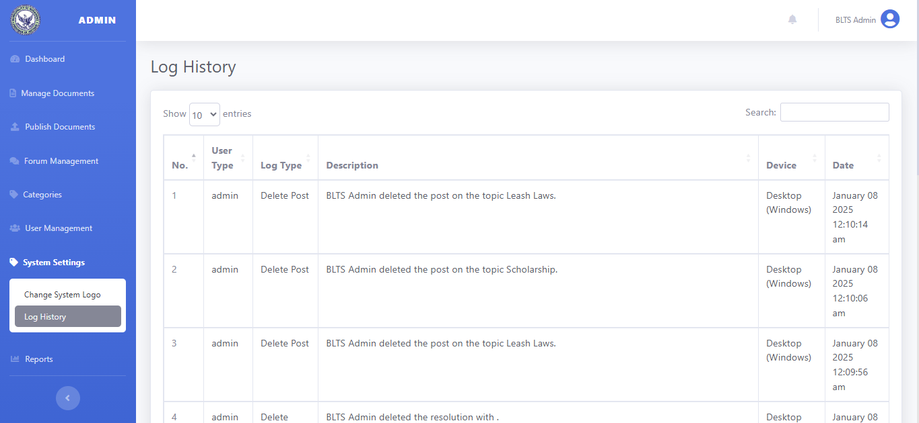System settings
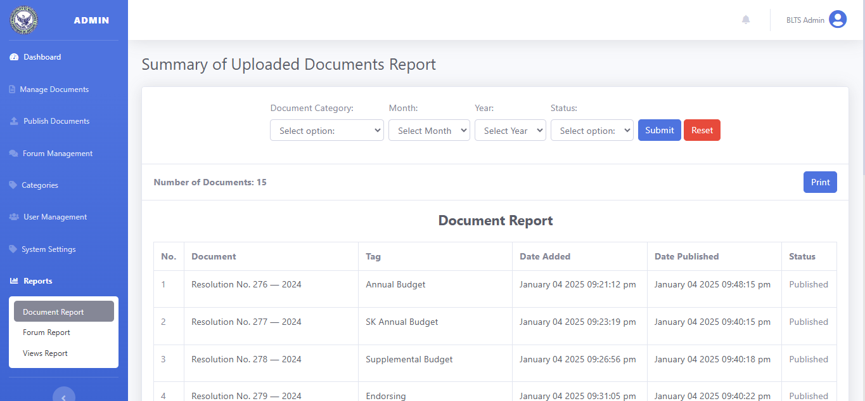
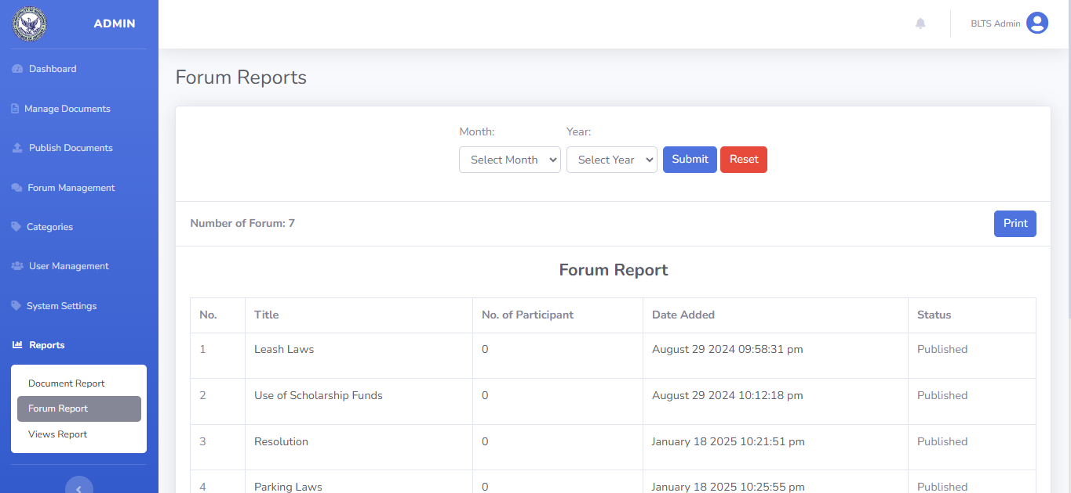
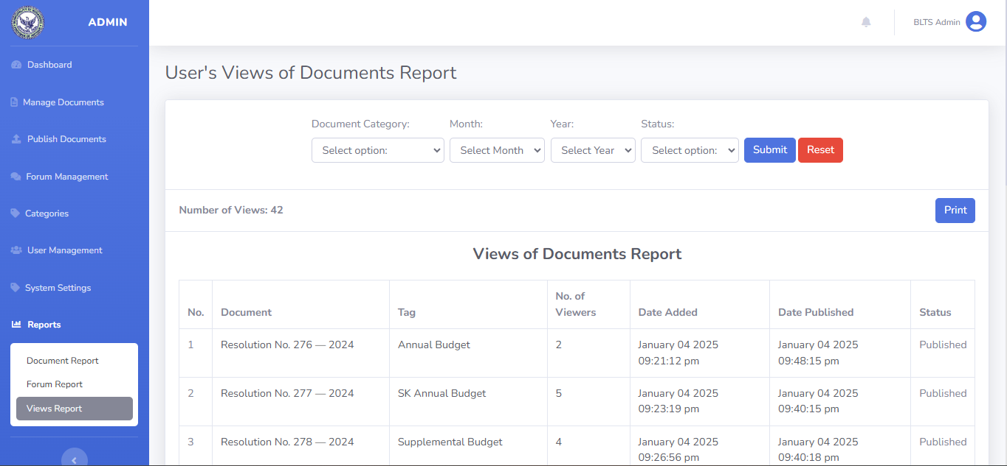
Generate Report
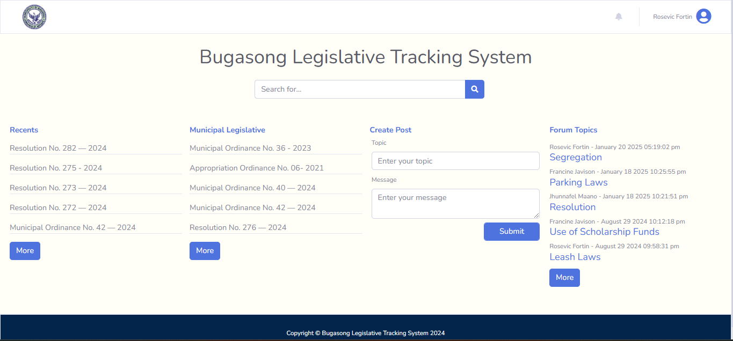Citizens Users Panel
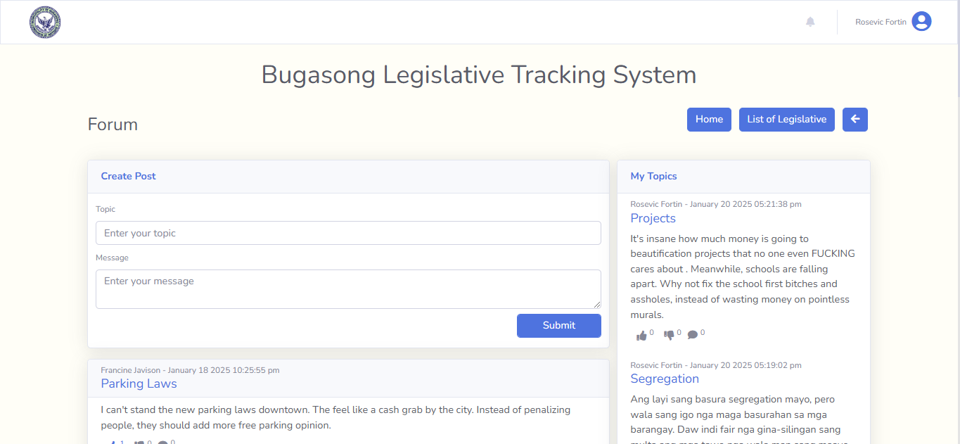Posting Feedback or Insights
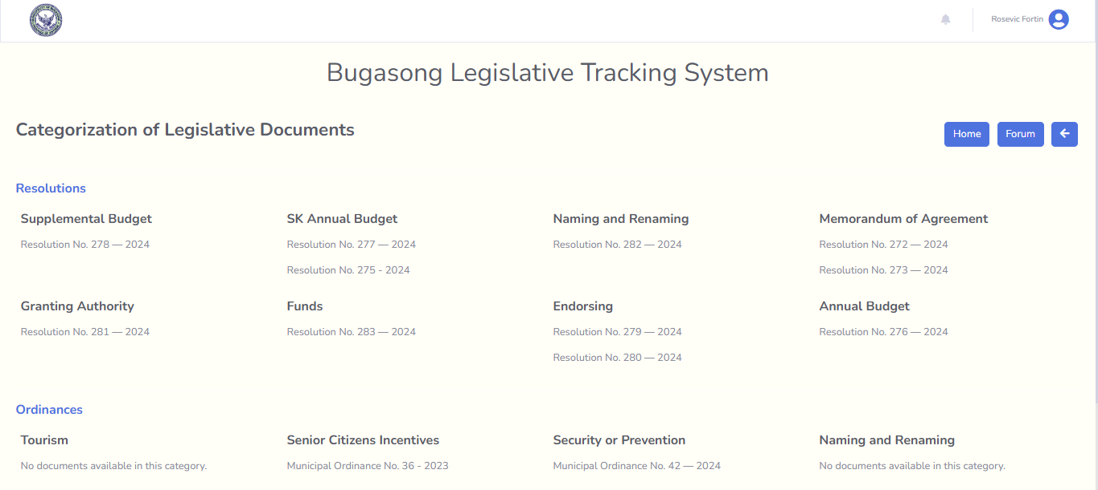
List of Legislatives

APPENDIX H
USER GUIDE/USER MANUAL

USER MANUAL

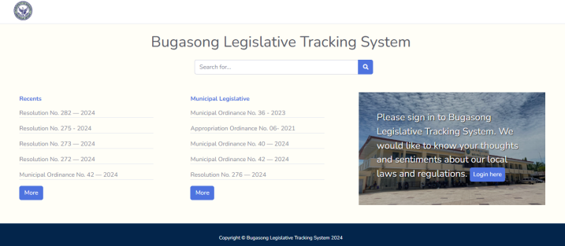
- Register an account to those who would like to participate in forum through posting feedbacks and insights regarding local laws. For those who only want to access ordinance and resolution files, you don’t need to create an account.

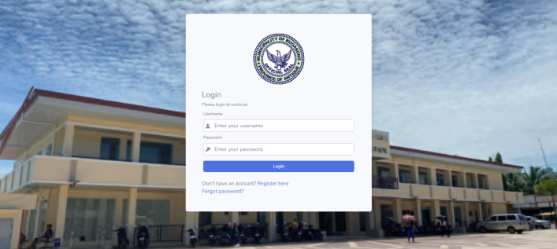
- Log in your registered account.

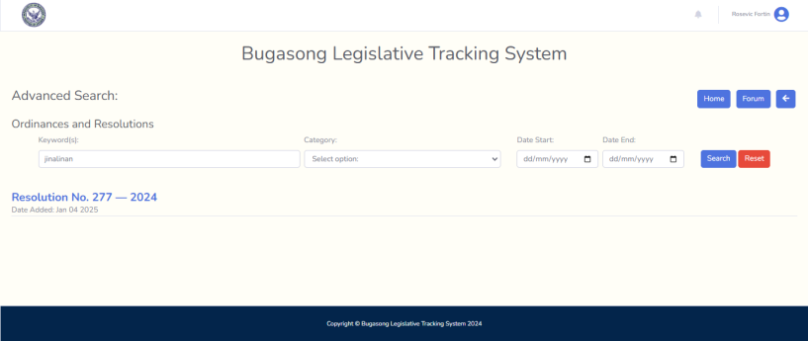
- Use search engine to find the documents you would like to view and download.

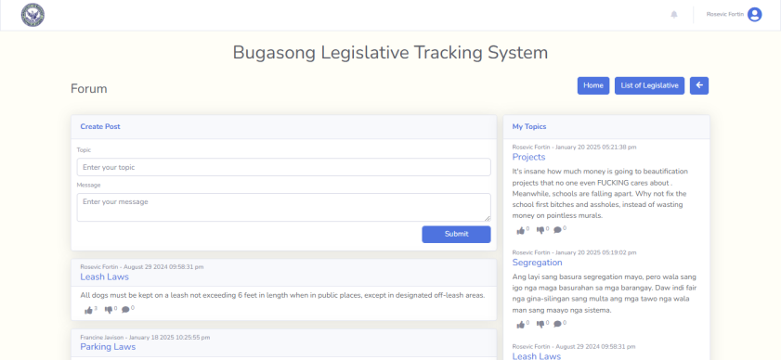
- You can post your insights about local laws in your community through filling the topic and message text area. Then click submit, and there’s notification if your post is approved if there is no offensive words used and if not it will not appear to other users.


- Click the button “List of Legislative” to access the files in a categorize pattern.

Uploading using Optical Character Recognition for Admin

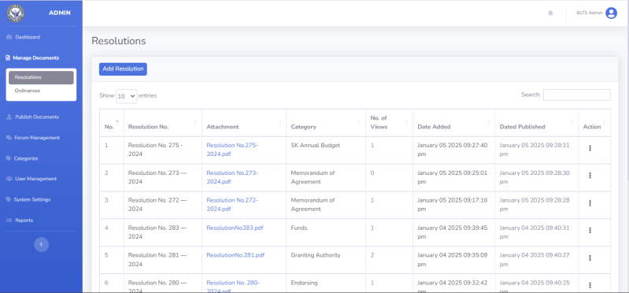
- Go to “Manage Documents” and choose from resolution and ordinance button.

- If you wish to upload file for municipal resolution click “add resolution” button.

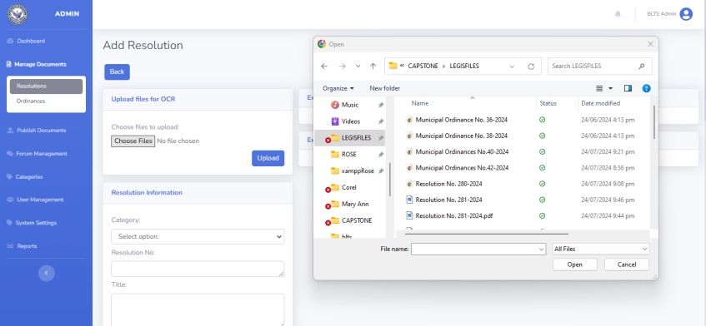
- Select the document files you wish to upload from your local storage.

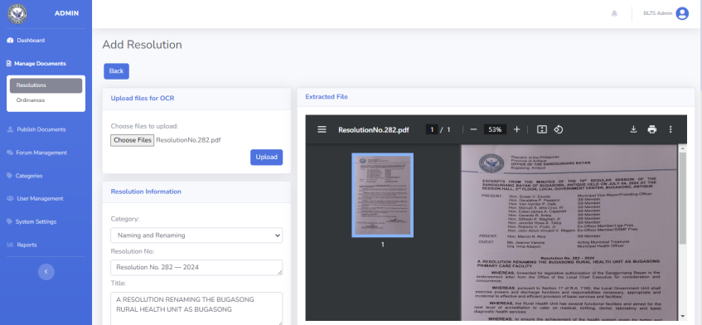
- Click Upload then wait a seconds for the extraction of text from scanned documents. Once the document is uploaded, OCR Technology will extract the text and automatically populate the relevant textboxes with information from the ordinance or resolution sections.

- Select first in what category of the files you uploaded to enhance organization and searchability. Then, check the textboxes and make sure to filled in those textboxes before you submit.

- After you submit the files, you can now decide if you would like to publish it immediately so that it accessible to users.
Forum with Sentiment Analysis

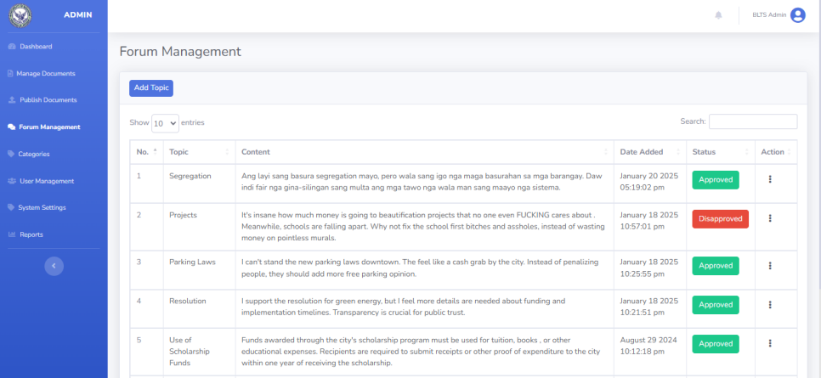
An administrator can only check the feedback or insights posted by citizen users. The admin can also view all users and delete them if necessary.

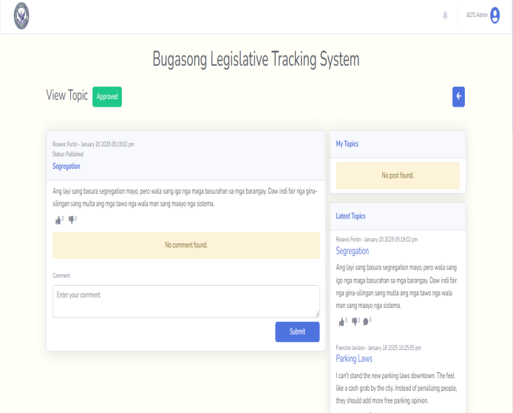
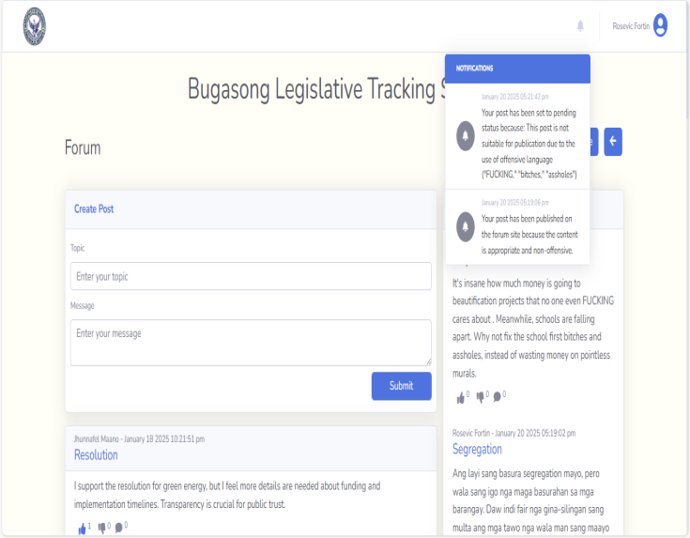
All users can comment and post topics regarding any concerns about local laws. Once a post is submitted, Sentiment Analysis is applied to determine whether the topic and message are appropriate to be approved for publication. If the content contains offensive words, it will be automatically disapproved. Users will receive a notification informing them whether their post was approved, along with the reasons for disapproval.

APPENDIX I
TEST RESULT

FUNCTIONAL SUITABILITY

- Completeness
15 IT Expert
Mean = [5(9 ) + 4(6 ) + 3(0 ) + 2(0 ) + 1(0 )] / 15
= 4.60
For 5: (5-4.60)² = 0.16
0.16*9=1.44
For 4: (4-4.60)² = 0.36
0.36*6=2.6
Total : ∑fi(xi−μ)² = 1.44+2.6 = 3.60
σ=√3.6/15 = √0.24 = 0.49

8 Sangguniang Bayan Staff
Mean = [5(7 ) + 4(1 ) + 3(0 ) + 2(0 ) + 1(0 )] / 8
= 4.88
For 5: (5-4.88)² = 0.0144
0.0144*7= 0.1
For 4: (4-4.88)² = 0.77
0.77*1= 0.77
Total : ∑fi(xi−μ)² = 0.1+0.77 = 0.87
σ=√0.87/8 = √0.11 = 0.33

7 People in the Community
Mean = [5(7 ) + 4(0 ) + 3(0 ) + 2(0 ) + 1(0 )] / 7
= 5
For 5: (5-5)² = 0
0*7= 0
Total : ∑fi(xi−μ)² = 0
σ=√0/7 = 0

Entire Group (n = 30)
Mean = [5(23) + 4(7) + 3(0) + 2(0) + 1(0)] / 30
= 4.77
Total : ∑fi(xi−μ)² = 5.37
σ = √(5.37/30) = √0.179 = 0.42

- Accurateness
15 IT Expert
Mean = [5(7 ) + 4(8 ) + 3(0 ) + 2(0 ) + 1(0 )] / 15
= 4.47
For 5: (5-4.47)² = 0.28
0.28*7=1.96
For 4: (4-4.47)² = 0.22
0.22*8=1.76
Total : ∑fi(xi−μ)² = 1.96+1.76 = 3.72
σ=√3.72/15 = √0.248 = 0.5
8 Sangguniang Bayan Staff
Mean = [5(7 ) + 4(1 ) + 3(0 ) + 2(0 ) + 1(0 )] / 8
= 4.88
For 5: (5-4.88)² = 0.0144
0.0144*7= 0.1
For 4: (4-4.88)² = 0.77
0.77*1= 0.77
Total : ∑fi(xi−μ)² = 0.1+0.77 = 0.87
σ=√0.87/8 = √0.11 = 0.33

7 People in the Community
Mean = [5(6 ) + 4(1 ) + 3(0 ) + 2(0 ) + 1(0 )] / 7
= 4.86
For 5: (5-4.86)² = 0.02
0.02*6= 0.12
For 4: (4-4.86)² = 0.74
0.74*1= 0.74
Total : ∑fi(xi−μ)² = 0.12+0.74 = 0.86
σ=√0.86/7 = √0.12 = 0.35

Entire Group (n = 30)
Mean = [5(20) + 4(10) + 3(0) + 2(0) + 1(0)] / 30
= 4.67
Total : ∑fi(xi−μ)² = 6.67
σ = √(6.67/30) = √0.222 = 0.47

- Correctness
15 IT Expert
Mean = [5(9 ) + 4(4 ) + 3(2 ) + 2(0 ) + 1(0 )] / 15
= 4.47
For 5: (5-4.47)² = 0.28
0.28*9=2.52
For 4: (4-4.47)² = 0.22
0.22*4=0.88
For 3: (3-4.47)² = 2.16
2.16*2=4.32
Total : ∑fi(xi−μ)² = 7.73
σ = √(7.73/15) = √0.516 = 0.72

8 Sangguniang Bayan Staff
Mean = [5(7 ) + 4(1 ) + 3(0 ) + 2(0 ) + 1(0 )] / 8
= 4.88
For 5: (5-4.88)² = 0.0144
0.0144*7= 0.1
For 4: (4-4.88)² = 0.77
0.77*1= 0.77
Total : ∑fi(xi−μ)² = 0.1+0.77 = 0.87
σ=√0.87/8 = √0.11 = 0.33
7 People in the Community
Mean = [5(6 ) + 4(1 ) + 3(0 ) + 2(0 ) + 1(0 )] / 7
= 4.86
For 5: (5-4.86)² = 0.02
0.02*6= 0.12
For 4: (4-4.86)² = 0.74
0.74*1= 0.74
Total : ∑fi(xi−μ)² = 0.12+0.74 = 0.86
σ=√0.86/7 = √0.12 = 0.35

Entire Group (n = 30)
Mean = [5(22) + 4(6) + 3(2) + 2(0) + 1(0)] / 30
= 4.67
Total : ∑fi(xi−μ)² = 10.67
σ = √(10.67/30) = √0.356 = 0.60

Entire Group
Mean = [5(65) + 4(23) + 3(2) + 2(0) + 1(0)] / 90 (30 evaluators × 3 sub-characteristics)
= 4.70
Total : ∑fi(xi−μ)² = 22.90
σ = √(22.90/90) = √0.254 = 0.50

RELIABILITY

- Maturity
15 IT Expert
Mean = [5(7 ) + 4(6 ) + 3(2 ) + 2(0 ) + 1(0 )] / 15
= 4.33
For 5: (5-4.33)² = 0.45
0.45*7=3.15
For 4: (4-4.33)² = 0.1
0.1*6=0.6
For 3: (3-4.33)² = 1.77
1.77*2=3.54
Total : ∑fi(xi−μ)² = 7.33
σ = √(7.33/15) = √0.489 = 0.70

8 Sangguniang Bayan Staff
Mean = [5(7 ) + 4(1 ) + 3(0 ) + 2(0 ) + 1(0 )] / 8
= 4.88
For 5: (5-4.88)² = 0.0144
0.0144*7= 0.1
For 4: (4-4.88)² = 0.77
0.77*1= 0.77
Total : ∑fi(xi−μ)² = 0.1+0.77 = 0.87
σ=√0.87/8 = √0.11 = 0.33
7 People in the Community
Mean = [5(5 ) + 4(2 ) + 3(0 ) + 2(0 ) + 1(0 )] / 7
= 4.72
For 5: (5-4.72)² = 0.08
0.08*5= 0.4
For 4: (4-4.72)² = 0.52
0.52*2= 1.04
Total : ∑fi(xi−μ)² = 1.43
σ = √(1.43/7) = √0.204 = 0.45

Entire Group (n = 30)
Mean = [5(19) + 4(9) + 3(2) + 2(0) + 1(0)] / 30
= 4.57
Total : ∑fi(xi−μ)² = 11.37
σ = √(11.37/30) = √0.379 = 0.62

- Fault Tolerance
15 IT Expert
Mean = [5(7 ) + 4(6 ) + 3(2 ) + 2(0 ) + 1(0 )] / 15
= 4.33
For 5: (5-4.33)² = 0.45
0.45*7=3.15
For 4: (4-4.33)² = 0.1
0.1*6=0.6
For 3: (3-4.33)² = 1.77
1.77*2=3.54
Total : ∑fi(xi−μ)² = 7.33
σ = √(7.33/15) = √0.489 = 0.70

8 Sangguniang Bayan Staff
Mean = [5(5 ) + 4(3 ) + 3(0 ) + 2(0 ) + 1(0 )] / 8
= 4.63
For 5: (5-4.63)² = 0.14
0.14*5= 0.7
For 4: (4-4.63)² = 0.4
0.4*3= 1.2
Total : ∑fi(xi−μ)² = 0.7+1.2 = 1.9
σ=√1.9/8 = √0.24 = 0.49

7 People in the Community
Mean = [5(2 ) + 4(5 ) + 3(0 ) + 2(0 ) + 1(0 )] / 7
= 4.29
For 5: (5-4.29)² = 0.5
0.5*2= 1
For 4: (4-4.29)² = 0.08
0.08*5= 0.4
Total : ∑fi(xi−μ)² = 1.43
σ = √(1.43/7) = √0.204 = 0.45
Entire Group (n = 30)
Mean = [5(14) + 4(14) + 3(2) + 2(0) + 1(0)] / 30
= 4.40
Total : ∑fi(xi−μ)² = 11.20
σ = √(11.20/30) = √0.373 = 0.61

- Recoverability
15 IT Expert
Mean = [5(9 ) + 4(5 ) + 3(1 ) + 2(0 ) + 1(0 )] / 15
= 4.53
For 5: (5-4.53)² = 0.22
0.22*9=1.98
For 4: (4-4.53)² = 0.28
0.28*5=1.4
For 3: (3-4.53)² = 2.34
2.34*1=2.34
Total : ∑fi(xi−μ)² = 1.98+1.4+2.34 = 5.72
σ=√5.72/15 = √ 0.38= 0.62

8 Sangguniang Bayan Staff
Mean = [5(6 ) + 4(2 ) + 3(0 ) + 2(0 ) + 1(0 )] / 8
= 4.75
For 5: (5-4.75)² = 0.06
0.06*6=0.36
For 4: (4-4.75)² = 0.56
0.56*2=1.12
Total : ∑fi(xi−μ)² = 1.50
σ = √(1.50/8) = √0.188 = 0.43

7 People in the Community
Mean = [5(4 ) + 4(3 ) + 3(0 ) + 2(0 ) + 1(0 )] / 7
= 4.57
For 5: (5-4.57)² = 0.18
0.18*4=0.72
For 4: (4-4.57)² = 0.32
0.32*3=0.96
Total : ∑fi(xi−μ)² = 0.72+0.96= 1.68
σ=√1.68/7 = √0.24 = 0.49

Entire Group (n = 30)
Mean = [5(19) + 4(10) + 3(1) + 2(0) + 1(0)] / 30
= 4.60
Total : ∑fi(xi−μ)² = 9.20
σ = √(9.20/30) = √0.307 = 0.55

- Availability
15 IT Expert
Mean = [5(11 ) + 4(4 ) + 3(0 ) + 2(0 ) + 1(0 )] / 15
= 4.73
For 5: (5-4.73)² = 0.07
0.07*11=0.77
For 4: (4-4.73)² = 0.53
0.53*4=2.12
Total : ∑fi(xi−μ)² = 0.77+2.12 =2.89
σ=√2.89/15 = √0.19 = 0.44

8 Sangguniang Bayan Staff
Mean = [5(7 ) + 4(1 ) + 3(0 ) + 2(0 ) + 1(0 )] / 8
= 4.88
For 5: (5-4.88)² = 0.01
0.01*7=0.07
For 4: (4-4.88)² = 0.77
0.77*1=0.77
Total : ∑fi(xi−μ)² = 0.07+0.77 =0.84
σ=√0.84/8 = √0.11 = 0.33

7 People in the Community
Mean = [5(6 ) + 4(1 ) + 3(0 ) + 2(0 ) + 1(0 )] / 7
= 4.86
For 5: (5-4.86)² = 0.02
0.02*6=0.12
For 4: (4-4.86)² = 0.74
0.74*1=0.74
Total : ∑fi(xi−μ)² = 0.12+0.74 = 0.86
σ=√0.86/7 = √ 0.12= 0.35

Entire Group (n = 30)
Mean = [5(24) + 4(6) + 3(0) + 2(0) + 1(0)] / 30
= 4.80
Total : ∑fi(xi−μ)² = 4.80
σ = √(4.80/30) = √0.160 = 0.40

Entire Group
Mean = [5(76) + 4(39) + 3(5) + 2(0) + 1(0)] / 120 (30 evaluators × 4 sub-characteristics)
= 4.59
Total : ∑fi(xi−μ)² = 38.99
σ = √(38.99/120) = √0.325 = 0.57

USABILITY

- Appropriateness Recognizability
15 IT Expert
Mean = [5(11 ) + 4(3 ) + 3(1 ) + 2(0 ) + 1(0 )] / 15
= 4.67
For 5: (5-4.67)² = 0.11
0.11*11= 1.21
For 4: (4-4.67)² = 0.45
0.45*3= 1.35
For 3: (3-4.67)² = 2.79
2.79*1= 2.79
Total : ∑fi(xi−μ)² = 1.21+1.35+ 2.79 = 5.35
σ=√5.35/15 = √ 0.36 = 0.6

8 Sangguniang Bayan Staff
Mean = [5(8 ) + 4(0 ) + 3(0 ) + 2(0 ) + 1(0 )] / 8
= 5
For 5: (5-5)² = 0
0*8= 0
Total : ∑fi(xi−μ)² = 0
σ=√0/8 = 0

7 People in the Community
Mean = [5(5 ) + 4(2 ) + 3(0 ) + 2(0 ) + 1(0 )] / 7
= 4.71
For 5: (5-4.71)² = 0.08
0.08*5= 0.4
For 4: (4-4.71)² = 0.5
0.5*2= 1
Total : ∑fi(xi−μ)² = 0.4+1 =1.4
σ=√1.4/7 = √0.2 = 0.45

Entire Group (n = 30)
Mean = [5(24) + 4(5) + 3(1) + 2(0) + 1(0)] / 30
= 4.77
Total : ∑fi(xi−μ)² = 7.37
σ = √(7.37/30) = √0.246 = 0.50

- Learnability
15 IT Expert
Mean = [5(12 ) + 4(2 ) + 3(1 ) + 2(0 ) + 1(0 )] / 15
= 4.73
For 5: (5-4.73)² = 0.07
0.07*12= 0.84
For 4: (4-4.73)² = 0.53
0.53*2= 1.06
For 3: (3-4.73)² = 2.99
2.99*1= 2.99
Total : ∑fi(xi−μ)² = 0.84+1.06+2.99 = 4.89
σ=√4.89/15 = √0.33 = 0.57

8 Sangguniang Bayan Staff
Mean = [5(7 ) + 4(1 ) + 3(0 ) + 2(0 ) + 1(0 )] / 8
= 4.88
For 5: (5-4.88)² = 0.01
0.01*7= 0.07
For 4: (4-4.88)² = 0.77
0.77*1= 0.77
Total : ∑fi(xi−μ)² = 0.07+0.77 = 0.84
σ=√0.84/8 = √0.11 = 0.33

7 People in the Community
Mean = [5(6 ) + 4(1 ) + 3(0 ) + 2(0 ) + 1(0 )] / 7
= 4.86
For 5: (5-4.86)² = 0.02
0.02*6= 0.12
For 4: (4-4.86)² = 0.74
0.74*1= 0.74
Total : ∑fi(xi−μ)² = 0.12+0.74 = 0.86
σ=√0.86/7 = √0.12 = 0.35

Entire Group (n = 30)
Mean = [5(25) + 4(4) + 3(1) + 2(0) + 1(0)] / 30
= 4.80
Total : ∑fi(xi−μ)² = 6.80
σ = √(6.80/30) = √0.227 = 0.48

- Operability
15 IT Expert
Mean = [5(12 ) + 4(0 ) + 3(3 ) + 2(0 ) + 1(0 )] / 15
= 4.60
For 5: (5-4.60)² = 0.16
0.16*12= 1.92
For 3: (3-4.60)² = 2.56
2.56*3= 7.68
Total : ∑fi(xi−μ)² = 1.92+7.68 = 9.6
σ=√9.6/15 = √0.64 = 0.8

8 Sangguniang Bayan Staff
Mean = [5(7 ) + 4(1 ) + 3(0 ) + 2(0 ) + 1(0 )] / 8
= 4.88
For 5: (5-4.88)² = 0.01
0.01*7= 0.07
For 4: (4-4.88)² = 0.77
0.77*1= 0.77
Total : ∑fi(xi−μ)² = 0.07+0.77 = 0.84
σ=√0.84/8 = √0.11 = 0.33

7 People in the Community
Mean = [5(6 ) + 4(1 ) + 3(0 ) + 2(0 ) + 1(0 )] / 7
= 4.86
For 5: (5-4.86)² = 0.02
0.02*6= 0.12
For 4: (4-4.86)² = 0.74
0.74*1= 0.74
Total : ∑fi(xi−μ)² = 0.12+0.74 = 0.86
σ=√0.86/7 = √0.12 = 0.35

Entire Group (n = 30)
Mean = [5(25) + 4(2) + 3(3) + 2(0) + 1(0)] / 30
= 4.73
Total : ∑fi(xi−μ)² = 11.87
σ = √(11.87/30) = √0.396 = 0.63

- User Interface Aesthetics
15 IT Expert
Mean = [5(9 ) + 4(6 ) + 3(0 ) + 2(0 ) + 1(0 )] / 15
= 4.60
For 5: (5-4.60)² = 0.16
0.16*9= 1.44
For 4: (4-4.60)² = 0.36
0.36*6= 0.96

Total : ∑fi(xi−μ)² = 3.60
σ = √(3.60/15) = √0.240 = 0.49
8 Sangguniang Bayan Staff
Mean = [5(8 ) + 4(0) + 3(0 ) + 2(0 ) + 1(0 )] / 8
= 5
For 5: (5-5)² = 0
0*8= 0
Total : ∑fi(xi−μ)² = 0
σ=√0/8 = 0

7 People in the Community
Mean = [5(6 ) + 4(1 ) + 3(0 ) + 2(0 ) + 1(0 )] / 7
= 4.86
For 5: (5-4.86)² = 0.02
0.02*6= 0.12
For 4: (4-4.86)² = 0.74
0.74*1= 0.74
Total : ∑fi(xi−μ)² = 0.12+0.74 = 0.86
σ=√0.86/7 = √0.12 = 0.35

Entire Group (n = 30)
Mean = [5(23) + 4(7) + 3(0) + 2(0) + 1(0)] / 30
= 4.77
Total : ∑fi(xi−μ)² = 5.37
σ = √(5.37/30) = √0.179 = 0.42

- User Error Protection
15 IT Expert
Mean = [5(7 ) + 4(7 ) + 3(1) + 2(0) + 1(0 )] / 15
= 4.40
For 5: (5-4.40)² = 0.36
0.36*7= 2.52
For 4: (4-4.40)² = 0.16
0.16*7= 1.12
For 3: (3-4.40)² = 1.96
1.96*1= 1.96
Total : ∑fi(xi−μ)² = 2.52+1.12+1.96 = 5.6
σ=√5.6/15 = √0.37= 0.61
8 Sangguniang Bayan Staff
Mean = [5(7 ) + 4(1 ) + 3(0 ) + 2(0 ) + 1(0 )] / 8
= 4.88
For 5: (5-4.88)² = 0.01
0.01*7= 0.07
For 4: (4-4.88)² = 0.77
0.77*1= 0.77
Total : ∑fi(xi−μ)² = 0.07+0.77 = 0.84
σ=√0.84/8 = √0.11 = 0.33

7 People in the Community
Mean = [5(3 ) + 4(4 ) + 3(0 ) + 2(0 ) + 1(0 )] / 7
= 4.43
For 5: (5-4.43)² = 0.32
0.32*3= 0.96
For 4: (4-4.43)² = 0.18
0.18*4= 0.72
Total : ∑fi(xi−μ)² = 0.96+0. 72= 1.68
σ=√1.68/7 = √0.24 = 0.49

Entire Group (n = 30)
Mean = [5(17) + 4(12) + 3(1) + 2(0) + 1(0)] / 30
= 4.53
Total : ∑fi(xi−μ)² = 9.47
σ = √(9.47/30) = √0.316 = 0.56
- Accessibility
15 IT Expert
Mean = [5(10 ) + 4(5 ) + 3(0 ) + 2(0 ) + 1(0 )] / 15
= 4.67
For 5: (5-4.67)² = 0.11
0.11*10 = 1.1
For 4: (4-4.67)² = 0.45
0.45*5 = 2.25
Total : ∑fi(xi−μ)² = 1.1+2.25 = 3.35
σ=√3.35/15 = √0.22= 0.47

8 Sangguniang Bayan Staff
Mean = [5(8 ) + 4(0 ) + 3(0 ) + 2(0 ) + 1(0 )] / 8
= 5
For 5: (5-5)² = 0
0*8= 0
Total : ∑fi(xi−μ)² = 0
σ=√0/8 = 0

7 People in the Community
Mean = [5(5 ) + 4(2 ) + 3(0 ) + 2(0 ) + 1(0 )] / 7
= 4.71
For 5: (5-4.71.)² = 0.08
0.08*5 = 0.4
For 4: (4-4.71)² = 0.5
0.5*2 = 1
Total : ∑fi(xi−μ)² = 0.4+1 = 1.4
σ=√1.4/7 = √0.2 = 0.45

Entire Group (n = 30)
Mean = [5(23) + 4(7) + 3(0) + 2(0) + 1(0)] / 30
= 4.77
Total : ∑fi(xi−μ)² = 5.37
σ = √(5.37/30) = √0.179 = 0.42

Entire Group
Mean = [5(137) + 4(37) + 3(6) + 2(0) + 1(0)] / 180 (30 evaluators × 6 sub-characteristics)
= 4.73
Total : ∑fi(xi−μ)² = 47.66
σ = √(47.66/180) = √0.265 = 0.51

EFFICIENCY

- Time Behavior
15 IT Expert
Mean = [5(10 ) + 4(4 ) + 3(1 ) + 2(0 ) + 1(0 )] / 15
= 4.60
For 5: (5-4.60)² = 0.16
0.16*10 = 1.6
For 4: (4-4.60)² = 0.36
0.36*4 = 1.44
For 3: (3-4.60)² = 2.56
2.56*1 = 2.56
Total : ∑fi(xi−μ)² = 1.6+1.44+2.56 = 5.6
σ=√5.6/15 = √0.37= 0.61
8 Sangguniang Bayan Staff
Mean = [5(6 ) + 4( 2) + 3(0 ) + 2(0 ) + 1(0 )] / 8
= 4.75
For 5: (5-4.75)² = 0.06
0.06*6 = 0.36
For 4: (4-4.75)² = 0.56
0.56*2 = 1.12
Total : ∑fi(xi−μ)² = 1.50
σ = √(1.50/8) = √0.188 = 0.43

7 People in the Community
Mean = [5(6 ) + 4(1 ) + 3(0 ) + 2(0 ) + 1(0 )] / 7
= 4.86
For 5: (5-4.86)² = 0.02
0.02*6= 0.12
For 4: (4-4.86)² = 0.74
0.74*1= 0.74
Total : ∑fi(xi−μ)² = 0.12+0.74 = 0.86
σ=√0.86/7 = √0.12 = 0.35

Entire Group (n = 30)
Mean = [5(22) + 4(7) + 3(1) + 2(0) + 1(0)] / 30
= 4.70
Total : ∑fi(xi−μ)² = 8.30
σ = √(8.30/30) = √0.277 = 0.53

- Resource Utilization
15 IT Expert
Mean = [5(12 ) + 4( 3) + 3(0 ) + 2(0 ) + 1(0 )] / 15
= 4.80
For 5: (5-4.80)² = 0.04
0.04*12 = 0.48
For 4: (4-4.80)² = 0.64
0.64*3 = 1.92
Total : ∑fi(xi−μ)² = 0.48+1.92 = 2.4
σ=√2.4/15 = √0.16 = 0.4

8 Sangguniang Bayan Staff
Mean = [5(6 ) + 4(2 ) + 3(0 ) + 2(0 ) + 1(0 )] / 8
= 4.75
For 5: (5-4.75)² = 0.06
0.06*6 = 0.36
For 4: (4-4.75)² = 0.56
0.56*2 = 1.12
Total : ∑fi(xi−μ)² = 1.50
σ = √(1.50/8) = √0.188 = 0.43

7 People in the Community
Mean = [5(6) + 4(1 ) + 3(0 ) + 2(0 ) + 1(0 )] / 7
= 4.86
For 5: (5-4.86)² = 0.02
0.02*6= 0.12
For 4: (4-4.86)² = 0.74
0.74*1= 0.74
Total : ∑fi(xi−μ)² = 0.12+0.74 = 0.86
σ=√0.86/7 = √0.12 = 0.35

Entire Group (n = 30)
Mean = [5(24) + 4(6) + 3(0) + 2(0) + 1(0)] / 30
= 4.80
Total : ∑fi(xi−μ)² = 4.80
σ = √(4.80/30) = √0.160 = 0.40

- Capacity
15 IT Expert
Mean = [5(12 ) + 4(3 ) + 3(0 ) + 2(0 ) + 1(0 )] / 15
= 4.80
For 5: (5-4.80)² = 0.04
0.04*12 = 0.48
For 4: (4-4.80)² = 0.64
0.64*3 = 1.92
Total : ∑fi(xi−μ)² = 0.48+1.92 = 2.4
σ=√2.4/15 = √0.16 = 0.4

8 Sangguniang Bayan Staff
Mean = [5(7 ) + 4(1 ) + 3(0 ) + 2(0 ) + 1(0 )] / 8
= 4.88
For 5: (5-4.88)² = 0.01
0.01*7= 0.07
For 4: (4-4.88)² = 0.77
0.77*1= 0.77
Total : ∑fi(xi−μ)² = 0.07+0.77 = 0.84
σ=√0.84/8 = √0.11 = 0.33

7 People in the Community
Mean = [5(4) + 4(3 ) + 3(0 ) + 2(0 ) + 1(0 )] / 7
= 4.57
For 5: (5-4.57)² = 0.18
0.18*4 = 0.72
For 4: (4-4.57)² = 0.32
0.32*3 = 0.96
Total : ∑fi(xi−μ)² = 0.72+0.96 = 1.68
σ=√1.68/7 = √0.24 = 0.49

Entire Group (n = 30)
Mean = [5(23) + 4(7) + 3(0) + 2(0) + 1(0)] / 30
= 4.77
Total : ∑fi(xi−μ)² = 5.37
σ = √(5.37/30) = √0.179 = 0.42

Entire Group
Mean = [5(69) + 4(20) + 3(1) + 2(0) + 1(0)] / 90 (30 evaluators × 3 sub-characteristics)
= 4.76
Total : ∑fi(xi−μ)² = 18.62
σ = √(18.62/90) = √0.207 = 0.45

MAINTAINABILITY

- Analyzability
15 IT Expert
Mean = [5(10 ) + 4(5 ) + 3(0 ) + 2(0 ) + 1(0 )] / 15
= 4.67
For 5: (5-4.67)² = 0.11
0.11*10 = 1.1
For 4: (4-4.67)² = 0.45
0.45*5 = 2.25
Total : ∑fi(xi−μ)² = 1.1+2.25 = 3.35
σ=√3.35/15 = √0.22= 0.47

8 Sangguniang Bayan Staff
Mean = [5(6 ) + 4(2 ) + 3(0 ) + 2(0 ) + 1(0 )] / 8
= 4.75
For 5: (5-4.75)² = 0.06
0.06*6 = 0.36
For 4: (4-4.75)² = 0.56
0.56*2 = 1.12
Total : ∑fi(xi−μ)² = 1.50
σ = √(1.50/8) = √0.188 = 0.43

7 People in the Community
Mean = [5(2 ) + 4(5 ) + 3(0 ) + 2(0 ) + 1(0 )] / 7
= 4.29
For 5: (5-4.29)² = 0.5
0.5*2 = 1
For 4: (4-4.29)² = 0.08
0.08*5 = 0.4
Total : ∑fi(xi−μ)² = 1+0.4 = 1.4
σ=√1.4/7 = √0.2 = 0.45

Entire Group (n = 30)
Mean = [5(18) + 4(12) + 3(0) + 2(0) + 1(0)] / 30
= 4.60
Total : ∑fi(xi−μ)² = 7.20
σ = √(7.20/30) = √0.240 = 0.49

- Modularity
15 IT Expert
Mean = [5(11 ) + 4(4 ) + 3(0 ) + 2(0 ) + 1(0 )] / 15
= 4.73
For 5: (5-4.73)² = 0.07
0.07*11 = 0.77
For 4: (4-4.73)² = 0.53
0.53*4 = 2.12
Total : ∑fi(xi−μ)² = 0.77+2.12 = 2.89
σ=√2.89/15 = √0.19= 0.44

8 Sangguniang Bayan Staff
Mean = [5(8 ) + 4(0 ) + 3(0 ) + 2(0 ) + 1(0 )] / 8
= 5.00
For 5: (5-5)² = 0
0*8= 0
Total : ∑fi(xi−μ)² = 0
σ=√0/7 = 0

7 People in the Community
Mean = [5(2 ) + 4(4 ) + 3(1 ) + 2(0 ) + 1(0 )] / 7
= 4.14
For 5: (5-4.14)² = 0.74
0.74*2 = 1.48
For 4: (4-4.14)² = 0.02
0.02*4 = 0.08
For 4: (3-4.14)² = 1.3
1.3*1 = 1.3
Total : ∑fi(xi−μ)² = 1.48+0.08+1.3 = 2.86
σ=√2.86/7 = √0.41 = 0.64

Entire Group (n = 30)
Mean = [5(21) + 4(8) + 3(1) + 2(0) + 1(0)] / 30
= 4.67
Total : ∑fi(xi−μ)² = 8.67
σ = √(8.67/30) = √0.289 = 0.54

- Modifiability
15 IT Expert
Mean = [5(11 ) + 4(3 ) + 3(1 ) + 2(0 ) + 1(0 )] / 15
= 4.67
For 5: (5-4.67)² = 0.11
0.11*11 = 1.21
For 4: (4-4.67)² = 0.45
0.45*3 = 1.35
For 3: (3-4.67)² = 2.79
2.79*1 = 2.79
Total : ∑fi(xi−μ)² = 1.21+1.35+2.79 = 5.35
σ=√5.35/15 = √0.36= 0.6

8 Sangguniang Bayan Staff
Mean = [5(8 ) + 4(0 ) + 3(0 ) + 2(0 ) + 1(0 )] / 8
= 5.00
For 5: (5-5)² = 0
0*8= 0
Total : ∑fi(xi−μ)² = 0
σ=√0/7 = 0
7 People in the Community
Mean = [5(4 ) + 4(2 ) + 3(1 ) + 2(0 ) + 1(0 )] / 7
= 4.43
For 5: (5-4.43)² = 0.32
0.32*4 = 1.28
For 4: (4-4.43)² = 0.18
0.18*2 = 0.36
For 4: (3-4.43)² = 2.04
2.04*1 = 2.04
Total : ∑fi(xi−μ)² = 1.28+0.36+2.04 = 3.68
σ=√3.68/7 = √0.53 = 0.73

Entire Group (n = 30)
Mean = [5(23) + 4(5) + 3(2) + 2(0) + 1(0)] / 30
= 4.70
Total : ∑fi(xi−μ)² = 10.30
σ = √(10.30/30) = √0.343 = 0.59

- Testability
15 IT Expert
Mean = [5(10 ) + 4( 4) + 3(1 ) + 2(0 ) + 1(0 )] / 15
= 4.60
For 5: (5-4.60)² = 0.16
0.16*10 = 1.6
For 4: (4-4.60)² = 0.36
0.36*4 = 1.44
For 3: (3-4.60)² = 2.56
2.56*1 = 2.56
Total : ∑fi(xi−μ)² = 1.6+1.44+2.56 = 5.6
σ=√5.6/15 = √0.37= 0.61

8 Sangguniang Bayan Staff
Mean = [5(7) + 4(1 ) + 3(0 ) + 2(0 ) + 1(0 )] / 8
= 4.88
For 5: (5-4.88)² = 0.01
0.01*7= 0.07
For 4: (4-4.88)² = 0.77
0.77*1= 0.77
Total : ∑fi(xi−μ)² = 0.07+0.77 = 0.84
σ=√0.84/8 = √0.11 = 0.33
7 People in the Community
Mean = [5(7 ) + 4(0 ) + 3(0 ) + 2(0 ) + 1(0 )] / 7
= 5.00
For 5: (5-5)² = 0
0*7= 0
Total : ∑fi(xi−μ)² = 0
σ=√0/7 = 0

Entire Group (n = 30)
Mean = [5(24) + 4(5) + 3(1) + 2(0) + 1(0)] / 30
= 4.77
Total : ∑fi(xi−μ)² = 7.37
σ = √(7.37/30) = √0.246 = 0.50

- Reusability
15 IT Expert
Mean = [5(11 ) + 4(4 ) + 3(0 ) + 2(0 ) + 1(0 )] / 15
= 4.73
For 5: (5-4.73)² = 0.07
0.07*11 = 0.77
For 4: (4-4.73)² = 0.53
0.53*4 = 2.12
Total : ∑fi(xi−μ)² = 0.77+2.12 = 2.89
σ=√2.89/15 = √0.19= 0.44

8 Sangguniang Bayan Staff
Mean = [5(6 ) + 4(2 ) + 3(0 ) + 2(0 ) + 1(0 )] / 8
= 4.75
For 5: (5-4.75)² = 0.06
0.06*6 = 0.36
For 4: (4-4.75)² = 0.56
0.56*2 = 1.12
Total : ∑fi(xi−μ)² = 1.50
σ = √(1.50/8) = √0.188 = 0.43

7 People in the Community
Mean = [5(4 ) + 4(2 ) + 3(1 ) + 2(0 ) + 1(0 )] / 7
= 4.43
For 5: (5-4.43)² = 0.32
0.32*4 = 1.28
For 4: (4-4.43)² = 0.18
0.18*2 = 0.36
For 4: (3-4.43)² = 2.04
2.04*1 = 2.04
Total : ∑fi(xi−μ)² = 1.28+0.36+2.04 = 3.68
σ=√3.68/7 = √0.53 = 0.73

Entire Group (n = 30)
Mean = [5(21) + 4(8) + 3(1) + 2(0) + 1(0)] / 30
= 4.67
Total : ∑fi(xi−μ)² = 8.67
σ = √(8.67/30) = √0.289 = 0.54

Entire Group
Mean = [5(107) + 4(38) + 3(5) + 2(0) + 1(0)] / 150 (30 evaluators × 5 sub-characteristics)
= 4.68
Total : ∑fi(xi−μ)² = 42.64
σ = √(42.64/150) = √0.284 = 0.53

PORTABILITY

- Installability
15 IT Expert
Mean = [5(11 ) + 4(4 ) + 3(0 ) + 2(0 ) + 1(0 )] / 15
= 4.73
For 5: (5-4.73)² = 0.07
0.07*11 = 0.77
For 4: (4-4.73)² = 0.53
0.53*4 = 2.12
Total : ∑fi(xi−μ)² = 0.77+2.12 = 2.89
σ=√2.89/15 = √0.19= 0.44

8 Sangguniang Bayan Staff
Mean = [5(6 ) + 4( 2) + 3(0 ) + 2(0 ) + 1(0 )] / 8
= 4.75
For 5: (5-4.75)² = 0.06
0.06*6 = 0.36
For 4: (4-4.75)² = 0.56
0.56*2 = 1.12
Total : ∑fi(xi−μ)² = 1.50
σ = √(1.50/8) = √0.188 = 0.43

7 People in the Community
Mean = [5(4 ) + 4(3 ) + 3(0 ) + 2(0 ) + 1(0 )] / 7
= 4.57
For 5: (5-4.57)² = 0.18
0.18*4 = 0.72
For 4: (4-4.57)² = 0.32
0.32*3 = 0.96
Total : ∑fi(xi−μ)² = 0.72+0.96 = 1.68
σ=√1.68/7 = √0.24 = 0.49

Entire Group (n = 30)
Mean = [5(21) + 4(9) + 3(0) + 2(0) + 1(0)] / 30
= 4.70
Total : ∑fi(xi−μ)² = 6.30
σ = √(6.30/30) = √0.210 = 0.46

- Adaptability
15 IT Expert
Mean = [5(12 ) + 4(3 ) + 3(0 ) + 2(0 ) + 1(0 )] / 15
= 4.80
For 5: (5-4.80)² = 0.04
0.04*12 = 0.48
For 4: (4-4.80)² = 0.64
0.64*3 = 1.92
Total : ∑fi(xi−μ)² = 0.48+1.92 = 2.4
σ=√2.4/15 = √0.16= 0.4

8 Sangguniang Bayan Staff
Mean = [5(6 ) + 4(2 ) + 3(0 ) + 2(0 ) + 1(0 )] / 8
= 4.75
For 5: (5-4.75)² = 0.06
0.06*6 = 0.36
For 4: (4-4.75)² = 0.56
0.56*2 = 1.12
Total : ∑fi(xi−μ)² = 1.50
σ = √(1.50/8) = √0.188 = 0.43

7 People in the Community
Mean = [5(5) + 4(2 ) + 3(0 ) + 2(0 ) + 1(0 )] / 7
= 4.71
For 5: (5-4.71)² = 0.08
0.08*5 = 0.4
For 4: (4-4.71)² = 0.5
0.5*2 = 1
Total : ∑fi(xi−μ)² = 1.43
σ = √(1.43/7) = √0.204 = 0.45

Entire Group (n = 30)
Mean = [5(23) + 4(7) + 3(0) + 2(0) + 1(0)] / 30
= 4.77
Total : ∑fi(xi−μ)² = 5.37
σ = √(5.37/30) = √0.179 = 0.42

- Replaceability
15 IT Expert
Mean = [5(6 ) + 4(6) + 3(3 ) + 2(0 ) + 1(0 )] / 15
= 4.20
For 5: (5-4.20)² = 0.64
0.64*6 = 3.84
For 4: (4-4.20)² = 0.04
0.04*6 = 0.24
For 3: (3-4.20)² = 1.44
1.44*3 = 4.32
Total : ∑fi(xi−μ)² = 3.84+0.24+4.32 = 8.4
σ=√8.4/15 = √0.56= 0.75

8 Sangguniang Bayan Staff
Mean = [5(6 ) + 4(2) + 3(0 ) + 2(0 ) + 1(0 )] / 8
= 4.75
For 5: (5-4.75)² = 0.06
0.06*6 = 0.36
For 4: (4-4.75)² = 0.56
0.56*2 = 1.12
Total : ∑fi(xi−μ)² = 1.50
σ = √(1.50/8) = √0.188 = 0.43

7 People in the Community
Mean = [5(5 ) + 4(2) + 3(0 ) + 2(0 ) + 1(0 )] / 7
= 4.71
For 5: (5-4.71)² = 0.08
0.08*5 = 0.4
For 4: (4-4.71)² = 0.5
0.5*2 = 1
Total : ∑fi(xi−μ)² = 1.43
σ = √(1.43/7) = √0.204 = 0.45

Entire Group (n = 30)
Mean = [5(17) + 4(10) + 3(3) + 2(0) + 1(0)] / 30
= 4.47
Total : ∑fi(xi−μ)² = 13.47
σ = √(13.47/30) = √0.449 = 0.67

Entire Group
Mean = [5(61) + 4(26) + 3(3) + 2(0) + 1(0)] / 90 (30 evaluators × 3 sub-characteristics)
= 4.64
Total : ∑fi(xi−μ)² = 26.62
σ = √(26.62/90) = √0.296 = 0.54

SECURITY

- Confidentiality
15 IT Expert
Mean = [5(10 ) + 4(5 ) + 3(0 ) + 2(0 ) + 1(0 )] / 15
= 4.67
For 5: (5-4.67)² = 0.11
0.11*10 = 1.1
For 4: (4-4.67)² = 0.45
0.45*5 = 2.25
Total : ∑fi(xi−μ)² = 1.1+2.25 = 3.35
σ=√3.35/15 = √0.22= 0.47

8 Sangguniang Bayan Staff
Mean = [5(8) + 4(0) + 3(0 ) + 2(0 ) + 1(0 )] / 8
= 5.00
For 5: (5-5)² = 0
0*8= 0
Total : ∑fi(xi−μ)² = 0
σ=√0/8 = 0

7 People in the Community
Mean = [5(6 ) + 4(1 ) + 3(0 ) + 2(0 ) + 1(0 )] / 7
= 4.86
For 5: (5-4.86)² = 0.02
0.02*6= 0.12
For 4: (4-4.86)² = 0.74
0.74*1= 0.74
Total : ∑fi(xi−μ)² = 0.12+0.74 = 0.86
σ=√0.86/7 = √0.12 = 0.35

Entire Group (n = 30)
Mean = [5(24) + 4(6) + 3(0) + 2(0) + 1(0)] / 30
= 4.80
Total : ∑fi(xi−μ)² = 4.80
σ = √(4.80/30) = √0.160 = 0.40

- Integrity
15 IT Expert
Mean = [5(9 ) + 4(5 ) + 3(1 ) + 2(0 ) + 1(0 )] / 15
= 4.53
For 5: (5-4.53)² = 0.22
0.22*9 = 1.98
For 4: (4-4.53)² = 0.28
0.28*5 = 1.4
For 3: (3-4.53)² = 2.34
2.34*1 = 2.34
Total : ∑fi(xi−μ)² = 1.98+1.4+2.34 = 5.72
σ=√5.72/15 = √0.38= 0.62

8 Sangguniang Bayan Staff
Mean = [5(8 ) + 4(0 ) + 3(0 ) + 2(0 ) + 1(0 )] / 8
= 5.00
For 5: (5-5)² = 0
0*8= 0
Total : ∑fi(xi−μ)² = 0
σ=√0/8 = 0
7 People in the Community
Mean = [5(7 ) + 4(0 ) + 3(0 ) + 2(0 ) + 1(0 )] / 7
= 5.00
For 5: (5-5)² = 0
0*7= 0
Total : ∑fi(xi−μ)² = 0
σ=√0/7 = 0

Entire Group (n = 30)
Mean = [5(24) + 4(5) + 3(1) + 2(0) + 1(0)] / 30
= 4.77
Total : ∑fi(xi−μ)² = 7.37
σ = √(7.37/30) = √0.246 = 0.50

- Non-repudiation
15 IT Expert
Mean = [5(8 ) + 4(6 ) + 3(1 ) + 2(0 ) + 1(0 )] / 15
= 4.47
For 5: (5-4.47)² = 0.28
0.28*8 = 2.24
For 4: (4-4.47)² = 0.22
0.22*6 = 1.32
For 3: (3-4.47)² = 2.16
2.16*1 = 2.16
Total : ∑fi(xi−μ)² = 2.24+1.32+2.16 = 5.72
σ=√5.72/15 = √0.38= 0.62

8 Sangguniang Bayan Staff
Mean = [5(8 ) + 4(0 ) + 3(0 ) + 2(0 ) + 1(0 )] / 8
= 5.00
For 5: (5-5)² = 0
0*8= 0
Total : ∑fi(xi−μ)² = 0
σ=√0/8 = 0

7 People in the Community
Mean = [5(2 ) + 4(4) + 3(1 ) + 2(0 ) + 1(0 )] / 7
= 4.14
For 5: (5-4.14)² = 0.74
0.74*2 = 1.48
For 4: (4-4.14)² = 0.02
0.02*4 = 0.08
For 4: (3-4.14)² = 1.3
1.3*1 = 1.3
Total : ∑fi(xi−μ)² = 1.48+0.08+1.3 = 2.86
σ=√2.86/7 = √0.41 = 0.64

Entire Group (n = 30)
Mean = [5(18) + 4(10) + 3(2) + 2(0) + 1(0)] / 30
= 4.53
Total : ∑fi(xi−μ)² = 11.47
σ = √(11.47/30) = √0.382 = 0.62

- Authentication
15 IT Expert
Mean = [5(10 ) + 4(3 ) + 3(2 ) + 2(0 ) + 1(0 )] / 15
= 4.53
For 5: (5-4.53)² = 0.22
0.22*10 = 2.2
For 4: (4-4.53)² = 0.28
0.28*3 = 0.84
For 3: (3-4.53)² = 2.34
2.34*2 = 4.68
Total : ∑fi(xi−μ)² = 7.73
σ = √(7.73/15) = √0.516 = 0.72

8 Sangguniang Bayan Staff
Mean = [5(8) + 4(0 ) + 3(0 ) + 2(0 ) + 1(0 )] / 8
= 5.00
For 5: (5-5)² = 0
0*8= 0
Total : ∑fi(xi−μ)² = 0
σ=√0/8 = 0

7 People in the Community
Mean = [5(6 ) + 4(1) + 3(0 ) + 2(0 ) + 1(0 )] / 7
= 4.86
For 5: (5-4.86)² = 0.02
0.02*6= 0.12
For 4: (4-4.86)² = 0.74
0.74*1= 0.74
Total : ∑fi(xi−μ)² = 0.12+0.74 = 0.86
σ=√0.86/7 = √0.12 = 0.35

Entire Group (n = 30)
Mean = [5(24) + 4(4) + 3(2) + 2(0) + 1(0)] / 30
= 4.73
Total : ∑fi(xi−μ)² = 9.87
σ = √(9.87/30) = √0.329 = 0.57

- Accountability
15 IT Expert
Mean = [5(10 ) + 4(2 ) + 3(3 ) + 2(0 ) + 1(0 )] / 15
= 4.47
For 5: (5-4.47)² = 0.28
0.28*10 = 2.8
For 4: (4-4.47)² = 0.22
0.22*2 = 0.44
For 3: (3-4.47)² = 2.16
2.16*3 = 6.48
Total : ∑fi(xi−μ)² = 2.8+0.44+6.48 = 9.72
σ=√9.72/15 = √0.648= 0.80

8 Sangguniang Bayan Staff
Mean = [5(8 ) + 4(0 ) + 3(0 ) + 2(0 ) + 1(0 )] / 8
= 5.00
For 5: (5-5)² = 0
0*8= 0
Total : ∑fi(xi−μ)² = 0
σ=√0/8 = 0

7 People in the Community
Mean = [5(4 ) + 4(2) + 3(1 ) + 2(0 ) + 1(0 )] / 7
= 4.43
For 5: (5-4.43)² = 0.32
0.32*4 = 1.28
For 4: (4-4.43)² = 0.18
0.18*2 = 0.36
For 4: (3-4.43)² = 2.04
2.04*1 = 2.04

Total : ∑fi(xi−μ)² = 1.28+0.36+2.04 = 3.68
σ=√3.68/7 = √0.53 = 0.73

Entire Group (n = 30)
Mean = [5(22) + 4(4) + 3(4) + 2(0) + 1(0)] / 30
= 4.60
Total : ∑fi(xi−μ)² = 15.20
σ = √(15.20/30) = √0.507 = 0.71

Entire Group

Mean = [5(112) + 4(29) + 3(9) + 2(0) + 1(0)] / 150 (30 evaluators × 5 sub-characteristics)
= 4.69
Total : ∑fi(xi−μ)² = 50.27
σ = √(50.27/150) = √0.335 = 0.58

COMPATIBILITY

- Co-existence
15 IT Expert
Mean = [5(12 ) + 4(3 ) + 3(0 ) + 2(0 ) + 1(0 )] / 15
= 4.80
For 5: (5-4.80)² = 0.04
0.04*12 = 0.48
For 4: (4-4.80)² = 0.64
0.64*3 = 1.92
Total : ∑fi(xi−μ)² = 0.48+1.92 = 2.4
σ=√2.4/15 = √0.16= 0.4

8 Sangguniang Bayan Staff
Mean = [5(8 ) + 4(0) + 3(0 ) + 2(0 ) + 1(0 )] / 8
= 5.00
For 5: (5-5)² = 0
0*8= 0
Total : ∑fi(xi−μ)² = 0
σ=√0/8 = 0

7 People in the Community
Mean = [5(5 ) + 4(1 ) + 3(1 ) + 2(0 ) + 1(0 )] / 7
= 4.57
For 5: (5-4.57)² = 0.18
0.18*5 = 0.9
For 4: (4-4.57)² = 0.32
0.32*1 = 0.32
For 4: (3-4.57)² = 2.46
2.46*1 = 2.46
Total : ∑fi(xi−μ)² = 0.9+0.32+2.46 = 3.68
σ=√3.68/7 = √0.53 = 0.73

Entire Group (n = 30)
Mean = [5(25) + 4(4) + 3(1) + 2(0) + 1(0)] / 30
= 4.80
Total : ∑fi(xi−μ)² = 6.80
σ = √(6.80/30) = √0.227 = 0.48

- Interoperability
15 IT Expert
Mean = [5(10 ) + 4(5 ) + 3(0 ) + 2(0 ) + 1(0 )] / 15
= 4.67
For 5: (5-4.67)² = 0.11
0.11*10 = 1.1
For 4: (4-4.67)² = 0.45
0.45*5 = 2.25
Total : ∑fi(xi−μ)² = 1.1+2.25 = 3.35
σ=√3.35/15 = √0.22= 0.47
8 Sangguniang Bayan Staff
Mean = [5(7 ) + 4(1 ) + 3(0 ) + 2(0 ) + 1(0 )] / 8
= 4.88
For 5: (5-4.88)² = 0.01
0.01*7= 0.07
For 4: (4-4.88)² = 0.77
0.77*1= 0.77
Total : ∑fi(xi−μ)² = 0.07+0.77 = 0.84
σ=√0.84/8 = √0.11 = 0.33

7 People in the Community
Mean = [5(6 ) + 4(1 ) + 3(0 ) + 2(0 ) + 1(0 )] / 7
= 4.86
For 5: (5-4.86)² = 0.02
0.02*6= 0.12
For 4: (4-4.86)² = 0.74
0.74*1= 0.74
Total : ∑fi(xi−μ)² = 0.12+0.74 = 0.86
σ=√0.86/7 = √0.12 = 0.35

Entire Group (n = 30)
Mean = [5(23) + 4(7) + 3(0) + 2(0) + 1(0)] / 30
= 4.77
Total : ∑fi(xi−μ)² = 5.37
σ = √(5.37/30) = √0.179 = 0.42

Entire Group
Mean = [5(48) + 4(11) + 3(1) + 2(0) + 1(0)] / 60 (30 evaluators × 2 sub-characteristics)
= 4.78
Total : ∑fi(xi−μ)² = 12.18
σ = √(12.18/60) = √0.203 = 0.45

APPENDIX J
SAMPLE GENERATED OUTPUT OF SYSTEM

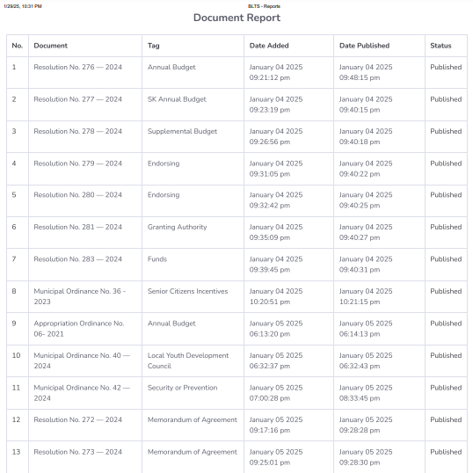

APPENDIX K
CERTIFICATE OF ACCEPTANCE



APPENDIX L
DOCUMENTATIONS

PREPARATION FOR TITLE DEFENSE



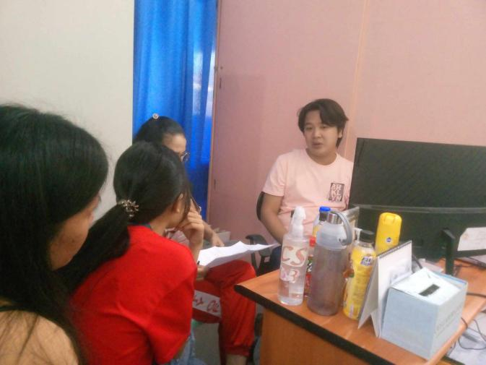


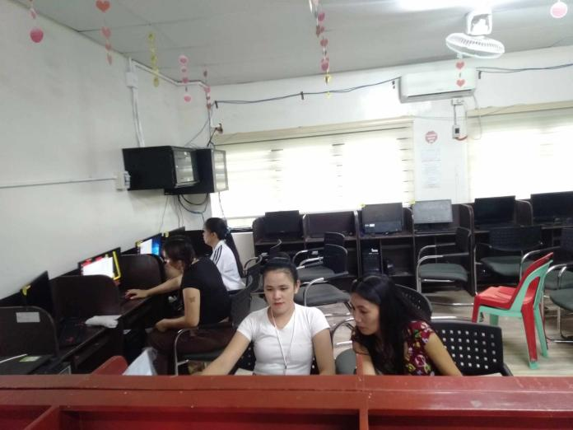
Interview in SB Office





PRE ORAL DEFENSE
Evaluate

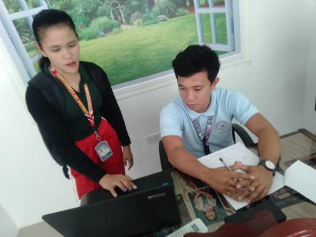
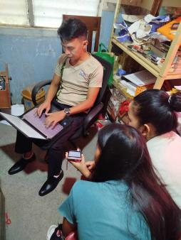
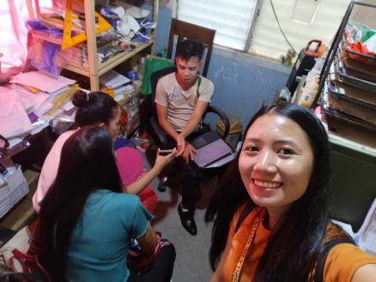
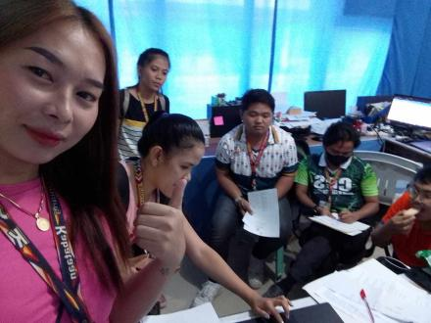
Statistician


FINAL DEFENSE

With Sangguniang Bayan Secretary



APPENDIX M
RESUME


ROSEVIC J. FORTIN
ADDRESS: San Francisco Norte, Tibiao, Antique
MOBILE NO: 09365536696
EMAIL: rosevic.fortin@antiquespride.edu.ph

OBJECTIVE:
Motivated and passionate college student eager to apply my skills and knowledge in information technology to make a meaningful contribution to your company and gain experiences.

PERSONAL INFORMATION:
Age : 21
Date of Birth : February 13. 2003
Place of Birth : San Francisco Norte, Tibiao, Antique
Gender : Female
Civil Status : Single
Religion : UCCP
Citizenship : Filipino
Father’s Name : Rande A. Fortin
Mother’s Name : Victoria J. Fortin

EDUCATION ATTAINMENT:
TERTIARY : BACHELOR OF SCIENCE IN INFORMATION TECHNOLOGY
University of Antique
Poblacion, Tibiao, Antique
(2021 - Present)

SECONDARY : TARIO LIM NATIONAL MEMORIAL HIGH SCHOOL
Poblacion, Tibiao, Antique
(2015 - 2021)

PRIMARY : SAN FRANCISCO NORTE ELEMENTARY SCHOOL
San Francisco Norte Tibiao, Antique
(2009 - 2015)

SKILLS

- Time Management
- Multitasking
- Teamwork and Collaboration
- Communication
ABILITY

- Punctuality
- Focus and Concentration
- Resilience

TRAININGS/ SEMINARS/ WORKSHOP ATTENDED

International Conference on Science and Computing
Cebu Normal University
One Central Hotel Cebu, City
October 28-30, 2024

Labor Education for Graduating Students (LEGS) and Pre- Employment Orientation Seminar (PEOS)
University of Antique Tario Lim Memorial Campus
Tibiao, Antique
November 5, 2024

REFERENCES

DELFIN CHRISTIAN BELIRAN
Part-time Instructor
University of Antique Tario Lim Memorial Campus
Tibiao, Antique

MAY LYNN M. FARREN Ph.D.TM.
Associate Dean, College of Computer Studies
University of Antique Tario Lim Memorial Campus
Tibiao, Antique

I hereby certify that the above information is true and correct to the best of my knowledge and belief.

ROSEVIC J. FORTIN
Applicant


JEROLETTE A. DOMINGO
ADDRESS: Tibiao, Antique
MOBILE NO: 09708863025
EMAIL: domingojerolette@gmail.com

OBJECTIVE:

To be part of this organization that offers excellent training for professional growth and development.

PERSONAL INFORMATION:
Age : 22
Date of Birth : October 16, 2002
Place of Birth : Malabor, Tibiao, Antique
Gender : Female
Civil Status : Single
Religion : Assembly of God
Citizenship : Filipino
Father’s Name : Rodrigo P. Domingo
Mother’s Name : Jarlita A. Domingo

EDUCATION ATTAINMENT:
TERTIARY : BACHELOR OF SCIENCE IN INFORMATION TECHNOLOGY
University of Antique
Poblacion, Tibiao, Antique
(2021 - Present)

SECONDARY : TARIO LIM NATIONAL MEMORIAL HIGH SCHOOL
Poblacion, Tibiao, Antique
(2015 - 2021)

PRIMARY : MALABOR ELEMTARY SCHOOL
Malabor, Tibiao, Antique
(2009 - 2015)

SKILLS
- Time Management
- Teamwork and Collaboration
- Adaptability

TRAININGS/ SEMINARS/ WORKSHOP ATTENDED

Labor Education for Graduating Students (LEGS) and Pre- Employment Orientation Seminar (PEOS)
University of Antique Tario Lim Memorial Campus
Tibiao, Antique
November 5, 2024

REFERENCES

DELFIN CHRISTIAN BELIRAN
Part-time Instructor
University of Antique Tario Lim Memorial Campus
Tibiao, Antique

MAY LYNN M. FARREN Ph.D.TM.
Associate Dean, College of Computer Studies
University of Antique Tario Lim Memorial Campus
Tibiao, Antique

I hereby certify that the above information is true and correct to the best of my knowledge and belief.

JEROLETTE A. DOMINGO
Applicant


JHUNNAFEL A. MAANO
ADDRESS: Purok 1, Martinez, Tibiao, Antique
MOBILE NO: 09675833891
EMAIL: jijienrile@gmail.com

OBJECTIVE:
To seek, learn, and gain experiences, and I am eager to utilize my skills and education for the growth of your industry.

PERSONAL INFORMATION:
Age : 23
Date of Birth : January 7, 2002
Place of Birth : Martinez, Tibiao, Antique
Gender : Female
Civil Status : Single
Religion : Roman Catholic
Citizenship : Filipino
Father’s Name : June M. Maano
Mother’s Name : Amfilfrida A. Maano

EDUCATION ATTAINMENT:
TERTIARY : BACHELOR OF SCIENCE IN INFORMATION TECHNOLOGY
University of Antique
Poblacion, Tibiao, Antique
(2021 - Present)

SECONDARY : TARIO LIM NATIONAL MEMORIAL HIGH SCHOOL
Poblacion, Tibiao, Antique
(2015 - 2021)

PRIMARY : Sta. Justa Elementary School
Tibiao, Antique
(2009 - 2015)

SKILLS
- Time Management
- Patient
- Communication and written skills

ABILITY
- Punctuality

TRAININGS/ SEMINARS/ WORKSHOP ATTENDED
Labor Education for Graduating Students (LEGS) and Pre- Employment Orientation Seminar (PEOS)
University of Antique Tario Lim Memorial Campus
Tibiao, Antique
November 5, 2024

REFERENCES

DELFIN CHRISTIAN BELIRAN
Part-time Instructor
University of Antique Tario Lim Memorial Campus
Tibiao, Antique

MAY LYNN M. FARREN Ph.D.TM.
Associate Dean, College of Computer Studies
University of Antique Tario Lim Memorial Campus
Tibiao, Antique

I hereby certify that the above information is true and correct to the best of my knowledge and belief.

JHUNNAFEL A. MAANO
Applicant


AL FRANCIS JAVISON
ADDRESS: Tibiao, Antique
MOBILE NO: 09656236559
EMAIL: alfrancis.javison@antiquespride.edu.ph

OBJECTIVE:
To secure a challenging position in a reputable organization to expand my learnings, knowledge, and skills.

PERSONAL INFORMATION:
Age : 24
Date of Birth : October 16, 2000
Place of Birth : Jinalinan, Bugasong, Antique
Gender : Transgender
Civil Status : Single
Religion : Roman Catholic
Citizenship : Filipino
Father’s Name : Allan Javison
Mother’s Name : Rhodora Javison

EDUCATION ATTAINMENT:
TERTIARY : BACHELOR OF SCIENCE IN INFORMATION TECHNOLOGY
University of Antique
Poblacion, Tibiao, Antique
(2021 - Present)

SECONDARY : ANTIQUE VOCATIONAL SCHOOL
Ilaya, Bugasong, Antique
(2019 - 2020)

PRIMARY : JINALINAN PALIWAN ELEMENTARY SCHOOL
Paliwan, Bugasong, Antique
(2009 - 2013)

SKILLS
- Communication Skills
- Encoding
- Powerpoint presentation
- Designing

ABILITY
- Creativity

TRAININGS/ SEMINARS/ WORKSHOP ATTENDED
Labor Education for Graduating Students (LEGS) and Pre- Employment Orientation Seminar (PEOS)
University of Antique Tario Lim Memorial Campus
Tibiao, Antique
November 5, 2024

REFERENCES

DELFIN CHRISTIAN BELIRAN
Part-time Instructor
University of Antique Tario Lim Memorial Campus
Tibiao, Antique

MAY LYNN M. FARREN Ph.D.TM.
Associate Dean, College of Computer Studies
University of Antique Tario Lim Memorial Campus
Tibiao, Antique

I hereby certify that the above information is true and correct to the best of my knowledge and belief.

AL FRANCIS JAVISON
Applicant


ANGEL REA ORCASITAS
ADDRESS: Bitadtun Sur, Culasi, Antique
MOBILE NO: 09636576982
EMAIL: orcasitasangelrea@gmail.com

OBJECTIVE:

Seeking a challenging opportunity where I will be able to utilize my strong organizational skills, educational background and ability to work well with people, which will allow me to grow personally and professionally.

PERSONAL INFORMATION:
Age : 26
Date of Birth : February 22, 1999
Place of Birth : Bitadtun Sur. Culasi. Antique
Gender : Female
Civil Status : Single
Religion : IFI
Citizenship : Filipino
Father’s Name : Reynaldo P. orcasitas
Mother’s Name : Edna D. Orcasitas

EDUCATION ATTAINMENT:
TERTIARY : BACHELOR OF SCIENCE IN INFORMATION TECHNOLOGY
University of Antique
Poblacion, Tibiao, Antique
(2021 - Present)

SECONDARY : Bitadtun National High School
Bitadtun Sur. Culasi. Antique
(2013 - 2019)

PRIMARY : Bitadtun Elementary School
Tibiao, Antique
(2007 - 2013)

SKILLS
- Time Management
- Computer Skills

ABILITY
- Punctuality

TRAININGS/ SEMINARS/ WORKSHOP ATTENDED
Labor Education for Graduating Students (LEGS) and Pre- Employment Orientation Seminar (PEOS)
University of Antique Tario Lim Memorial Campus
Tibiao, Antique
November 5, 2024

REFERENCES

DELFIN CHRISTIAN BELIRAN
Part-time Instructor
University of Antique Tario Lim Memorial Campus
Tibiao, Antique

MAY LYNN M. FARREN Ph.D.TM.
Associate Dean, College of Computer Studies
University of Antique Tario Lim Memorial Campus
Tibiao, Antique

I hereby certify that the above information is true and correct to the best of my knowledge and belief.

ANGEL REA ORCASITAS
Applicant

REFERENCES

