C H A P T E R 1
INTRODUCTION

Background of the Study
Bugasong, a growing municipality in Antique province, envisions a better life for its people through culture and sustainable development. The local government oversees twenty-seven barangays, aspiring to restore the town's cultural and economic prominence. It has a total population of 22,713 based on the 2024 Census of Population (POPCEN) of the Philippine Statistics Authority (PSA, 2024), and it implemented a total of 127 resolutions and ordinances in 2024, based on the records of the Sangguniang Bayan Office.
Facing challenges in legislative processes, Bugasong struggles with managing resolutions and ordinances efficiently. The manual system in place limits transparency, accessibility, and overall legislative efficiency. Based on the interview and survey, there was no efficient way for the public to access ordinances and resolutions. Meanwhile, the staff of the Sangguniang Bayan had difficulty storing and searching for specific documents. One of the elected officials interviewed by the researcher also mentioned that they would like to gather the reactions and feedback of citizens regarding the local laws being implemented. They would also like to know the suggestions and thoughts of the people regarding legislative matters for the betterment of their municipality. In storing and managing resolutions and ordinances, the office of the Sangguniang Bayan often uses Microsoft Excel and Microsoft Word to organize and access the documents. According to the designated recorder, they published and paid for publication in a newspaper to inform the public. If someone requested a copy of these documents, they searched in the Excel and Word files and printed it out.
The researchers proposed a system that aimed to replace physical archives with a digital repository for better document management. Recognizing the need for modernization, this project introduced the Legislative Tracking System for Bugasong, Antique.

Statement of the Problem
- Resolutions and ordinances are hard to retrieve in hard copy form, susceptible to damage from wear and tear and natural calamities.
- Difficulty in searching for existing documents leads to the duplication of resolutions and ordinances.
- Public dissemination is challenging as not everyone reads documents posted in public areas.
- Lack of a system to recognize text in scanned documents, making it hard to convert files into digital text formats.
- Absence of a forum or feedback section to gather thoughts and sentiments of Bugasong Residents.

General Objectives
This study aimed to develop a Legislative Tracking System for Bugasong, Antique, with the goal of streamlining the search and storage of legislative documents. The system was intended to simplify access to ordinances and resolutions, thereby improving efficiency for both the municipality and its citizens.
Specific Objectives:
- Create a secure platform for storing resolutions and ordinances in both text and scanned formats.
- Implement user-friendly search functions for quick and precise retrieval of documents based on keywords, dates, or other relevant criteria.
- Establish a transparent platform for citizens to access and view resolutions and ordinances, promoting informed participation.
- Incorporate Optical Character Recognition (OCR) technology to recognize text in scanned documents, facilitating easy conversion into digital text files.
- Integrate a forum or feedback section with sentiment analysis to collect thoughts and sentiments from the people of Bugasong.

Conceptual Framework
The Bugasong Legislative Tracking System (BLTS) was illustrated through a schematic diagram representing its conceptual framework. The process began with the verification of admin/staff credentials, ensuring secure access to the system. Following this, existing hard copy resolutions and ordinances underwent digitization, a critical step for efficient document management. Optical Character Recognition (OCR) technology was then applied to the scanned documents, enhancing text recognition for improved search capabilities. The integration of user-friendly search functionalities facilitated quick and precise document retrieval. A feedback mechanism was established through an email-authenticated forum, promoting citizen engagement and transparency. Sentiment analysis was applied when citizens posted feedback or insights to determine the emotional tone and sentiment conveyed. The system concluded with the creation of a secure and organized centralized repository, providing a digital platform for the storage and easy access of Bugasong's legislative documents. This schematic diagram summarized the comprehensive and efficient workflow of the Bugasong Legislative Tracking System, contributing to the modernization of Bugasong's legislative processes.

< Admin/Staff >
- Email Address
- Password
- Existing Resolutions and Ordinances
- Feedback from Citizens
- Scanned Documents
- Keywords and Criteria

< Public View >
- Search Criteria
- Feedback
  - Email-authenticated forum
- Verification of username and password
- Conversion of hard copy documents into digital formats.
- Apply OCR technology to recognize text in scanned documents.
- Integration of search functionalities for quick and precise document retrieval.
- Feedback mechanisms
- Secure and organized Centralized Repository
- Sentiment Analysis
Bugasong Legislative Tracking System (BLTS)
Evaluation ISO 25010
Input Process Output

Figure 1. The figure above displays a schematic Diagram that illustrates the Conceptual Framework of Bugasong Legislative Tracking System.

Figure 1 illustrated the process of input and output, showing how the system functioned. It began with inputs, which passed through a series of processes and resulted in outputs. The inputs handled by the admin included login information, scanned documents of ordinances and resolutions, citizen feedback, and search keywords or criteria. In the process phase, these inputs underwent verification, conversion of scanned documents into text format using Optical Character Recognition (OCR), application of search functionality, implementation of a feedback mechanism, secure storage in a centralized repository, and sentiment analysis. The outputs generated from these inputs and processes led to the development of the proposed system—the Bugasong Legislative Tracking System.
Definition of Terms
The following terms used in this study have been defined operationally to ensure clarity and a better understanding:
Digital Repository: As used in this study, refers to an online platform where admin, can upload, search, and download legislative documents. It ensures that these documents are digitally preserved and accessible remotely by authorized users.
Email-authenticated Forum: As used in this study, it refers to an online discussion platform where users participate by using their email credentials, offering a secure space for contributing to discussions and sharing opinions.
Feedback Mechanism: As used in this study, it refers to a system, such as an email-authenticated forum, that allows users to share thoughts and feedback, providing a means for citizen engagement and communication.
Legislative Tracking System (LTS): As used in this study, it refers to a tailored digital tool specifically designed to help track and manage legislative documents. It simplifies and organizes the legislative process by enabling to easily input, monitor, and retrieve key documents such as resolutions and ordinances.
Optical Character Recognition (OCR) Technology: As used in this study, it refers to a technology that allows the conversion of scanned documents into editable and searchable data, making it easier to work with and retrieve information from these documents.
Scanned Documents: As used in this study, this refers to digitized copies in PDF format of original hard copy legislative materials such as ordinances and resolutions that are uploaded to the Bugasong Legislative Tracking System for archiving, tracking, and public access purposes.
Secure and Organized Centralized Repository: As used in this study, it is a protected, well-organized central location where digital legislative documents are stored, ensuring their safety, easy management, and accessibility for authorized users.
Sentiment Analysis: As used in this study, it refers to the use of computational techniques to automatically analyze citizens' posts in a forum and determine the sentiment or emotional tone expressed in each piece of text.
Transparent Platform: As used in this study, it is an open and user-friendly digital space designed for citizens to easily access and view legislative documents, promoting transparency and information sharing.
Significance of the Study
The result of this study benefited the following group of people in the community or municipality:
People in the community. This study helped the people in the community track the ordinances and resolutions implemented by the mayor, vice mayor, and SB officials. It made them aware of the laws in place, and enabled them to file complaints about occurrences around them that were against the law.
Mayor. This study helped the municipal mayor enhance transparency in governance by making legislative records accessible and accountable to the public and other officials.
Vice Mayor. This study helped the presiding officer improve legislative management and coordination with SB members, and supported leadership in legislative activities.
SB Members. This study provided the Sangguniang Bayan (SB) members faster access to documents, streamlined the legislative process, and enhanced collaboration and accountability.
Future Researchers. This study may be cited as a reference to create new related research for future research studies specifically about legislative tracking in the municipality through system.

Scope and Limitations
The Bugasong Legislative Tracking System (BLTS) was designed to address specific challenges in the legislative processes of Bugasong, Antique, with a focus on enhancing transparency, accessibility, and efficiency. The system worked by digitizing and organizing ordinances and resolution documents, making them accessible to both municipal staff and the public. There were two types of users: admins and citizens. The system utilized Optical Character Recognition (OCR) for uploading scanned documents, enabling them to be converted into machine-readable text. It also incorporated sentiment analysis to analyze and determine the tone and behavior of posts made by either admin or citizens in the feedback forum. Public users could easily search for and access resolutions or ordinances, even if they were scanned documents.
The system's scope included the digitization of existing hard copy resolutions and ordinances, the implementation of OCR technology for text recognition in scanned documents, and the creation of a centralized digital repository for secure storage. Additionally, the BLTS integrated user-friendly search functions, enabling quick and precise retrieval of legislative documents based on keywords, dates, and other relevant criteria. The system aimed to establish a transparent platform, allowing citizens to access and view resolutions and ordinances, promoting informed participation and civic engagement. Furthermore, the BLTS incorporated a feedback mechanism with sentiment analysis through an email-authenticated forum to collect thoughts from Bugasong residents, encouraging citizen engagement and transparency.
However, it was important to acknowledge certain limitations. First, users were required to have access to compatible devices and a reliable internet connection. This meant that for the system to work properly, users had to use devices like a computer, smartphone, or tablet that could support the system. These devices needed to meet certain requirements, such as having a compatible operating system or browser, to ensure everything worked as it should. An internet connection was required to perform tasks like sentiment analysis, and the system operated entirely through the internet, allowing users to access it from any device with a compatible browser and internet connection. Second, the system could not guarantee a hundred percent awareness of the ordinances and resolutions, as it depended on people's interest in knowing about them. The system simply offered an additional means of making the documents available and easy to access. Third, the accuracy of Optical Character Recognition (OCR) technology was subject to the clarity of the printed text in scanned documents; if the text was not clear, accurate conversion to digital text could be compromised. Lastly, in sentiment analysis, several limitations could affect the accuracy and reliability of the results, including difficulty with context sensitivity (e.g., sarcasm), ambiguity in word meanings, and challenges in interpreting sentiment across different languages, dialects, or cultural nuances. Despite these challenges, the BLTS aimed to bring a modernized approach to Bugasong's legislative processes, continually improving and considering user feedback to shape future enhancements.

C H A P T E R 2
REVIEW OF RELATED LITERATURE
This chapter provided an overview of relevant literature, systems, and studies, both local and international, that were pertinent to this research. The sources included contributed to a better understanding of information related to and aligned with the current study.
Foreign Studies
Legislation Information System
As stated by Perbangsa et al. (2018), the implementation of legislation processes still faces obstacles, ranging from submitting legislation programs to publication, which is still done manually and in hard copy form. From the list of approved legislation, only a few people can access it. This is due to the lack of publication and limited access to the public. The study intends to develop a system model that manages the legislation process, from proposing legislation to harmonization and publication. The model of the legislative system presented in this study can facilitate legislative activities in government.
eGaz: Enhanced Search Engine for Gazette Publication
The government of Sri Lanka intends to acquire an official website for legislation management (Mendis et al., 2022). Through the gazette implemented by the government, the government can facilitate the legislation accordingly. A government gazette is a periodical distribution that has been approved to be distributed to the public or legitimate takes note. Presently, government gazettes are published on the official website with the facility of downloading individual files in portable document format. Even though these gazettes are categorized into a few types, individual gazettes contain a diverse amount of material from various sectors of the government, making it harder for the reader to search for their preferred information without reading the complete file. This study introduced the development of an enhanced search engine for gazette publications to address this problem as a possible convenient solution. The system is able to scrape gazette files from the official website, which is followed by a progression of text extraction, summarizing and clustering the extracted data, and hoarding them in a distributed system.
Using OCR Framework and Information Extraction for Thai Documents Digitization
Digital transformation has taken into account any businesses, so the data has been stored and structured into usable format for analytic purposes. However, some data has been stored in the format of hard copies, scanned documents, images, and PDFs, which need to be transformed into digital form for future use. The objective of this paper is to propose a technique for recognizing text from a physical document in digital format by using optical character recognition, also called OCR, which attempts to extract all the text from photocopies into a database structure (Chumwatana and Rattana-umnuaychai , 2021).
Local Studies
LeMTrac: Legislative Management Tracking System
Information and communications technology (ICT) has rationalized government services into a more efficient and transparent government (Pandes et al., 2018). However, a large part of government services remained constant in the manual process due to the high cost of ICT. The purpose of this paper is to explore the role of e-governance and ICT in the legislative management of municipalities in the Philippines. This study adopted the phases of Princeton Project Management Methodology (PPMM) as the approach in the development of LeMTrac.
OCR Based Document Archiving and Indexing Using PyTesseract: A OCR Based Management System for DSWD Caraga, Philippines
Jayoma et al. (2020) addressed the problems in managing multiple records of the Department of Social Welfare and Development (DSWD) Caraga, which continuously generates records daily. Still, their records management system is conventional, giving them a hard time retrieving and keeping track of the record's whereabouts. With this, DSWD Caraga embarks on record's digitization for its management to ensure the preservation of permanent and valuable papers, secured and accessible for future reference as required by the organization's different offices based on existing rules and regulations in records management. This paper endeavors to automate record classification using the open-source Python-Tesseract (PyTesseract) library, the wrapper for Google's Tesseract-OCR Engine. The process starts by converting paper-based documents into digital format (scanning) and then recognizing and extracting the text using the PyTesseract library. By integrating this library with Django and MySQL, management of record's classification, indexing, and archiving becomes easy. With the help of this system, record's safekeeping and retrieval bring comfort to the records officer.
Prior Arts
OCR System Evaluation Method, Apparatus and Device, and Readable Storage Medium
Publication: WO2022100452A1
Provided are an OCR system evaluation method, apparatus and device, and a readable storage medium. The method comprises: obtaining a training image, inputting the training image into an initial OCR system, so as to train the initial OCR system, and to obtain a corresponding OCR system after the training of the initial OCR system is completed (S10); inputting an image to be recognized into the OCR system to determine a character recognition result corresponding to the image on the basis of the OCR system (S20); and determining a character recall rate corresponding to the OCR system and a character recognition accuracy rate corresponding to the OCR system on the basis of the character recognition result and actual annotation data corresponding to the image, and calculating an evaluation index of the OCR system on the basis of the character recall rate and the character recognition accuracy rate so as to evaluate the performance of the OCR system on the basis of the evaluation index (S30). The problem in the prior art that character detection and character recognition are separately and independently evaluated, and consequently evaluation indexes cannot objectively reflect the overall performance of an OCR system is solved.
System For Optical Character Recognition (OCR)
Publication: EP3611664A1
A system for optical character recognition (OCR) from an image containing text shall minimize transcription errors and improve the quality of the resulting machine-encoded text. To this end, the system comprises:- a text area dispatcher module, connected to a collection of OCR engines (aTR1, aTR2,...aTRn), and configured to allocate said image as input to a plurality of said OCR engines (aTR1, aTR2,...aTRn) and receive machine-encoded texts as output from each of said plurality of said OCR engines (aTR1, aTR2,...aTRn), and- an OCR validation engine module, configured to receive said machine-encoded texts and assign a confidence level to each of said machine-encoded texts, wherein said text area dispatcher module is further configured to receive said confidence levels from the OCR validation engine module, wherein said plurality of said OCR engines (aTR1, aTR2,...aTRn) is a proper subset of said collection of OCR engines (aTR1, aTR2,...aTRn), and wherein said text area dispatcher module is further configured to choose said plurality of said OCR engines (aTR1, aTR2,...aTRn) based on previously received confidence levels.
Extract Data From A True PDF Page
Publication: US2023065934A1
The system may perform a method comprising analyzing metadata of a text layer of a page of a first pdf document to determine that the pdf document is a first true pdf document; receiving the first true pdf document, in response to the first pdf document being the first true pdf document; receiving a selection of a field including first data to be extracted from the first true pdf document; displaying the first data; creating a template including the coordinates corresponding to the selected field and the first data of the first true pdf document; and extracting from an accessible text layer of a second true pdf document, second data based on the template from the first true pdf document.

Summary
The study conducted by Perbangsa et al. (2018) addressed issues in the implementation of legislative processes, particularly the lack of publication and limited public access. The system presented in their study aimed to solve the problems faced in the publication process, which was still being done manually and in hard copy form. With the help of the system, legislative processes became more convenient, accessible, and effectively managed.
The study of Mendis et al. (2022) addressed the need to enhance the search functionality of government gazettes. Its goal was to facilitate the searching of preferred documents. The proposed solution to this issue was the development of an enhanced search engine for gazette publications, known as eGaz.
According to Chumwatana and Rattana-umnuaychai (2021), the storage of hard copy formats, images, and PDFs needs to be transformed into digital form for better use in the future. Their paper introduced the use of optical character recognition (OCR) for extracting text from a physical form or soft copy into a database structure or digital form. This will make the digitized documents searchable and editable when storing documents.
The study of Pandes et al. (2018) aimed to develop a legislative management and tracking system within the Sangguniang Bayan (SB) Office in the Municipal Local Government Units (LGU) of Nabua and Bula, Camarines Sur to address the need of the municipality for the improvement of government services manual processes in a more efficient and transparent way.
Jayoma et al. (2020) addressed the problem of time-consuming retrieval and tracking of records in the records management system of the Department of Social Welfare and Development (DSWD) at Caraga, Philippines. They embark on the digitization of records management and endeavors to automate record classification by integrating the open-source Python-Tesseract (PyTesseract) library to help recognize and extract the text.
The OCR system evaluation method described in patent WO2022100452A1 explains the process of recognizing and training images to determine the result on the basis of the OCR system. This system obtains and trains the image into an OCR system, determines a character recognition result, and determines its accuracy rate.
A system for optical character recognition (OCR) from an image containing text shall minimize transcription errors and improve the quality of the resulting machine-encoded text, as stated by patent EP3611664A1. It described the work of OCR engines from image to encoded text for the validation of the OCR engine module based on the received confidence level.
Based on patent US2023065934A1, the system may analyze metadata of a text layer of a PDF document to extract data. A selection of a field receiving the extracted first data from the first true PDF document.
In comparison, the proposed study, Bugasong Legislative Tracking System, shares common goals with the studies by Pandes et al. (2018), Mendis et al. (2022), Perbangsa et al. (2018), Chumwatana and Rattana-umnuaychai (2021), and Jayoma et al. (2020) in terms of publishing and tracking legislative documents. Meanwhile, the BLTS incorporate OCR for easy searching or tracking of the documents. Unlike LeMTrac by Pandes et al. (2018), which focuses on legislative management, the BLTS purpose is to securely store ordinances and resolutions and facilitate the easy retrieval of documents. In eGaz by Mendis et al. (2022), the aim is to enhance the searching of legislative documents, while the BLTS incorporates optical character recognition (OCR) to facilitate the recognition and conversion of scanned documents into digital text files for better tracking of documents. The Perbangsa et al. (2018) study addresses the publication and accessibility of legislation similar to the objectives of BLTS, but the difference is that BLTS integrates forums or feedback from the people or citizens. Chumwatana and Rattana-umnuaychai (2021) and Jayoma et al. (2020) both introduced OCR to convert documents into digital format for better document management, and the same with BLTS but it is not limited to the management of legislation but also for tracking legislative precisely. The OCR system, on the basis of WO2022100452A1, EP3611664A1, and US2023065934A1, and the Bugasong Legislative Tracking System (BLTS), all integrated OCR to recognize images or scanned documents to result in digital text. However, BLTS can upload files and track the text by using OCR. None of the reviewed studies combined OCR-based digitization, public access to legislative documents, and a sentiment-moderated citizen feedback forum for a Philippine municipal Sangguniang Bayan, which is the gap that this study addressed.

OVERVIEW OF THE REVIEWED SOURCES
Research Title and Author | Country of Origin | Purpose/Objective | Type of Source | Summary Points
Legislation Information System Perbangsa et al. (2018) | Indonesia | Legislation process management and accessible for people | Journal Article | - Access to the public  - Proposing, harmonization and publication of legislation
eGaz (Enhanced Search Engine for Gazette Publications)  Mendis et al. (2022) | Sri Lanka | Enhanced the search functionality | Journal Article | - Scrape gazette files from the official website  - Allow the public to view and download in portable document format
Using OCR Framework and Information Extraction for Thai Documents Digitization  Chumwatana & Rattana-umnuaychai (2021) | Thailand | Recognizing the text from physical document into digital format | Journal Article | - Use OCR to extract the text
LeMTrac (Legislative Management and Tracking System)  Pandes et al. (2018) | Philippines | Explore the role of e-governance and ICT in the legislative management | Journal Article | - Legislative management

OCR Based Document Archiving and Indexing Using PyTesseract: A Record Management System for DSWD  Jayoma et al. (2020) | Philippines | Record’s digitization for its management. | Journal Article | - Automate records classification using Python-Tesseract library
OCR System Evaluation Method, Apparatus and Device, and Readable Storage Medium  Gao & Xu (2022) | China | Recognize image in OCR system. | Patent | - Character Recognition of image
System For Optical Character Recognition (OCR)  Schreiber et al. (2020) | European Patent Office | Image containing text shall minimize transcription errors and improve the quality of the resulting machine-encoded text. | Patent | - Input image in OCR engines to result in machine-encoded text
Extract Data From A True PDF Page  Srinivas (2023) | USA | Perform a method for extracting data from an accessible text layer of PDF document. | Patent | - Extract text from PDF document
Table 1: Overview of the Reviewed Source
Table 1 presents and organizes data in a summary format of related literature relevant to this study for clearer understanding.

SUMMARY OF FEATURES

Functionality  /Features | BLTS | LeMTrac | eGaz | Legislation Information System | Thai Document Digitization | Record Management System | Prior Art 1 | Prior Art 2 | Prior Art 3
Document Management
Search Functionality
Document Viewer
Citizen Access
OCR
Feedback or Forum with Sentiments Analysis


Table 2: Summary of Features

Table 2 shows the summary of features of Bugasong Legislative Tracking System and other related studies. It highlights the similarities and differences between the functionalities of the Bugasong Legislative Tracking System and those of related studies.

C H A P T E R 3
RESEARCH METHODOLOGY
Project Description
In Bugasong, several challenges hindered the effective management and dissemination of resolutions and ordinances. Physical copies of these documents had been difficult to access and were at risk of damage due to wear and tear or natural disasters. The process of searching for existing documents had been inefficient, often leading to the duplication of efforts. Additionally, public access to resolutions and ordinances had been limited, as not everyone had read the documents posted in public areas. The absence of a text recognition system for scanned documents had further complicated the conversion of physical files into digital formats. Moreover, there had been no platform in place to gather feedback or sentiments from residents, making it harder to engage the community in decision-making processes. These issues had highlighted the need for a more efficient and accessible system to manage and share public records.
The proposed Bugasong Legislative Tracking System had aimed to replace physical archives with a digital repository to improve document management and tracking. It had been designed to make it easier to access and view various ordinances and resolutions of the municipality. The system had addressed problems related to storing, searching, and disseminating legislative documents, recognizing text in scanned documents, and gathering the sentiments of the people.
The admin had managed legislative documents by publishing and digitizing them using OCR technology. They had also been able to monitor the digitization status and manage existing records. In handling hard copy documents, OCR had been applied to scanned files to convert them into digital text formats. The documents had then been published to ensure they were accessible to users and that only verified and accurate versions were made available for viewing. Users had been able to view and search for specific documents using keywords, date ranges, and document types. Search results had displayed matching documents with options for viewing, downloading, and printing. A feedback forum had also been available for users to discuss and provide input on legislative matters.
Development Process
The researchers used the mixed-method approach and employed the Agile Model as research design, as it was suitable for web-based systems and emphasized continuous collaboration and improvement. It allowed for easy changes based on user feedback to better meet their needs and help avoid mistakes. The Agile framework used by the researchers was Scrum, a management approach that enabled the team to work together in an efficient and organized way. The process was divided into five distinct phases: initiation, planning and estimates, implementation, review and retrospective, and the release phase (Donato, 2023).

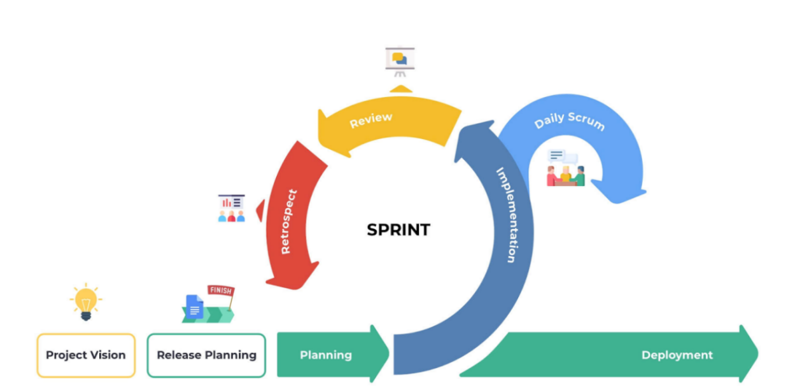
Figure 2: Diagram of Scrum Methodology
The diagram in Figure 2 illustrates the sequence of activities for the project's development.
Phase 1:Initiation
This phase was one of the most critical steps of the Scrum methodology. During this phase, the team created the project’s vision, essentially outlining a roadmap with the main objectives, goals, and deliverables. The stakeholders identified in this project were Sangguniang Bayan members and people in the community. This also included assigning team members to each role in developing the project and determining the product backlog. The project vision helped align the team’s efforts with the end goal, ensuring that every Sprint and backlog item contributed to realizing the vision. The researcher first identified the problem in the office of Sangguniang Bayan in Bugasong. The objectives and the system functionality were identified and presented to the stakeholders for suggestions and improvements. The researcher’s team developed a tracking system of ordinances and resolutions.
Phase 2: Planning and Estimates
In this stage, the researchers conducted interviews with the organization to determine the problems faced by the stakeholders. They conducted interviews with the Sangguniang Bayan (SB) member and staff. After analyzing the data collected through the interviews, the sprint goal was to develop a system with features that could easily track scanned documents of ordinances and resolutions. The team selected and reviewed backlog items for the sprint, such as:
User story 1: Can upload and store PDF files
User story 2: Can manage publish documents, user, and forum.
User story 3: Citizens can access and track the scanned documents.
User story 4. Citizens can participate in forum section and post any topic regarding the local laws.
During this phase, the team did the sprint planning and identified which user stories could be accomplished during the sprint, which was called the sprint backlog. The team estimated the time it would take to complete each sprint and which elements the team would deliver in due time. The sprint backlog identified by the team were the following:
- Display recent documents uploads and user activities.
- Upload, edit, delete, and digitize documents with OCR integration.
- Advanced search options (keywords, date range, document type).
- OCR text overlay for scanned documents to enable text selection and copying.
- User-friendly interface for browsing and viewing documents, participating in the feedback forum.
- Email-authenticated posting and responses, topic-based discussions.
- User role management, system configuration, and report generation.

Hardware Requirements | Software Requirements
- 16 - 64 GB RAM  - Intel Core i5 or i7  - Windows 10/11 | - HTML  - PHP  - MySQL and Apache  - Web Browser
Table 3: Hardware and Software Requirements
Use Case Diagram
A use case diagram is a representation of a user’s interaction with the Bugasong Legislative Tracking System that shows the interpretation between the user and the different object in which the user is involved.
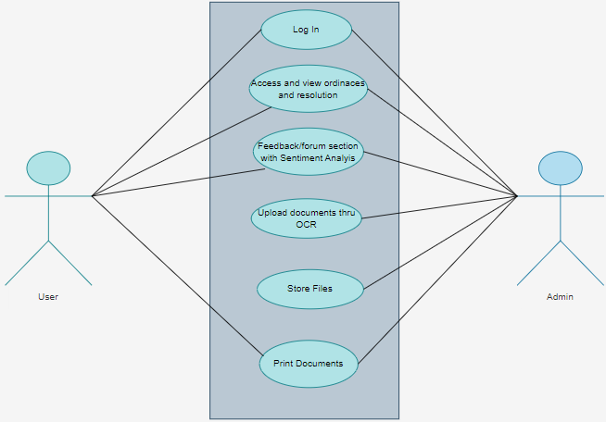Figure 3: Use Case Diagram of Bugasong Legislative Tracking System
Figure 3 shows how the researchers produced the two actors, which are the user and the administrator. The citizen serves as a user, wherein they will benefit from the system, while the administrator is the one who manages the legislative documents and feedback or forum. The citizen can sign in, search for particular documents, and view ordinances or resolutions. The user can also post feedback or comments in the forum section that the post submitted analyze first by the sentiments analysis. While the administrator can sign in, upload documents through OCR, and manage legislative documents. The admin can also create topics in a forum and manage the forum.
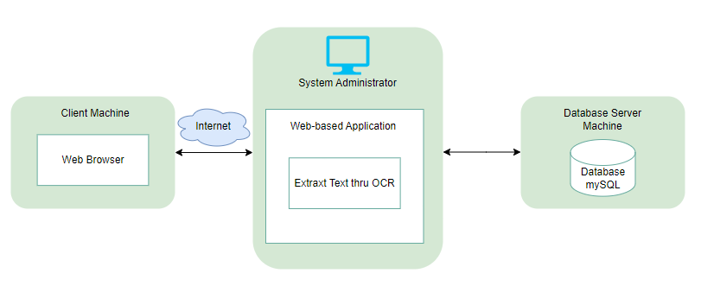
Figure 4: System Architecture Diagram
Figure 4 shows the system architecture diagram of BLTS. It shows how the users and components communicate and interact with each other.
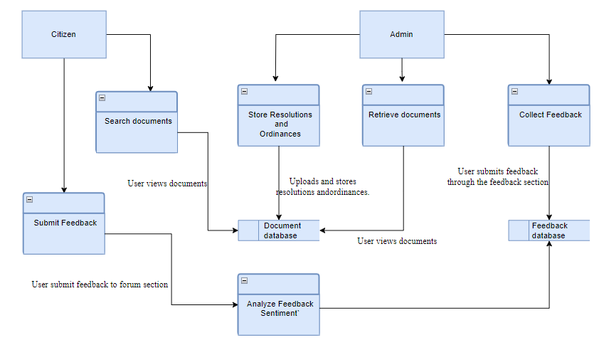
Figure 5: Data Flow Diagram
Figure 5 shows the data flow diagram of Bugasong Legislative Tracking System. The researchers used Gane and Sarson symbols to show the flow of process of the system. The four components of this diagram are external entity in a rectangle symbols, process represent in rectangles with rounded corners, data store represent in the open ended rectangles, and arrow as the data flow. Citizen can search any documents of ordinances and resolution and view the scanned documents. Also, citizen can also create feedback topic and then submit. While admin, upload a file from local storage and extract by Optical Character Recognition to text format. Admin can also manage the users and forum.

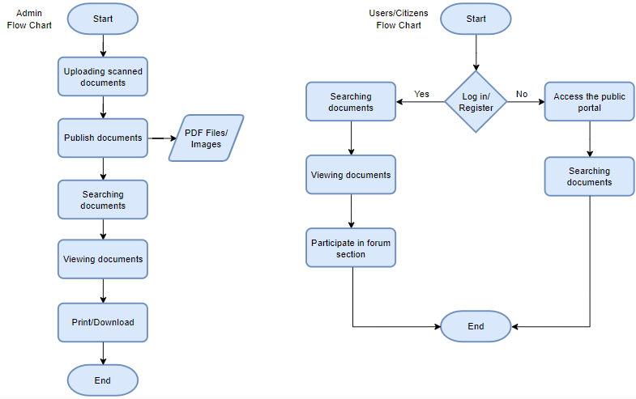
Figure 6: Flow Chart Diagram
Figure 6 shows the flow chart diagram of Bugasong Legislative Tracking System. It contains four (4) symbols such as process symbol, start/end symbol, decision symbol, and input/output symbol. The flow of this system process in admin is uploading a documents, decide if it is to publish or not, searching of documents, and print/download if necessary. For citizens users, they can access and view documents, and can post feedback or any insights.
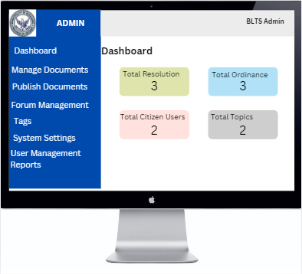
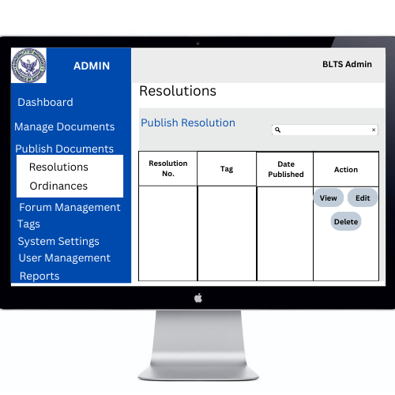
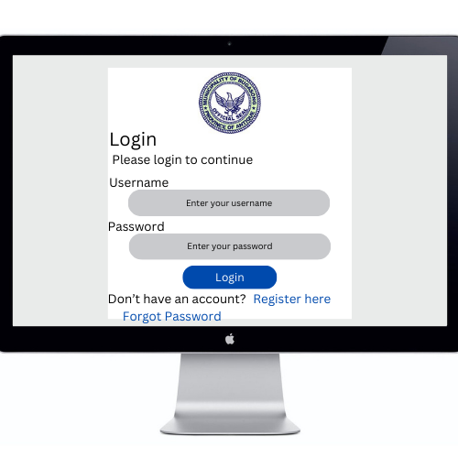
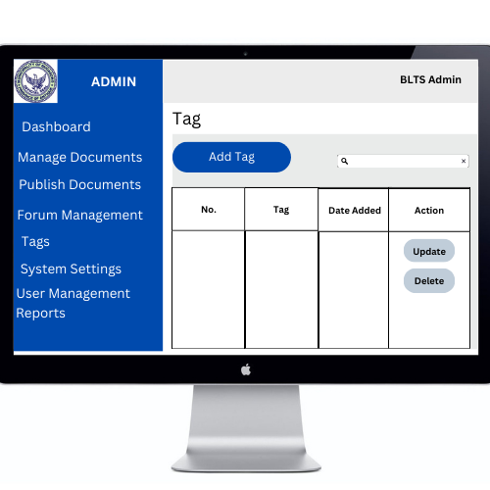
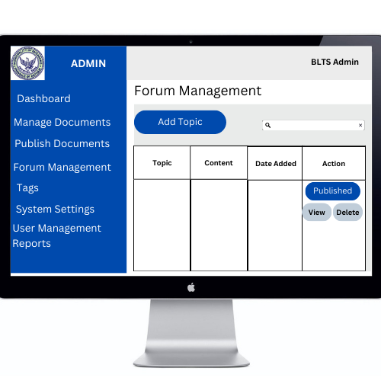
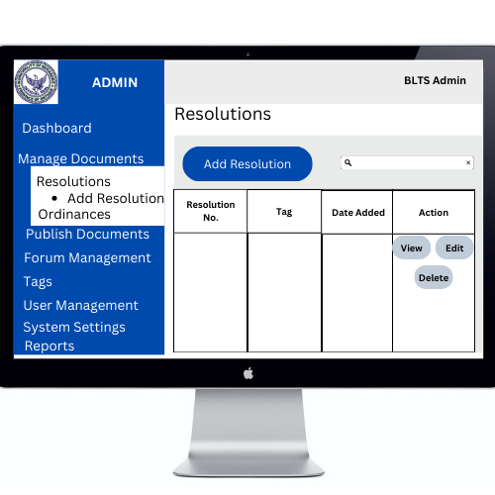
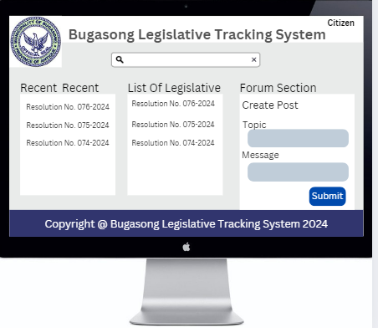
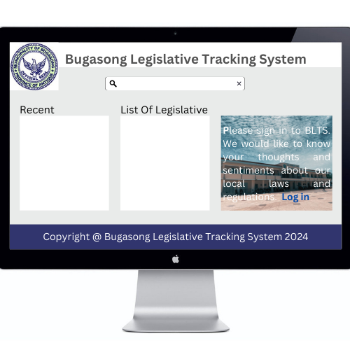
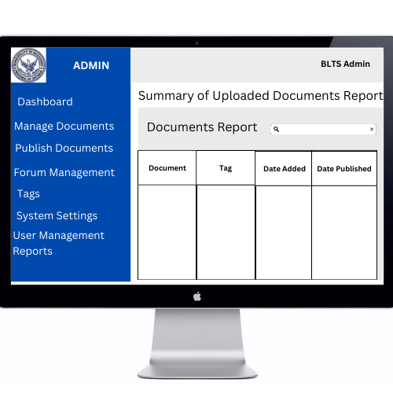
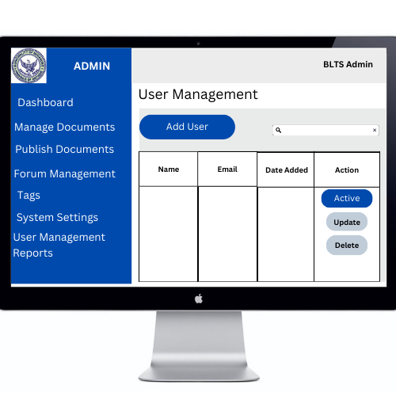
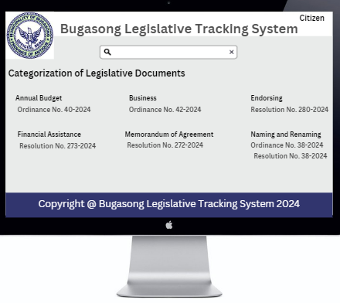
Figure 7: Wireframe
Figure 7 shows the wireframe of the system that represents the basic structure and layout of its user interface that designed to manage and analyze public feedback or documents.
Phase 3: Implementation
This phase focused on the execution of the tasks and activities of users in the system. The team’s daily stand-up meetings and burndown chart monitoring were the fundamental Scrum processes during this stage. Daily stand-up meetings were regular touchpoints that the team used to check the task status of the Bugasong Legislative Tracking System, align on sprint progress, and identify possible issues. These meetings occurred two (2) to three (3) times a week. Burndown charts were graphs that illustrated how much the team had completed compared to how much they were expected to accomplish.
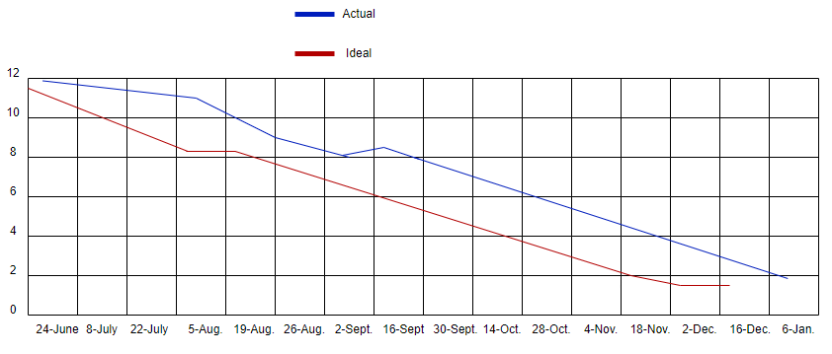
Figure 8: Burn-down Chart
Figure 8 shows the time and task in developing the project. It components are X-axis - time remaining until the project deadline, Y-axis - amount of tasks, Ideal work remaining - illustrates the perfect pace of the team, and Actual time remaining - tracks the team’s actual progress in real-time.
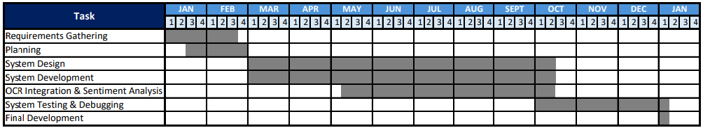
Figure 9: Gantt Chart
Figure 9 illustrated the start and end dates of individual tasks across a timeline. The first column showed the list of activities or tasks based on the stages of development of the Bugasong Legislative Tracking System, while the remaining columns displayed the timeline of development.
Phase 4: Review and Retrospect
The review and retrospective phase was an essential part of the Agile Scrum process and was conducted after each sprint ended. It provided an opportunity to evaluate what had been successful, what could have been improved, and how to move forward by gathering user feedback and team insights. The sprint review allowed stakeholders and team members to assess the project’s progress. The sprint retrospective provided a chance to reflect on their experience, share their thoughts, and decide how to optimize the process.
Sprint 1: Login form, login function, registration form, dashboard, search function with parameters, document viewer, document management, publish documents, admin panel are done successfully.
Sprint 2: Creating citizen portal, and forum section.
Sprint 3: Integration of OCR. Uploading scanned documents and extraction of text and files.
Sprint 4: Changes in placing buttons, and combining buttons with the same function.
Sprint 5: Add homepage for users to view the ordinances and resolutions even without account.
Sprint 6: Adding attachment in database column.
Sprint 7: Introducing and showing the system to stakeholders. Gathering their feedback and suggestions.
Sprint 8: Changes in forum management, admin should check first the post submitted by the users.
Sprint 9: Creating menu in citizens portal for easy navigation, and changing background color in citizen homepage.
Phase 5: Deployment
This phase, also known as the release phase, was the final step in the Scrum methodology and focused on preparing the final project deliverables and turning them over to the relevant stakeholders. In this stage, the project team planned when to hand over the Bugasong Legislative Tracking System to the stakeholders, along with formal Working Deliverables Agreement documents upon the successful completion of the release. Afterwards, the stakeholders and Scrum team members assembled to reflect on the release and to identify, document, and internalize the lessons learned, which often led to improvements for future projects.
Project Evaluation
An assessment was conducted to confirm that the Bugasong Legislative Tracking System complies with the ISO/IEC 25010 software product quality model. It offers standards for assessing interactive systems' satisfaction, effectiveness, and efficiency. It was used to compile the evaluators' opinions and consists of thirty-one (31) sub-characteristics.
Respondents of the Study
Purposive sampling was applied to determine the evaluators of the study. It allows researchers to carefully select participants who will willingly provide insights for the research study. In selecting participants, the researchers consider factors such as willingness, availability, or ease of access or approach.
The researchers selected a total of thirty (30) participants to evaluate and test the system, consisting of eight (8) Sangguniang Bayan (SB) members or staff from Bugasong Municipality, seven (7) members of the local community, and fifteen (15) IT experts or professionals, ensuring a diverse range of perspectives for a comprehensive evaluation. To determine the evaluators, the researchers purposely selected individuals based on specific characteristic required for this study.

RESPONDENTS | NUMBER | PERCENTAGE(%)
People from the community | 7 | 23.33
SB Members/Staff | 8 | 26.67
IT Experts/ Professional | 15 | 50.00
Total | 30 | 100.00

Table 4: Summary of the Evaluators
Evaluation Instruments
The study participants' data was gathered through the survey methods. The ISO/IEC 25010 standard was applied to data collection method. An efficient, reliable, compatible, usable, maintainable, portable, and functioning system that can be assessed by IT experts or professionals is included in this standard. The system's usability and user experience can be evaluated by community members using the ISO/IEC 25010 tool.
Evaluation Procedure
The selected thirty (30) respondents evaluated the system using the provided assessment tools. The following are the evaluation procedures: invite the respondents, explain the project description to the respondents, allow respondents to explore and use the system, distribute copies of the evaluation instruments using the ISO/IEC 25010 model to the respondents, request the respondents to rate the system, the evaluation formation rate from 1 to 5, with 1 as the lowest and 5 as the highest. Apply statistical treatment of data to total the points and calculate the Mean of each criterion as well as the overall mean, and use the equivalent descriptive rating in Table 5 to interpret the data.
Statistical Treatment of Data
The Mean was used to assess the system's validity in relation to the ISO 25010 standard for software evaluation. The following scales were used to analyze the results and to compare the ratings of the IT experts, Sangguniang Bayan staff, and community evaluators. The Entire Group mean of each indicator was computed from the combined responses of all thirty (30) evaluators, so each group is weighted by its size, and the standard deviation (population formula) was computed from the individual responses rather than from the group means. The Mean Average of each characteristic was computed from all responses to its sub-characteristics.
NUMERICAL SCALE | INTERPRETATION
4.21 – 5.00 | Very Satisfactory
3.41 – 4.20 | Satisfactory
2.61 – 3.40 | Neutral
1.81 – 2.60 | Unsatisfactory
1 – 1.80 | Very Unsatisfactory

Table 5: 5- point Likert Scale

All statistical computations were computer-processed using the Microsoft Excel application.

C H A P T E R 4
RESULTS AND DISCUSSION
This chapter provides an analysis and interpretation of the collected data. The general objective of the study was to develop a Bugasong Legislative Tracking System. The Municipality of Bugasong faced multiple challenges in managing its legislative documents, including the difficulty of retrieving hard copies, vulnerability to damage, inefficient search processes that led to duplication, and limited public access. Additionally, there was no system in place for recognizing text in scanned documents or collecting feedback from residents. To address these issues, the study aimed to develop the Bugasong Legislative Tracking System (BLTS), a web-based platform designed to improve the storage, search, and dissemination of resolutions and ordinances. The system included secure storage for both text and scanned files, implemented user-friendly search functions, integrated Optical Character Recognition (OCR) for text conversion, and featured a feedback forum with sentiment analysis to promote transparency and citizen engagement. The researchers employed the Agile Model with the Scrum framework. Purposive sampling was used to select participants who could provide valuable insights for the study. Thirty participants were chosen, including eight (8) Sangguniang Bayan members or staff, seven (7) local community members from Bugasong, and fifteen (15) IT experts, ensuring diverse perspectives for a comprehensive evaluation.
Development of Bugasong Legislative Tracking System
The Bugasong Legislative Tracking System was developed and designed to be used by the Sangguniang Bayan staff in tracking and storing scanned documents of ordinances and resolution. Citizens were able to access and view legislative documents and post feedback in the forum section.
With the following aspects, the researchers successfully evaluated the future user of Bugasong Legislative Tracking System.
- How to develop a system where resolutions and ordinances are stored on a secure platform and easy to search and access it.
- How to create a system that the citizens can access and view the local government laws.
- How to create a system that can recognize text in scanned documents using Optical Character Recognition (OCR) technology.
- How to create a system that citizen can post insights about local government laws, which include sentiment analysis to assess the feedback.
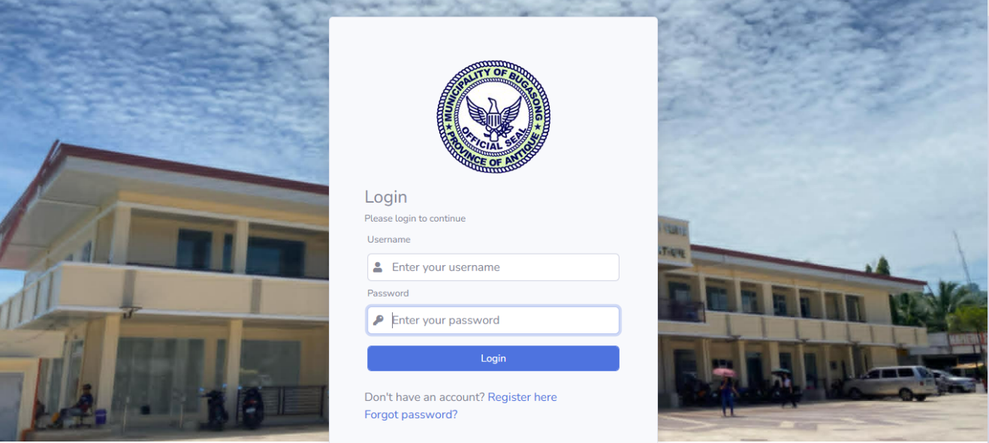
Figure 10: User Login Interface
Figure 10 displays the login interface for both admin and citizen users, allowing them to verify their identities before gaining access to the Bugasong Legislative Tracking System.
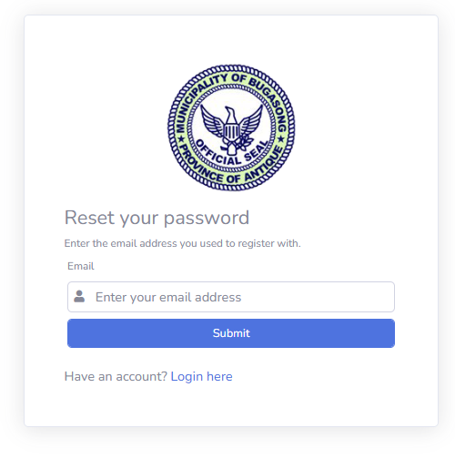
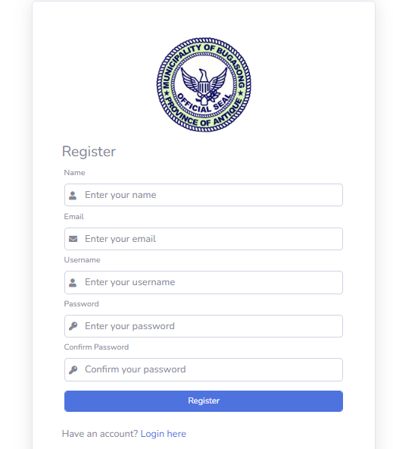
Figure 11: User Registration Form
Figure 11 shows the user registration form of the system that allows new users to create an account to access and interact with the system’s features. This process is designed to ensure that only authorized individuals can use the system.
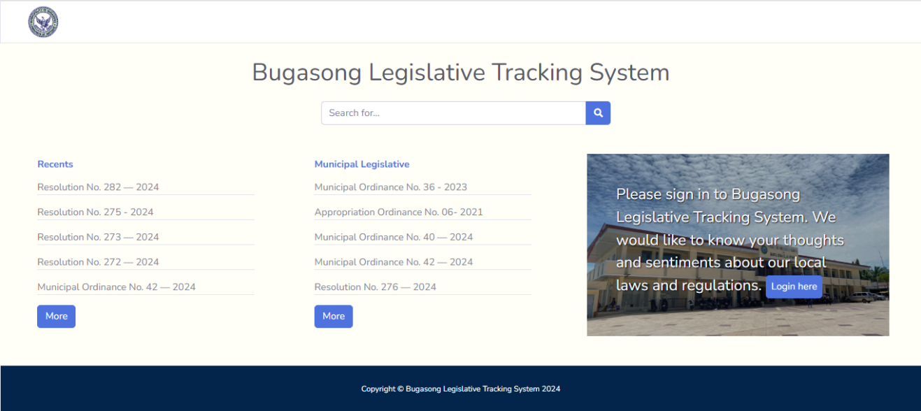
Figure 12: Homepage View
Figure 12 displays the homepage of the system, where users can access legislative documents. The page also features a login button for authorized users to gain access to additional system functionalities.
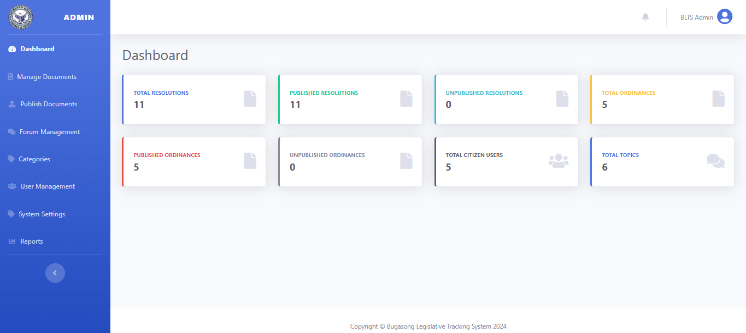Figure 13: Admin Dashboard
Figure 13 illustrates the real-time monitoring dashboard for admins, displaying the total number of documents, users, and topics within the forum section. This dashboard allows administrators to efficiently track system activity.
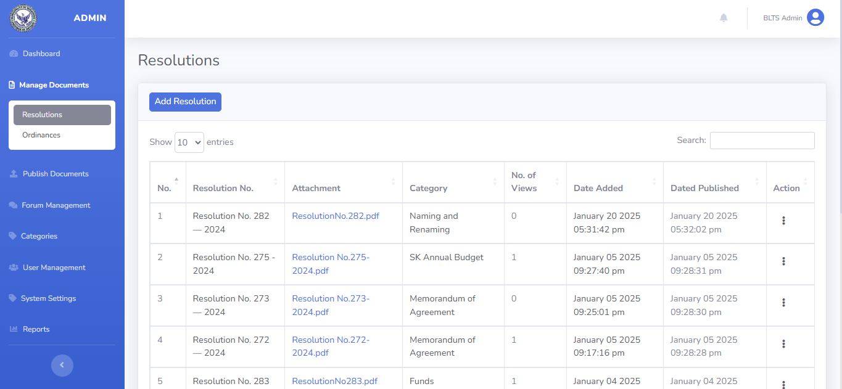
Figure 14: Manage Documents Panel
Figure 14 is designed to allow the admin to upload resolutions and ordinances. In this section, the admin can also monitor most recently uploaded documents.
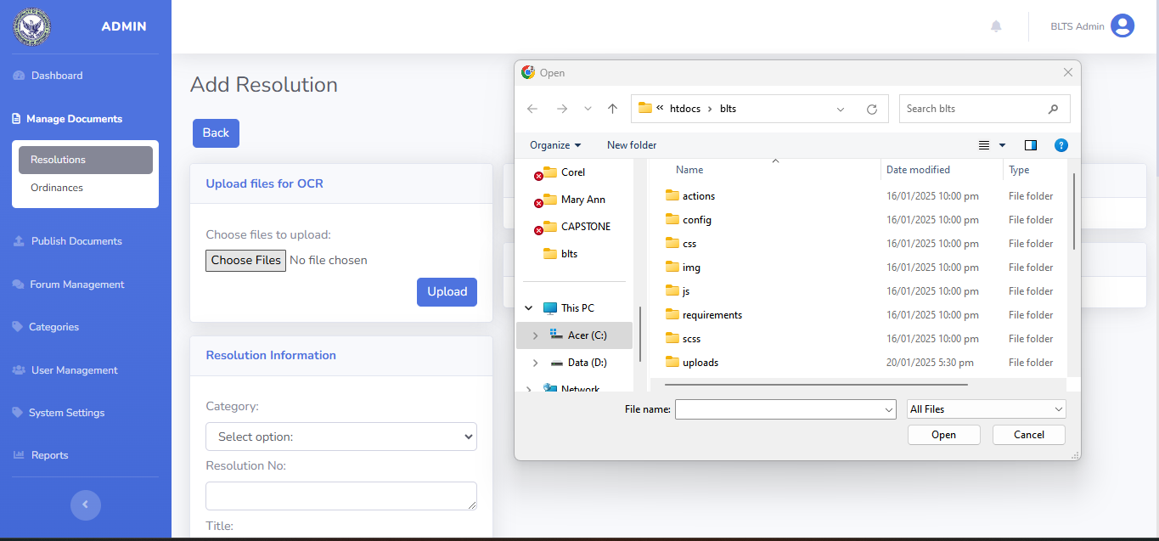
Figure 15: Add Resolution/ Ordinances Interface
Figure 15 illustrates how the admin uploads files by selecting them from local storage.
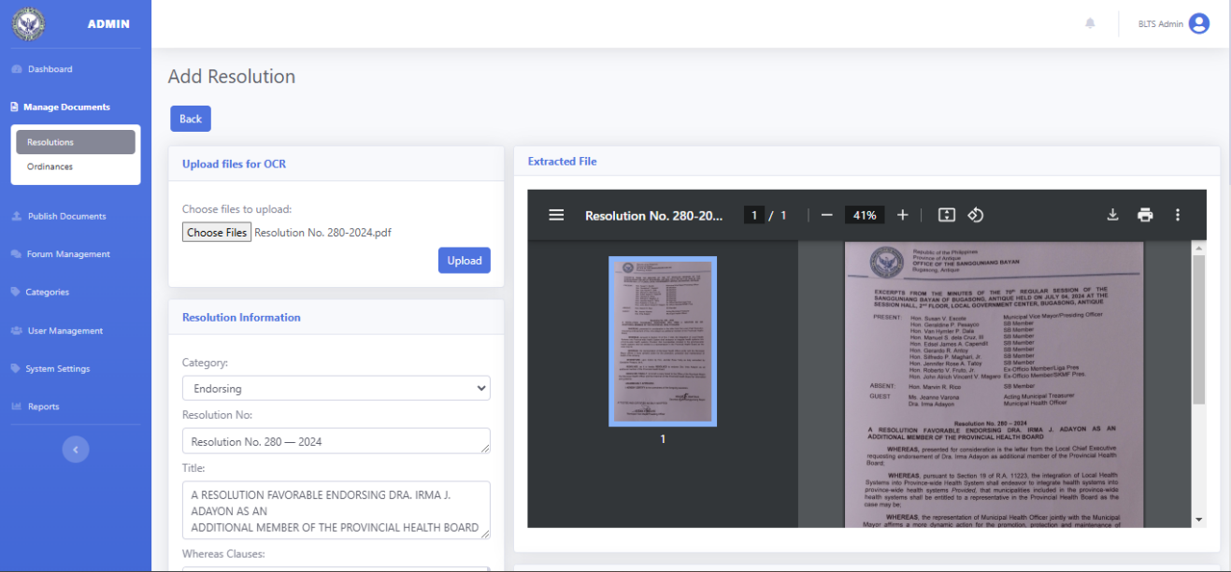Figure 16: Document Upload Module
Figure 16 shows how the admin uploads scanned documents and extracts text using Optical Character Recognition (OCR). Once the document is uploaded, OCR Technology will extract the text and automatically populate the relevant texboxes with information from the ordinance and resolution sections. The admin can also edit or insert text to correct errors, such as misspelled words.

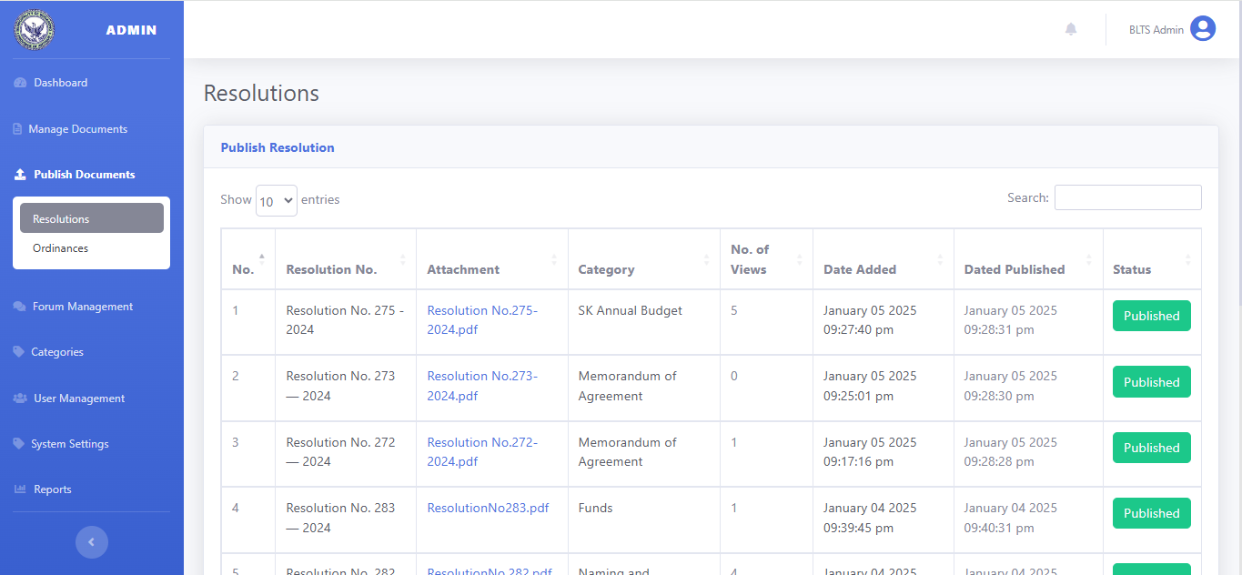Figure 17: Publish Document Module
Figure 17 shows the publish documents section facilitates the process of making documents available to users. Administrators can review uploaded documents and decide whether they are ready for publication. Once approved, documents can be published to ensure they are accessible to users. This step ensures that only verified and accurate documents are made available for viewing.
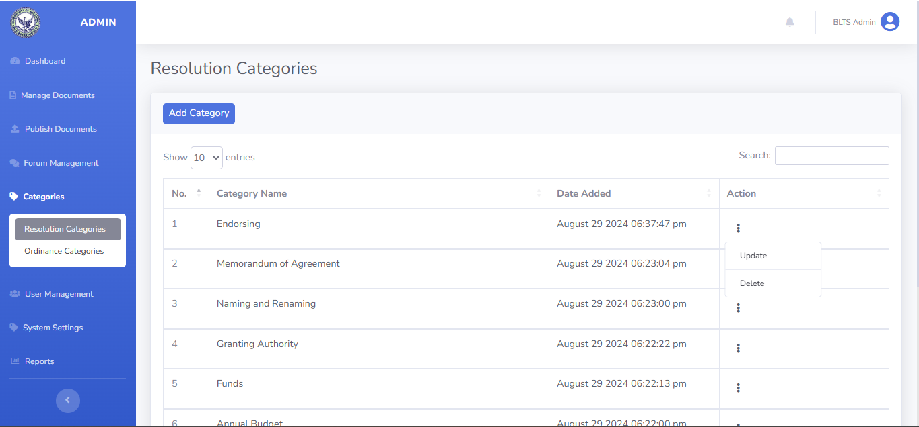Figure 18: Categories Management Panel
Figure 18 shows the Categories button. Admin can add category of resolutions and ordinance based on their purpose, services or content.
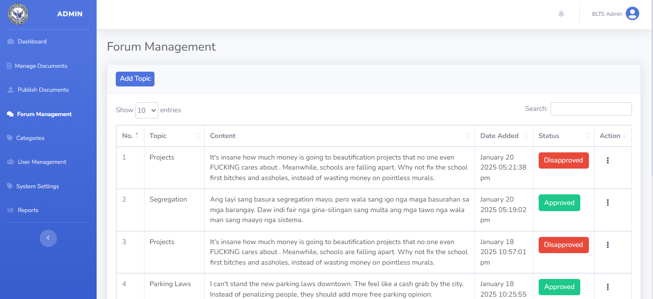
Figure 19: Forum Management Panel
Figure 19 shows the forum management section of admin. The admin will gather the feedback posted by the citizens. All users of this system can participate in the feedback forum to discuss and provide input on legislative matters. This section also used sentiments analysis to assess the tone and words used by the users in forum. This analysis will help the admin to monitor whether to approve or disapproved the feedback or sentiments posted.
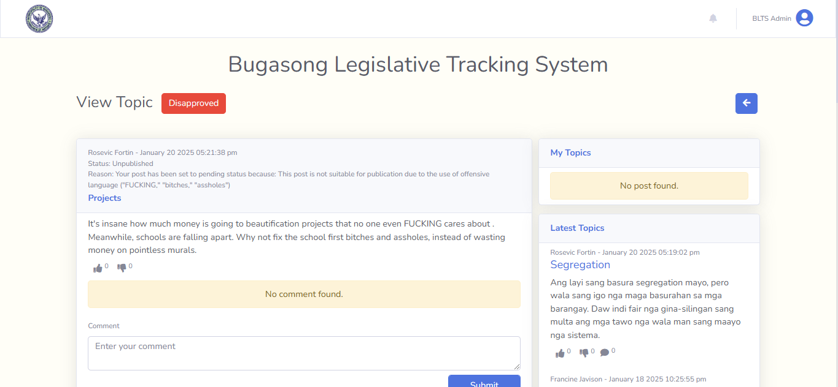Figure 20: Discussion Forum Section
Figure 20 shows the section displaying feedback content posted by users. All users can participate by commenting and giving a thumbs up or down on the feedback. The admin can respond to citizens' posts and monitor the forum.
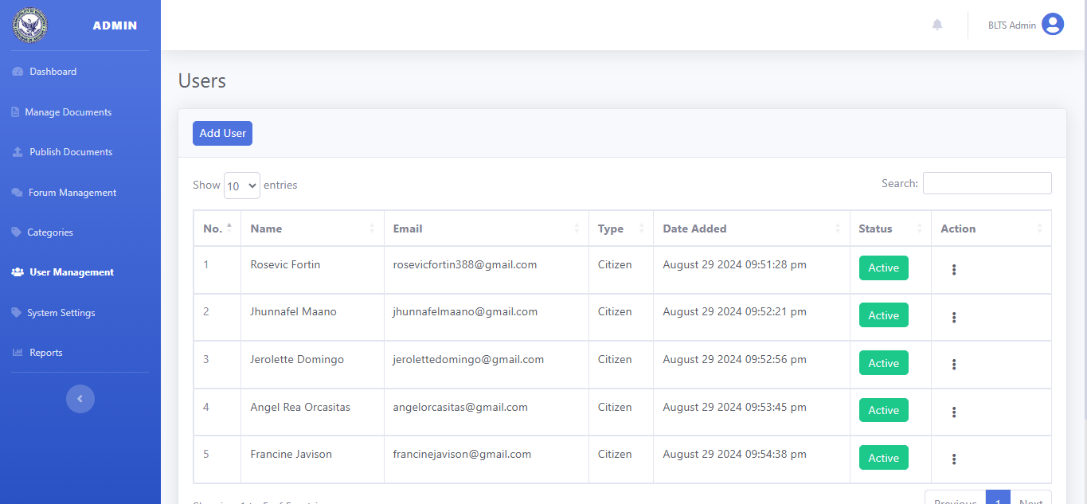
Figure 21: User Management Panel
Figure 21 illustrates the User Management section of the admin interface. Through this section, the admin can add new users and manage the users logged into the system.
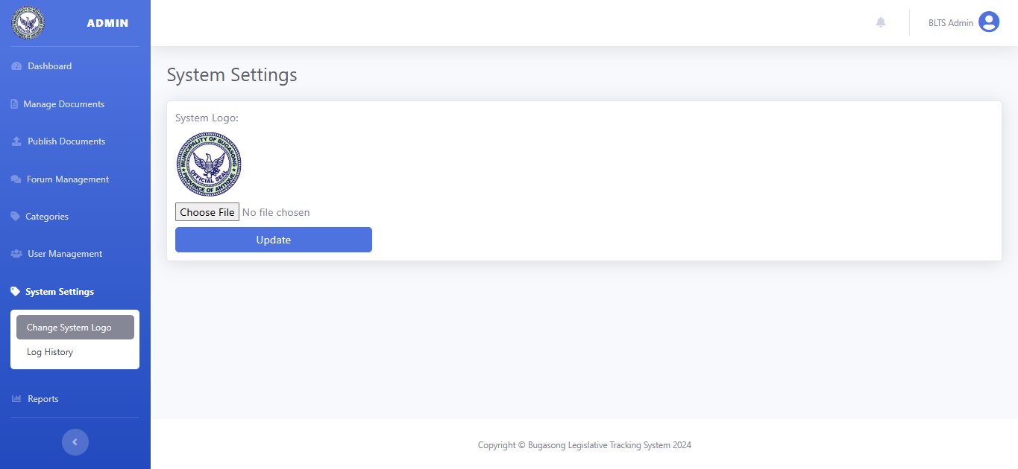Figure 22: System Settings Interface
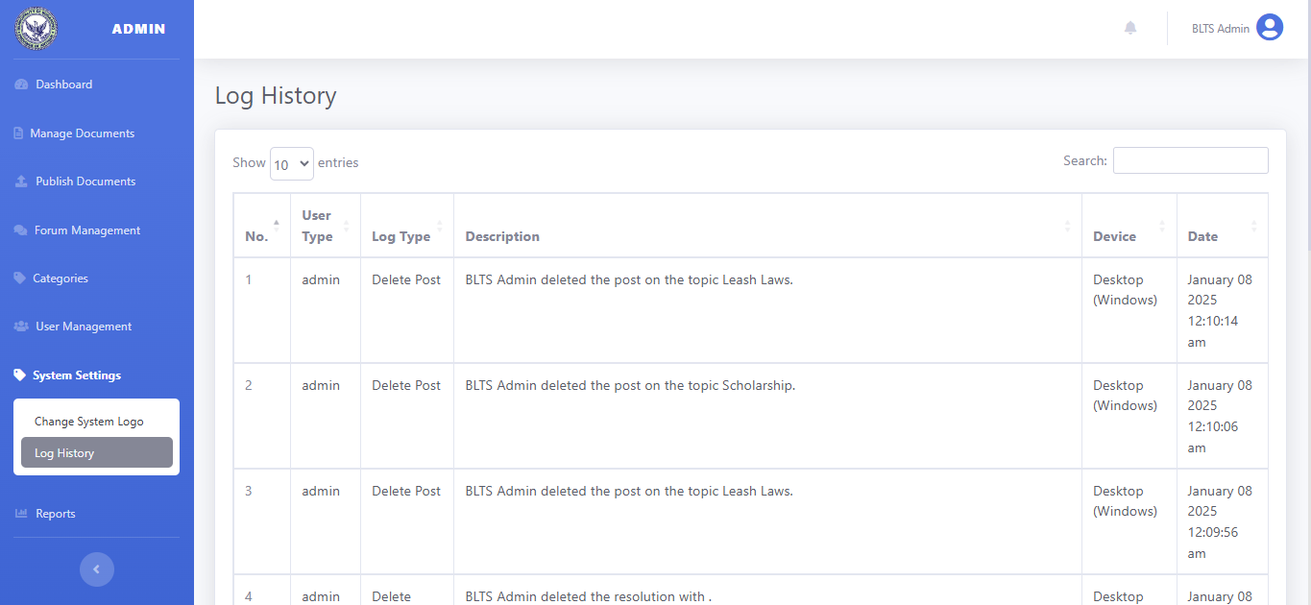
Figure 22 shows the setup of this system, where the admin can change the system logo.

Figure 23: Log History Interface
Figure 23 shows the log history, where the admin can track activities, actions, or changes made to the system.
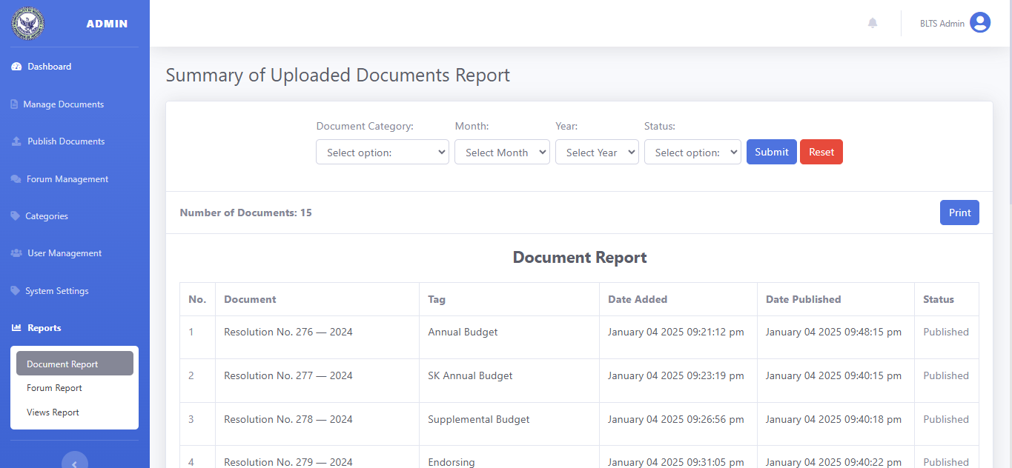Figure 24: Report Generation Interface
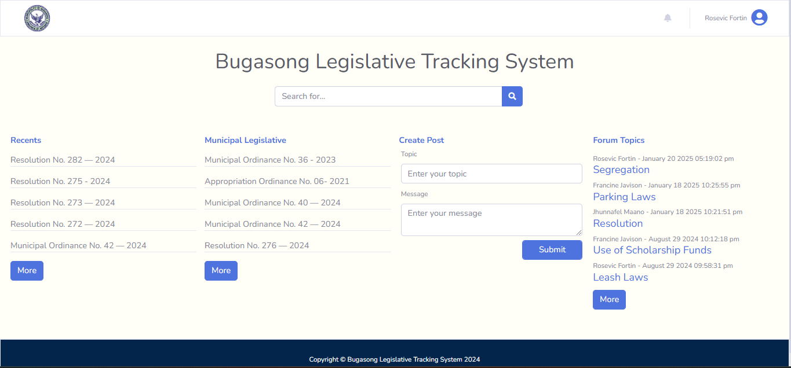
Figure 24 shows how admin can generate document, forum , and views report. This feature allows the admin to access the detailed insights and track performance of the system.

Figure 25: Citizens Users Panel
Figure 25 shows the citizens user panel wherein the registered user can only access. If citizen want to post feedback and express sentiments regarding ordinances and resolution, they need to register to access this panel.
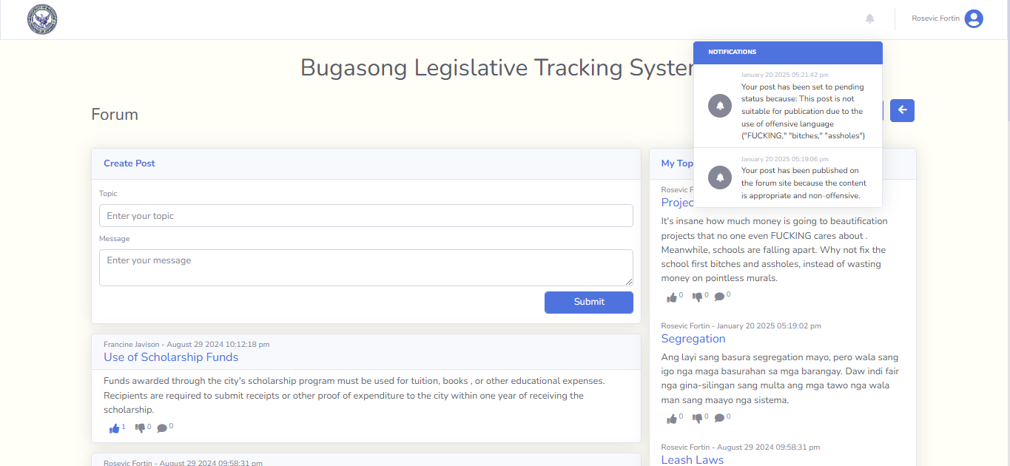
Figure 26: Feedback or Insights Posting Interface
Figure 26 shows the forum section for citizens, where they can create topics and contribute content related to legislative matters. The feature also includes a sentiment analysis tool that notify users if their content is appropriate for public discussion, helping to maintain a respectful and constructive environment.
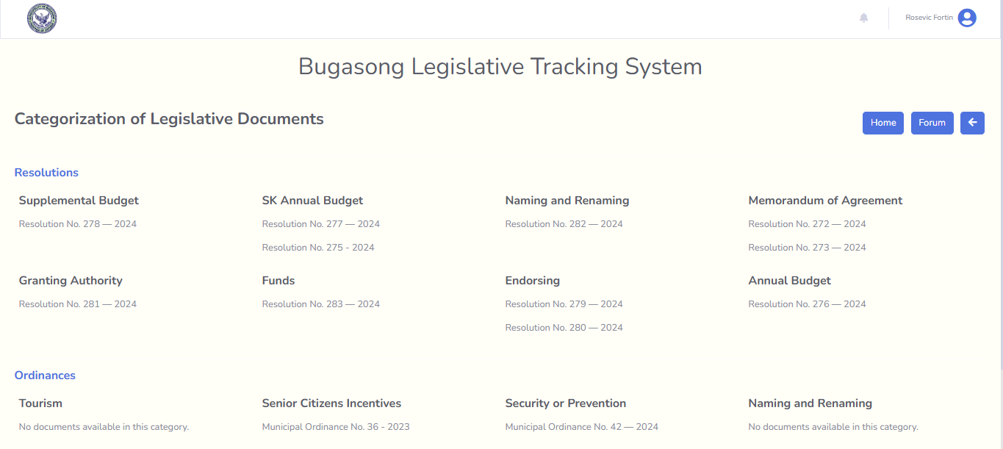Figure 27: List of Legislative Documents
Figure 27 shows the list of legislative documents where all documents of resolutions and ordinances are organize or categorized. This allows users to quickly find relevant documents by topic, date, or type, streamlining the search process and enhancing the overall user experience.
Table 6: Level of Functional Suitability of the Bugasong Legislative Tracking System
Functional Suitability | IT Experts  (15) | Sangguniang Bayan Staff  (8) | People from the community  (7) | Entire Group  (30)
Functional Suitability | M SD Desc. | M SD Desc. | M SD Desc. | M SD Desc.
Functional Completeness | 4.6 0.49 VS | 4.88 0.33 VS | 5.00 0 VS | 4.77 0.42 VS
Functional Accurateness | 4.47 0.5 VS | 4.88 0.33 VS | 4.86 0.35 VS | 4.67 0.47 VS
Functional Correctness | 4.47 0.72 VS | 4.88 0.33 VS | 4.86 0.35 VS | 4.67 0.60 VS
Mean Average | 4.51 0.58 VS | 4.88 0.33 VS | 4.90 0.29 VS | 4.70 0.50 VS
VS - Very Satisfactory S - Satisfactory
Legend:
4.21 - 5.00 = Very Satisfactory (VS)
3.41 - 4.20 = Satisfactory (S)
2.61 - 3.40 = Neutral (N)
1.81 - 2.60 = Unsatisfactory (U)
1 - 1.80 = Very Unsatisfactory (VU)
The table shows that the Bugasong Legislative Tracking System in terms of functional suitability as to the category of functional completeness has the highest rate which proves that the system meets all user goals and specified tasks.
As to the category of functional accurateness, Bugasong Legislative Tracking System was rated by the IT expert (M=4.47 ), Sangguniang Bayan staff (M=4.88), and People from the community (M=4.86 ) as “Very Satisfactory”.
This is to prove that this system in terms of functionality as to the category of accurateness for the entire group performs its specified tasks accurately.
In terms of functional correctness. Bugasong Legislative Tracking System was rated by the IT experts (M=4.47), Sangguniang Bayan staff (M=4.88 ), and people from the community (M= 4.86) as “Very Satisfactory”.
It only means that the Bugasong Legislative Tracking System in terms of functionality as to the category of correctness for the entire group provides correct results with the needed degree of precision.
Out of the three (3) categories of functionality , the completeness of the system (M=4.77) had the highest rating among the evaluators, while the accurateness and correctness of the system (M=4.67) had the same rate and the lowest rating.
This states that the system in terms of accurateness and correctness needs an improvement to interact with components or systems. If the ratings are compared, the rate of accurateness and correctness in every group of evaluators is completely the same with IT Experts (M=4.47), Sangguniang Bayan staff (M=4.88), and people from the community (M=4.86).
The result of the evaluation shows that the Bugasong Legislative Tracking System is highly functional, with a total mean average of 4.70, and the users are very satisfied with the result.
Table 7: Level of Reliability of the Bugasong Legislative Tracking System
Reliability | IT Experts | Sangguniang Bayan staff | People from the community | Entire Group
Reliability | M SD Desc. | M SD Desc. | M SD Desc. | M SD Desc.
Maturity | 4.33 0.70 VS | 4.88 0.33 VS | 4.71 0.45 VS | 4.57 0.62 VS
Fault Tolerance | 4.33 0.70 VS | 4.63 0.48 VS | 4.29 0.45 VS | 4.40 0.61 VS
Recoverability | 4.53 0.62 VS | 4.75 0.43 VS | 4.57 0.49 VS | 4.60 0.55 VS
Availability | 4.73 0.44 VS | 4.88 0.33 VS | 4.86 0.35 VS | 4.80 0.40 VS
Mean Average | 4.48 0.65 VS | 4.78 0.41 VS | 4.61 0.49 VS | 4.59 0.57 VS
VS - Very Satisfactory S - Satisfactory
Legend:
4.21 - 5.00 = Very Satisfactory (VS)
3.41 - 4.20 = Satisfactory (S)
2.61 - 3.40 = Neutral (N)
1.81 - 2.60 = Unsatisfactory (U)
1 - 1.80 = Very Unsatisfactory (VU)
The table shows that the Bugasong Legislative Tracking System in terms of reliability as to the category of availability for the entire group has the highest rate, which proves that the system is operational and accessible when required for use.
As to the category of maturity, Bugasong Legislative Tracking System was rated by the IT experts (M=4.33), Sangguniang Bayan staff (M=4.88), and people from the community (M=4.71) as “Very Satisfactory”.
It only means that the Bugasong Legislative Tracking System in terms of reliability as to the category of maturity for the entire group the system has reached optimal functionality, stability, and effectiveness through continuous improvement and refinement.
As to the category of fault tolerance, Bugasong Legislative Tracking System was rated by the IT experts (M=4.33), Sangguniang Bayan staff (M=4.63 ), and people from the community (M=4.29) as “Very Satisfactory”.
This means that the Bugasong Legislative Tracking System in terms of reliability as to the category of fault tolerance shows that the system operates as intended despite the presence of hardware or software faults.
As to the category of recoverability, Bugasong Legislative Tracking System was rated by the IT expert (M=4.53), Sangguniang Bayan staff (M=4.75), and people from the community (M=4.57 ) as “Very Satisfactory”.
This is to prove that this system in terms of reliability as to the category of recoverability for the entire group can bring back the failed system to full operation.
Out of the four (4) categories of reliability , the availability of the system (M=4.80) had the highest rating among the evaluators, while the fault tolerance of the system (M=4.40) had the lowest rating.
This implies that the system in terms of fault tolerance has to be enhanced with its function to prevent interruption when there is hardware and software faults. Although the fault tolerance got the lowest ratings, it still on the level of very satisfactory. The system might have some errors, but as long the system can still function after encountering errors, still the system achieved its effectiveness in terms of reliability.
The result of the evaluation shows that the Bugasong Legislative Tracking System is highly reliable, with a total mean average of 4.59, and the users are very satisfied with the result.
Table 8: Level of Usability of the Bugasong Legislative Tracking System
Usability | IT Experts | Sangguniang Bayan staff | People from the community | Entire Group
Usability | M SD Desc. | M SD Desc. | M SD Desc. | M SD Desc.
Appropriateness Recognizability | 4.67 0.6 VS | 5 .00 0 VS | 4.71 0.45 VS | 4.77 0.50 VS
Learnability | 4.73 0.57 VS | 4.88 0.33 VS | 4.86 0.35 VS | 4.80 0.48 VS
Operability | 4.60 0.8 VS | 4.88 0.33 VS | 4.86 0.35 VS | 4.73 0.63 VS
User Interface Aesthetics | 4.60 0.49 VS | 5 .00 0 VS | 4.86 0.35 VS | 4.77 0.42 VS
User Error Protection | 4.40 0.61 VS | 4.88 0.33 VS | 4.43 0.49 VS | 4.53 0.56 VS
Accessibility | 4.67 0.47 VS | 5 .00 0 VS | 4.71 0.45 VS | 4.77 0.42 VS
Mean Average | 4.61 0.61 VS | 4.94 0.24 VS | 4.74 0.44 VS | 4.73 0.51 VS
VS - Very Satisfactory S - Satisfactory
Legend:
4.21 - 5.00 = Very Satisfactory (VS)
3.41 - 4.20 = Satisfactory (S)
2.61 - 3.40 = Neutral (N)
1.81 - 2.60 = Unsatisfactory (U)
1 - 1.80 = Very Unsatisfactory (VU)
Table 8 shows that the Bugasong Legislative Tracking System in terms of usability as to the category of learnability for the entire group has the highest rate, proving that the system is user-friendly and user can easily to learn or understand the features.
As to the category of appropriateness recognizability, Bugasong Legislative Tracking System was rated by the IT experts (M=4.67), Sangguniang Bayan staff (M=5.00 ), and people from the community (M=4.71) as “Very Satisfactory”.
This indicates that the Bugasong Legislative Tracking System in terms of usability, as to the of appropriateness recognizability for the entire group can be easily recognized by users as an product of a system that can help to accomplish their needed tasks.
In terms of operability, Bugasong Legislative Tracking System was rated by IT Expert (M=4.60), Sangguiang Bayan Staff (M=4.88), and people from the community (M=4.86) as “Very Satisfactory”.
It simply implies that the Bugasong Legislative Tracking System in terms of usability as to the category of operability for the entire group, is user-friendly, responsive, and efficient in helping users achieve their goals.
As to the category of user error protection, Bugasong Legislative Tracking System was rated by IT Expert (M=4.40), Sangguiang Bayan Staff (M=4.88), and people from the community (M=4.43) as “Very Satisfactory”.
It only means that the Bugasong Legislative Tracking System in terms of usability as to the category of user error protection for the entire group can protect users against errors.
As to the category of accessibility, Bugasong Legislative Tracking System was rated by IT Expert (M=4.67), Sangguiang Bayan Staff (M=5.00), and people from the community (M=4.71) as “Very Satisfactory”.
It means that the Bugasong Legislative Tracking System in terms of usability as to the category of accessibility for the entire group, can be easily accessed when needed.
Of the six (6) categories of usability , the learnability of the system (M=4.80) had the highest rating among the evaluators, while the user error protection of the system (M=4.53) had the lowest rating. This implies that the system in terms of user error protection has to be enhanced to ensure the system operation and help users when errors occurs.
As a result, the evaluation shows that the Bugasong Legislative Tracking System in terms of usability, with total mean average of 4.73, the system achieves its intended usefulness towards the user.
Table 9: Level of Efficiency of the Bugasong Legislative Tracking System
Efficiency | IT Experts | Sangguniang Bayan staff | People from the community | Entire Group
Efficiency | M SD Desc. | M SD Desc. | M SD Desc. | M SD Desc.
Time Behavior | 4.60 0.61 VS | 4.75 0.43 VS | 4.86 0.35 VS | 4.70 0.53 VS
Resource Utilization | 4.80 0.4 VS | 4.75 0.43 VS | 4.86 0.35 VS | 4.80 0.40 VS
Capacity | 4.80 0.4 VS | 4.88 0.33 VS | 4.57 0.49 VS | 4.77 0.42 VS
Mean Average | 4.73 0.49 VS | 4.79 0.41 VS | 4.76 0.43 VS | 4.76 0.45 VS

VS - Very Satisfactory S - Satisfactory
Legend:
4.21 - 5.00 = Very Satisfactory (VS)
3.41 - 4.20 = Satisfactory (S)
2.61 - 3.40 = Neutral (N)
1.81 - 2.60 = Unsatisfactory (U)
1 - 1.80 = Very Unsatisfactory (VU)
The table shows that the Bugasong Legislative Tracking System in terms of efficiency as to the category of resource utilization has the highest rate, proves that the system utilize measurement of time of resources when performing task.
As to the category of time behavior, Bugasong Legislative Tracking System was rated by the IT expert (M=4.60 ), Sangguniang Bayan staff (M=4.75), and people from the community (M=4.86) as “Very Satisfactory”.
This is to prove that this system in terms of efficiency as to the category of time behavior for the entire group can perform faster processing time.
In terms of capacity. Bugasong Legislative Tracking System was rated by the IT experts (M=4.80), Sangguniang Bayan staff (M=4.88), and people from the community (M= 4.57) as “Very Satisfactory”.
It only means that the Bugasong Legislative Tracking System in terms of efficiency as to the category of capacity for the entire group meet the system requirements.
Out of the three (3) categories of efficiency , the resource utilization of the system (M=4.80 ) had the highest rating among the evaluators, while the time behavior of the system (M=4.70) had the lowest rating.
Although the time behavior got the lowest rating, it still on the level of very satisfactory. The result of the evaluation shows that the Bugasong Legislative Tracking System is highly efficient, with a total mean average of 4.76, and the users are very satisfied with the result.
Table 10: Level of Maintainability of the Bugasong Legislative Tracking System
Maintainability | IT Experts | Sangguniang Bayan staff | People from the community | Entire Group
Maintainability | M SD Desc. | M SD Desc. | M SD Desc. | M SD Desc.
Analyzability | 4.67 0.47 VS | 4.75 0.43 VS | 4.29 0.45 VS | 4.60 0.49 VS
Modularity | 4.73 0.44 VS | 5.00 0 VS | 4.14 0.64 S | 4.67 0.54 VS
Modifiability | 4.67 0.6 VS | 5.00 0 VS | 4.43 0.73 VS | 4.70 0.59 VS
Testability | 4.60 0.61 VS | 4.88 0.33 VS | 5.00 0 VS | 4.77 0.50 VS
Reusability | 4.73 0.44 VS | 4.75 0.43 VS | 4.43 0.73 VS | 4.67 0.54 VS
Mean Average | 4.68 0.52 VS | 4.88 0.33 VS | 4.46 0.65 VS | 4.68 0.53 VS
VS - Very Satisfactory S - Satisfactory
Legend:
4.21 - 5.00 = Very Satisfactory (VS)
3.41 - 4.20 = Satisfactory (S)
2.61 - 3.40 = Neutral (N)
1.81 - 2.60 = Unsatisfactory (U)
1 - 1.80 = Very Unsatisfactory (VU)
Table 10 shows that the Bugasong Legislative Tracking System in terms of maintainability as to the category of testability for the entire group has the highest rate, proves the system is tested as being effective and maintainable.
As to the category of analyzability, Bugasong Legislative Tracking System was rated by the IT experts (M=4.67), Sangguniang Bayan staff (M=4.75 ), and people from the community (M=4.29) as “Very Satisfactory”.
This indicates that the Bugasong Legislative Tracking System in terms of maintainability as to the category of analyzability for the entire group ensures that the system provides users with the necessary tools and information to monitor, evaluate, and interpret its performance, data, and outputs.
As to the category of modularity, Bugasong Legislative Tracking System was rated by the IT experts (M=4.73), Sangguniang Bayan staff (M=5.00 ) as “Very Satisfactory”, and people from the community (M=4.14) as “Satisfactory”.
This means that the Bugasong Legislative Tracking System in terms of maintainability as to the category of modularity is flexible with other components.
As to the category of modifiability, Bugasong Legislative Tracking System was rated by the IT expert (M=4.67), Sangguniang Bayan staff (M=5.00), and people from the community (M=4.43 ) as “Very Satisfactory”.
This is to prove that this system in terms of maintainability as to the category of modifiability for the entire group can easily adapt with the updates changes.
In terms of reusability, Bugasong Legislative Tracking System was rated by the IT expert (M=4.73), Sangguniang Bayan staff (M=4.75), and people from the community (M=4.43 ) as “Very Satisfactory”.
This indicates that this system in terms of maintainability as to the category of reusability for the entire group can optimize the development process and enhance efficiency.
Out of the five (5) categories of maintainability , the testability of the system (M=4.77) had the highest rating among the evaluators, while the analyzability of the system (M=4.60) had the lowest rating. Although, the analyzability got the lowest rating, it is still on the level of very satisfactory.
This implies that the Bugasong Legislative Tracking System is highly maintainable, with a total mean average of 4.68.

Table 11: Level of Portability of the Bugasong Legislative Tracking System
Portability | IT Experts | Sangguniang Bayan staff | People from the community | Entire Group
Portability | M SD Desc. | M SD Desc. | M SD Desc. | M SD Desc.
Installability | 4.73 0.44 VS | 4.75 0.43 VS | 4.57 0.49 VS | 4.70 0.46 VS
Adaptability | 4.80 0.4 VS | 4.75 0.43 VS | 4.71 0.45 VS | 4.77 0.42 VS
Replaceability | 4.20 0.75 S | 4.75 0.43 VS | 4.71 0.45 VS | 4.47 0.67 VS
Mean Average | 4.58 0.61 VS | 4.75 0.43 VS | 4.67 0.47 VS | 4.64 0.54 VS
VS - Very Satisfactory S - Satisfactory
Legend:
4.21 - 5.00 = Very Satisfactory (VS)
3.41 - 4.20 = Satisfactory (S)
2.61 - 3.40 = Neutral (N)
1.81 - 2.60 = Unsatisfactory (U)
1 - 1.80 = Very Unsatisfactory (VU)
The table shows that the Bugasong Legislative Tracking System in terms of portability as to the category of adaptability has the highest rate, proves that the system adapt to new specifications changes.
As to the category of installability, Bugasong Legislative Tracking System was rated by the IT expert (M=4.73 ), Sangguniang Bayan staff (M=4.75), and people from the community (M=4.57 ) as “Very Satisfactory”.
This is to prove that this system in terms of portability as to the category of installability for the entire group can be successfully installed in a specified environments.
In terms of replaceability. Bugasong Legislative Tracking System was rated by the IT experts (M=4.20) as “Satisfactory”, Sangguniang Bayan staff (M=4.75 ), and people from the community (M= 4.71) as “Very Satisfactory”.
It indicates that the Bugasong Legislative Tracking System in terms of portability as to the category of replaceability for the entire group is capable to be replace by other software.
Out of the three (3) categories of portability , the adaptability of the system (M=4.77) had the highest rating among the evaluators, while the replaceability of the system (M=4.47) had the lowest rating, but still it is on the level of very satisfactory.
This implies that the Bugasong Legislative Tracking System is highly portable, with a total mean average of 4.64.
Table 12: Level of Security of the Bugasong Legislative Tracking System

Security | IT Experts | Sangguniang Bayan staff | People from the community | Entire Group
Security | M SD Desc. | M SD Desc. | M SD Desc. | M SD Desc.
Confidentiality | 4.67 0.47 VS | 5.00 0 VS | 4.86 0.35 VS | 4.80 0.40 VS
Integrity | 4.53 0.62 VS | 5.00 0 VS | 5.00 0 VS | 4.77 0.50 VS
Non-repudiation | 4.47 0.62 VS | 5.00 0 VS | 4.14 0.64 S | 4.53 0.62 VS
Authentication | 4.53 0.72 VS | 5.00 0 VS | 4.86 0.35 VS | 4.73 0.57 VS
Accountability | 4.47 0.81 VS | 5.00 0 VS | 4.43 0.73 VS | 4.60 0.71 VS
Mean Average | 4.53 0.66 VS | 5.00 0 VS | 4.66 0.58 VS | 4.69 0.58 VS
VS - Very Satisfactory S - Satisfactory
Legend:
4.21 - 5.00 = Very Satisfactory (VS)
3.41 - 4.20 = Satisfactory (S)
2.61 - 3.40 = Neutral (N)
1.81 - 2.60 = Unsatisfactory (U)
1 - 1.80 = Very Unsatisfactory (VU)
The table shows that the Bugasong Legislative Tracking System in terms of security as to the category of confidentiality for the entire group has the highest rate. This proves that the system can be accessed by authorized users only and it can prevent unauthorized manipulation of information.
As to the category of non-repudiation, Bugasong Legislative Tracking System was rated by the IT experts (M=4.47), Sangguniang Bayan staff (M=5.00 ) as “Very Satisfactory”, and people from the community (M=4.14) as “Satisfactory”.
This means that the Bugasong Legislative Tracking System in terms of security as to the category of non-repudiation can authenticate the identification of user in transaction.
As to the category of authentication, Bugasong Legislative Tracking System was rated by the IT expert (M=4.53), Sangguniang Bayan staff (M=5.00), and people from the community (M=4.86) as “Very Satisfactory”.
This is to prove that this system in terms of security as to the category of authentication for the entire group the system can easily identify who is accessing the information.
In terms of accountability, Bugasong Legislative Tracking System was rated by the IT expert (M=4.47), Sangguniang Bayan staff (M=5.00), and people from the community (M=4.43) as “Very Satisfactory”.
This indicates that this system in terms of security as to the category of accountability for the entire group, the system can monitor the performance of users.
Out of the five (5) categories of security , the confidentiality of the system (M=4.80) had the highest rating among the evaluators, while the non-repudiation of the system (M=4.53) had the lowest rating. Although, the non-repudiation got the lowest rating, it is still on the level of very satisfactory.
This implies that the Bugasong Legislative Tracking System is highly secured, with a total rating of 4.69.
Table 13: Level of Compatibility of the Bugasong Legislative Tracking System
Compatibility | IT Experts | Sangguniang Bayan staff | People from the community | Entire Group
Compatibility | M SD Desc. | M SD Desc. | M SD Desc. | M SD Desc.
Co-existence | 4.80 0.4 VS | 5.00 0 VS | 4.57 0.73 VS | 4.80 0.48 VS
Interoperability | 4.67 0.47 VS | 4.88 0.33 VS | 4.86 0.35 VS | 4.77 0.42 VS
Mean Average | 4.73 0.44 VS | 4.94 0.24 VS | 4.71 0.59 VS | 4.78 0.45 VS
VS - Very Satisfactory S - Satisfactory
Legend:
4.21 - 5.00 = Very Satisfactory (VS)
3.41 - 4.20 = Satisfactory (S)
2.61 - 3.40 = Neutral (N)
1.81 - 2.60 = Unsatisfactory (U)
1 - 1.80 = Very Unsatisfactory (VU)
Table 13 shows that the Bugasong Legislative Tracking System in terms of compatibility as to the category of co-existence for the entire group has the highest rate. This proves that the system can operate alongside other software without adverse effects.
As to the category of interoperability, Bugasong Legislative Tracking System was rated by the IT experts (M=4.67), Sangguniang Bayan staff (M=4.88), and people from the community (M=4.86) as “Very Satisfactory”.
It indicates that the Bugasong Legislative Tracking System in terms of compatibility as to the category of interoperability for the entire group can exchange and use information with other systems.
Out of the two (2) categories of compatibility , the co-existence of the system (M=4.80) had the highest rating among the evaluators, while the interoperability of the system (M=4.77) had the lowest rating.
As a result, it implies that the Bugasong Legislative Tracking System is highly compatible, with a total rating of 4.78.

Table 14: Perception of the Evaluators When Taken as a Whole
As a Whole | IT Experts | Sangguniang Bayan staff | People from the community
As a Whole | M SD Desc. | M SD Desc. | M SD Desc.
Functionality | 4.51 0.58 VS | 4.88 0.33 VS | 4.90 0.29 VS
Reliability | 4.48 0.65 VS | 4.78 0.41 VS | 4.61 0.49 VS
Usability | 4.61 0.61 VS | 4.94 0.24 VS | 4.74 0.44 VS
Efficiency | 4.73 0.49 VS | 4.79 0.41 VS | 4.76 0.43 VS
Maintainability | 4.68 0.52 VS | 4.88 0.33 VS | 4.46 0.65 VS
Portability | 4.58 0.61 VS | 4.75 0.43 VS | 4.67 0.47 VS
Security | 4.53 0.66 VS | 5.00 0 VS | 4.66 0.58 VS
Compatibility | 4.73 0.44 VS | 4.94 0.24 VS | 4.71 0.59 VS
Mean Average | 4.60 0.59 VS | 4.88 0.33 VS | 4.67 0.52 VS
VS - Very Satisfactory S - Satisfactory
Legend:
4.21 - 5.00 = Very Satisfactory (VS)
3.41 - 4.20 = Satisfactory (S)
2.61 - 3.40 = Neutral (N)
1.81 - 2.60 = Unsatisfactory (U)
1 - 1.80 = Very Unsatisfactory (VU)
Table 14 shows that the Bugasong Legislative Tracking System, in terms of functionality as for the entire group is highly functional. The system accomplish the desired features and operations.
In terms of reliability as a whole, the Bugasong Legislative Tracking System was rated by the IT Experts (M=4.48), Sangguniang Bayan Staff (M=4.78), and people from the Community (M=4.61) as “Very Satisfactory”.
This implies that the Bugasong Legislative Tracking System in terms of reliability for the entire group, operates as expected over time, without failures, interruptions, or errors.
In terms of usability as a whole, the Bugasong Legislative Tracking System was rated by the IT Experts (M=4.61), Sangguniang Bayan Staff (M=4.94), and people from the Community (M=4.74) as “Very Satisfactory”.
It indicates that the Bugasong Legislative Tracking System in terms of usability for the entire group, can help the users to perform the system operation and achieve their task effectively and efficiently.
In terms of efficiency as a whole, the Bugasong Legislative Tracking System was rated by the IT Experts (M=4.73), Sangguniang Bayan Staff (M=4.79), and people from the Community (M=4.76) as “Very Satisfactory”.
This means that the Bugasong Legislative Tracking System in terms of efficiency for the entire group is highly efficient and can perform tasks and deliver results efficiently.
In terms of maintainability as a whole, the Bugasong Legislative Tracking System was rated by the IT Experts (M=4.68), Sangguniang Bayan Staff (M=4.88), and people from the Community (M=4.46) as “Very Satisfactory”.
Therefore, the Bugasong Legislative Tracking System in terms of maintainability for the entire group ensures that the system meets the requirements for its intended use and can easily identify the failures.
In terms of portability as a whole, the Bugasong Legislative Tracking System was rated by the IT Experts (M=4.58), Sangguniang Bayan Staff (M=4.75), and people from the Community (M=4.67) as “Very Satisfactory”.
This means that the Bugasong Legislative Tracking System in terms of portability for the entire group is easy to adapt in any operating environments.
In terms of security as a whole, the Bugasong Legislative Tracking System was rated by the IT Experts (M=4.53), Sangguniang Bayan Staff (M=5.00), and people from the Community (M=4.66) as “Very Satisfactory”.
This implies that the Bugasong Legislative Tracking System in terms of security for the entire group, can protect the users from unauthorized access.
In terms of compatibility as a whole, the Bugasong Legislative Tracking System was rated by the IT Experts (M=4.73), Sangguniang Bayan Staff (M=4.94), and people from the Community (M=4.71) as “Very Satisfactory”.
This means that the Bugasong Legislative Tracking System in terms of compatibility for the entire group the system can interact and work together with other system or software products.
The results confirm, Hinkley’s (2023) state that advances in data storage, sharing, analytics, and visualization can improve government transparency and accountability, enabling citizens to understand resource usage and program effectiveness, and holding governments accountable. The findings agreed that the system is effective, and it is highly functional, highly reliable, highly usable, highly efficient, highly maintainable, highly portable, highly secure, and highly compatible. Furthermore, all three groups of evaluators, namely the IT Experts, Sangguniang Bayan Staff, and people from the Community, rated every characteristic of the Bugasong Legislative Tracking System within the "Very Satisfactory" range.

Table 15: Results of the Mean Average for Bugasong Legislative Tracking System When the Entire Group is considered.
Category | Entire Group
Category | Mean | SD | Description
Functional | 4.70 | 0.50 | Very Satisfactory
Reliability | 4.59 | 0.57 | Very Satisfactory
Usability | 4.73 | 0.51 | Very Satisfactory
Efficiency | 4.76 | 0.45 | Very Satisfactory
Maintainability | 4.68 | 0.53 | Very Satisfactory
Portability | 4.64 | 0.54 | Very Satisfactory
Security | 4.69 | 0.58 | Very Satisfactory
Compatibility | 4.78 | 0.45 | Very Satisfactory
Mean Average | 4.69 | 0.53 | Very Satisfactory
VS - Very Satisfactory
Legend:
4.21 - 5.00 = Very Satisfactory (VS)
3.41 - 4.20 = Satisfactory (S)
2.61 - 3.40 = Neutral (N)
1.81 - 2.60 = Unsatisfactory (U)
1 - 1.80 = Very Unsatisfactory (VU)
As shown in Table 15, the mean average of the entire group of 4.69 is described as “Very Satisfactory”.
The category of reliability with a mean value of 4.59 got the lowest among the eight (8) categories, while the category of compatibility got the highest mean with a value of 4.78. Both has the description of very satisfactory.
The result implies that the developed Bugasong Legislative Tracking System conforms to the requirements set in the standard of ISO 25010. The result indicates that the developed Bugasong Legislative Tracking System needs some enhancement and improvement to address the desired design and development aspects of the system.
There are some suggestions that the researchers gathered from the respondents during the evaluation. The IT expert group suggested optimizing the document upload process, changing the navigation for viewing files by clicking on the link of the resolution number, checking the existing resolutions, separating the types of resolutions from the types of ordinances, change the view, update, and delete button in action category into three dots, and including a log history in the system. They also commented that the buttons and tables are organized properly. Additionally, some respondents complimented the design, noting that it is simple and visually appealing. Moreover, Sangguniang Bayan staff, stated that the system is beneficial for their office as it helped improved the document tracking and effective dissemination of information to the public. As for the community respondents, said that the system helps people easily access resolutions and ordinances online without the need to visit the Sangguniang Bayan office to request copies of the documents.
As a result, this indicates that the Bugasong Legislative Tracking System is both beneficial and satisfactory to all the respondents.

C H A P T E R 5
SUMMARY, FINDINGS, CONCLUSIONS AND RECOMMENDATIONS

Summary
Bugasong, one of the municipalities in Antique, has a Sangguniang Bayan office that currently relies on a manual system, which limits transparency and efficiency in accessing resolutions and ordinances. The problem lies in the difficulty of retrieving and managing resolutions and ordinances due to their vulnerability to damage, challenges in searching for existing documents, limited public access to information, the lack of text recognition in scanned files, and the absence of a platform for gathering feedback from Bugasong residents.
The primary objective was to develop a Bugasong Legislative Tracking System that replaces physical archives with a digital repository, improving document management and tracking. This system will facilitate easier access to ordinances and resolutions, address challenges in storing and searching legislative documents, streamline the dissemination of information, recognize text in scanned documents, and gather public sentiments effectively. This aims to create a secure platform for storing resolutions and ordinances, implement user-friendly search functions, provide transparent access for citizens, incorporate OCR technology for text recognition in scanned documents, and integrate a forum with sentiment analysis for collecting feedback from the people of Bugasong.
Compared to other related literature, the uniqueness of this system lies in its additional features, including document management, the application of Optical Character Recognition (OCR) for uploading scanned documents, improved search functionality, and easier document access. Additionally, it incorporates sentiment analysis when posting feedback or insights, helping to determine the tone and identify offensive words to decide whether the content is appropriate for public posting.
The researchers used the scrum agile methodology in developing the proposed Bugasong Legislative Tracking System for the Municipality of Bugasong, Antique. This methodology was properly enforced and intended for all the system development efforts.

Findings
- The functionality of the system was found to be very satisfactory, as confirmed by the respondents, who proved that the system is complete, accurate, and correct.
- The reliability of the developed system was found to be very satisfactory, as the results demonstrated that the system is dependable, based on its maturity, fault tolerance, recoverability, and availability.
- The usability of the system was found to be very satisfactory, as it was proven that the interface is easy for users to interact with and access.
- The performance efficiency of the system was found to be very satisfactory, as the results showed that the system does not take too much time for users to complete tasks.
- The maintainability of the system was found to be very satisfactory, as it was confirmed through testing by the respondents.
- The respondents found the system's portability to be very satisfactory, as it provides a supportive environment and adapt to new specification changes.
- The system security was found to be very satisfactory, as it effectively protects user data.
- The compatibility of the system was found to be very satisfactory proven of the result rated by the respondents.

Conclusions
This study was able to fulfill the objectives based on the structures of system. The system’s features and design were created to meet the needs of citizens in transparency of local laws and can engage meaningfully. The forum section was developed to enable the users to post any topic of feedback and insights and share ideas regarding ordinances and resolutions with other users and admin. Applying Optical Character Recognition in uploading files can make the file searchable and easy to access. The integration of sentiment analysis in the Bugasong Legislative Tracking System enhances its ability to assess public feedback effectively. By evaluating the tone and detecting offensive language, the system helps the administrator screen content before it is shared with the public, promoting a positive and respectful environment.
The Bugasong Legislative Tracking System is effective and beneficial for its users, primarily due to its user-friendly interface and intuitive design. Overall, its effectiveness lies in its ability to make legislative processes more accessible and comprehensible for everyone.

Recommendations
Based on the findings of the study and the suggestions of the evaluators, the following recommendations were drawn:
- Improve the OCR (Optical Character Recognition) features to more effectively process old or poor-quality legislative documents by integrating advanced preprocessing techniques such as image enhancement, noise reduction, and text alignment correction. Additionally, consider using deep learning-based OCR tools that will help to increase accuracy in recognizing faded or handwritten texts.
- Enhance sentiment data collection by incorporating additional structured feedback mechanisms, such as emoji-based reactions, to improve the quality and reliability of sentiment analysis.
- Update the sentiment analysis component to better understand local language patterns, including local dialects such as Kinaray-a or Hiligaynon.
- Develop a mobile application version of the system to expand accessibility and reach a wider range of users that should provide real-time access to the latest ordinances or resolutions.
- Conduct training for the Sangguniang Bayan staff on uploading, OCR correction, publishing, and forum moderation as part of the turnover of the system to the Municipality of Bugasong.
- Define the responsibility for hosting, domain renewal, regular database backup, and maintenance of the system after turnover.
- Add a data privacy notice and consent to the citizen registration form in compliance with the Data Privacy Act of 2012 (RA 10173).
- Strengthen the lowest-rated aspects of the system, namely fault tolerance, user error protection, and replaceability.
- Future researchers may measure the accuracy of the OCR and sentiment analysis features and involve a larger number of community evaluators.

REFERENCES

Chumwatana, T., & Rattana-umnuaychai, W. (2021). Using OCR Framework and Information Extraction for Thai Documents Digitization. 2021 9th International Electrical Engineering Congress (IEECON). https://doi.org/10.1109/ieecon51072.2021.9440300
Donato, H. (2023, January 3). What Are The Phases Of Scrum? Workamajig. https://www.workamajig.com/blog/scrum-methodology-guide/scrum-phases
Gao, C., & Xu, G. (2022). OCR system evaluation method, apparatus and device, and readable storage medium (International Patent Application No. WO2022100452A1). World Intellectual Property Organization. https://worldwide.espacenet.com/patent/search/family/07378 5570/publication/WO2022100452A1?q=OCR
Jayoma, J. M., Moyon, E. S., & Morales, E. M. O. (2020). OCR Based Document Archiving and Indexing Using PyTesseract: A Record Management System for DSWD Caraga, Philippines. 2020 IEEE 12th International Conference on Humanoid, Nanotechnology, Information Technology, Communication and Control, Environment, and Management (HNICEM). https://doi.org/10.1109/hnicem51456.2020.9400000
Mendis, P., Perera, M., Karunaratne, D., Silva, Haddela, P. S., & Dimuth Adeepa Gunarathne. (2022). eGaz: Enhanced Search Engine for Gazette Publications. 2022 IEEE 7th International Conference for Convergence in Technology (I2CT). https://doi.org/10.1109/i2ct54291.2022.9824623
Mino, S. (2021, April 15). 8 Reasons Why PHP Is Still So Important for Web Development. Jobsity. https://www.jobsity.com/blog/8-reasons-why-php-is-still-so- important-for-web-development
Pandes, T. L. O., Omorog, C. D., & Medrano, R. B. (2018). LeMTrac: Legislative Management and Tracking System. IEEE Xplore. https://doi.org/10.1109/HNICEM.2018.8666260
Perbangsa, A. S., Hariawan, M., & Pardamean, B. (2018). Legislation information system. 2018 International Conference on Information Management and Technology (ICIMTech). https://doi.org/10.1109/icimtech.2018.8528176
Philippine Statistics Authority. (2024). Philippine Standard Geographic Code (PSGC): Bugasong, Antique [2024 Census of Population]. https://psa.gov.ph/classification/psgc/citimuni/0600600000
Schreiber, G., et al. (2020). System for optical character recognition (OCR) (European Patent Application No. EP3611664A1). European Patent Office. https://worldwide.espacenet.com/patent/search/family/063294036/publication/EP3611664A1?q=OCR
Srinivas, L. (2023). Extract data from a true PDF page (U.S. Patent Application No. US2023065934A1). U.S. Patent and Trademark Office. https://worldwide.espacenet.com/patent/search/family/085287955/publication/US2023065934A1?q=pn%3DUS2023065934A1

