Học phần: Kiểm thử phần mềm

TP. HỒ CHÍ MINH, THÁNG 4 NĂM 2025

TP. HỒ CHÍ MINH, THÁNG 4 NĂM 2025

TP. HỒ CHÍ MINH, THÁNG 4 NĂM 2025

TP. HỒ CHÍ MINH, THÁNG 4 NĂM 2025

ỦY BAN NHÂN DÂN TP . HỒ CHÍ MINH
TRƯỜNG ĐẠI HỌC SÀI GÒN
KHOA CÔNG NGHỆ THÔNG TIN



BÁO CÁO BÀI TẬP GIỮA KỲ

Đề tài: Bài tập – Phân tích yêu cầu nghiệp vụ
Giảng viên hướng dẫn: TS. Đỗ Như Tài
TP. HỒ CHÍ MINH, THÁNG 4 NĂM 2025

Nhóm sinh viên thực hiện:

STT | Họ và tên | MSSV
1 | Trang Gia Huy | 3122411068
2 | Nguyễn Lê Quỳnh Hương | 3122411078

TP. HỒ CHÍ MINH, THÁNG 4 NĂM 2025

MỤC LỤC
BẢNG PHÂN CÔNG CÔNG VIỆC 3
1. Introduction 4
2. Business context 5
3. Conceptual Model 6
4. User Story: 7
5. Use Case 10
5.1. Authentication & Access Control: Đăng ký, đăng nhập, đăng xuất, quản lý thông tin tài khoản. 11
5.2. Product Catalog Management: Xem danh sách sản phẩm, tìm kiếm/lọc, xem chi tiết, quản lý sản phẩm và danh mục (dành cho SysAdmin). 12
5.3. Shopping Cart Management: Thêm sản phẩm vào giỏ, cập nhật/xóa sản phẩm trong giỏ, xem tổng chi phí. 13
5.4. Ordering & Payment: Thanh toán, đặt hàng, nhận thông báo xác nhận, theo dõi trạng thái đơn hàng, quản lý đơn hàng (dành cho SysAdmin). 14
5.5. Address Management: Thêm, cập nhật, xóa địa chỉ giao hàng của Buyer. 15
5.6. File & Resource Management: Quản lý hình ảnh sản phẩm, tài nguyên đi kèm (SysAdmin). 15

BẢNG PHÂN CÔNG CÔNG VIỆC
STT | Họ và tên | MSSV | Nội dung công việc
1 | Trang Gia Huy | 3122411068 | - Phân tích nghiệp vụ  - Soạn báo cáo  - Vẽ conceptual model
2 | Nguyễn Lê Quỳnh Hương | 3122411078 | - Phân tích nghiệp vụ  - Soạn ppt  - Vẽ use case

1. Introduction
Shopease is a full-stack e-commerce web application for selling clothing, developed using Spring Boot on the backend and React on the frontend. It demonstrates how to design and integrate a modern web system that supports essential business flows such as product browsing, category management, user authentication, shopping cart, order placement, and address handling.
The project combines the Java Spring ecosystem with React’s component-based UI approach to deliver a scalable and interactive shopping experience. It uses Spring Security with JWT authentication, JPA/Hibernate for persistence, and a modular service-controller-repository structure on the backend. On the frontend, React provides a responsive and user-friendly interface for customers.

2. Business context
Shopease Website has the basic business scenario for Authentication & Access Control, Product Catalog, Shopping Cart, Ordering & Payment, File Upload, and Address Management.
With Authentication & Access Control, Buyer can register a new account and login to the system with her email and password. Once authenticated, she can update her personal information and manage her delivery addresses. SysAdmin in the system can also login, logout and will be directed to the administration page, where he has full control over product, category, and order management.
With Product Catalog, Buyer can browse the products list with supported filtering by category and view details of each product. In the product detail page, she can see a name, description, price, brand, rating, product variants such as color and size, stock availability, new arrival status, and product resources like images. SysAdmin in the system can manage the products, add new ones, update existing ones, delete outdated ones, and also organize products into categories and category types.
With Shopping Cart, Buyer can add any product into the cart either from the product list page or from the product detail page. After adding products, she should see them in the shopping cart together with a summary panel including basic information such as total item count, subtotal cost, shipping cost, and total order amount. Whenever she adds or removes products from the cart, the shopping cart and summary panel should be updated immediately. After reviewing the cart, she can proceed with the checkout process by clicking the Check Out button. SysAdmin can see all the shopping carts of any user so that he can disable invalid or incomplete carts if necessary.
With Ordering & Payment, after Buyer clicks the checkout button, the system will create a new order, validate the product information, and process the payment. Buyer will be able to track her order status, such as pending, confirmed, shipped, or delivered. After successful payment, the system will notify Buyer with confirmation details. SysAdmin can view and manage all orders in the system, ensuring smooth order processing and delivery.
With File Upload, SysAdmin can upload product images or related resources so that products in the catalog always display updated visuals for Buyer.
With Address Management, Buyer can add and update her delivery addresses including street, city, state, zip code, and phone number. These addresses are then used during checkout to ensure accurate shipping.
Some of the one-off tasks need to be done when Shopease website starts such as creating one SysAdmin user, two Buyer users, and sample data for product catalog, categories, and orders so that the system can be tested and demonstrated properly.
3. Conceptual Model
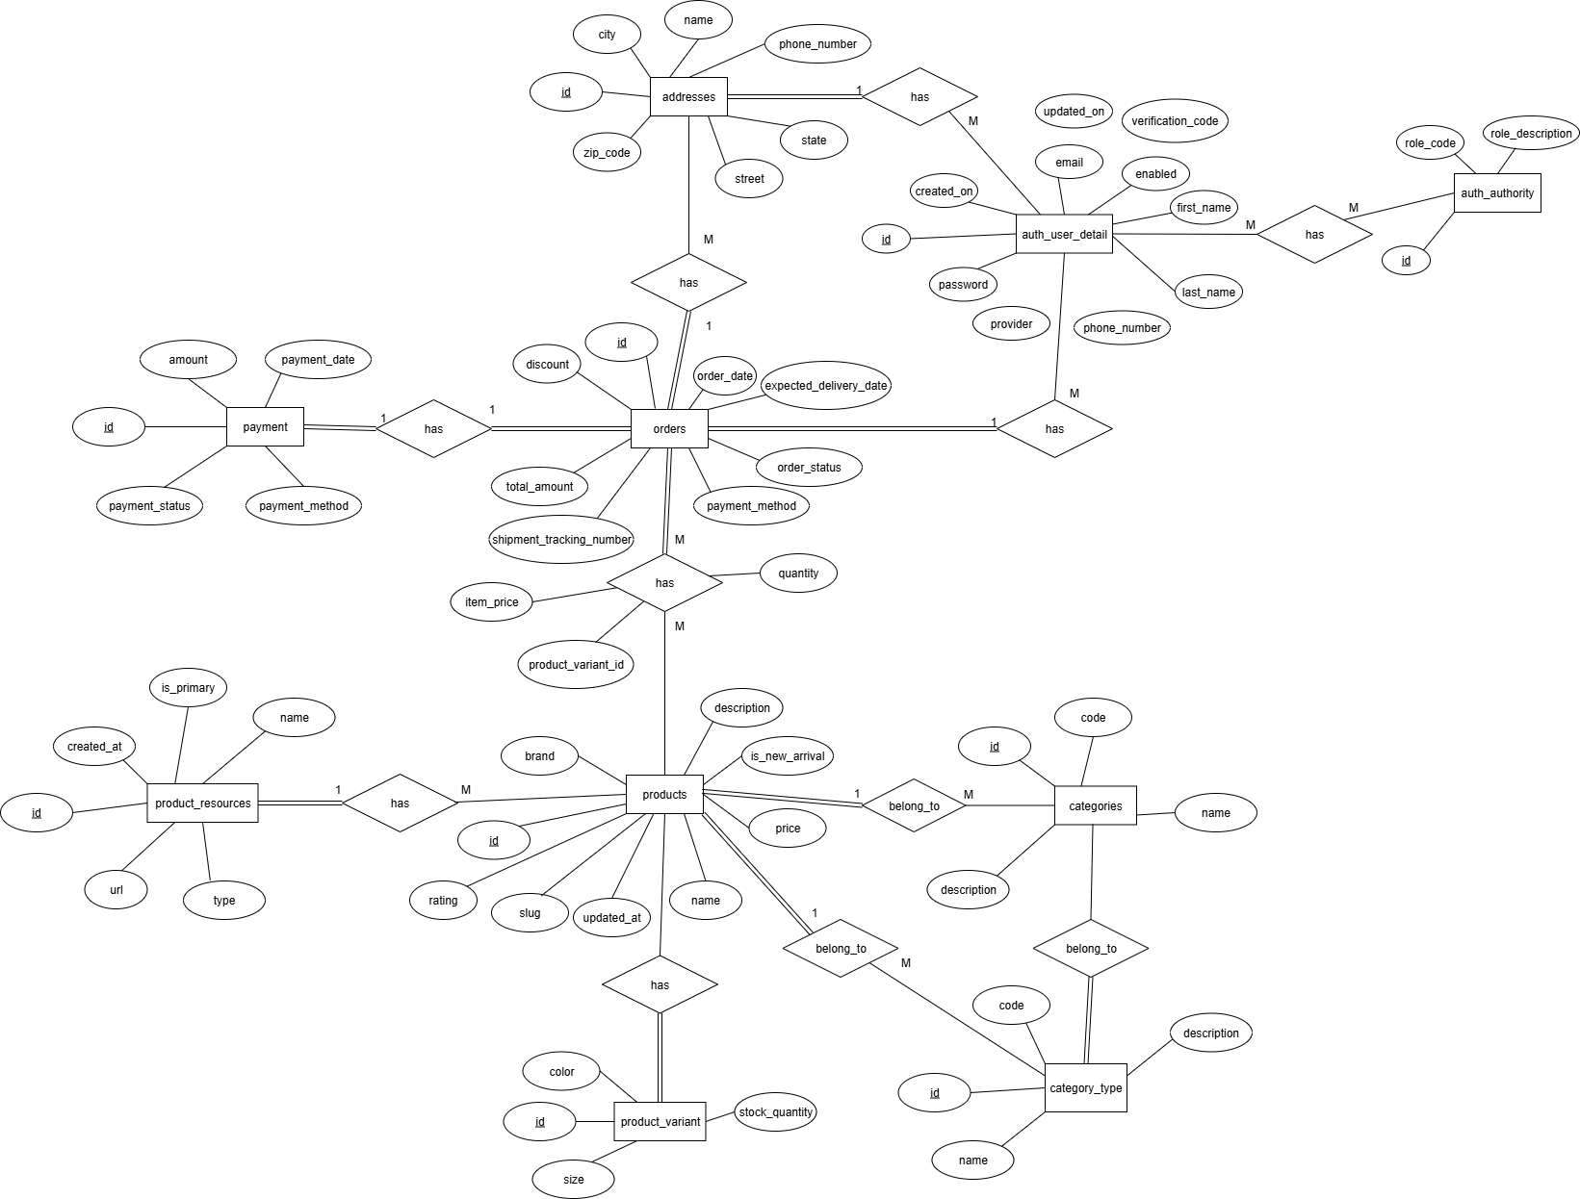
4. User Story:
Authentication & Access Control
- As a Buyer, I want to register an account so that I can shop online.
- As a Buyer, I want to login with my credentials so that I can access my personal shopping account.
- As a Buyer, I want to update my profile information so that my personal details are accurate.
- As a Buyer, I want to logout so that I can secure my account after shopping.
- As a SysAdmin, I want to login with admin credentials so that I can manage the system.
- As a SysAdmin, I want to logout so that I can secure my account.
Product Catalog
- As a Buyer, I want to browse all products so that I can see the available clothing items.
- As a Buyer, I want to filter products by category so that I can quickly find what I need.
- As a Buyer, I want to view product details (name, description, price, brand, rating, images, variants) so that I can decide whether to purchase.
- As a Buyer, I want to see stock availability for each product variant so that I know if my size/color is available.
- As a Buyer, I want to see new arrival products so that I don’t miss the latest items.
- As a SysAdmin, I want to add new products so that I can expand the catalog.
- As a SysAdmin, I want to update product details so that information is always correct.
As a SysAdmin, I want to delete products so that outdated or unavailable items are removed.
- As a SysAdmin, I want to manage categories and category types so that products are organized logically.
Shopping Cart
- As a Buyer, I want to add products to the cart from the product list or detail page so that I can prepare for checkout.
- As a Buyer, I want to view my shopping cart so that I can review selected items.
- As a Buyer, I want to update product quantities in the cart so that I buy the correct amount.
- As a Buyer, I want to remove products from the cart so that I can adjust my purchase.
- As a Buyer, I want to see a summary panel (subtotal, shipping cost, total) so that I know the final amount.
- As a SysAdmin, I want to view all user carts so that I can detect invalid carts.
- As a SysAdmin, I want to disable invalid carts so that the system remains consistent.
Ordering & Payment
- As a Buyer, I want to checkout my cart so that I can place an order.
- As a Buyer, I want to provide a delivery address at checkout so that my order is shipped correctly.
- As a Buyer, I want to receive order confirmation so that I know my purchase is successful.
- As a Buyer, I want to track my order status (pending, confirmed, shipped, delivered) so that I know where my order is.
- As a Buyer, I want to pay for my order securely so that I complete the purchase.
- As a SysAdmin, I want to view all orders so that I can monitor system activity.
- As a SysAdmin, I want to update order status so that delivery progress is reflected accurately.
Address Management
- As a Buyer, I want to add multiple addresses so that I can choose different delivery locations.
- As a Buyer, I want to update or delete my addresses so that my information stays up-to-date.
File Upload
- As a SysAdmin, I want to upload product images so that products have visuals in the catalog.
- As a SysAdmin, I want to update product resources (primary and secondary images) so that Buyers see correct visuals.
Initialization & Sample Data
- As a SysAdmin, I want to have an initial admin account so that I can start managing the system.
- As a SysAdmin, I want to have sample Buyer accounts and product data so that the system can be tested and demonstrated.

5. Use Case
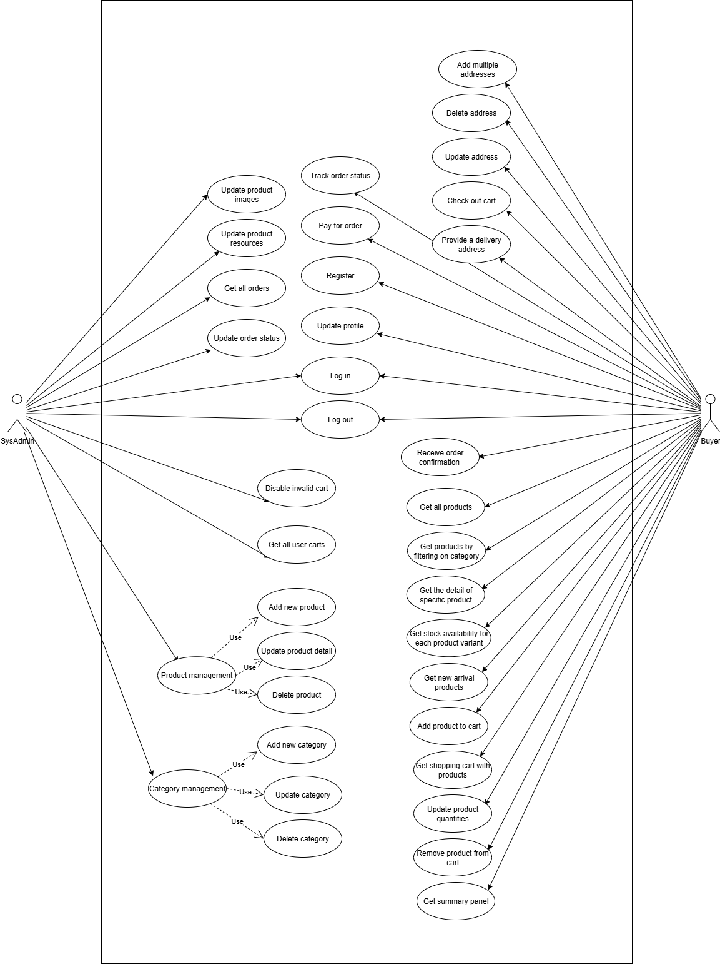
5.1. Authentication & Access Control: Đăng ký, đăng nhập, đăng xuất, quản lý thông tin tài khoản.
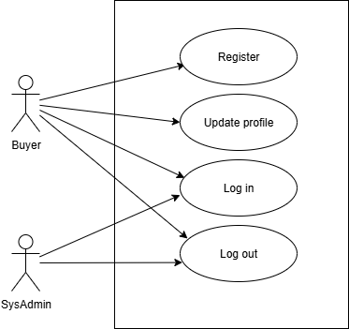

5.2. Product Catalog Management: Xem danh sách sản phẩm, tìm kiếm/lọc, xem chi tiết, quản lý sản phẩm và danh mục (dành cho SysAdmin).
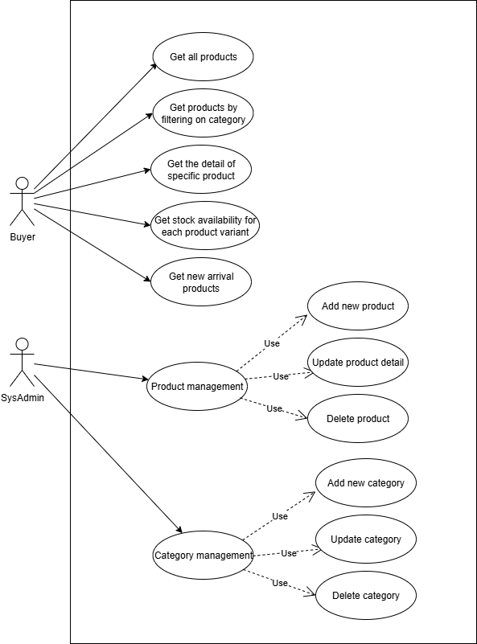
5.3. Shopping Cart Management: Thêm sản phẩm vào giỏ, cập nhật/xóa sản phẩm trong giỏ, xem tổng chi phí.
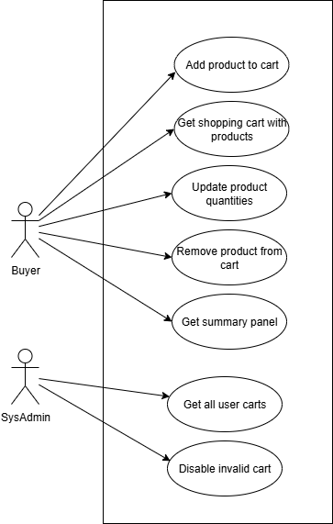

5.4. Ordering & Payment: Thanh toán, đặt hàng, nhận thông báo xác nhận, theo dõi trạng thái đơn hàng, quản lý đơn hàng (dành cho SysAdmin).
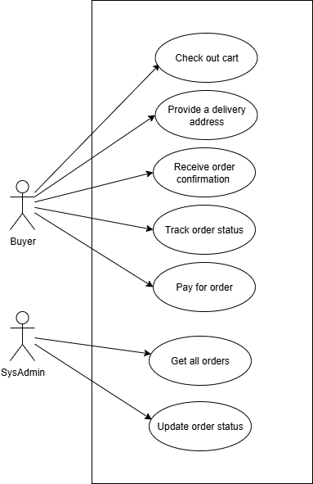

5.5. Address Management: Thêm, cập nhật, xóa địa chỉ giao hàng của Buyer.
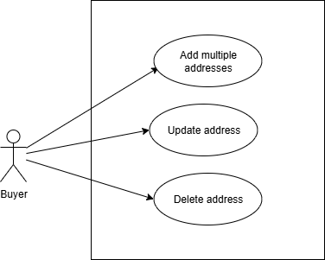
5.6. File & Resource Management: Quản lý hình ảnh sản phẩm, tài nguyên đi kèm (SysAdmin).
