Cover page
Citygarden market research analysis

Table of content
Cover page 1
Table of content 2
1. Introduction 4
1.1 Startup Overview 4
1.2 Problem Statement 4
1.3 Research Objectives 4
2. Research Methodology 5
2.1 Research Approach 5
2.2 Questionnaire Design 5
2.3 Respondent Profile 6
2.4 Data Collection Process 8
3. Market Research Findings 9
3.1 Market Understanding 9
3.1.1 Market Trends 9
3.1.2 Market Dynamics 9
3.1.3 Market Challenges 10
3.1.4 Survey Findings 10
3.2 Market Size and Growth Potential 17
3.2.1 Industry Overview 17
3.2.2 Market Size 18
3.2.3 Growth Rate 18
3.2.4 Potential Opportunities 18
3.2.4.1 Commercial Market Opportunities 18
3.2.4.2 Sustainability and Urban Living Opportunities 19
3.3 Target Market Segmentation 20
3.3.1 Demographic Segmentation 20
3.3.2 Geographic and Residential Segmentation 20
3.3.3 Psychographic Segmentation 20
3.3.4 Behavioural Segmentation 21
3.3.5 Target Customer Persona 21
3.4 Competitive Landscape Analysis 22
3.4.1 Key Competitors 22
3.4.2 Competitor Strengths 23
3.4.3 Competitor Weaknesses 23
3.4.4 Market Share Comparison 23
3.4.5 Differentiation Strategy 24
3.5 SWOT Analysis 25
3.5.1 Strengths 25
3.5.2 Weaknesses 25
3.5.3 Opportunities 25
3.5.4 Threats 26
4. Conclusion and Recommendations 26
4.1 Summary of Findings 26
4.2 Recommendations 27
Reference 28
Appendices 30
Appendix A: Survey Questionnaire 30
Appendix B: Survey Charts 30
Appendix C: Table 30

1. Introduction

1.1 Startup Overview
CityGarden is a website-based urban gardening service platform designed to help urban residents create and maintain sustainable gardens in limited living spaces. The platform focuses on providing practical gardening solutions for individuals living in apartments, condominiums, student hostels, and other urban residential areas where space constraints often prevent gardening activities.
CityGarden offers personalised gardening recommendations, garden planning guidance, installation services, and maintenance support through its online platform. The business aims to encourage urban communities to adopt greener lifestyles by making gardening more accessible, convenient, and environmentally sustainable.
The startup is built around the concept of space-saving gardening solutions, including vertical gardening systems, eco-friendly gardening materials, and low-maintenance gardening setups. By addressing common challenges faced by urban residents, CityGarden seeks to promote healthier living environments while supporting sustainable urban development.

1.2 Problem Statement
Rapid urbanisation has led to an increasing number of people living in apartments, condominiums, and other high-density residential areas where outdoor space is limited. Although many urban residents are interested in gardening, various challenges prevent them from starting or maintaining home gardens effectively.
The survey findings indicate that lack of time (52%) and lack of physical space (50%) are the two most significant barriers preventing respondents from engaging in home gardening. In addition, 34% of respondents reported insufficient gardening knowledge, while 38% identified messiness, dirt, and insect-related issues as major concerns. These findings suggest that urban residents require practical, space-efficient, and easy-to-maintain gardening solutions that fit their lifestyles.
Furthermore, many existing gardening solutions are either designed for larger residential properties or require substantial maintenance and gardening expertise. As a result, there is a growing need for a service platform that simplifies gardening for urban residents while promoting sustainable and environmentally friendly practices.

1.3 Research Objectives
The objectives of this market research are:
- To analyse the current urban gardening market, including market trends, dynamics, challenges, and consumer perceptions.
- To evaluate the market size, growth potential, and business opportunities within the urban gardening industry.
- To identify and segment the target market based on demographic, geographic, psychographic, and behavioural characteristics.
- To examine the competitive landscape by analysing key competitors, their strengths, weaknesses, and market positioning.
- To assess the internal and external factors affecting CityGarden through a SWOT analysis and develop strategic recommendations for future business growth.

2. Research Methodology

2.1 Research Approach
This study adopted a quantitative research approach to collect and analyse data regarding consumer perceptions, preferences, and behaviours related to urban gardening. A quantitative approach was selected because it enables the collection of measurable data from a larger group of respondents, allowing trends and patterns to be identified effectively.
A structured questionnaire was developed and distributed online using Google Forms. The survey focused on understanding respondents' gardening interests, challenges, preferred gardening features, purchasing intentions, and attitudes towards sustainable urban gardening solutions.
The collected data were analysed using descriptive statistics, including frequencies and percentages. The findings were then used to evaluate market demand, identify target customer segments, assess business opportunities, and support strategic recommendations for the proposed startup, CityGarden.

2.2 Questionnaire Design
The questionnaire was designed to gather information relevant to the objectives of the market research. It consisted of 18 questions divided into two main sections.
The first section collected demographic information, including age, gender, occupation, monthly income, and type of residence. This information was used to identify and segment potential target customers.
The second section focused on respondents’ interest in urban gardening, plant-growing preferences, perceived benefits of home greenery, gardening challenges, community gardening participation, acceptance of vertical gardening and automatic watering systems, attitudes towards eco-friendly materials, preferred product features, willingness to pay, preferred purchasing channels, interest in rooftop and balcony greening services, and purchase intentions towards the proposed CityGarden products and services.
A combination of multiple-choice questions, Likert-scale questions, and preference-based questions was used to ensure that the survey could capture both respondent characteristics and consumer behaviour effectively.

2.3 Respondent Profile
A total of 50 valid responses were collected for this study through an online survey distributed via Google Forms.
The respondents consisted of individuals from various demographic backgrounds. The survey collected information on age, gender, occupation, monthly income, and residential type to provide a comprehensive understanding of the target market.
The majority of respondents were young adults aged between 18 and 25 years old, reflecting a strong representation of students and young working adults. Respondents also represented different income groups and residential categories, including student hostels, apartments, condominiums, and landed properties.
The demographic information obtained from the survey serves as the foundation for the target market segmentation analysis presented in later sections of this report.
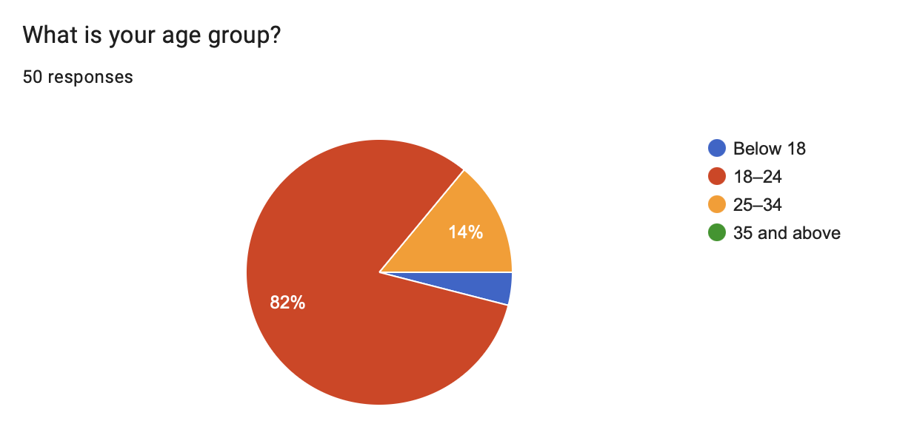
Figure 1. Age Distribution of Respondents
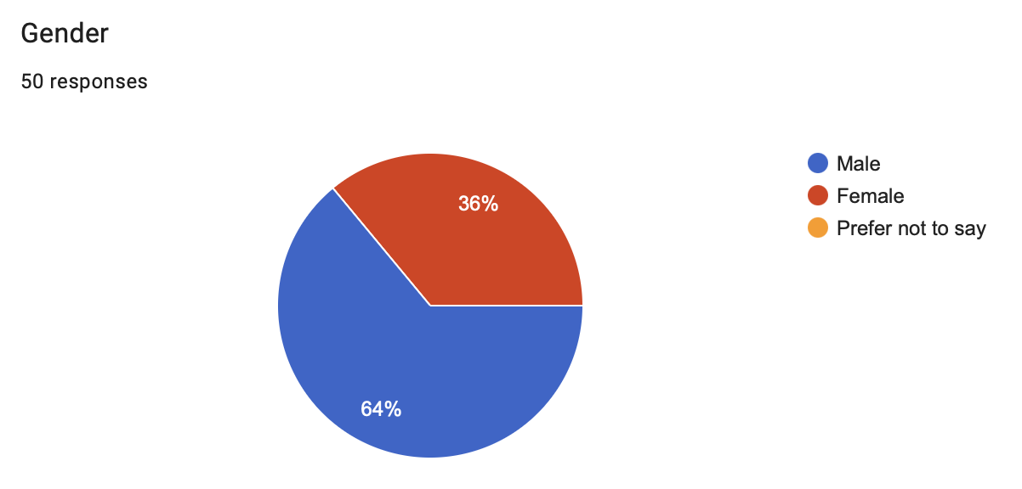
Figure 2. Gender Distribution of Respondents
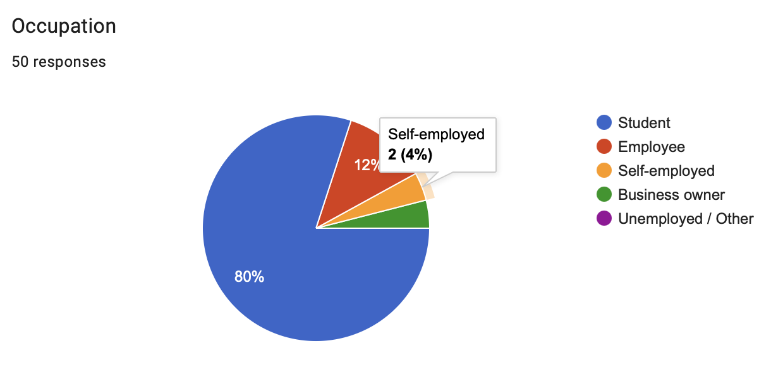
Figure 3. Occupation Distribution of Respondents
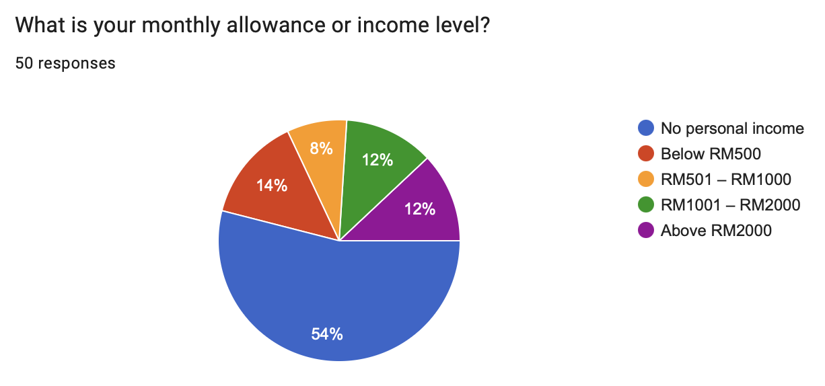
Figure 4. Monthly Income Distribution of Respondents
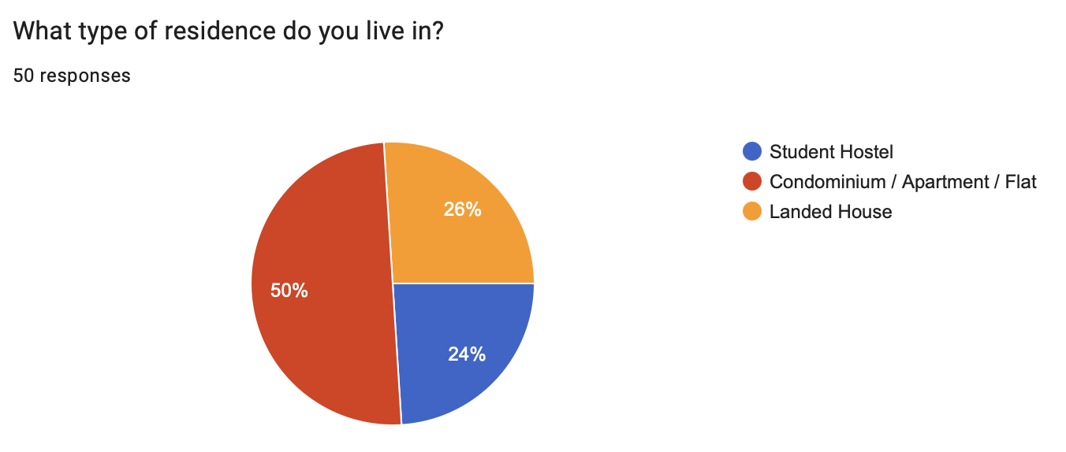
Figure 5. Residential Type Distribution of Respondents

2.4 Data Collection Process
The questionnaire was created using Google Forms and distributed through online communication platforms, including social media and messaging applications. Convenience sampling was used due to its practicality and accessibility in reaching potential respondents within a limited timeframe.
Data collection was conducted over a designated survey period, during which 50 valid responses were successfully obtained. Participation in the survey was voluntary, and respondents were informed about the purpose of the study before completing the questionnaire.
After data collection was completed, the responses were compiled and analysed using descriptive statistical methods. The results were subsequently used to support the market analysis, customer segmentation, competitive analysis, and strategic recommendations for CityGarden.

3. Market Research Findings

3.1 Market Understanding

3.1.1 Market Trends
Urban gardening has become an increasingly popular trend in recent years due to rapid urbanisation, growing environmental awareness, and the increasing demand for sustainable lifestyles. As more people move into apartments, condominiums, and high-density residential areas, traditional gardening practices have become less practical because of limited outdoor space. As a result, urban residents are increasingly seeking alternative gardening solutions that can be implemented in small living spaces (UNiCCM, 2026).
At the same time, sustainability has become a major concern among consumers. Many individuals are becoming more conscious of environmental issues and are seeking ways to reduce their environmental footprint through eco-friendly practices. Home gardening is increasingly viewed as a sustainable activity that contributes to food security, environmental conservation, and personal well-being (Santos et al., 2022).
Another notable trend is the growing adoption of space-saving gardening methods such as vertical gardening, balcony gardening, and rooftop gardening. These approaches enable urban residents to maximise limited space while maintaining access to greenery and gardening activities. This trend is particularly relevant to CityGarden, as the business focuses on providing practical gardening solutions for individuals living in urban environments.

3.1.2 Market Dynamics
Several factors are driving the growth of the urban gardening market. One of the primary drivers is increasing urbanisation, which has resulted in higher population densities and reduced access to traditional gardening spaces. Consequently, consumers are looking for innovative and space-efficient gardening solutions that suit urban lifestyles.
Consumer preferences have also shifted towards healthier and more sustainable lifestyles(Mimatik.com and S-cape.cz, 2024). Many individuals are becoming interested in growing their own vegetables, herbs, and ornamental plants to improve food quality, reduce household expenses, and enhance their living environment.
Technological advancements and the availability of online gardening resources have further contributed to market growth. Consumers now have easier access to gardening information, products, and services through digital platforms, making gardening more accessible to beginners and experienced gardeners alike. These market dynamics create favourable conditions for businesses such as CityGarden to offer gardening guidance, installation services, and sustainable gardening solutions through an online platform.

3.1.3 Market Challenges
Despite the increasing popularity of urban gardening, several challenges continue to limit consumer participation. One of the most common challenges is the lack of available space, particularly among individuals living in apartments, condominiums, and student hostels. Limited space often restricts the types of plants that can be grown and discourages potential gardeners from starting gardening activities (Like, 2026).
Another challenge is the lack of time required to maintain a garden. Urban residents often have busy schedules, making it difficult to consistently care for plants and perform routine gardening tasks. In addition, many individuals possess limited gardening knowledge and may feel uncertain about plant selection, maintenance requirements, and gardening techniques(Galhena et al., 2013).
Environmental factors such as pests, insects, weather conditions, and maintenance costs may also discourage participation in gardening activities. These challenges highlight the need for practical, user-friendly, and space-saving gardening solutions that can simplify the gardening process for urban residents.

3.1.4 Survey Findings
The survey findings provide valuable insights into consumer attitudes, preferences, and purchasing behaviour related to urban gardening. Overall, the results indicate strong market interest in urban gardening solutions and support the commercial potential of CityGarden.
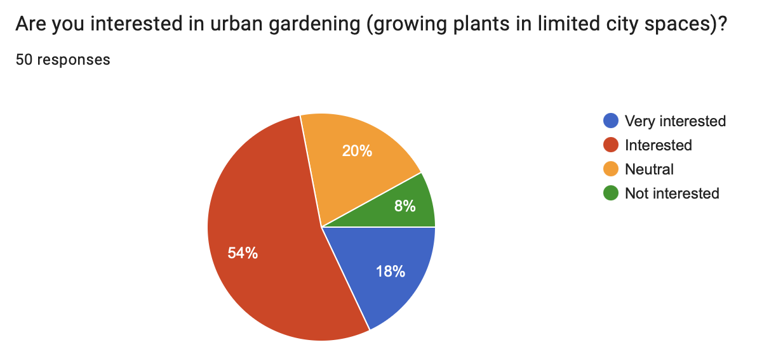
Figure 6. Level of Interest in Urban Gardening Among Respondents
As shown in Figure 6, a significant majority of respondents expressed positive interest in urban gardening, with 72% indicating that they were either interested or very interested in growing plants within limited urban spaces. This suggests that urban gardening is becoming increasingly attractive among urban residents.

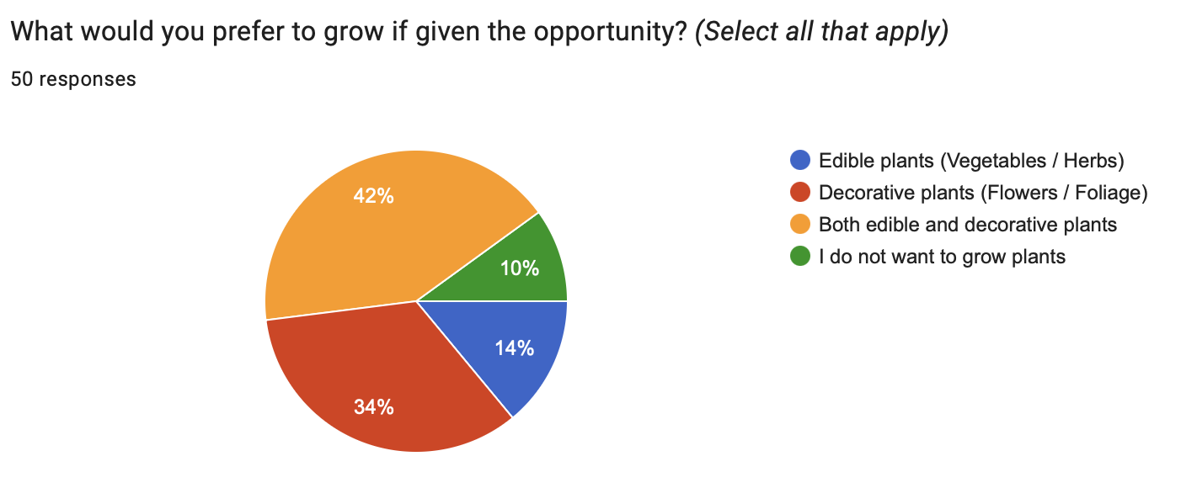
Figure 7. Respondents’ Preferences for Plant Types in Home Gardening
Regarding gardening preferences, Figure 7 shows that 42% of respondents preferred growing both edible and decorative plants, while 34% preferred decorative plants and 14% preferred edible plants. This indicates that consumers value both aesthetic and functional benefits when engaging in gardening activities. Therefore, CityGarden should consider offering flexible gardening solutions that accommodate various plant types.
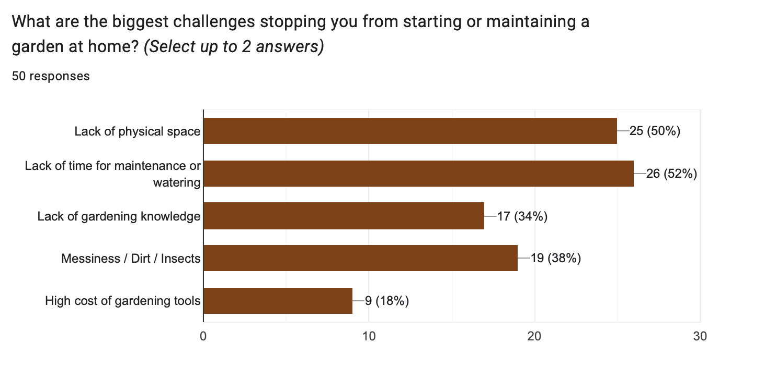
Figure 8. Major Challenges Faced by Respondents in Home Gardening
The survey also identified several barriers that prevent consumers from starting or maintaining a home garden. According to Figure 8, lack of time for maintenance (52%) and lack of physical space (50%) were the most common challenges reported by respondents. Other concerns included messiness, insects, and insufficient gardening knowledge. These findings highlight a clear market need for low-maintenance and space-efficient gardening solutions.

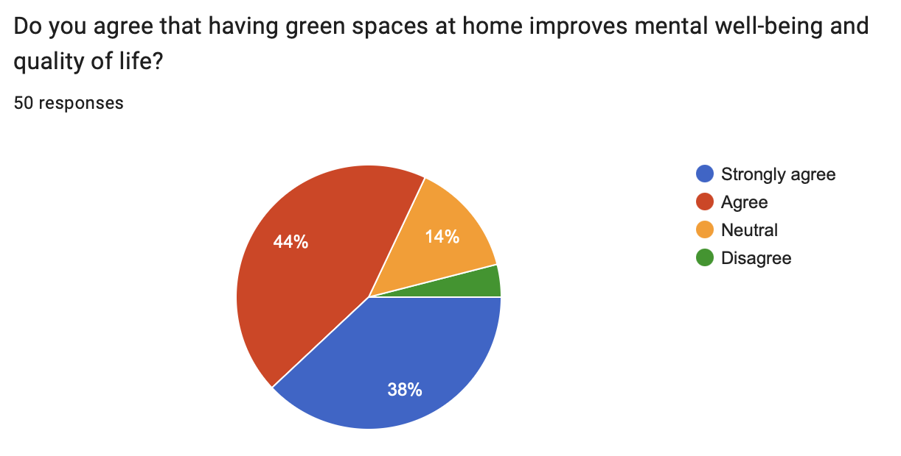
Figure 9. Agreement on the Benefits of Home Green Spaces for Mental Well-being
In addition, Figure 9 reveals that 82% of respondents either agreed or strongly agreed that having green spaces at home improves mental well-being and quality of life. This demonstrates that consumers perceive gardening not only as a hobby but also as a contributor to personal wellness and healthier living environments.
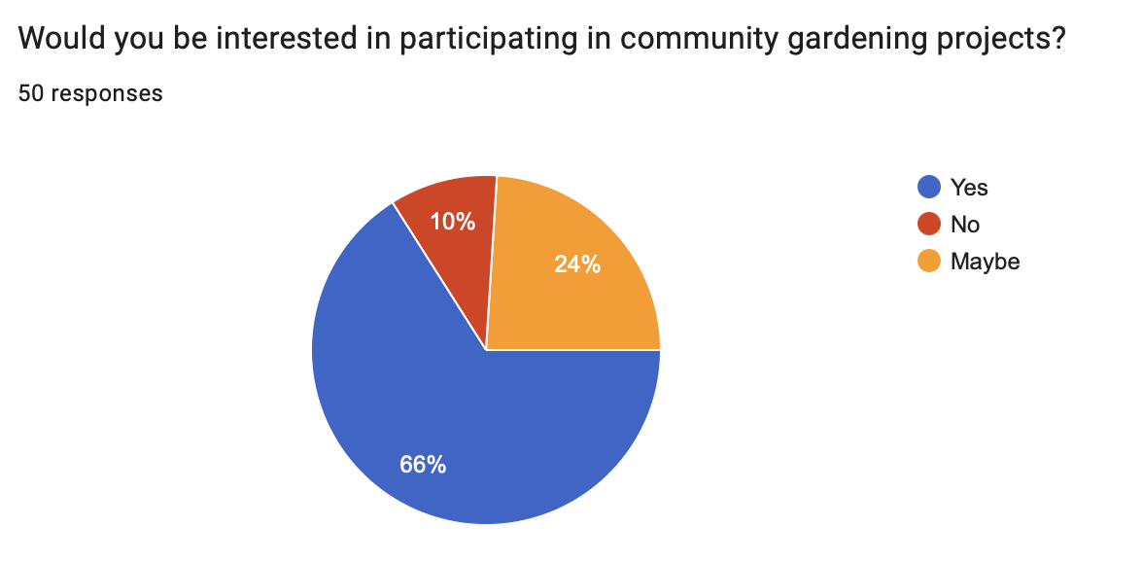
Figure 10. Respondents’ Willingness to Participate in Community Gardening Projects
Community engagement also appears to be an important aspect of urban gardening. As shown in Figure 9, 66% of respondents expressed interest in participating in community gardening projects, while only 10% were not interested. This suggests that consumers value social interaction and collaborative environmental activities.

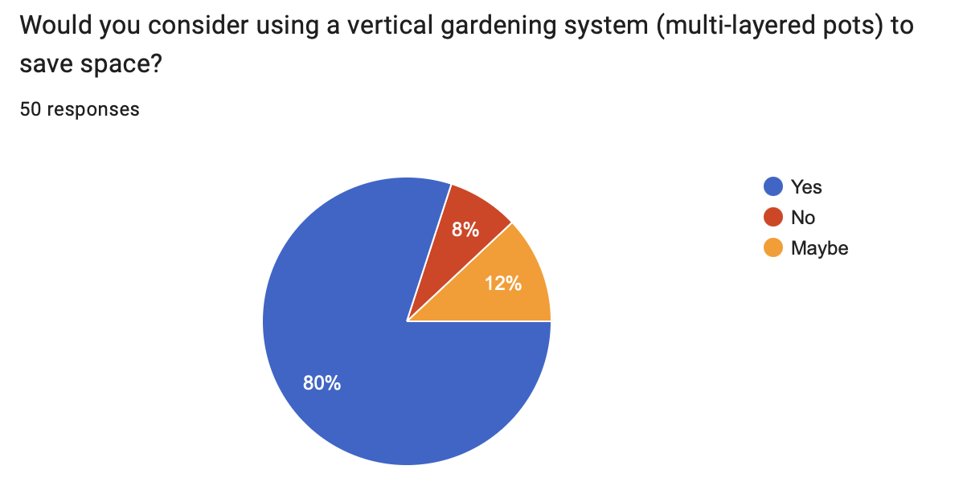
Figure 11. Willingness to Use Vertical Gardening Systems for Space Saving
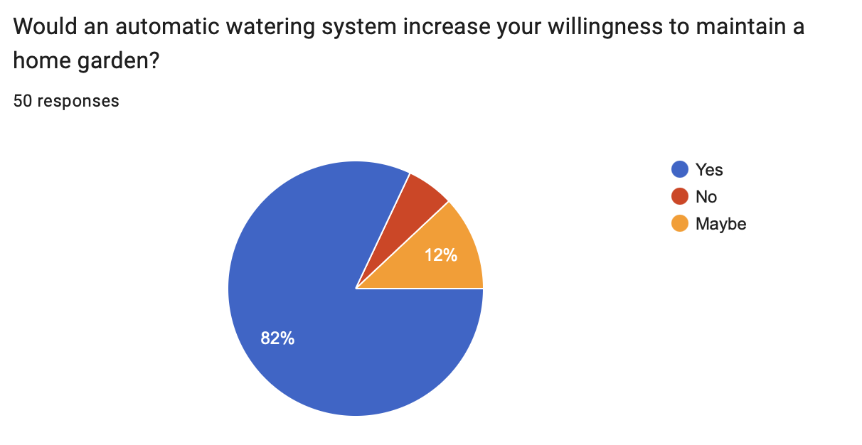
Figure 12. Impact of Automatic Watering Systems on Willingness to Maintain a Home Garden
The demand for innovative gardening solutions is further reflected in Figures 11 and 12. Approximately 80% of respondents were willing to consider using vertical gardening systems, while 82% indicated that an automatic watering system would increase their willingness to maintain a home garden. These findings strongly support CityGarden’s concept of providing space-saving and user-friendly gardening solutions.

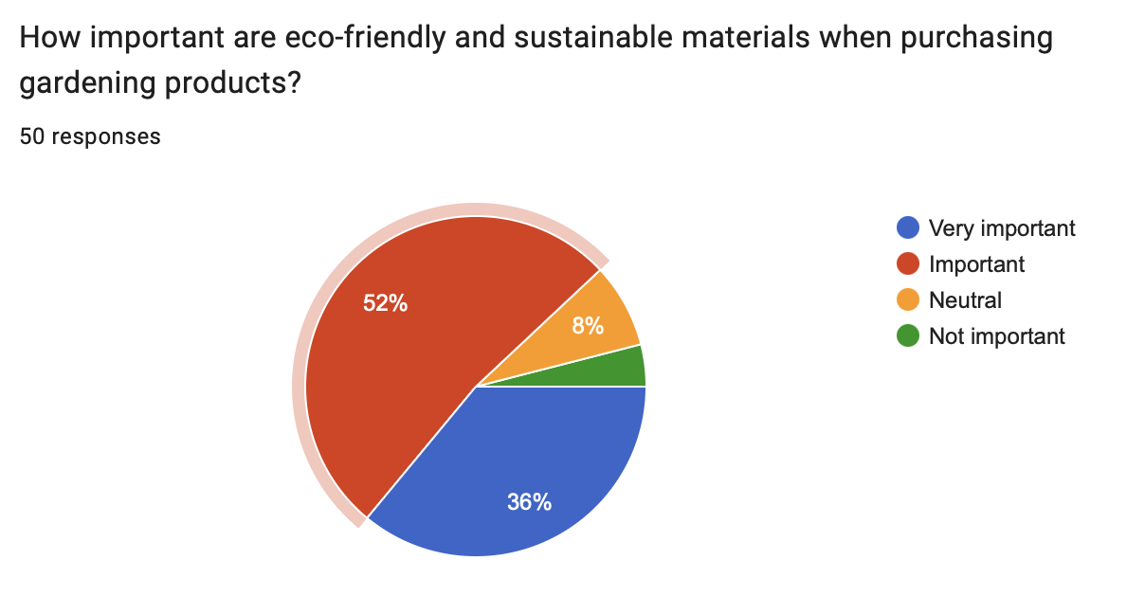
Figure 13. Consumer Perceptions of Eco-Friendly and Sustainable Materials in Gardening Products
Environmental sustainability was another important factor influencing consumer decisions. Figure 13 shows that 88% of respondents considered eco-friendly and sustainable materials to be either important or very important when purchasing gardening products. This indicates strong consumer awareness of environmental responsibility and supports the use of sustainable materials within CityGarden’s product offerings.
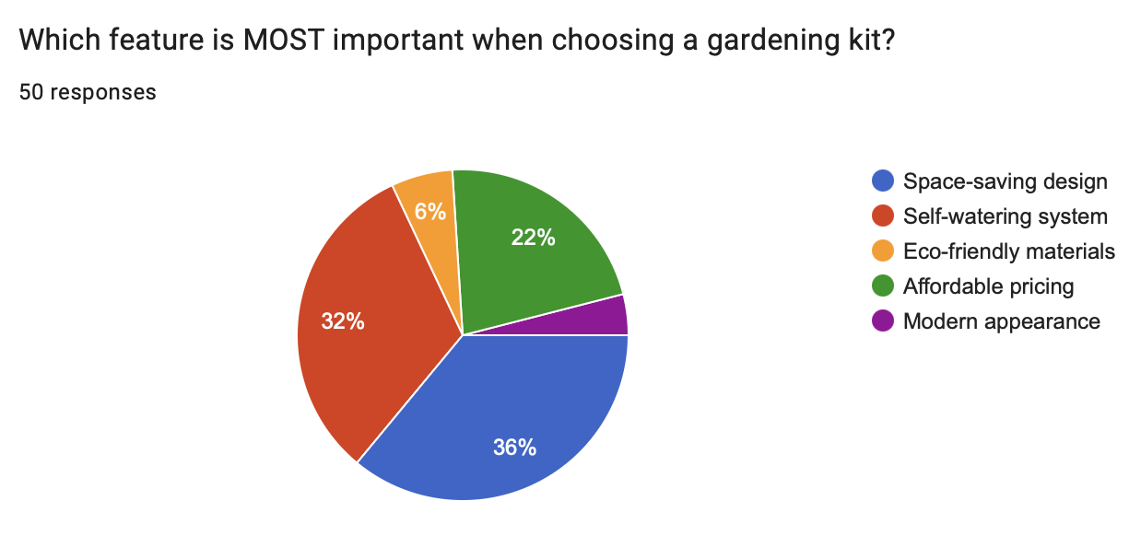
Figure 14. Most Important Features Considered When Choosing a Gardening Kit
When evaluating product features, Figure 14 reveals that space-saving design (36%) and self-watering functionality (32%) were the two most important considerations when selecting a gardening kit. Affordable pricing was also identified as a significant factor by 22% of respondents. These findings provide valuable guidance for product development and service design.

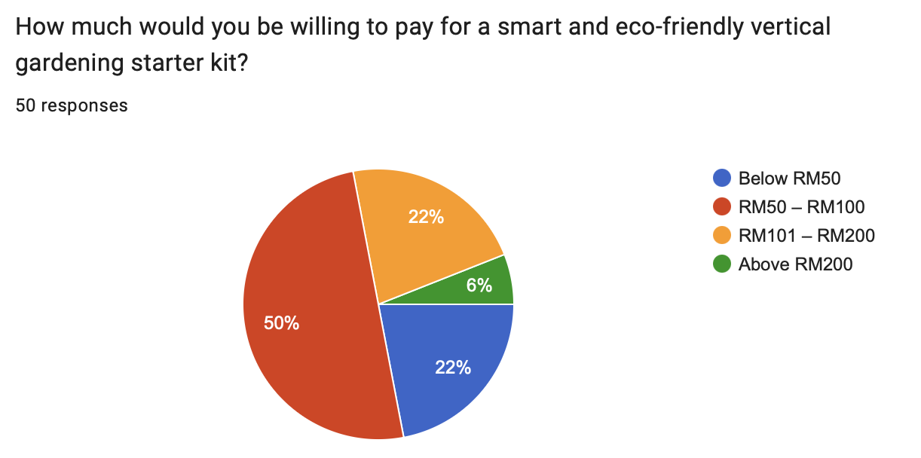
Figure 15. Consumers’ Willingness to Pay for a Smart and Eco-Friendly Vertical Gardening Starter Kit
Price sensitivity was examined through respondents’ willingness to pay for a smart and eco-friendly vertical gardening starter kit. As shown in Figure 15, half of the respondents preferred a price range between RM50 and RM100, while only 6% were willing to pay more than RM200. This suggests that CityGarden should adopt a competitive pricing strategy to appeal to its target market.
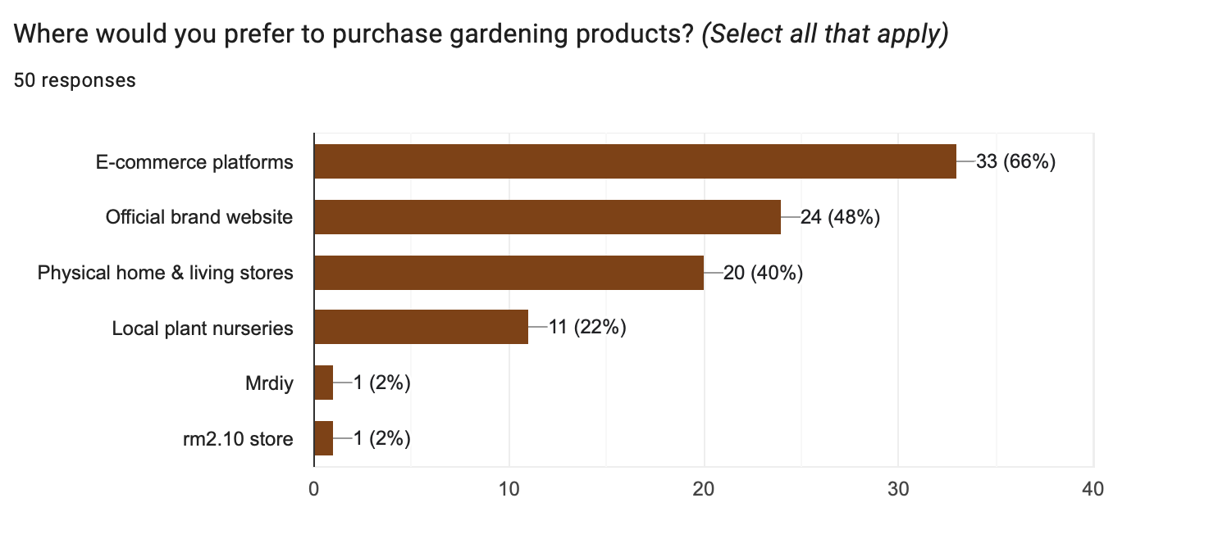
Figure 16. Preferred Channels for Purchasing Gardening Products
The survey also explored preferred purchasing channels. Figure 16 indicates that e-commerce platforms (66%) and official brand websites (48%) were the most preferred purchasing channels among respondents. This finding strongly supports CityGarden’s website-based business model and highlights the importance of establishing a strong online presence.

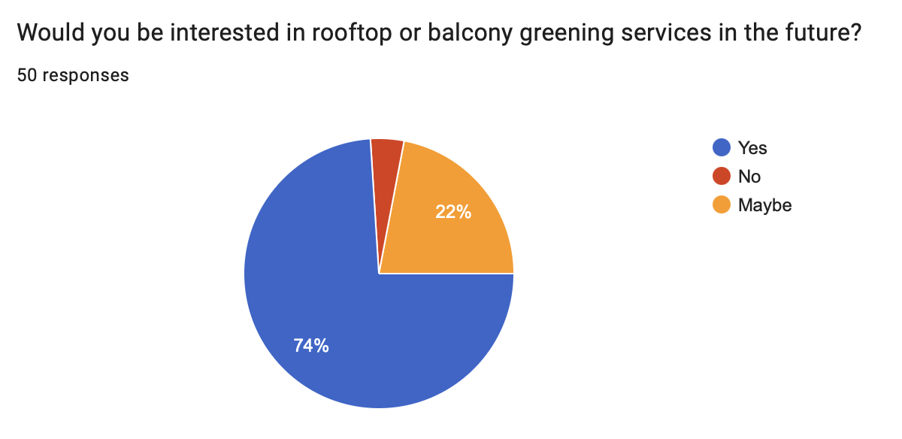
Figure 17. Interest in Future Rooftop and Balcony Greening Services
Furthermore, Figure 17 demonstrates strong interest in future rooftop and balcony greening services, with 74% of respondents expressing interest in such services. This finding suggests that CityGarden may have opportunities to expand beyond gardening kits and offer installation or consultation services in the future.

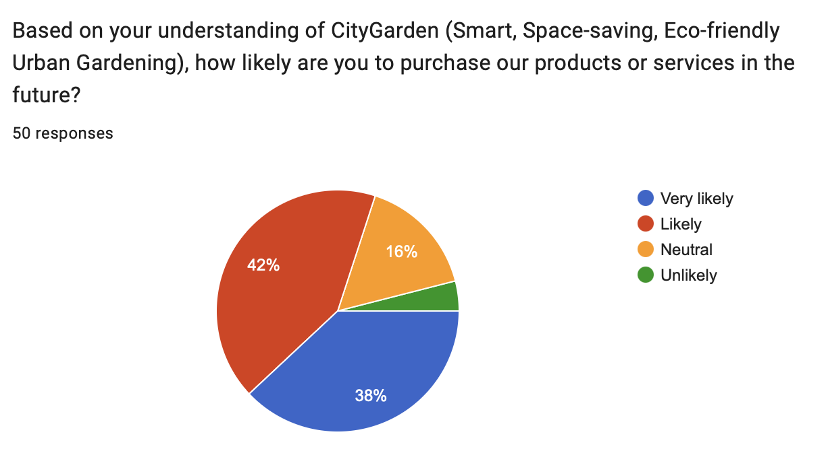
Figure 18. Likelihood of Purchasing CityGarden Products or Services in the Future
Finally, Figure 18 indicates positive market acceptance of the CityGarden concept. A total of 80% of respondents reported that they were either likely or very likely to purchase CityGarden’s products or services in the future. This result provides strong evidence of market potential and supports the feasibility of the proposed business idea.
Overall, the survey findings indicate that consumers are highly interested in urban gardening, value sustainability, prefer convenient and space-saving solutions, and demonstrate positive purchase intentions towards CityGarden. These findings validate the business concept and provide a strong foundation for subsequent market segmentation and competitive analysis.

3.2 Market Size and Growth Potential

3.2.1 Industry Overview
The urban gardening and home gardening industry has experienced significant growth in recent years, driven by increasing urbanisation, environmental awareness, and consumer interest in sustainable living practices. As more people live in apartments, condominiums, and other high-density residential areas, demand for gardening solutions that can be implemented in limited spaces has increased substantially.
The industry encompasses a wide range of products and services, including gardening kits, vertical gardening systems, smart irrigation technologies, gardening consultation, landscaping services, and urban farming solutions. In addition to recreational gardening, consumers are increasingly adopting home gardening to improve food security, reduce environmental impact, enhance mental well-being, and create healthier living environments.
Survey findings further support the relevance of this industry. The majority of respondents expressed interest in urban gardening, while 82% agreed that having green spaces at home improves mental well-being and quality of life. Additionally, 80% of respondents indicated willingness to use vertical gardening systems, highlighting growing consumer acceptance of innovative urban gardening solutions. These findings suggest that urban residents are becoming more receptive to gardening products and services that address space limitations and maintenance challenges.
The industry is also benefiting from technological advancements such as automatic watering systems, smart gardening devices, and online gardening platforms, which make gardening more accessible to beginners. Combined with increasing consumer demand for eco-friendly products and sustainable lifestyles, these developments create favourable conditions for businesses such as CityGarden that provide convenient, space-saving, and environmentally responsible gardening solutions.

3.2.2 Market Size
The global home gardening market has demonstrated substantial market value and continues to expand due to increasing consumer interest in sustainable lifestyles and urban gardening practices.
According to industry reports, the global home gardening market was valued at approximately USD 15.78 billion in 2025 and is projected to reach USD 26.47 billion by 2034 (Web Series Reviews, 2025). This indicates strong long-term market potential and growing consumer demand for gardening-related products and services.
In addition, the broader gardening market was valued at approximately USD 120 billion in 2024 and is expected to reach USD 150 billion by 2030 (MarkNtel Advisors, 2025). The growth of these markets reflects increasing consumer awareness of sustainability, home food production, and urban gardening solutions.
These market indicators suggest significant opportunities for startups such as CityGarden to participate in the growing gardening and urban agriculture industry.

3.2.3 Growth Rate
The gardening and urban agriculture industry is expected to maintain positive growth over the coming years. Industry reports estimate that the global home gardening market will grow at a compound annual growth rate (CAGR) of approximately 5.92% between 2025 and 2034 (Web Series Reviews, 2025).
Similarly, the broader gardening market is projected to grow at an estimated CAGR of approximately 5% during the forecast period(MarkNtel Advisors, 2025). This growth is driven by increasing environmental awareness, demand for sustainable food production, interest in home gardening, and the growing popularity of urban farming practices.
The positive growth outlook indicates that consumer demand for gardening-related products and services is likely to continue increasing. This creates favourable business opportunities for startups such as CityGarden that focus on sustainable and space-saving gardening solutions

3.2.4 Potential Opportunities

3.2.4.1 Commercial Market Opportunities
The continued growth of the urban gardening industry presents significant commercial opportunities for CityGarden. Increasing urbanisation, rising environmental awareness, and growing interest in sustainable living have created demand for gardening solutions that are practical, affordable, and suitable for limited living spaces.
The survey findings further support the commercial viability of the proposed business concept. According to Figure 17, 74% of respondents expressed interest in rooftop and balcony greening services, indicating strong demand for urban greening solutions among city residents. This suggests that consumers are actively seeking ways to introduce greenery into their homes despite space limitations.
In addition, Figure 18 reveals that 80% of respondents were either likely or very likely to purchase CityGarden’s products or services in the future. This high level of purchase intention demonstrates positive market acceptance and indicates the existence of a potential customer base for the startup.
The survey also revealed strong interest in vertical gardening systems, automatic watering features, and eco-friendly materials. These preferences align closely with CityGarden’s value proposition and provide opportunities to develop products and services that directly address consumer needs.
Furthermore, the growing preference for online purchasing channels creates additional opportunities for CityGarden’s website-based business model. By offering convenient access to gardening products, installation services, and educational resources through an online platform, CityGarden can effectively reach its target market while maintaining lower operating costs compared to traditional retail businesses.
Overall, the combination of positive market trends, strong consumer interest, and favourable purchase intentions suggests that CityGarden has considerable commercial potential within the expanding urban gardening market.

3.2.4.2 Sustainability and Urban Living Opportunities
Beyond commercial opportunities, broader social and environmental trends also create favourable conditions for CityGarden. Increasing awareness of environmental sustainability has encouraged consumers to adopt greener lifestyles and seek environmentally responsible products and services.
The survey findings indicate that a large majority of respondents considered eco-friendly materials important when purchasing gardening products. In addition, most respondents agreed that having green spaces at home improves quality of life and mental well-being. These findings suggest that consumers increasingly view gardening as a way to support both personal wellness and environmental sustainability.
The growing popularity of urban living further strengthens this opportunity. As more individuals live in apartments, condominiums, and other high-density residential environments, demand for space-saving gardening solutions is expected to increase. This trend creates favourable conditions for CityGarden to provide vertical gardening systems, balcony gardening solutions, and other urban gardening services.
By aligning its products and services with sustainability values and urban lifestyle needs, CityGarden can establish a strong market position while contributing positively to environmental and community well-being.

3.3 Target Market Segmentation

3.3.1 Demographic Segmentation
Based on the demographic findings presented in Figures 1 to 4, CityGarden's primary target market consists of young adults, particularly individuals aged between 18 and 35 years old. This segment is highly relevant because younger consumers are generally more receptive to sustainable lifestyle practices and are more likely to engage with digital platforms when seeking products and services.
The survey results also indicate strong representation from students and young working adults. These groups often live independently in urban areas and are increasingly interested in improving their living environments despite facing space limitations. As a result, they represent a promising customer segment for CityGarden.
From an income perspective, CityGarden should focus on middle-income consumers and students who seek affordable yet practical gardening solutions. Therefore, the business should offer cost-effective packages that provide convenience and value while remaining accessible to its target audience.

3.3.2 Geographic and Residential Segmentation
Based on the residential characteristics identified in Figure 5, CityGarden should primarily target consumers living in urban areas, particularly those residing in apartments, condominiums, and student accommodation.
These residential environments often have limited outdoor gardening space, making traditional gardening methods impractical. Consequently, residents require gardening solutions that maximise available space while remaining easy to install and maintain.
This market segment aligns closely with CityGarden's value proposition, which focuses on providing space-saving gardening solutions such as vertical gardens and balcony gardening systems. Therefore, urban residential communities represent the most attractive geographic market for the startup.

3.3.3 Psychographic Segmentation
CityGarden’s target customers are primarily individuals who value sustainability, personal well-being, and environmentally responsible lifestyles. Based on the findings presented in Figures 9, 10, and 13, respondents demonstrated strong positive attitudes towards green living, community engagement, and eco-friendly consumption.
A substantial majority of respondents agreed that having green spaces at home improves mental well-being and quality of life (Figure 9). This suggests that consumers view gardening not merely as a leisure activity but also as a means of enhancing their physical and psychological well-being.
Furthermore, Figure 10 indicates strong interest in community gardening projects, suggesting that many respondents appreciate social interaction, collaboration, and shared environmental initiatives. This reflects a growing preference for community-oriented and sustainable lifestyles.
Environmental consciousness is also evident from Figure 13, where most respondents considered eco-friendly and sustainable materials important when purchasing gardening products. This indicates that sustainability has become an important purchase consideration rather than a secondary benefit.
In addition, Figure 7 reveals that many respondents preferred growing both edible and decorative plants. This preference reflects a combination of practical and lifestyle motivations, as consumers seek both functional benefits, such as food production, and aesthetic benefits that enhance their living environments.
Therefore, CityGarden should position itself as a sustainable lifestyle brand that promotes wellness, environmental responsibility, and urban green living rather than merely selling gardening products.

3.3.4 Behavioural Segmentation
The behavioural characteristics of CityGarden’s target customers are reflected in their purchasing preferences, desired product features, spending expectations, and preferred buying channels.
Figures 11 and 12 indicate strong acceptance of innovative gardening solutions. Most respondents expressed willingness to use vertical gardening systems and automatic watering technologies. These findings suggest that consumers prefer gardening solutions that minimise maintenance effort while maximising convenience and space efficiency.
Product feature preferences further support this observation. As shown in Figure 14, respondents identified space-saving design and self-watering functionality as the most important considerations when selecting a gardening kit. This demonstrates that convenience and practicality strongly influence purchasing decisions.
Price sensitivity is another important behavioural characteristic. Figure 15 shows that most respondents preferred a price range between RM50 and RM100 for a smart and eco-friendly gardening starter kit. This suggests that consumers are interested in innovative gardening products but remain price conscious.
The survey also reveals a clear preference for online purchasing behaviour. According to Figure 16, e-commerce platforms and official brand websites were the most preferred purchasing channels. This supports CityGarden’s decision to operate primarily through a website-based business model and highlights the importance of digital marketing strategies.
Additionally, Figure 17 indicates strong interest in rooftop and balcony greening services. This suggests that consumers are not only interested in purchasing gardening products but are also receptive to installation, consultation, and maintenance-related services.
Finally, Figure 18 demonstrates positive purchase intentions towards CityGarden. A large proportion of respondents indicated that they were likely or very likely to purchase CityGarden’s products or services in the future. This reflects favourable market acceptance and strong commercial potential for the proposed business concept.

3.3.5 Target Customer Persona
Based on the demographic, psychographic, and behavioural segmentation analysis, CityGarden's primary target customer can be described as a young urban resident aged between 18 and 35 years old who lives in an apartment, condominium, or student accommodation with limited gardening space.
This customer is interested in urban gardening and values the benefits of having greenery at home, particularly for improving quality of life and mental well-being. They are environmentally conscious and prefer products made from sustainable and eco-friendly materials. In addition, they appreciate opportunities to participate in community-based environmental activities and support initiatives that promote sustainable urban living.
The customer is interested in growing both decorative and edible plants, reflecting a desire to combine aesthetic enjoyment with practical benefits. However, they often face challenges such as limited physical space, lack of time for maintenance, and insufficient gardening knowledge.
As a result, they actively seek gardening solutions that are convenient, low-maintenance, and space-efficient. Features such as vertical gardening systems and automatic watering technologies are particularly attractive because they help overcome common barriers associated with urban gardening.
From a purchasing perspective, this customer prefers buying products through e-commerce platforms or official brand websites and expects affordable pricing, typically within the RM50 to RM100 range. They also demonstrate interest in rooftop and balcony greening services and show a positive willingness to purchase CityGarden’s products and services in the future.
Therefore, CityGarden’s ideal customer is a digitally connected, sustainability-oriented urban resident seeking practical and innovative gardening solutions that fit modern city lifestyles.

3.4 Competitive Landscape Analysis

3.4.1 Key Competitors
The urban gardening industry is becoming increasingly competitive as consumer interest in sustainable living and home gardening continues to grow. Several businesses currently offer products or services that partially overlap with the proposed CityGarden concept.
One of the major competitors is IKEA Malaysia, which offers a variety of indoor plants, gardening accessories, storage solutions, and home improvement products that support small-space gardening. IKEA benefits from strong brand recognition and a well-established customer base.
Another competitor is KebunBandar, which focuses on urban farming and gardening education. The company promotes community gardening initiatives and provides gardening-related knowledge and resources to urban residents.
In addition, online marketplaces such as Shopee and Lazada host numerous gardening product sellers that offer gardening kits, plant containers, seeds, tools, and gardening accessories at competitive prices. These platforms provide customers with a wide range of options and convenient purchasing channels.
While these competitors address certain aspects of urban gardening, none of them combine gardening products, installation services, gardening guidance, sustainability-focused solutions, and a dedicated website platform within a single integrated service model. This creates an opportunity for CityGarden to differentiate itself within the market.

3.4.2 Competitor Strengths
Each competitor possesses unique strengths that contribute to its market position.
IKEA Malaysia benefits from strong brand reputation, extensive product variety, established supply chains, and nationwide customer reach. The company also offers affordable home improvement solutions that complement small-space gardening.
KebunBandar's primary strength lies in its expertise in urban farming education and community engagement. Its strong focus on sustainability and gardening knowledge enables it to attract environmentally conscious consumers.
Online marketplace sellers on Shopee and Lazada benefit from competitive pricing, large product selection, customer reviews, and convenience. These platforms provide consumers with easy access to gardening products from multiple vendors.
The strengths of these competitors demonstrate that customers value affordability, convenience, accessibility, and gardening knowledge when selecting gardening-related products and services.

3.4.3 Competitor Weaknesses
Despite their strengths, competitors also possess limitations that create opportunities for CityGarden.
Although IKEA Malaysia offers gardening-related products, gardening is not its primary business focus. The company generally provides products rather than personalised gardening guidance, installation services, or ongoing gardening support.
KebunBandar focuses heavily on education and community gardening but offers limited integrated commercial solutions for consumers seeking convenient gardening products and services.
Similarly, gardening sellers on Shopee and Lazada mainly focus on product sales. Customers often need to independently select products, obtain gardening knowledge, and manage installation and maintenance without professional assistance.
These weaknesses indicate a gap in the market for a customer-focused platform that combines products, services, education, and support within a single urban gardening ecosystem.

3.4.4 Market Share Comparison
As CityGarden is a proposed startup, it does not currently possess measurable market share. Therefore, the comparison focuses on relative market presence and competitive influence within the urban gardening market.
IKEA Malaysia holds a strong market position due to its established brand recognition, extensive product range, and nationwide customer reach. Its presence within the home improvement and lifestyle market provides a significant competitive advantage.
Shopee and Lazada gardening sellers collectively represent a substantial share of online gardening product sales due to their large customer base, extensive product variety, and competitive pricing strategies.
KebunBandar occupies a smaller but specialised niche market, focusing primarily on urban farming education, community gardening initiatives, and sustainability awareness.
In contrast, CityGarden aims to enter the market by targeting a specific niche segment consisting of urban residents seeking integrated gardening solutions. Rather than competing directly on scale, CityGarden will compete through service differentiation, customer support, and specialised urban gardening expertise.

Competitor | Strength | Weakness
IKEA | Strong brand | Not gardening specialist
KebunBandar | Education expertise | Limited products
Shopee/Lazada | Low prices | No personalised support
CityGarden | Integrated solution | New startup

3.4.5 Differentiation Strategy
CityGarden’s primary differentiation strategy is based on providing an integrated urban gardening solution rather than simply selling gardening products.
Unlike IKEA Malaysia, which primarily focuses on retail products, CityGarden combines gardening products with educational content, installation services, and gardening guidance specifically designed for urban residents.
Compared to online marketplace sellers, CityGarden offers a curated and customer-focused experience. Rather than requiring customers to search through numerous products independently, the platform provides tailored recommendations and support that simplify the gardening process.
While KebunBandar focuses on education and community engagement, CityGarden integrates educational resources with practical gardening solutions and commercial services. This enables customers to obtain both knowledge and implementation support from a single platform.
Furthermore, CityGarden’s emphasis on vertical gardening systems, eco-friendly materials, automatic watering solutions, and urban space optimization directly addresses the needs identified through the survey findings. These features create a unique value proposition that differentiates the startup from existing competitors.

3.5 SWOT Analysis

3.5.1 Strengths
CityGarden possesses several strengths that support its business potential within the urban gardening market. The startup offers an integrated service model that combines gardening products, gardening guidance, installation services, and sustainability-focused solutions through a dedicated online platform.
The business concept directly addresses major consumer challenges identified in the survey, including limited space, lack of time, and insufficient gardening knowledge. In addition, CityGarden’s focus on vertical gardening systems, automatic watering solutions, and eco-friendly materials aligns closely with consumer preferences and current market trends.
As a website-based platform, CityGarden can operate with lower overhead costs compared to traditional retail businesses while maintaining accessibility and convenience for customers.

3.5.2 Weaknesses
As a new startup, CityGarden faces several internal limitations. The business currently lacks brand recognition and an established customer base, making it challenging to gain market trust during the initial stages of operation.
Financial and operational resources may also be limited compared to larger competitors such as IKEA and established online marketplaces. Furthermore, because CityGarden relies heavily on online channels, its success depends significantly on effective digital marketing and customer acquisition strategies.
The business may also face challenges in scaling installation and maintenance services as customer demand grows.

3.5.3 Opportunities
The urban gardening industry presents numerous opportunities for CityGarden. Increasing urbanisation, growing environmental awareness, and rising interest in sustainable living continue to drive demand for urban gardening solutions.
The survey findings indicate strong consumer interest in urban gardening, rooftop and balcony greening services, and environmentally friendly gardening products. In addition, the positive purchase intentions expressed by respondents suggest strong market potential for CityGarden’s products and services.
The increasing popularity of e-commerce platforms and online purchasing behaviour further supports the startup’s website-based business model. Future opportunities may also include expanding into gardening consultation, customised installation services, and community gardening programmes.

3.5.4 Threats
CityGarden operates within a competitive market environment. Large retailers such as IKEA and numerous sellers on Shopee and Lazada possess greater resources, stronger brand recognition, and larger customer bases.
Price competition may present a challenge, particularly when consumers compare products across multiple online platforms. Economic uncertainty and changes in consumer spending behaviour may also affect demand for gardening-related products and services.
In addition, rapidly changing consumer preferences and technological developments may require continuous adaptation to remain competitive within the market.

4. Conclusion and Recommendations

4.1 Summary of Findings
This market research report was conducted to evaluate the feasibility and market potential of the proposed CityGarden startup. The findings indicate that the urban gardening market presents promising opportunities driven by increasing urbanisation, sustainability awareness, and consumer interest in home gardening activities.
The survey results revealed strong interest in urban gardening among respondents. Consumers demonstrated positive attitudes towards vertical gardening systems, automatic watering solutions, eco-friendly materials, and rooftop or balcony greening services. The findings also identified key challenges faced by consumers, including limited space, lack of time, and insufficient gardening knowledge.
Market analysis further showed that the gardening industry continues to experience steady growth, creating favourable conditions for businesses that provide sustainable and space-saving gardening solutions. The target market primarily consists of young urban residents living in apartments, condominiums, and student accommodation who value convenience, sustainability, and quality of life.
Competitive analysis revealed that while existing competitors offer gardening products or educational services, there remains a market opportunity for a platform that integrates gardening products, installation services, educational resources, and customer support into a single solution.
Overall, the findings support the viability of CityGarden and suggest that the startup possesses strong potential to establish a competitive position within the growing urban gardening market.

4.2 Recommendations
Based on the findings of this study, several recommendations are proposed for the successful development of CityGarden.
First, CityGarden should focus on providing space-saving gardening solutions, particularly vertical gardening systems and balcony gardening kits, as these features align closely with consumer preferences and address the challenge of limited urban living space.
Second, the startup should incorporate user-friendly features such as automatic watering systems and easy-maintenance gardening setups to accommodate consumers who have limited time and gardening experience.
Third, sustainability should remain a core element of the business strategy. The use of eco-friendly materials and environmentally responsible practices will strengthen CityGarden’s appeal among environmentally conscious consumers.
Fourth, the company should utilise its website as the primary sales and communication platform. Educational content, gardening tutorials, and customer support resources should be integrated into the platform to improve customer engagement and build long-term relationships.
Finally, CityGarden should consider expanding into installation services, customised gardening consultations, and rooftop or balcony greening projects, as these services demonstrated strong interest among survey respondents and may provide additional revenue opportunities in the future.

Reference
(2026). Uniccm.com. https://www.uniccm.com/blog/urban-garden-how-to-create-a-green-environment-in-small-spaces
Santos, M., Moreira, H., Cabral, J. A., Gabriel, R., Teixeira, A., Bastos, R., & Aires, A. (2022). Contribution of Home Gardens to Sustainable Development: Perspectives from a Supported Opinion Essay. International Journal of Environmental Research and Public Health, 19(20), 13715. https://doi.org/10.3390/ijerph192013715
Like, G. (2026, March 19). Small Space Vegetable Gardening | Grow Vertical | joegardener®. Joegardener® | Organic Gardening like a Pro. https://joegardener.com/podcast/small-space-vegetable-gardening-mark-ridsdill-smith/
Galhena, D. H., Freed, R., & Maredia, K. M. (2013). Home gardens: a promising approach to enhance household food security and wellbeing. Agriculture & Food Security, 2(1). https://doi.org/10.1186/2048-7010-2-8
Web Series Reviews. (2025, March 26). Custom Market Insights. https://www.custommarketinsights.com/report/home-gardening-market/
MarkNtel Advisors. (2025). Global Gardening Market Research Report: Forecast (2025-2030). MarkNtel Advisors. https://www.marknteladvisors.com/research-library/gardening-market.html
Mimatik.com and S-cape.cz. (2024). Health & Wellness: Adapting to New Consumer Demands | Kestria. Kestria.com. https://kestria.com/insights/health-and-wellness-trends-adapting-to-the-new-con/

‌

‌

Appendices

Appendix A: Survey Questionnaire

Appendix B: Survey Charts

Appendix C: Table

‌

‌

‌

