华为自动化测试方案

1. 概述

根据华为的测试需求，为RPDU开发一个自动化测试软件，实现自动测试功能，然后把测试数据按照华为要求的格式进行保存。

1. 测试硬件系统框图

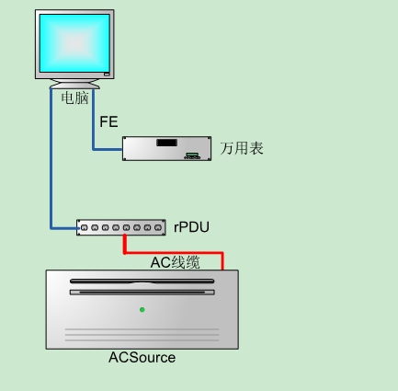

3、测试方案流程图

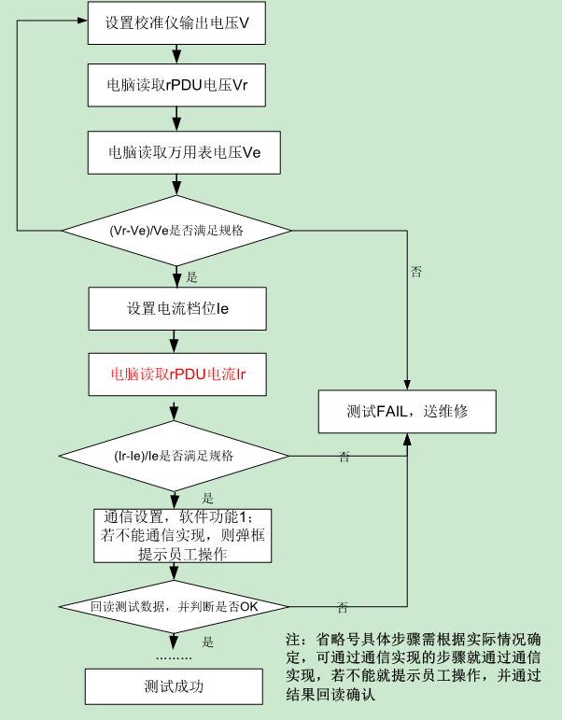

4、测试数据保存格式

{

"factory": "厂区",

"line": "加工线体",

"uut_info": {

"work_order": "订单号(任务令)",

"uut_type": "被测对象类型",

"uut_name": "物料名称",

"uut_code": "物料编码",

"serial_number": "物料条码",

"supplier ": "物料供应商",

"date_code": "物料批次DateCode",

"lot_code": "物料批次LotCode",

"mould": "物料模具",

"cavity": "物料模穴",

"colour": "物料颜色"

},

"ate_info": {

"ate_name": "测试设备名",

"computer_name": "设备主机名",

"fixuer_id": "夹具唯一标识"

},

"program_info": {

"program_name": "测试程序名称",

"program_ver": "测试程序版本"

},

"uut_result": {

"operator": "操作员",

"operation_sequence": "测试工序",

"site_code": "测试工站",

"start_time": "测试开始时间",

"stop_time": "测试结束时间",

"test_result": "测试结果"

},

"test_item_list": [{

"id": "测试项目ID",

"item_name": "测试项目名称",

"start_time": "测试项目开始测试时间",

"stop_time": "测试项目结束测试时间",

"test_result": "测试项目测试结果",

"result_desc": "测试项目测试结果描述",

"value_flag": "值类型标识位",

"lower_limit": "下限",

"upper_limit": "上限",

"test_value": "测试值",

"segment_1": "预留字段1",

"segment_2": "预留字段2",

"segment_3": "预留字段3",

"segment_4": "预留字段4",

"segment_5": "预留字段5",

"segment_6": "预留字段6"

"sub_test_item_list": [{

"id": "测试子项编号",

"sub_item_name": "测试子项名称",

"start_time": "测试子项开始测试时间",

"stop_time": "测试子项结束测试时间",

"test_result": "测试子项测试结果",

"result_desc": "测试子项测试结果描述",

"value_flag": "值类型标识位",

"lower_limit": "下限",

"upper_limit": "上限",

"test_value": "测试值"，

"segment_1": "预留字段1",

"segment_2": "预留字段2",

"segment_3": "预留字段3",

"segment_4": "预留字段4",

"segment_5": "预留字段5",

"segment_6": "预留字段6"

},

{

...

},

...]

},

{

...

},

...],

"segment_1": "预留字段1",

"segment_2": "预留字段2",

"segment_3": "预留字段3",

"segment_4": "预留字段4",

"segment_5": "预留字段5",

"segment_6": "预留字段6"

}