实验报告

实验名称 | 多线程并发实验
实验教室 |  | 实验日期 | 2020年 5月 14日
学 号 | 2018213553 | 姓 名 | 董英浩
专业班级 | 软件工程三班
指导教师 | 王波

东北林业大学
信息与计算机工程学院

- 实验目的
1．掌握使用Thread子类和Runnable接口创建多线程的方法。
2．掌握线程的执行过程。

- 实验环境

（1）计算机的硬件配置
PC系列微机，包括奔腾及各种兼容机，要求内存为1G以上，一个硬盘驱动器。80列字符监视器。配备鼠标器。
（2）计算机的软件配置
Windows。
javav语言的集成开发环境JDK1.8。
- 实验内容、代码及结果截图
1（题目编号7179）、利用多线程技术编写一个模拟龟兔赛跑的程序，要求如下：（1）乌龟每次跑一个单位，兔子每次跑10个单位；（2）每个线程运行时，判断是否达到终点，如果到达终点，给出提示信息，未到终点则提示目前距离终点的距离，并判断是否领先；（3）如果兔子领先，则显示“我跑得快，睡一觉”信息，并睡一会。
2（题目编号8690）、编写多线程应用程序，模拟多人过独木桥的模拟。独木桥每次只能通过一个人，每个人通过木桥的时间为5秒，随机生成10个人，同时准备过此独木桥，显示一下每次通过独木桥人的姓名。需要用到随机数。
3（题目编号7180）、哈尔滨火车站下面有三个火车票代售点：哈站、哈东站、哈西站，假如哈尔滨到北京的火车票总共是200张，如何用程序来实现三个售票点同时卖票的功能。注意：考虑线程同步问题，避免出现重复卖票问题。需要考虑同步问题。

package com.experiment07.bridge;
import java.util.LinkedHashSet;
import java.util.Set;
public class Main implements Runnable {
private static int time = 0;
synchronized public void run() {
time = time + 1000;
try {
System.out.println(Thread.currentThread().getName()
+ " 开始过独木桥");
Thread.sleep(time);
} catch (InterruptedException e) {
e.printStackTrace();
}
System.out.println(Thread.currentThread().getName()
+ " 已过独木桥");

}

public static void main(String[] args) {
String ary[] = {"赵", "钱", "孙", "李", "周", "吴", "郑", "王", "冯", "陈"};
Main guoQiao = new Main();
Set<Integer> set = new LinkedHashSet<Integer>();
while (true) {
if (set.size() == 10) {
break;
}

int a = (int) (Math.random() * 10);
set.add(a);
}
for (int b : set) {
Thread th = new Thread(guoQiao, ary[b]);
th.start();
}
}

}

package com.experiment07.run;
import java.util.concurrent.*;
public abstract class Animal implements Runnable {
protected String name;//动物名称

protected int speed;//动物速度

protected int now;//当前已经跑的路程

protected ExecutorService executor;//线程管理器，方便结束线程

protected CyclicBarrier barrier;//等待计时器，要求两个参赛选手 都准备就绪后才 开始比赛

public static volatile boolean FINISH = false;//是否比赛完成的标记

public final static int SUCCESS = 100;//比赛的路程
Animal(String name, int speed, ExecutorService executor, CyclicBarrier barrier) {
this.name = name;
this.speed = speed;
this.executor = executor;
this.barrier = barrier;
}

Animal(String name, int speed, ExecutorService executor) {
this.name = name;
this.speed = speed;
this.executor = executor;
}

@Override
public abstract void run();

//判断是否完成比赛
protected void finish() {
if (now >= SUCCESS) {
System.out.println(name + " 跑完了,结束比赛!");
FINISH = true;
executor.shutdownNow();
}
}

}

package com.experiment07.run;
import java.text.SimpleDateFormat;
import java.util.concurrent.CyclicBarrier;
import java.util.concurrent.ExecutorService;
public class Rabbit extends Animal {
Rabbit(String name, int speed, ExecutorService executor, CyclicBarrier barrier) {
super(name, speed, executor, barrier);
}

Rabbit(String name, int speed, ExecutorService executor) {
super(name, speed, executor);
}
@Override
public void run() {
try {
barrier.await();//等待参赛选手都准备就绪
} catch (Exception e1) {
}
SimpleDateFormat sdf = new SimpleDateFormat("yyyy-MM-dd HH:mm:ss");
System.out.println(sdf.format(System.currentTimeMillis()));
while (!FINISH) {
System.out.println(this.name + " : 我的速度是：" + this.speed + " 我跑了这么多" + this.now + "了");
try {
System.out.println("我跑的快，先睡一会");
Thread.sleep(1000);
if (now % 10 == 0) {
Thread.sleep(1000);
}

} catch (InterruptedException e) {
}
now += speed;
finish();
}
}

}

package com.experiment07.run;
import java.text.SimpleDateFormat;
import java.util.concurrent.CyclicBarrier;
import java.util.concurrent.ExecutorService;
public class Tortoise extends Animal{
Tortoise(String name, int speed, ExecutorService executor, CyclicBarrier barrier) {
super(name, speed, executor, barrier);
}
Tortoise(String name, int speed, ExecutorService executor) {
super(name, speed, executor);
}

@Override
public void run() {
System.out.println();
try {
Thread.sleep(2000);
barrier.await();
} catch (Exception e1) {}
SimpleDateFormat sdf = new SimpleDateFormat("yyyy-MM-dd HH:mm:ss");
System.out.println(sdf.format(System.currentTimeMillis()));
while (!FINISH) {
System.out.println(this.name + " : 我的速度是：" + this.speed + " 我跑了这么多" + this.now + "了");
now += speed;
finish();
try {
Thread.sleep(1000);
} catch (InterruptedException e) {
}
}
}

}

package com.experiment07.ticket.entity;

public class Ticket {
private int id;
private String from;
private String to;
public Ticket(int id ,String from,String to){
this.id = id;
this.from = from;
this.to = to;
}

public int getId() {
return id;
}

public void setId(int id) {
this.id = id;
}

public String getFrom() {
return from;
}

public void setFrom(String from) {
this.from = from;
}

public String getTo() {
return to;
}

public void setTo(String to) {
this.to = to;
}
}

package com.experiment07.ticket.entity;

import java.util.LinkedList;
import java.util.List;

public class TrainDepartment {
private static final List<Ticket> tickets = create();
private static List<Ticket> create(){
List<Ticket> tickets = new LinkedList<>();
for (int i = 0; i < 200; i++) {
Ticket t = new Ticket(i,"harbin","beijing");
tickets.add(t);
}
return tickets;
}
public static synchronized Ticket getTicket(){
Ticket t = null;
if(tickets.size() > 0){
t = tickets.get(0);
tickets.remove(t);
}
return t;
}
}
package com.experiment07.ticket.entity;

import java.util.LinkedList;
import java.util.List;
import java.util.Random;

public class TrainOutlet {
private String name;
private List<Ticket> tickets = new LinkedList<>();
private static Random random = new Random();
public Ticket sell(){
Ticket ticket = TrainDepartment.getTicket();
if(ticket != null){
try {
Thread.sleep(random.nextInt(50));
tickets.add(ticket);
} catch (InterruptedException e) {
e.printStackTrace();
}
}
return ticket;
}
public int getCount(){
return tickets.size();
}
}

package com.experiment07.ticket;
import com.experiment07.ticket.entity.*;
public class Test {
public static void main(String[] args) throws InterruptedException {
test();
}
private static void test() throws InterruptedException {
TrainOutlet t1 = new TrainOutlet();
TrainOutlet t2 = new TrainOutlet();
TrainOutlet t3 = new TrainOutlet();

new Thread(()->{
while(t1.sell()!=null) {

}
}).start();

new Thread(()->{
while(t2.sell()!=null) {

}
}).start();

new Thread(()->{
while(t3.sell()!=null) {

}
}).start();

Thread.sleep(6000);

System.out.println(t1.getCount());
System.out.println(t2.getCount());
System.out.println(t3.getCount());
}
}

四、实验过程分析与讨论
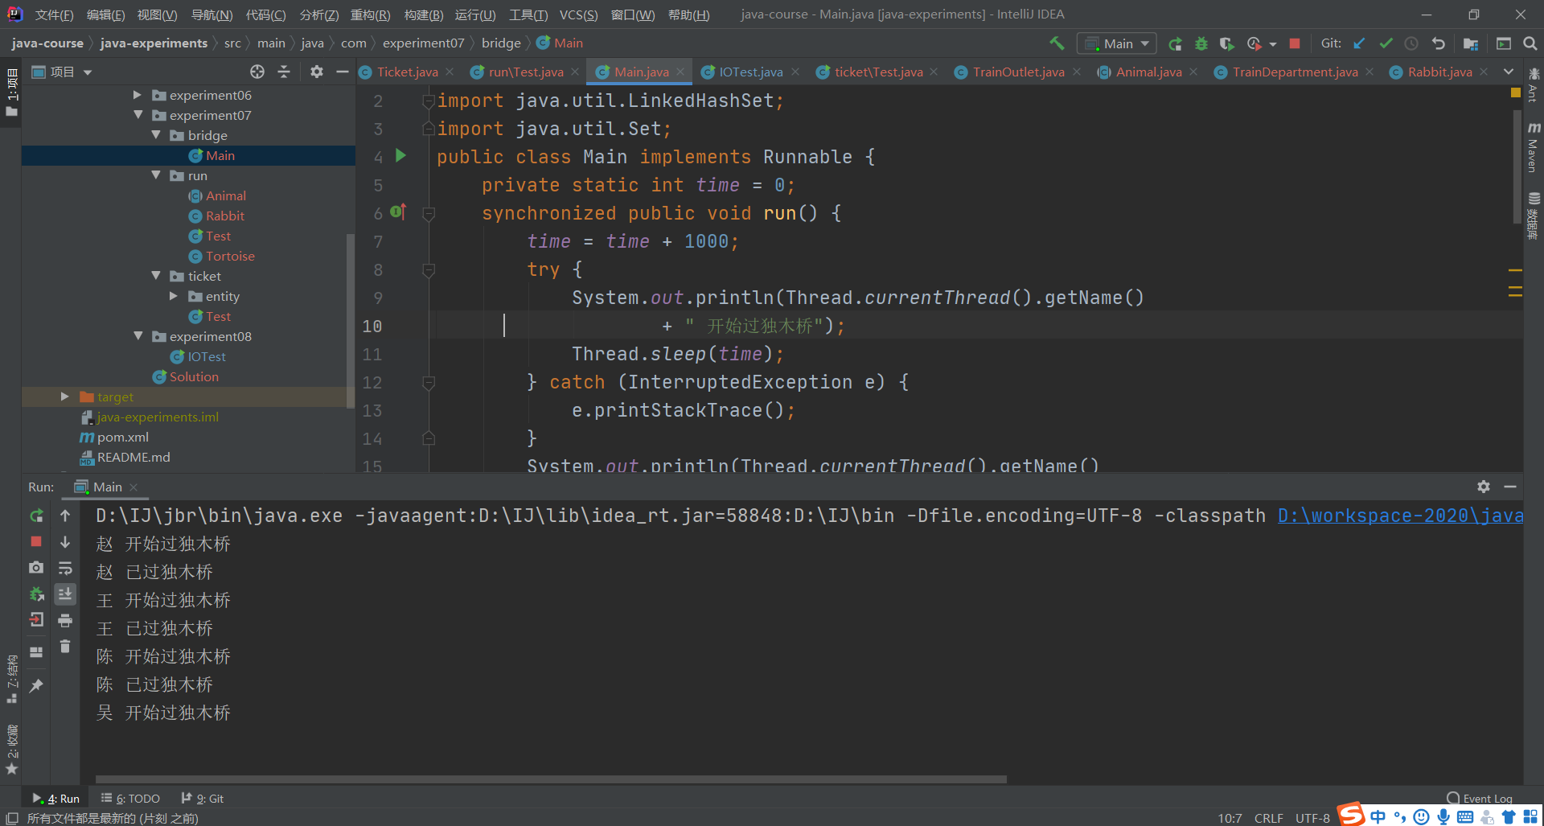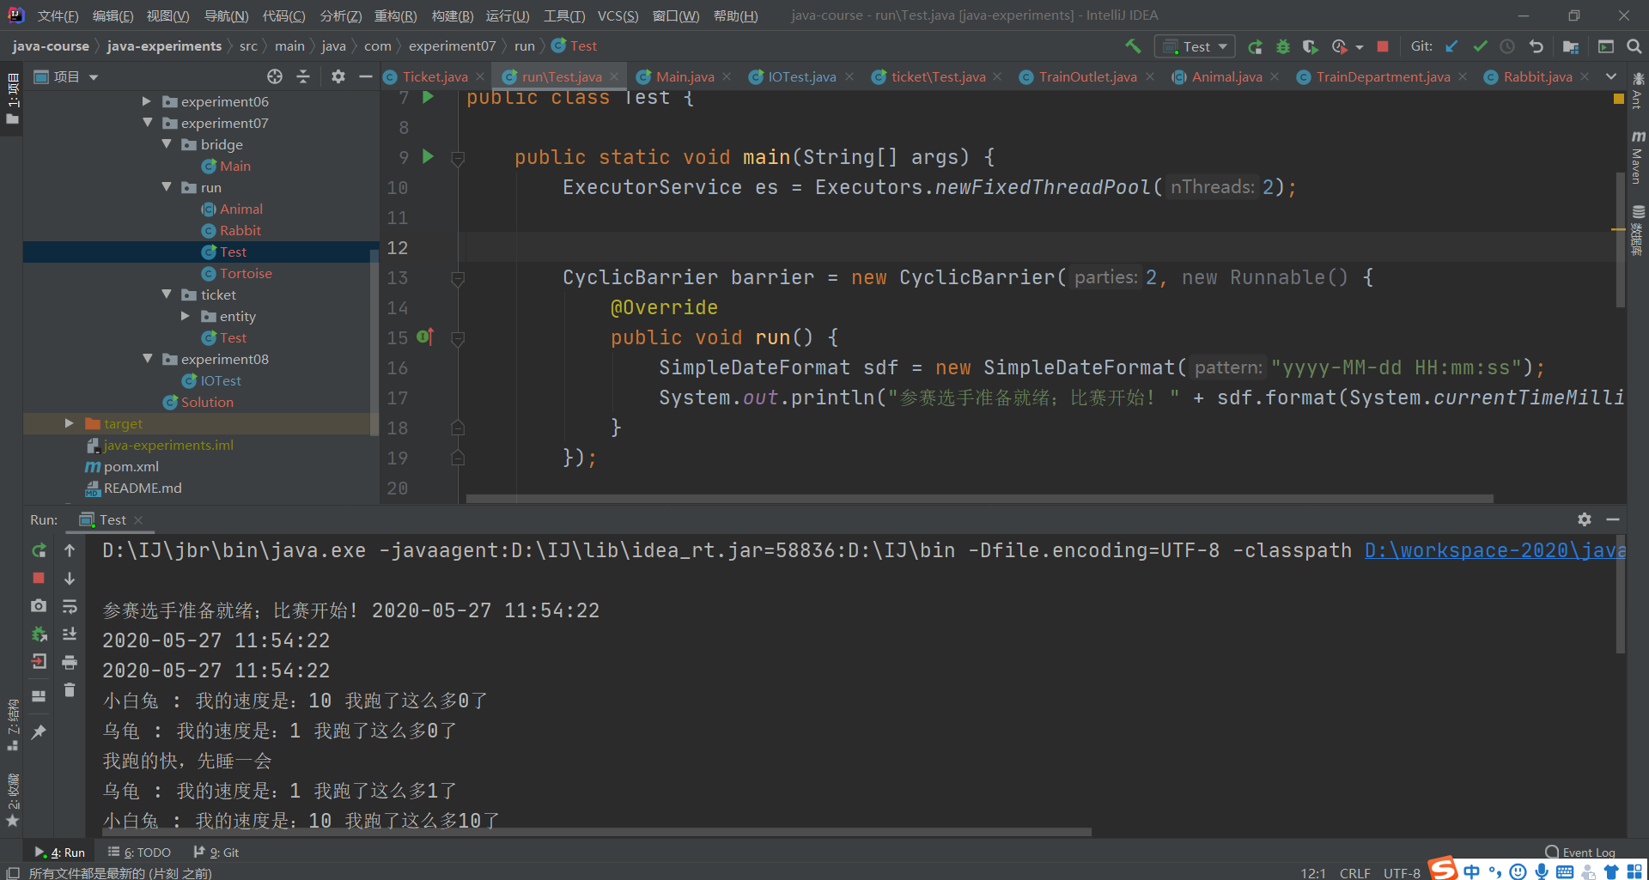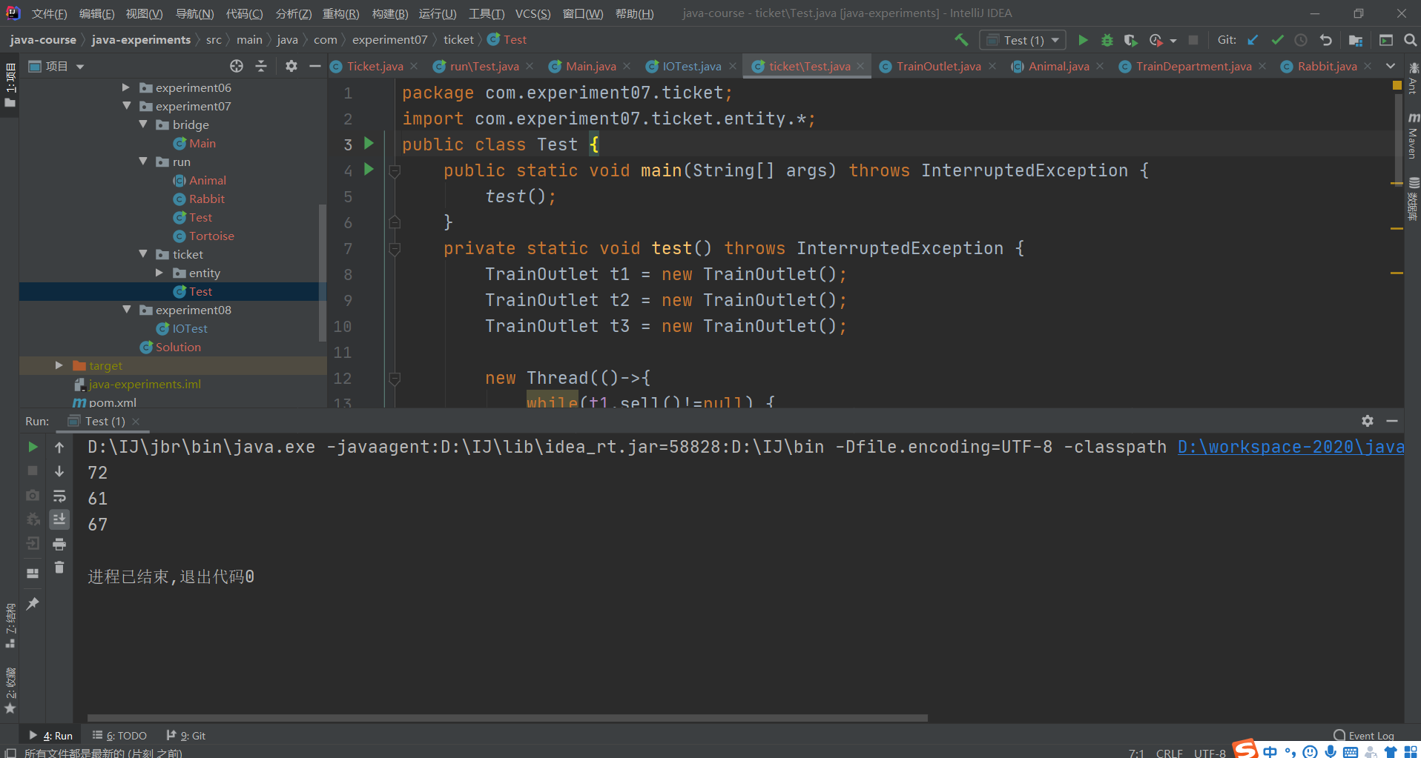

- 指导教师意见

指导教师签字：
年 月 日

