COMP4447 / COMP5047 Project Proposal
Wildlife-First Adaptive Path Light
University of Sydney · Semester 2 2026 · Week 4 proposal (1–2 pages)

Team members
Name | Email | Student ID | Project manager?
Xinlong Bao | xbao0618@uni.sydney.edu.au | 550048909 | ☐
Tianqi Wang | twan0795@uni.sydney.edu.au | 550216999 | ☐

Tick exactly one PM. Proposed split (swap if needed): Xinlong — hardware and enclosure; Tianqi — firmware and docs. Shared: integrate, dusk trials, video, presentation. Two people does not reduce scope.

Challenge statement
Artificial light at night (ALAN) is among the fastest-growing pollutants globally (skyglow ~9.6%/year; Kyba et al. 2023). Standard path lighting treats darkness as a human hazard to eliminate, and wildlife impact as an externality. For nocturnal species that share remnant bushland edges with people, darkness is habitat: commuting space, foraging space, and the insect prey base that insectivorous microbats depend on.
We address one local situation: a bushland-edge pedestrian path in a Sydney urban park. Across Greater Sydney, light at the forest edge is an anthropogenic barrier. Clutter-adapted microbats — notably Gould’s long-eared bat (Nyctophilus gouldi), plus chocolate wattled bat (Chalinolobus morio) and little forest bat (Vespadelus vulturnus) — are less active at lit edges than in dark interiors, and N. gouldi is almost confined to remnant bushland (Threlfall et al. 2013; Haddock et al. 2019a). Faster open-space species such as Gould’s wattled bat (C. gouldii) and the white-striped free-tailed bat (Austronomus australis) still use lit edges; that is not a licence to light. Cool-white and even filtered-white LEDs pull flying insects out of vegetation without a matching increase in bat feeding (Robert et al. 2025). National guidance is therefore: keep connecting corridors dark; if a person must walk, use low, warm, downward, shielded light, on only while they are there (DCCEEW 2023).

Non-human stakeholder analysis
Primary — Gould’s long-eared bat (N. gouldi) and other clutter-adapted Sydney edge species. Radio-tracked N. gouldi in Cumberland State Forest barely enter the urban matrix; lit gaps inside remnant bush suppress Nyctophilus activity (Threlfall et al. 2013). Haddock et al. (2019a) found the same pattern at 31 Greater Sydney forest edges for Nyctophilus spp., C. morio and V. vulturnus*. Need: a dark, glare-free vegetation corridor.
Secondary — co-occurring open-space microbats (C. gouldii, A. australis). Light-tolerant at Sydney edges (Haddock et al. 2019a); C. gouldii shows no short-term melatonin disruption under several LED spectra (Dimovski et al. 2023). They still do not gain a feeding benefit when LEDs vacuum insects (Robert et al. 2025). Need: dark intervals and no cool-white prey trap. Their louder calls are the acoustic proxy that the corridor is in use (C. gouldii ~25–34 kHz; A. australis* search calls ~10–15 kHz, often audible — Pennay et al.).
Tertiary — nocturnal moths and other flying invertebrates. White LEDs are an ecological trap; a large fraction of insects at lamps die (Owens & Lewis 2018; Owens et al. 2020). Need: not an always-on cool-white beacon.
The system does not claim to know what a bat wants (Mancini 2016). It operationalises DCCEEW / EUROBATS consensus — less light, warmer spectrum, shorter duration, directional shielding, on only when a person is present — as default behaviour.

Project idea
Context of use. A low bollard on the walkable side of a bushland-edge path. Default: off. Sensing runs continuously at low power. There is no screen, app, or explicit human UI. The interaction is ambient: light appears, a 180° blade shields the bush, and both withdraw by themselves.
How the system behaves
- Night, no person. Ambient lux confirms dark; mmWave presence is clear. LED off. Blade closed toward the bush.
- Person approaching (~5 m). LED fades up over ~1.5 s to a low 2200 K / PC-amber output on the path only. A measured path-illuminance floor is held so a pedestrian can still see the ground.
- Bat-band activity while a person is present. Dual-band energy (~10–15 kHz or ~25–35 kHz) exceeds threshold at a minimum pulse rate. The blade tightens onto the path; the LED may dim but never below the human-safety floor. Hold 20 s after the last detection.
- Person leaves. LED fades off over ~5 s. Return to (1).
- Dawn or existing spill. Ambient lux above threshold. LED stays disabled.
- Maintenance. Low battery, sensor fault, or a long gap in bat-band activity: a slow-pulsing amber indicator on the underside of the fixture only.
Context recognition. Four on-device signals — ambient lux, human presence/range, bat-band sound, time-of-night (BoM sunrise/sunset, cached) — fused in a rule-based ESP-IDF state machine on an ESP32-S3. The analog frequency-division front-end must pass two bands: ~10–15 kHz (A. australis) and ~25–35 kHz (C. gouldii). Nyctophilus calls are faint steep FM; we do not claim live species-ID. TinyML is an upgrade, not the demo path. BLE, if used, is maintainer logs only.

Hardware / software architecture
On-device only: world → sense → fuse → actuate. No screen.
Architecture map. Bush/bats, path/walker, and night lux feed three sensors (analog frequency-division mic, LD2410, BH1750/VEML7700) plus a cached sunset. An ESP32-S3 running ESP-IDF persists, fuses, and runs a six-state machine, then drives a 2200 K path LED, an MG90S 180° bush blade, and an underside amber maintainer LED. USB/18650 powers the bench build; recorded NSW playback is the Week 13 stimulus.
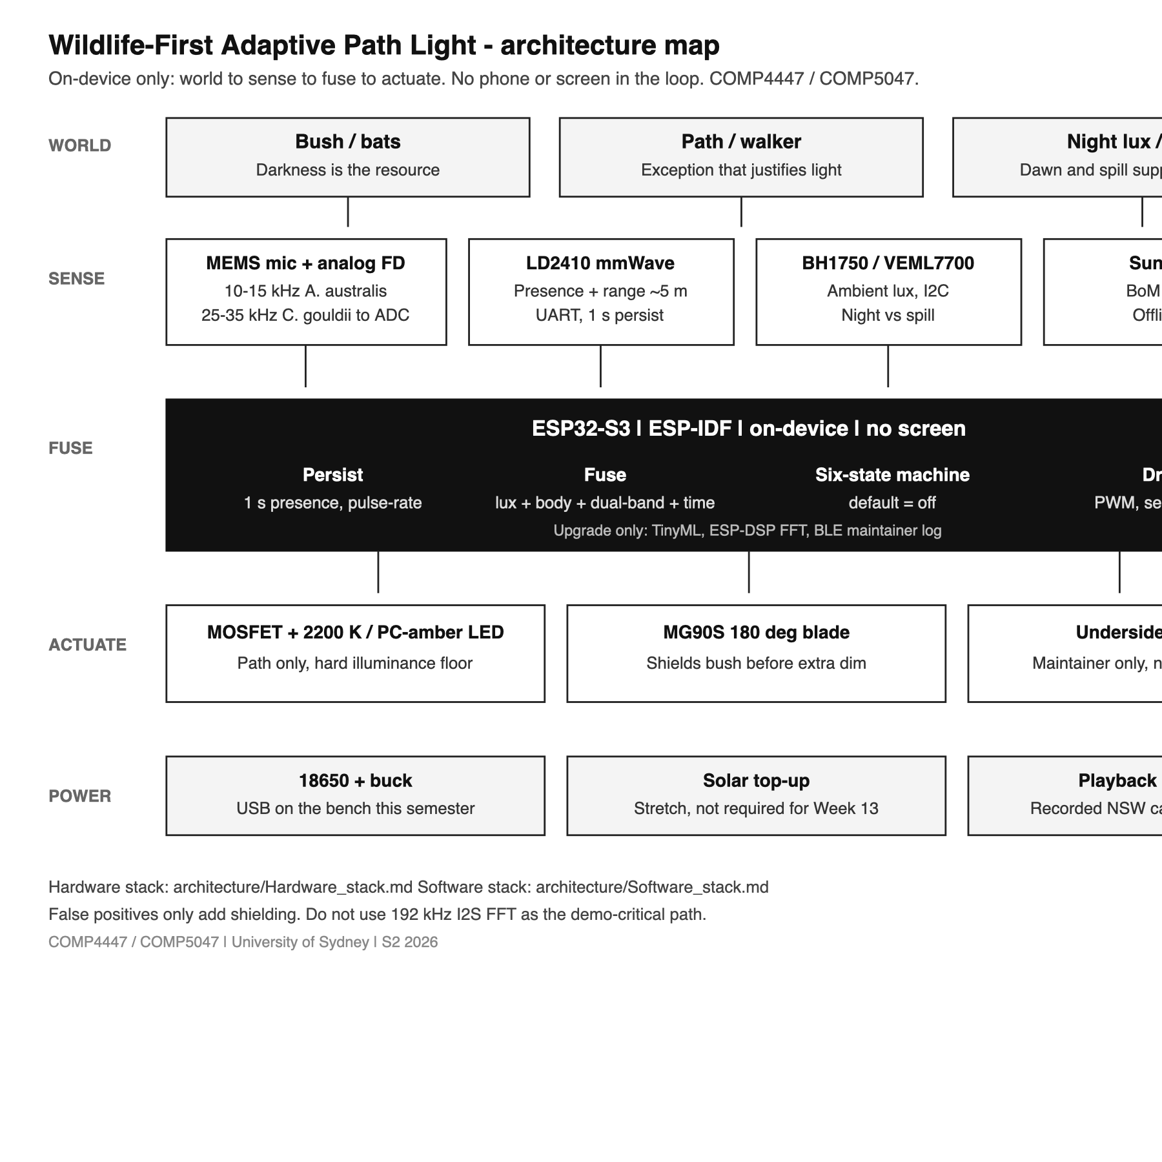
Figure 1. Hardware and software architecture map (world → sense → ESP32-S3 fusion → actuate). TinyML, FFT, BLE and solar are upgrades, not the Week 13 demo path.
Hardware stack
Layer | Parts | Bus
Enclosure | PETG bollard, downward hood, printed 180° blade | —
Power | USB bench, or 18650 + buck (solar = stretch) | 5 V / 3.3 V
Compute | ESP32-S3 | —
Sense | BH1750/VEML7700; LD2410; MEMS mic + analog FD (gates ~10–15 kHz and ~25–35 kHz) | I2C; UART; ADC
Actuate | MOSFET + 2200 K / PC-amber LED; MG90S blade; underside amber | LEDC PWM / GPIO
Demo | Playback source into the analog front-end | —

Software stack (ESP-IDF / FreeRTOS). Drivers (I2C, UART, ADC, LEDC) → fusion (1 s presence persist, dual-band energy, pulse-rate, lux, sunset cache, illuminance floor) → six-state policy (night_idle, human_path, bat_shield, person_leaving, dawn_inhibit, maintainer_fault) → PWM/servo/GPIO. TinyML, ESP-DSP FFT, and BLE are upgrades after this path works. No phone UI.

Parts required
Hardware. ESP32-S3; BH1750 or VEML7700; LD2410; MEMS ultrasonic mic plus analog frequency-division module into ADC (not a from-scratch 192 kHz design); 2200 K or PC-amber LED + MOSFET; MG90S + printed 180° blade; underside amber LED; 18650 + buck; USB bench power; playback source. Solar is stretch.
Software / APIs. ESP-IDF firmware for sensor fusion and actuation. Cached Bureau of Meteorology sunrise/sunset. Atlas of Living Australia / iNaturalist for the species list (design evidence, not runtime). Optional later: ESP-DSP FFT, TinyML, BLE log dump.
Enclosure. Fusion 360, FDM PETG bollard with downward hood, printed 180° blade. Form: a shrouded low-glare path light.

Timeline
Proposed split (swap if needed): Xinlong — hardware, CAD, enclosure; Tianqi — firmware, docs. Shared: order parts, integrate, dusk trials, video, presentation. W4 submit and order. W5–6 lux + mmWave bring-up (Xinlong); analog bat front-end + thresholding (Tianqi). W6–8 LED + 180° blade and CAD v1 (Xinlong); fusion state machine (Tianqi). W9 mid-project check-in (after the mid-semester break). W10–11 print, gasket, integrate, campus dusk trials with playback. W11–12 report and manual. W12 video. W13 presentation.

Potential risks
Ultrasound. Wind, insects, and servo noise can look like calls. Mitigation: dual-band gates (~10–15 and ~25–35 kHz) + pulse-rate; false positives only add shielding; servo does not move in a detection window; the demo uses recorded NSW playback. We do not depend on 192 kHz I2S FFT — analog frequency-division into the ADC is the path that must work. We do not claim to detect live Nyctophilus.
Presence vs safety. mmWave may trigger on dogs, possums, or vegetation (~1 s persistence + range gate). Shielding/dimming must not make the path unwalkable (hard illuminance floor). Briefly lighting a non-human body is preferable to leaving a person unlit.
Scope and access. Two people still owe a fabricated enclosure, working features, report, and video. Night park access needs permission. Mitigation: order parts in W4; campus dusk trials first; gasketed PETG bollard; document outdoor v2 (solar, IP rating) in the report rather than calling weatherproofing “out of scope.”
Theory. Every actuation (spectrum, blade, duration, default-off) will be justified against a named non-human need (ACI / multispecies design). We will not claim a one-semester population increase.

Appendix
Still to attach (hand drawings):
- Bollard sketch: downward path beam vs bush side blocked by the 180° blade.
- State-machine diagram of the six behaviours (Figure 1 covers the hardware/software map).
- Spectral note: 4000 K white vs 2200 K / PC-amber (DCCEEW; Robert et al. 2025, amber λP 601 nm).

Selected references
Threlfall, C.G., Law, B. & Banks, P.B. (2013). The urban matrix and artificial light restricts the nightly ranging behaviour of Gould’s long-eared bat. Austral Ecology, 38(8), 921–930.
Haddock, J.K., Threlfall, C.G., Law, B. & Hochuli, D.F. (2019a). Light pollution at the urban forest edge negatively impacts insectivorous bats. Biological Conservation, 236, 17–28.
Haddock, J.K., Threlfall, C.G., Law, B. & Hochuli, D.F. (2019b). Responses of insectivorous bats and nocturnal insects to local changes in street light technology. Austral Ecology.
Robert, K.A. et al. (2025). Divergent responses of insectivorous bats and flying insects to experimental LED illumination of different spectra. Ecosphere, 16(5), e70291.
Dimovski, A.M., Robert, K.A. & Griffiths, S.R. (2023). A light-exploiting insectivorous bat shows no melatonin disruption under lights with different spectra. Royal Society Open Science, 10, 221436.
DCCEEW (2023). National Light Pollution Guidelines for Wildlife.
Kyba, C.C.M. et al. (2023). Citizen scientists report global rapid reductions in the visibility of stars from 2011 to 2022. Science, 379, 265–268.
Owens, A.C.S. & Lewis, S.M. (2018). The impact of artificial light at night on nocturnal insects. Ecology and Evolution, 8, 11337–11358.
Voigt, C.C. et al. (2018). Guidelines for consideration of bats in lighting projects. EUROBATS Publication Series No. 8.
Mancini, C. (2016). Towards an animal-centred ethics for Animal–Computer Interaction. International Journal of Human-Computer Studies, 98, 221–233.

