shiyan11-Circleloss-nominer

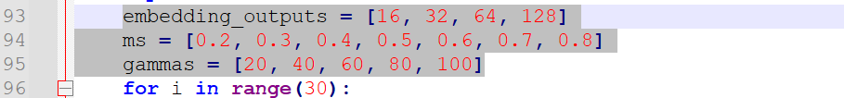

shiyan11-FastAPloss

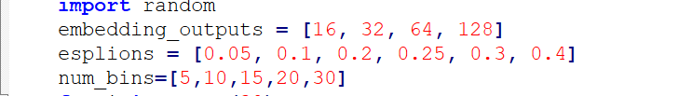

shiyan11-IntraPairVarianceloss-nominer

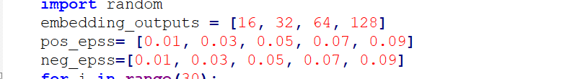

shiyan11-Multisimilarity-nominer

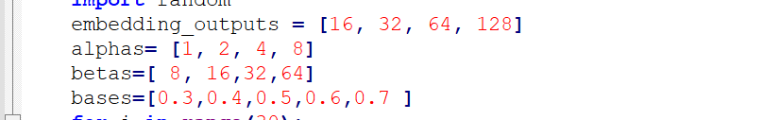

shiyan11-NCAloss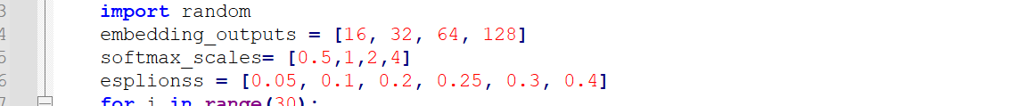

shiyan11-SignalToNoiseRatioContrastiveloss

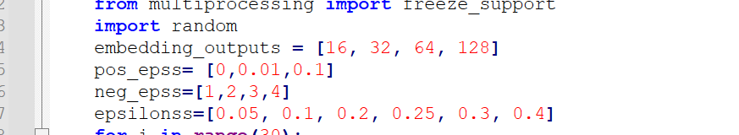

shiyan11-Supconloss

