E-COMMERCE DATA ANALYSIS REPORT
NAME: Okonkwo Uchechukwu Faith
DATASET: E-commerce Database
COURSE PROJECT: SQL Data Analysis
DATE: April 2026

Contents
Introduction 1
Findings 2
Conclusion and Recommendation 7

Introduction
This project focuses on analyzing an e-commerce database containing transactional records of a retail business. The dataset includes information on employees, customers, orders, products, and categories, covering sales activity across multiple countries over the years 1996 and 1997.
The goal of this project is to utilize SQL (Structured Query Language) to query, aggregate, and analyze the data, with the aim of answering fifteen business questions related to sales performance, customer behavior, employee productivity, and product trends. The insights derived from this analysis can support data-driven decision-making in areas such as inventory management, customer relationship management, and sales strategy.

Findings
This section presents the major findings from the analysis, and screenshots of the result. Each finding directly corresponds to one of the questions that guided this study.
1. Total Sales by Employee:
- Write a query to calculate the total sales (in dollars) made by each employee, considering the quantity and unit price of products sold.
Result: Below is a screenshot of the result table from the query, which shows the total sales made by each employee in descending order. The employee with the highest sales is notably Margaret Peacock with total sales of over $9,000. Employee Adam West with employee ID 10 made no sales. He truly is an old chum.
EmployeeID | First Name | Last Name | Total Sales
4 | Margaret | Peacock | 9164.997
1 | Nancy | Davolio | 4932.127
3 | Janet | Leverling | 4675.578
2 | Andrew | Fuller | 3489.095
8 | Laura | Callahan | 3448.231
6 | Michael | Suyama | 2902.494
5 | Steven | Buchanan | 2177.7424
9 | Anne | Dodsworth | 2017.975
7 | Robert | King | 1966.565

2. Top 5 Customers by Sales:
- Identify the top 5 customers who have generated the most revenue. Show the customer’s name and the total amount they’ve spent.
Result: Below are the top five customers who have patronized the most. Most notable being Ernst Handel with over $3,000 dollars in revenue.
Customer Name | Top5Revenue
Ernst Handel | 3476.62
Frankenversand | 1846.873
Hungry Owl All-Night Grocers | 1665.992
QUICK-Stop | 2095.848
Save-a-lot Markets | 1881.038

3. Monthly Sales Trend:
- Write a query to display the total sales amount for each month in the year 1997.
Result: The query returned the total sales for each month in 1997. As seen in the table below, January recorded the highest sales at $5,925.20, while February dropped significantly to $2,007.64, suggesting a slowdown after the new year peak. The variation across months highlights seasonal patterns in purchasing behavior.
Month | Total Sales
January | 5925.201
February | 2007.638
4. Order Fulfilment Time:
- Calculate the average time (in days) taken to fulfil an order for each employee. Assuming shipping takes 3 or 5 days respectively depending on if the item was ordered in 1996 or 1997.
Result: The query calculated the average fulfilment time for each employee based on the year the order was placed, applying a 5-day shipping assumption for 1996 orders and 3 days for 1997 orders. The results show that all employees had average fulfilment times between approximately 3.0 and 3.9 days. Steven Buchanan had the lowest average at exactly 3.0 days, while Janet Leverling had the highest at approximately 3.84 days. Overall, fulfilment times were fairly consistent across the team, indicating a stable order processing workflow. The screenshot below shows the full result.
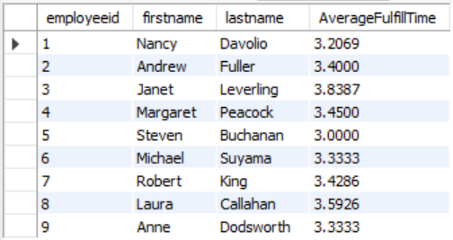

5. London Customers and Their Sales:
- List the customers operating in London and total sales for each.
Result: The query returned five customers based in London. Seven Seas Imports generated the highest revenue among them at $1,010.62, followed by Eastern Connection at $355.18. B’s Beverages had the lowest sales at $70.86. The table below presents all five London-based customers alongside their respective total sales figures.
Customer Name | City | Total Sales
Around the Horn | London | 235.97
B''s Beverages | London | 70.86
Consolidated Holdings | London | 101.618
Eastern Connection | London | 355.178
Seven Seas Imports | London | 1010.622

6. Customers with Multiple Orders on the Same Date:
- Write a query to find customers who have placed more than one order on the same date.
Result: Only one customer was found. Customer being Bottom-Dollar Marketse with ID 10.
Customer Name | Customer ID | Order Date | No of Orders
Bottom-Dollar Marketse | 10 | 1997-01-10 00:00:00 | 2

7. Average Discount per Product:
- Calculate the average discount given per product across all orders. Round to 2 decimal places.
Result: A screenshot of the top of the table and the bottom of the table is available below, displaying each product and the average discount applied to each.
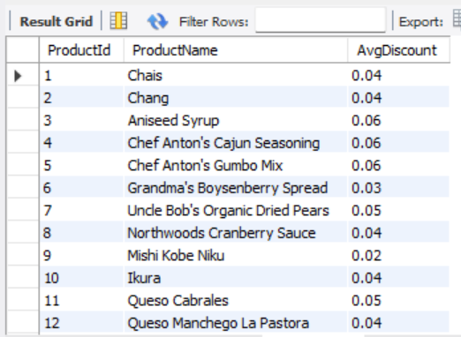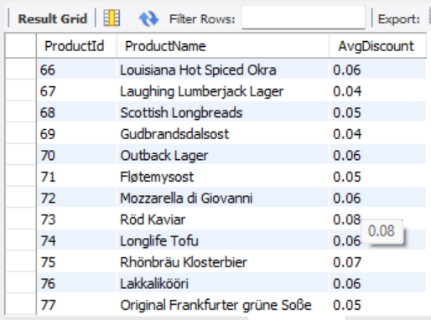

8. Products Ordered by Each Customer:
- For each customer, list the products they have ordered along with the total quantity of each product ordered.
Result: This is a screenshot of the beginning and end result. Arranged in alphabetical order or the customer names, it lists each product they purchased and the quantity of each product.
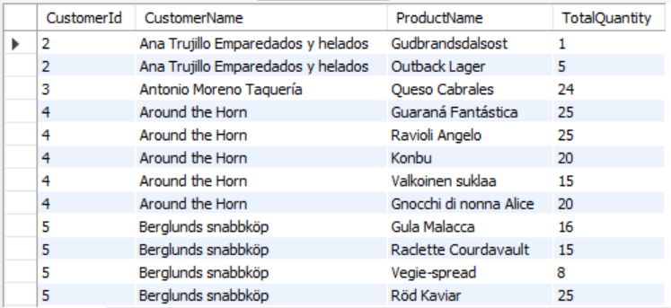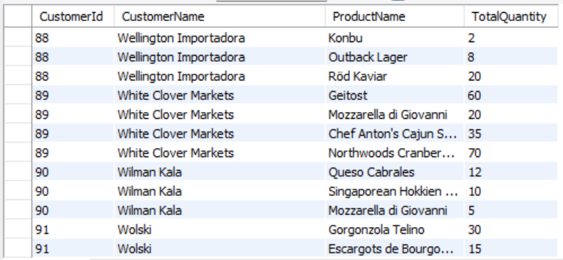

9. Employee Sales Ranking:
- Rank employees based on their total sales. Show the employee name, total sales, and their rank.
Result: The query ranked all nine active employees by their total sales. Margaret Peacock came in first place with total sales of $9,164.997, which is almost double that of the second-ranked employee, Nancy Davolio at $4,932.127. Janet Leverling came in third at $4,675.578. Robert King ranked last with $1,966.565. The screenshot below shows the full ranked list.
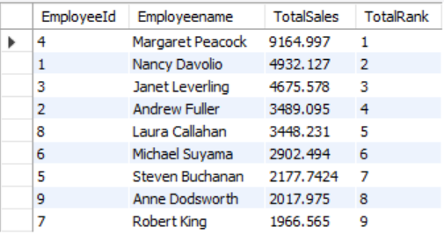

10. Sales by Country and Category:
- Write a query to display the total sales amount for each product category, grouped by country.
Result: This is a screenshot of the beginning and end of the result table, displaying total sales of categories of products in each country.
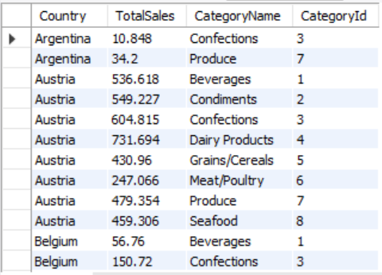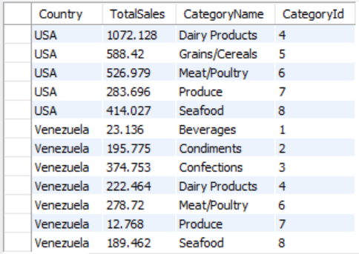

11. Year-over-Year Sales Growth:
- Calculate the percentage growth in sales from one year to the next for each product.
Result: The query compared sales figures from 1996 to 1997 for each product and calculated the percentage change. A number of products, including Chef Anton’s Cajun Seasoning, Chef Anton’s Gumbo Mix, and Ikura, experienced a 100% decline, meaning they had sales in 1996 but zero sales in 1997. On the other hand, Queso Manchego La Pastora showed remarkable growth at +414.27%, and Aniseed Syrup also grew significantly at +230.17%. Products like Chais and Chang saw moderate declines of around 57% and 49% respectively. Overall, the majority of products declined year-over-year, which may point to inventory or demand issues in 1997. The screenshots below show the beginning and end of the result table.
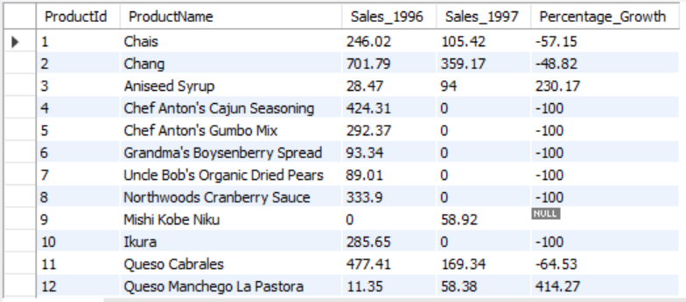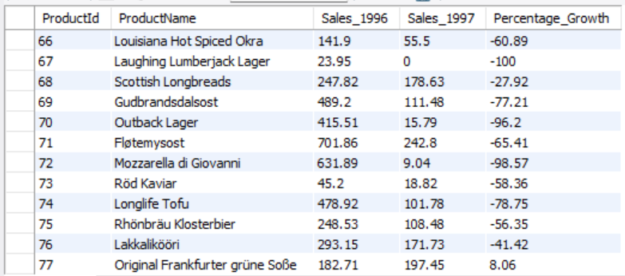

12. Order Quantity Percentile:
- Calculate the percentile rank of each order based on the total quantity of products in the order.
Result: The beginning and end of the table result screenshot is available below. Most notable ranks include: Order 10422 as the lowest percentile rank and the Order 10324 as the top 1 percentile rank based on the total quantity.
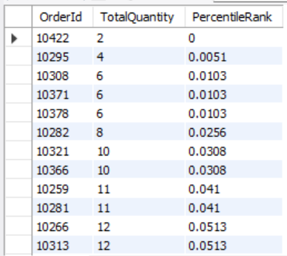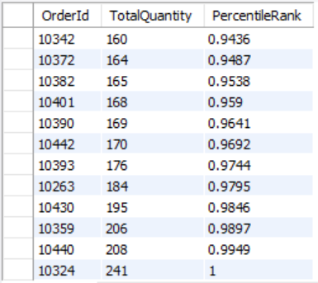

13. Products Never Reordered:
- Identify products that have been sold but have never been reordered (ordered only once).
Result: The query identified four products that appeared in the order details only once, meaning they were never reordered. These products are Mishi Kobe Niku (Product ID 9), Chocolade (ID 48), Røgede sild (ID 45), and Laughing Lumberjack Lager (ID 67). Each of these products had a count of exactly one order. This could indicate low customer demand, poor product visibility, or that these items were discontinued shortly after their initial sale. The screenshot below shows the full result.
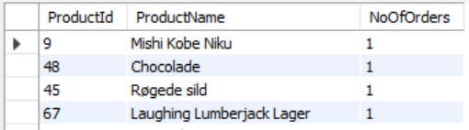

14. Most Valuable Product by Revenue:
- Write a query to find the product that has generated the most revenue in each category.
Result: The query returned the top revenue-generating product in each product category. Within the Seafood category, Nord-Ost Matjeshering led with a total revenue of $660.042, followed closely by Inlagd Sill at $635.495 and Boston Crab Meat at $546.382. The results provide a clear picture of which products are carrying each category in terms of revenue, and can help management decide where to focus marketing and restocking efforts. The screenshots below show the results across categories.
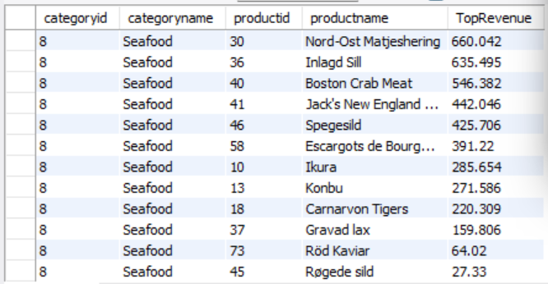

15. Complex Order Details:
- Identify orders where the total price of all items exceeds $100 and contains at least one product with a discount of 5% or more.
Result: The query successfully filtered orders that met both conditions — a total order value above $100 and at least one discounted item with a discount rate of 5% or more. A significant number of orders qualified, ranging from Order ID 10250 ($185.87) to Order ID 10442 ($296.46), with Order ID 10263 recording the highest total at $715.67. This finding shows that discounting is a common occurrence in high-value orders, which may suggest that discounts are being used as a tool to encourage larger purchases. The screenshot below shows the complete result.
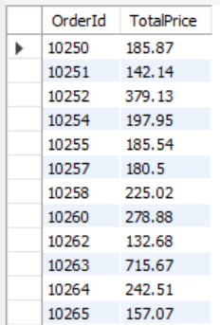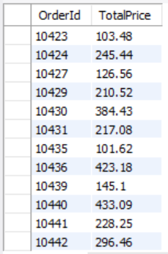

Conclusion and Recommendation
This project involved querying an e-commerce database using SQL to answer fifteen business-driven questions. The analysis covered a wide range of areas including employee sales performance, customer spending behavior, order fulfilment times, product revenue, discount patterns, and year-over-year growth trends. The findings revealed several key insights that are valuable to the business.
In terms of employee performance, Margaret Peacock was the clear top performer with total sales of $9,164.997, significantly outpacing her colleagues. On the other end, Employee 10 recorded no sales at all, which is a concern that management should look into. The fulfilment time analysis showed that all employees processed orders within a relatively narrow range of 3.0 to 3.84 days, indicating a generally efficient and consistent shipping process.
From the customer analysis, Ernst Handel emerged as the highest-spending customer with a total of $3,476.62, making them the most valuable client in the dataset. The analysis of London-based customers also showed that Seven Seas Imports was the top-performing customer in that region. Notably, only one customer, Bottom-Dollar Marketse, placed more than one order on the same date, which suggests that multiple same-day ordering is not a widespread pattern in this dataset.
The product-level analysis uncovered that the majority of products experienced a decline in sales from 1996 to 1997, with several products dropping to zero sales entirely. However, a few products such as Queso Manchego La Pastora (+414.27%) and Aniseed Syrup (+230.17%) bucked the trend and grew strongly. Four products were identified as having been ordered only once and never reordered, which may signal poor customer reception or limited availability.
Overall, this project demonstrated the power of SQL in extracting meaningful business insights from relational databases. The queries used in this analysis ranged from basic aggregations to more advanced techniques such as window functions, joins, and conditional logic, all of which contributed to a comprehensive understanding of the e-commerce dataset.

