Issue1:

**Description:** After registration, user is not logged in by default.

**Url:** <https://buggy.justtestit.org/>

**Browser:** Chrome

**Steps to reproduce:**

1. Navigate to Registration page
2. Fill in the fields and Register

**Actual Result:** User is not logged in.

**Expected Result:** User should be logged into the application.

Issue2:

**Description:** Update Profile page retains when the user clicks Logout from the page

**Url:** <https://buggy.justtestit.org/>

**Browser:** Chrome

**Steps to reproduce:**

1. Login with a user [Ex: Login10/Testing@1]
2. Navigate to Update Profile [Do not click Cancel]
3. Click Logout
4. Login with another credential [Ex: AM/Testing@1]

**Actual Result:** The update profile of the previous user retains. The page url is ‘https://buggy.justtestit.org/profile’

**Expected Result:** Once the logout is clicked, the user should be taken to home page’ <https://buggy.justtestit.org/>’.

**Screenshot:**

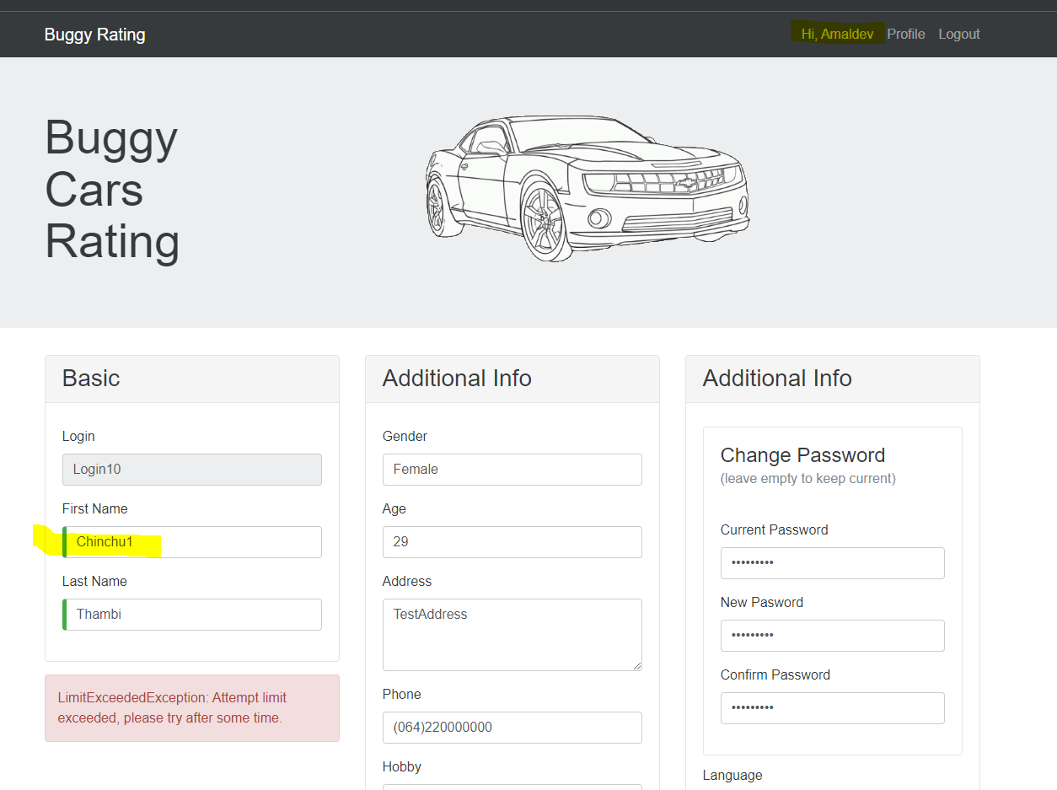

Issue3:

**Description:** Register page retains even after user logs in

**Url:** <https://buggy.justtestit.org/>register

**Browser:** Chrome

**Steps to reproduce:**

1. Navigate to User registration page
2. Register a new user [Don’t click Cancel]
3. Click Login and login with the user credentials

**Actual Result:** Register page stays even after login

**Expected Result:** Once the logs in, the user should be taken to home page ’<https://buggy.justtestit.org/>’

**Screenshot:**

Issue4:

**Description:** Application has no forgot password option

**Url:** <https://buggy.justtestit.org/>

**Browser:** Chrome

**Screenshot:**

**Issue5:**

**Description:** Registration can be done when a user is logged in

**Url:** <https://buggy.justtestit.org/>register

**Browser:** Chrome

**Steps to Reproduce:**

1. Register a user > Don’t click Cancel
2. Login the registered login and password
3. Register page remains as is [Issue3]
4. Now register another issue

**Actual Result:** Registration is successful

**Expected Result:** Once the user is logged in, register page should disappear and a registration should not be allowed when a user is logged in

There are more bugs identified which maybe I can take you thru during the interview. Please let me know.