**PROJECT-NAME: NETBANKING OF HDFC BANK**

# Chindaliya Bharath Singh

## 

## Presents

**OVERVIEW:** Thissite tells about the customer’s daily financial status and Which avoid bank visitings for each and evrything

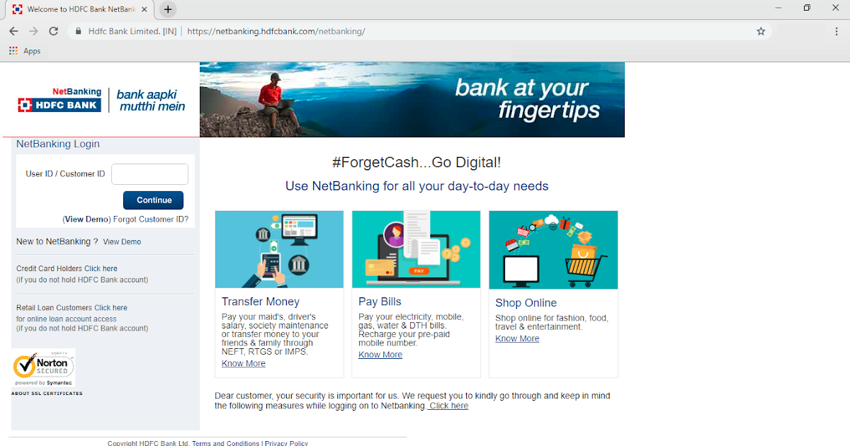

**HOME PAGE:**

1. Log-In Page
2. User ID/CustomerID
3. Enter Your Password
4. Chage Password

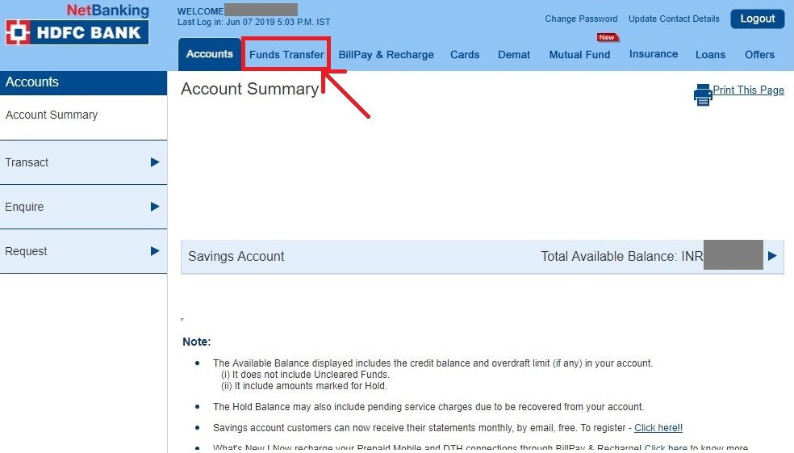

**2.Landing page:** This is the a post login page for user when he logged into his netbanking

**3.Features:**

* Header – ( Logo,chage password,Update Address/contact)
* ICONS - (Account,Fund Trasfer,Billpay&Recharge,Cards,etc.,)
* DEALS IN OFFER SECTION- (IMAGES)
* FEATURED - (IMAGES)
* ADDRESS SELECTION : when user’s are trying to pay their payments we have a facility to pay their payments
* PAYMENT METHOD - (PHONEPE , GOOGLE PAY , BHIM UPI ,
  + - * + COD , CREDIT/DEBIT CARD , NET

BANKING , EMI , PAYTM)

**4.Technologies Used in Netbanking:**

1. Html

2. Css

3. Bootstrap

**4. React Dynamic:**

1. JavaScript

2. Ci/cd with AWS

3. Login and Logout

**Database:**

1. Mongo dB

2. Json Data

**Code compilers:**

1. Visual studio code

2. Git bash

3. Git hub

4. Node js