IoT Cat Feeder
An automatic, timed cat feeder with a web dashboard on the ESP8266
Software Requirements Specification
Chindanai Jaiman 662115012
Bachelor of Science Software Engineering Program
College of Arts, Media, and Technology, Chiang Mai University
November 2026
Project Advisor
Asst.Prof.Phudinan Singkhamfu, Ph.D.

Table of Contents
Chapter 1 Introduction 3
1.1 Purpose 3
1.2 Scope 3
1.3 Product Perspective 3
1.4 Product Functions 4
1.5 User Characteristics 4
1.6 Limitations 4
1.7 Assumptions and Dependencies 4
1.8 Acronyms and Definitions 5
1.9 References 5
1.10 Document Control 6
Chapter 2 Specification Requirements 7
2.1 Feature Description 7
2.2 Use Case Diagram 8
2.3 Use Case Description 9
2.4 Activity Diagram 11
2.5 Functional Requirements 11
2.6 External Interface Requirements 12
2.7 Data Requirements 13
2.8 Quality Requirements 14
2.9 Design Constraints 14
2.10 Verification 14
Appendix A Rubric Coverage 16

Chapter 1 Introduction

1.1 Purpose
This document specifies the requirements for the IoT Cat Feeder, version 1.0.0. It is written for the project advisor as the acceptance basis, for the developer as the input to the design, and for the examiner as the evidence that each requirement has a stated, checkable condition.
The document follows the structure of ISO/IEC/IEEE 29148 for software requirements. The section order is adapted to the size of the project: the standard separates product functions from detailed requirements, which this document keeps, and it separates verification from the requirement text, which this document keeps as a matrix in Section 2.10.

1.2 Scope
The product is a single-board appliance that dispenses dry cat food on a schedule and on demand, and reports its state through a web page served by the same board.
Table 1. System identification
Item | Value
Product name | IoT Cat Feeder
Version specified | 1.0.0
Platform | NodeMCU v3, ESP8266EX, 80 MHz, 4 MB flash
Runtime | Arduino core for ESP8266, single-threaded main loop
Network role | Wi-Fi station client with an embedded HTTP server on port 80
Users | One owner, one cat
Operating environment | Indoor, 2.4 GHz Wi-Fi, 5 V 2 A supply

The product does not store data outside the device, does not authenticate users, and does not depend on any external service other than a network time server.

1.3 Product Perspective
The device is a standalone system. It replaces the manual act of pouring food, not a software component inside another product.
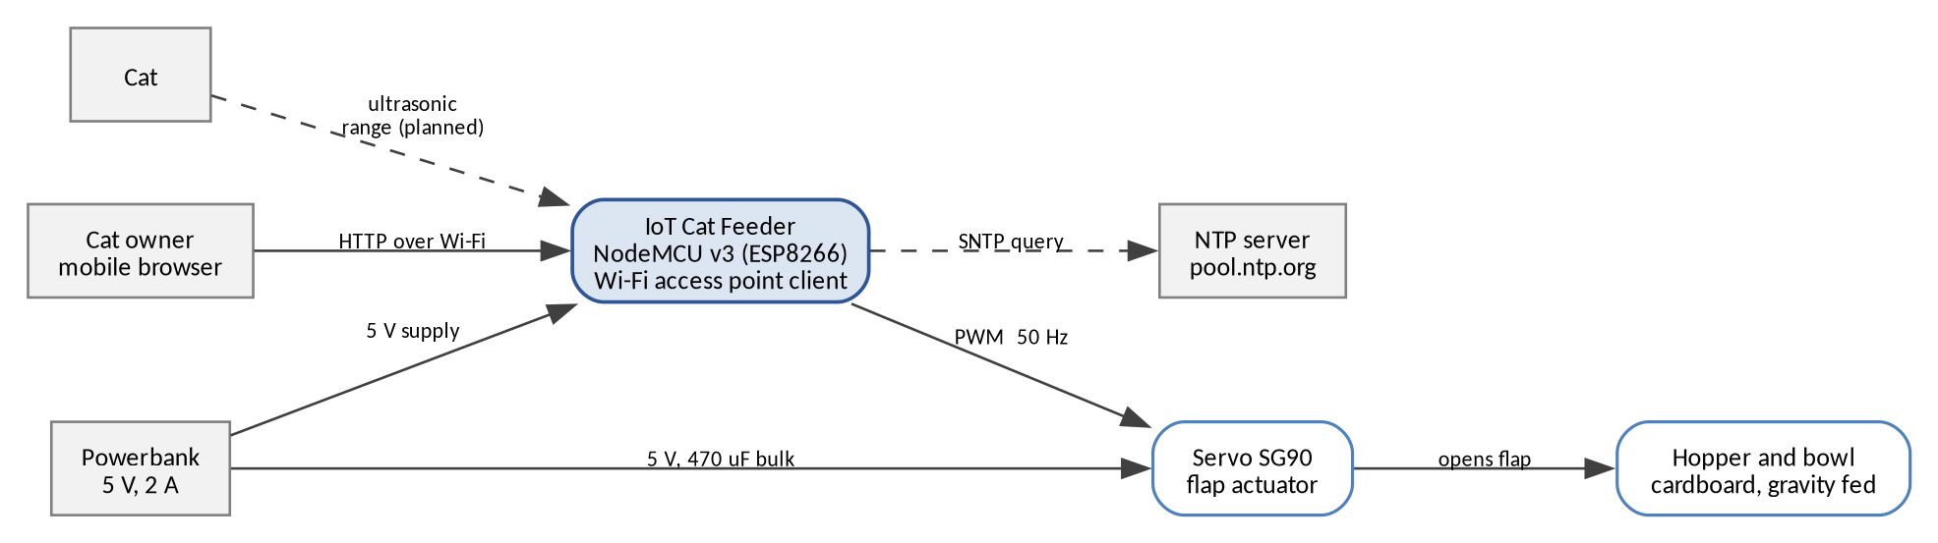
Figure 1. System context. Dashed elements are planned.
The owner is the only human actor. The clock is an external service that provides the time reference. The cat is an environmental actor whose position may become an input once the presence requirement is delivered.

1.4 Product Functions
Table 2. Product functions
ID | Function | Summary | Status
F1 | Scheduled feeding | Dispenses one meal at each configured time, using network time. | Delivered
F2 | On-demand feeding | Dispenses one meal when the owner presses the dashboard button. | Delivered
F3 | Status and history | Reports flap state, daily count, last meal, and link quality. | Delivered
F4 | Presence-triggered feeding | Dispenses a meal when a cat is detected near the bowl. | Parts received
F5 | Hopper level monitoring | Reports the remaining food as a percentage of hopper depth. | Parts received

1.5 User Characteristics
Table 3. User classes
User class | Technical level | Characteristics and needs
Owner | Non-technical | Uses a phone browser. Expects a single page with a single action. Cannot be asked to install software, create an account, or read a manual.
Maintainer | Technical | Rebuilds and reflashes the device. Needs the wiring, the pin map, the library list, and the credentials file documented.
Cat | None | Interacts physically. Must not be able to open the flap or be caught by it.

1.6 Limitations
- History is held in RAM. A reboot clears the daily count.
- Any device on the same Wi-Fi network can issue a feeding command, because there is no authentication.
- Only dry food with a free-flowing particle size can be dispensed.
- The device cannot detect that the bowl is already full before dispensing.
- Only one feeder and one hopper are supported.
- The system does not operate without a 5 V supply.

1.7 Assumptions and Dependencies
Table 4. Assumptions and dependencies
ID | Statement | Effect if false
A-01 | The Wi-Fi network is 2.4 GHz and reachable from the device position. | The device cannot join. The dashboard is unreachable.
A-02 | A network time server is reachable at least once after each boot. | Scheduled feeding is disabled. Manual feeding still works.
A-03 | The hopper holds at least 300 g of dry food. | Meals become short. The level requirement reports the shortage.
A-04 | The servo can lift the flap without stalling. | Brownout or a failed meal. R-01 in the proposal covers the mitigation.
A-05 | The owner's phone and the device are on the same subnet. | The dashboard cannot be reached by name or address.

1.8 Acronyms and Definitions

1.8.1 Acronyms
Table 5. Acronyms
Acronym | Meaning
AP | Access point
GPIO | General purpose input and output
HTTP | Hypertext Transfer Protocol
HX711 | 24-bit load cell amplifier
JSON | JavaScript Object Notation
NTP, SNTP | Network Time Protocol and its simplified form
PWM | Pulse width modulation
SRS | Software Requirements Specification
SDD | Software Design Description
UART | Universal asynchronous receiver and transmitter

1.8.2 Definitions
Table 6. Definitions
Term | Definition
Meal | One dispense cycle, defined as one flap open event followed by an automatic close.
Flap | The servo-driven cover that gates the hopper outlet.
Hopper | The container that holds dry food above the flap.
Schedule minute | A minute of local time that appears in the configured meal table.
Source | The trigger of a meal: manual, schedule, or presence.
Minute key | An integer that identifies one calendar minute, used to prevent duplicate meals.
Parts received | The hardware for this requirement is on the bench and wired. The firmware integration and the acceptance test are still outstanding.

1.9 References
Table 7. References
Reference | Use in this document
ISO/IEC/IEEE 29148:2018, Requirements engineering | Structure of the requirement sections.
IEEE Std 1016-2009, Software design descriptions | Structure of the companion SDD.
Arduino core for ESP8266, reference documentation | Behaviour of ESP8266WebServer, configTime, and WiFi.
HC-SR04 ultrasonic sensor datasheet | Range, beam angle, and supply voltage limits.
HX711 datasheet | Clock timing and gain selection.
SG90 servo datasheet | Stall current and torque limits.
Project rubric, Idea 50 / Circuit 30 / Doc 20 | Coverage check in Appendix A.

1.10 Document Control
Table 8. Revision history
Version | Date | Author | Change
0.9 | 30 October 2026 | C. Jaiman | First draft in Thai, requirements only.
1.0.0 | 4 November 2026 | C. Jaiman | Baselined. Sensor requirements marked as target.

Chapter 2 Specification Requirements

2.1 Feature Description

2.1.1 F1: Scheduled Feeding
At each configured meal time the device dispenses one meal without any user action. The time reference comes from a network time server, so the schedule stays correct after a power cut without a battery-backed clock.
Table 9. F1 parameters
Parameter | Value
Meal times | 08:00, 13:00, 18:00
Time zone | UTC+7, no daylight saving
Time sources | pool.ntp.org, time.nist.gov
Duplicate suppression | One meal per calendar minute
Behaviour before time is valid | Scheduler disabled, dashboard shows --:--:--

2.1.2 F2: On-Demand Feeding
The owner presses a button on the dashboard and receives a meal within 1.5 seconds. The request is a POST to /feed. The button disables itself for 1.3 seconds after the press so that a double tap does not produce two overlapping cycles.
Table 10. F2 parameters
Parameter | Value
Endpoint | POST /feed
Response | 200 with {"ok":true}
Flap open duration | 900 ms
Client lockout | 1300 ms
Accepted methods | POST only. Others return 404.

2.1.3 F3: Status and History
The dashboard shows five values and refreshes without user action. The values answer one question: was the cat fed today, and by what.
Table 11. F3 parameters
Displayed value | Source field | Format
Flap state | open | Open, or Closed
Meals today | count | Integer with unit
Last meal | last, source | HH:MM with trigger in brackets
Device time | time | HH:MM:SS
Configured schedule | schedule | Three times separated by a middle dot
Link quality | rssi, ip | dBm and dotted quad

2.1.4 F4: Presence-Triggered Feeding (target)
An ultrasonic sensor aimed at the approach path detects a cat within 60 cm. A confirmed detection dispenses one meal, subject to a cooldown and a daily cap. Confirmation requires three consecutive readings inside range, which prevents a single stray echo from feeding the cat.
Table 12. F4 parameters
Parameter | Value
Detection range | 60 cm
Confirmation | 3 consecutive readings
Cooldown after a presence meal | 30 minutes
Daily cap | Configurable, default 6
Sensor | HC-SR04 or HC-SR04P, echo divided to 3.3 V

2.1.5 F5: Hopper Level Monitoring
A second ultrasonic sensor aimed down into the hopper estimates the remaining food as a percentage of the usable depth. Portion control by weight moved to Future Work on 2 November, when the amplifier header pins were found to be unsoldered.
Table 13. F5 parameters
Parameter | Value
Measurement | Distance from the lid to the food surface
Level reporting | Percentage of usable hopper depth
Empty depth | 18 cm, measured on the assembled hopper
Full depth | 4 cm, measured on the assembled hopper
Filtering | Median of the last five samples

2.2 Use Case Diagram
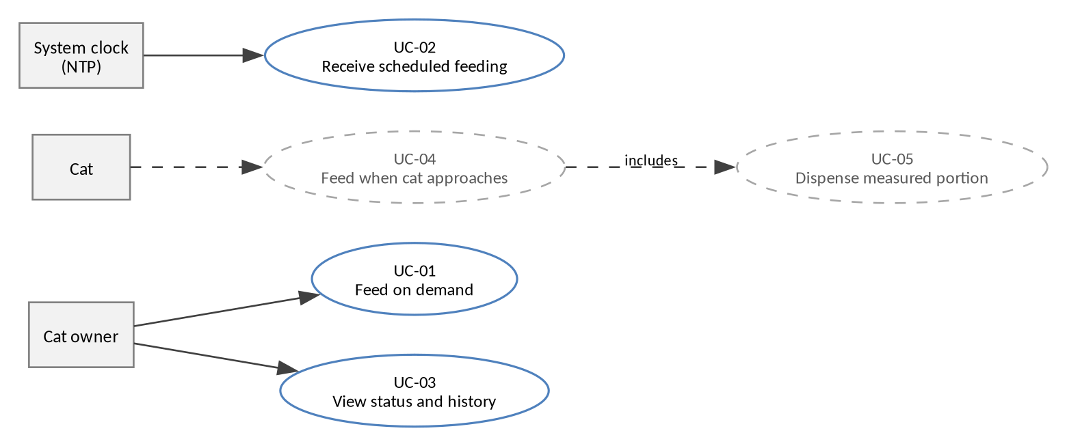
Figure 2. Use cases. Dashed use cases are planned extensions and are not part of version 1.0.0.

2.3 Use Case Description

2.3.1 UC-01: Feed the Cat on Demand
Table 14. UC-01: Feed the cat on demand
Item | Description
Actor | Owner
Goal | Dispense one meal immediately.
Precondition | The device is powered and reachable on the network. A browser has loaded the dashboard.
Trigger | The owner presses the feeding button.
Main flow | 1. The browser sends POST /feed.  2. The device validates the method.  3. The device records the meal with source manual.  4. The device drives the servo to the open angle.  5. The device returns {"ok":true}.  6. After 900 ms the main loop closes the flap.
Alternate flow | A1. The request times out: the browser shows a connection failure, and the flap still closes because the close is driven locally.
Postcondition | One meal is counted. The flap is closed.
Frequency | Up to several times per day.

2.3.2 UC-02: Receive a Scheduled Feeding
Table 15. UC-02: Receive a scheduled feeding
Item | Description
Actor | System clock, provided by NTP
Goal | Dispense one meal at a configured time without user action.
Precondition | The device has a valid time, meaning the epoch is later than 9 September 2020.
Trigger | Local time reaches a minute in the meal table.
Main flow | 1. The main loop reads the local time.  2. The minute key is computed.  3. If the key equals the previous key, the loop exits.  4. If the minute matches a meal time, one meal is dispensed with source schedule.  5. The flap closes after 900 ms.
Alternate flow | A1. Time is not yet valid: the loop exits without dispensing. A2. The clock jumps backward after a resync: a repeated minute key still produces at most one meal.
Postcondition | One meal is counted with source schedule.
Frequency | Three times per day.

2.3.3 UC-03: View Status and History
Table 16. UC-03: View status and history
Item | Description
Actor | Owner
Goal | Confirm that the cat has been fed and inspect the device clock.
Precondition | The device is reachable.
Trigger | The owner opens the dashboard, or the two-second refresh fires.
Main flow | 1. The browser sends GET /status.  2. The device serialises eight fields.  3. The page updates five display rows and the link footer.
Alternate flow | A1. The request fails: the footer reports a lost connection and the previous values stay on screen.
Postcondition | No state changes on the device.
Frequency | Continuous while the page is open.

2.3.4 UC-04: Feed When the Cat Approaches (target)
Table 17. UC-04: Feed when the cat approaches
Item | Description
Actor | Cat
Goal | Dispense a meal when the cat is at the bowl and the cooldown has expired.
Precondition | The presence sensor is connected and calibrated. The daily cap is not reached.
Trigger | Three consecutive distance readings below 60 cm.
Main flow | 1. The loop polls the sensor.  2. The median distance is computed.  3. The confirmation counter increments.  4. A meal is dispensed with source presence.  5. The cooldown starts.
Alternate flow | A1. The cat leaves before confirmation: the counter resets. A2. Cooldown is active: the request is ignored and no meal is counted.
Postcondition | One meal is counted. The presence cooldown is running.
Frequency | At most once per 30 minutes.

2.3.5 UC-05: Dispense a Measured Portion (deferred)
Table 18. UC-05: Dispense a measured portion
Item | Description
Actor | System
Goal | Deliver a mass of food within tolerance of the target.
Precondition | The load cell is calibrated at zero with an empty bowl.
Trigger | Any feeding path starts.
Main flow | 1. The flap opens.  2. The amplifier is sampled ten times per second.  3. The mass delta is compared with the target.  4. The flap closes when the target is reached.
Alternate flow | A1. The timeout of 3 s expires: the flap closes and the meal is recorded with a shortfall flag.
Postcondition | The dispensed mass and the shortfall are recorded.
Frequency | Once per meal.

2.3.6 UC-06: Recover From a Network Loss
Table 19. UC-06: Recover from a network loss
Item | Description
Actor | System
Goal | Return to the network without a reboot.
Precondition | The device was connected and lost the link.
Trigger | The connection state changes to disconnected.
Main flow | 1. The loop checks the connection state.  2. A retry is issued no more than once every 5 seconds.  3. On success the local address is printed once to the serial console.
Alternate flow | A1. The network is absent: retries continue indefinitely at the same rate.
Postcondition | The dashboard is reachable again. No meal state is lost.
Frequency | On every disconnection.

2.4 Activity Diagram
The activity diagram below shows one iteration of the main loop. The close of the flap is evaluated on every iteration and does not depend on an HTTP request completing.
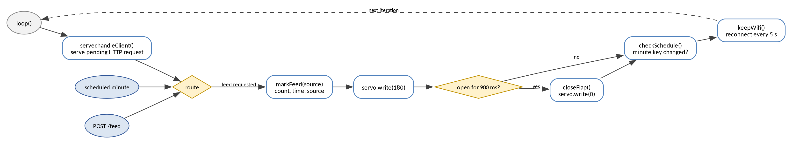
Figure 3. Main loop activity.

2.5 Functional Requirements
Priority uses MoSCoW. Verification uses one of T for test, D for demonstration, A for analysis, or I for inspection.
Table 20. Functional requirements
ID | Requirement | Priority | Verification | Status
FR-01 | The device shall dispense one meal at 08:00, 13:00, and 18:00 local time. | Must | T | Delivered
FR-02 | The device shall obtain local time from a network time server and shall not evaluate the schedule until the time is valid. | Must | T | Delivered
FR-03 | The device shall dispense at most one scheduled meal per calendar minute. | Must | T | Delivered
FR-04 | The device shall dispense one meal when it receives POST /feed. | Must | T | Delivered
FR-05 | The device shall close the flap within 1000 ms of opening it, on every code path. | Must | T | Delivered
FR-06 | The device shall reject any method other than POST on /feed. | Must | T | Delivered
FR-07 | The device shall return the eight status fields defined in the status table above on GET /status. | Must | T | Delivered
FR-08 | The dashboard shall refresh its values every 2 seconds without user action. | Must | D | Delivered
FR-09 | The device shall reset the daily meal count when the local date changes. | Must | T | Delivered
FR-10 | The device shall record the trigger source of every meal as manual, schedule, or presence. | Must | T | Delivered
FR-11 | The device shall serve the dashboard page on GET / with no external asset. | Must | T | Delivered
FR-12 | The device shall return 404 for every undefined path. | Must | T | Delivered
FR-13 | The device shall detect a cat within 60 cm of the bowl after three consecutive readings. | Should | T | Parts received
FR-14 | The device shall not dispense more than one presence-triggered meal in 30 minutes. | Should | T | Parts received
FR-15 | The device shall dispense a mass within 15 percent of the configured target. | Could | T | Future work
FR-16 | The device shall report hopper level as a percentage of usable depth. | Could | D | Parts received
FR-17 | The device shall persist the daily history across a reboot. | Could | T | Future work
FR-18 | The device shall refuse a meal when the configured daily cap is reached. | Should | T | Future work

2.6 External Interface Requirements

2.6.1 User Interface
One page, one column, maximum width 420 px, in Thai. The page uses a light background and a single accent colour. It has no navigation, no form, and no settings panel.
Table 21. Dashboard elements
Element | Type | Behaviour
Title block | Static text | Names the device and states the primary action.
Status card | Five text rows | Rebuilt from /status on every refresh.
Feed button | Button | Sends POST /feed, disables itself for 1300 ms.
Link footer | Text | Shows RSSI and IP, or a lost-connection message.

2.6.2 Software Interface
Table 22. HTTP interface
Method | Path | Request body | Response
GET | / | None | HTML, 200
GET | /status | None | JSON, 200, application/json; charset=utf-8
POST | /feed | None | JSON {"ok":true}, 200
Any | Other | None | Text, 404

Table 23. Status response fields
Field | Type | Range | Meaning
open | Boolean | true, false | Flap is open.
count | Integer | 0 to 255 | Meals counted since local midnight.
last | String | HH:MM or - | Local time of the last meal.
source | String | manual, schedule, presence, empty | Trigger of the last meal.
time | String | HH:MM:SS or --:--:-- | Device local time.
schedule | String | Three times | Configured meal times.
ip | String | Dotted quad | Device address.
rssi | Integer | -90 to -30 | Signal strength in dBm.

2.6.3 Hardware Interface
Table 24. Hardware interface
Device | Signal | Pin | Electrical notes | Status
Servo SG90 | PWM | D5, GPIO14 | 50 Hz, 1 to 2 ms pulse. Powered from VIN, not 3V3. | Connected
Servo SG90 | Supply | VIN, GND | 5 V from powerbank. 470 uF across the rail. | Connected
HC-SR04 presence | Trig | D6, GPIO12 | 3.3 V drive is accepted. | Wired
HC-SR04 presence | Echo | D7, GPIO13 | 5 V output. Divided to 3.00 V with 2.2k and 3.3k. | Wired
HC-SR04 level | Trig | D1, GPIO5 | Aimed down into the hopper. | Wired
HC-SR04 level | Echo | D2, GPIO4 | Divided with a second 2.2k and 3.3k pair. | Wired
Status LED | Digital out | D4, GPIO2 | Bring-up only. Active low on this board. | Test

2.7 Data Requirements
The device keeps one record in RAM. There is no database, no file system, and no remote store in the delivered baseline.
Table 25. Persistent and in-memory data
Name | Type | Lifetime | Purpose
Feeder state | Struct of six fields | Until reboot | Flap state, count, last meal, source, day.
Meal table | Constant array of three hours | Firmware constant | Schedule definition.
Minute key | Integer | Until reboot | Duplicate suppression for the scheduler.
Last connection attempt | Unsigned long | Until reboot | Rate limit for Wi-Fi retries.

Requirement FR-17 would add a flash record with one line per meal, written append-only, capped at the last 32 meals. That record is not part of version 1.0.0.

2.8 Quality Requirements
Table 26. Non-functional requirements
ID | Category | Requirement | Verification
NFR-PM-01 | Performance | A dashboard request completes within 2 s on the same network. | T
NFR-PM-02 | Performance | A manual meal starts within 1.5 s of the button press. | T
NFR-PM-03 | Performance | Presence detection dispenses within 2 s of entering range. | T
NFR-RL-01 | Reliability | The flap is never open longer than 3 s. | T
NFR-RL-02 | Reliability | The device rejoins the network within 30 s of it returning, with no reboot. | T
NFR-RL-03 | Reliability | Schedule timing drifts by no more than 1 minute over 24 hours. | T
NFR-RL-04 | Reliability | A failed HTTP response does not leave the flap open. | A
NFR-UH-01 | Usability | The dashboard is readable at 375 px width without zoom. | D
NFR-UH-02 | Usability | A first-time user feeds the cat without instruction. | D
NFR-UH-03 | Usability | The dashboard states the connection state when the link fails. | D
NFR-SEC-01 | Security | Wi-Fi credentials are excluded from version control. | I
NFR-SEC-02 | Security | Only documented methods and paths are served. | T
NFR-SEC-03 | Security | The device exposes no administrative endpoint. | I
NFR-OP-01 | Maintainability | The firmware builds from a documented library set. | I
NFR-OP-02 | Maintainability | The pin map and wiring are documented in one page. | I
NFR-CP-01 | Constraint | The device runs from a 5 V 2 A powerbank with no host computer. | T
NFR-CP-02 | Constraint | The device operates on 2.4 GHz Wi-Fi only. | I
NFR-CP-03 | Constraint | The firmware fits in the 4 MB flash of the NodeMCU v3. | I

2.9 Design Constraints
- The servo signal uses GPIO14 because the board exposes it as D5 with no boot-time conflict.
- The echo line of a 5 V ultrasonic sensor must be divided before it reaches a 3.3 V input.
- No blocking delay is permitted in the main loop, because the HTTP server is polled from the same loop.
- The dashboard must be complete in one response under 4 KB, because it is compiled into the binary.

2.10 Verification
Each requirement maps to one test case in the SDD. The matrix below states the method and the pass condition at requirement level.
Table 27. Verification matrix
Requirement group | Method | Pass condition
FR-01 to FR-03 | Timed observation | Exactly three scheduled meals in 24 hours, each within 1 minute.
FR-04, FR-05 | Manual test, 50 repetitions | Every repetition dispenses and closes. No flap stays open.
FR-06, FR-12 | Request inspection | Non-POST and unknown paths return 404 with no side effect.
FR-07, FR-10, FR-11 | Response inspection | All fields present, values match the device state.
FR-08 | Observation | The page changes without user action within 2 s.
FR-09 | Clock rollover | The count returns to zero after local midnight.
FR-13, FR-14 | Field test with the cat | 16 of 20 detections correct. No second meal inside 30 minutes.
FR-16 | Level comparison | Reported percentage within 10 points of the measured fill at three known levels.
FR-17 | Power cycle | History survives a reboot. Currently fails by design.
NFR-PM-01 | Stopwatch | Median response under 2 s across 20 requests.
NFR-RL-02 | Router power cycle | The device rejoins with no manual action.
NFR-SEC-01 | Repository inspection | secrets.h is absent from the tree and from history.

Appendix A Rubric Coverage
The assessment rubric weights Idea 50, Circuit 30, and Doc 20. The table maps each criterion to the section that satisfies it.
Table 28. Rubric coverage
Criterion | Weight | Where it is answered
Concept and problem fit | Idea | Proposal, motivation and purpose
Innovation and impact | Idea | Proposal, strengths and opportunities; feature F5
UX and use-case clarity | Idea | Proposal, target users; use case descriptions; dashboard layout
Architecture concept and feasibility | Idea | Proposal, technology review; design document, architecture chapter
Hardware implementation | Circuit | Hardware interface table; design document, power design
Software and firmware | Circuit | Functional requirements; design document, component description
System integration and IoT connectivity | Circuit | HTTP interface; design document, interface design
SRS | Doc | This document
Proposal and abstract | Doc | Proposal, introduction
SDD | Doc | Design document, architecture and detailed design
Output and discussion | Doc | To be written after testing on 3 November
Photos and evidence | Doc | Test record and photographs of the assembled device
Conclusion and future work | Doc | Proposal, future work; conclusion to be written

